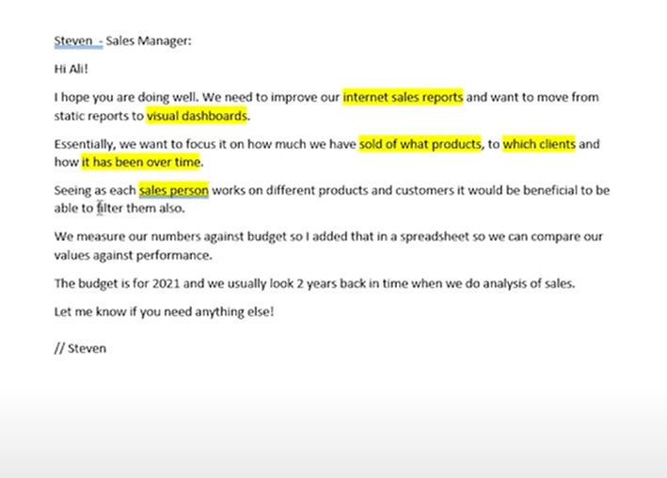

Business demand overview:

* Reporter: steven-sale manager
* Value of change: visual dasboards and improve sales reporting
* Necessary system: Power BI,CRM system
* Other relevant information: budget have been delivered excel for 2021

User stories:

|  |  |  |  |  |
| --- | --- | --- | --- | --- |
| No | As a (role) | I want( request/demand) | So that I (user value) | Acceptaince criteria |
| 1 | Sales manager | To get a dashboard overview of internet sales | Can follow better which customer and products sale the best | A Power BI dashboard which update data once a day |
| 2 | Sale representative | A detailed overview of internet sale per customer | Can follow up my customers that buys the most and who we can sell are to | A power BI pdashboard allows me to fillter data for each customer |
| 3 | Sale representative | A detailed overview of internet sale per product | Can follow up my products that sells the most | A power BI pdashboard allows me to fillter data for each product |
| 4 | Sales manager | A dashboard overivew of internt sales | Follow sales over time against budget | A power BI dashboard with graphs and KPIs comparing agianst budgets |