2 AT THE CONFERENCE HOTEL

**CHECKING IN**

2.16 Listen to Allie checking in. Answer the questions. (âm thanh)

1. Does the receptionist call Allie 'Ms Gray' or 'Mrs Gray'?

* Ms Gray

2. How many nights is Allie staying?

* six nights

3. What's her room number?

* 419

4. What time's breakfast?

* From seven to nine

5. Which floor is the Pavilion Restaurant on?

* The 6th

**CALLING RECEPTION**

b Listen again. Complete the YOU HEAR phrases. (âm thanh)

YOU HEAR

Hello, reception.

How can I help you?

I'm sorry, ma'am. I'll **send** someone up to look at it right now.

**RS Room** service. Can I help you?

Whole wheat or **white** bread?

**RS With** or without mayo?

With **french** **fries** or salad?

**Anything** to drink?

With **ice** and lemon?

It’ll be there in fine minutes, ma’am.

YOU SAY

Hello. This is room 419.

I have a problem with the air-conditioning. It isn't working, and it's very hot in my room.

Thank you.

Hello. This is room 419.

Can I have a tuna sandwich, please?

Whole wheat, please.

Without.

Salad, please.

Yes, a Diet Coke.

Just ice.

Thank you.

a 2.17 Cover the dialogues and listen. Who does Allie phone? Why?  
(âm thanh)

1. She phones reception because she has a problem with the air-conditioning.
2. She also phones room service hecause she wants a sandwich.

c 2.18 Listen and repeat the YOU SAY phrases. Copy the rhythm. (âm thanh)

d In pairs, roleplay the dialogues. **A** (book open) you're the receptionist / room service, **B** (book closed) you're Allie. Swap roles.

**SOCIAL ENGLISH** coffee before the conference

a 2.19 Listen and mark the sentences T (true) or F (false). (âm thanh)

1. Mark is going to take Allie to dinner tonight. **F**
2. The cocktail party is on Thursday. **F**
3. Allie wants to see the bay and the Golden Gate Bridge. **F**
4. Brad is from the San Francisco office. **T**
5. Brad offers to take Allie sightseeing. **T**

b Complete the USEFUL PHRASES. Listen again and check.(âm thanh)

**USEFUL PHRASES**

**A** Well done!

**M** Did you sleep well?

**A** How are things ?

**M** They're fine.

**A** What are the plans for the week?

**M** Allie, this is Brad Martin.

**M** It's time to go.

c 2.20 Listen and repeat the phrases. How do you say them in your language? ( âm thanh)

The story behind a photo

a Match the questions with paragraphs 1-5.

What was happening when you took the photo? **3**

Where do you keep it? Why do you like it? **5**

What's your favourite photo? **1**

Who took it? When? Where? **2**

Tell me more about who or what is in the photo. **4**

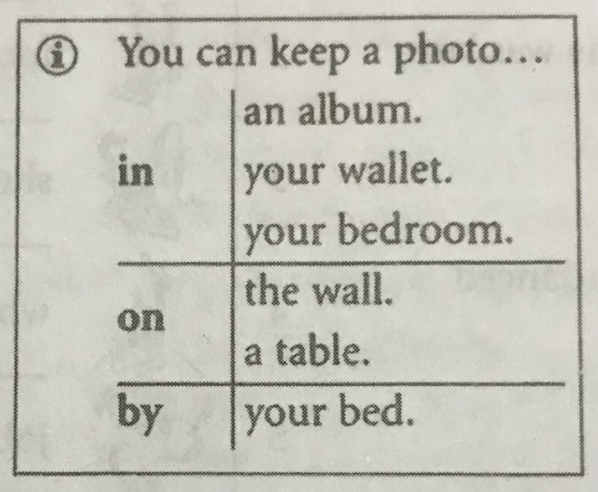

b Complete the text with at, in, or on.

1 One of my favourite photos is of a man cooking fish.

2 I took the photo **in** the summer of 1994 when I was **on** holiday in Africa.

3 We were **in** Zanzibar, and we were sailing round the islands. We caught some fish, and then landed **on** one of the islands, and our guide made a fire and cooked the fish.

4 Richie, the guide, was a wonderful person - he became a good friend. He was also a fantastic cook. I can't remember exactly what fish he was cooking in the photo, but it tasted delicious!

5 I keep this photo **on** the wall in my studio. **On** a grey, rainy day in London, I just have to look **at** it and then memories of a wonderful adventure come back, and I can imagine that I'm **in** sunny Africa again.

