<https://webtestfunix.000webhostapp.com/>

đã đặt title descripstion keyword

google analytic

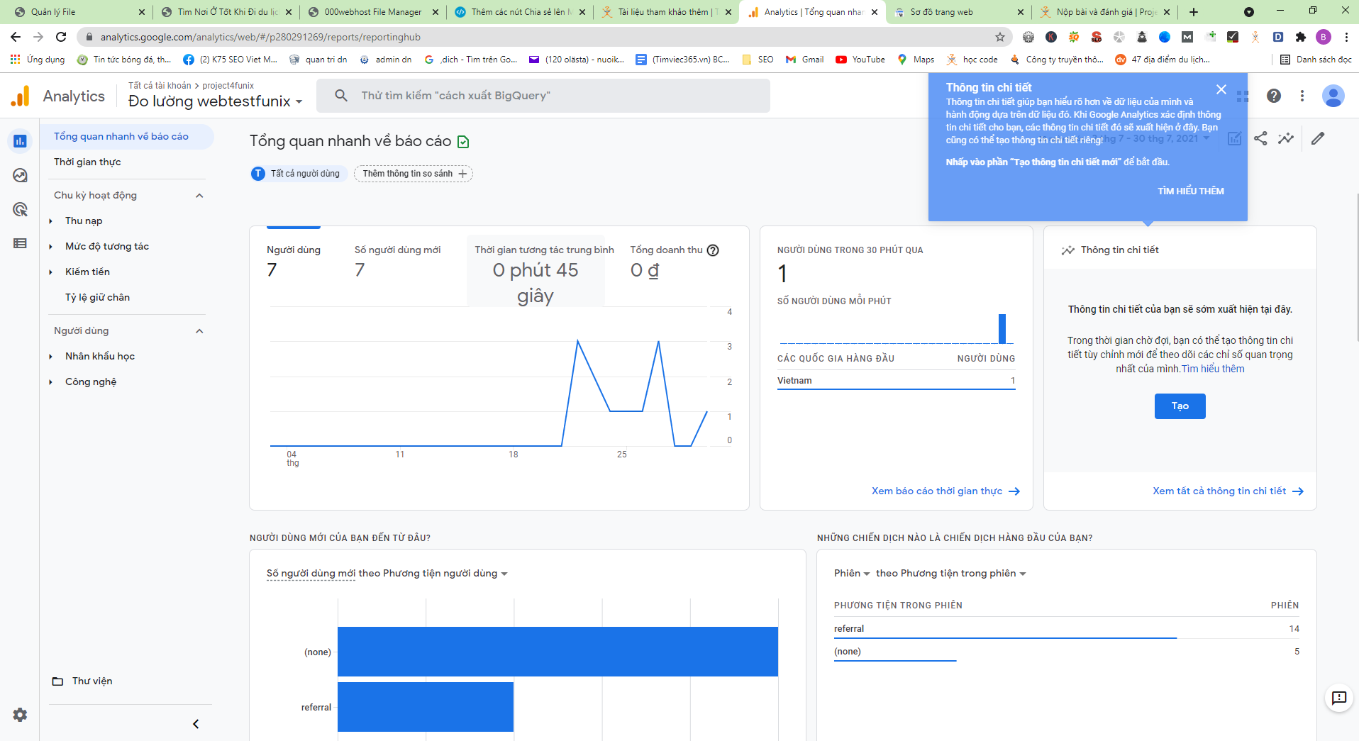

Google seach console

