Flood Monitoring and Prediction System for Short-Term Flood Risk Forecasting

Nguyen Hai Dang¹, Nguyen Tan Dat¹, Dinh Thanh Tung¹
¹FPT University, Hoa Lac High-Tech Park, Km29 Thang Long Boulevard, Hoa Lac District, Hanoi, Vietnam
Corresponding author: Haidang1932006@gmail.com

Abstract. Flooding is one of the most frequent and destructive natural hazards, causing serious impacts on human safety, transportation, infrastructure, agriculture, and local economic activities. Timely flood risk forecasting is therefore essential for early warning and disaster preparedness. This paper presents an AI-driven flood monitoring and prediction system designed as a product-oriented prototype for short-term flood risk forecasting. The proposed system integrates meteorological and hydrological information collected from public data services, including rainfall, temperature, humidity, pressure, wind speed, and river discharge. These data are processed through an end-to-end pipeline that includes data collection, preprocessing, SQL-based storage, feature engineering, historical flood label construction, machine learning model training, multi-horizon prediction, alert generation, and safety recommendation. Unlike algorithm-centered studies that only report model performance, this work focuses on the design of a usable flood early warning product. Historical flood disaster records are converted into daily binary labels, and machine learning classifiers are trained to estimate flood occurrence for three forecast horizons: D+1, D+2, and D+3. Random Forest and XGBoost are implemented as baseline ensemble models for structured tabular data. The model probability is transformed into product-oriented outputs, including Flood Probability, Flood Risk Score, Alert Level, River Trend, Confidence Score, Main Risk Factors, and Safety Recommendation. Final numerical results are intentionally left as placeholders because the corrected D+1, D+2, and D+3 models must be re-evaluated on a valid test set containing both flood and non-flood events. The prototype demonstrates the feasibility of combining public APIs, SQL storage, machine learning, and rule-based decision support for practical flood early warning.
Keywords: Flood prediction; flood monitoring; early warning system; machine learning; river discharge; rainfall; Open-Meteo; EM-DAT; Random Forest; XGBoost; decision support system.
1 Introduction
Flooding remains one of the most damaging hydrometeorological hazards in many regions. A flood event can interrupt transportation, damage buildings and crops, reduce local economic activity, and threaten human life. In areas that frequently experience heavy rainfall and rapid river flow changes, a short-term warning system is valuable because it gives residents and local authorities additional time to monitor conditions, prepare supplies, protect property, and respond to emergency instructions.
Conventional flood warning systems often depend on river gauge thresholds, hydrological simulation, hydraulic modeling, and expert-defined rules. These approaches are important, but they can require dense sensor networks, detailed river basin data, terrain information, calibration, and domain expertise. For student projects or early-stage products, such requirements are difficult to satisfy. Meanwhile, public meteorological and hydrological data services have become more accessible. This creates an opportunity to build a data-driven flood monitoring product that can collect public data, process it automatically, train machine learning models, and translate model output into warning information that users can understand.
The system presented in this paper is designed from a product perspective. The purpose is not to propose a new machine learning algorithm, but to build a coherent AI-driven flood monitoring and prediction pipeline. The product collects weather and river discharge data, stores and cleans the data, creates hydrometeorological features, constructs historical flood labels, trains classification models, predicts short-term flood risk, and generates decision-support outputs. The system currently focuses on two study locations, Hue and Quang Nam, and supports three forecast horizons: D+1, D+2, and D+3.
A practical flood prediction system should not only return a binary label. A user-facing product should explain the warning in a simple way. Therefore, the proposed system converts predicted flood probability into Flood Risk Score, Alert Level, River Trend, Confidence Score, Main Risk Factors, and Safety Recommendation. These outputs are intended to support non-technical users and to make the machine learning prediction more useful in an early warning context.
The main contributions of this paper are summarized as follows. First, an end-to-end flood monitoring pipeline is organized from data collection to warning output generation. Second, historical disaster events are transformed into daily labels for supervised learning. Third, a multi-horizon forecasting design is used to predict flood risk for D+1, D+2, and D+3. Fourth, Random Forest and XGBoost classifiers are used as practical baseline models for structured data. Finally, model outputs are transformed into product-oriented warnings and recommendations rather than being presented only as raw probabilities.
2 Literature Review
Flood prediction has been studied using physical hydrological models, statistical methods, machine learning, deep learning, and hybrid approaches. Hydrological and hydraulic models are useful because they are based on physical processes, but they often require detailed catchment characteristics and calibrated parameters. Machine learning provides an alternative when historical data are available and when the relationship between rainfall, river discharge, and flood occurrence is complex.
Mosavi et al. reviewed machine learning models for flood prediction and showed that ensemble methods, optimization, and hybrid modeling are common directions in data-driven flood forecasting. This supports the selection of Random Forest and XGBoost in the current prototype because both methods are ensemble-based models suitable for nonlinear tabular data. Nevo et al. presented an operational flood forecasting framework using machine learning in a complete system that includes validation, forecasting, inundation modeling, and alert distribution. Their work is relevant because it treats flood forecasting as an operational pipeline rather than an isolated algorithm.
Recent AI-based flood forecasting studies also show the importance of scalability and data availability. Nearing et al. demonstrated that artificial intelligence can support flood prediction even in areas with limited local gauge data. This idea is related to the current prototype because the system uses publicly available data sources instead of relying only on local sensors. In addition, disaster databases such as EM-DAT are useful for constructing event-based flood labels, although such records usually describe disaster events at an administrative level rather than detailed local inundation depth.
Compared with many algorithm-centered studies, this paper emphasizes the product design of a flood prediction system. The system connects data ingestion, preprocessing, SQL storage, feature engineering, model inference, alert thresholds, risk factor explanation, and safety recommendation. This makes the system more similar to an early warning product than to a pure classification experiment.
3 Methodology and System Architecture
3.1 Product-Oriented System Overview
The proposed system is organized as an AI-driven flood monitoring and prediction product. The workflow begins with public data collection and ends with user-facing flood warning outputs. The system first retrieves meteorological and hydrological variables for selected locations. The raw data are exported for traceability, cleaned into a consistent structure, and stored in SQL tables. After that, feature engineering is applied to generate rainfall accumulation, river discharge change, month, and season features. Historical flood labels are created from disaster event records and used to train supervised machine learning models. During prediction, the system calls forecast APIs, prepares the same features used in training, loads saved models, and produces warning outputs.
The product architecture is shown conceptually in [Figure 1]. This figure should present the full pipeline from API data collection to final alert and recommendation. It is important that the figure shows the product flow, not only the machine learning model, because the main contribution of the project is the integration of data engineering, modeling, and decision support.
[Figure 1]
Overall architecture of the AI-driven flood monitoring and prediction system.
Fig. 1. Overall system architecture from data collection to alert generation.

3.2 Data Collection and Storage
The data collection module retrieves weather variables and river discharge values for selected locations. In the current code, weather variables are collected from Open-Meteo services, while river discharge is collected through the Open-Meteo Flood API. The API module separates weather variables from flood-related river discharge variables, calls the corresponding endpoints, merges the responses by date, and exports raw location-level CSV files.
The main meteorological variables include rainfall, temperature, relative humidity, pressure, and wind speed. The main hydrological variable is river discharge. These variables were selected because rainfall and river flow are directly related to flood conditions, while temperature, humidity, pressure, wind speed, month, and season provide additional environmental and temporal context.
After collection and cleaning, the data are stored in a structured SQL design. The database separates location information, weather records, and river records into different tables. This design makes the system easier to extend when new provinces, districts, stations, or variables are added. The SQL storage layer is also important from a product perspective because it separates raw data management from model training and prediction.
Table 1. Dataset and System Input Summary
Item | Description
Study locations | Hue and Quang Nam
Data level | Daily record per location
Main weather variables | Rainfall, temperature, humidity, pressure, wind speed
Main hydrological variable | River discharge
Engineered variables | 3-day rainfall, 7-day rainfall, river discharge change, month, season
Label source | Historical flood disaster event records from EM-DAT
Forecast horizons | D+1, D+2, D+3
Learning task | Binary classification for each forecast horizon

3.3 Data Preprocessing
The preprocessing stage standardizes the raw API output into a model-ready dataset. Column names are converted into simple project-level names, such as rainfall, temperature, humidity, pressure, wind_speed, and river_discharge. The date column is converted into datetime format, numerical variables are converted into numeric types, duplicate records are checked, and missing values are inspected. The cleaned dataset is then saved as a CSV file and used for SQL insertion and feature engineering.
This stage is necessary because API outputs are not always in the exact form required by the training pipeline. A clean and consistent dataset ensures that the same feature names can be used later in training and prediction. This is also important when the model is deployed as a product, because prediction-time data must follow the same structure as training-time data.

3.4 Feature Engineering
Feature engineering is used to transform raw daily observations into indicators that better represent flood-related conditions. Flood risk is not determined only by rainfall on one day; it is also affected by accumulated rainfall and river flow changes. Therefore, the system creates rainfall accumulation and discharge variation features.
rainfall_3days_t = rainfall_t + rainfall_{t-1} + rainfall_{t-2}
rainfall_7days_t = sum_{i=0}^{6} rainfall_{t-i}
river_discharge_change_t = river_discharge_t - river_discharge_{t-1}
The 3-day cumulative rainfall feature captures short-term heavy rainfall, while the 7-day cumulative rainfall feature captures antecedent rainfall conditions. River discharge change indicates whether river flow is increasing, decreasing, or stable. Month and season are added because flood risk in central Vietnam is strongly seasonal. In the current prototype, the rainy season is represented using a simple month-based rule.

3.5 Flood Label Construction
The system uses historical flood disaster records to construct binary flood labels. Each flood event has a start date, end date, and affected location information. The label construction notebook filters flood events associated with the selected study locations, expands each event into daily records from its start date to its end date, and marks those days as flood days. All other dates in the weather dataset are labeled as non-flood days.
The basic daily label is defined as follows:
flood_t = 1 if date t belongs to a historical flood event; otherwise flood_t = 0
To make the system a forecasting product rather than a same-day classifier, three future labels are created by shifting the flood label inside each location time series:
flood_d1_t = flood_{t+1}
flood_d2_t = flood_{t+2}
flood_d3_t = flood_{t+3}
With this design, the input features at day t are used to predict whether a flood will occur one, two, or three days later. This structure is more suitable for early warning than predicting the flood status of the same day.

3.6 Model Training
The model training notebook trains Random Forest and XGBoost classifiers. Both models are suitable choices for the current prototype because the dataset is structured tabular data and the relationships among rainfall, river discharge, season, and flood occurrence can be nonlinear. Random Forest is also useful because it provides feature importance, while XGBoost is a strong gradient boosting baseline for tabular classification tasks.
The system trains separate models for each forecast horizon. This means that the D+1 model predicts flood_d1, the D+2 model predicts flood_d2, and the D+3 model predicts flood_d3. The same feature set is used for each horizon, but the target label changes. The trained models are saved as pickle files so that the prediction notebook can load them without retraining.

Table 2. Saved Model Artifacts Used by the Product Prototype
Model Group | Saved File | Purpose
Random Forest D+1/D+2/D+3 | rf_flood_models_3days.pkl | Dictionary of Random Forest models for three horizons
XGBoost D+1/D+2/D+3 | xgb_flood_models_3days.pkl | Dictionary of XGBoost models for three horizons
Feature columns | model_features.pkl | Column order used during training and prediction
Compatibility model | best_flood_model.pkl | Single D+1 model kept for simple one-day prediction tests

3.7 Prediction Workflow and Decision-Support Output
The prediction notebook represents how the product would work in a real application. Instead of manually entering all features, the user selects a location such as Hue or Quang Nam. The system calls the weather forecast API and the flood API, merges weather and river discharge data by date, applies the same feature engineering process used in training, aligns the columns with model_features.pkl, and sends the input to the trained model.
The model returns a flood probability. This probability is then converted into a Flood Risk Score from 0 to 100. The risk score is mapped to an alert level using rule-based thresholds. The system also produces River Trend based on river discharge change, identifies main risk factors using simple rules, and generates a safety recommendation. These post-processing steps are important because they transform a machine learning output into practical warning information.
Flood Risk Score = P(flood) x 100
Confidence Score = max(P(flood), P(non-flood))
Table 3. Alert Level Rules Used in the Prototype
Risk Score | Alert Level | Suggested Meaning
0-19 | Green | Low risk; continue monitoring
20-39 | Yellow | Monitor rainfall and river conditions
40-59 | Orange | Prepare for possible flooding
60-79 | Red | High flood risk; avoid low-lying areas
80-100 | Severe Red | Very high risk; follow official evacuation instructions

4. Results and Discussion

4.1 Dataset Characteristics
The cleaned training dataset contains daily records for Hue and Quang Nam. Each record corresponds to one location on one date and includes both original API variables and engineered variables. The exact number of records, date range, and label distribution should be calculated from the current data_train.csv file before final submission.
A key characteristic of the dataset is class imbalance. Flood events occur much less frequently than normal days, so a model can achieve high accuracy by predicting non-flood most of the time. For this reason, Accuracy alone is not an appropriate evaluation metric. Recall, F1-score, ROC-AUC, and PR-AUC should be reported, and special attention should be given to false negatives because missing a real flood event is more serious than producing a false alarm.
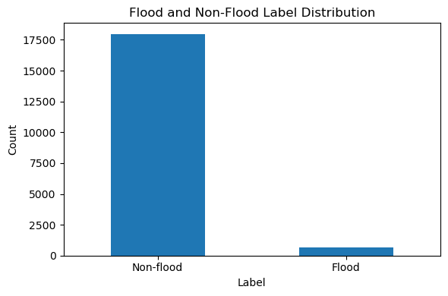Flood and non-flood label distribution in the training dataset.
Fig. 2. Label distribution showing the imbalance between flood and non-flood days.

4.2 Exploratory Analysis
Exploratory analysis should be used to show why the selected variables are meaningful for flood prediction. Rainfall trends can reveal extreme precipitation peaks, monthly rainfall averages can show seasonal patterns, and cumulative rainfall plots can illustrate how flood days may be associated with previous rainfall conditions. River discharge distribution can show how hydrological conditions differ between flood and non-flood periods.
The paper should include only the clearest figures. It is not necessary to insert every plot generated during experimentation. A good product paper should include figures that directly explain the system and support the design choices. Recommended figures are the system architecture, label distribution, monthly rainfall pattern, river discharge distribution, feature importance, confusion matrix, and final prediction output example.
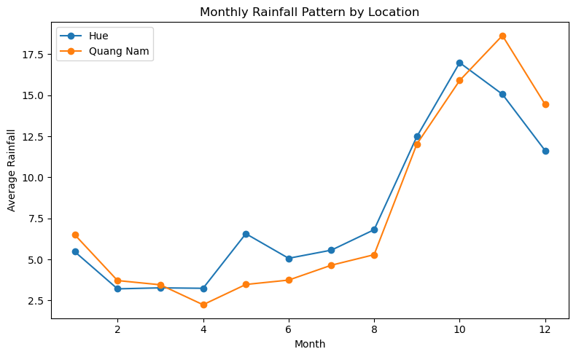Monthly average rainfall by location, used to justify the season/month features.
Fig. 3. Monthly rainfall pattern for the selected study locations.
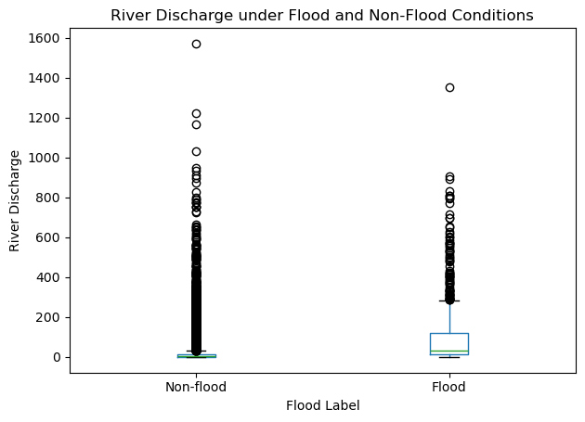River discharge distribution or trend under flood and non-flood conditions.
Fig. 4. River discharge behavior in relation to flood labels.

4.3 Model Evaluation
The final evaluation should compare Random Forest and XGBoost for D+1, D+2, and D+3. The current code already trains separate models for each horizon and stores the results in a DataFrame. However, the evaluation must be checked carefully before reporting numerical values in the paper. If the selected test period contains only non-flood days, metrics such as Recall, F1-score, ROC-AUC, and PR-AUC become unreliable or undefined. In that case, the split strategy should be adjusted so that the test set contains both flood and non-flood cases.
The paper should not reuse the old regression metrics such as MAE, RMSE, and R2 from the previous flood_risk_score experiment. The corrected system is a classification system, so the appropriate metrics are Accuracy, Precision, Recall, F1-score, ROC-AUC, and PR-AUC. The final result table below should be filled only after running the corrected training notebook.
Table 4. Model Performance Comparison for Multi-Horizon Flood Prediction
Model | Horizon | Accuracy | Precision | Recall | F1-score
Random Forest | D+1 | 1.000000 | 0.0 | 0.0 | 0.0
Random Forest | D+2 | [run] | 0.0 | 0.0 | 0.0
Random Forest | D+3 | [run] | 0.0 | 0.0 | 0.0
XGBoost | D+1 | [run] | 0.0 | 0.0 | 0.0
XGBoost | D+2 | [run] | 0.0 | 0.0 | 0.0
XGBoost | D+3 | [run] | 0.0 | 0.0 | 0.0

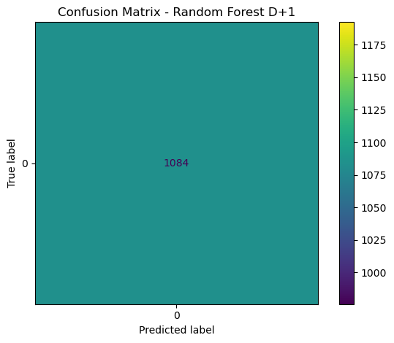Confusion matrix for the selected final model and horizon.
Fig. 5. Confusion matrix for flood classification. False negatives should be interpreted carefully.

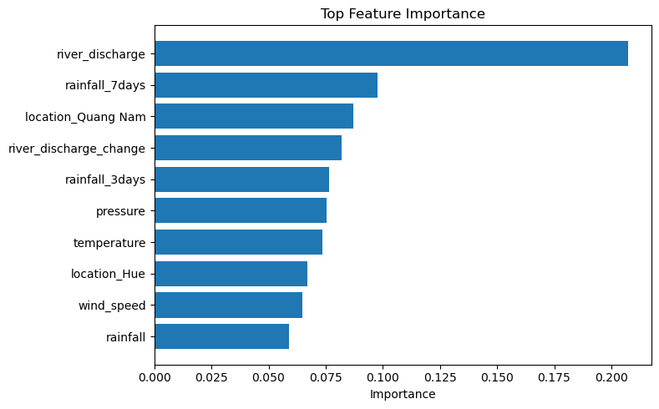Top feature importance from Random Forest or XGBoost.
Fig. 6. Feature importance of the selected flood prediction model.

4.4 Product Output Example
The most important output of the product is not only the model metric table, but the warning screen that the user receives. The prediction notebook should produce a compact three-day forecast table that shows D+1, D+2, and D+3 risk scores, alert levels, river trends, risk factors, and safety recommendations. This output format is suitable for a dashboard or web application because it communicates the warning in a way that non-technical users can understand.
The current prediction notebook should be extended to produce all three horizons in one final DataFrame. This table can be inserted into the paper as an example product output after the model is loaded and the API forecast is processed.
Table 5. Example Product Output for Three-Day Flood Forecasting
Horizon | Forecast Date | Flood Probability | Risk Score | Alert Level | River Trend | Recommendation
D+1 | 2026-07-02 | 0.0 | 0.0 | Green | Stable | Normal condition. Continue monitoring.
D+2 | 2026-07-03 | 0.0 | 0.0 | Green | Stable | Normal condition. Continue monitoring.
D+3 | 2026-07-04 | 0.0 | 0.0 | Green | Stable | Normal condition. Continue monitoring.

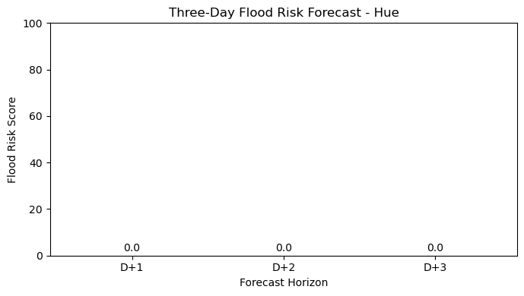Simple bar chart of D+1, D+2, and D+3 Flood Risk Scores with alert colors.
Fig. 7. Example visualization of three-day flood risk scores.

4.5 Discussion
The proposed system demonstrates that an AI-driven flood monitoring product can be built by combining public APIs, structured storage, feature engineering, machine learning, and rule-based decision support. The system is valuable as a product prototype because it shows how raw environmental data can be transformed into practical warning information. The multi-horizon design also improves usability because users can see not only tomorrow's risk but also how the risk may change over the next three days.
The current prototype still has limitations. First, the flood labels are derived from historical disaster event records rather than precise local water-depth observations. This means the labels indicate event occurrence, not exact inundation depth. Second, the dataset is imbalanced because flood days are rare compared with normal days. Third, the test set must be designed carefully; if it contains no positive flood events, the evaluation will not be meaningful. Fourth, important spatial factors such as elevation, land cover, drainage capacity, soil moisture, and distance to river are not yet included. Finally, the system should not claim to predict water depth or flood duration unless reliable ground-truth data are added.
From a product perspective, these limitations do not invalidate the prototype, but they define the boundary of what the system can responsibly claim. The current system can be described as a short-term flood risk monitoring and warning prototype. Before deployment in real disaster management, it should be validated with official hydrological observations, additional locations, local flood reports, and expert-reviewed alert thresholds.

5. Conclusion
This paper presented an AI-driven flood monitoring and prediction system for short-term flood risk forecasting. The proposed system was designed as a product-oriented prototype that connects data collection, preprocessing, SQL storage, feature engineering, flood label construction, machine learning training, multi-horizon prediction, alert generation, and safety recommendation. The system currently supports D+1, D+2, and D+3 flood risk prediction for selected locations using meteorological and hydrological data.
The main value of the system is its end-to-end workflow. It does not stop at training a model; instead, it converts model probabilities into Flood Risk Score, Alert Level, River Trend, Main Risk Factors, Confidence Score, and Safety Recommendation. This makes the output more suitable for a flood early warning product and easier for non-technical users to interpret.
Future work should expand the dataset to more provinces and flood events, improve label quality using official local flood reports, include spatial variables such as elevation and distance to river, and add probability calibration and explainability methods such as SHAP. The prototype should also be deployed as a web application using FastAPI, Streamlit, or a dashboard interface with scheduled API updates and map-based warning visualization.

References
[1] A. Mosavi, P. Ozturk, and K. W. Chau, "Flood Prediction Using Machine Learning Models: Literature Review," Water, vol. 10, no. 11, 1536, 2018. DOI: 10.3390/w10111536.
[2] S. Nevo et al., "Flood forecasting with machine learning models in an operational framework," Hydrology and Earth System Sciences, vol. 26, pp. 4013-4032, 2022. DOI: 10.5194/hess-26-4013-2022.
[3] G. Nearing et al., "Global prediction of extreme floods in ungauged watersheds," Nature, vol. 627, pp. 559-563, 2024. DOI: 10.1038/s41586-024-07145-1.
[4] CRED, "EM-DAT: The International Disaster Database." Available: https://www.emdat.be/.
[5] Open-Meteo, "Weather Forecast API Documentation." Available: https://open-meteo.com/.
[6] Open-Meteo, "Global Flood API Documentation." Available: https://open-meteo.com/en/docs/flood-api.

