Full name: Vũ Hải Đăng – 20226021

Lab 01

1. Getting started

Download JDK 8:

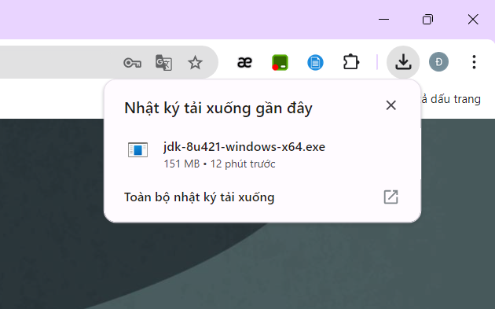

Set the variable name:

Modify variable Path:

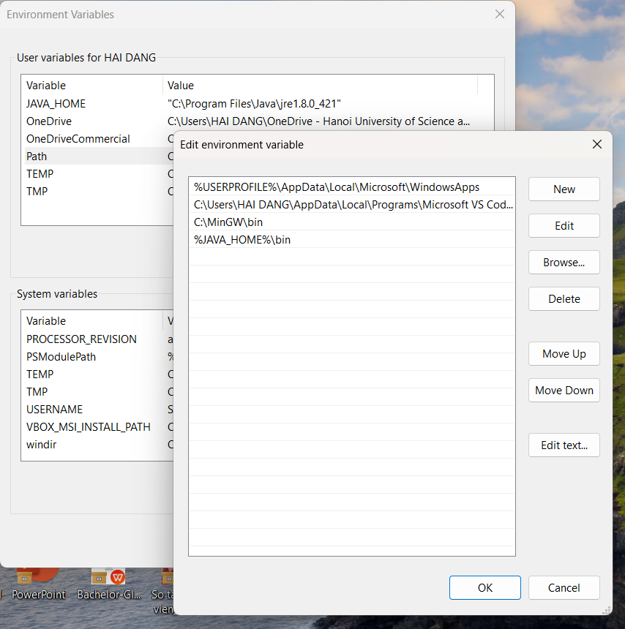

Verify the JDK Installation:

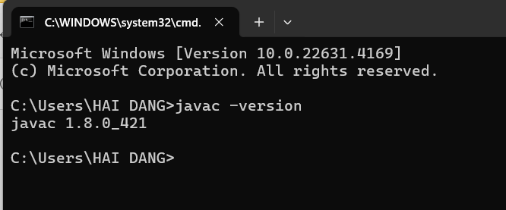

2. First Program

2.1 Java Programming Steps

