MANUAL FOR TODOAPP ASE456

Overview:
This is a python app that uses Python and Sqlite to plan activites.
The app has the following features:
record: record an activity
delete: delete an activity
query: search for an activity
priority: filter out the most frequent activities
list: list all the activities
report: report activites that happened or will happen in a certain time frame

To run the app, the user must open their terminal of choice and navigate to the directory that has the program
To add a todo item, the user must use the command
record [<Date>] [<FROM>] [<TO>] [<TASK>] [<TAG>]

The program will tell the user that the record has successfully been added.

To query the results, the user can use the command
query [<DATE> <TASK> <TAG>]

This command takes 1 argument and will search the database for anything that matches that argument in Tags, Tasks or Date
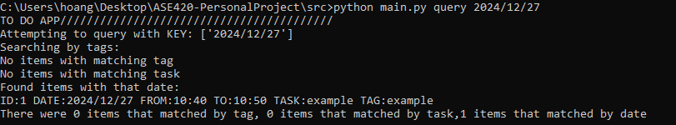
To list all items the user can use the command
list [detail/simple]

Example:

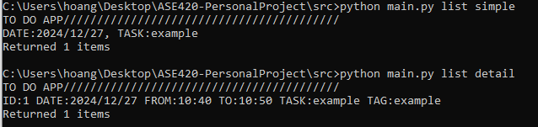
To get items from a specific time interval, the user can use the command
report [from] [to]

Example:

To get activities that appear most ofter, the user can use the command
Priority: priority [number of tasks]
This command will give the user a list of the user’s most frequent activites. The user can specify how many activities he wants to see

Example:

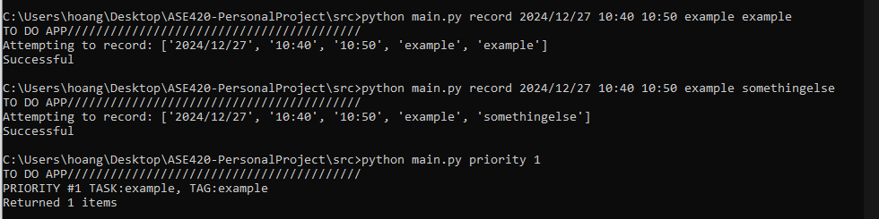

The last command the user can use is the delete command, which deletes 1 item using the items ID
delete [<ID>]

The user can get an items ID by listing it with the list command and the detail option. Additionally, ethe query and report commands will get data that show also show the ID of each item.
Example:
