Hardware Design of
Real-time Classification Algorithm
TEAM POOR HANDWRITING
Haining Qiu, Harry Zhao, Justin Qiao, Qikun Liu



Interface Document

- Hardware Block Diagram
  - Top Level
    - Top Level Memory Mapped Registers
    - Top Level Memory Blocks
  - CPU
    - PC Interface
    - PC Registers
  - Extended ALU
    - Floating-point Adder
      - Left Shifter Interface
      - Right Shifter Interface
    - Floating-point Multiplier
    - Float-to-integer Unit
    - Integer-to-float Unit
    - 16-by-16 Integer Multiplier
  - Stack
  - Image Compressor and Storage
    - Image Compressor Interface
    - Image Compressor Register
    - Image Memory Interface
    - Image Memory Registers
- Software
  - Machine Learning Software
  - Assembly Firmware

Hardware Block Diagrams

Top Level
The top level includes instantiations of the following modules.
A set of modules come from the tutorial of exploring Camera. They are: Sdram_Control, RAW2GRAY, CCD_Capture, I2C_CCD_Config, Reset_Delay, and VGA_Controller.
A set of modules are fully self-implemented and added for the required function. They are: image_mem, weight_rom, spart, PLL, and rst_sync. The details are explained in the following sections.
The modification on the CPU is explained in the following section.

VGA_Controller
I2C_CCD_Config
RAW2GRAY
Sdram_Control
CCD_Capture
image_compressor
image_mem
weight_rom
PLL
spart
CPU
rst_synch
TX/RX
SDRAM
image
compress_img

ImageRecog.sv

D5M_CAM

image
compress_img
VGA
D5M_I2C

ref_clk

rst
clk

Reset_Delay

Top Level Memory Mapped Registers
Register Address: | Description:
0x0000C000 | Write to this address will write to LEDR[9:0] of board
0x0000C001 | Read from this address will return state of SW[9:0] of board
0x0000C004 | Transmit Buffer (IOR/W = 0); Receive Buffer (IOR/W = 1)
0x0000C005 | Status Register (IOR/W = 1)
0x0000C006 | DB(Low) Division Buffer
0x0000C007 | DB(High) Division Buffer
0x0000C008 | Set to 1 to request compressing the image, it will pull down once the compression is finished.

Top Level Memory Blocks
Name: | Start Addr | End Addr | Description:
image_mem | 0x00010000 | 0x0001030F | Image memory RAM, take inputs from image compressor and output values to VGA and processor
weight_mem | 0x00020000 | 0x00021E9F | Weight memory ROM, values load from ML software, output to processor

CPU
This is a high level block diagram of our modified processor. The original 16-bit pipeline logic was mostly preserved. We only expanded the data paths to 32 bits and added new modules. For detailed interface specifications, please refer to the following sections.
ID
ALU
EXT_ALU
STACK
IF
PC
Instr_mem
Data_mem
Instr_mem
WB

SPART, image_mem,SW
RF

PC (Program Counter) Interface
The PC controls the flow of instruction execution. This unit computes the next instruction to fetch based on the instruction flow and CPU stall logic.
Signal: | Dir: | Description:
Flow_change_ID_EX | In | Indicates PC will be updated due to branch or jump (from ID unit)
stall_IM_ID | in | Asserted if stalling pipe due to load/use or MOVC related stall
dst_ID_EX[31:0] | In | Branch target address from ALU
pc[31:0] | out | Forms address to instruction memory
PC_ID_EX[31:0] | out | Piped version needed in EX stage for computing new branch target
PC_EX_DM[31:0] | out | Piped to EX_DM for JAL instruction store in R15

PC (Program Counter) Registers
Register: | Description:
dst_ID_EX, pc, PC_ID_EX,PC_EX_DM  All 32-bits | Described in table above
Flow_change_ID_EX, stall_IM_ID  All 1 bit | Described in table above
pc_IM_ID[31:0] | Updated PC if no stall happens.
nxt_pc[31:0] | The expected next pc if no branch or jump instruction (pc+1)

Extended ALU
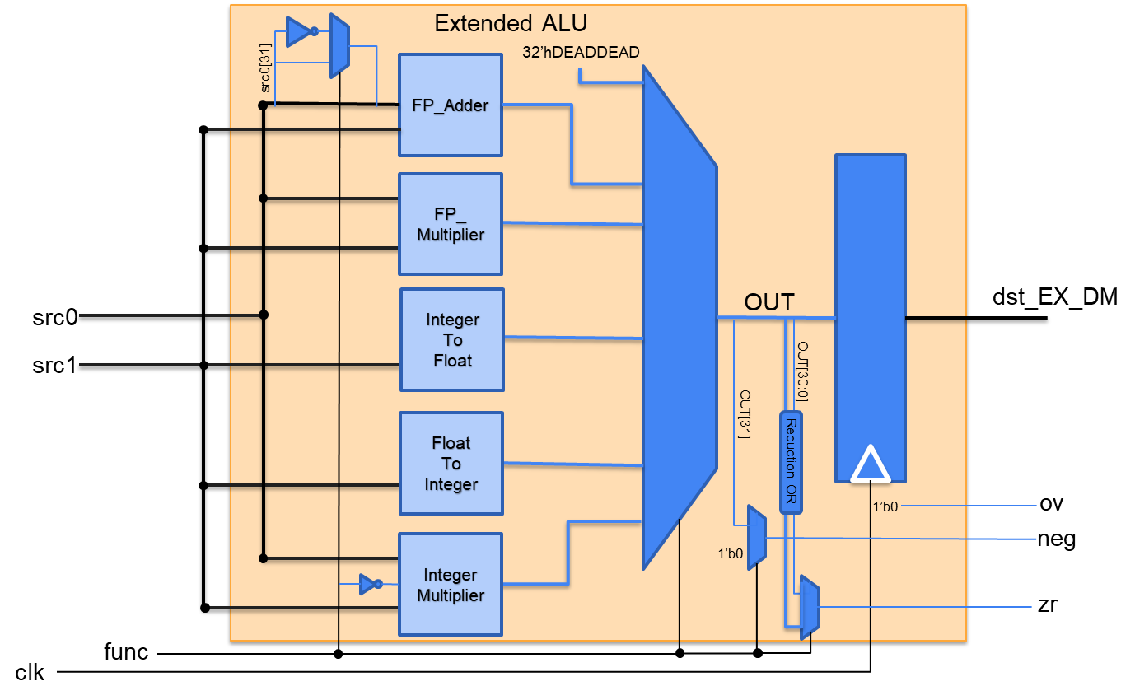
The extended ALU is in the same pipeline stage of the original ALU in the processor while its hardware supports floating-point operations and integer multiplication. It contains five submodules for floating-point addition and multiplication, conversions between float and integer, and integer multiplication. Its output value and flags are selected by the func signal.
Signal: | Dir: | Description:
clk | in | 50MHz system clock
src1[31:0] | in | 32-bit source 1 into ALU
src0[31:0] | in | 32-bit source 0 into ALU
func[2:0] | in | 3-bit OP Code:  000 ==> MUL  001 ==> UMUL  010 ==> ADDF  011 ==> SUBF  100 ==> MULF  101 ==> ITF  110 ==> FTI  111 ==> undefined
dst_EX_DM[31:0] | in | 32-bit ALU output
ov | out | Overflow flag - but this is always 0!!! Kept here for following branch ops
zr | out | Zero flag - high when output is 0 (int zero or FP zeroes)
neg | out | Negative flag - high when output is negative

Floating Point Adder Interface
Signal: | Dir: | Description:
A[31:0] | in | 32-bit input interpreted as an IEEE-754 floating-point number
B[31:0] | in | 32-bit input interpreted as an IEEE-754 floating-point number
Out[31:0] | out | 32-bit output as an IEEE-754 floating-point number

Left Shifter Interface
Signal: | Dir: | Description:
In[23:0] | in | 24-bit mantissa input to be logically left-shifted
ShAmt[4:0] | in | 5-bit left shift amount
Out[23:0] | out | 24-bit mantissa output normalized into IEEE-754 format

Right Shifter Interface
Signal: | Dir: | Description:
In[23:0] | in | 24-bit mantissa input to be logically right-shifted
ShAmt[4:0] | in | 5-bit right shift amount
Out[23:0] | out | 24-bit mantissa output normalized to a common exponent

Floating-point Multiplier Interface
Signal: | Dir: | Description:
A[31:0] | in | 32-bit input interpreted as an IEEE-754 floating-point number
B[31:0] | in | 32-bit input interpreted as an IEEE-754 floating-point number
OUT[31:0] | out | 32-bit output as an IEEE-754 floating-point number

Float-to-integer Unit Interface
Signal: | Dir: | Description:
FP_val[31:0] | in | 32-bit input interpreted as an IEEE-754 floating-point number
signed_int_val[31:0] | out | 32-bit output converted into a signed integer

Integer-to-float Unit Interface
Signal: | Dir: | Description:
signed_int_val[31:0] | in | 32-bit input interpreted as a signed integer
FP_val[31:0] | out | 32-bit output converted into an IEEE-754 floating-point number

16-by-16 Integer Multiplier Interface
Signal: | Dir: | Description:
A[31:0] | in | 32-bit input interpreted as an integer
B[31:0] | in | 32-bit input interpreted as an integer
sign | in | 1 for signed multiplication; 0 for unsigned multiplication
OUT[31:0] | out | 32-bit output as an integer

Stack
Signal: | Dir: | Description:
clk | in | 50M system clock
rst_n | in | active low reset
push | in | push wdata onto stack
pop | in | pop top of stack to stack_EX_DM
wdata[31:0] | in | 32-bit data to be pushed
stack_EX_DM[31:0] | out | 32-bit data being popped

Image Processing and Storage

Image Compressor Interface
Signal: | Dir: | Description:
clk | in | 25MHz clock signal from VGA display
rst_n | in | System reset signal
start | in | Signals a valid pixel color input starting from 0
pix_color_in[7:0] | in | 8-bit pixel color value from VGA DRAM (0 to 255 grayscale)
pix_haddr[7:0] | in | 8-bit pixel horizontal address (0 to 223)
pix_vaddr[7:0] | in | 8-bit pixel vertical address (0 to 223)
sram_wr | out | Write enable signal to the SRAM memory storing compressed image
pix_color_out[7:0] | out | 8-bit compressed pixel color by taking average value among an 8*8 block
compress_addr[9:0] | out | 10-bit compressed image pixel address (0 to 783 for an 28*28 image)

Image Compressor Registers
Register: | Description:
compress_addr[9:0] | Described in table above.  Reset to 10’d784; zero-set when start asserted; incremented when sram_wr asserted.  Namely, it increments to the next available SRAM address after an image memory write and stalls itself when the entire image memory gets written until the next asserted start signal.
block[13:0][0:27] | 28 14-bit wide SRAM blocks to store the accumulated sum of every pixel value inside 28 8*8 blocks.  We need 28 of them since at least one row of 8*8 blocks should be saved for averaging, and there are 28 blocks per row (224/8 = 28). Its address is determined by the upper 5 bits of pix_haddr, named b_haddr.  14-bit is needed since it stores the sum of 64 8-bit wide pixel color values. The average value is taken from its upper 8 bits to produce a compressed pixel color value.

Image Memory Interface
Signal: | Dir: | Description:
clk | in | 50MHz system clock. Note that this is 2 times faster than the clock of the image compressor module, but this is safe since every correct data will get written twice at the same address.
we | in | Write enable signal of image SRAM memory from image compressor
waddr[9:0] | in | 10-bit write address of SRAM from image compressor
wdata[7:0] | in | 8-bit compressed pixel color value from image compressor
raddr[9:0] | in | 10-bit read address of SRAM (0 to 783)
rdata[7:0] | out | 8-bit read port of SRAM for a compressed pixel color value

Image Memory Registers
Register: | Description:
rdata[9:0][0:783] | Described in table above. There are 784 SRAM blocks just enough for a compressed 28*28 image. This SRAM is written by the image compressor.

Software

Machine Learning Software
Input: | Output:
keras.datasets.mnist  - 60,000 images with labels | weight.hex  - contains 7840 8-digits hex numbers, one per line

One high-level software is used for this project. The purpose of the software is to provide the weight matrix that is used to make predictions by performing matrix multiplication on our input image data. This software is written in Python on Google Colaboratory. It includes a Python notebook and a Python script file. The script file contains helper functions and the notebook will read input, call functions, and generate output.
The software does its work in three steps: it reads train data in, trains on the data, and produces the weight matrix. It is currently using the Keras dataset that contains 60,000 different images of 28*28 pixels of handwritten number, and corresponding label to indicate their values. The first 40,000 images are used for training, and the next 10,000 images are used for validation during training, and the last 10,000 images are used for testing the accuracy of the trained model.
The model used for this software is softmax loss linear classifier, which utilizes the difference of ideal logistic probabilities and the current logistic probabilities as the loss function and employs gradient descent to minimize the loss function. This training procedure is repeated at least 200 times. The training process uses the PyTorch library to help boost the performance and reduce the training time. With appropriate learning rate and regularization factors, the training accuracy can be over 90%, and the testing accuracy is around 88.6% for recognizing individual digits.
After finding the best performance model, we extract the transpose of the weight matrix. The transposed weight matrix is flatten into a list of 784 = (28*28) floating-point numbers. For each row, each of the 28 numbers is parsed into hex numbers and pasted into a .hex file, where each line is in the format of {LINE_NUMBER} {HEX_NUMBER}. This file can be directly loaded into the FPGA board as a ROM, which is later read for the matrix multiplication.

Assembly Firmware
Register: | Description:
R1 | 1
R2 | pointer to weight matrix
R3 | pointer of image matrix
R4 | pointer to DM
R5 | loop index
R6 through R16 | compute regs
R17 | loop number 9 (i <= 9)
R18 | current number
R19 | current number - current max
R20 | 9 - i
R21 | current max
R22 | current max index
R23 | SW status
R24 | SW1 mask
R25 | step size
R27 | 0x00000030 ASCII number offset
R28 | 0x0000C000 base address of peripherals
R29 | matrix index
R30 | result pointer, results will be in DM at addr = 1000 through 1009

Our firmware contains three main layers. The first layer is executed once for each requested matrix multiplication. It obtains one number from image_mem and one number from weight_mem, multiplies them together and stores the result to the DM. 784 of such multiplies are calculated and stored in DM[0] through DM[783] in FP format. The second layer is a tree adder of the 784 products to obtain a score. We first add every 7 consecutive numbers together to reduce the 784 numbers to 114. Then add every 7 consecutive numbers of the 114 values again to get 16 numbers. FInally we add the 16 numbers together to get the ultimate score. Each three sub-layers of additions are done with tree adders at the assembly level to mitigate FP addition errors caused by adding two FP numbers with big differences in their exponent values. Finally, a third layer is used to find the max value of the calculated scores for each possible character, and print the prediction result (a ASCII character) to the terminal via Spart.

