FPT UNIVERSITY
CAMPUS FPTU - HOA LAC
-----------✽✽✽------------



PRM393 - Mobile Programming

PROJECT NAME: Restaurant Booking
Class | : | SE1882-NET
Lecturer | : | Bùi Thị Loan
Group 5 | : | Trần Nguyên Vũ | HE186197
 |  | Lê Vũ Hải | HE186288
 |  | Phương Hải Nam | HE181352
 |  | Cà Việt Cường | HE187156
 |  | Lâm Anh Tùng | HE187123
Due date | : | February 05, 2026

Use Case Diagram
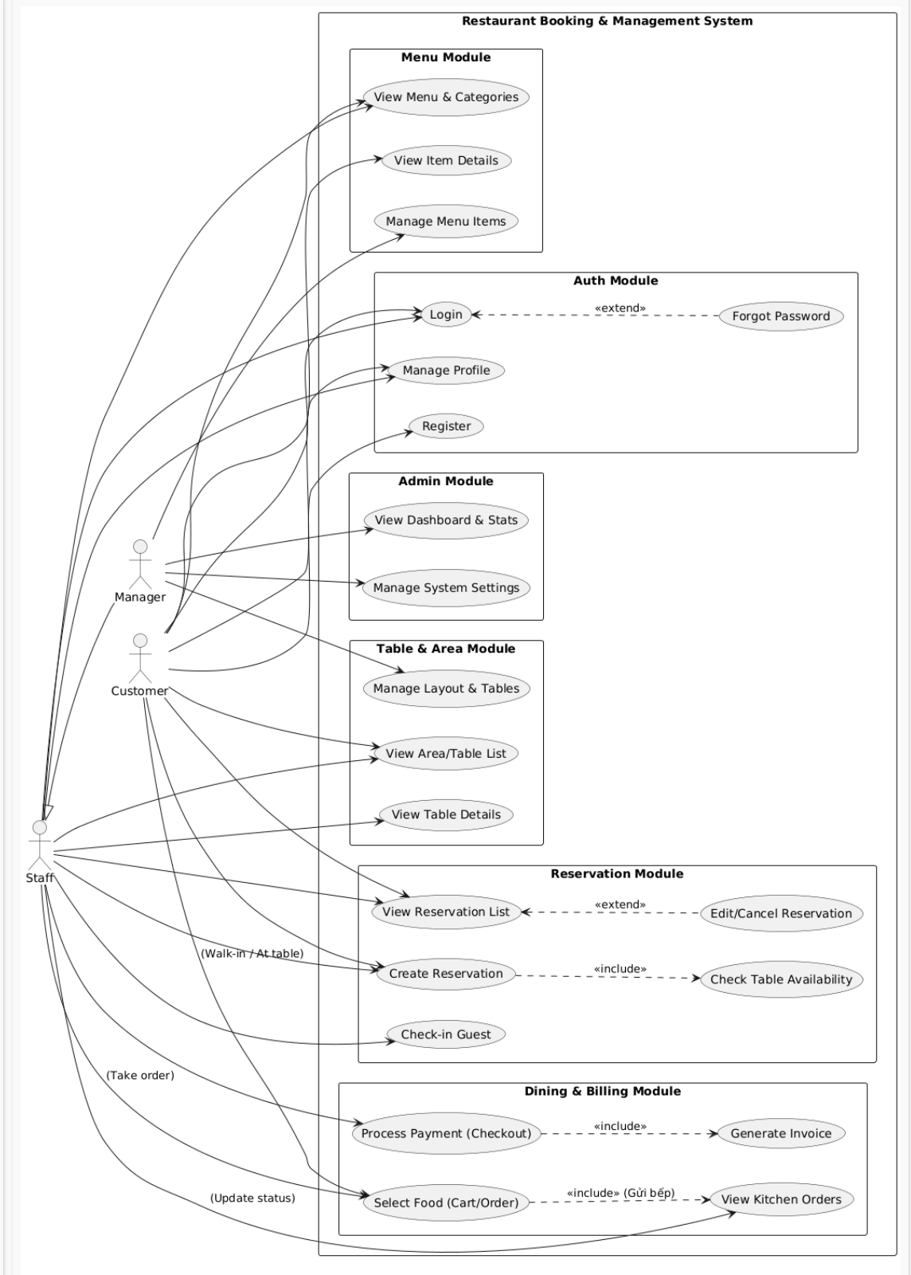

ID | Use Case | Use Case Description
UC01 | Login to System | Allows members to authenticate using their credentials (username/email and password) to access the application.
UC02 | Register Account | Allows new users to create an account to access the system.
UC03 | Manage Profile | Allows users to view and update their personal information.
UC04 | Change Password | Allows users to update their current login password for security purposes.
UC05 | View Area List | Displays a list of restaurant zones or areas (e.g., Main Hall, Terrace, VIP Room).
UC06 | View Table List | Displays all dining tables, often filtered by specific areas or status.
UC07 | View Table Details | Shows specific details of a table (status, capacity, location/ID).
UC08 | Add/Edit Table | Allows adding a new table to the layout or modifying an existing table's information.
UC09 | View Reservation List | Displays a list of table reservations (upcoming, current, or history).
UC10 | Create Reservation | Allows the user to book a new reservation for a customer (selecting time, table, and guest count).
UC11 | View Reservation Details | Shows detailed information about a specific booking (customer contact, special requests).
UC12 | Edit/Cancel Reservation | Allows modifying booking details (e.g., time change) or cancelling the reservation entirely.
UC13 | View Category List | Displays menu categories (e.g., Appetizers, Main Course, Drinks) to organize items.
UC14 | View Menu Items | Displays the list of food and beverage items available in the restaurant.
UC15 | View Menu Item Details | Shows specific details of a dish (image, price, description, ingredients).
UC16 | Add/Edit Menu Item | Allows adding a new dish to the menu or updating an existing item (price, stock, image).
UC17 | View Dashboard | Displays a high-level overview of daily operations and key performance indicators.
UC18 | View Statistics | Displays detailed charts and reports regarding revenue, orders, and customer traffic.
UC19 | Manage Settings | Allows configuration of application settings (e.g., language, theme, notification preferences).
UC20 | View Notifications | Displays a list of system alerts, updates, or activity reminders for the user.

Entity Relationship Diagram
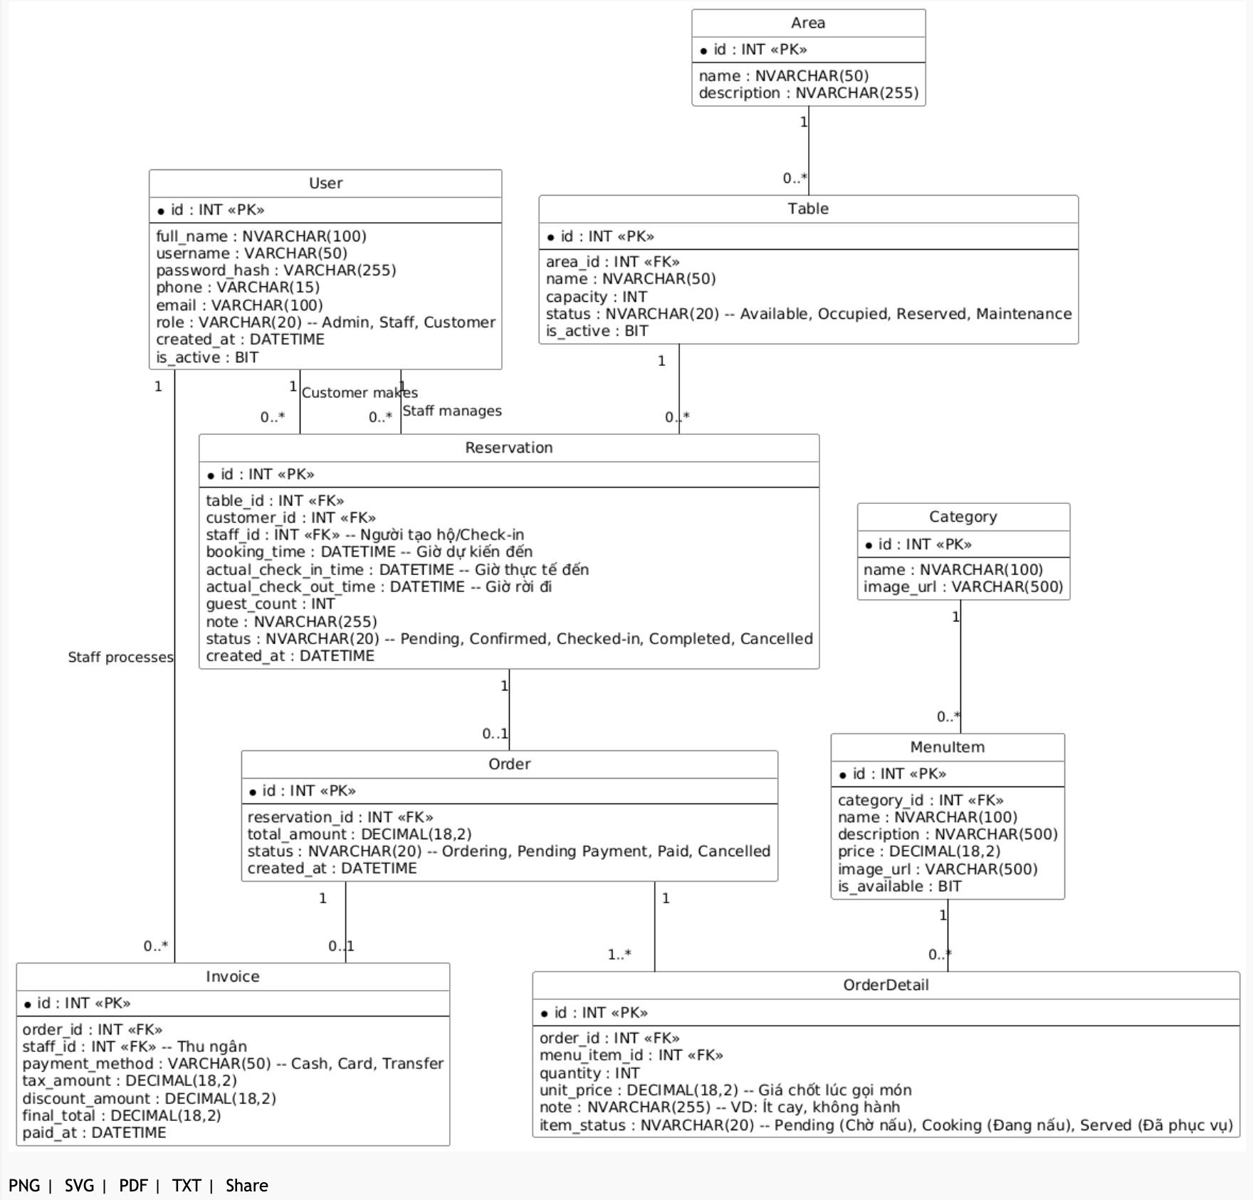

Sequence Diagram

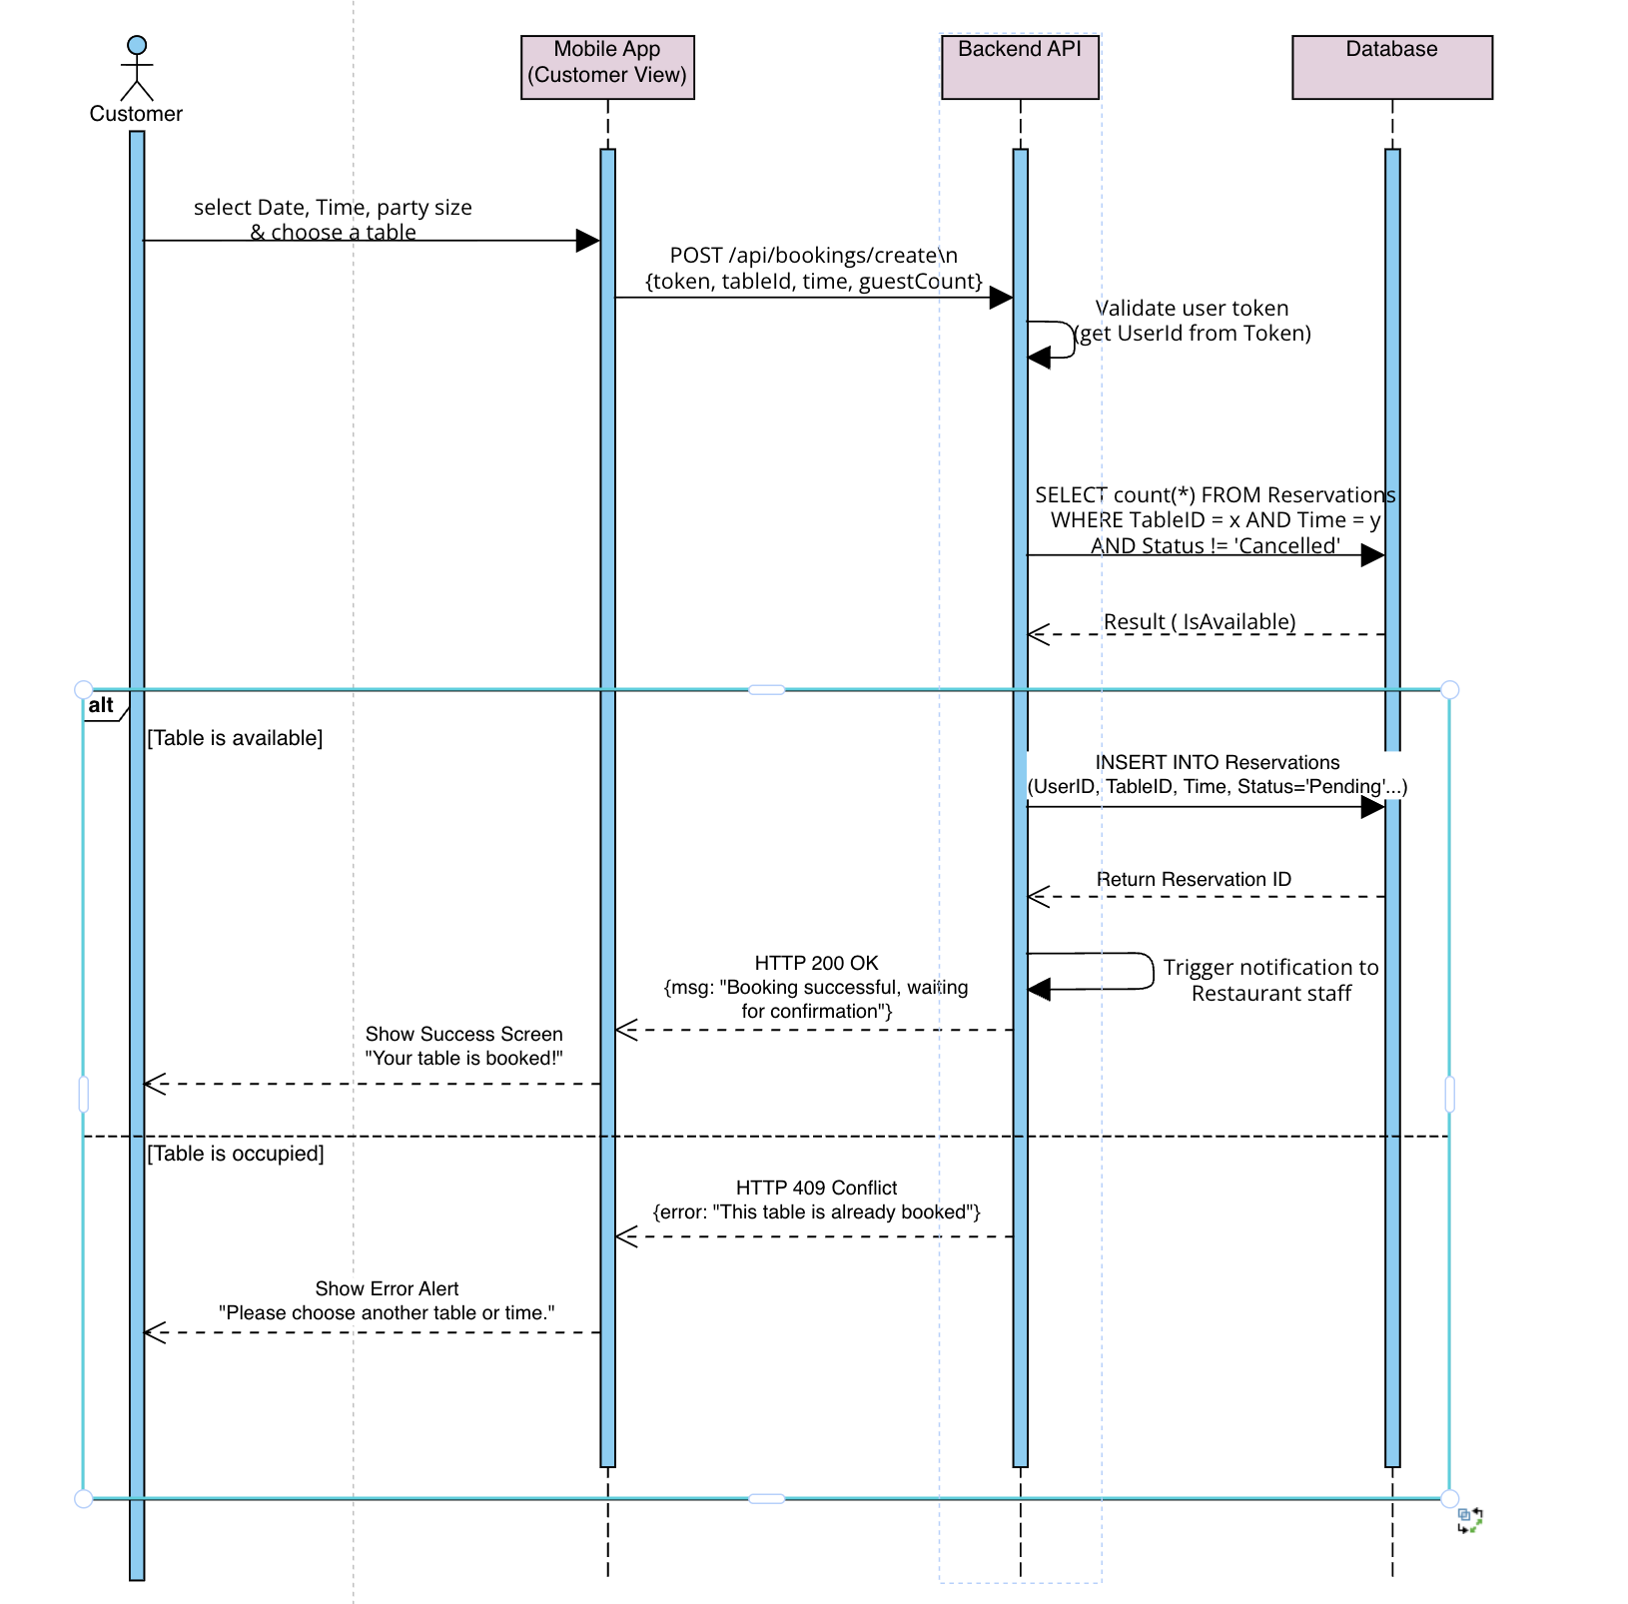
Figure 2.1: Sequence diagram for Create Reservation
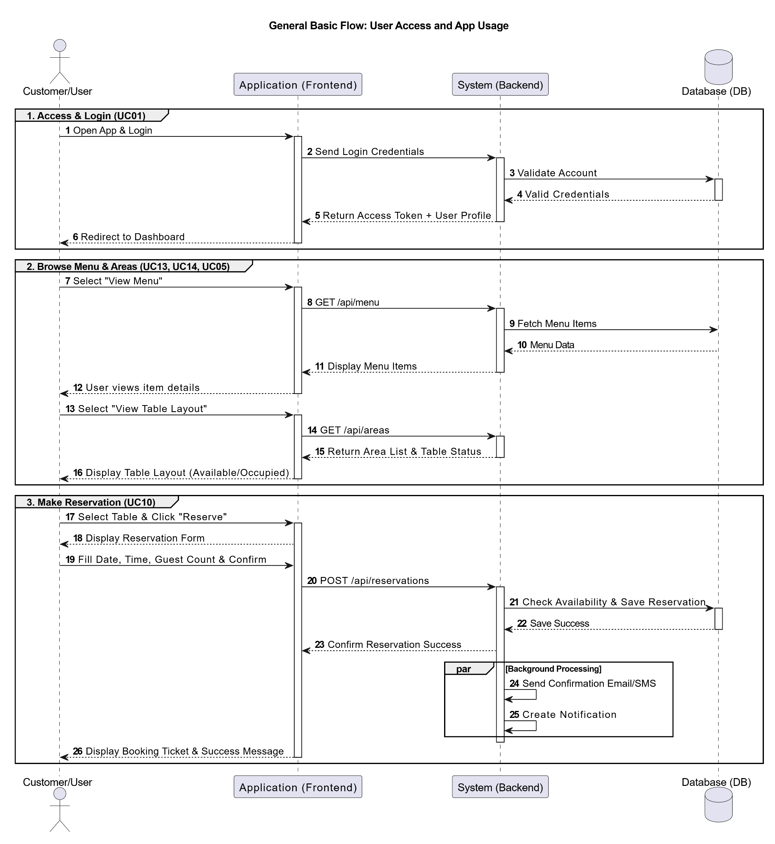

Screen Design
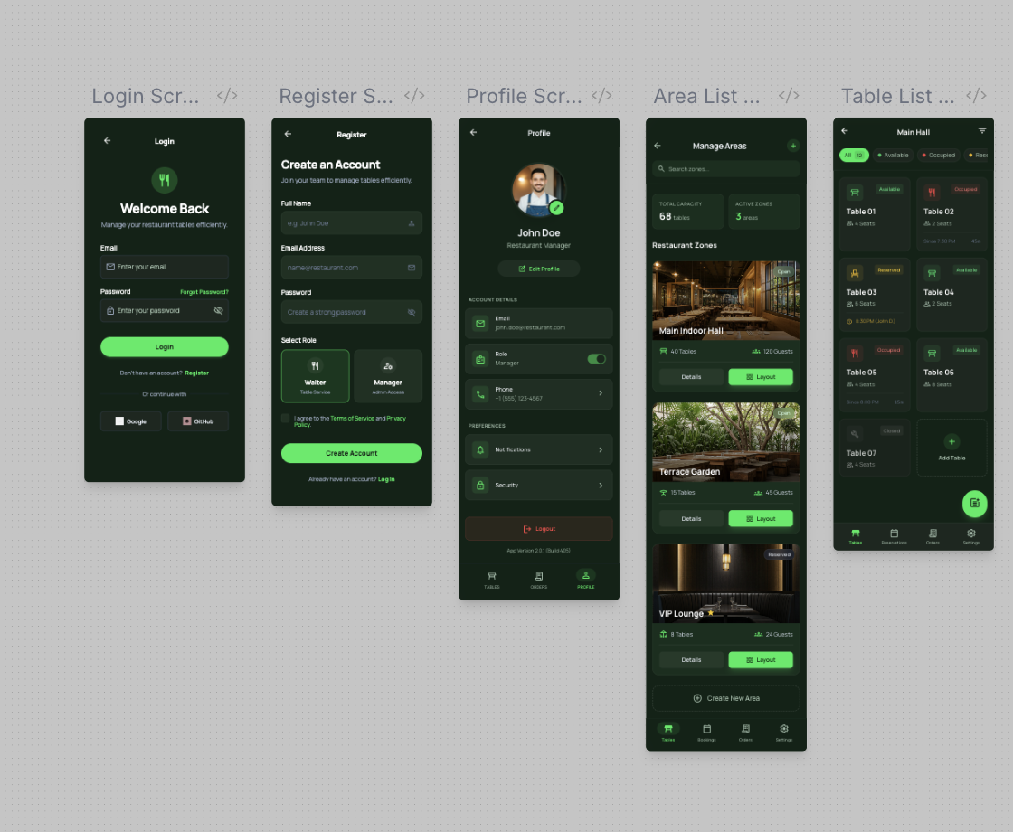
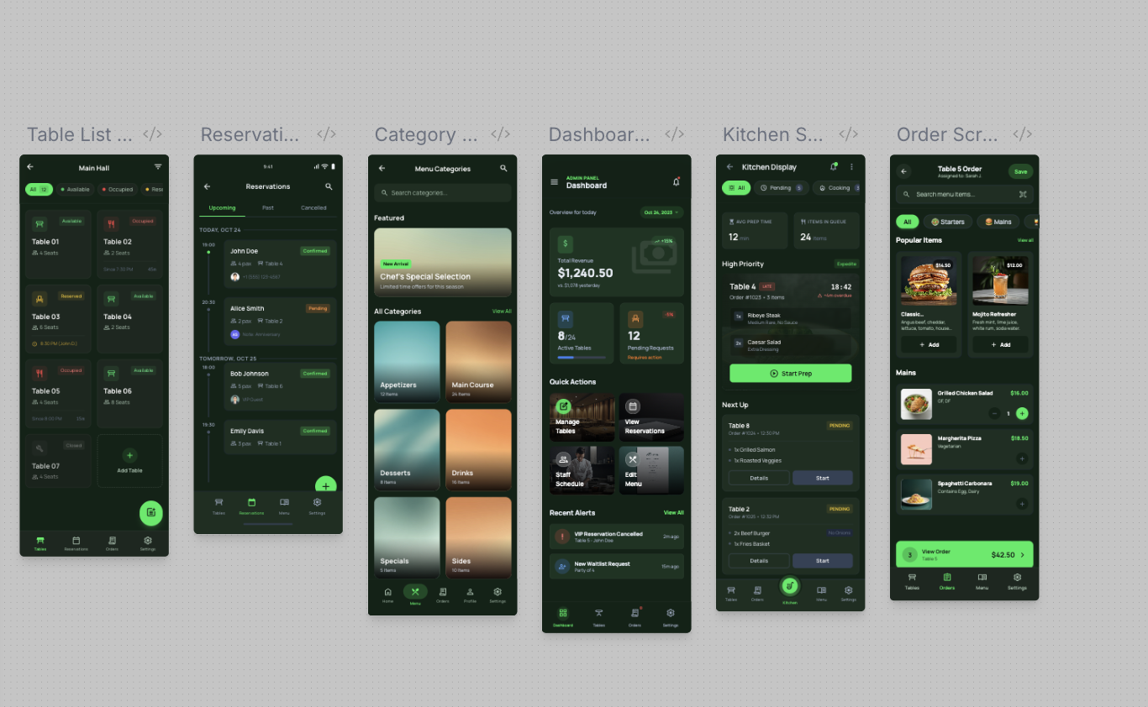

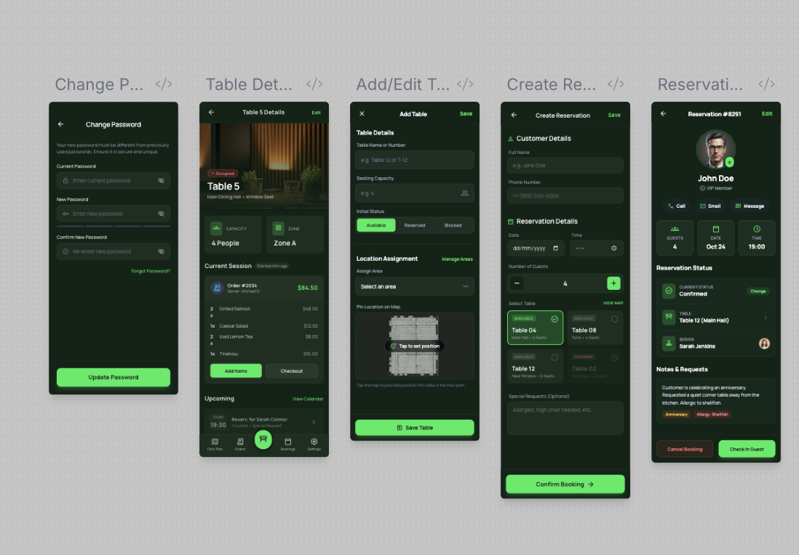
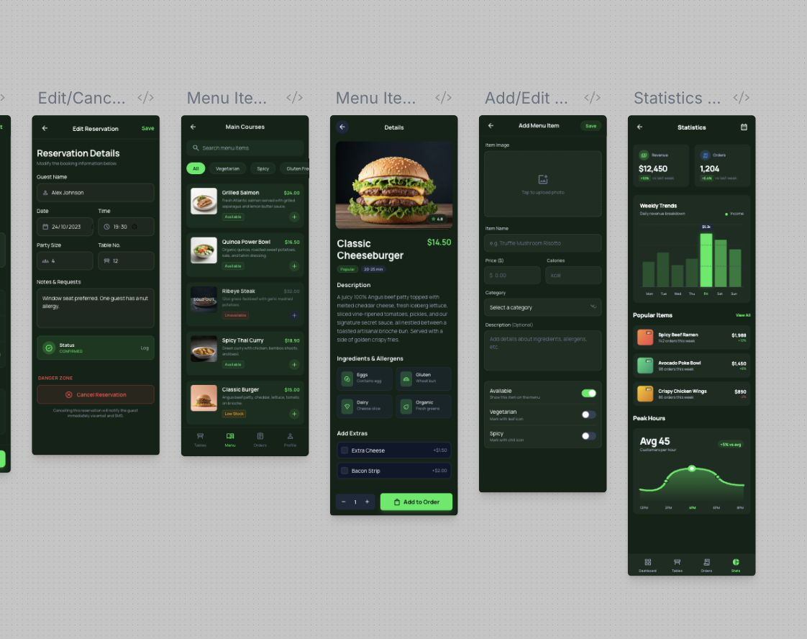
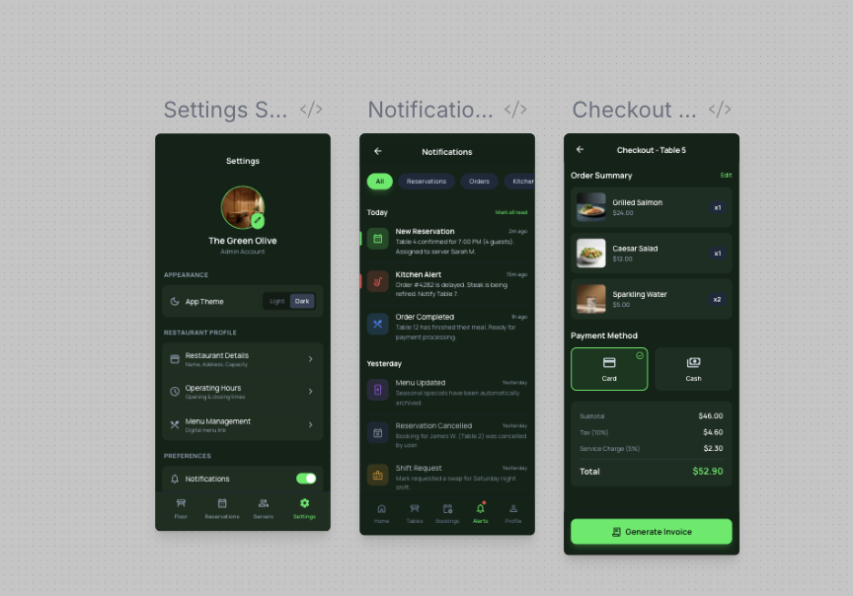

Project Tracking

ID | Use Case | Module | Assigned Member | Status (Todo/In Progress/Done)
UC01 | Login to System | Auth | Nam | To Do
UC02 | Register Account | Auth | Nam | To Do
UC03 | Manage Profile | Auth | Nam | To Do
UC04 | Change Password | Auth | Nam | To Do
UC05 | View Area List | Tables | Vũ | To Do
UC06 | View Table List | Tables | Vũ | To Do
UC07 | View Table Details | Tables | Vũ | To Do
UC08 | Add/Edit Table | Tables | Vũ | To Do
UC09 | View Reservation List | Reservation | Tùng | To Do
UC10 | Create Reservation | Reservation | Tùng | To Do
UC11 | View Reservation Details | Reservation | Tùng | To Do
UC12 | Edit/Cancel Reservation | Reservation | Tùng | To Do
UC13 | View Category List | Menu | Hải | To Do
UC14 | View Menu Items | Menu | Hải | To Do
UC15 | View Menu Item Details | Menu | Hải | To Do
UC16 | Add/Edit Menu Item | Menu | Hải | To Do
UC17 | View Dashboard | Statistics | Cường | To Do
UC18 | View Statistics | Statistics | Cường | To Do
UC19 | Manage Settings | Statistics | Cường | To Do
UC20 | View Notifications | Statistics | Cường | To Do
UC21 | Create Order (Cart) | Dining | Tùng | To Do
UC22 | Update Kitchen Status | Dining | Hải | To Do
UC23 | Process Checkout (Invoice) | Dining | Cường | To Do

Technologies and Libraries

Technologies (Flutter)
- Database: SQL Server Management Studio
- Back End: .NET 8.0

Libraries (Flutter)
1) Core / App Architecture
- go_router: điều hướng màn hình gọn, hỗ trợ nested routes.

