Typing Game

**Software Design Document**

**Group 4:**

* Nguyễn Ngọc Thanh Hải
* Trần Quang Phúc
* Hà Võ Minh
* Nguyễn Toàn Thắng

Date: (10/23/2014)

I. INTRODUCTION 2

1. Purpose 2

2. Overview 2

II. SYSTEM OVERVIEW 3

III. SYSTEM ARCHITECTURE 3

1. Architectural design: 3

2. Design Pattern: 3

3. Use case Diagram: 3

4. Class Diagram: 3

5. Activity Diagram 4

IV. DATA DESIGN 7

# INTRODUCTION

* 1. Purpose
     + This is software design document describes the architecture and system design of Typing Game.
     + The purpose of SDD about Typing Game is to carry to people an overview of what system can do, and then this document is going to bring stakeholder a view of how developer will built it. This document will make the developing process easier because of its explicitness in the interaction between classes or actors. To make clear for developer going ahead for coding process, this file contain the following important things such as system architectural design, class diagram, sequence diagram and database design.
  2. Overview

There are sections of this SDD:

+ Design Overview: A simple introduction before entering into details.

+ System Architectural Design: To descried which architectural design will be applied on the project.

+ Class Diagram: the interactions between classes of this system.

+ Activity Diagram: Containing flow of activity.

+User Interface Design: Some simple user-interface for the future system.

+ Database Design: What attributes an object should have, this section is going to do that

# SYSTEM OVERVIEW

* Typing Game is a web game for people who want to improve their typing skill or have some challenges with their friends.
* Typing Game configuration info:
* Language: Java – JavaEE 6 Web
* Database Server: MySQL Server
* IDE: Netbeans
* Web server: Tomcat 7
* Source control: SVN – Tortoise SVN

# SYSTEM ARCHITECTURE

* 1. Architectural design: MVC
  2. Design Pattern: Façade pattern , singleton pattern
  3. Use case Diagram:

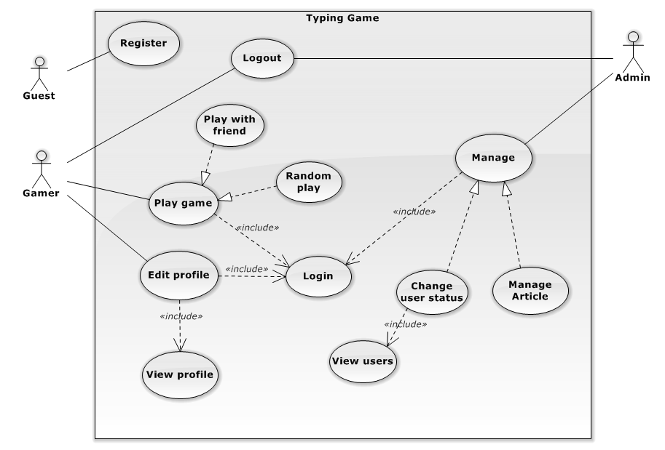

* 1. Class Diagram:

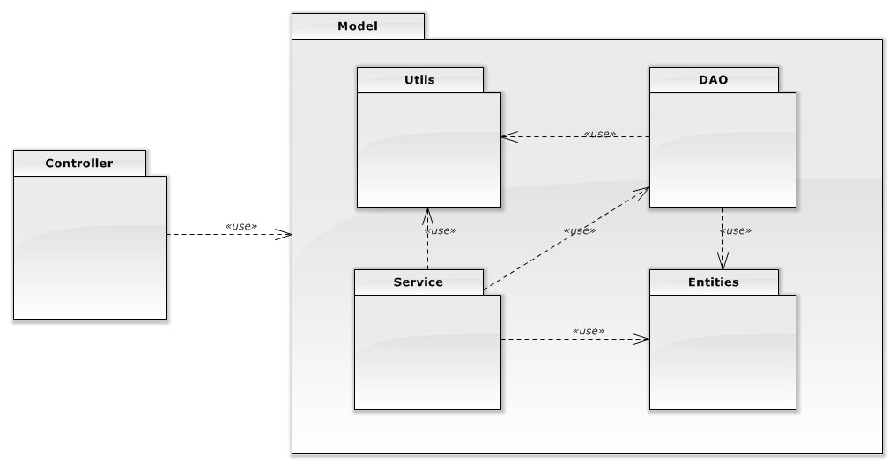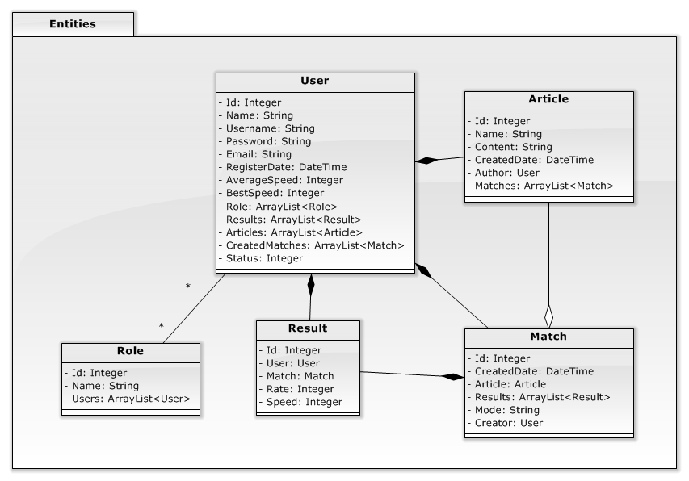

* 1. Activity Diagram

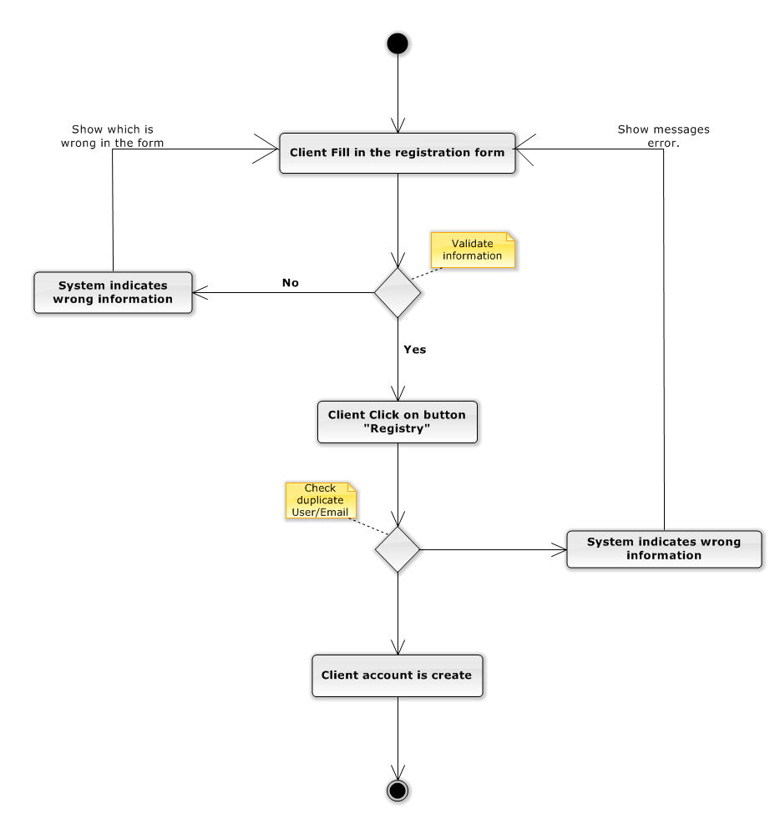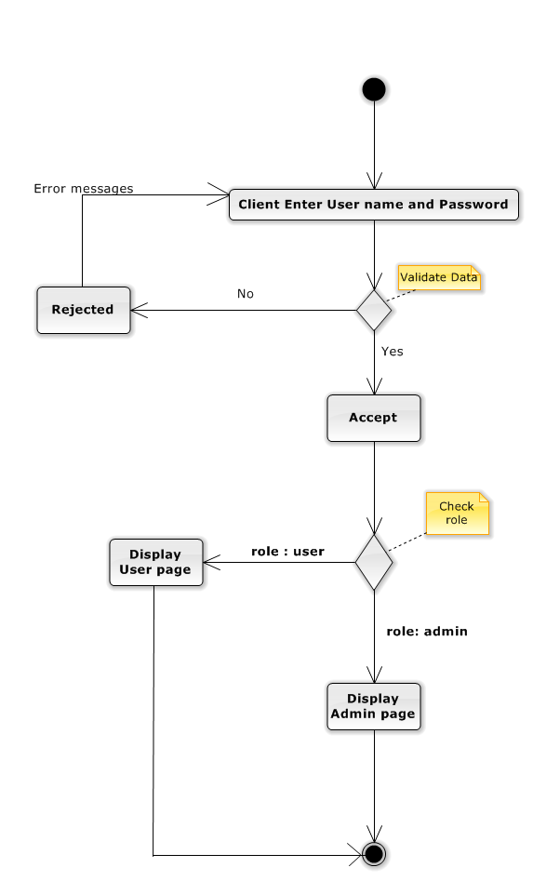

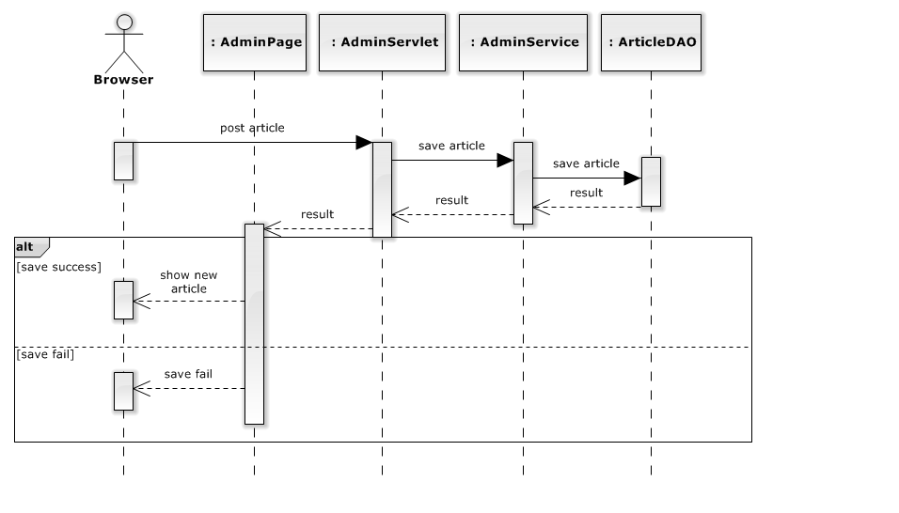

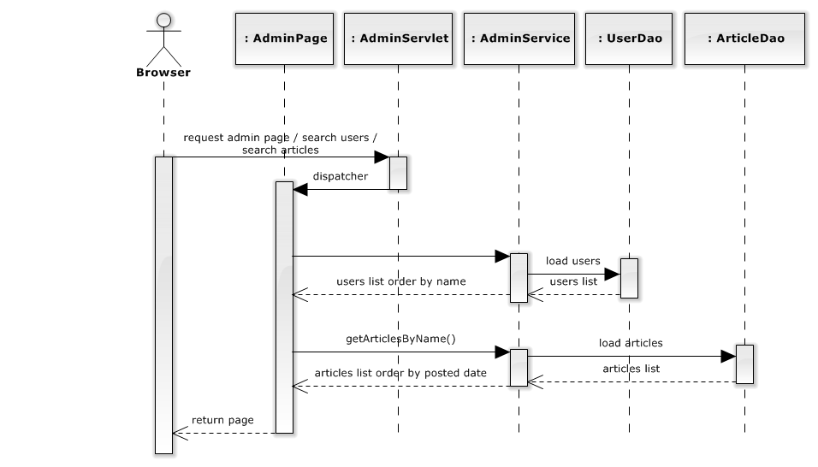

# 

# DATA DESIGN

# 