**Họ tên: Nguyễn Xuân Hải**

**Lớp:11_DH_TMDT**

**MSSV:1150070010**

**Bài tập lý thuyết 7**

Bước 1. Tạo project mới

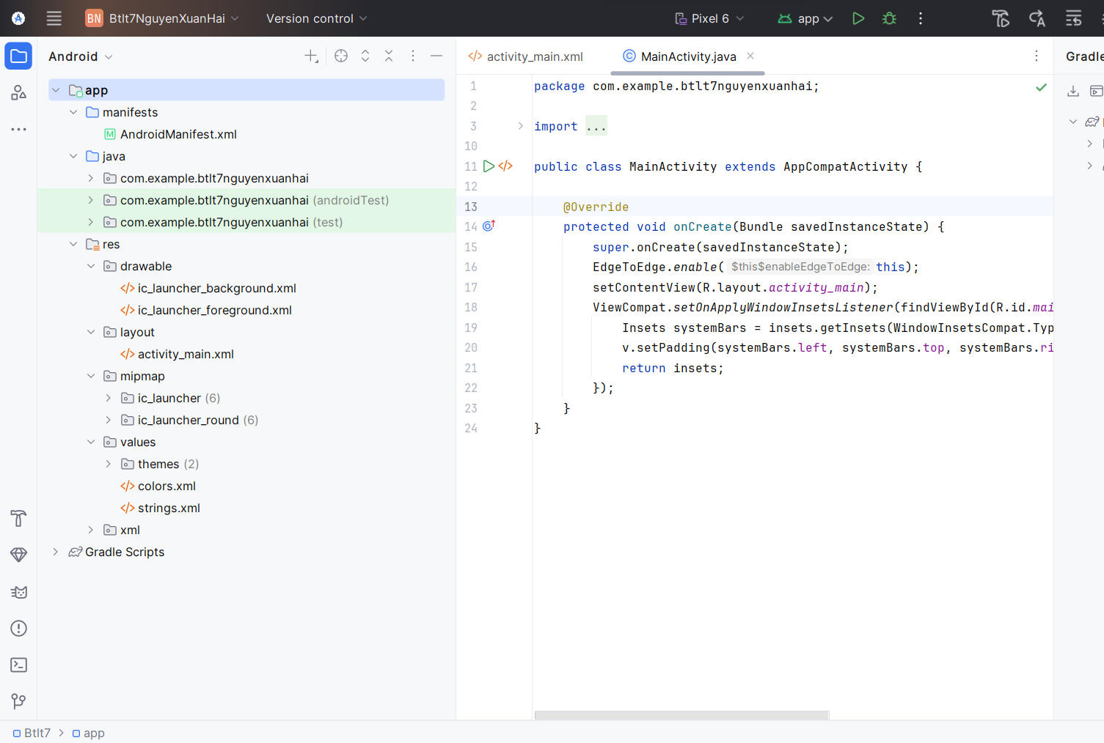

Tạo file giao diện chính (activity_main.xml)

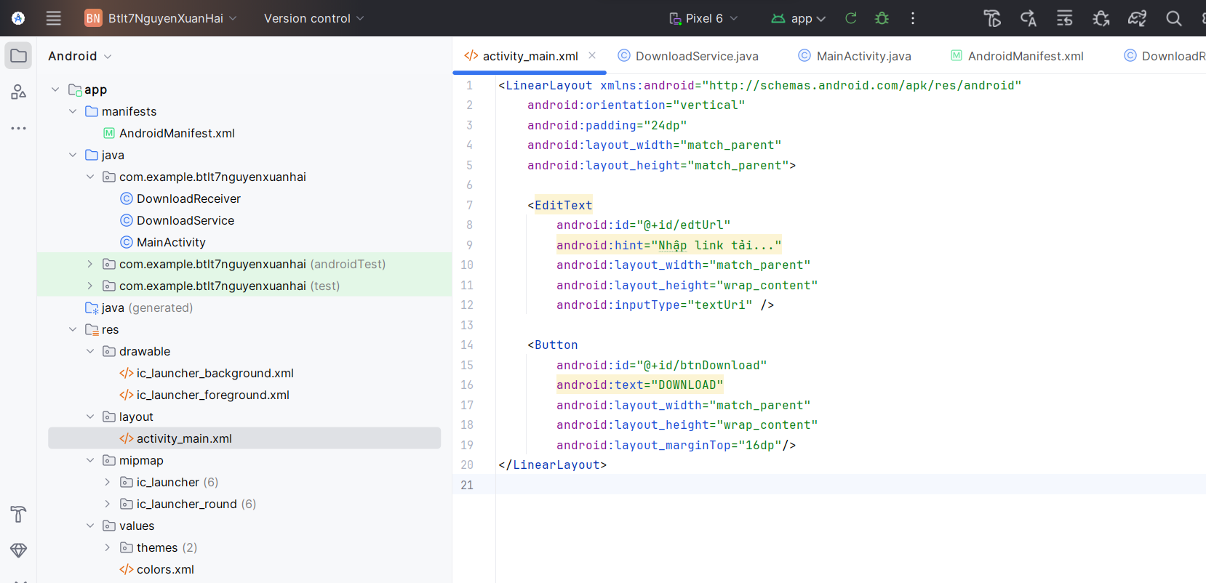

Code

<LinearLayout xmlns:android="http://schemas.android.com/apk/res/android"  
 android:orientation="vertical"  
 android:padding="24dp"  
 android:layout_width="match_parent"  
 android:layout_height="match_parent">  
  
 <EditText  
 android:id="@+id/edtUrl"  
 android:hint="Nhập link tải..."  
 android:layout_width="match_parent"  
 android:layout_height="wrap_content"  
 android:inputType="textUri" />  
  
 <Button  
 android:id="@+id/btnDownload"  
 android:text="DOWNLOAD"  
 android:layout_width="match_parent"  
 android:layout_height="wrap_content"  
 android:layout_marginTop="16dp"/>  
</LinearLayout>

Tạo class mới tên DownloadService.java

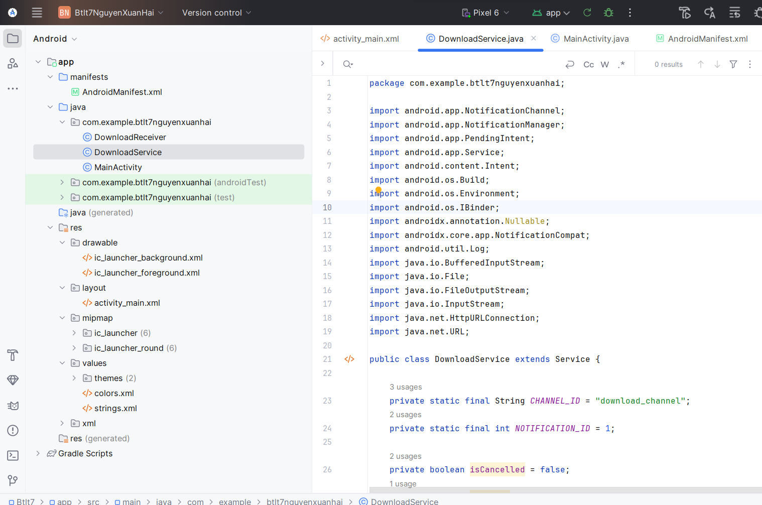

Code

package com.example.btlt7nguyenxuanhai;  
  
import android.app.NotificationChannel;  
import android.app.NotificationManager;  
import android.app.PendingIntent;  
import android.app.Service;  
import android.content.Intent;  
import android.os.Build;  
import android.os.Environment;  
import android.os.IBinder;  
import androidx.annotation.Nullable;  
import androidx.core.app.NotificationCompat;  
import android.util.Log;  
import java.io.BufferedInputStream;  
import java.io.File;  
import java.io.FileOutputStream;  
import java.io.InputStream;  
import java.net.HttpURLConnection;  
import java.net.URL;  
  
public class DownloadService extends Service {  
  
 private static final String *CHANNEL_ID* = "download_channel";  
 private static final int *NOTIFICATION_ID* = 1;  
  
 private boolean isCancelled = false;  
 private boolean isPaused = false;  
  
 @Nullable  
 @Override  
 public IBinder onBind(Intent intent) {  
 return null;  
 }  
  
 @Override  
 public int onStartCommand(Intent intent, int flags, int startId) {  
 String fileUrl = intent.getStringExtra("url");  
 if (fileUrl == null || fileUrl.isEmpty()) {  
 stopSelf();  
 return *START_NOT_STICKY*;  
 }  
  
 createNotificationChannel();  
 startForeground(*NOTIFICATION_ID*, getBaseNotification("Đang chuẩn bị tải...", 0).build());  
  
 new Thread(() -> downloadFile(fileUrl)).start();  
  
 return *START_STICKY*;  
 }  
  
 private void downloadFile(String fileUrl) {  
 try {  
 URL url = new URL(fileUrl);  
 HttpURLConnection connection = (HttpURLConnection) url.openConnection();  
 connection.connect();  
  
 int totalLength = connection.getContentLength();  
 if (totalLength <= 0) totalLength = 1;  
  
 *// ✅ Lưu vào thư mục "Download" mặc định có sẵn trên mọi máy ảo* File file = new File(getExternalFilesDir(Environment.*DIRECTORY_DOWNLOADS*), "downloaded_file.pdf");  
 FileOutputStream output = new FileOutputStream(file);  
 Log.*d*("DownloadService", "Đang lưu file tại: " + file.getAbsolutePath());  
  
 InputStream input = new BufferedInputStream(connection.getInputStream());  
 byte[] data = new byte[1024];  
 int count;  
 int total = 0;  
  
 while ((count = input.read(data)) != -1) {  
 if (isCancelled) {  
 Log.*d*("DownloadService", "Đã hủy tải");  
 break;  
 }  
 while (isPaused) Thread.*sleep*(500);  
  
 total += count;  
 output.write(data, 0, count);  
  
 int progress = (int) ((total * 100L) / totalLength);  
 updateNotification("Đang tải...", progress);  
 }  
  
 output.flush();  
 output.close();  
 input.close();  
  
 if (!isCancelled) {  
 showCompletedNotification(file.getAbsolutePath());  
 }  
  
 stopForeground(true);  
 stopSelf();  
  
 } catch (Exception e) {  
 Log.*e*("DownloadService", "Lỗi tải: " + e.getMessage());  
 stopSelf();  
 }  
 }  
  
 private NotificationCompat.Builder getBaseNotification(String title, int progress) {  
 Intent cancelIntent = new Intent(this, DownloadReceiver.class);  
 cancelIntent.setAction("ACTION_CANCEL");  
 PendingIntent pCancel = PendingIntent.*getBroadcast*(this, 1, cancelIntent, PendingIntent.*FLAG_IMMUTABLE*);  
  
 return new NotificationCompat.Builder(this, *CHANNEL_ID*)  
 .setContentTitle(title)  
 .setContentText("Tiến trình: " + progress + "%")  
 .setSmallIcon(android.R.drawable.*stat_sys_download*)  
 .setProgress(100, progress, false)  
 .addAction(android.R.drawable.*ic_delete*, "Cancel", pCancel)  
 .setOngoing(true)  
 .setPriority(NotificationCompat.*PRIORITY_LOW*);  
 }  
  
 private void updateNotification(String title, int progress) {  
 NotificationManager manager = getSystemService(NotificationManager.class);  
 manager.notify(*NOTIFICATION_ID*, getBaseNotification(title, progress).build());  
 }  
  
 private void showCompletedNotification(String filePath) {  
 NotificationCompat.Builder builder = new NotificationCompat.Builder(this, *CHANNEL_ID*)  
 .setContentTitle("Tải xuống hoàn tất ✅")  
 .setContentText("File lưu tại: " + filePath)  
 .setSmallIcon(android.R.drawable.*stat_sys_download_done*)  
 .setAutoCancel(true);  
 NotificationManager manager = getSystemService(NotificationManager.class);  
 manager.notify(2, builder.build());  
 }  
  
 private void createNotificationChannel() {  
 if (Build.VERSION.*SDK_INT* >= Build.VERSION_CODES.*O*) {  
 NotificationChannel channel = new NotificationChannel(  
 *CHANNEL_ID*,  
 "Download Channel",  
 NotificationManager.*IMPORTANCE_LOW* );  
 NotificationManager manager = getSystemService(NotificationManager.class);  
 manager.createNotificationChannel(channel);  
 }  
 }  
}

MainActivity.java

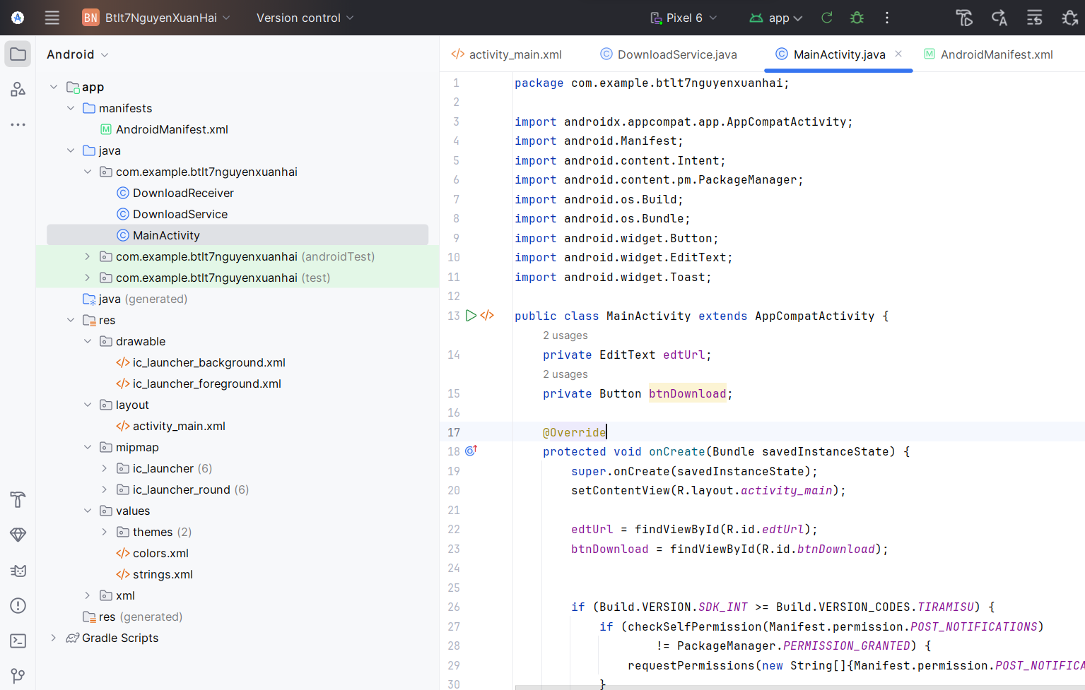

Code

package com.example.btlt7nguyenxuanhai;  
  
import androidx.appcompat.app.AppCompatActivity;  
import android.Manifest;  
import android.content.Intent;  
import android.content.pm.PackageManager;  
import android.os.Build;  
import android.os.Bundle;  
import android.widget.Button;  
import android.widget.EditText;  
import android.widget.Toast;  
  
public class MainActivity extends AppCompatActivity {  
 private EditText edtUrl;  
 private Button btnDownload;  
  
 @Override  
 protected void onCreate(Bundle savedInstanceState) {  
 super.onCreate(savedInstanceState);  
 setContentView(R.layout.*activity_main*);  
  
 edtUrl = findViewById(R.id.*edtUrl*);  
 btnDownload = findViewById(R.id.*btnDownload*);  
  
 if (Build.VERSION.*SDK_INT* >= Build.VERSION_CODES.*TIRAMISU*) {  
 if (checkSelfPermission(Manifest.permission.*POST_NOTIFICATIONS*)  
 != PackageManager.*PERMISSION_GRANTED*) {  
 requestPermissions(new String[]{Manifest.permission.*POST_NOTIFICATIONS*}, 101);  
 }  
 }  
  
 btnDownload.setOnClickListener(v -> {  
 String url = edtUrl.getText().toString().trim();  
 if (url.isEmpty()) {  
 Toast.*makeText*(this, "Vui lòng nhập URL hợp lệ!", Toast.*LENGTH_SHORT*).show();  
 return;  
 }  
  
 Intent intent = new Intent(this, DownloadService.class);  
 intent.putExtra("url", url);  
 startService(intent);  
 });  
 }  
  
 @Override  
 public void onRequestPermissionsResult(int requestCode, String[] permissions, int[] grantResults) {  
 super.onRequestPermissionsResult(requestCode, permissions, grantResults);  
 if (requestCode == 101) {  
 if (grantResults.length > 0 && grantResults[0] == PackageManager.*PERMISSION_GRANTED*) {  
 Toast.*makeText*(this, "Đã cấp quyền hiển thị thông báo", Toast.*LENGTH_SHORT*).show();  
 } else {  
 Toast.*makeText*(this, "Không có quyền hiển thị thông báo", Toast.*LENGTH_SHORT*).show();  
 }  
 }  
 }  
}

Tạo file DownloadReceiver

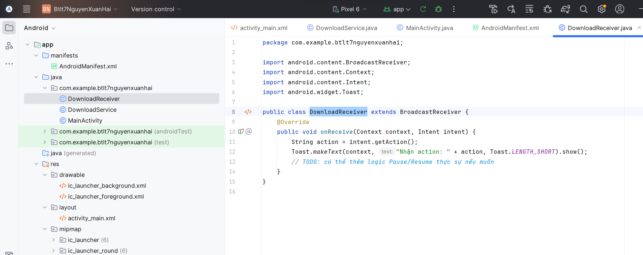

Code

package com.example.btlt7nguyenxuanhai;  
  
import android.content.BroadcastReceiver;  
import android.content.Context;  
import android.content.Intent;  
import android.widget.Toast;  
  
public class DownloadReceiver extends BroadcastReceiver {  
 @Override  
 public void onReceive(Context context, Intent intent) {  
 String action = intent.getAction();  
 Toast.*makeText*(context, "Nhận action: " + action, Toast.*LENGTH_SHORT*).show();  
 *// TODO: có thể thêm logic Pause/Resume thực sự nếu muốn* }  
}

Kết quả

