Họ tên: Nguyễn Xuân Hải

Lớp 11_DH_TMDT

MSSV:1150070010

**Lab4**

Tạo dự án mới, New Project → Empty Views Activity → đặt tên TeoappNguyenXuanHaibtlt4 → Finish.

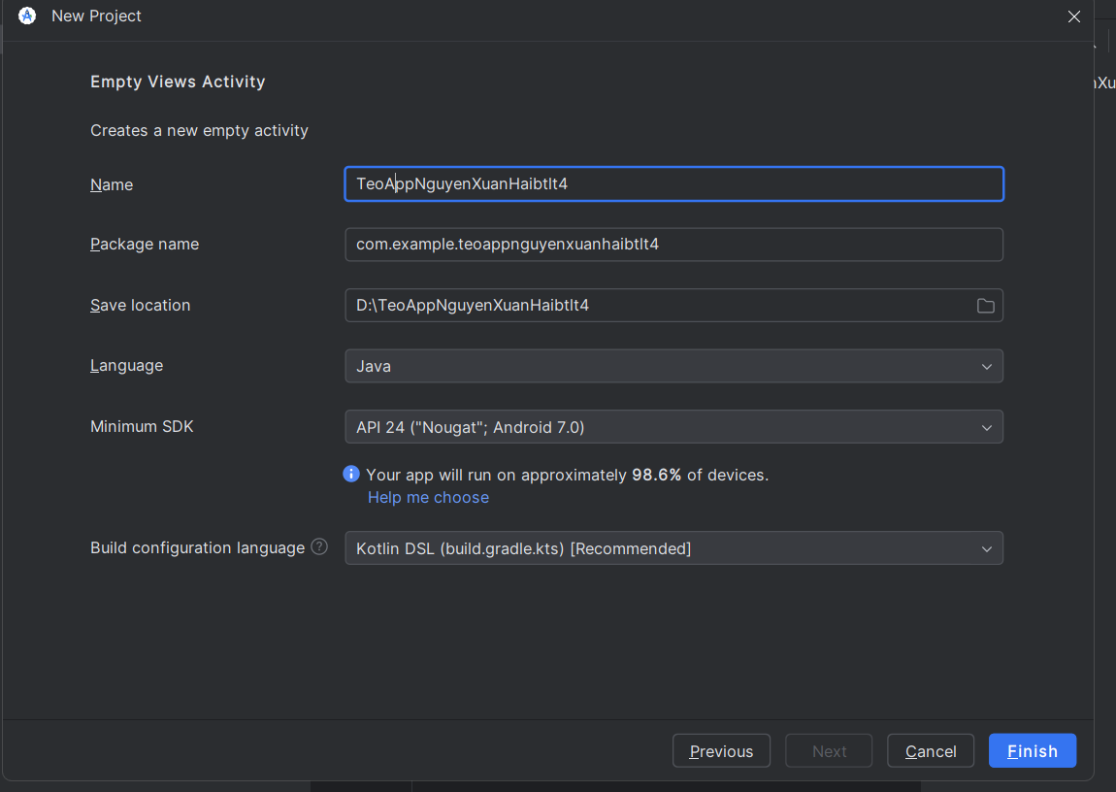

Tạo và thiết kế giao diện cho activity_main.xml, gồm 2 nút HelloWorld và Register

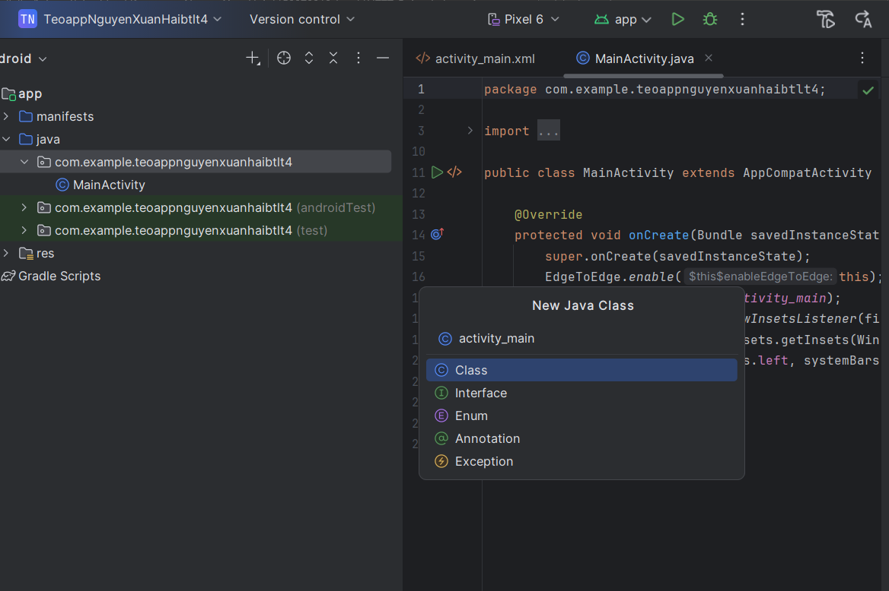

Code file layout activity_main.xml

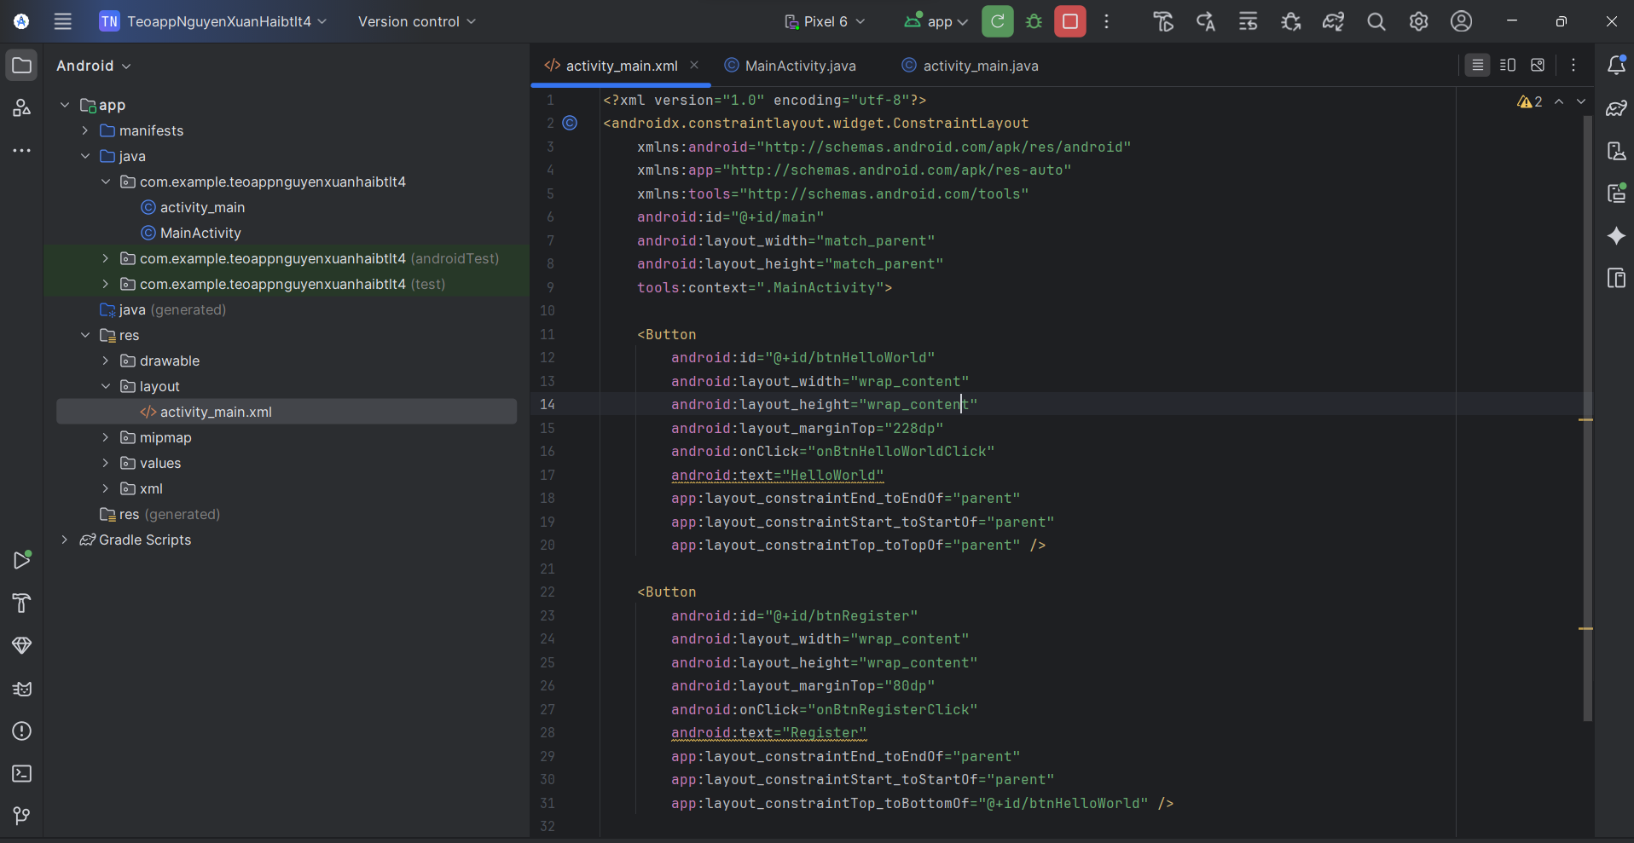

<?xml version="1.0" encoding="utf-8"?>  
<androidx.constraintlayout.widget.ConstraintLayout  
 xmlns:android="http://schemas.android.com/apk/res/android"  
 xmlns:app="http://schemas.android.com/apk/res-auto"  
 xmlns:tools="http://schemas.android.com/tools"  
 android:id="@+id/main"  
 android:layout_width="match_parent"  
 android:layout_height="match_parent"  
 tools:context=".MainActivity">  
  
 <Button  
 android:id="@+id/btnHelloWorld"  
 android:layout_width="wrap_content"  
 android:layout_height="wrap_content"  
 android:layout_marginTop="228dp"  
 android:onClick="onBtnHelloWorldClick"  
 android:text="HelloWorld"  
 app:layout_constraintEnd_toEndOf="parent"  
 app:layout_constraintStart_toStartOf="parent"  
 app:layout_constraintTop_toTopOf="parent" />  
  
 <Button  
 android:id="@+id/btnRegister"  
 android:layout_width="wrap_content"  
 android:layout_height="wrap_content"  
 android:layout_marginTop="80dp"  
 android:onClick="onBtnRegisterClick"  
 android:text="Register"  
 app:layout_constraintEnd_toEndOf="parent"  
 app:layout_constraintStart_toStartOf="parent"  
 app:layout_constraintTop_toBottomOf="@+id/btnHelloWorld" />  
  
</androidx.constraintlayout.widget.ConstraintLayout>

Thêm hàm xử lý sự kiện onClick trong class MainActivity.java

code

package com.example.teoappnguyenxuanhaibtlt4;  
  
import android.os.Bundle;  
import android.view.View;  
import android.widget.Toast;  
  
import androidx.activity.EdgeToEdge;  
import androidx.appcompat.app.AppCompatActivity;  
import androidx.core.graphics.Insets;  
import androidx.core.view.ViewCompat;  
import androidx.core.view.WindowInsetsCompat;  
  
public class MainActivity extends AppCompatActivity {  
  
 @Override  
 protected void onCreate(Bundle savedInstanceState) {  
 super.onCreate(savedInstanceState);  
 EdgeToEdge.enable(this);  
 setContentView(R.layout.activity_main);  
 ViewCompat.setOnApplyWindowInsetsListener(findViewById(R.id.main), (v, insets) -> {  
 Insets systemBars = insets.getInsets(WindowInsetsCompat.Type.systemBars());  
 v.setPadding(systemBars.left, systemBars.top, systemBars.right, systemBars.bottom);  
 return insets;  
 });  
 }  
  
 // Thêm phương thức xử lý nút HelloWorld  
 public void onBtnHelloWorldClick(View view) {  
 Toast.makeText(this, "Hello World clicked!", Toast.LENGTH_SHORT).show();  
 }  
  
 // Thêm phương thức xử lý nút Register  
 public void onBtnRegisterClick(View view) {  
 Toast.makeText(this, "Register clicked!", Toast.LENGTH_SHORT).show();  
 }  
}

Kết quả

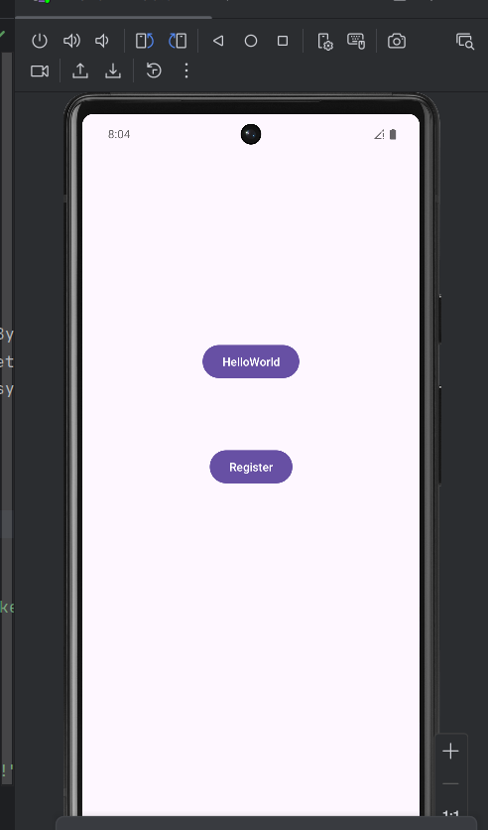

**Bài 1: Đăng ký BroadcastReceiver bằng code. Tạo ứng dụng nhận tin nhắn**

Bước 1:Tạo file res/layout/activity1_main.xml

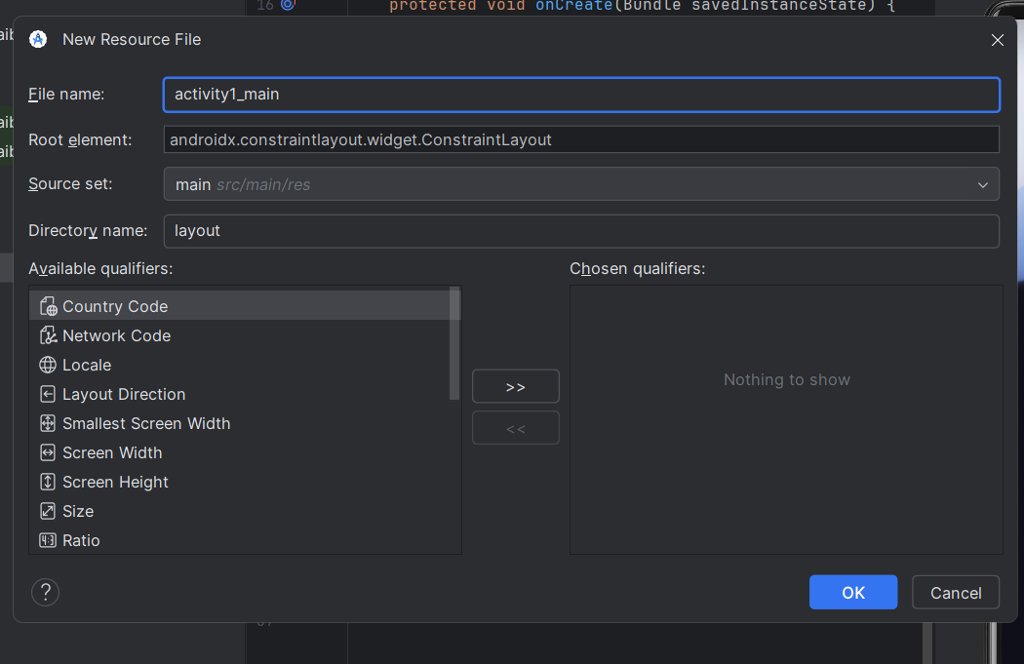

Code

<?xml version="1.0" encoding="utf-8"?>  
<LinearLayout xmlns:android="http://schemas.android.com/apk/res/android"  
 xmlns:tools="http://schemas.android.com/tools"  
 android:layout_width="match_parent"  
 android:layout_height="match_parent"  
 android:orientation="vertical"  
 android:padding="@dimen/margin_base"  
 tools:context=".MainActivity">  
  
 <TextView  
 android:id="@+id/tv_content"  
 android:layout_width="match_parent"  
 android:layout_height="wrap_content"  
 android:textSize="@dimen/text_medium"  
 android:text="No messages yet" />  
</LinearLayout>

Bước 2: Khai báo các giá trị dimens

Tạo file dimens.xml trong res/values/

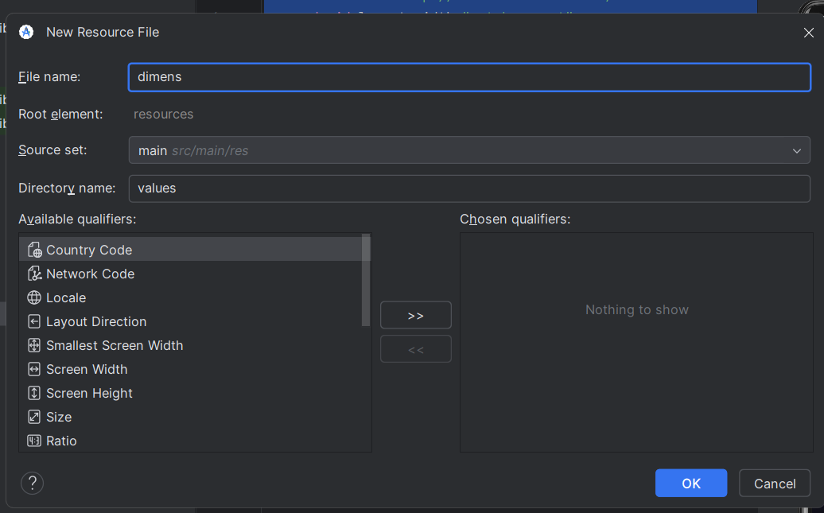

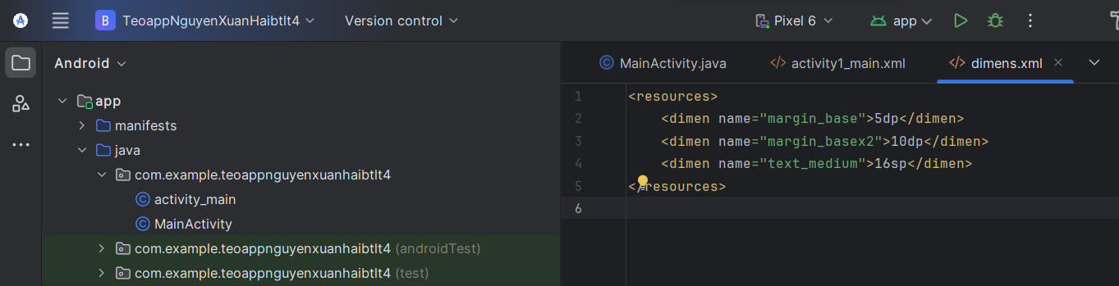

Code

<resources>  
 <dimen name="margin_base">5dp</dimen>  
 <dimen name="margin_basex2">10dp</dimen>  
 <dimen name="text_medium">16sp</dimen>  
</resources>

Bước 3: Khai báo string

Tạo file strings.xml trong res/values/

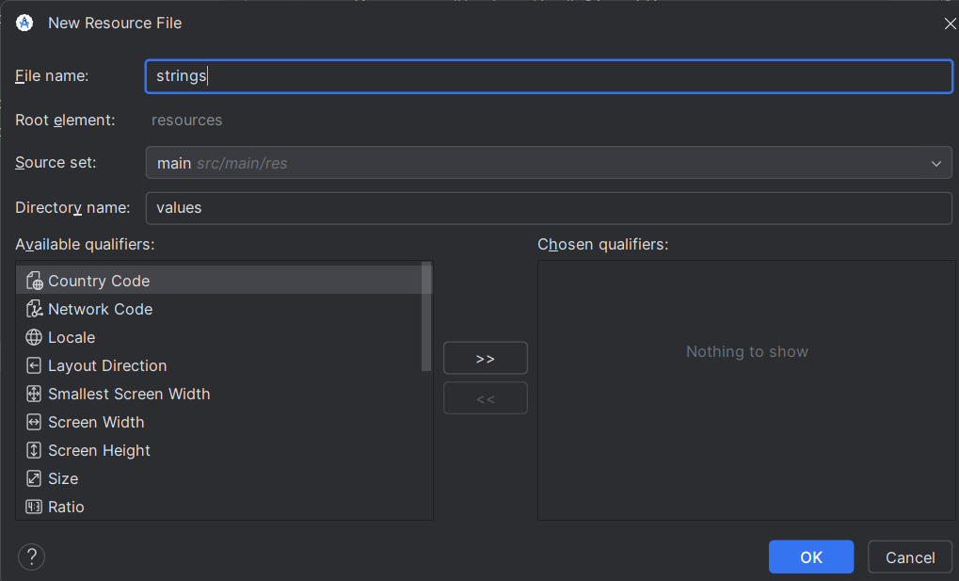

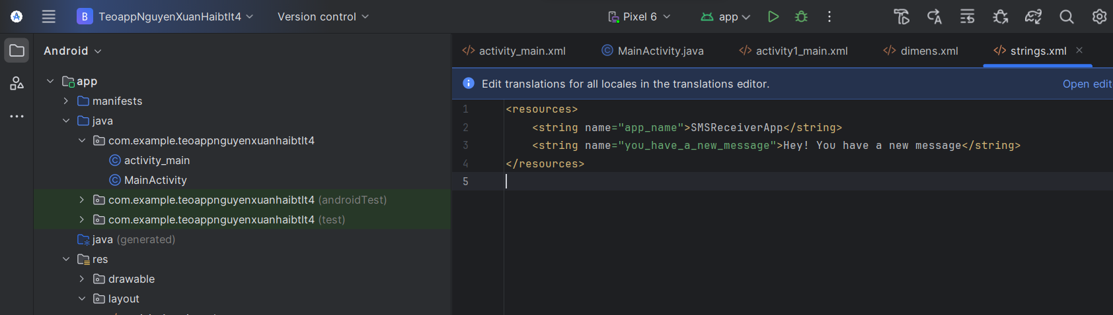

Code

<resources>  
 <string name="app_name">SMSReceiverApp</string>  
 <string name="you_have_a_new_message">Hey! You have a new message</string>  
</resources>

Bước 4: Cấp quyền nhận SMS trong AndroidManifest.xml:

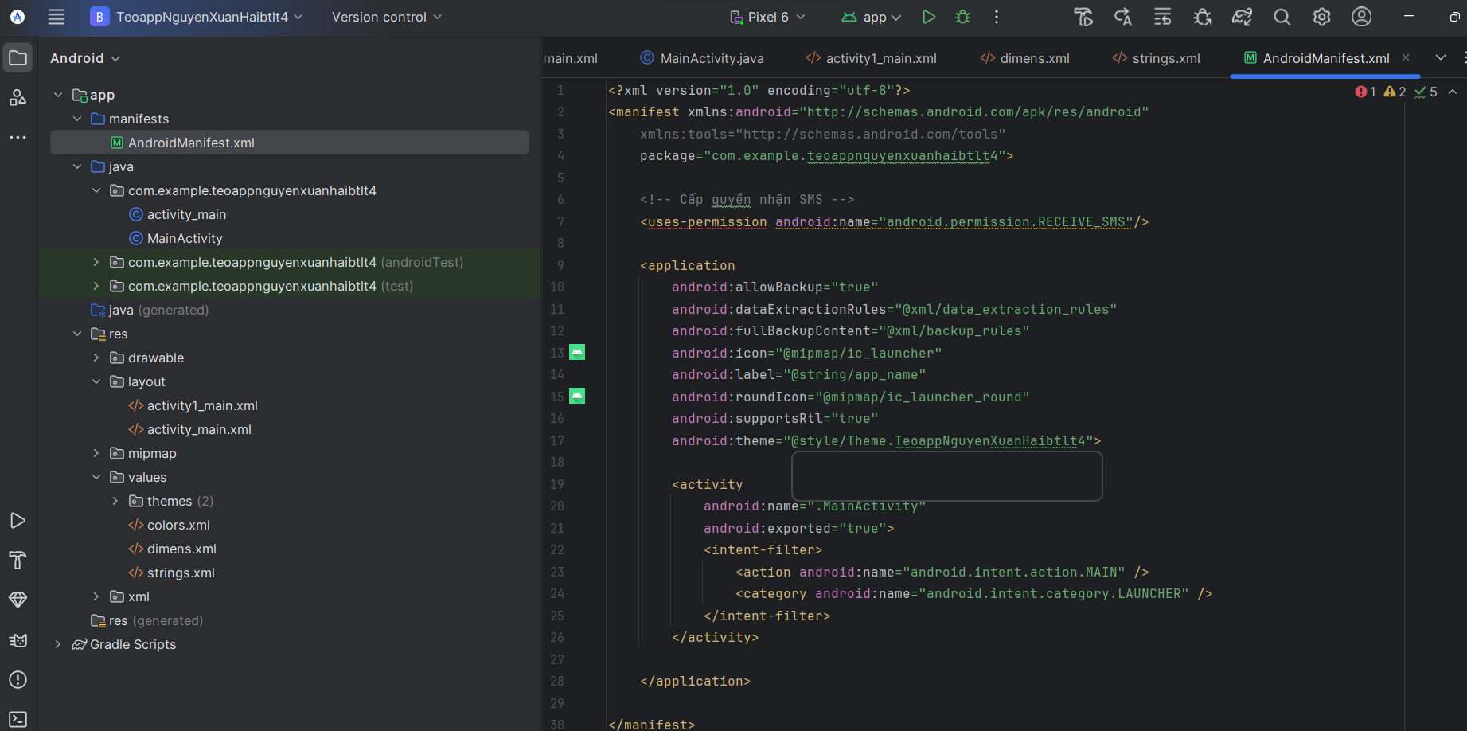

Code

<?xml version="1.0" encoding="utf-8"?>  
<manifest xmlns:android="http://schemas.android.com/apk/res/android"  
 xmlns:tools="http://schemas.android.com/tools"  
 package="com.example.teoappnguyenxuanhaibtlt4">  
  
 <!-- Cấp quyền để nhận tin nhắn SMS -->  
 <uses-permission android:name="android.permission.RECEIVE_SMS" />  
  
 <!-- Khai báo rằng chức năng điện thoại không phải là yêu cầu bắt buộc -->  
 <uses-feature android:name="android.hardware.telephony" android:required="false"/>  
  
 <application  
 android:allowBackup="true"  
 android:dataExtractionRules="@xml/data_extraction_rules"  
 android:fullBackupContent="@xml/backup_rules"  
 android:icon="@mipmap/ic_launcher"  
 android:label="@string/app_name"  
 android:roundIcon="@mipmap/ic_launcher_round"  
 android:supportsRtl="true"  
 android:theme="@style/Theme.TeoappNguyenXuanHaibtlt4">  
  
 <activity  
 android:name=".MainActivity1"  
 android:exported="true">  
 <intent-filter>  
 <action android:name="android.intent.action.MAIN" />  
 <category android:name="android.intent.category.LAUNCHER" />  
 </intent-filter>  
 </activity>  
  
 </application>  
  
</manifest>

Bước 5: Code trong MainActivity1.java:

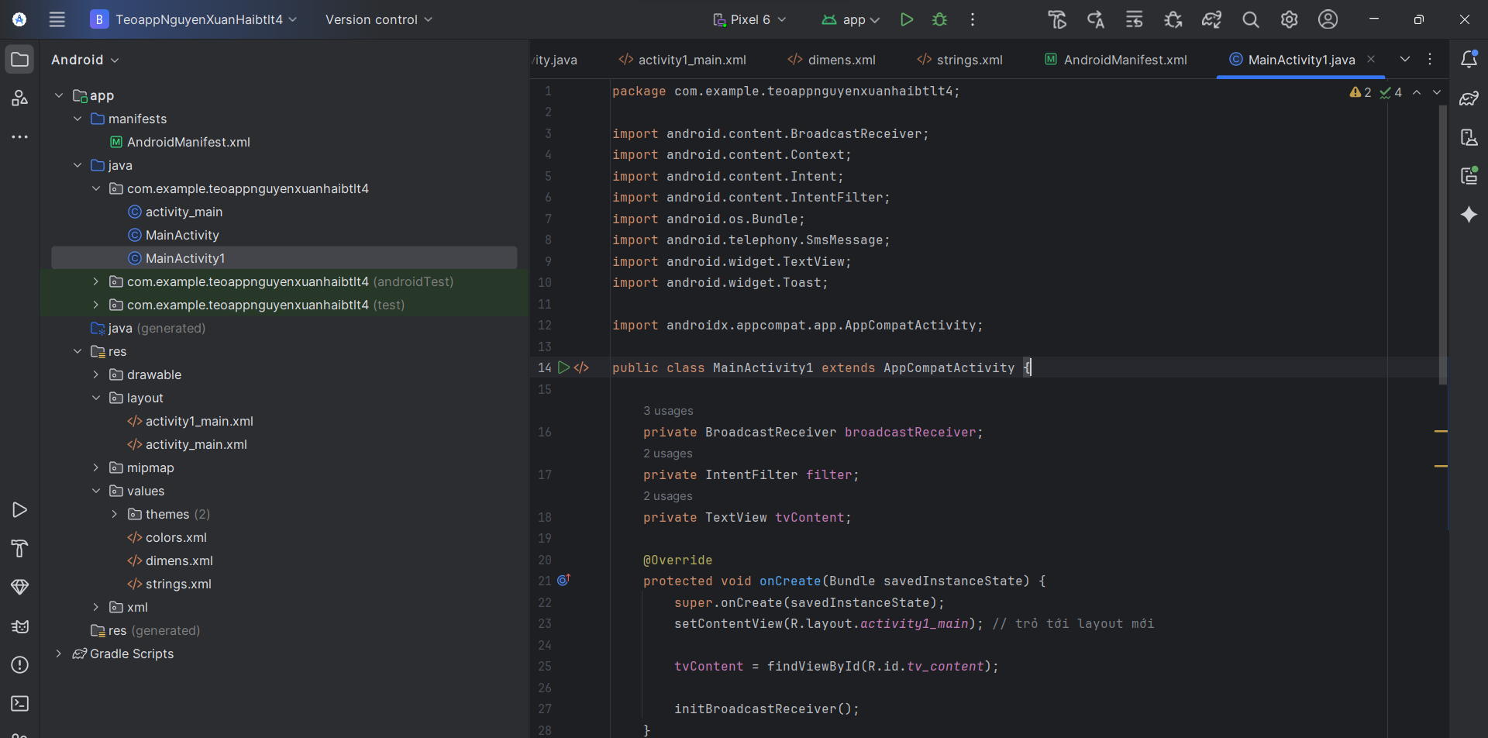

Code

package com.example.teoappnguyenxuanhaibtlt4;  
  
import android.content.BroadcastReceiver;  
import android.content.Context;  
import android.content.Intent;  
import android.content.IntentFilter;  
import android.content.pm.PackageManager;  
import android.os.Bundle;  
import android.telephony.SmsMessage;  
import android.widget.TextView;  
import android.widget.Toast;  
  
import androidx.annotation.NonNull;  
import androidx.appcompat.app.AppCompatActivity;  
import androidx.core.app.ActivityCompat;  
import androidx.core.content.ContextCompat;  
  
import android.Manifest;  
  
public class MainActivity1 extends AppCompatActivity {  
  
 private static final int *PERMISSION_REQUEST_CODE* = 100;  
 private BroadcastReceiver smsReceiver;  
 private IntentFilter filter;  
 private TextView tvContent;  
  
 @Override  
 protected void onCreate(Bundle savedInstanceState) {  
 super.onCreate(savedInstanceState);  
 // Thiết lập layout  
 setContentView(R.layout.*activity1_main*);  
  
 // Ánh xạ TextView từ layout  
 tvContent = findViewById(R.id.*tv_content*);  
  
 // Kiểm tra và yêu cầu quyền RECEIVE_SMS  
 if (ContextCompat.*checkSelfPermission*(this, Manifest.permission.*RECEIVE_SMS*)  
 != PackageManager.*PERMISSION_GRANTED*) {  
 ActivityCompat.*requestPermissions*(this,  
 new String[]{Manifest.permission.*RECEIVE_SMS*}, *PERMISSION_REQUEST_CODE*);  
 } else {  
 initBroadcastReceiver();  
 }  
 }  
  
 // Xử lý kết quả yêu cầu quyền  
 @Override  
 public void onRequestPermissionsResult(int requestCode, @NonNull String[] permissions, @NonNull int[] grantResults) {  
 super.onRequestPermissionsResult(requestCode, permissions, grantResults);  
  
 if (requestCode == *PERMISSION_REQUEST_CODE*) {  
 if (grantResults.length > 0 && grantResults[0] == PackageManager.*PERMISSION_GRANTED*) {  
 // Quyền được cấp, khởi tạo BroadcastReceiver  
 initBroadcastReceiver();  
 Toast.*makeText*(this, "Permission granted!", Toast.*LENGTH_SHORT*).show();  
 } else {  
 Toast.*makeText*(this, "Permission denied. The app cannot receive SMS.", Toast.*LENGTH_SHORT*).show();  
 }  
 }  
 }  
  
 private void initBroadcastReceiver() {  
 smsReceiver = new BroadcastReceiver() {  
 @Override  
 public void onReceive(Context context, Intent intent) {  
 // Nhận các tin nhắn SMS từ Intent  
 Bundle bundle = intent.getExtras();  
 if (bundle != null) {  
 Object[] pdus = (Object[]) bundle.get("pdus");  
 if (pdus != null) {  
 StringBuilder sb = new StringBuilder();  
 for (Object pdu : pdus) {  
 SmsMessage smsMessage = SmsMessage.*createFromPdu*((byte[]) pdu);  
 String sender = smsMessage.getOriginatingAddress();  
 String messageBody = smsMessage.getMessageBody();  
 sb.append("From: ").append(sender).append("\n");  
 sb.append("Message: ").append(messageBody).append("\n\n");  
 }  
 String fullMessage = sb.toString();  
 tvContent.setText(fullMessage);  
 Toast.*makeText*(context, "Hey! You have a new message", Toast.*LENGTH_SHORT*).show();  
 }  
 }  
 }  
 };  
  
 filter = new IntentFilter("android.provider.Telephony.SMS_RECEIVED");  
 }  
  
 @Override  
 protected void onResume() {  
 super.onResume();  
 if (smsReceiver != null) {  
 // Đăng ký BroadcastReceiver khi activity hiển thị  
 registerReceiver(smsReceiver, filter);  
 }  
 }  
  
 @Override  
 protected void onPause() {  
 super.onPause();  
 if (smsReceiver != null) {  
 // Hủy đăng ký BroadcastReceiver khi activity không còn hiển thị  
 unregisterReceiver(smsReceiver);  
 }  
 }  
  
 @Override  
 protected void onDestroy() {  
 super.onDestroy();  
 // Đảm bảo hủy đăng ký để tránh rò rỉ bộ nhớ  
 if (smsReceiver != null) {  
 unregisterReceiver(smsReceiver);  
 }  
 }  
}

Kết quả

