Security use case – Access Control

Access control application using Peripheral Touch Controller and TrustZone on SAML11  This application demonstrates the access control use case by using a QT3 Xplained keypad and SAMLL11 microcontroller with Arm TrustZone capability.  Arm TrustZone  Providing the flexibility for hardware isolation of memories and peripherals, therefore reinforcing the ability of Intellectual Properties (IP) and Data protection. SAML11 provides up to six regions for the Flash, up to two regions for Data Flash, up to two regions for SRAM and the ability to assign peripherals, I/O pins, interrupts to secure or non-secure application.  Peripheral Touch Controller (PTC)  Supporting up to 20 self-capacitance channels and up to 100 mutual-capacitance channels with hardware noise filtering and noise signal desynchronization. Low power, high sensitivity, environmentally robust capacitive buttons, sliders, and wheels.  Block Diagram  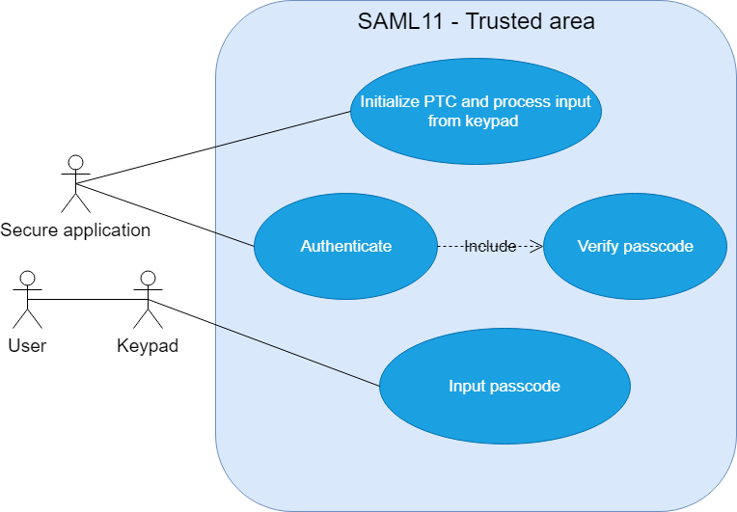  Access control use case |   For more information please visit:  Github link  Email

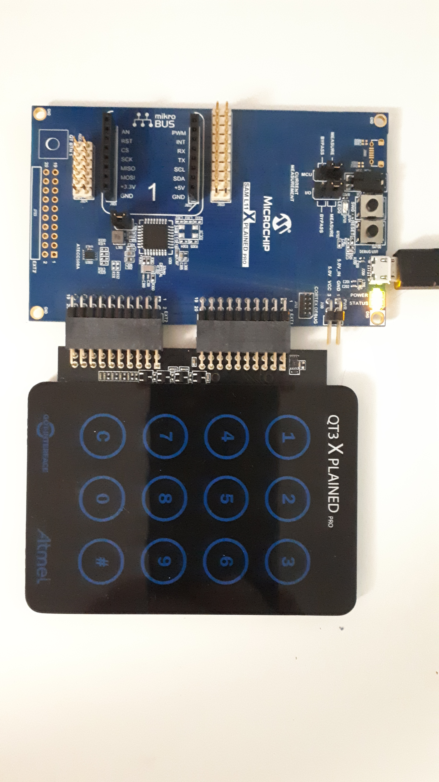  Use case setup  Description  The secure application located in TrustZone initializes the PTC and process the input from the keypad. Whenever user presses a key, the pressed key is displayed on the console terminal. The user can enter the passcode through the keypad. The user can enter number from 0 – 9 as passcode, clear the previous value, and start authenticating.  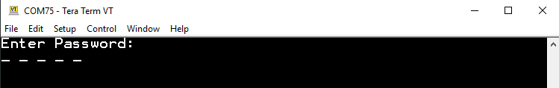  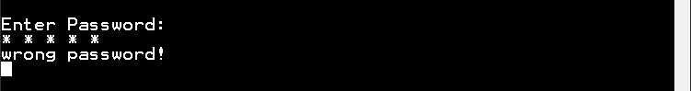  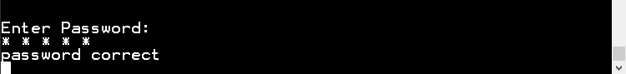  Output on console erminal  When the authentication process has been started, the secure application verifies if the passcode entered by user is correct or not and prints the result on the console terminal.  Possible Application  - Access Control  - Authentication
  Features/Benefits
  - IP protection
  - Software isolation
  - Authentication
  - Access control
  Key Components
  - SAML11
  - QT3 Xplained pro
For more information please visit
Official github link

