# Project source:

<https://github.com/HaiQNguyen/SAML11_TZ_MPLAB>

# Setup

* Blank SAML11-Xplained
* Sample project generated by Atmel Start and developed in Atmel Studio

# Procedure

1. Import „Secure_project“ into MPLAB
2. Compile the project
3. Import „Non-Secure_project“ into MPLAB
4. Compile the project

**Error:**

c:/program files (x86)/atmel/studio/7.0/toolchain/arm/arm-gnu-toolchain/bin/../lib/gcc/arm-none-eabi/6.3.1/../../../../arm-none-eabi/bin/ld.exe: cannot find -lsecure_gateway_veneer

**Analysis:**

Linking problem when importing the project from Atmel Studio

**Resolution:**

* + Delete the linking and manually add the secure_gateway_veneer.
  + Right click on Non-Secure_Project, choose Properties and follow the picture below

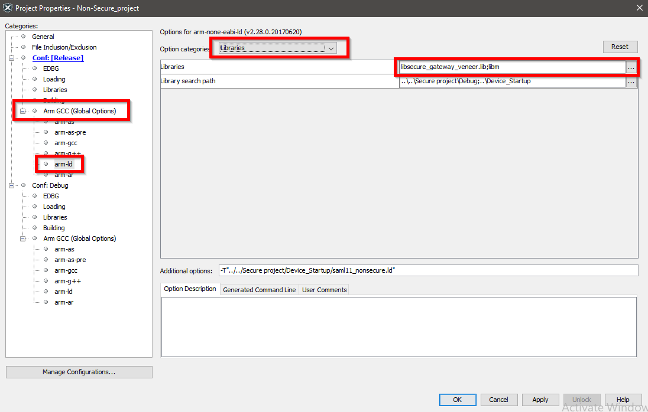

* Delete *libsercure_gateway_veneer.lib*
* Go to Libraries entry (see picture below) and manually add *libsercure_gateway_veneer.lib* into the project. The lib file can be found at: *your_project_location/TrustZone_mplab/Secure project/Debug*

1. Compile the project again (should be no error)
2. Linking the binary from Non-Secure_project to Secure_project. Right click at Secure_project, choose Properties 🡪 Loading 🡪 Add Loadable File choose the file *Non-Secure_project.hex.* That file locates in *your_project_location/TrustZone_mplab/Non-Secure project/Debug.*

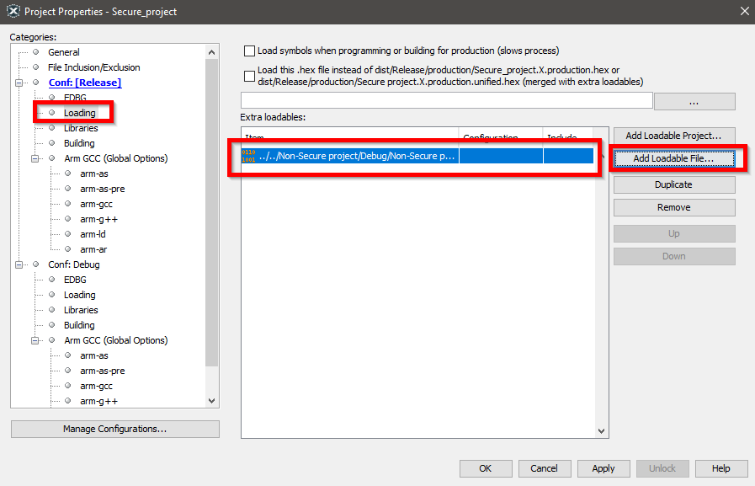

1. Set Secure_project as main project then compile it.

**Error:**

* (960) unexpected record type (3) on line 51 of "../../Non-Secure project/Debug/Non-Secure project.hex"

1. Ignore the error and choose Debug Main Project:

Compiling and Linking process are successful, the image is loaded into the board and the board works properly:

