EXERCISE 1
NAME: Nguyễn Nhật Hải STUDENT CODE: 3122411046

- VERIFICATION AND VALIDATION
Description: The purpose is to help users to solve a 2-degree equation (ax
2+bx+c).
Spec: Given input of a, b, and c; the system returns the outputs of x1 and x2 (extreme cases are temporarily not considered)
Two systems are developed as follows.
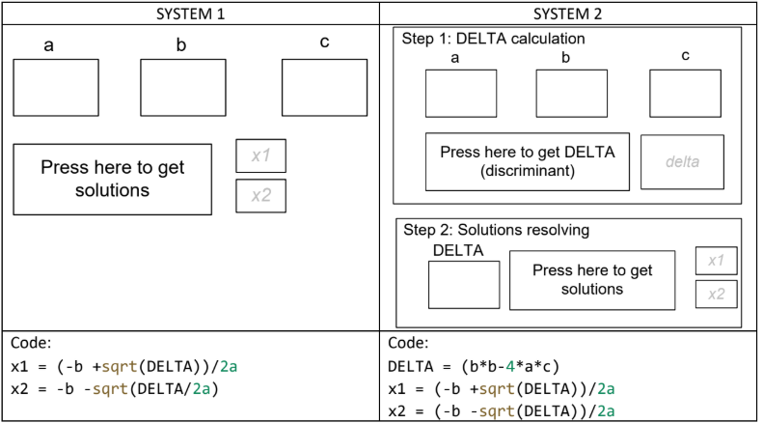
What are the problems of those two systems? Write down your answer here.
- Problem in system 1:
- Wrong formula: x2 = -b - sqrt(DELTA)/2a
→ The correct formula should be: x2 = (-b - sqrt(DELTA)) / (2a)
- No calculation of DELTA
- No handling of special cases (a=0 or DELTA=0)
- Problem in system 2:
- No handling of special cases (a=0 or DELTA=0)
- DELTA is calculated correctly but no condition handling: the system doesn’t check DELTA < 0. It still tries sqrt(DELTA) → runtime error.
- TEST-CASES.
Description: Some input values
a) How many test-cases we need for the following function f1. What are they?
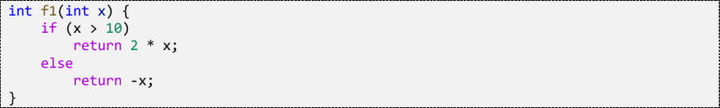
We need two test cases: x > 10 and x ≤ 10
Test case | Input | Expected Output | Actual Ouput | Result
1 | 11 | 22 | 22 | Pass
2 | 10 | -10 | -10 | Pass

b) Check if your test-cases can detect error if f1 is implemented as follows.
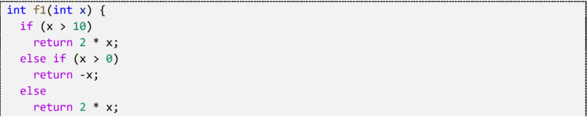
In this case, how many test-cases we need to test this function? What are they?
We need three test cases: x > 10, 0 < x ≤ 10 and x ≤ 0
Test case | Input | Expected Output | Actual Ouput | Result
1 | 11 | 22 | 22 | Pass
2 | 9 | -9 | -9 | Pass
3 | -5 | 5 | -10 | Fail

c) How many test-cases we need to test this function? What are they?
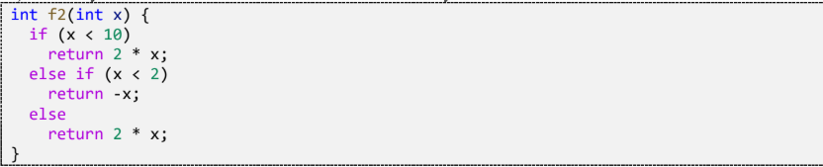
The function f2 always returns 2*x for any input, because if ( x < 2 ) then it already sastified (x < 10) before. Therefore, 2 test case is needed.
Test case | Input | Expected Output | Actual Ouput | Result
1 | 1 | -1 | 2 | Fail
2 | 5 | 10 | 10 | Pass

d) How many test-cases we need to test this function? What are they?
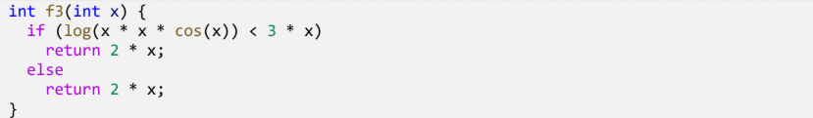
Both branches return the same value (2 * x). Therefore, only 1 test case is needed.
Test case | Input | Expected Output | Actual Ouput | Result
1 | 2 | 4 | 4 | Pass

e) Check if your test-cases can detect error if findMax is implemented as follows
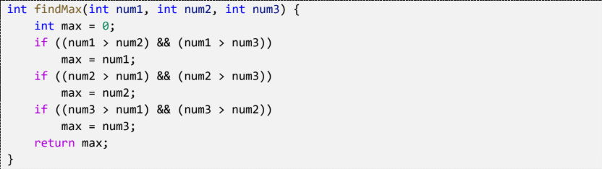
In this case, how many test-cases we need to test this function? What are they?
The function does not handle equal numbers. If two numbers are equal and the largest, max remains 0. To detect the bug, we need test cases where two or more numbers are equal.
Test case | Input | Expected Output | Actual Ouput | Result
1 | 5,3,2 | 5 | 5 | Pass
2 | 3,6,4 | 6 | 6 | Pass
3 | 8,8,8 | 8 | 0 | Fail
4 | 7,7,2 | 7 | 0 | Fail

