11/22/2020

Submitted by: imdad-ullah

(fa18-bse-106)

**Airline reservation system**

**Proposal:**

Airline reservation system is concept of flight reservation system. Airline reservation system enables the users to look at seat availability, look for airline flights between two traveling cities on a specified date & time, view a flight details, flight reservation and cancellation of reservation.

Airline reservation system allows the airline passenger to look for available flights that are available between the 2 traveling cities, namely the “Departure city” and “Arrival city” for a specific departure and arrival dates and time. The system displays all the flight related details like flight number, name of flight, price and duration of journey etc.

**Question**

Write one mission statement of your semester project in chapter 2?

**Mission statement:**

“Airline reservation system” mission statement is “**committed to provide every citizen of the world with the best service of the air travel to the extensive selection of destination possible**.”

**Conceptual database modeling.**

* Airplane owned by airline
* Airline flies flight
* Flight travels on route
* Booking office has ticket
* Airplane lands on airport

**User interface:**

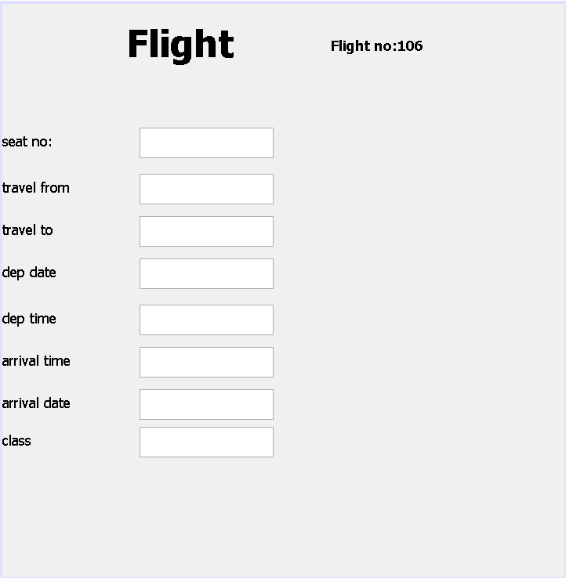

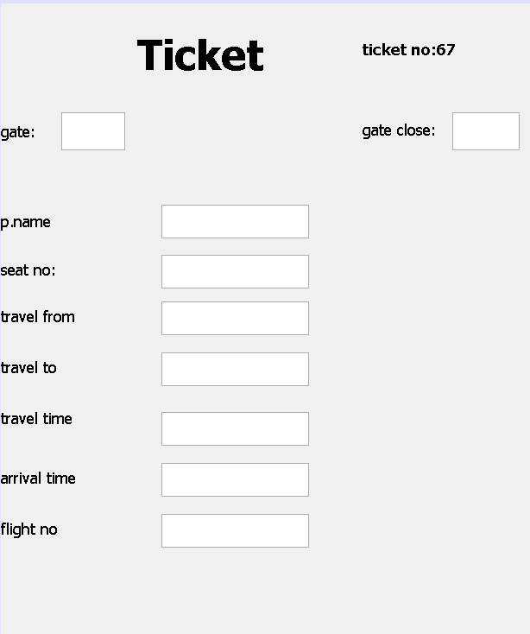

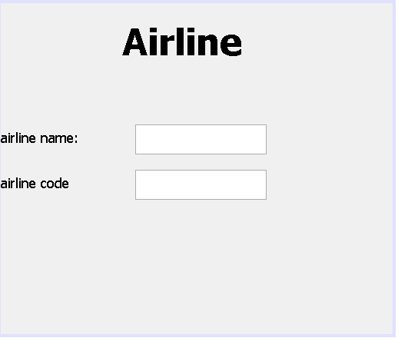

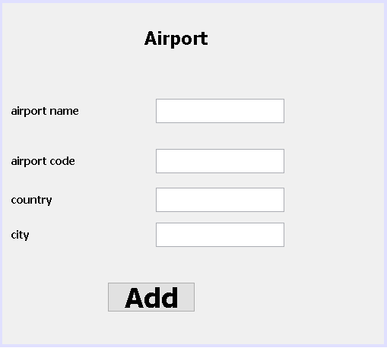

**ERD:**

Lands on

Has

Fliess

**Airport**

**Passenger**

Books ticket

**Payment**

Has

**Ticket**

**Booking office**

Travels On

Charges

**route**

**Flight**

**Airlines**

Owned by

**Airplane**