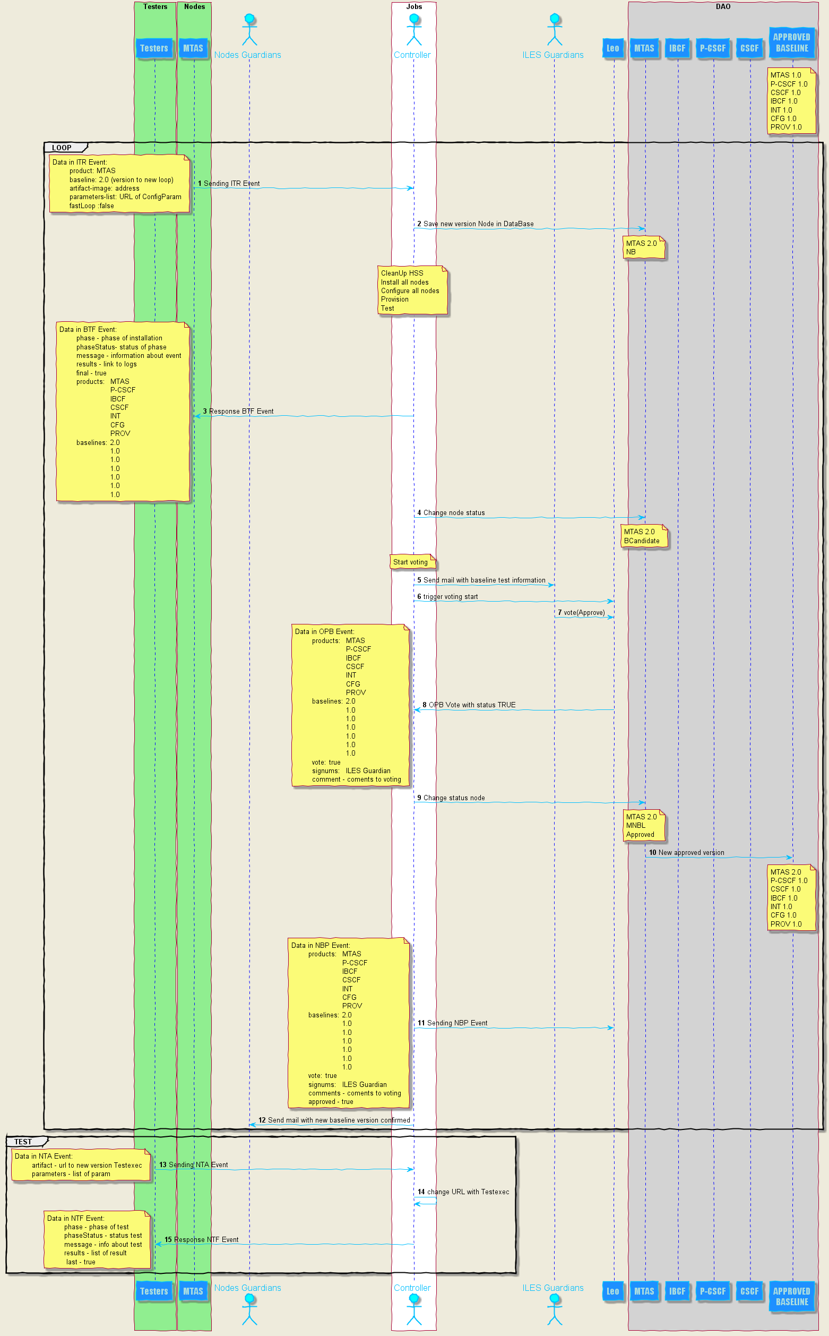
Data Flow with example INT (MTAS 2.0)

Eiffel Exchange
Properties in EiffelGlobalConfig:
MessageBus exchange name – exchange
Component name – component
DomainId – domain
Properties in Controller:
In Eiffel Rule Trigger we must set eiffel binding on :
experimental.generic.*.domain

In RabbitMq create queue with binding to exchange, name is :
domain.component.nwft-consumer.durable
and create queue for RuleTrigger with name:
domain.component.UNIQUE_NUMBER-RuleTrigger.durable
Both of queue exist routing key:
experimental.generic.*.domain
Nodes send and recive with routing key:
experimental.generic.{NameOfNodes}.domain

