Ticket 1: Recommendations UI
- Heading: “Recommendations”
- Sub Heading: “Customize your experience by selecting filters that match your interests. Based on your preferences, the system will provide personalized recommendations tailored to what’s most relevant to you.”
- Content Type Menu
  - This is for the user to select the type of media to recommend
  - For the time being, podcast content from youtube, so the only option should be videos, all others should be greyed out.
  - 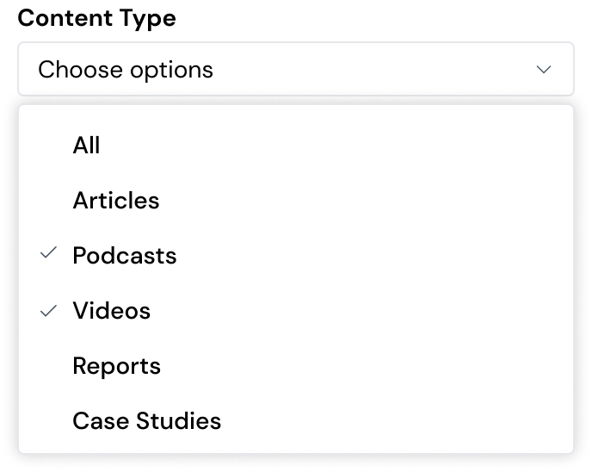

- Project Menu
  - Select a project from which to get recommendations
    - The RecSys will see what content has been saved and recommend content based on that project’s context.
  - Only Display Projects which are Smart Projects,
  - Any Smart Project that has been shared to the user should be displayed

- Search bar
  - Allows to search for sources
  - Apply the same search logic as applied in project sources

- Sources
  - Source cards, displayed in two columns
  - Display:
    - Source Name
    - Source Description/Preview
    - Embedded thumbnail
    - Relevance Score.
  - More options
    - Rename
    - Save to
    - Not Interested

Ticket 2: Access “Recommendations” from left sidebar
- Users should be able to access their Recommendations page by hovering over the left sidebar and clicking on Recommendations, which should be at the very top of the sidebar.
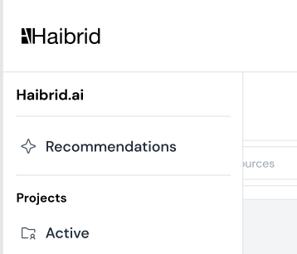

- The default layout of the page, with no filters applied, should display the recommendations with the highest Relevance Score: n/100.
- If not recommendations are available, display the following:
  - “No recommendations available for your selected filters. Please try different criteria.”
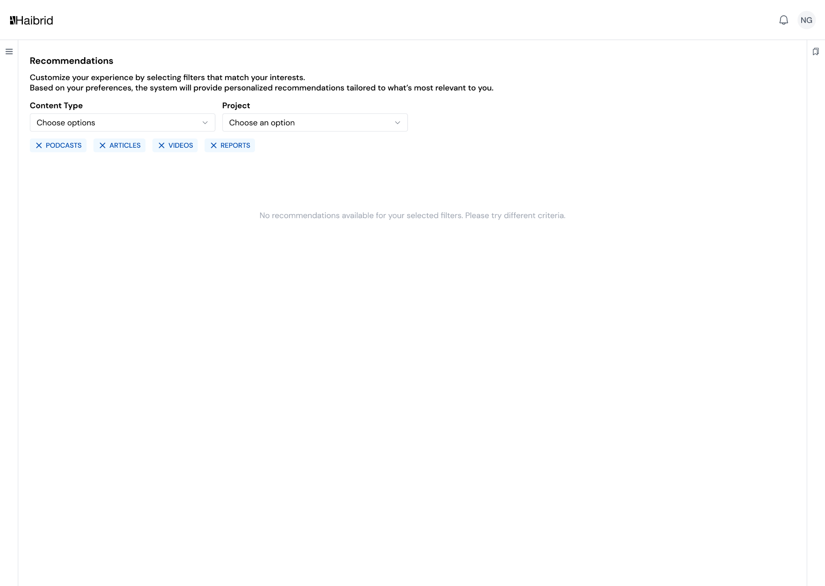

Ticket 3: Source Options
- Rename
  - Opens rename modal
  - Displays changes straight away once user clicks save
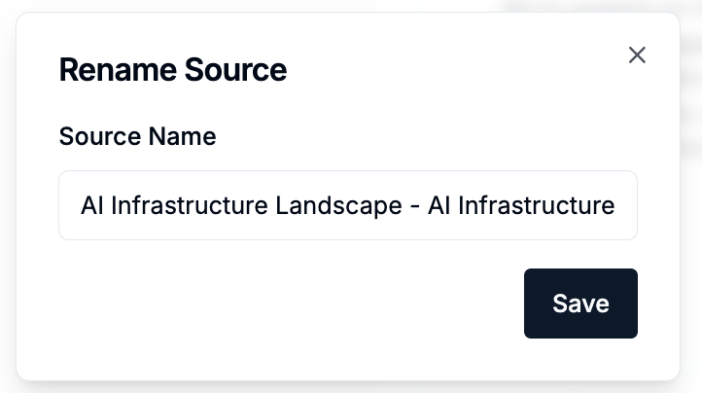

- Save to
  - Open Save modal
  - Removes source from recommendations to the intended project
  - 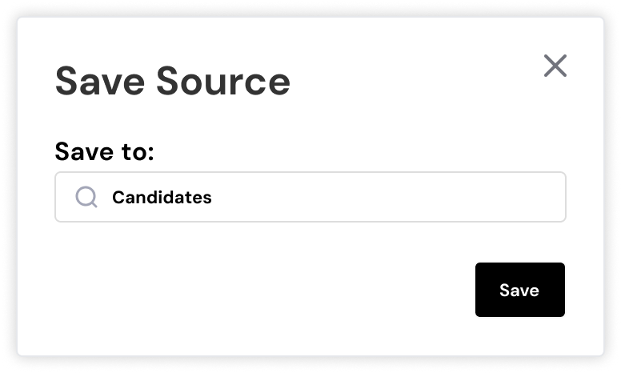
- Not Interested
  - Removes source from recommendations
  - Feedbacks the info to the RecSys.
  - 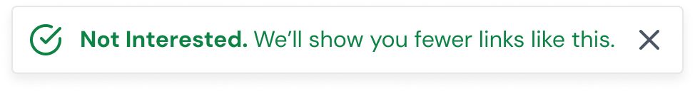

Ticket 4:

Ticket 5:

