# Results Summary

**Q1. What is the most dangerous NYC borough / area for a bicycle rider? Use visualization.**

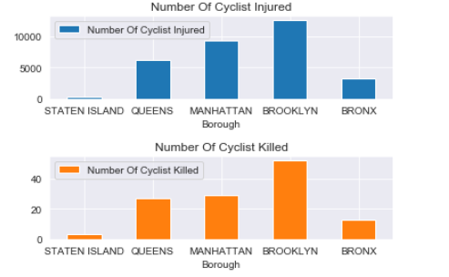

**Figure 1: As shown, the most dangerous borough for cyclists is Brooklyn**

**Q2. What would you change in the locations of bike stations to increase safety? Use visualization.**

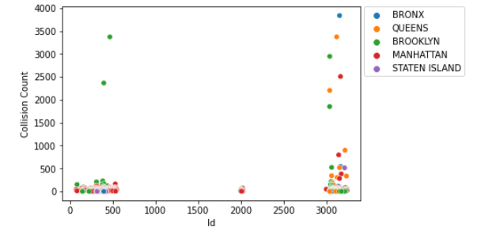

**Figure 3:The increase the safety overall, the location of bike stations with Collision Count > 50,000 need to be moved in area of bike stations with Collision Count < 25,000 as per given data. However, for better recommendation, data such as traffic congestion, weather, no. of buildings(infrastructure) and population would be required.**

# Additional Findings:

* Mostly Collisions occur due to Driver's Fault or Driver's Distraction
* However, Collisions caused because Breaking of Traffic Rules result in more deaths
* There are more accidents in later half of the year hence resulting in more injuries and deaths
* Accidents increased over the year until 2019.There's a significant drop in 2020 probably due to Covid 19 Outbreak
* Mostly accidents occur in weekdays probably because these are working days
* More Accidents occur on Fridays, perhaps because it's the start of weekend and people go to their homes (nearby counties/states), get out for partying while the daily traffic congestion is still there

Conclusion:

* Data set is more suited to find the no. of accidents on a given day(forecasting) rather than where an accident can occur
* Traffic congestion data, infrastructure data, weather data, population data would be required for further and interesting insights