Alert Fatigue Reduction: Wazuh SIEM Tuning Project
SOC L1 Portfolio Project by Haider Jamal

Objective
SOC teams drown in low-value alerts. This project demonstrates the full analyst workflow around that problem — not just generating alerts, but reducing noise through custom detection tuning while proving, not assuming, that true-positive detection survived the tuning. The lab used a Wazuh SIEM manager (Rocky Linux) monitoring a Windows 10 agent and the manager host itself, with VirusTotal and Sysmon integrations.

Methodology
Baseline traffic composition was built to resemble a real SOC's noise mix rather than an artificially inflated one:
- Benign failed-login noise: scattered, single/double RDP auth failures from an internal test range, spaced minutes apart - not a tight-interval pattern (which would itself be an attack signature)
- FIM noise: routine file creation/deletion in a monitored path (/etc)
- Native OS/background noise: Windows service and licensing events, agent heartbeats, WPAD DNS timeouts
- Separately tracked true positives: EICAR test file, Hydra brute-force against RDP - fired once for baseline, then re-fired identically post-tuning to validate detection survived
Workflow order enforced throughout: baseline capture → tuning → re-injection/re-validation → final measurement → writeup. Re-validation was never skipped, even when it surfaced a real problem (see Key Finding below).

Phase 0: Environment Check
Confirmed Wazuh manager, indexer, and dashboard services were active before generating any test traffic.
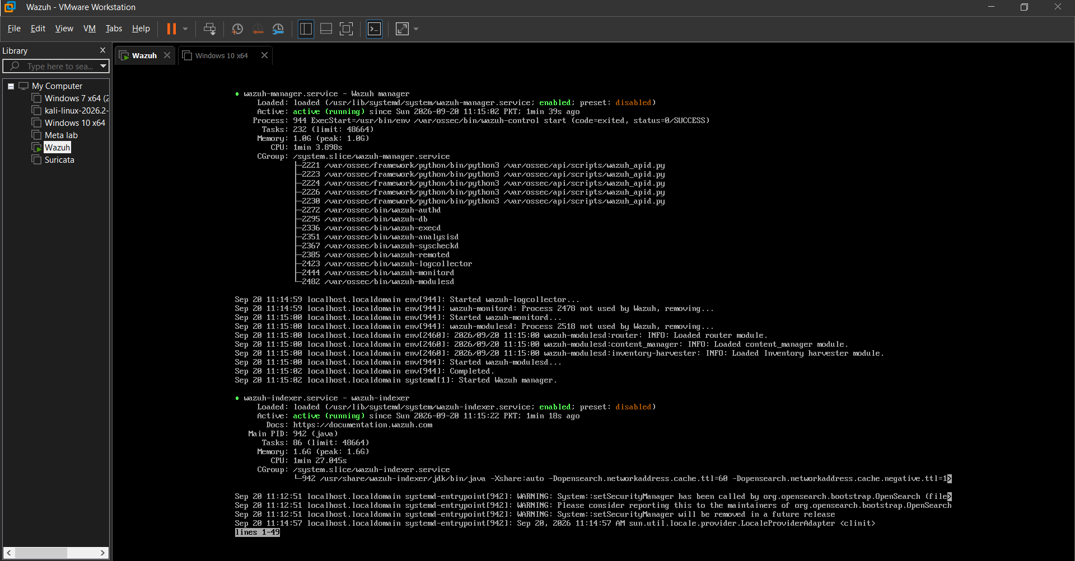

Phase 1: Baseline Traffic Generation
Generated a realistic mix of benign noise (FIM file touches, scattered failed logins) and separately tracked true positives, avoiding artificially inflated volume.
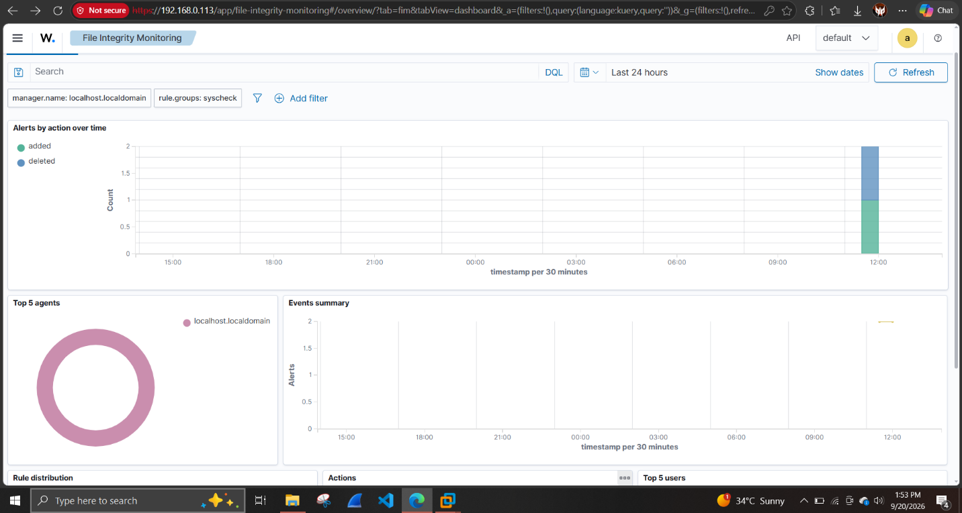

Infrastructure Troubleshooting (notable, not a flaw)
The Windows agent repeatedly disconnected during setup due to a dynamic manager IP (changed three times across the project via DHCP) and malformed XML in local configuration files (uppercase tag names, misplaced INTEGRATION block). Both were diagnosed from first principles using agent logs and fixed.

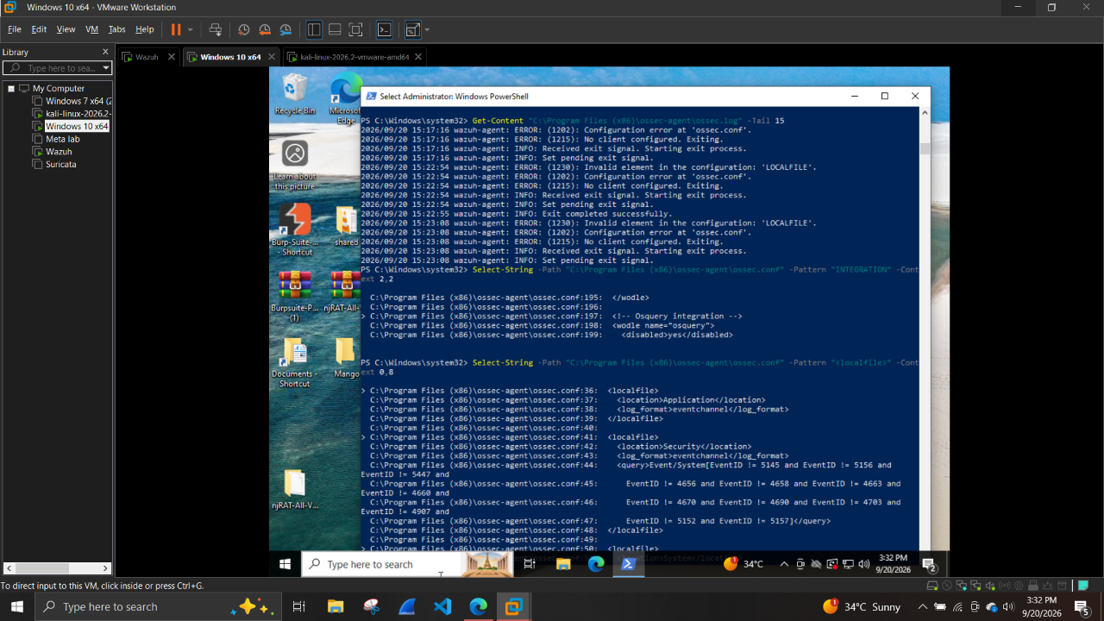
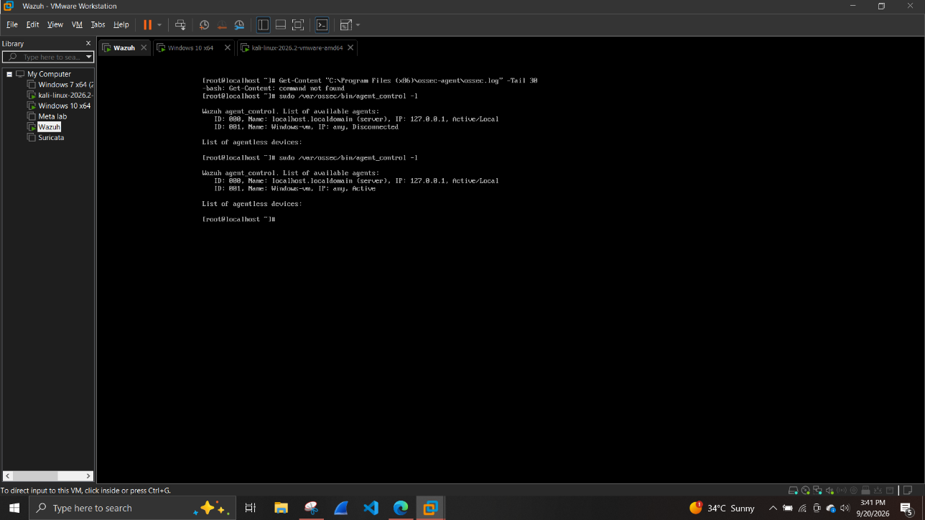

Track A: Benign Noise
- Scanner noise: a polite nmap -sT -T2 scan generated zero Wazuh alerts — a native detection gap, not a missed test (no IDS/Suricata correlation by default)
- DNS lookup noise: dig queries against uncommon domains
- RDP failed-login noise: scattered xfreerdp auth-only attempts, correctly landing as low-severity Logon Failure events

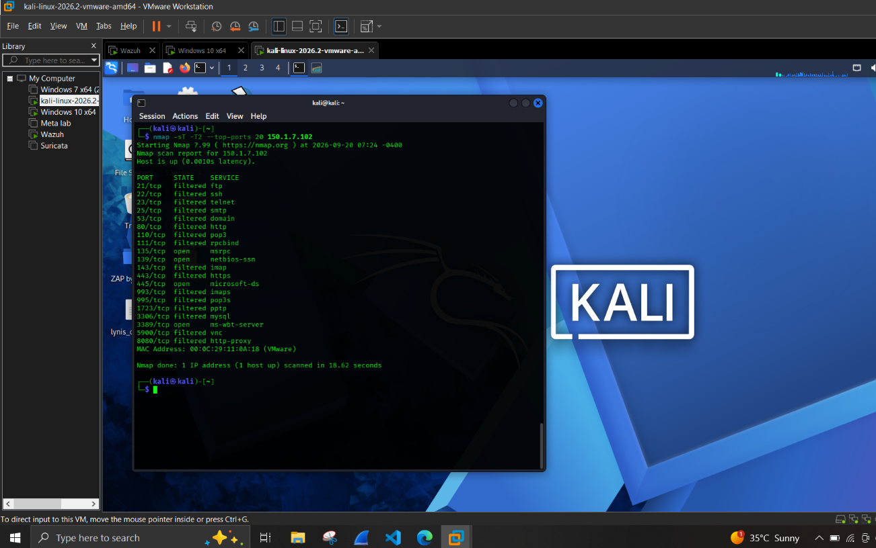
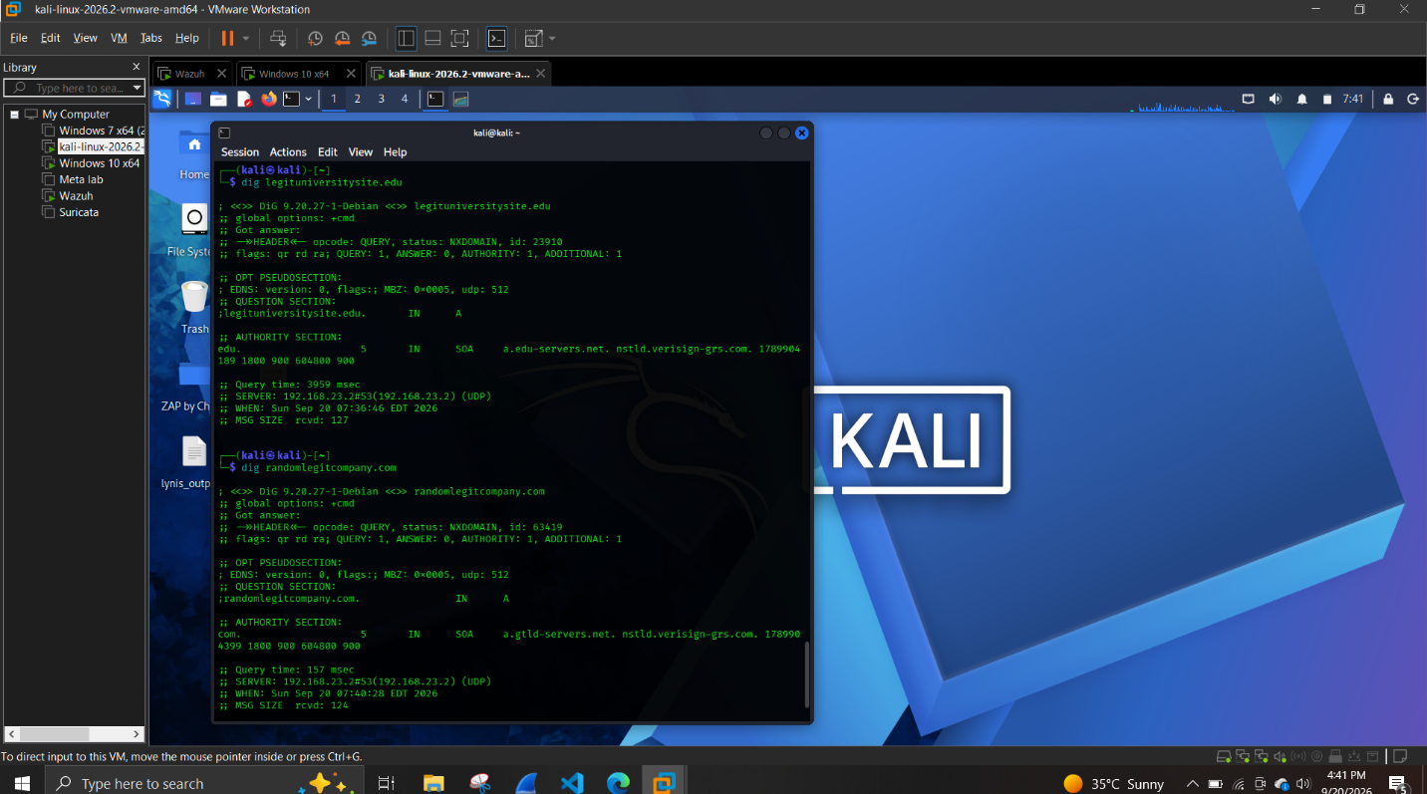

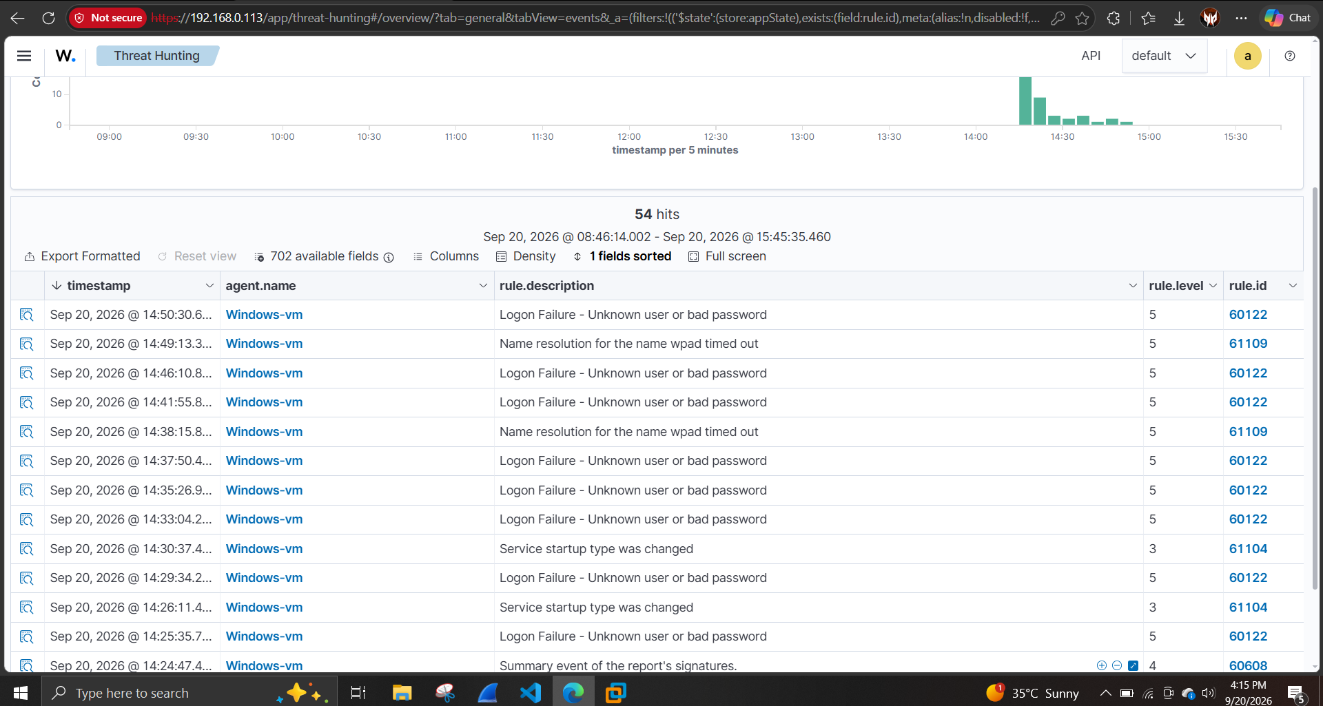

Track B: True Positives (Baseline)
- EICAR test file, detected via File Integrity Monitoring (rule 554)
- Hydra brute-force attack against RDP, detected via native frequency correlation (rule 60204, escalating to level 10)

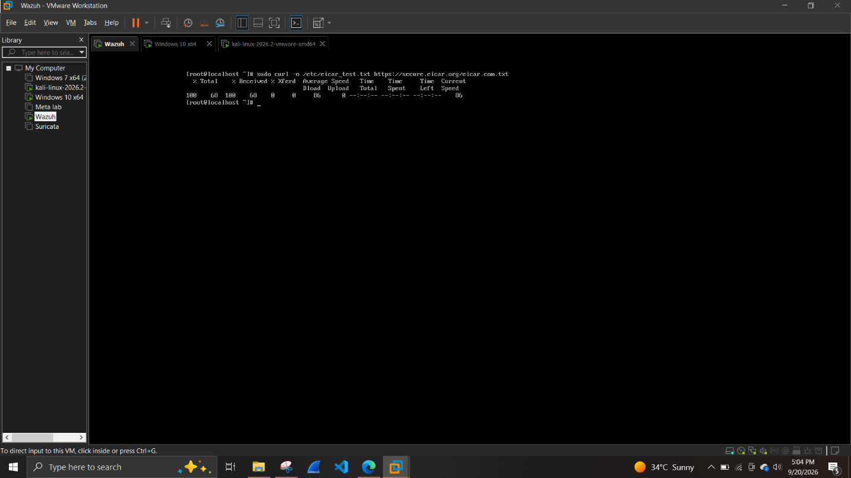

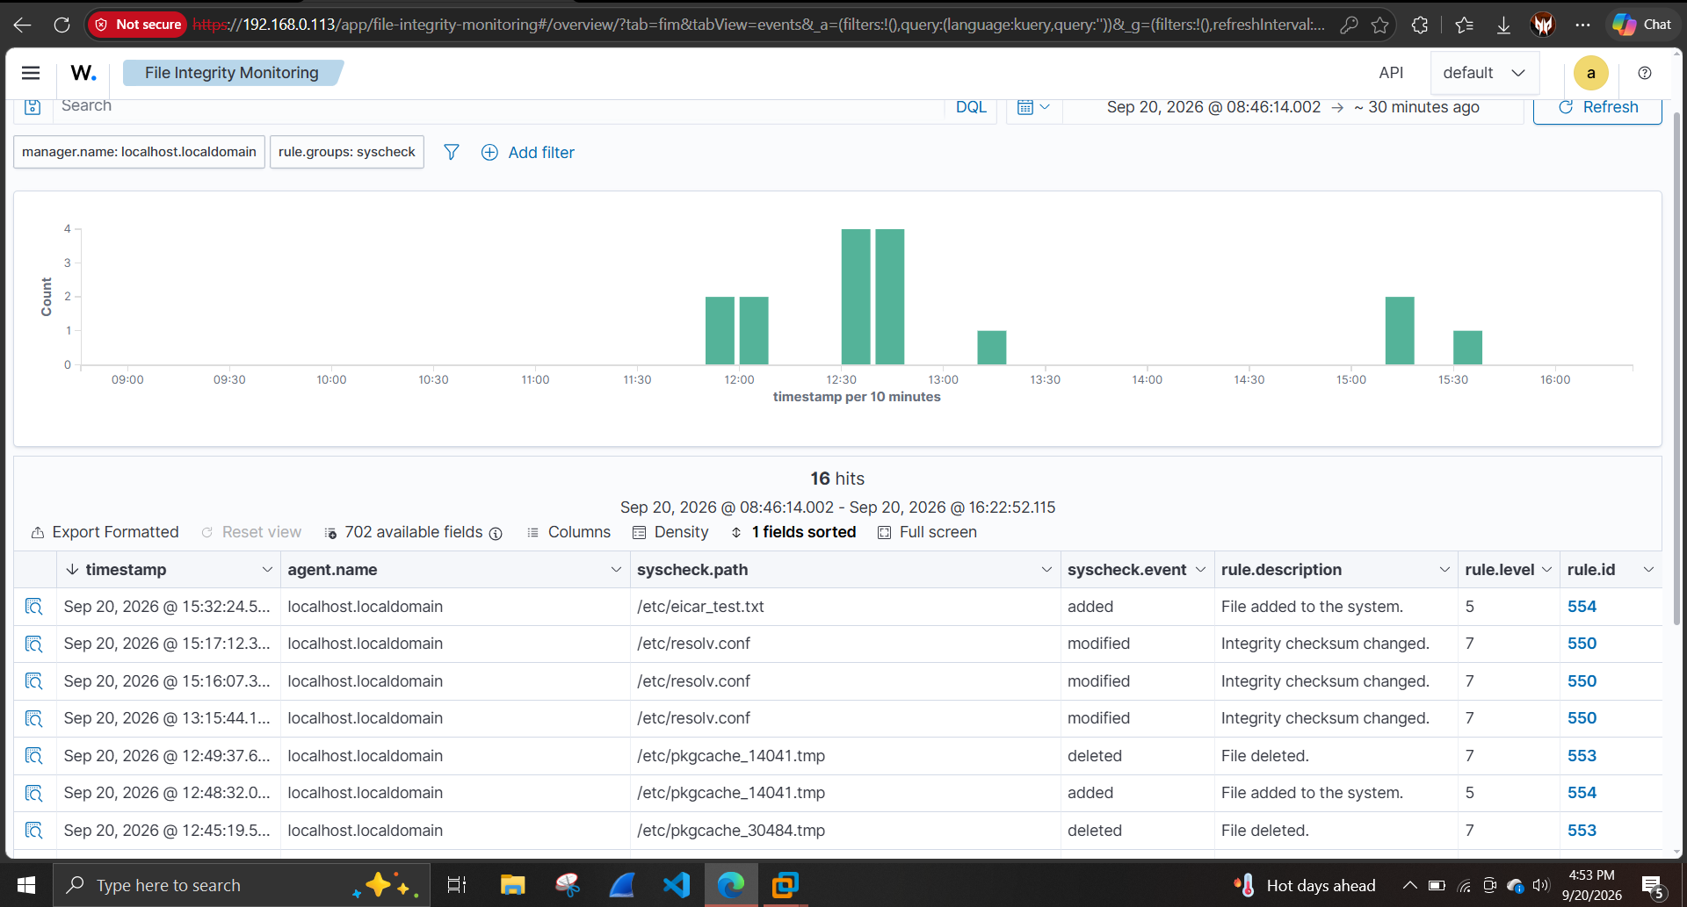

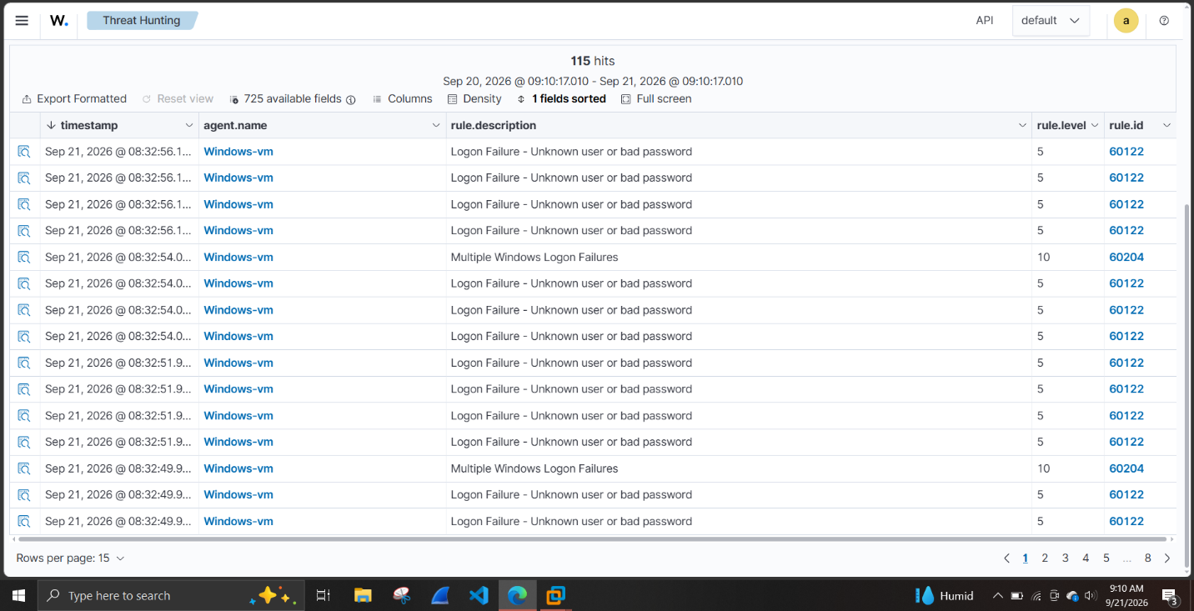

Phase 2: Baseline Measurement
Raw session total: 469 alerts. After excluding 106 alerts from a separate, unrelated malware-analysis testing session (confirmed via a distinct Windows user context, "Victim" vs. the analyst's own account) and periodic SCA/CIS benchmark scans triggered by manager restarts, the clean baseline was 364 alerts. Every alert was classified — true positive or benign — and traced to a specific rule ID.

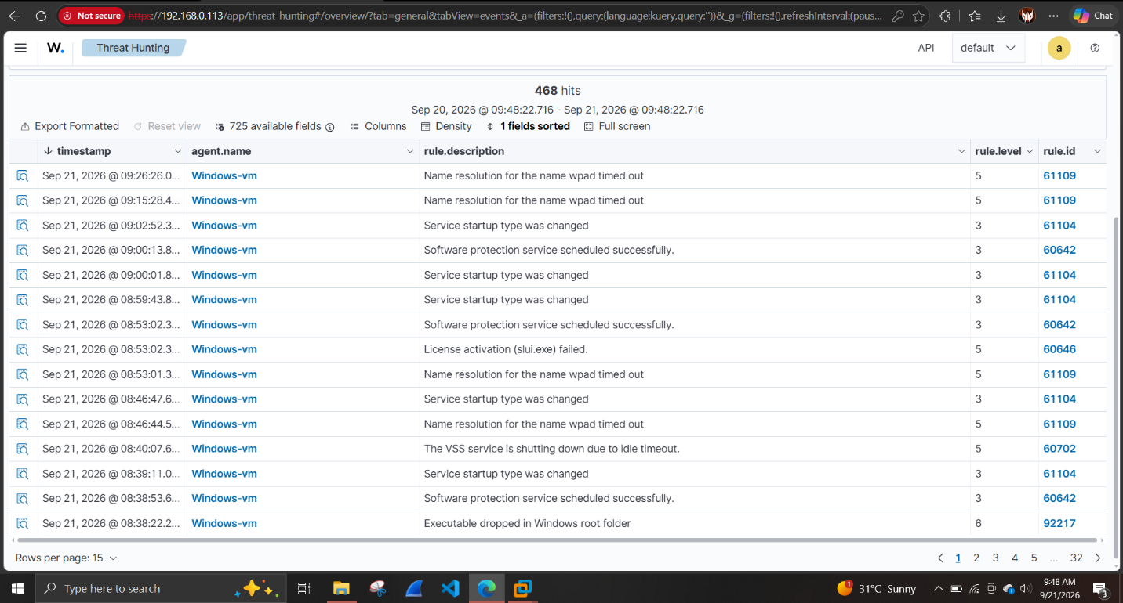
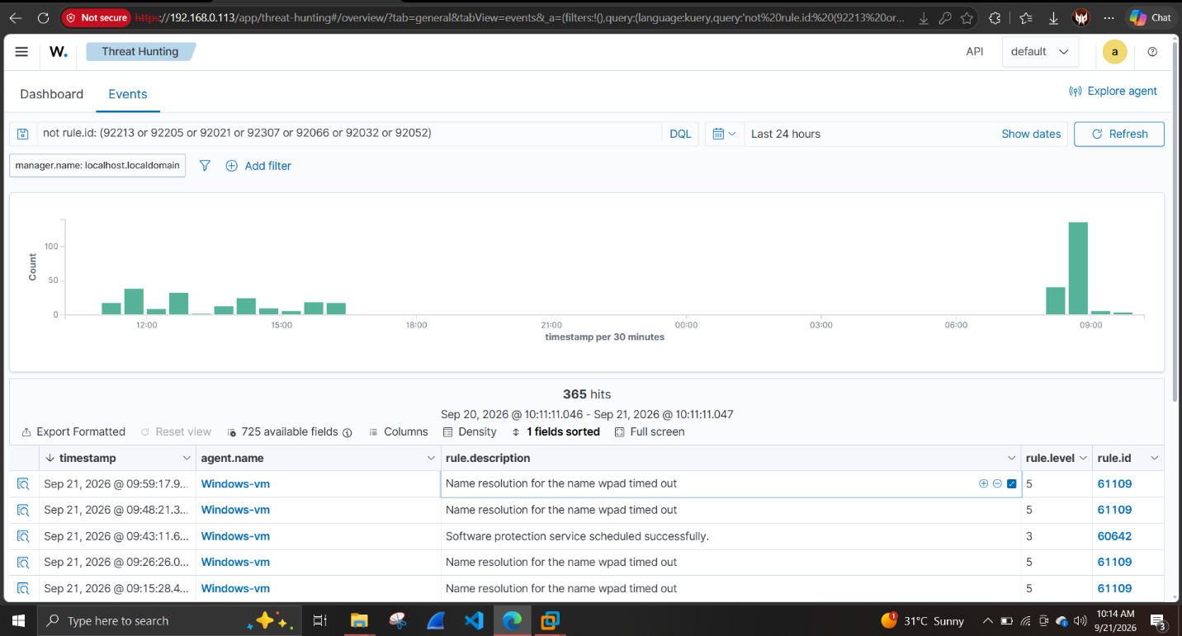

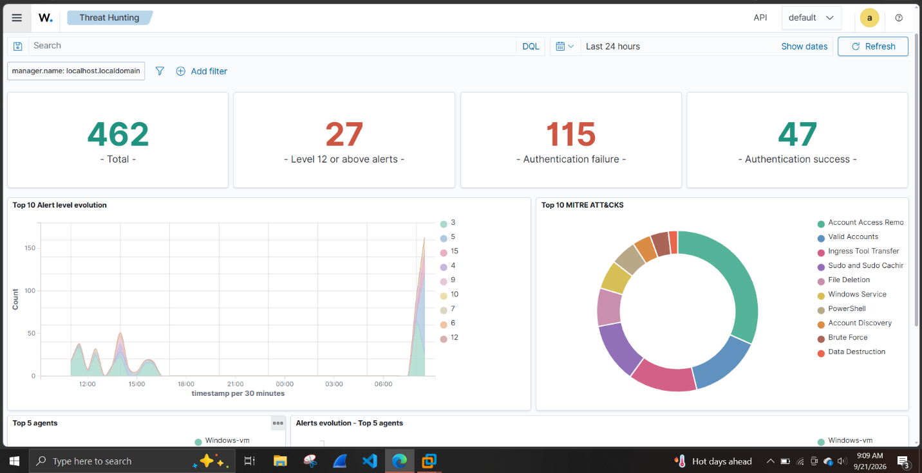

MITRE ATT&CK Mapping Accuracy Check
An unexplained "Account Access Removal" (T1531) tag was traced to a bulk password-regeneration tool (wazuh-passwords-tool.sh -gf) run during infrastructure troubleshooting — legitimate admin activity that behaviorally resembles the technique. Reinforced that MITRE tags reflect pattern-matching on behavior, not confirmed intent.

Phase 3: Custom Rules Written
Rule ID | Target | Mechanism | Result
100010 | 60122 (RDP failed logon) | Downgrade level 5->3, matched on win.eventdata.ipAddress field | Working 99 events in final test, consistent downgrade
100011 | 5402 (sudo to root) | Suppress (level 0); tried <user>, <field name="dstuser">, <dstuser> | Not functional - engine rejected field as reserved/static
100012 | 5501/5502 (PAM session) | Suppress via if_group and dstuser matching | Not functional - same field reference constraint
100013 | 553/554 (FIM) | Suppress by filename pattern pkgcache_ only; eicar_* excluded | Working - confirmed via dedicated control test
100014 | 92217 (Defender/Update false positive) | Suppress by targetFilename containing SoftwareDistribution | Not functional - loaded fine but did not suppress
100015 | authentication_failed group | New correlation rule, freq=8, timeframe=240, group-based not rule-ID-based | Working - fixes blind spot from rule 100010

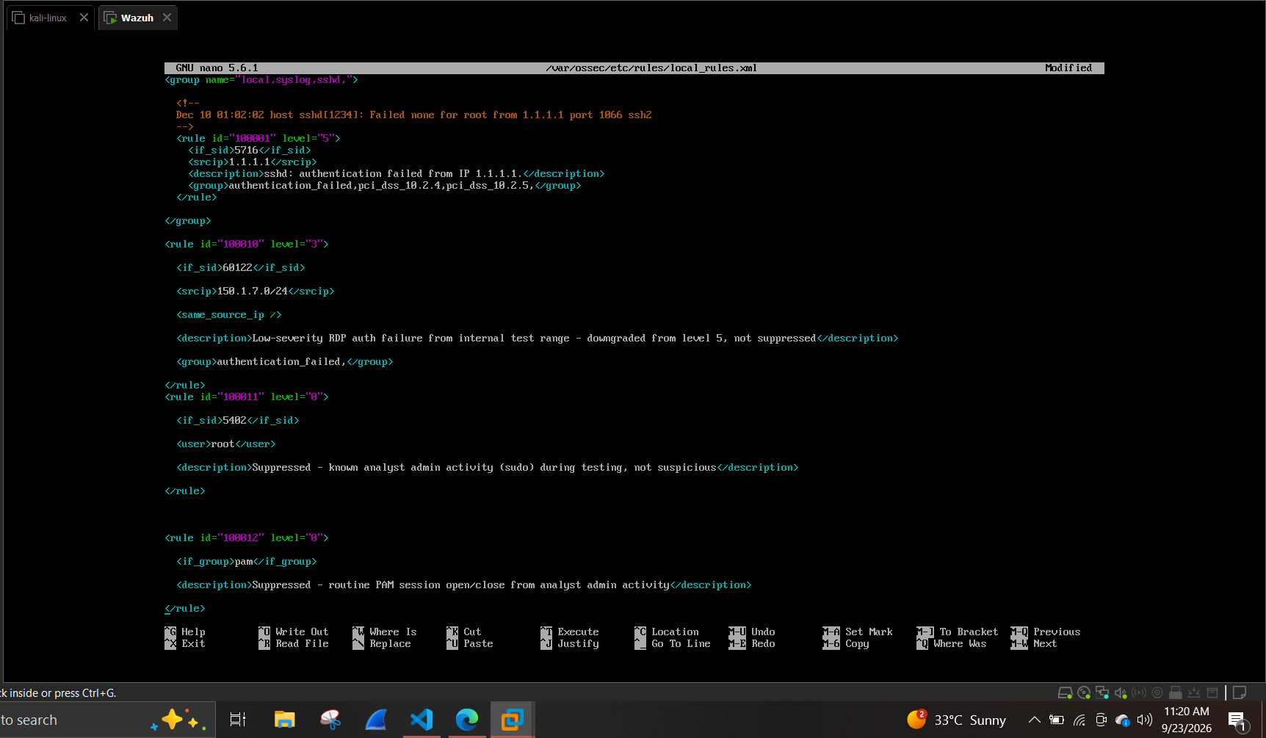

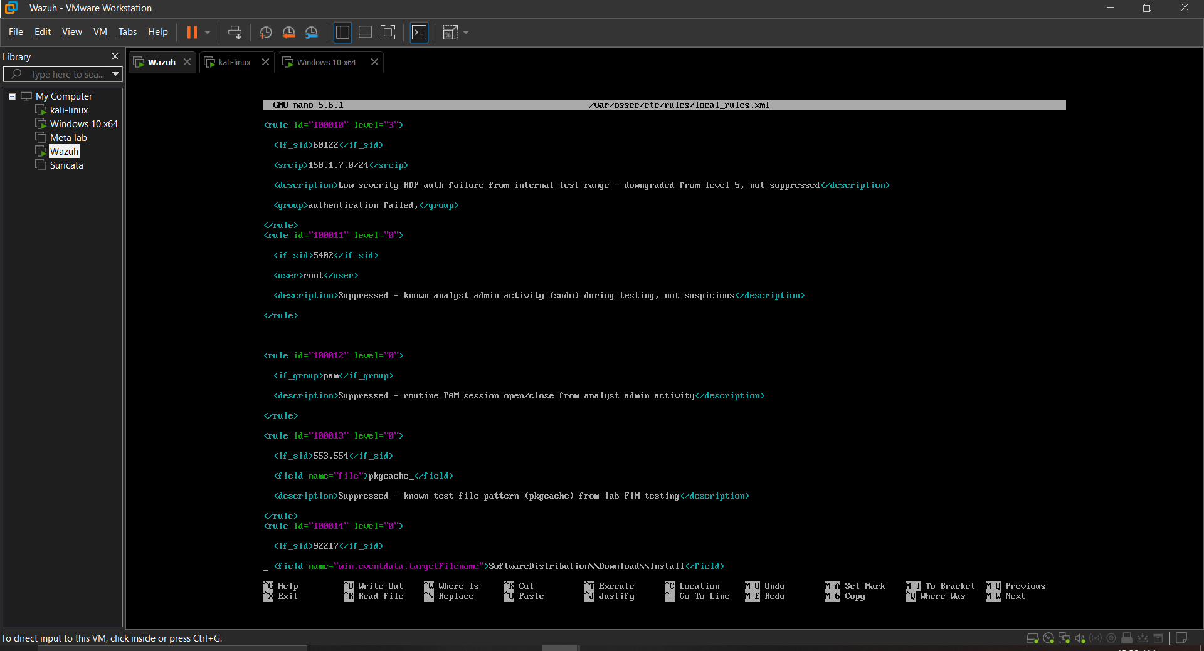

Key Finding: Tuning Introduced a Detection Blind Spot - Caught and Fixed in Re-Validation
This is the centerpiece finding of the project, and the reason Phase 5 (re-validation) is a mandatory, non-skippable step rather than a formality.

What happened
Rule 100010 downgrades individual RDP failed-logon events by overriding the fired rule ID to 100010. Wazuh's native brute-force correlation rule (60204) detects brute-force patterns by counting occurrences of rule ID 60122 specifically. Once 100010 relabeled those events, 60204 never saw them — the correlation engine had nothing to count. A genuine brute-force attack, post-tuning, would have gone undetected at high severity.

How it was caught
Re-running the identical Hydra brute-force attack used in the baseline (per the mandatory re-validation step) produced zero hits on rule 60204, despite the underlying events clearly firing in a tight burst that should have crossed the correlation threshold.

Root cause process
- Confirmed the burst volume and timing were sufficient (12+ events in 4 seconds, well above the native rule's frequency=8, timeframe=240 threshold)
- Pulled the native rule's actual definition from the ruleset (0580-win-security_rules.xml) and confirmed it correlates on group/rule-ID counting, not a field value
- Concluded the override was removing the event from correlation scope entirely

Fix
Added rule 100015 — a new correlation rule keyed to the authentication_failed group rather than the specific rule ID, immune to the ID-override problem, using the exact frequency/timeframe values matched from the native rule.

Validation
Re-ran the brute-force attack again after the fix. Rule 100015 fired consistently (12 events, level 10) across the final clean test run, confirming brute-force detection was restored without losing the noise-reduction benefit of the original downgrade.

Phase 4 & 5: Post-Tuning Re-Validation
True Positive | Mechanism | Baseline | Post-Tuning
EICAR file | FIM (rule 554) | Detected, level 5 | Detected, level 5 — unaffected by rule 100013
EICAR file | VirusTotal (rule 87105) | Not functional (misconfig) | Detected, level 12, 66+ engines, after fix
Hydra brute force | Native correlation | Detected, level 10 (60204) | Detected via rule 100015, level 10, post-fix

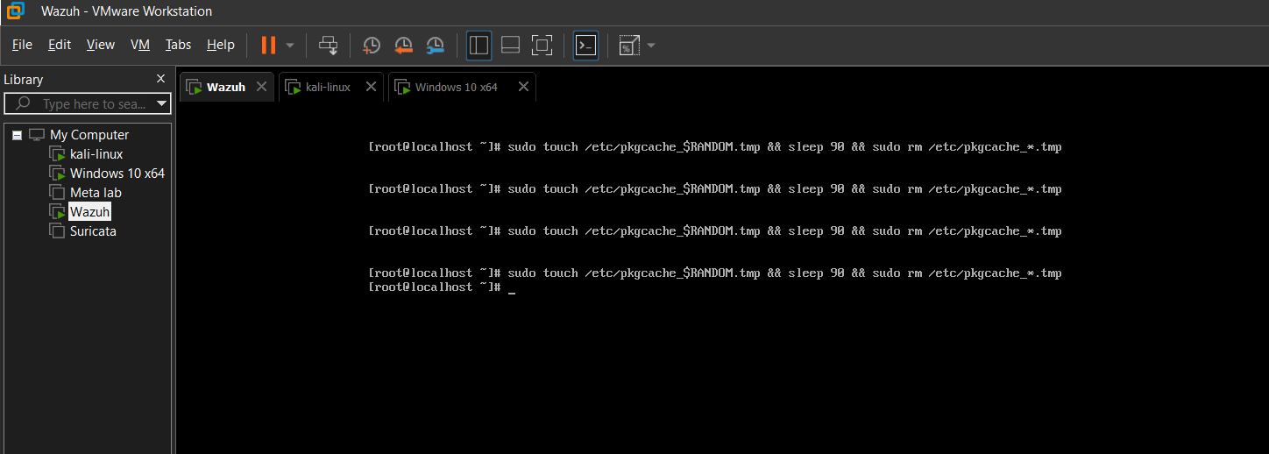

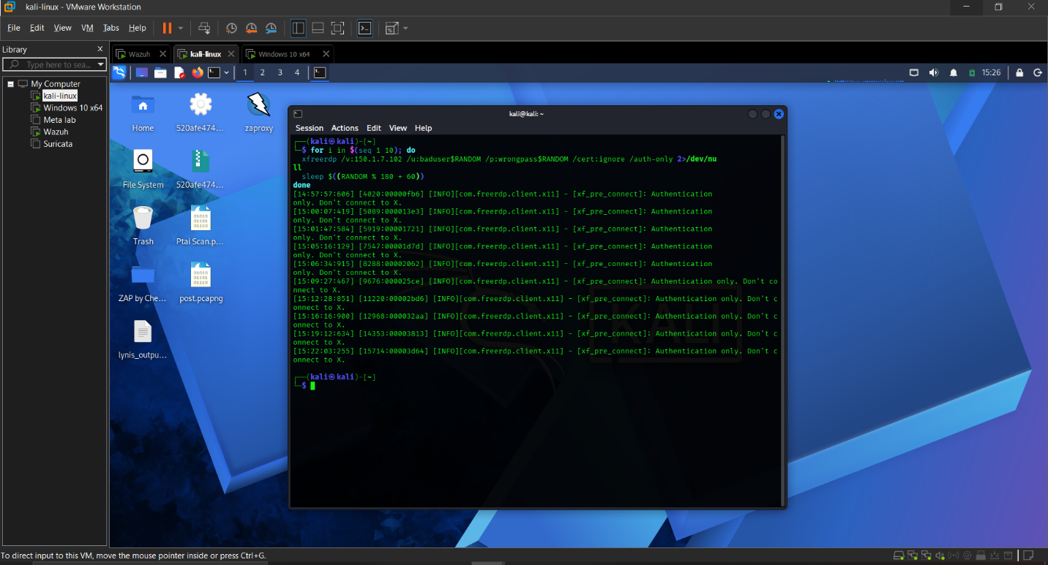

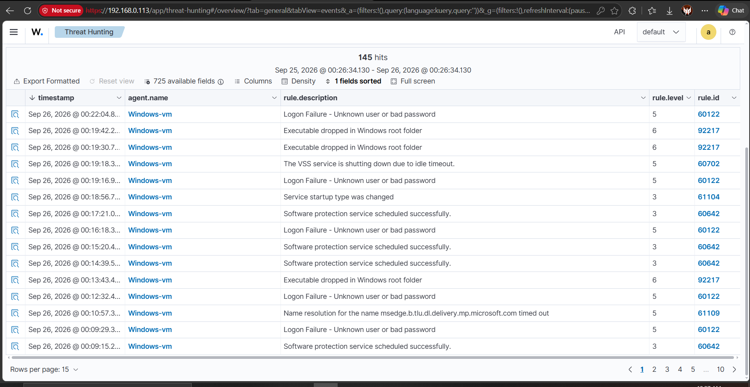

Phase 6: Final Clean Comparison
Baseline (Phase 2): 364 clean alerts, full session capture with contamination excluded.
Post-tuning clean test (Phase 6): 185 events across a dedicated clean window (99x rule 100010, 12x rule 100015, remainder native OS/background noise and confirmed true positives).

Why this is a rule-mechanism comparison, not a raw percentage
An early draft of this project considered a single headline number (e.g. "X% reduction"). That was deliberately abandoned: the later test exports spanned a different time window and volume of deliberate test traffic than the original baseline capture, and presenting a raw before/after total would have compared two non-equivalent samples. The honest, defensible result is per-mechanism:
- RDP failed-login severity: 100% of matching events correctly downgraded from level 5 to level 3, consistently, across every re-test
- FIM test-file noise: 100% suppressed, proven via a dedicated control test isolating suppression from coincidental absence
- Brute-force detection: preserved at full severity (level 10) after a self-discovered and corrected blind spot — net zero loss in detection capability
- Sudo/PAM/Defender-path suppression: 0% successful, root-caused and documented rather than claimed

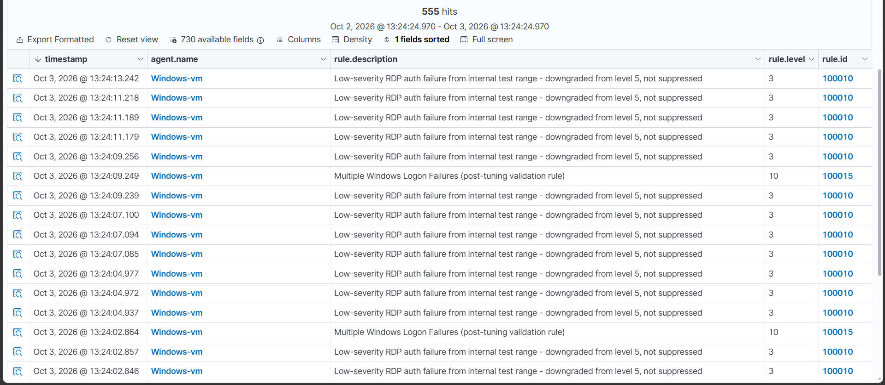

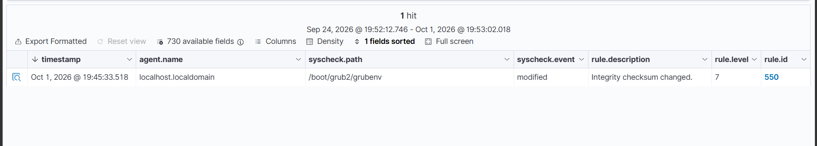

Known Limitations (Documented Honestly, Not Hidden)
Three of five custom rules did not achieve their intended suppression, despite loading without syntax errors:
- 100011 / 100012 (sudo/PAM suppression): Wazuh's analysis engine explicitly rejected two different field-matching syntaxes — "Field 'dstuser' is static" and "Invalid option 'dstuser'" — pointing to a genuine version-specific constraint, not a configuration mistake.
- 100014 (Defender path suppression): Loaded cleanly with a confirmed-correct field reference, but did not suppress matching events in live testing. Root cause not fully isolated — deprioritized to complete the project.
This is reported as-is rather than omitted: the rule files exist in the project's local_rules.xml and would be visible to anyone reviewing the configuration directly. A 60% success rate on custom suppression logic, with the two failures root-caused to specific, explainable engine behavior, is more defensible than an unverified claim of full success.
VirusTotal integration was initially non-functional for two separate reasons, both diagnosed and corrected: originally configured on the Windows agent instead of the manager with invalid uppercase XML tags; after correction, still failed to trigger because the monitored directory lacked hash-checking attributes (check_md5sum), without which syscheck has no file hash to submit. Once both issues were fixed, the integration worked correctly and independently confirmed the EICAR true positive.
Dynamic manager IP: The Wazuh manager's IP address changed three separate times during the project (DHCP lease renewal), silently disconnecting the Windows agent each time with no alert raised for the disconnection itself — a real operational gap worth flagging for production deployment (static IP/DNS name, plus an alert rule for prolonged agent disconnection).

