The University of Lahore, CS&IT Department

# Java Software Development Paradigm

Start-Date 14-03-2023 Total Marks 10

Due-Date 23-03-2023 Program: BSCS

Design a program, which provides the following banking facilities according to screens.





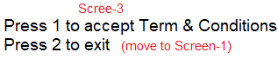

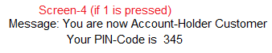

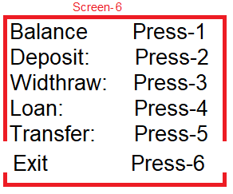

Conditions

* User apply for loan and loan should not more than current balance in user account.
* Loan interest rate based on per minute interest and deduct from user balance.
* Saving will be increased by per minute profit (interest).