Contents

**Executive Summary** 1

**1. Global Overview: Supply, Demand, and Strategic Importance** 2

Table 1: Global REE Production and Reserve Profile (2024) 2

**2. Price Volatility and Supply Risk** 3

**3. China’s Dominance and Global Response** 4

Table 2: China’s Market Control by Supply Stage 4

**4. Pakistan’s Geological Potential** 4

**6. Strategic SWOT Analysis of Pakistan’s REE Launch** 6

**7. Economic and Strategic Impact** 7

Short-Term: 7

Long-Term: 7

**8. Geopolitical Leverage and External Relations** 7

**9. Risk of Resource Curse in Conflict Zones** 8

**10. Plausible Production Timeline and Recommendations** 8

Recommendations: 8

**Conclusion** 9

📚 Reference Sources 9

**Executive Summary**

Rare Earth Elements (REEs), crucial for modern technologies like electric vehicles and defense systems, are experiencing record demand. The global market was valued at over USD 4 billion in 2025 and may surpass USD 9 billion by 2034. However, global dependence on China—holding 69% of mining and 90% of processing—raises strategic concerns.

Pakistan is emerging as a potentially important new player. With speculative REE reserves, supportive policy reforms (SIFC, National Minerals Harmonization Framework), and strategic alliances, Pakistan could help diversify the global REE supply. Still, internal hurdles—security risks, infrastructure deficits, and environmental concerns—must be overcome. If successful, Pakistan could reshape global supply dynamics, mitigate price risks, and amplify its diplomatic influence between the U.S. and China.

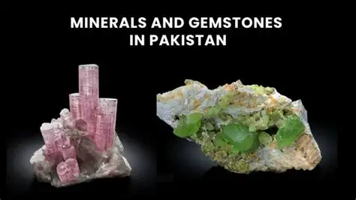

**1. Global Overview: Supply, Demand, and Strategic Importance**

Rare Earth Elements (REEs) are 17 metallic elements grouped into:

* **Light REEs (LREEs)**: e.g., neodymium (Nd), praseodymium (Pr)  
  → used in NdFeB magnets (essential for EVs, turbines, consumer electronics)
* **Heavy REEs (HREEs)**: e.g., dysprosium (Dy), terbium (Tb)  
  → improve magnet performance in extreme environments; key for aerospace and military

**Market Scale:**

* Valued at $4.1B in 2025, REE market projected to grow to $9.91B by 2034 (CAGR: 10.21%)
* Major market volume growth is in high-powered magnets (8%+ CAGR)

Table 1: Global REE Production and Reserve Profile (2024)

| **Country** | **Mine Production (tons)** | **Global Share (%)** | **Reserves (tons)** | **Share of Reserves (%)** |
| --- | --- | --- | --- | --- |
| China | 270,000 | 69.2% | 44,000,000 | 48.9% |
| United States | 45,000 | 11.5% | 1,900,000 | 2.1% |
| Myanmar | 31,000 | 7.9% | — | — |
| Australia | 13,000 | 3.3% | 5,700,000 | 6.3% |
| Vietnam | 4,300 | 1.1% | 22,000,000 | 24.4% |
| Brazil | 20 | <0.1% | 21,000,000 | 23.3% |
| India | 2,900 | 0.7% | 6,900,000 | 7.7% |
| Russia | 2,500 | 0.6% | 3,800,000 | 4.2% |

**2. Price Volatility and Supply Risk**

REE prices are highly volatile, driven not by volume, but by:

* Processing capacity (e.g., separating Nd or Dy)
* Demand inelasticity
* Centralized supply (especially for HREEs)

⏱ Historical example: In 2010, China's embargo on Japan triggered a 5x price jump for neodymium oxide. From 2020–2023, prices ranged from $40/kg to $190/kg. Volatility is worsened by policy decisions and limited substitutes.

**3. China’s Dominance and Global Response**

China’s long-term industrial policy has created a vertically integrated monopoly:

Table 2: China’s Market Control by Supply Stage

| **Stage** | **China’s Share (%)** | **Alternatives** |
| --- | --- | --- |
| Mining | ~69% | U.S. (MP Materials), Australia |
| Refining & Separation | ~90% | Lynas (Malaysia), Estonia |
| Magnet Manufacturing | >92% | Japan, Germany |

Policy Response:

* **U.S.**
  + Inflation Reduction Act
  + DoD subsidies (e.g., $400M to MP Materials)
  + Guaranteed price floor ($110/kg) for NdPr
* **EU**
  + Critical Raw Materials Act (2030): 40% domestic processing target
  + No >65% reliance from one country

**4. Pakistan’s Geological Potential**

Estimates suggest Pakistan holds trillions in mineral wealth, including REEs. Resource identification is ongoing.

Key prospective regions:

* **Balochistan – Chagai District**: Tethyan Magmatic Arc (also home to Reko Diq)
* **Khyber Pakhtunkhwa (KP) & Gilgit-Baltistan**: Known for monazite and bastnäsite

However, REE-specific reserves remain **largely unquantified** pending feasibility and drilling.

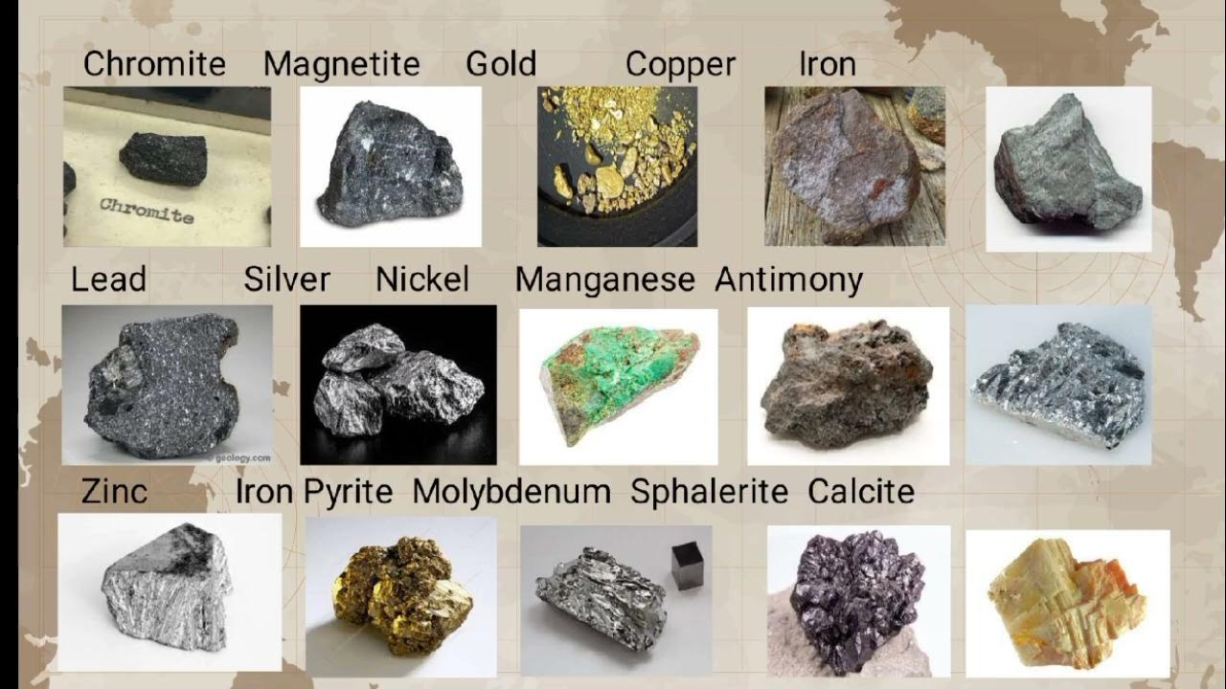

**5. Institutional Advances: SIFC & National Minerals Framework**

Pakistan introduced crucial reforms:

* **SIFC (est. June 2023)**  
  High-level civil-military body acting as single-window platform for REE-related investment
* **National Minerals Harmonisation Framework (2025)**
  + Unifies provincial-federal laws
  + Enables company licensing
  + Introduces ESG obligations and conflict resolution mechanisms

If enforced, these could structurally attract foreign direct investment.

**6. Strategic SWOT Analysis of Pakistan’s REE Launch**

| **Strengths** | **Weaknesses** |
| --- | --- |
| Untapped REE-rich terrain | Lack of domestic REE processing infrastructure |
| SIFC ensures continuity & stability | Inadequate security in mineral zones (Balochistan) |
| Proximity to Gulf & Central Asia | Tier-2 infrastructure, especially in remote areas |
| **Opportunities** | **Threats** |
| “Geopolitical premium” for non-China producers | Insurgency targeting foreign-backed projects |
| Saudi & U.S. investment interest | Environmental damage & socio-political backlash |
| Global demand for high-value HREEs | Contractual breaches and historical governance gaps |

**7. Economic and Strategic Impact**

Short-Term:

* Pakistan’s market entry may intensify price volatility
* China could flood supply to deter competition (as done in past)

Long-Term:

* Successful operations may enhance price stability
* Reduction in global strategic risk
* If refining capacity is added, Pakistan could capture greater value

**8. Geopolitical Leverage and External Relations**

U.S.–China strategic rivalry over critical minerals positions Pakistan advantageously:

* **U.S. engagement**: via USGS, DoD technical partnership, ESG collaboration
* **China**: Long-standing trade/investment partner via CPEC

Pakistan may pursue **“strategic balancing”**—engaging both superpowers for capital and tech.

—

**9. Risk of Resource Curse in Conflict Zones**

* Biggest risk factor: **Balochistan insurgency**
* Groups like the **Baloch Liberation Army (BLA)** oppose foreign resource deals
* Resource revenues may deepen local frustration if exclusion persists

🔁 With local benefit-sharing and accountability, REE projects could **fuel instability** rather than development.

**10. Plausible Production Timeline and Recommendations**

Global averages from discovery to full production: **15–20 years**  
In Pakistan: **10–15 years minimum** if coordinated action taken now

🕒 Example: Reko Diq (discovered in 1990s) won’t start production until 2028

Recommendations:

**For Investors:**

* Conduct in-depth political/security due diligence
* Ensure ESG safeguards
* Enter joint ventures backed by state or multilateral guarantees

**For Western Policymakers:**

* Incentivize early-stage exploration
* Match Chinese capital clout with risk-tolerant support
* Tie aid to verifiable governance reform

**For Pakistan:**

* Prioritize durable political settlement in Balochistan
* Invest in **downstream processing**—don’t export raw ore only
* Enforce mineral framework laws consistently & transparently

**Conclusion**

Pakistan stands at a decisive crossroads. It holds the geological promise and geopolitical positioning to become a leading REE supplier—but only if long-standing governance, infrastructure, and security challenges are resolved and communities are included in the benefits.

Its trajectory will serve as a test case for how emerging markets transform resource potential into long-term development.

***“The contest is no longer just for minerals. It is for trust.”  
— Strategic Insight, REE 2025 Outlook***

📚 Reference Sources

* **World Bank**, **USGS**, **IEA**
* **Mining.com**, **Lynas**, **MP Materials**
* **ResearchGate**, **Chatham House**, **CSIS**
* **Dawn**, **Arab News**, **Pakistan Today**, **Jamestown**
* **SIFC, GSP, and National Mineral Framework resources**