HOW PTC DISTRIBUTOR WORKS

PTC assign monthly targets to its Distributor like below

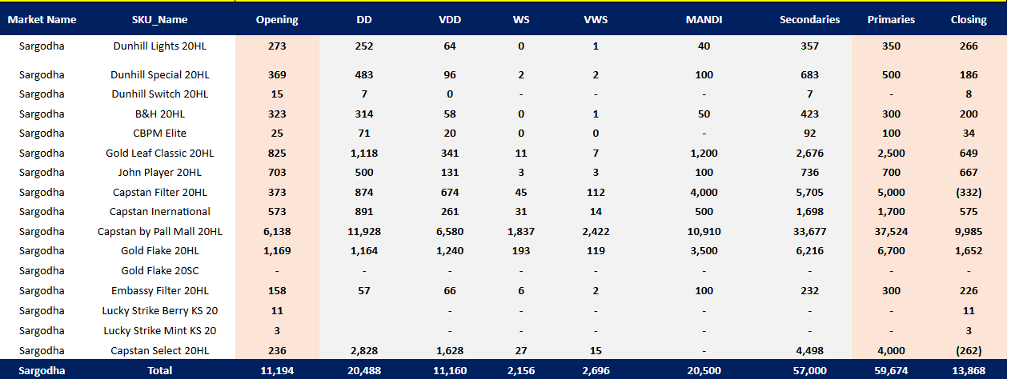
Table shows PTC gave us channel wise and sku wise targets for sep 2026
In SKU column we have all our FMC brands (FMC is a category used for Cigrettes)
In Opening Column, we have our last month closing number in M’s. (M is a unit of volume in PTC industry. 1 M means 1000 cigarette sticks. A CBC contains 10 M’s Stock and 10000 cigarette sticks)
DD Column show us our targets for DD (Direct Sale & Delivery i.e. Urban Retail)
VDD Column shows our targets for VDD (Village Direct Sales & Delivery i.e. RURAL RETAIL)
WS Column show our targets for WS (Urban Whole Sale i.e. Urban Scattered)
VWS Column show our targets for VWS (Village Whole Sale i.e. Rural Scattered)
MANDI column shows our targets for MWS (Mandi Whole Sale)
PRIMARIES are the stock lifted by Distributor from company
SECONDARIES are the Sales which a Distributor performs in all Above-Mentioned Sales Channels like DD, VDSD, UWS, RWS, MANDI)
Distributor has his own field force for covering the assigned area of PTC. The Layer of Field Force is as under,
- DR Distribution Representative or Salesman
Urban DR (covers urban market)
Rural DR (covers rural market)
Mandi DR (covers wholesale mandi)
- FSO Filed Force Officer.
Every FSO supervise the team of 7 DR’s normally, number may be vary according to need but Max. number is 7 for every FSO.
- DM Distribution Manager
Distribution Manager supervise the whole field force for the smoothly execution of Primaries and Secondaries Targets and RTM’s compliance overall.

All the DR’s are assigned their market wise outlets in their devices and are being tagged with unique DR ID’s i.e. SGD_SGD_DR01, SGD_SGD_DR02 and so on.
DR’s are assigned with monthly volume and RTM’s target according to their market volume size.
RTM Route to the Market is a term used by PTC to gauge the quality of work of DR’s. In basics of RTM we often discuss the Unique Handlers and Active Handlers.

Unique Handler & Active Handler An outlet named ABC if purchased any FMC or NC sku from DR will become Unique Handler of that typical SKU. And if that shop buys that typical sku 3 more time, will become an Active Handler. So to become Unique Handler just 1 single purchase and to become Active Handler 4 times purchase is mandatory.

So, we calculate DR wise, Sku wise Active and Unique Handling on daily and monthly basis.

SD-20 is a main document of PTC in shape of register which we have to fill manually on daily basis. This register is being updated in excel files and KPO put this data from excel sheets to SD-20 Register manually.

As discussed above that Distributor has to achieve all secondaries targets of PTC and some times according to market situation when markets demand is not according to assigned targets, Distributor has to adjust this stock in automated sales but physically stock remains in On Hands. So we must need documents which show Actual On hands and On hands in sales books. In short, we run 2 different inventories at the same times. One is According to Company on Hands and the other is Actual On hands.
Whole sale mandi is the biggest sales channel in our Distribution setup and the rates for this channel are changed daily or weekly, according to market situation so we have to Update rates for this channel accordingly.
The volume we adjusted in any channel like DD, VDD, UWS and RWS, being sold later in Mandi Whole Sale. So we need all the record of adjusted volume in any channel as well.

