# **Blue Gravity Task-1**

## **Game System**

### Player Controller Player Controller is working on the basis of rigid body which can be controlled by using the keyboard arrow keys.

### Intractable Environment Environment is intractable as move around different objects. While player can earn by cutting the woods & Change its look by interacting with the shopkeeper outside the clothing shop. The below is an overview of the environment. Where with area mentioned with 1 is the wooden area where user can cut the wood & earn some coins which can be used at the area mentioned with 2 where user can buy & sell clothes along with this there are gems can be converted to coins too.

## C:\Users\haide\AppData\Local\Microsoft\Windows\INetCache\Content.Word\Environment.png

2

1

### **Game UI & Assets** For the game UI & Environment Assets I Used the following that are available on asset store for free. <https://assetstore.unity.com/packages/2d/gui/icons/2d-casual-ui-hd-82080>

### <https://assetstore.unity.com/packages/2d/characters/medieval-warrior-pack-2-174788>

### <https://assetstore.unity.com/packages/2d/characters/mighty-heroes-rogue-2d-fantasy-characters-pack-85770>

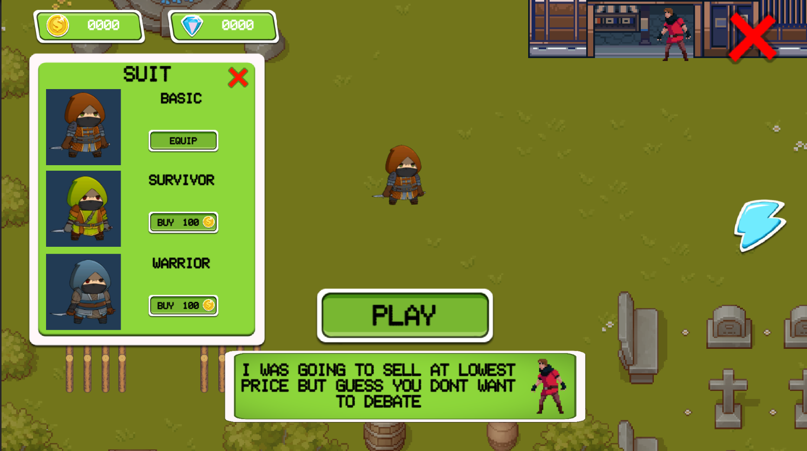

## **Game Code**

There is a script Folder in the Main Asset Folder which contain all the scripts that are made during the development process & each of the scripts are made from scratch. Means none of the code is copied or took from any reference or Internet.

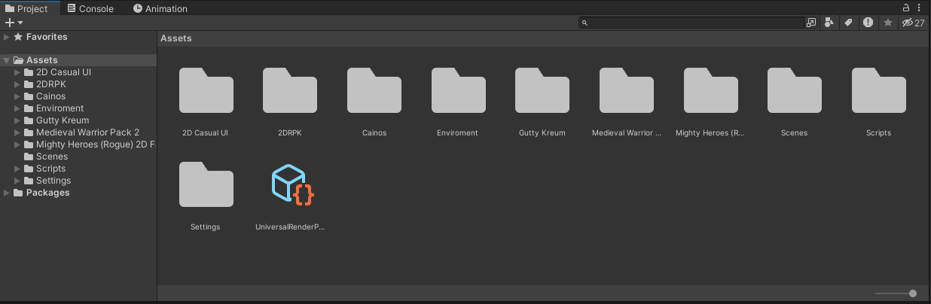

## **Thought Process**

* 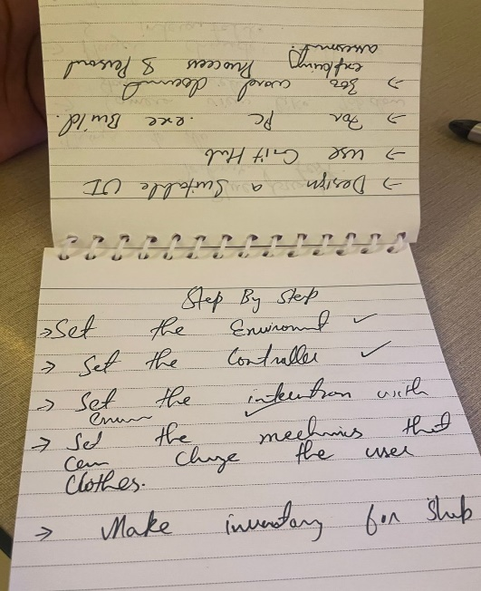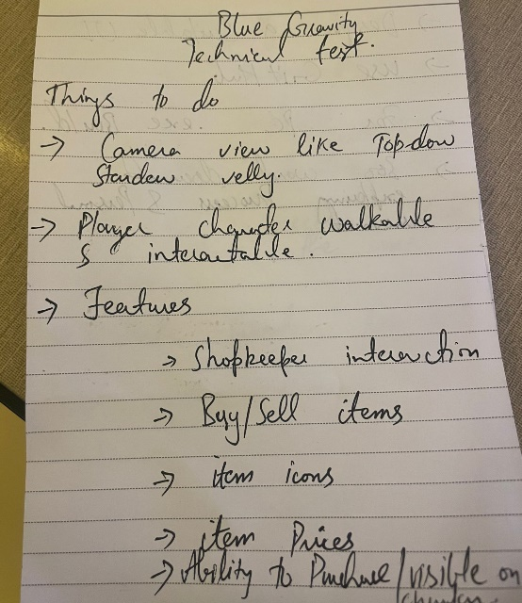**Things I Do Before Development**I firstly note all the things that are need to be done in the task. Like what are the required features, what I’ll need during development, how should be game flow along with the game environment design.  
  Then I move towards writing down the task step by step. Like what I’m going to do first & then afterwards and then I Check the task when it is completed. It helps me being motivated during the development process & not go black after completing a single task that what I need to do next.  
  I also write down the Code Development process too that how I’m going to code how much Scripts do I need & where do I need the script along with what I’m going to write in the scripts too.  
   Ref are shown Below

**Personal Assessment**

I participated in Development of a 2D game task. Being good in analyzing what I need to do in the development process helps me boost my work & meet deadlines resulting in a more than above average product. I would have done a lot better if the whole game design & assets were provided as I would have only focused on the gameplay development not on how the game should look & would have given the results in lesser time. But still I think there are areas of improvement from my side too as Code would have been more generic. But still we can add multiple players along with it we can also add more clothes that can be customized on the player in that same code. I would rate myself 7/10. I can go 10/10 with the proper game design document & game assets.

Game Link:

<https://github.com/HaiderBuzdar/Blue-Gravity-Interview-Task1/tree/main>

<https://drive.google.com/file/d/1TnzG5-J7xy1TuP-xWBbgxZO3WjUW1Xvt/view?usp=drive_link>