National University of Computer and Emerging Sciences Chiniot-Faisalabad Campus



**Industrial Project Management**

### Software Requirements Specification (SRS)

### Semester Project

### WEB

### BS (SE) 6A

## Team Name: Under Taker

## Team Member’s:

## 21F-9516 -> Suresh Kumar

## 21F-9519-> Rai Umer

## 21F-9409-> Syed Haider

1. Introduction

The Industrial Project Management system aims to streamline the process of managing industrial projects, including project proposals, company registrations, project approvals, and project categorization. This document outlines the requirements for the system based on the identified modules and contributors.

2. Overall Description

2.1 Product Perspective

The system will serve as a centralized platform for users to register companies, submit project proposals, view available industrial projects, and manage project approvals. It will interact with users through a web-based interface and store data in a secure database.

2.2 User Classes and Characteristics

• Admin: Responsible for managing user accounts, reviewing and approving projects.

• Student: Submits project proposals and views available industrial projects.

• User: Registers companies and manages project details.

2.3 Operating Environment

The system will be deployed on a web server and accessible through modern web browsers. It will require a stable internet connection for users to interact with the platform.

3. Specific Requirements

3.1 Admin Module (Contributor: Haider Ali - 21F-9409)

• Responsibilities:

• Implement user account management functionalities.

• Develop project approval and categorization features.

• Contributions:

• Haider Ali will be responsible for implementing the admin module, including user account management, project approval workflows, and project categorization functionalities.

3.2 User Module (Contributor: Rai Umer - 21F-9519)

• Responsibilities:

• Develop company registration functionality.

• Implement project management features for users.

• Contributions:

• Rai Umer will be responsible for implementing the user module, which includes developing the company registration process and providing project management capabilities for users.

3.3 Student Module (Contributor: Suresh Kumar - 21F-9516)

• Responsibilities:

• Develop industrial project viewing functionality for students.

• Implement project proposal submission features.

• Contributions:

• Suresh Kumar will be responsible for implementing the student module, including developing the functionality for students to view available industrial projects and submit project proposals.

## Architecture Diagram: -

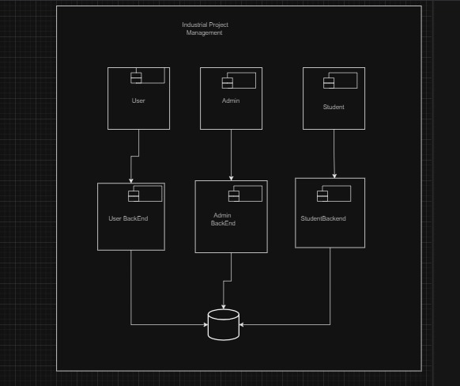

## Package Diagram: -

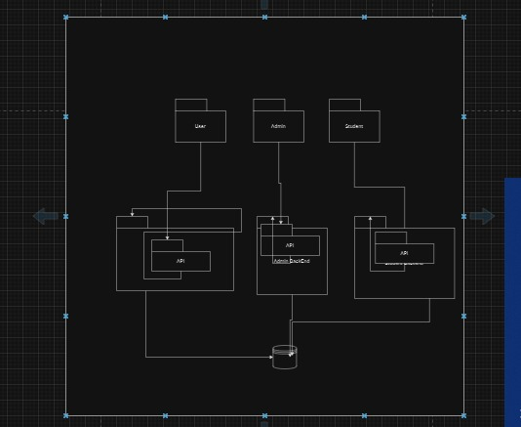

## ER Diagram: -