# Capstone Project - Analysis on Milan's Neighborhood

## Introduction: Business Problem

Milan is Italy’s city of the future, a fast-paced metropolis where money talks, creativity is big business and looking good is an art form. Internationally recognised as one of the world’s most important fashion capitals, but it also has a wealth of interesting museums and things to see and do

The objective of this project is to analyze and select the best locations in the city of Milan, what are the most prominent restaurants for potential stakeholders

## Data

to perform this analysis, we will need the following data:

* List of the neighborhoods in Milan
* Geo-coordinates of the neighbordhoods in Milan
* Top venues by neighborhoods

List of the neighbordhoods, populatio nwill be obtained from **Milan data portal** where all sort of demographic and territorial information about the city are stored. Venues data will be obtained from **Foursquare through an API**.  
Geo-coordinates of districts will be obtained with the help of the **geocoder tool in the notebook**.

## Methodology

In this project we will direct our efforts on detecting areas of Milan that have restaurants and find what kind of restaurants

In first step we have collected the required **data: location and type (category) of every restaurant within**. We have also **identified estaurants** (according to Foursquare categorization).

Second step in our analysis will be calculation and exploration of '**restaurant across** different areas of Milan..

In third and final step we will focus on creating **clusters of locations that meet some basic requirements**. We will present map of all such locations but also create clusters (using **k-means clustering**) of those locations to identify general zones / neighborhoods .

## Analysis

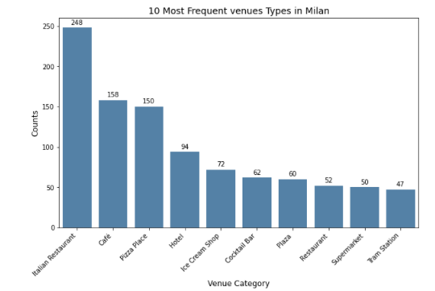

As we can see **Italian Restaurant** is the most frequent type of venue in Milan Followed by **coffe shop, pizza place, hotel and ice cream.**

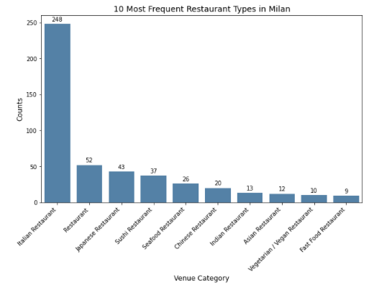

After **italian restaurant the most prelevant are japanese, seafood and chinese** even tho compared to italian restaurant they only amount to a small percentage.

## 

## Results and Discussion

Our analysis shows that although there is a great number of restaurants in Milan, cluster 1 and 2 have the highest concentration of restaurants, which is not surprising since that is the center of Milan and nearby wih Most of the restaurants offer Italian cuisine. Cluster 2 most common restaurant is Italian followed by predominantly African restaurants. Cluster 1 has the most variaety.

## Conclusion

Purpose of this project was to identify what kind of restaurants are present in Milan. By calculating restaurant density distribution from Foursquare data we have first identified general boroughs and then generated extensive collection of locations which satisfy some basic requirements regarding existing nearby restaurants. Clustering of those locations was then performed in order to further understand the data.

This was just a general analysis that can be taken to gain further insight by performing a deeper analysis on the data to recommend a restaurant, to find a place for stakeholders to build one etc.