**Sp21-bse-007 Eman Waheed**

**Use case UC1: View Product**

**Brief use case:**

In this use case, both customers and visitors will be able to view the recommended product. They will be able to see every detail of the desired product, including its quality, usage instructions, and so on, by viewing it. Its detail may also include product price, category, and size if required.

**Fully addressed use case:**

|  |  |
| --- | --- |
| Use case name | View Product |
| Scope | Infinity boutique |
| Level | User goal |
| Primary actor | Customer, Visitor |
| Stakeholder and interest | * Visitor: want to view the product and must register if he/she wants to order it. * Customer: want to view the product of their choice and wants to know about the product details. |
| Precondition | * The user must visit the official website to view the product * The user must have a stable internet connection. |
| Success guarantee (post condition) | The user after viewing the product can add it to cart if they wish to order it. |
| Main success scenario | 1. The user will visit the official website.  2. The user will click on the product to view it.  3. The product details of the product will be visible to the user. |
| Exception | * If the user is not able to view the product, then he/she should refresh the page. * The user should be re-visiting the website. |
| Special requirement | If the product is not viewed, then the system will immediately show the message of refresh the page. |
| Technology and data variation list | * The name of the product should be entered by the keyboard. * The programming language used is java. * The interface is designed using NetBeans. |
| Frequency of occurrence | This will occur multiple times as the user wants to view different products. |
| Miscellaneous | Can the customer directly view the products without visiting the official website? |

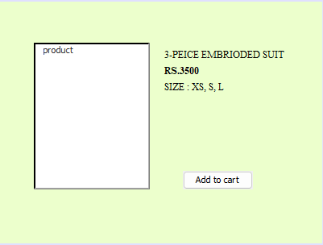

**Sequence Diagram of View Product:**

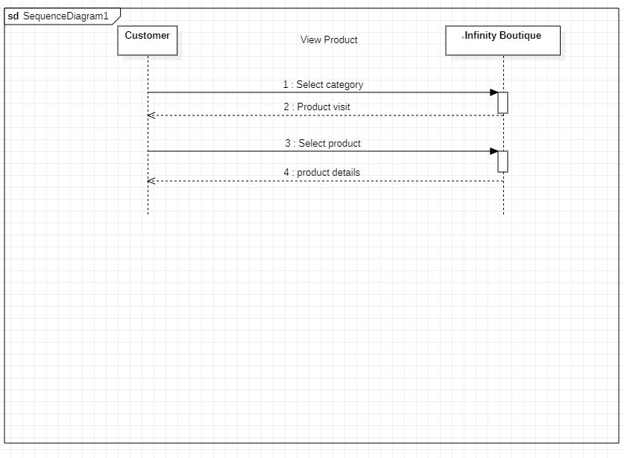

**Operation Contract:**

**Contract Co 1:**

|  |  |
| --- | --- |
| Operation | Select Category |
| Cross Reference | Use Case: View Product |
| Pre-Condition | Visit the official website  Explore the page |
| Post Condition | The product description will be available |

**Use case UC2: Search Product**

**Brief use case:**

If the user can't find their desired product on the main page, they can click on the search panel and search for the specific product that they desire. This use case helps them to find the product of their choice.

**Fully addressed use case:**

|  |  |
| --- | --- |
| Use case name | Search Product |
| Scope | Infinity boutique |
| Level | User goal |
| Primary actor | Customer, Visitor |
| Stakeholder and interest | * Visitor: want to search the product in the infinity boutique system. * Customer: want to search the product in the infinity boutique system. |
| Precondition | * The user must visit the official website to search the product * The user must have a stable internet connection. |
| Success guarantee (post condition) | The user can view the desired searched product.  The user can add the product to the cart. |
| Main success scenario | 1. The user will visit the official website. 2. The user will click on the search bar. 3. The user will search for the product of their choice. 4. The user can view the product |
| Exception | *A. At any time when the search bar is not proper functioning:   * The user will find the product from the categories. |
| Special requirement | It should take less than 10 characters.  Both upper and lower-case characters can be used.  There should be no numerical value. |
| Technology and data variation list | * The name of the product should be entered by the keyboard. * The programming language used is java. * The interface is designed using NetBeans. |
| Frequency of occurrence | * It will be continuous as multiple users will be searching for different products. |
| Miscellaneous | Can users search for the product by its bar code or just by its name?  Is the search bar functional or not. |

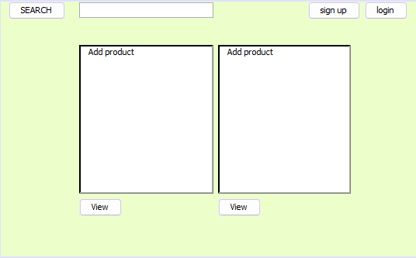

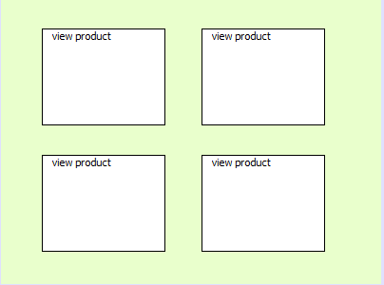

**Sequence Diagram of Search Product:**

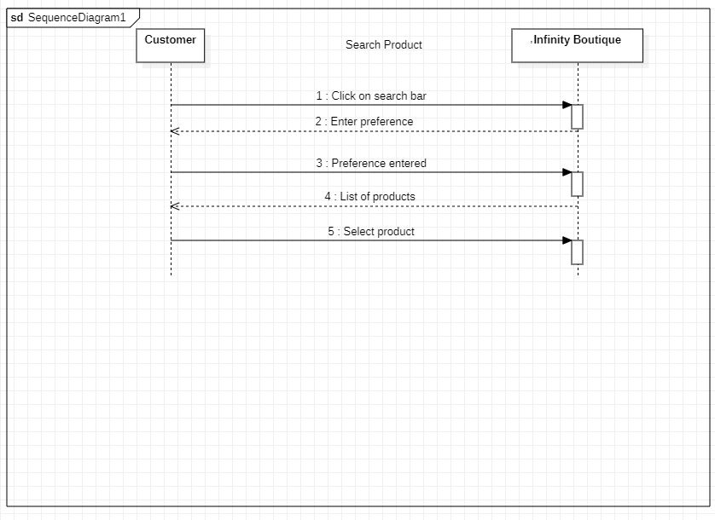

**Operations Contract:**

**Contract Co 2: Click Search Bar**

|  |  |
| --- | --- |
| Operation | Click Searchbar |
| Cross Reference | Use case: Search Product |
| Pre-Condition | Visit the Official Website |
| Post Condition | The specific product will be visible to the customer |