**Hololens_RaspberryPi Project**

Hololens Client Application Design Prototype

* Name: HoloPi
* Version: V1_Release

Basic work flow:

1. 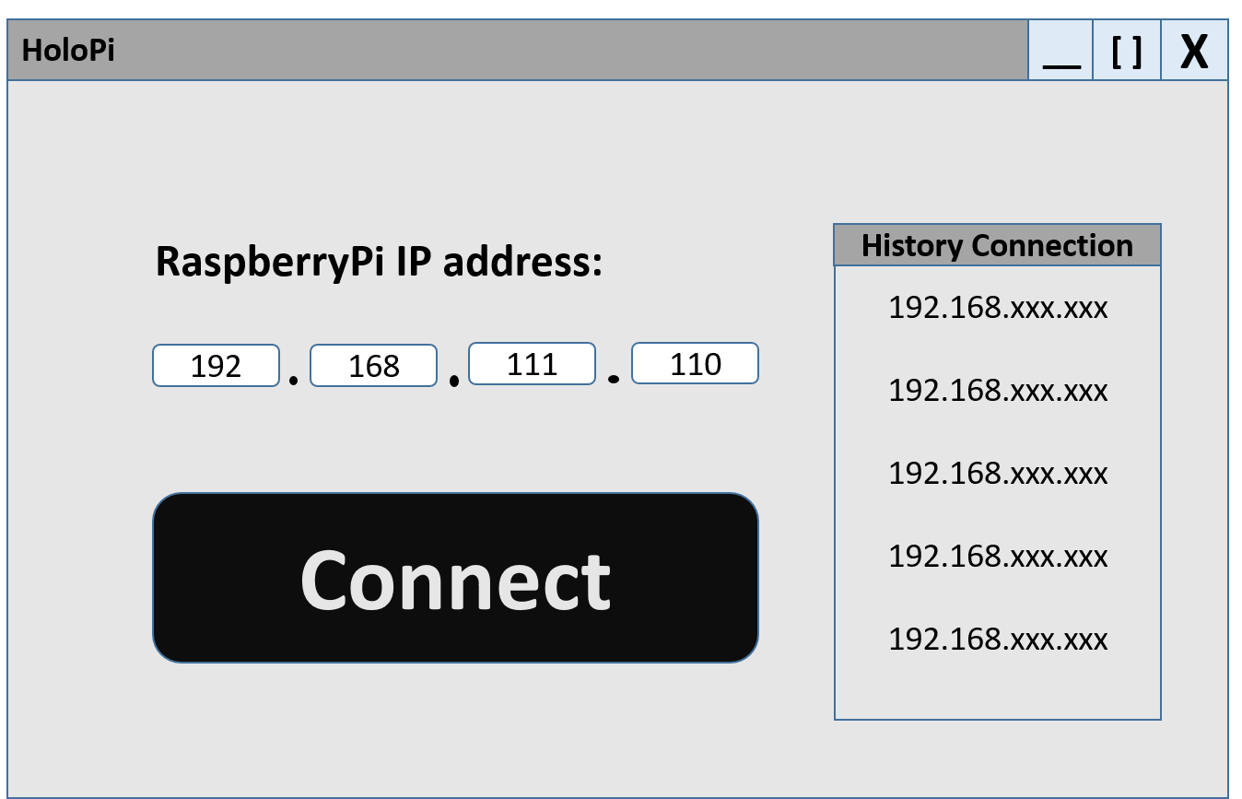Launch the application ‘HoloPi’ on Hololens Device, and get into this page

Now you have two choices, either enter a new Raspberry Pi IP address or choose one of your history IP addresses.

Notice: only five history IP addresses will be stored in the list, so the new one will be pushed into the list and the oldest will be popped out permanently.

After that, click on ‘Connect’ button to trigger the next step.

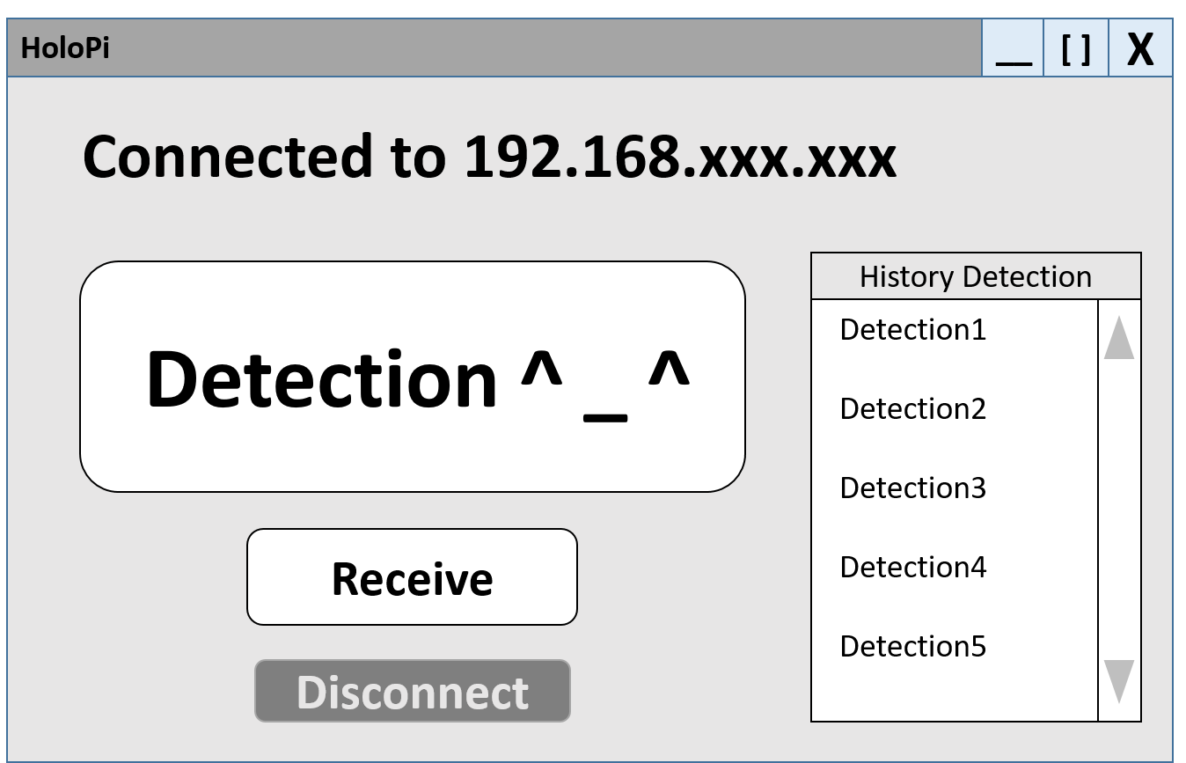

1. After you click on the ‘Connect’ button, the application will try to send an empty request to the web server published on Raspberry Pi device (which owns the IP address you chose on step 1) to verify the connection. If everything goes right, you are guided to the next page.

And on this page, simply click on ‘Detection’ button to start the following events:

* First, after clicking the ‘Detection’ button, you will be asked to take a picture using Hololens Camera;
* Second, the photo you took will be sent automatically to the Raspberry Pi for further processing.
* Third, the response will be sent back to your Hololens after the processing is done on Raspberry Pi device. And you will see the detection result on the next page:

Or, you can select one of your history detections to review the results.

Or, you can click on the ‘Receive’ button and it triggers following:

* First, it checks the storage of Raspberry Pi to see if there’s any shared items left to be received.
* Second, if shared items do exist on Raspberry Pi, a Receiving Page will be popped up to let you see all those shared items stored on Raspberry Pi. Once you have received, those shared items would be no longer available as they are deleted for good.
* If no shared items are available on Raspberry Pi, you will see a message that says: “nothing to receive”.

Or, you can click the ‘Disconnect’ button to terminate your current connection and go back to the launching page you see on step 1.

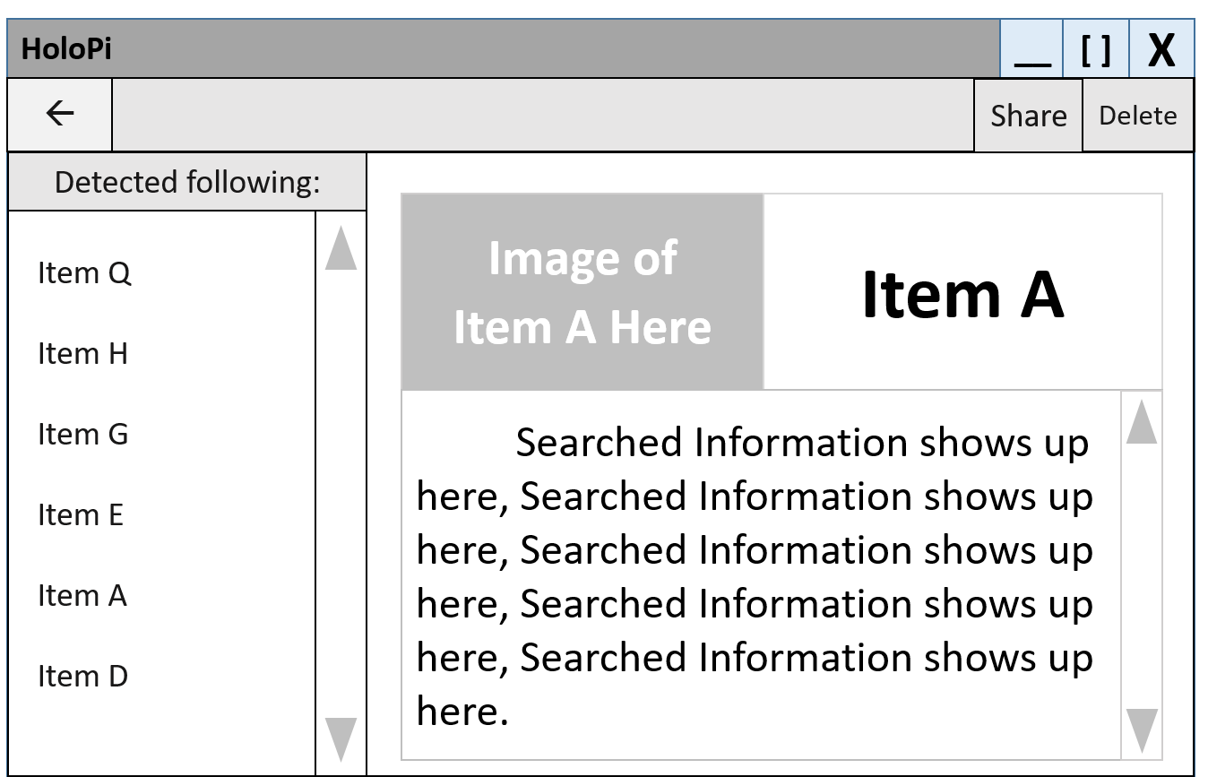

1. On this page, you are able to the following things:

* **Browse the information of those detected items from the image you took before.**

On the left column, detected items are listed and when you choose a particular one, on the right side of this page, all information of that item will show up including the image, a title and brief introduction text.

* **Delete a chosen item and corresponding information from local application data.**

By clicking on the Delete command on the top right side of the page, you can delete the current showing item and it will no more shows up in this page.

* **Share the results with other users who are also running ‘HoloPi’ on their Hololens.**

By clicking the ‘Share’ command on the top right side of the page, you are able to either the whole results or one specific detected item result to other users.

* **Go back to the previous page to start a new detection mission.**

You are also able to go back to the previous page and do things that you can on that page.

1. If you click on ‘Receive’ button and get a positive response from Raspberry Pi, you will see the following page:

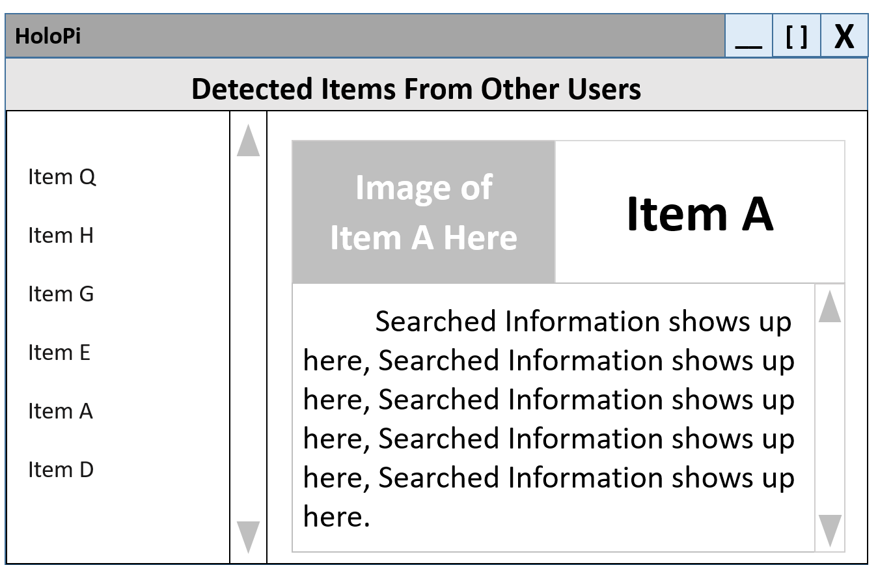

On this page, you can explore all shared items sent by others but that’s it, you can do nothing but browse the information of these stuff. Once you have finished reading, close it.