## Compiling FAST v8 using gfortran for Windows

The makefile in the FAST/Compiling folder can be used to compile FAST v8 using gfortran. This script was tested using MinGW32-make with gcc version 4.6.2.

## LAPACK routines

FAST v8 uses some LAPACK routines (<http://www.netlib.org/lapack/index.html>). We have made the decision to link with prebuilt libraries, which should include highly optimized versions of the Basic Linear Algebra Subprograms (BLAS).

These prebuilt libraries (typically?) come installed on Linux and Mac operating systems. They are also available as part of the Math Kernel Library (MKL) that comes with Intel Fortran compilers[1].

gfortran (gcc) for Windows will require you to download the LAPACK and BLAS binary files, which you can get here: <http://icl.cs.utk.edu/lapack-for-windows/index.html>. For 32-bit Windows, you will need these files[2]:

* <http://icl.cs.utk.edu/lapack-for-windows/libraries/VisualStudio/3.5.0/Dynamic-MINGW/Win32/liblapack.dll>
* <http://icl.cs.utk.edu/lapack-for-windows/libraries/VisualStudio/3.5.0/Dynamic-MINGW/Win32/liblapack.lib>
* <http://icl.cs.utk.edu/lapack-for-windows/libraries/VisualStudio/3.5.0/Dynamic-MINGW/Win32/libblas.dll>
* <http://icl.cs.utk.edu/lapack-for-windows/libraries/VisualStudio/3.5.0/Dynamic-MINGW/Win32/libblas.lib>

When you use gfortran for Windows, you will need to make sure these .dll files are on your Windows PATH so that the executables will run.

To use the LAPACK and BLAS libraries in gfortran, use linking options –llapack and –lblas. (if you are having trouble, this web site may also provide some useful information: <http://www.math.utah.edu/software/lapack.html>)

To use the MKL in Intel, you will need to set *Project* -> {project name} *Properties* -> *Configuration* *Properties* -> *Fortran* -> *Libraries* -> *Use Intel Math Kernel Library* to **Sequential (/Qmkl:sequential)**.

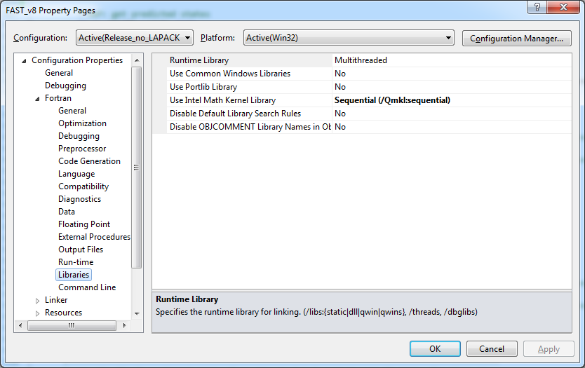

## Compiling in Double Precision

To compile FAST in double precision:

* Use the DoubPrec.f90 file instead of SingPrec.f90 from the NWTC Subroutine Library.
* If you are using the FFTpack routines, you will also need to set the default Real and Double KINDs to 8 and 16 bytes, respectively. (Default REAL must be the same as ReKi and Default Double must be the same as DbKi.)

### LAPACK in Double Precision

To facilitate compiling in double precision, we have created some wrapper routines in for the LAPACK and ScaLAPACK routines used in FAST and its modules.

*The NWTC wrapper routines for LAPACK have been written assuming that they are calling prebuilt libraries*. If you choose to compile with the LAPACK source files instead of using the prebuilt libraries (not recommended), you must make sure that default Real and Double KINDs for the LAPACK routines are 4 and 8 bytes, respectively.

1. Some older versions of Intel Fortran may not include MKL. However, you can find LAPACK binaries that work with Intel on Windows on the web, too. See this site for instructions: <http://icl.cs.utk.edu/lapack-for-windows/index.html>.
2. At the time of this writing, the web site had typos in the links for liblapack.dll and liblapack.lib; use the links listed here.