Compiling FAST v8.10.00a-bjj

Bonnie Jonkman  
National Renewable Energy Laboratory  
March 31, 2015

# Introduction

FAST v8.10.00a-bjj is distributed with executables of both 32-bit and 64-bit Windows applications. Unless you are compiling for a different architecture or are adding functionality to FAST, you should not have to recompile the code.

FAST v8.10.00a-bjj is distributed with several options for compiling the source code. It contains a Visual Studio project file, a Windows® batch file for Intel Fortran, and a makefile for gfortran. The FAST archive contains all of the source files necessary to compile, and the compiling tools are set up with the correct paths to those files. The tools also set up all the compiling options required to compile FAST.

Figure 1. Source Files in the FAST v8.10.00 Visual Studio Project

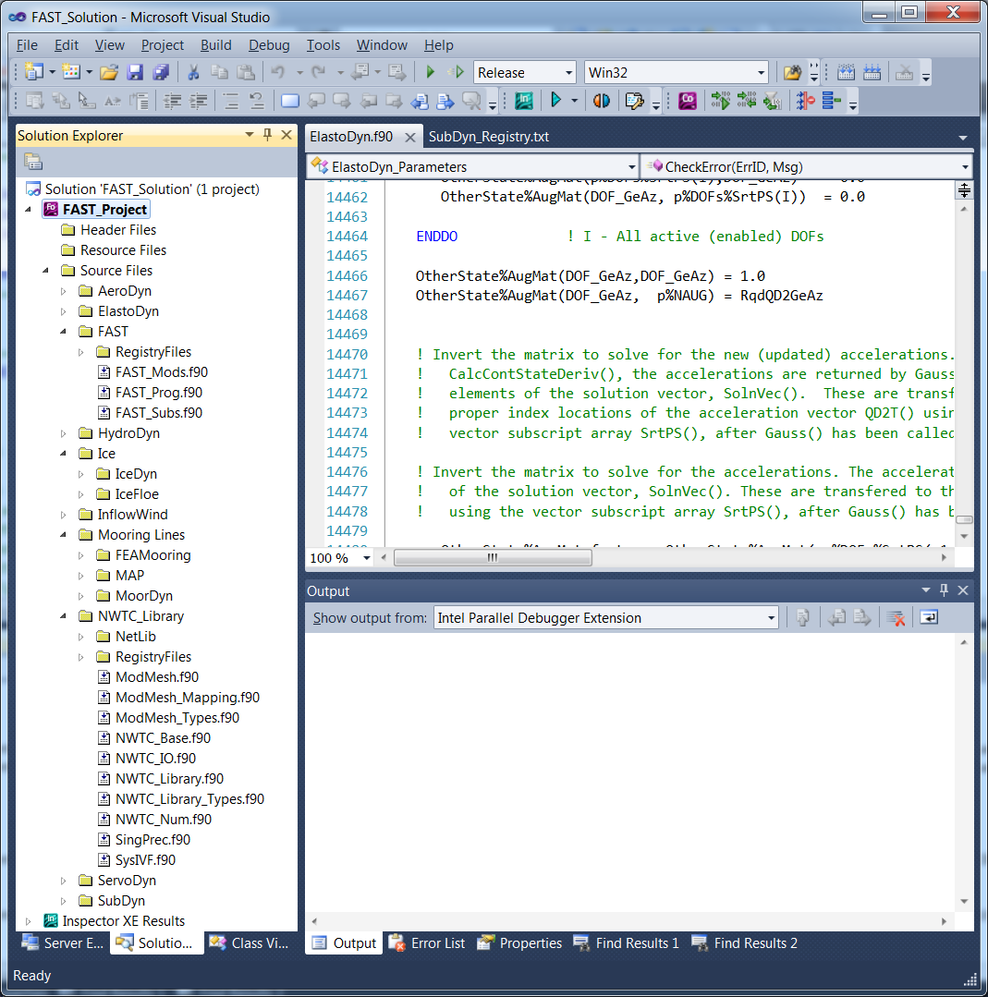

The compiling tools distributed with FAST v8.10.00a-bjj were created for Windows® systems. However, they can be adapted for use on non-Windows® systems. Please see “Compiling on Linux or Mac” at the end of this document for some suggestions.

We have developed these instructions with the following two compilers:

* Intel® Visual Fortran (IVF) Composer XE 2011, version 12.1.3.300  
  Intel Math Kernel Library (MKL) 10.3 Update 9  
  Microsoft Visual Studio 2010 Shell
* gfortran/gcc version 4.6.2  
  mingw32

# Compiling with Intel Fortran in Visual Studio

Open “FAST_Project.vfproj” in the Compiling\VisualStudio directory of the FAST v8 archive. This should open a Solution Explorer window that lists all of the source files and Registry input files for FAST v8. See Figure 1.

Choose either Debug or Release configuration from the Configuration manager (Debug is the default), and then select “Build Solution” from the “Build” menu. This will run the FAST Registry to produce the *_Types.f90 files needed in the project and then will compile and link the project. When it has successfully completed, it will place an executable called “FAST_dev_Win32.exe” (Release mode) or “FAST_dev_debug_Win32.exe” (Debug mode) in the <FAST v8>\bin folder. (Note that if you are using Visual Studio 2013 or newer, the executable might be placed in the <FAST8>\Compiling\VisualStudio folder. This is a result of differences in formats between Visual Studio 2010 and 2013).

When you compile the first time, a box will probably pop up to ask you to save the solution file. Select “ok” to save the solution file in the same directory as your project file.

Note that sometimes the Registry will create a *_Types.f90 file that does not get compiled when building the solution. If that happens, you will need to select “Build Solution” a second time, so the *_Types.f90 file will compile.

Note that this solution requires that you have the Intel® Math Kernel Library (MKL) to access LAPACK routines. MKL comes with newer versions of Intel® Visual Fortran (IVF), however some old versions of IVF required a separate license for MKL. If you have the Intel compiler without access to MKL, see the instructions at this web site: <http://icl.cs.utk.edu/lapack-for-windows/lapack/> for help in installing LAPACK and BLAS libraries for Release and Debug modes.

# Compiling with Intel Fortran from a Windows Command Prompt

FAST is distributed with a batch file called “Compile_FAST.bat” that will compile the code using Intel Visual Fortran (IVF) from the command line. However, if you are using IVF for Windows, we recommend using Visual Studio instead of the command prompt to compile.

Before using Compile_FAST.bat, either you must modify variables in the section labeled “set compiler internal variables” or you must run Compile_FAST.bat *only* from the compiler’s command prompt window.

## Setting Compiler Environment Variables

In the “Set Compiler Internal Variables” section of the batch script, you make sure that the proper paths and environment variables are set for the compiler and linker. If this step is not done correctly, you will not be able to build the executable. The **blue** text shown in Figure 2 (copied from Compile_FAST.bat) must be changed to reflect your compiler.

REM ----------------------------------------------------------------------------

REM set compiler internal variables

REM ----------------------------------------------------------------------------

REM You can run this bat file from the IVF compiler's command prompt (and not

REM do anything in this section). If you choose not to run from the IVF command

REM prompt, you must call the compiler's script to set internal variables.

REM TIP: Right click on the IVF Compiler's Command Prompt shortcut, click

REM properties, and copy the target (without cmd.exe and/or its switches) here:

CALL **"C:\Program Files (x86)\Intel\Composer XE 2011 SP1\bin\ipsxe-comp-vars.bat" ia32 vs2010**

REM ----------------------------------------------------------------------------

REM -------------------- LOCAL VARIABLES ---------------------------------------

REM ----------------------------------------------------------------------------

SET ROOT_NAME=FAST

SET COMPOPTS=/threads /O2 /inline:speed /traceback /Qzero /Qsave /real_size:32 /assume:byterecl

SET LINKOPTS=/link

REM ----------------------------------------------------------------------------

REM ------------------------- LOCAL PATHS --------------------------------------

REM ----------------------------------------------------------------------------

REM -- USERS WILL NEED TO EDIT THESE PATHS TO POINT TO FOLDERS ON THEIR LOCAL --

REM -- MACHINES. NOTE: do not use quotation marks around the path names!!!! ---

REM ----------------------------------------------------------------------------

REM NWTC_Lib_Loc is the location of the NWTC subroutine library files

REM AeroDyn_Loc is the location of the AeroDyn source files

REM Wind_Loc is the location of the AeroDyn wind inflow source files

REM FAST_LOC is the location of the FAST source files

REM ----------------------------------------------------------------------------

SET NWTC_Lib_Loc=C:\Users\bjonkman\Data\DesignCodes\NWTC Library\source

SET AeroDyn_Loc=C:\Users\bjonkman\Data\DesignCodes\AeroDyn\Source

SET Wind_Loc=C:\Users\bjonkman\Data\DesignCodes\AeroDyn\Source\InflowWind\Source

SET FAST_Loc=C:\Users\bjonkman\Data\DesignCodes\FAST\Source

REM SET NWTC_Lib_Loc=D:\DATA\DesignCodes\miscellaneous\nwtc_subs\SVNdirectory\source

REM SET AeroDyn_Loc=D:\DATA\DesignCodes\simulators\AeroDyn\SVNdirectory\trunk\Source

REM SET Wind_Loc=D:\DATA\DesignCodes\simulators\AeroDyn\SVNdirectory\trunk\Source\InflowWind\Source

REM SET FAST_Loc=D:\DATA\DesignCodes\simulators\FAST\SVNdirectory\trunk\Source

REM ----------------------------------------------------------------------------

REM -------------------- LIST OF ALL SOURCE FILES ------------------------------

REM ----------------------------------------------------------------------------

SET NWTC_Files=

SET NWTC_Files=%NWTC_Files% "%NWTC_Lib_Loc%\SingPrec.f90"

SET NWTC_Files=%NWTC_Files% "%NWTC_Lib_Loc%\SysIVF.f90"

SET NWTC_Files=%NWTC_Files% "%NWTC_Lib_Loc%\NWTC_IO.f90"

SET NWTC_Files=%NWTC_Files% "%NWTC_Lib_Loc%\NWTC_Num.f90"

SET NWTC_Files=%NWTC_Files% "%NWTC_Lib_Loc%\NWTC_Aero.f90"

SET NWTC_Files=%NWTC_Files% "%NWTC_Lib_Loc%\NWTC_Library.f90"

SET Wind_Files=

SET Wind_Files=%Wind_Files% "%Wind_Loc%\SharedInflowDefs.f90"

SET Wind_Files=%Wind_Files% "%Wind_Loc%\HHWind.f90"

SET Wind_Files=%Wind_Files% "%Wind_Loc%\FFWind.f90"

SET Wind_Files=%Wind_Files% "%Wind_Loc%\HAWCWind.f90"

SET Wind_Files=%Wind_Files% "%Wind_Loc%\FDWind.f90"

SET Wind_Files=%Wind_Files% "%Wind_Loc%\CTWind.f90"

SET Wind_Files=%Wind_Files% "%Wind_Loc%\UserWind.f90"

SET Wind_Files=%Wind_Files% "%Wind_Loc%\InflowWindMod.f90"

SET AeroDyn_Files=

SET AeroDyn_Files=%AeroDyn_Files% "%AeroDyn_Loc%\SharedTypes.f90"

SET AeroDyn_Files=%AeroDyn_Files% "%AeroDyn_Loc%\AeroMods.f90"

SET AeroDyn_Files=%AeroDyn_Files% "%AeroDyn_Loc%\GenSubs.f90"

SET AeroDyn_Files=%AeroDyn_Files% "%AeroDyn_Loc%\AeroSubs.f90"

SET AeroDyn_Files=%AeroDyn_Files% "%AeroDyn_Loc%\AeroDyn.f90"

SET FAST_Files=

SET FAST_Files=%FAST_Files% "%FAST_LOC%\fftpack.f"

SET FAST_Files=%FAST_Files% "%FAST_LOC%\FFTMod.f90"

SET FAST_Files=%FAST_Files% "%FAST_LOC%\HydroCalc.f90"

SET FAST_Files=%FAST_Files% "%FAST_LOC%\FAST_Mods.f90"

SET FAST_Files=%FAST_Files% "%FAST_LOC%\Noise.f90"

SET FAST_Files=%FAST_Files% "%FAST_LOC%\FAST_IO.f90"

SET FAST_Files=%FAST_Files% "%FAST_LOC%\FAST.f90"

SET FAST_Files=%FAST_Files% "%FAST_LOC%\FAST_Lin.f90"

SET FAST_Files=%FAST_Files% "%FAST_LOC%\FAST2ADAMS.f90"

IF /I "%1"=="DLL" GOTO dllFiles

SET FAST_Files=%FAST_Files% "%FAST_LOC%\PitchCntrl_ACH.f90"

SET FAST_Files=%FAST_Files% "%FAST_LOC%\UserSubs.f90"

SET FAST_Files=%FAST_Files% "%FAST_LOC%\UserVSCont_KP.f90"

GOTO endFASTfiles

:dllFiles

SET FAST_Files=%FAST_Files% "%FAST_LOC%\BladedDLLInterface.f90"

SET FAST_Files=%FAST_Files% "%FAST_LOC%\UserSubs_forBladedDLL.f90"

SET FAST_Files=%FAST_Files% "%FAST_LOC%\UserVSCont_KP_forBladedDLL.f90"

REM NOTE: UserSubs_forBladedDLL.f90 is a copy of UserSubs.f90 with SUBROUTINES UserHSSBr() and UserYawCont() commented out

REM UserVSCont_KP_forBladedDLL.f90 is a copy of UserVSCont_KP.f90 with SUBROUTINE UserVSCont() commented out

SET ROOT_NAME=%ROOT_NAME%_DLL

:endFASTfiles

SET FAST_Files=%FAST_Files% "%FAST_LOC%\AeroCalc.f90"

SET FAST_Files=%FAST_Files% "%FAST_LOC%\SetVersion.f90"

SET FAST_Files=%FAST_Files% "%FAST_LOC%\FAST_Prog.f90"

:ivf

REM ----------------------------------------------------------------------------

REM ---------------- COMPILE WITH INTEL VISUAL FORTRAN -------------------------

REM ----------------------------------------------------------------------------

REM compile

ECHO.

ECHO Compiling FAST, AeroDyn, and NWTC_Library routines to create %ROOT_NAME%.exe:

ifort %COMPOPTS% %NWTC_Files% %Wind_Files% %AeroDyn_Files% %FAST_Files% %LINKOPTS% /out:%ROOT_NAME%.exe

:end

REM ----------------------------------------------------------------------------

REM ------------------------- CLEAR MEMORY -------------------------------------

REM ------------- and delete all .mod and .obj files ---------------------------

REM ----------------------------------------------------------------------------

ECHO

DEL *.mod

DEL *.obj

SET ROOT_NAME=

SET COPTS=

SET NWTC_Files=

SET Wind_Files=

SET AeroDyn_Files=

SET FAST_Files=

SET A2AD_Files=

SET Fixed_Files=

SET NWTC_Lib_Loc=

SET Wind_Loc=

SET AeroDyn_Loc=

SET A2AD_Loc=

SET FAST_Loc=

SET COMPOPTS=

SET LINKOPTS=

Figure . The "Set Compiler Internal Variables section of Compile_FAST.bat

One way to find this command is to open the shortcut to the IVF command prompt (also called IVF Build Environment in some versions). You can usually find the shortcut at a location named something like **Start** **>** **All Programs** **>** **Intel** *CompilerName* **>** *CommandPromptName*. (Different versions of the compiler may have more submenus.) Note that if the shortcut says “non-compilation mode”, then you likely have a version of Visual Studio without the Intel Fortran integrations installed. You need to have the integrated product for this script to work.

Right click on the shortcut to the command prompt and click “Properties.” (See Figure 3 for an example.) A window similar to Figure 4 will open.

Copy the text from the Shortcut’s “Target” field and paste it in the Compile_FAST.bat script:

C:\Windows\SysWOW64\cmd.exe /E:ON /V:ON /K ""C:\Program Files (x86)\Intel\Composer XE 2011 SP1\bin\ipsxe-comp-vars.bat" ia32 vs2010"

You will need to remove the call to cmd.exe and its switches, leaving you with the name of a batch file (and possibly some of its arguments):

"C:\Program Files (x86)\Intel\Composer XE 2011 SP1\bin\ipsxe-comp-vars.bat" ia32 vs2010

If you do not want to call this batch file from Compile_FAST.bat, you may remove the line from the file. However, you must then run Compile_FAST.bat *only* from the compiler’s command line window. Please refer to your compiler’s documentation about using **ifort** and calling it from the command line.

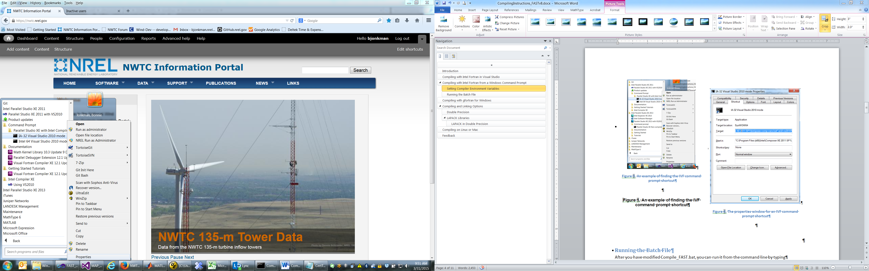

Figure 3. An example of finding the IVF command prompt shortcut

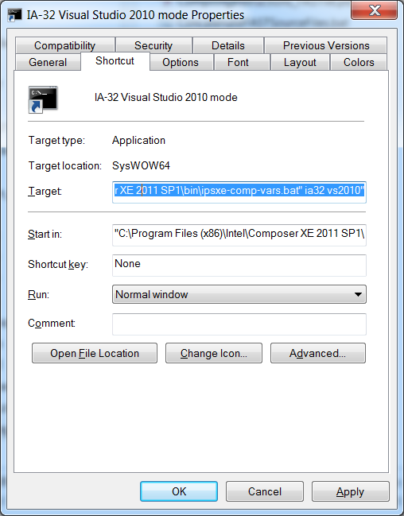

Figure 4. The properties window for an IVF command prompt shortcut

## Running the Batch File

After you have modified Compile_FAST.bat, you can run it from the command line by typing

Compile_FAST.bat

in the directory where the batch file is stored. Figure 5 shows the screen output after a successful build using Intel® Composer XE 2011. Notice the title of the command window after Compile_FAST.bat has been run. The script that you call in the “Set Compiler Internal Variables” section to set the paths and environment variables for the IVF compiler also modifies the title of the window. **If the title does not say anything about the compiler and Visual Studio versions, please verify that you have modified Compile_FAST.bat correctly.**

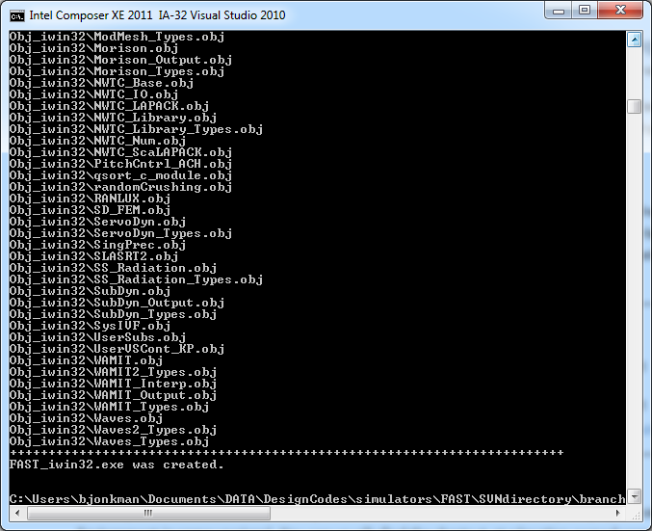

Figure . Screen output from Compile_FAST.bat. (Note that the title of the command window indicates that the batch script to set the compiler and linker paths was successfully run)

# Compiling with gfortran for Windows

The makefile in the FAST\Compiling folder can be used to compile FAST v8 using gfortran.

gfortran (gcc) for Windows will require you to download the LAPACK and BLAS binary files, which you can get here: <http://icl.cs.utk.edu/lapack-for-windows/index.html>. For 32-bit Windows, you will need these files[1]:

* <http://icl.cs.utk.edu/lapack-for-windows/libraries/VisualStudio/3.5.0/Dynamic-MINGW/Win32/liblapack.dll>
* <http://icl.cs.utk.edu/lapack-for-windows/libraries/VisualStudio/3.5.0/Dynamic-MINGW/Win32/liblapack.lib>
* <http://icl.cs.utk.edu/lapack-for-windows/libraries/VisualStudio/3.5.0/Dynamic-MINGW/Win32/libblas.dll>
* <http://icl.cs.utk.edu/lapack-for-windows/libraries/VisualStudio/3.5.0/Dynamic-MINGW/Win32/libblas.lib>

When you use gfortran for Windows, you will need to make sure these .dll files are on your Windows PATH so that the executables will run. The .lib files are required for linking.

To use the LAPACK and BLAS libraries in gfortran, use linking options –llapack and –lblas. (if you are having trouble, this web site may also provide some useful information: <http://www.math.utah.edu/software/lapack.html>)

# Compiling and Linking Options

**The options required to compile and link FAST v8.10.00a-bjj are already set in the compiling tools distributed with the code.** However, it is sometimes useful to modify the options for debugging or other purposes.

Table 1 lists several useful compiling options. The first column of the table indicates which options are required to compile FAST.

We also require some additional linking options:

* You must link with the MAP library. On Windows, this means adding MAP_Win32.lib (or MAP_x64.lib) to the linking command. On non-Windows machines, this means adding MAP_{OS name}.so to the linking command.
* SubDyn places some large matrices on the stack, and we have found that on Win32 systems, we sometimes need to increase the stack reserve size. The command option is:  
  /STACK:999999999 (IVF)  
  -Wl,--stack=999999999 (gfortran)
* Also on some large models (e.g., OC4 Jacket), we can exceed the 2-GB Windows memory limit for 32-bit processes. We can extend this limit when running the application on 64-bit computers by adding the option to Enable Large Addresses.  
  /LARGEADDRESSAWARE (IVF)  
  -Wl,--large-address-aware (gfortran)

If you compile a 64-bit version of FAST, you can omit the /STACK and /LARGEADDRESSAWARE options.

## Double Precision

To compile FAST in double precision:

* Use the preprocessor definition DOUBLE_PRECISION (for the NWTC Subroutine Library). This can be done from the command line by adding –DDOUBLE_PRECISION to the compile options, or using the appropriate GUI in Visual Studio (see Figure 6).

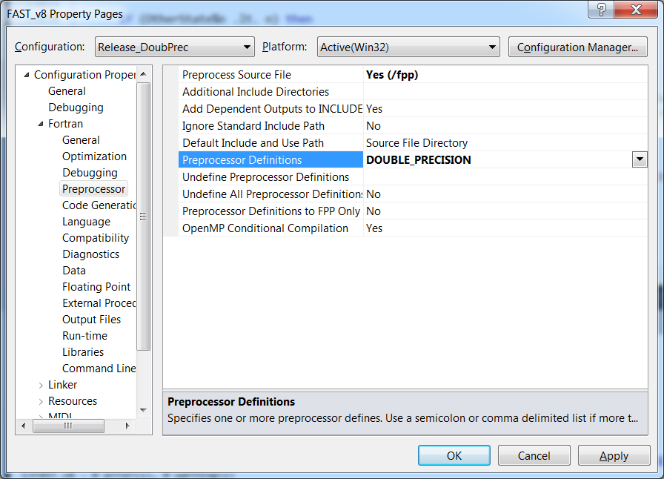

Figure 6: Adding preprocessor definitions to a Visual Studio project

* If you are using the FFTpack routines (i.e., HydroDyn), you will also need to set the default Real and Double KINDs to 8 and 16 bytes, respectively. (Default REAL must be the same as ReKi and Default Double must be the same as DbKi.)

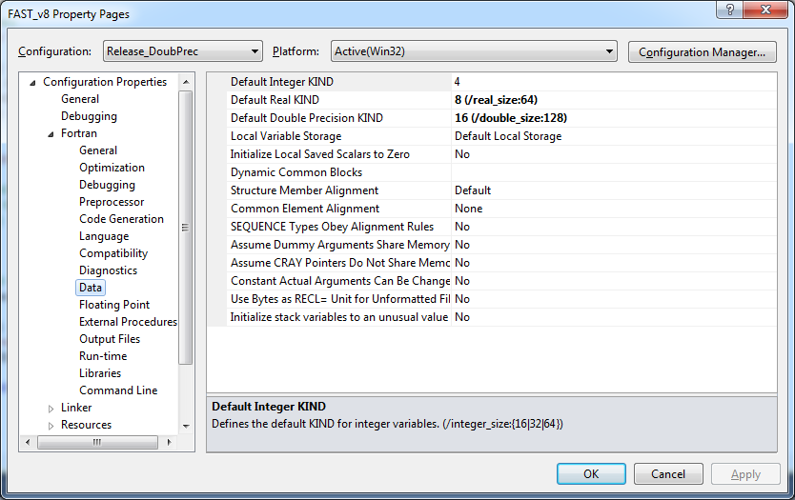

Figure 7: Changing default real and double sizes in Visual Studio

## LAPACK Libraries

FAST v8 uses some LAPACK routines (<http://www.netlib.org/lapack/index.html>). We have made the decision to link with prebuilt libraries, which should include highly optimized versions of the Basic Linear Algebra Subprograms (BLAS).

These prebuilt libraries typically come installed on Linux and Mac operating systems. Use linking options –llapack and –lblas for gfortran.

If you are using the Intel compiler, you can use the Intel® Math Kernel Library. To activate MKL, you will need to set *Project* -> {project name} *Properties* -> *Configuration* *Properties* -> *Fortran* -> *Libraries* -> *Use Intel Math Kernel Library* to **Sequential (/Qmkl:sequential)**.

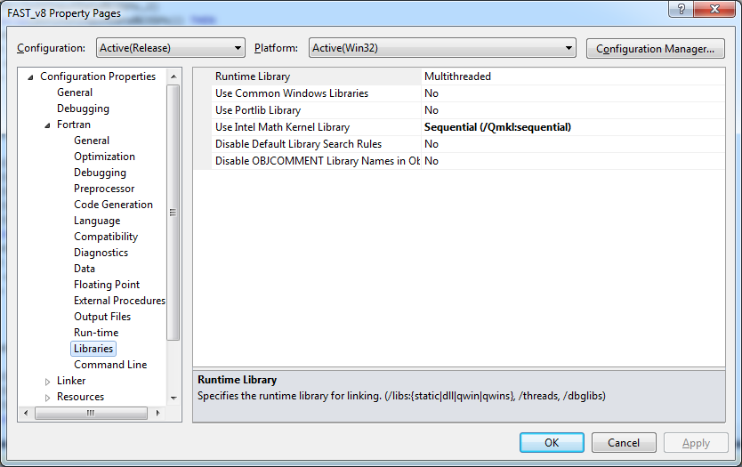

Figure . Setting Visual Studio to use LAPACK

With this option set, you can compile and use any routine in the LAPACK libraries.

If you have an older version of the Intel compiler, you may not have access to MKL. In that case, please see the instructions at this web site: <http://icl.cs.utk.edu/lapack-for-windows/lapack/> for help in installing LAPACK and BLAS libraries for Release and Debug modes.

### LAPACK in Double Precision

To facilitate compiling in double precision, we have created some wrapper routines in for the LAPACK and ScaLAPACK routines used in FAST and its modules.

*The NWTC wrapper routines for LAPACK have been written assuming that they are calling prebuilt libraries*. If you choose to compile with the LAPACK source files instead of using the prebuilt libraries (not recommended), you must make sure that default Real and Double KINDs for the LAPACK routines are 4 and 8 bytes, respectively (*even when compiling FAST in double precision*).

Table : Fortran Compiling Options

|  |  |  |  |  |
| --- | --- | --- | --- | --- |
|  | **Used in FAST?** | **Intel Fortran**  **(Windows)** | **Intel Fortran**  **(Linux and Mac)** | **GNU Fortran** |
| Data options |  |  |  |  |
| Define all default real (and complex) variables as 4 bytes long | Recommended  *(compiler default)* | /real-size:32 | -real-size 32 | *(set by default)* |
| Define all default real (and complex) variables as 8 bytes long |  | /real-size:64 | -real-size 64 | -fdefault-real-8 |
| Optimization options |  |  |  |  |
| Disable all optimizations (debug mode) | Recommended for Debug | /Od | -O0 | -O0 |
| Enable optimizations for speed (release mode) | Recommended for Release | /O2 | -O2 | -O2 |
| Enable higher optimizations (may set other options; may not be appropriate for all codes) |  | /O3 | -O3 | -O3 |
| External libraries |  |  |  |  |
| Use optimized LAPACK routines | **Required** | /Qmkl:sequential | -mkl=sequential | -llapack -lblas[2] |
| Debugging options |  |  |  |  |
| Provide source file traceback information when a severe error occurs at run time |  | /traceback | -traceback | -fbacktrace |
| Check array subscripts |  | /check:bounds | -check bounds | -fcheck=bounds |
| Fortran Dialect Options |  |  |  |  |
| Produce warning/error for non-standard Fortran 2003 code | Recommended | /stand:f03 | -std03 | -std=f2003 |
| Allow free-format code to exceed 132 columns | **Required** | *(allowed by default)* | | ‑ffree‑line‑length‑none |
| Other |  |  |  |  |
| Display compiler version information |  | /logo | -logo  -V | -v  --version |
| Preprocess source files before compilation | **Required** | /fpp | -fpp | -x f95-cpp-input |
| Create 32-bit code |  | *(use appropriate Visual Studio configuration or call appropriate script prior to using compiler from command line)* | | -m32 |
| Create 64-bit code |  | -m64 |

# Compiling on Linux or Mac

Some of the biggest challenges to compiling on non-Windows® systems come from the MAP++ dynamically linked library and the FAST Registry.

We have included the source code for the FAST Registry in the <FAST8>\Source\dependencies\Registry folder. That folder also contains a makefile that will generate the FAST Registry executable using gcc. It has been tested and run on a few Linux and Mac systems.

The source files for the MAP++ library are not included in the FAST archive, but are available on the MAP++ web site: <https://nwtc.nrel.gov/MAP> . The MAP++ archive contains a makefile (in the src folder) that can be used to generate the MAP++ library.

# Feedback

If you have questions or suggestions for improvements, please use our forums: <https://wind.nrel.gov/forum/wind/>

1. At the time of this writing, the web site had typos in the links for liblapack.dll and liblapack.lib; use the links listed here.
2. These are actually linking options in gfortran.