System Title

SRS

Introduced By Team 20

|  |  |  |  |  |
| --- | --- | --- | --- | --- |
| Version | Written By | Reviewed By | Approved By | Date |
| 0.X | Team 20 |  | doctor | 11/25/2018 |
| 1.X |  |  |  |  |

# Introduction

## Executive Summary

”Startups on the cloud” is a website which can be considered as the linkage between startups and their customers. It will be a very important tool for startups owners in order to market their projects. Startups on the cloud will also help whoever is looking for new nearby place (ex.: restaurant, café or co-working space) to find it easily.

## Document Overview

This document contains a description of our project. It describes and illustrates the diagrams of the system. It also illustrates the functions of the system. These functions are: the functional requirements, the non functional requirements, and the domain requirements as well. Not only that , this document provides the system user which provides user role description in details.

**Abbreviations and Terminologies**

Table of abbreviations and terminologies.

## References

1-https://en.wikipedia.org/wiki/Software_requirements_specification

2- The SRS template’s doctor.

# System Description

## Introduction

Startup on the cloud website is an online meeting point between customers and startup owners where startup owners can provide their startup service showing their category of service (Co-working space, event and project planning, handmade jewelry, custom clothes, open days, startup café, entertainment place, keto foods, vegan food). And from the customer side he/she can search for the category of place they want to visit and have an access to the location and ratings and reviews and after their visit they can give feedbacks and pros and cons about the startups so others can see, and also see the clouds rating

//Use block or context diagram to illustrate the system architecture.

## Users

## 1-The startups owners:

## Owners have a great chance as marketing platform for their projects to help customers reach them easily and faster and will be notified immediately if any customer choose them from our website with their generated promo codes to save their rights. Also update a complete profile for their startups as location, category, pictures and offers. Owners can view feedbacks, ratings from their customers.

## 2-The customers Users:

## Customers could search for all the nearest startups, just enter the region you want and the type of service you want to get, then any options will appear, you can find detailed description, reviews, the exact location and all the available offers, just choose your place from our website and you will get your promo code and of course you will be more than welcomed to leave your review or feedback after your great visit to help owners improve their services.

## Modules

# The system consists of following modules:

# Storage

Exam cloud uses different types of storage:

- Core storage for Startup information and user interaction.

- System storage for system configuration, users information and fresh logs.

- Indexing storage to support part and full text search engines.

- Analytics storage(s) to store the outcomes of data analytics module.

Core storage uses MYSQL database. SQL database is a Relational database. In an SQL database, data is stored in multiple tables instead of in a single row. The different tables are related or connected using a common field called the key that is common to one or more tables. Using SQL, the data from multiple tables can be combined to get the information that we need. If the library data in the above example is stored in a relational database, we could break up the long row of data into multiple tables. In a relational Database, System storage uses traditional structured database which provide better queries and data processing.

**• Data analysis.**

Startups on the cloud holds huge amount of Startup Projects, information about them and their locations , user interaction and logs. This modules is important to study the Projects carefully(Description and location). Basically this module support following data analytics. This analysis is important to avoid non useful Projects and incorrect data(like : location of startups ,user accounts) . Quality analysis to study the importance of the Startups based on user interaction. Statistical analysis to produce a set of statistical studies regarding Startups Projects and users interaction. It can study user satisfaction based on reviews, Rating, interaction with website and contribution to the system.

**• Indexing.**

This module is responsible for indexing textual contents to allow internal part and full text search queries. Full text and sub-part text search is used by final users to find certain contents. Also, it used by other modules like data processing to locate contents in a fixed time regardless the overall contents size.

**• Security.**

Security module is responsible for user authentication and communications security. User can register/login using internal accounts. The portal access is made using https protocol in order to secure the communication. Security module is also responsible for managing the permissions and roles.

**• Cloud Service.**

This module provides all system feature through set of APIs. APIs are required by mobile applications and other software interfaces. External developers with permissions can use those APIs to build additional applications with different flavors. Exam Cloud encourage developers to build dependent software systems. Developers may build software applications for Mobile, Web and Desktop.

**• Customer Area.**

This module provides user with all tools required to reach his destination. User can create account, add likes, comments and feedback. User can use the report button to announce for a problem so we send him an email containing a form to tell us his issue. The owner will be informed if the reports about a problem exceeds a certain number, in order to reach the user’s satisfaction and trust. There is also ‘contact’ us form if the user faces any problem with the website, if he wants to leave a message or a comment and it also have a rating question concerning the website.

**• Owners of Start Ups Area.**

This module provides the owner with main system activities like creating his own page, he/she can control it by writing description, uploading pictures or videos of the place & he/she can also update them, he/she can put their location so it helps the user to reach the destination faster. One of the important features he/she has, Which is replying to the customers and communicating with them. But his/her account has some different features than the user, he/she can’t search for any other page using this account, They have to make another account as a user, Because the user is the one who can do that.

**• Supervisors Area.**

This module is dedicated for system operators. System operators are responsible for managing the system operation and contents. System operators, can access all system contents, the report button which the user clicks, when he/she faces a problem, we directly send him/her an email with a form containing some questions which are the place name, the issue, when did this problem happened , was it the first time, what could the place do to compensate you? , and any other comment, this helps us a lot, because if a certain place got a certain number of reports, we as the supervisors send him an email and warn him/her, and if they don’t take an action, we delete them after giving him/her enough time to do something.

**• General mobile Application.**

Mobile application provides most of the web based system features using Mobile graphical user interface. Mobile application are offered to normal users like Customers & Startups Owners. Activities like administration, supervision, and authority management are supported only by the web based system. Mobile applications supports major mobile platforms like Android, Windows-Mobile and IOS.

**• START UPS Authority area.**

Users with permission (Owners) can edit the information, Update offers and view promo codes.

**• System Administration Area.**

This module is dedicated for system administrators. System administrators are responsible for system management, configuration, backup and solving technical issues. System administrator, can view system status, data status, logs and other system status and measures.

# System Users

**Developers**

They are responsible for creating & designing the webpages, managing the system operations and contents. If the website user faces a problem & reports a place for example, we directly send him/her an email with a form containing some questions which are the place name, the issue, when did this problem happened , was it the first time, what could the place do to compensate you? , and any other comment, this helps us a lot, because if a certain place got a certain number of reports, we as the supervisors send him an email and warn him/her, and if they don’t take an action, we delete the project from the website after giving him/her enough time to do something.

**Owners**

The owner of the startup can create his own page, he/she can control it by writing description, uploading pictures or videos of the place & he/she can also update them, he/she can put their location so it helps the user to reach the destination faster. One of the important features he/she has, is replying to the customers and communicating with them. But his/her account has some different features than the user, he/she can’t search for any other page using this account, They have to make another account as a user, Because the user is the one who can do that. **Customers**

Customer can create account, search for a nearby start-up (for example: co-working space, café or restaurant ), add likes, comments and feedback. Customer can use the report button to announce for a problem so we send him an email containing a form to tell us his issue. The owner will be informed if the reports about a problem exceeds a certain number, in order to reach the customer’s satisfaction and trust. There is also ‘contact’ us form if the user faces any problem with the website, if he wants to leave a message or a comment and it also have a rating question concerning the website.

# System Modules

# The system consists of following modules:

# Storage

Exam cloud uses different types of storage:

- Core storage for Startup information and user interaction.

- System storage for system configuration, users information and fresh logs.

- Indexing storage to support part and full text search engines.

- Analytics storage(s) to store the outcomes of data analytics module.

Core storage uses MYSQL database. SQL database is a Relational database. In an SQL database, data is stored in multiple tables instead of in a single row. The different tables are related or connected using a common field called the key that is common to one or more tables. Using SQL, the data from multiple tables can be combined to get the information that we need. If the library data in the above example is stored in a relational database, we could break up the long row of data into multiple tables. In a relational Database, System storage uses traditional structured database which provide better queries and data processing.

**Context diagram :**

Indexing storage

Core storage

Storage

Analytical Storage

System storage

**• Data analysis**

Startups on the cloud holds huge amount of Startup Projects, information about them and their locations , user interaction and logs. This modules is important to study the Projects carefully(Description and location). Basically this module support following data analytics. This analysis is important to avoid non useful Projects and incorrect data(like : location of startups ,user accounts) . Quality analysis to study the importance of the Startups based on user interaction. Statistical analysis to produce a set of statistical studies regarding Startups Projects and users interaction. It can study user satisfaction based on reviews, Rating, interaction with website and contribution to the system.

**Context diagram:**

Statistical analysis

Quality analysis

Data analysis system

**• Indexing.**

This module is responsible for indexing textual contents to allow internal part and full text search queries. Full text and sub-part text search is used by final users to find certain contents. Also, it used by other modules like data processing to locate contents in a fixed time regardless the overall contents size.

**• Security.**

Security module is responsible for user authentication and communications security. User can register/login using internal accounts. The portal access is made using https protocol in order to secure the communication. Security module is also responsible for managing the permissions and roles.

**• Cloud Service.**

This module provides all system feature through set of APIs. APIs are required by mobile applications and other software interfaces. External developers with permissions can use those APIs to build additional applications with different flavors. Exam Cloud encourage developers to build dependent software systems. Developers may build software applications for Mobile, Web and Desktop.

**• Customer Area**

This module provides user with all tools required to reach his destination. User can create account, add likes, comments and feedback. User can use the report button to announce for a problem so we send him an email containing a form to tell us his issue. The owner will be informed if the reports about a problem exceeds a certain number, in order to reach the user’s satisfaction and trust. There is also ‘contact’ us form if the user faces any problem with the website, if he wants to leave a message or a comment and it also have a rating question concerning the website.

**Data flow diagram:**



**• Owners of Start Ups Area.**

This module provides the owner with main system activities like creating his own page, he/she can control it by writing description, uploading pictures or videos of the place & he/she can also update them, he/she can put their location so it helps the user to reach the destination faster. One of the important features he/she has, Which is replying to the customers and communicating with them. But his/her account has some different features than the user, he/she can’t search for any other page using this account, They have to make another account as a user, Because the user is the one who can do that.

**Data flow diagram:**



**• Supervisors Area.**

This module is dedicated for system operators. System operators are responsible for managing the system operation and contents. System operators, can access all system contents, the report button which the user clicks, when he/she faces a problem, we directly send him/her an email with a form containing some questions which are the place name, the issue, when did this problem happened , was it the first time, what could the place do to compensate you? , and any other comment, this helps us a lot, because if a certain place got a certain number of reports, we as the supervisors send him an email and warn him/her, and if they don’t take an action, we delete them after giving him/her enough time to do something.

**• General mobile Application.**

Mobile application provides most of the web based system features using Mobile graphical user interface. Mobile application are offered to normal users like Customers & Startups Owners. Activities like administration, supervision, and authority management are supported only by the web based system. Mobile applications supports major mobile platforms like Android, Windows-Mobile and IOS.

**• START UPS Authority area.**

Users with permission (Owners) can edit the information, Update offers and view promo codes.

**• System Administration Area.**

This module is dedicated for system administrators. System administrators are responsible for system management, configuration, backup and solving technical issues. System administrator, can view system status, data status, logs and other system status and measures.

# System Functions

# 

**• Create accounts**

-Description: SOC allows you to create account for both our customers and the startup owners. At the start page, user should decide whether to enroll as a customer or a startup owner. SOC offers two different forms for each kind of user.

-Inputs: Customers should provide their name, e-mail, phone number and city. Startup owners should provide the startup’s name, kind of service, e-mail, location in details (Format: building number, street, district), google maps link, working hours and images.

- Output: The page as a user or owner according to the input information.

- Pre-condition: to input all the information in the form.

- post-condition: being able to chat

• **Give feedback**

It’s common that customers skip feedbacks, SOC solves this problem by offering a new method which is “pros and cons”. Also user can give an overall rating.

-Inputs: Customers can choose from default checkboxes statements to cover overall startup services as:

▪ Service ▪ Prices ▪ Quality ▪ Time Management

-Output: the rating

-Pre-condition:

-post-condition:

• **Startup page**

-Description: The Startup page contains information about the startup.

-Input: its name, service category, hotline, location in details, google maps link, working hours and images. Users also can reserve slots through the startup page, get membership offers (loyalty membership) and discounts (promo codes).

Moreover, the owner can check the reviews of the customers. Having pros and cons helps to provide better services.

They can recommend startups. The number of recommends hits will be displayed on the page. Ones with highest recommendation numbers will be shown at the top of the search result. And because startup can be good, very good or excellent, recommend won’t be enough to describe the excellence of a startup rather than another one. SOC provides cloud rating.

-Output: all the information you will need concerning the topic of the page

-pre-condition: every and each information that can be included in order to help the user and make it easy for him/her.

Post-condition: Being able to communicate with the page (messages).

•**Filter startups**

-Description: SOC offers categories for users to choose from, after the user choose his/her district, the results will be filtered

-Input: choosing the wanted district.

-Output: After that the users should choose the district they want, and the results shown to the users will be filtered according to their choices and preferences.

-pre-condition: Entering the wanted destination, and the preferred places in order to be recommended to him/her.

-Post-condition: Showing up after entering the recommended place first, and send a notification if there is any offers in the recommended places

•**Place of the day**

The website displays a place that is highly rated as the place of the day. This place changes daily and another place with high ratings gets the title and replaces the previous one.

-Input: just logging in to the website as a user.

-Output: place of the day will show up.

-Pre-condition: must be logged in to be able to see it.

-Post-condition: sending it as notification.

• **Set promo codes**

This allows the owner to set the number of promo codes per day, and the customer can get one once he visits our website and the promo code is available.

-Input: setting the number of promo code.

-Output: getting the discount.

-Pre-condition: visiting our website.

-Post-condition: Making promo codes for the special clients from the frequently pages he/she visits.

• **Loyalty membership**

SOC provides a special service for long term frequent visits for a startup. The owner can set custom privileges of loyalty membership so a customer gets discounts.

-Input: visiting the website frequently

-Output: getting discount

-pre-condition: visiting the website frequently.

-Post-condition: make the customer of the month as the number of visits become higher the discount increases.

• **Give a feedback**

SOC provides a textbox for users to express their opinions about the places or the events they attend. Users’ recommendations will help a lot. There is also a report button to allow users to explain a problem if needed

-input: the customer writes his opinion or pressing the report button.

-Output: helps in the recommendation and solving the problem.

-pre-condition: logging in

-Post-condition: direct contact with him/her and the place which have the report.

# System Models

## Use Case Diagrams

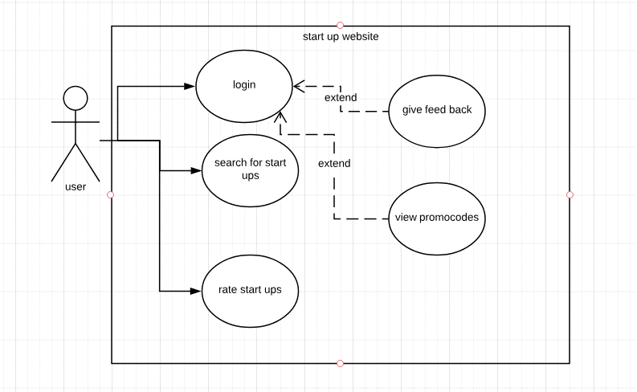

-This use case diagram shows the relation between the users of the website and the function he could do on the web site ,he could login to a personal acount which give him the authority to do many features such as feedbacking service and view promocodes to get discount from service owners for using our website.

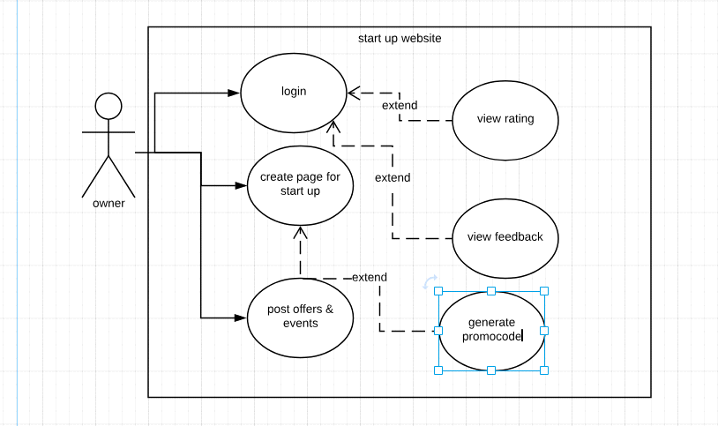

-This use case describe the relation between the owner of start ups and the function they could do on it such as creating page for marketing their startups and view the ratings of customer and benefit from their feedbacks to avoid mistakes and give a better service,they could olso post about events and offers for customer .

## Sequence Diagrams

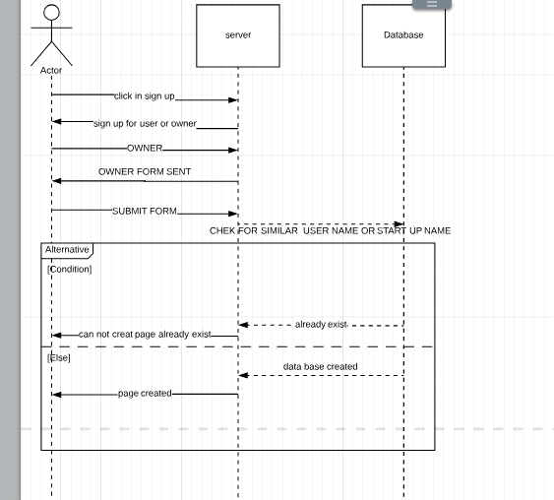

-This sequence diagram is used to show up a certain process function when owner asks to creat a page on our website the server should check in the data base that the entered user name and start up name doesn't exist to avoid repeation and problems later and if it is ok the page will be created successfully if not error message will pop for invaled information

..........................................................................................................................................

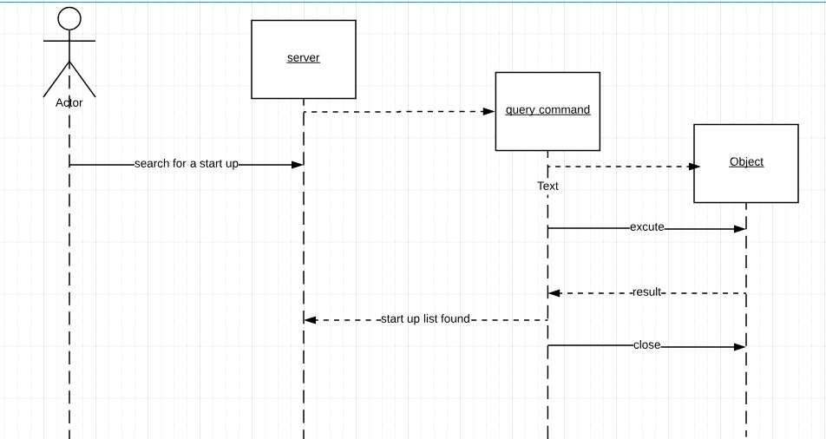

-This sequence diagram describe one of the basic functions on our website which is searching engine for startups as the user enter the service name a query connecting all the entered information is sent to the database which give back all near by results to the user and sent back to him to choose the best for him

# Non-Functional Requirements

**Security**

The website must be secure to insure the privacy of each user and to protect the user's accounts and information. This is achieved by using a proper login system as the user is requested to enter their own distinct usernames and passwords to avoid hacking.

**Usability**

The website must be user friendly to facilitate user's interactions and usage of the website. The users will be able to use this website easily ,effectively and efficiently.

**Performance**

There will be a continuous interaction between the users and the website to ensure high quality performance and to make sure that each user enjoys an excellent experience and reaches the most relevant information to his request in a short time. The response of the system is fast.

**Technology**

**Development**

The website is written using agile process.

**Delivery**

**Operation**

# Domain Requirements

## 

## Market Requirements

## Feedback and reviews are required to let owners cope with customer desires.

# System Interfaces

* **User Interfaces**
  + The users in our website are classified into:
    1. Owners of the startups
    2. Customers
* The Owner will be able to:
  + See all the categories (co-working spaces, cafés, and restaurants), so he can choose any of them.
  + Sign up to the website.
  + Login to the website where he can get the available promo codes.
  + Get in contact to the website owners in ‘contact us’ page.
  + Add, edit or delete his project.
  + Add a detailed description of his project (images, location, menus, offers…etc).
  + See the reviews of his project.
  + Set the number of available promo codes per day.
  + Get notified by taken promo codes.
  + The Customer will be able to:
    - See all the categories (co-working spaces, cafés, and restaurants), so he can choose any of them.
    - See the reviews of certain projects.
    - Sign up to the website.
    - Login to the website where he can get the available promo codes.
    - See the description of each project.
    - Get in contact to the website owners in ‘contact us’ page.
    - Report certain projects if any issue happen.
    - See the description of the website in ’About’ page.
* **Hardware interfaces**

There is no hardware interfaces