**System Description**

**Introduction**

Startup on the cloud website is an online meeting point between customers and startup owners where startup owners can provide their startup service showing their category of service (Co-working space, event and project planning, handmade jewelry, custom clothes, open days, startup café, entertainment place, keto foods, vegan food). And from the customer side he/she can search for the category of place they want to visit and have an access to the location and ratings and reviews and after their visit they can give feedbacks and pros and cons about the startups so others can see, and also see the clouds rating

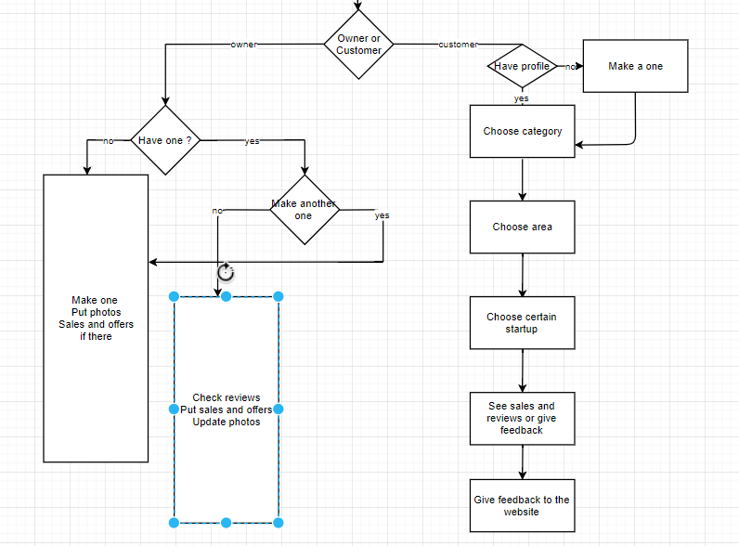

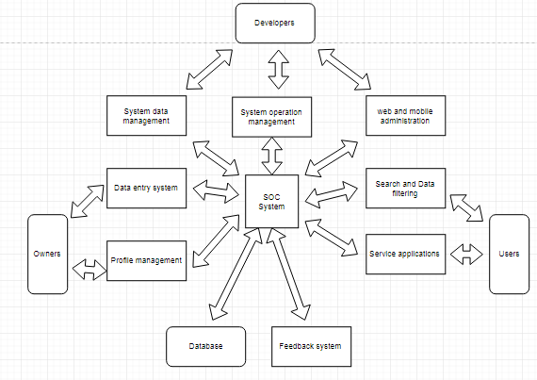**Users**

**1-The startups owners:**

Owners have a great chance as marketing platform for their projects to help customers reach them easily and faster and will be notified immediately if any customer choose them from our website with their generated promo codes to save their rights. Also update a complete profile for their startups as location, category, pictures and offers. Owners can view feedbacks, ratings from their customers.

**2-The customers Users:**

Customers could search for all the nearest startups, just enter the region you want and the type of service you want to get, then any options will appear, you can find detailed description, reviews, the exact location and all the available offers, just choose your place from our website and you will get your promo code and of course you will be more than welcomed to leave your review or feedback after your great visit to help owners improve their services.

**Modules**

The system consists of following modules:

* Storage

Exam cloud uses different types of storage:

- Core storage for Startup information and user interaction.

- System storage for system configuration, users information and fresh logs.

- Indexing storage to support part and full text search engines.

- Analytics storage(s) to store the outcomes of data analytics module.

Core storage uses MYSQL database. SQL database is a Relational database. In an SQL database, data is stored in multiple tables instead of in a single row. The different tables are related or connected using a common field called the key that is common to one or more tables. Using SQL, the data from multiple tables can be combined to get the information that we need. If the library data in the above example is stored in a relational database, we could break up the long row of data into multiple tables. In a relational Database, System storage uses traditional structured database which provide better queries and data processing.

**• Data analysis.**

Startups on the cloud holds huge amount of Startup Projects, information about them and their locations , user interaction and logs. This modules is important to study the Projects carefully(Description and location). Basically this module support following data analytics. This analysis is important to avoid non useful Projects and incorrect data(like : location of startups ,user accounts) . Quality analysis to study the importance of the Startups based on user interaction. Statistical analysis to produce a set of statistical studies regarding Startups Projects and users interaction. It can study user satisfaction based on reviews, Rating, interaction with website and contribution to the system.

**• Indexing.**

This module is responsible for indexing textual contents to allow internal part and full text search queries. Full text and sub-part text search is used by final users to find certain contents. Also, it used by other modules like data processing to locate contents in a fixed time regardless the overall contents size.

**• Security.**

Security module is responsible for user authentication and communications security. User can register/login using internal accounts. The portal access is made using https protocol in order to secure the communication. Security module is also responsible for managing the permissions and roles.

**• Cloud Service.**

This module provides all system feature through set of APIs. APIs are required by mobile applications and other software interfaces. External developers with permissions can use those APIs to build additional applications with different flavors. Exam Cloud encourage developers to build dependent software systems. Developers may build software applications for Mobile, Web and Desktop.

**• Customer Area.**

This module provides user with all tools required to reach his destination. User can create account, add likes, comments and feedback. User can use the report button to announce for a problem so we send him an email containing a form to tell us his issue. The owner will be informed if the reports about a problem exceeds a certain number, in order to reach the user’s satisfaction and trust. There is also ‘contact’ us form if the user faces any problem with the website, if he wants to leave a message or a comment and it also have a rating question concerning the website.

**• Owners of Start Ups Area.**

This module provides the owner with main system activities like creating his own page, he/she can control it by writing description, uploading pictures or videos of the place & he/she can also update them, he/she can put their location so it helps the user to reach the destination faster. One of the important features he/she has, Which is replying to the customers and communicating with them. But his/her account has some different features than the user, he/she can’t search for any other page using this account, They have to make another account as a user, Because the user is the one who can do that.

**• Supervisors Area.**

This module is dedicated for system operators. System operators are responsible for managing the system operation and contents. System operators, can access all system contents, the report button which the user clicks, when he/she faces a problem, we directly send him/her an email with a form containing some questions which are the place name, the issue, when did this problem happened , was it the first time, what could the place do to compensate you? , and any other comment, this helps us a lot, because if a certain place got a certain number of reports, we as the supervisors send him an email and warn him/her, and if they don’t take an action, we delete them after giving him/her enough time to do something.

**• General mobile Application.**

Mobile application provides most of the web based system features using Mobile graphical user interface. Mobile application are offered to normal users like Customers & Startups Owners. Activities like administration, supervision, and authority management are supported only by the web based system. Mobile applications supports major mobile platforms like Android, Windows-Mobile and IOS.

**• START UPS Authority area.**

Users with permission (Owners) can edit the information, Update offers and view promo codes.

**• System Administration Area.**

This module is dedicated for system administrators. System administrators are responsible for system management, configuration, backup and solving technical issues. System administrator, can view system status, data status, logs and other system status and measures.

**Domain Requirements**

**Market Requirements**

Feedback and reviews are required to let owners cope with customer desires.