Pwrap Materials and Digital Patterns Management System
(SRS Report)

Members: Chu Thị Yến Khanh ()
Đinh Thị Hải()
Đào Thanh Hiền()
Đinh Thị Khuê ()
Trần Thị Xuân Mến ()
Nguyễn Minh Nguyệt ()

Team guide: Vũ Quỳnh Anh

College Name: Hanoi University Department: Information Technology
Pwrap Materials and Digital Patterns Management System

INTRODUCTION
This Software Requirements Specification (SRS) document describes the detailed software requirements for the Pwrap – Wrap Materials and Digital Patterns Management System (Pcut).

1.1. PURPOSE
- The purpose of this document is to:
  - Define the functional and non-functional requirements of the system.
  - Serve as a reference for system design, development, testing, and deployment.
  - Provide a common understanding between stakeholders, including Sponsor, Project Manager, Business Analyst, Developers, Testers, Admins, and Staff.
  - Establish the project scope and system boundaries to support change control throughout the project lifecycle.
- This SRS will be used as the foundation for:
  - System architecture and technical design
  - Test planning and test case development
  - User Acceptance Testing (UAT)
  - Project completion and success evaluation

1.2. SCOPE
- The Pwrap – Wrap Materials and Digital Patterns Management System (Pcut) is a centralized internal web-based system developed to:
  - Manage physical wrap materials inventory
  - Manage digital cut file libraries
  - Manage B2B dealer orders
  - Control user access through role-based permissions
  - Protect proprietary digital assets

The system will provide the following major capabilities:
- User authentication and role-based access control (Admin, Staff)
- Upload, search, and version management of digital cut files
- Inventory management (restocking, stock monitoring, low-stock alerts)
- B2B order creation and management
- Order status tracking
- System log tracking and auditing
- Export reports (Excel/CSV format)

Out of Scope:
  - Full ERP system integration
  - Direct hardware control of vinyl cutting machines

1.3. Definition, Acronyms, Abbreviations
Term / Acronym | Definition
Wrap Material | Uncut rolls of decal, tint film, or PPF used for vehicle wrapping
Digital Pattern (Cut File) | Vector file (.cdr, .eps, .dxf) containing vehicle cut dimensions
Pre-cut Wrap | Finished product created after cutting wrap materials
Vinyl Cutter | Computer-controlled cutting machine
Dealer | Wholesale B2B customer
Admin | System administrator with full access
Staff | Internal operational user
Inventory Stock | Real-time physical material quantity
Payment Gateway | Third-party online payment service
SKU | Stock Keeping Unit
B2B | Business-to-Business
SRS | Software Requirements Specification
BRD | Business Requirements Document

OVERALL DESCRIPTION

2.1. PRODUCT PERSPECTIVE
- Current Situation
  - Physical inventory and digital assets are managed separately
  - Digital cut files are tracked manually
  - High risk of intellectual property leakage
  - No strict session control or detailed system logs
- Target System Perspective
  - Centralize inventory and digital file management
  - Implement granular role-based access control
  - Prevent concurrent logins (single active session per user)
  - Provide detailed system logs for auditing
  - Protect digital files using temporary download tokens
- Key Stakeholders
  - Project Sponsor (CEO)
  - Admin (Internal)
  - Staff (Internal)
  - Dealer (External B2B customer)

2.2. SOFTWARE REQUIREMENT

2.2.1 Operating Environment

Web-based application

Supported browsers: Chrome, Microsoft Edge, Firefox (latest versions)

Deployment: Cloud server or On-Premise server

Database: Relational Database Management System (e.g., MySQL, PostgreSQL)

2.2.2 Functional Software Capabilities
- The system shall:
  - Support secure login with authentication
  - Maintain only one active session per user
  - Process file uploads (≤ 50MB) within 5 seconds
  - Display search results within 2 seconds
  - Support at least 500 concurrent users
  - Generate temporary and expiring download tokens
  - Export reports in Excel/CSV format

2.2.3 Non-Functional Software Requirements

System response time shall not exceed 2 seconds for standard operations

Role-Based Access Control (RBAC) must be enforced

File version history must be stored

System data must be backed up periodically

The system must support scalability for future expansion

2.3. HARDWARE REQUIREMENT

2.3.1 Server Requirements
- Minimum 4-core CPU
- Minimum 16GB RAM
- SSD storage ≥ 500GB
- Separate backup storage solution

2.3.2 Client Requirements
- Desktop or laptop computer
- Minimum 8GB RAM
- Modern web browser
- Stable internet connection ≥ 20 Mbps

2.3.3 Network Requirements
- HTTPS protocol support
- Firewall protection
- VPN support (if remote internal access is required)

2.4.1. FUNCTIONAL REQUIREMENTS

R.1: System & User Management

R.1.1: Login

Input: Email/Username and Password.

Output: Redirect to Dashboard or error notification.

Processing: Authenticate information; check session to prevent concurrent login (Concurrent Login Prevention).

R.1.2: Manage Staff Permissions

State: User is logged in with an Admin role.

Input: Admin selects a Staff account and customizes granular module access (Files, Inventory, Orders).

Output: Successful permission update notification.

Processing: The system overwrites granular permission parameters in the database instead of using fixed roles. Changes take effect immediately upon the Staff's next module access.

R.1.3: View System Logs

Input: Admin selects to view logs or enters filter criteria (Staff ID, date range, or specific events).

Output: List of system events (login events, session terminations, file downloads).

Processing: The system retrieves and displays data from the Log storage table to support tracing data leak sources or inventory discrepancies.

R.2: Cut File Management

R.2.1: Upload Cut File

Input: Upload vector file (.cdr, .eps, .dxf) and metadata (Car Make, Model, Year, Cut Details).

Output: Successful upload confirmation; file becomes visible in the technical library.

Processing: The system validates file format and size (≤ 50MB). If valid, it stores the file on a secure server and records the metadata in the database.

R.2.2: Search Cut File

Input: Keywords or filters (Car Make, Model, Year, Material Type).

Output: List of matching cut patterns matching the search criteria.

Processing: The system executes a database query based on the metadata to return results within 2 seconds.

R.2.3: Update Cut File Version

State: Cut pattern already exists in the system.

Input: Upload new version file and input version notes.

Output: Successful update notification; displays the latest version number.

Processing: The system saves the new file as the active version, archives the old version in the history, and processes the upload within 5 seconds.

R.2.4: Preview Cut File

Input: Click to select a specific file to view a low-resolution preview.

Output: A low-resolution preview image embedded with the Pwrap watermark.

Processing: The system automatically generates a temporary image from the original vector file for visual verification before downloading.

R.3: Inventory Management

R.3.1: View Inventory

State: User is logged in and granted Inventory module access by Admin.

Input: Click the "View Inventory" button.

Output: Inventory statistics table by Material Code, color, and quantity (rolls or linear meters).

Processing: The system retrieves and displays current inventory data from the database.

R.3.2: Restock Materials

Input: Material Code, Color, Size (linear meters), Supplier, and Batch Number.

Output: Updated total inventory quantity; saved restock transaction log.

Processing: The system validates inputs, increments the stock quantity, and logs the transaction.

R.3.3: View Inventory Alerts

Output: Display of alerts or highlights for materials with stock levels below the set threshold (e.g., < 15 meters).

Processing: The system automatically compares current stock levels with the threshold and triggers an alert on the dashboard.

R.4: Order Management

R.4.1: Create Order

Input: Select Dealer, Product (Material or Cut File), Quantity, and Discount.

Output: New order created in "Draft" or "Processing" status.

Processing: The system checks inventory (for materials), calculates totals after discount, and reserves stock or generates a secure download link for digital files. Detailed transaction logs are recorded for audit and asset protection.

R.4.2: Track Order Status

Input: Enter Order ID or Dealer name.

Output: Real-time order status (Awaiting Payment, Processing, Shipping, Completed).

Processing: The system retrieves and displays the current status from the Order table.

R.4.3: Process Material Return

Input: Select order, material to return, quantity, and reason.

Output: Return confirmation; restored warehouse inventory quantity.

Processing: The system executes a reverse inventory flow, updates the stock count, and logs the return history.

R.4.4: Generate System Reports

Input: Select report type (Inventory, Download Logs, or Sales) and date range.

Output: Downloadable Excel or CSV file.

Processing: The system aggregates data, generates the file, and logs the export activity.

R.5: Product Catalog Management

R.5.1: Add Product

Input: Product Name, SKU/Product Code, Category, Base Price, and images.

Output: New product becomes available in the catalog.

Processing: The system validates SKU uniqueness and saves the product details to the Master Data.

R.5.2: Update Products Information

Input: Select product; enter updated price, description, or visibility status.

Output: Successful update confirmation.

Processing: The system updates the database; changes are applied to all subsequent orders.

2.4.2. NON FUNCTIONAL REQUIREMENTS
- Usability
The administrative interface is intuitively designed, allowing staff to easily search and preview cut patterns, while the system automatically generates temporary download tokens in the background to protect intellectual property without disrupting the user experience.
- Availability
The system must maintain a stable 24/7 operational state to serve the continuous inquiry and order creation needs of dealers at any time.
- Efficiency
The processing, validation, and uploading of digital cut files (capacity ≤ 50MB) must be received and fully completed by the system within a maximum of 5 seconds.
- Accuracy
The system must ensure absolute accuracy in automatically deducting inventory by linear meters and calculating costs (selling price, discounts) immediately upon order confirmation.
- Performance
The system must support a minimum of 500 concurrent users without lagging, while ensuring that the response time for common operations (searching cut patterns, loading the Dashboard, viewing products) always remains under 2 seconds.
- Reliability
The system must guarantee 100% data reliability for original vector files to prevent asset loss, accompanied by a continuous system logging mechanism to serve auditing and error tracing.

2.5. USER CHARACTERISTICS
The Pwrap – Wrap Materials and Digital Patterns Management System (Pcut) will be used by different categories of users with varying levels of technical knowledge and system privileges.

2.5.1 Admin
- Role: System Administrator
- Responsibilities:
  - Manage user accounts and permissions
  - Upload and update digital cut files
  - Manage product catalog
  - Monitor system logs
  - Generate reports
  - Configure stock thresholds
- Technical Expertise:
  - Intermediate to advanced computer skills
  - Familiar with inventory systems and digital file management
  - Basic understanding of data security principles
- System Access Level: Full system access with configuration privileges.

2.5.2 Staff
- Role: Operational/Internal User
- Responsibilities:
  - Search and access digital cut files
  - Restock materials
  - View inventory levels
  - Create and manage B2B orders
  - Process returns
  - Track order status
- Technical Expertise:
  - Basic to intermediate computer skills
  - Familiar with internal operational processes
  - Limited knowledge of system administration
- System Access Level: Access is restricted based on permissions granted by Admin (granular module-based access control).

2.5.3 Dealer (External User)
- Role: Wholesale Customer (B2B)
- Responsibilities:
  - Place orders (if portal access is provided in future phase)
  - Track order status
  - Access purchased digital files
- Technical Expertise:
  - Basic computer literacy
  - No internal system management knowledge required
- System Access Level: Restricted to dealer portal functions

2.6. CONSTRAINTS
The following constraints may affect the design, development, and deployment of the Pcut system:

2.6.1 Technical Constraints
- The system must be web-based (no desktop-native application).
- File upload size must not exceed 50MB.
- Search response time must not exceed 2 seconds.
- Upload processing time must not exceed 5 seconds.
- The system must support at least 500 concurrent users.
- Only one active session per user is allowed (concurrent login prevention).

2.6.2 Security Constraints
- Role-Based Access Control (RBAC) must be enforced.
- Digital cut files must be protected using temporary or expiring download tokens.
- All communication must use HTTPS protocol.
- System logs must be retained for auditing purposes.

2.6.3 Business Constraints
- The system must protect proprietary digital assets (intellectual property).
- The solution must align with Pwrap’s operational workflow.
- The implementation timeline is limited by project schedule constraints.
- Budget limitations may restrict advanced third-party integrations.

2.6.4 Regulatory and Compliance Constraints
- The system must comply with applicable data protection regulations.
- User authentication data must be securely stored and encrypted.

2.7. FLOW DIAGRAM
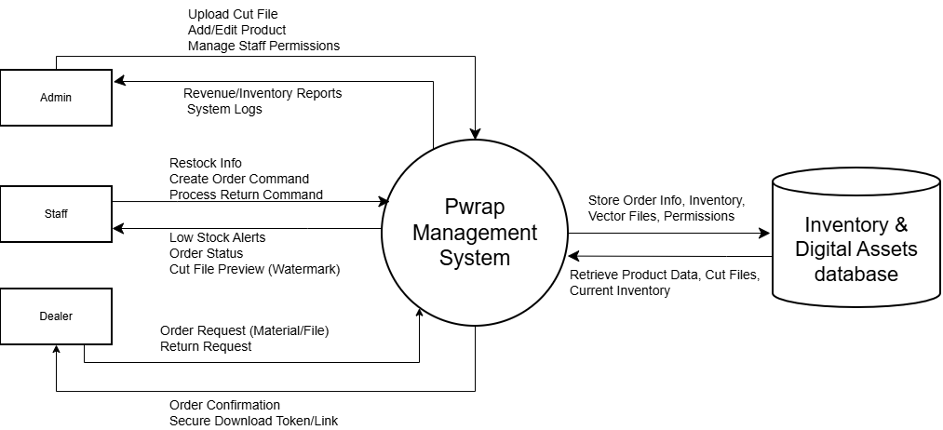

2.8. USE CASE MODEL DESCRIPTION
Use Case selection | Description
Use Case name | UC-09: Create Order
Level | User goal
Primary actor | Staff
Stakeholders and interest | Staff: Wants to process orders quickly and accurately without causing negative stock.  Dealer: Wants to get fair discounts and receive order confirmation instantly.  Admin: Wants to prevent sales to debtors and ensure inventory is correctly reserved.
Pre-condition | User is authenticated. Dealer has no overdue debt. Requested items exist in the system.
Post-condition | Order is saved in "Draft" or "Pending" status. Physical inventory is reserved (not deducted yet).
Main success scenario | 1. Staff selects an active Dealer.  2. System checks for overdue debts; if clear, proceeds.  3. Staff adds items (Materials/Cut Files) and quantities.  4. System applies a discount (Automated based on Dealer Tier).  5. Staff confirms the order.  6. System validates stock availability and marks requested quantity as "Reserved".  7. System notifies the Dealer of the new pending order.
Alternative flow | 1. Overdue Debt: System blocks order creation and displays error until debt is cleared (at step 2).  2. Insufficient Stock: System displays "Out of Stock" error and prompts Staff to adjust quantity (at step 6).  3. Admin Approval: If order value exceeds threshold, status is set to "Awaiting Approval".
Specific requirement | System must support real-time concurrent stock checks to prevent race conditions (âm kho) when multiple staff create orders simultaneously.
Table 1: table for UC-09 description.

Use Case selection | Description
Use Case name | UC-04: Upload Cut File
Level | User goal
Primary actor | Staff
Stakeholders and interest | Staff: Wants a simple interface to upload and categorize files.  Dealer: Wants to view the cut file catalog clearly before buying.  Admin: Wants to protect intellectual property (IP) from unauthorized downloads.
Pre-condition | User is authenticated. File is in a supported vector format (.ai, .eps, .svg).
Post-condition | Vector file is stored securely.
Main success scenario | 1. Staff navigates to Cut File Management and selects "Upload".  2. Staff inputs metadata (Car Make, Model, Year).  3. Staff uploads the original vector file.  4. System securely stores the file and assigns version V1.0.
Alternative flow | 1. Invalid File Format: System rejects the file if it is not a supported vector format and displays an error message.
Specific requirement | Files must be securely stored (e.g., protected directory or encryption mechanisms)
Table 2: table for UC-04 description.

Use Case selection | Description
Use Case name | UC-06: Restock materials
Level | User goal
Primary actor | Staff
Stakeholders and interest | Staff: Wants to quickly update inventory to clear system alerts.  Admin: Wants to track Supplier and Batch Numbers for quality control.
Pre-condition | User is authenticated. Material profile exists in the system database.
Post-condition | Available physical stock is increased. Transaction is logged with Batch Number. "Low Stock" alert is cleared.
Main success scenario | 1. Staff selects the Material Code to restock (often triggered by "Inventory Alerts").  2. Staff inputs arrival details (Quantity, Supplier, Batch Number).  3. Staff confirms restock.  4. System validates inputs.  5. System updates the MaterialInventory available stock.  6. System clears "Low Stock" alert for that item if it now exceeds the MOQ (Minimum Order Quantity).
Alternative flow | 1. Invalid Quantity: System rejects input if quantity is 0 or negative.  2. Missing Fields: System rejects input if mandatory fields (Supplier, Batch No) are blank.
Specific requirement | Inventory updates must be reflected in real-time across all active user sessions to ensure accurate order creation.
Table 3: table for UC-06 description.

2.9.1. USE CASE DIAGRAM

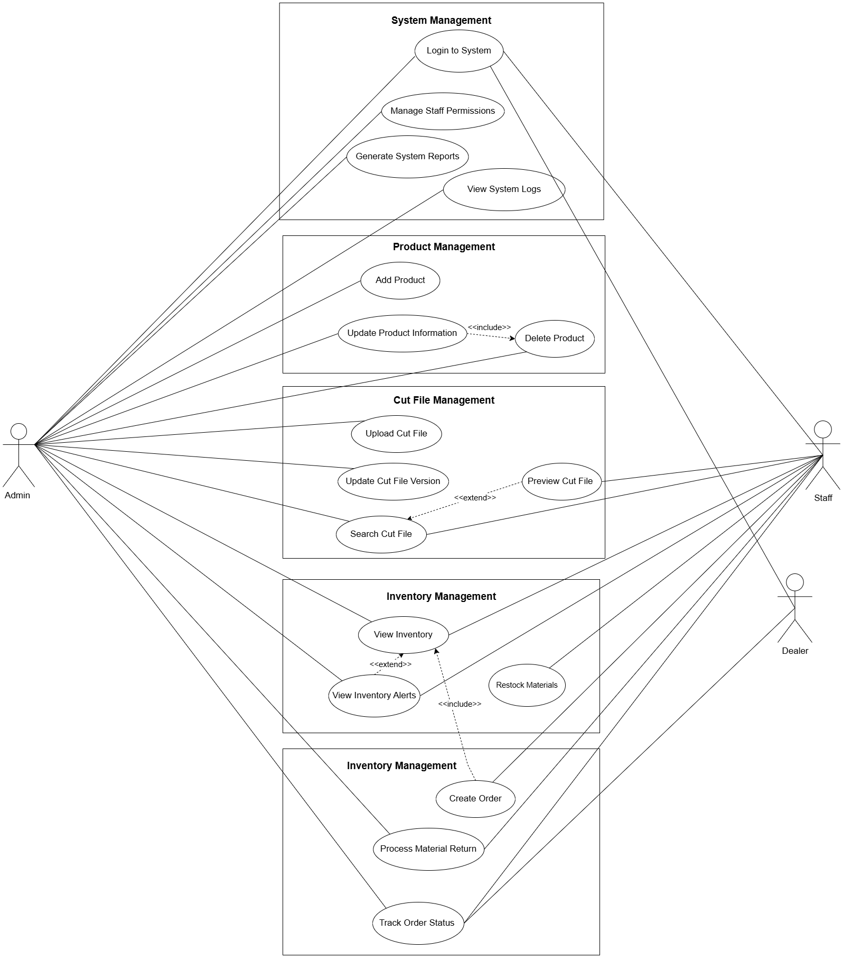
The Use Case Diagram illustrates the functional scope of the Pwrap Management System, emphasizing a secure B2B operational model.
- Actors & Access Control:
  - Admin: Possesses full administrative rights. Through Generalization, the Admin inherits all functions of the Staff.
  - Staff: Responsible for daily operations, including inventory, digital asset management, and B2B order processing.
  - Dealer (Client): Represents the B2B customers. To enforce strict intellectual property (IP) protection and prevent unauthorized file leaks, the Dealer's access is strictly limited to Login to System and Track Order Status. They are intentionally restricted from previewing or accessing the Cut File library directly.
- Functional Relationships:
  - <<include>>: Used for mandatory dependent steps. For example, "Add Product" strictly includes "Update Product Information" to ensure data completeness at initialization.
  - <<extend>>: "Restock Materials" extends "View Inventory," signifying that restocking is a conditional action triggered only when the Staff identifies low physical stock levels.

2.9.2. CLASS DIAGRAM
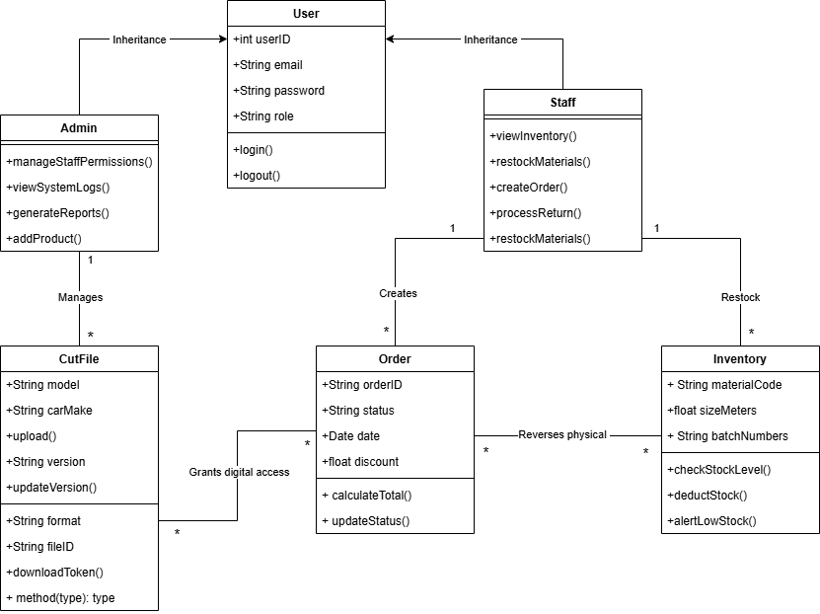
The Class Diagram defines the static structure, attributes, and behavioral methods within the system.
- Inheritance (RBAC): The User class acts as a base class containing shared attributes (email, password). Admin and Staff inherit from User, allowing for a clean implementation of Role-Based Access Control (RBAC).
- Asset Encapsulation: The system separately manages two distinct types of assets:
  - CutFile manages digital properties (model, format) and handles secure access via the downloadToken() method.
  - MaterialInventory manages physical stock measured in linear meters and encapsulates automated logic via checkStockLevel() and alertLowStock().
- Composition & Integrity: The Order class has a strict 1-to-many composition with OrderDetail. This ensures that order items cannot exist independently without a parent order, maintaining absolute referential data integrity during the sales process.

2.9.3. SEQUENTIAL DIAGRAM
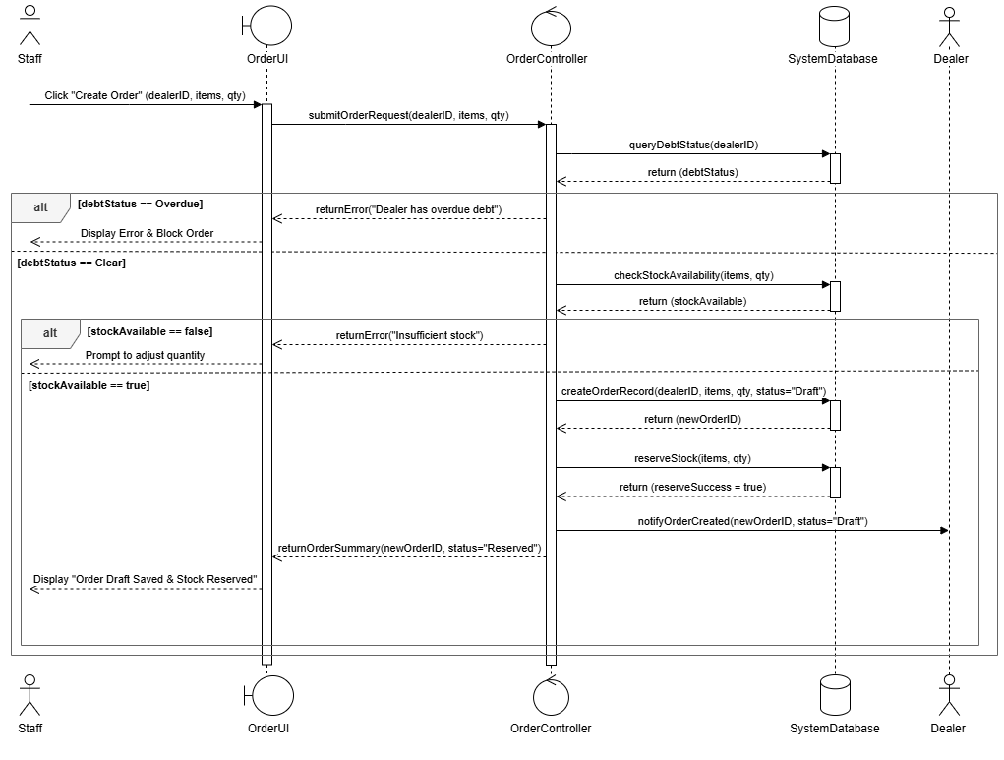

This Sequence Diagram illustrates the dynamic 3-layer interaction (UI -> Controller -> Database) during the B2B Order Creation process.
- Strict Business Validation (Guard Clauses): Before any transaction is saved, the OrderController executes two critical automated checks. First, it queries DebtStatus to block the order if the Dealer has an overdue balance. Only if clear, it proceeds to check StockAvailability. This branching logic (alt blocks) prevents financial risks and system errors.
- State Transition (Reservation Logic): To maintain absolute inventory accuracy, the Database does not deduct stock immediately upon order creation. Instead, it triggers a reserveStock operation. The order is saved as "Draft/Pending", and the physical stock is locked (Reserved) to prevent concurrent overselling while waiting for final payment confirmation.
- Automated Notification: Once the transaction is successfully recorded and the stock is reserved, the Controller automatically triggers a notifyOrderCreated event to the Dealer, ensuring seamless B2B communication without manual Staff intervention.

2.9.4. ACTIVITY DIAGRAM
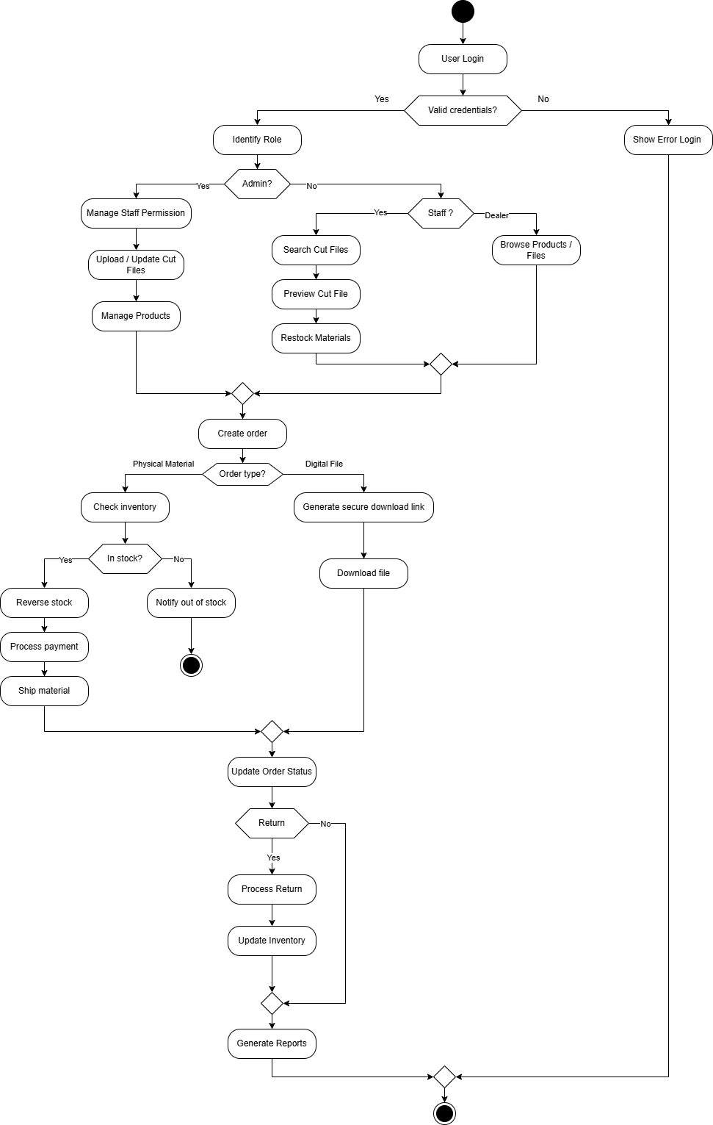
The end-to-end workflow of the Pwrap system begins with authentication (User Login).
Role-Based Navigation: Upon a successful login, the system determines the user's role (Identify Role) and routes them to specialized functions:
Admin: Manages system settings and products.
Staff: Operates inventory and cut files.
Dealer: Browses products and files.

Core Process: All individual user flows eventually converge at the central operation: Create order.

Dynamic Branching: At this stage, the process smartly branches depending on the order type:
- Physical Material: The system verifies inventory, reserves the items (Reverse stock), processes the payment, and ships the material.
- Digital File: The system immediately provides access by creating a secure token (Generate secure download link).
Post-Order Workflow: The cycle wraps up by updating the overall order status, handling any return requests if applicable (Process Return), and finally extracting data (Generate Reports), which concludes the lifecycle of the session.

2.10. ER DIAGRAM
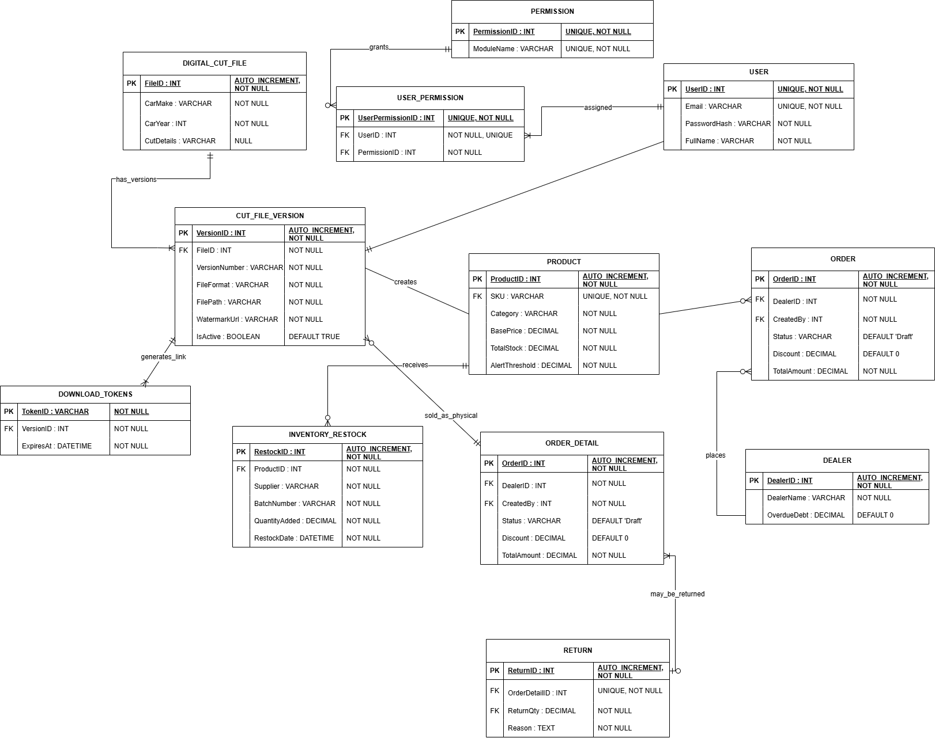
The Entity-Relationship Diagram (ERD) is categorized into five primary logical modules:
- Security & Access Control (USERS, PERMISSIONS, USER_PERMISSIONS): Implements a granular Role-Based Access Control (RBAC) mechanism. It securely stores internal workforce credentials and tracks active sessions to prevent unauthorized concurrent logins.
- B2B Customer Management (DEALERS): Isolates external wholesale clients from internal users. It tracks critical master data and financial constraints, such as overdue debt balances, which dictate order eligibility.
- Digital Asset Vault (DIGITAL_CUT_FILES, CUT_FILE_VERSIONS, DOWNLOAD_TOKENS): Safeguards the company’s proprietary vector files. It utilizes strict version control to archive historical patterns and generates time-expiring download tokens to prevent unauthorized IP sharing or leaks.
- Physical Inventory Tracking (PRODUCTS, INVENTORY_RESTOCKS): Manages physical wrap materials down to the linear meter. It tracks real-time stock levels, triggers low-stock thresholds, and maintains an immutable audit log of incoming batches and suppliers.
- Order Fulfillment (ORDERS, ORDER_DETAILS, RETURNS): Acts as the transactional core, seamlessly handling "hybrid" shopping carts. It dynamically associates a single order with either physical stock deductions (via ProductID) or secure digital file access (via VersionID). It also securely processes and audits defective physical returns.
Referential integrity is enforced across all modules via strict Foreign Key (FK) constraints, preventing orphaned records (e.g., an Order cannot exist without a valid Dealer). While data validation is achieved through utilizing database-level constraints (NOT NULL, UNIQUE, CHECK > 0) to prevent negative inventory values, duplicate SKUs, and redundant user permission assignments.

2.11. ASSUMPTIONS AND DEPENDENCIES

2.11.1 Assumptions
- Users have basic computer and web application knowledge.
- Stable internet and internal network are available.
- Required server infrastructure will be prepared before deployment.
- Initial inventory and digital file data are accurate for migration.
- Management supports system adoption and provides necessary training.

2.11.2 Dependencies
- Availability of hosting environment (Cloud or On-Premise).
- Operational relational database system.
- Proper network, firewall, and HTTPS configuration.
- Backup and recovery system setup.
- Third-party services (e.g., payment gateway) if implemented in future phases.

