- Employees earning above their department average

SELECT e.EmployeeID, e.FirstName, e.Salary, e.DepartmentID
FROM Employees e
WHERE e.Salary > (
SELECT AVG(Salary)
FROM Employees
WHERE DepartmentID = e.DepartmentID
);
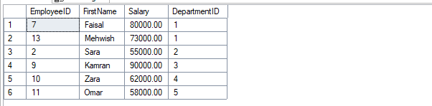
- Employees earning the highest salary in the company

SELECT EmployeeID, FirstName, Salary
FROM Employees
WHERE Salary = (SELECT MAX(Salary) FROM Employees);
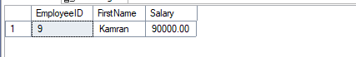

- Employees assigned to at least one project

SELECT EmployeeID, FirstName
FROM Employees
WHERE EmployeeID IN (
SELECT EmployeeID FROM EmployeeProjects
);
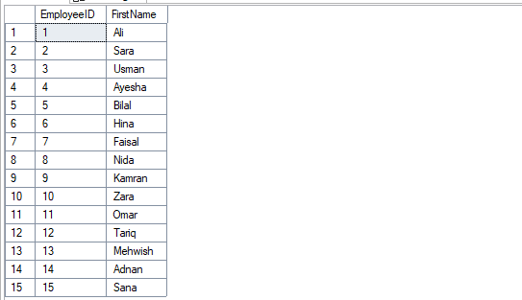
- Employees who have NEVER received a salary increase

SELECT EmployeeID, FirstName
FROM Employees
WHERE EmployeeID NOT IN (
SELECT EmployeeID FROM SalaryHistory
);
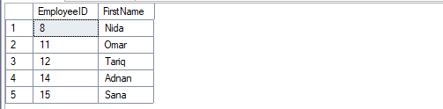
- Employees who worked on project "ERP System"

SELECT EmployeeID, FirstName
FROM Employees
WHERE EmployeeID IN (
SELECT EmployeeID
FROM EmployeeProjects
WHERE ProjectID = (
SELECT ProjectID
FROM Projects
WHERE ProjectName = 'ERP System'
)
);
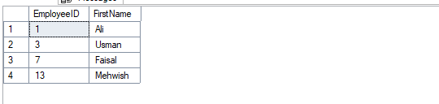

- Employees who exist in SalaryHistory (have changes recorded)

SELECT EmployeeID, FirstName
FROM Employees
WHERE EXISTS (
SELECT 1
FROM SalaryHistory
WHERE SalaryHistory.EmployeeID = Employees.EmployeeID
);
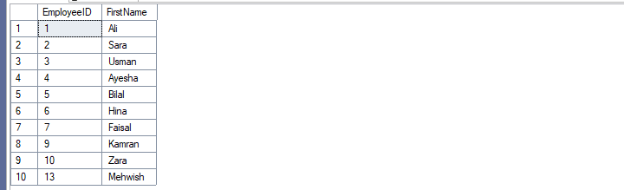
- Employees who are in the same department as 'Ali'

SELECT EmployeeID, FirstName, DepartmentID
FROM Employees
WHERE DepartmentID = (
SELECT DepartmentID
FROM Employees
WHERE FirstName = 'Ali'
);
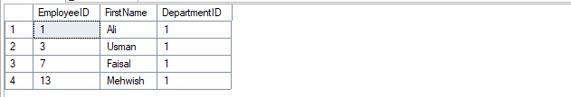

- Employees who are NOT in the same department as 'Sara'

SELECT EmployeeID, FirstName
FROM Employees
WHERE DepartmentID <> (
SELECT DepartmentID
FROM Employees
WHERE FirstName = 'Sara'
);
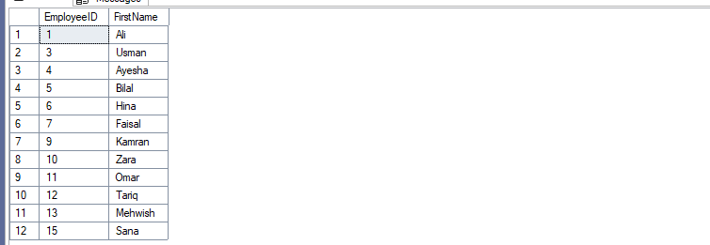

- Employees who exist in both EmployeeProjects and SalaryHistory

SELECT EmployeeID, FirstName
FROM Employees
WHERE EmployeeID IN (
SELECT EmployeeID FROM EmployeeProjects
)
AND EmployeeID IN (
SELECT EmployeeID FROM SalaryHistory
);
