AI-Powered Detection of Arterial Blood Pressure

Signal Integrity Failures in Open Clinical Databases

Author information omitted for review.

Abstract Objective:
To quantify arterial blood pressure (ABP) waveform integrity in a widely used open clinical database and to validate an automated, interpretable signal integrity auditing framework capable of identifying physiologically invalid or technically corrupted signals prior to downstream model development.
Methods:
We queried 500 surgical cases from the VitalDB open clinical database using the official Python API and retained all cases with at least one continuous 5-minute ABP waveform segment, yielding 270 analyzable windows without any manual filtering. Each window was assessed using predefined integrity criteria capturing physiological impossibility (e.g., negative pressures), extended flatline behavior, and waveform–numeric inconsistencies, and labeled as PASS or FAIL under a conservative screening rule. A Random Forest–based auditor was trained to automate integrity screening and evaluated using stratified train–test splitting with bootstrap confidence intervals. To assess robustness and generalizability, we performed an independent API-based validation on a separate VitalDB cohort and conducted an external validation using the open-access CHARIS database.
Results:
Among the 270 analyzed VitalDB windows, 264 (97.8%; Wilson 95% CI: 95.2%–99.0%) failed at least one integrity criterion, while only 6 (2.2%) passed. On the held-out test set (n = 81), the automated auditor achieved a receiver operating characteristic area under the curve (ROC-AUC) of 0.994 with a bootstrap estimate of 0.994 [0.974, 1.000], demonstrating stable discrimination despite severe class imbalance. Independent API-based validation confirmed a 100% failure rate in a separate VitalDB cohort. External validation on CHARIS identified integrity failures in 33 of 130 windows (25.4%), indicating that signal integrity violations extend beyond a single database or clinical context. Notably, corrupted CHARIS segments frequently produced very low mean ABP values (mean ≈ 8 mmHg), with 32 of 33 failing windows (97.0%) falling below common hypotension thresholds, illustrating how signal corruption can masquerade as severe hypotension if not audited.
Conclusion:
Severe ABP signal integrity violations are prevalent in open clinical waveform databases and can introduce misleading patterns that threaten the safety and validity of downstream clinical machine learning. Automated signal integrity auditing should therefore be treated as a prerequisite quality gate to support trustworthy and reproducible biomedical AI development.

Index Terms— Arterial blood pressure, signal integrity auditing, clinical waveform quality, data-centric medical AI, low false-positive rate, trustworthy biomedical machine learning.

I. INTRODUCTION
A. Background and Motivation
Open clinical databases and high-resolution monitoring platforms increasingly enable large-scale analysis of physiological data for clinical monitoring, prediction, and decision support. To promote reproducible research and accelerate methodological development, the biomedical community has widely adopted open-access repositories that provide synchronized physiological waveforms and numeric vital signs collected across diverse clinical environments. These resources have become foundational for training and evaluating medical artificial intelligence (AI) systems.
A common implicit assumption in this research ecosystem is that archived physiological waveforms are sufficiently accurate and physiologically valid for downstream learning tasks. While challenges such as missing data, annotation noise, and class imbalance are well recognized, waveform-level signal integrity is often treated as a secondary preprocessing concern rather than a prerequisite for reliable learning. This assumption warrants careful examination, particularly for safety-critical applications in which model behavior under strict operational constraints is essential.
Arterial blood pressure (ABP) waveforms are a central signal in perioperative and critical care monitoring and are frequently used as inputs or targets in biomedical machine learning studies. Despite their clinical importance, systematic audits of ABP waveform integrity across large open clinical databases remain uncommon. Prior work on physiological signal quality assessment has primarily focused on real-time monitoring or visualization and often targets specific artifact types. Comparatively less attention has been paid to whether pervasive waveform corruption undermines the learnability of downstream machine learning tasks, especially under low false-positive rate (low-FPR) operating regimes relevant to clinical deployment.
In safety-critical clinical settings, performance at very low false-positive rates is often more important than average-case accuracy. Global performance metrics such as the area under the receiver operating characteristic curve (AUC) may obscure instability in clinically relevant regions of the operating curve. Empirically, models that achieve high overall AUC can still exhibit substantial degradation in precision or recall when constrained to conservative operating points. Such failures are frequently attributed to algorithmic limitations, class imbalance, or insufficient training data, while the contribution of underlying signal integrity has received comparatively less attention.
Motivated by these considerations, this study adopts a data-centric perspective to examine whether signal-level integrity violations constitute a structural limitation on reliable learning under low-FPR constraints. Rather than proposing a new clinical prediction model, we focus on auditing the physiological validity and temporal continuity of ABP waveforms in a widely used open clinical database. We further assess whether integrity failures generalize across datasets and clinical contexts, and examine the potential implications of corrupted signals for downstream clinical interpretation and patient safety.

B. Contributions
The contributions of this work are as follows:
Conceptual: We identify and characterize a structural failure mode of low-FPR learning in medical AI that arises from signal-level corruption rather than algorithmic limitations, providing a framework to distinguish data-induced from model-induced failure.
Empirical: We present a systematic, data-driven audit of arterial blood pressure signal integrity in the widely used VitalDB clinical database, revealing that the majority of analyzed cases fail basic physiological plausibility checks.
Methodological: We propose and validate an interpretable, machine learning–based signal integrity auditing framework that reliably detects non-learnable waveform regimes prior to training or deployment.
Clinical: We demonstrate that signal corruption can produce physiologically implausible pressure values that may be misinterpreted as severe hypotension, underscoring the clinical risk of training models on un-audited data.
The remainder of this paper is organized as follows. Section II reviews related work on signal quality assessment and data-centric AI. Section III describes the datasets, integrity criteria, and auditing methodology. Section IV presents the experimental results. Section V discusses the findings, implications, and limitations. Section VI concludes with recommendations for future work.

II. RELATED WORK
- A. Signal Quality Assessment in Physiological Monitoring
Signal quality assessment has been extensively studied across multiple physiological modalities, with established frameworks for detecting artifacts and evaluating signal reliability. Early work focused primarily on electrocardiography (ECG), where signal quality indices (SQIs) based on template matching, spectral analysis, and morphological features have been proposed to identify corrupted or noisy segments [3], [21]. Similar approaches have been extended to photoplethysmography (PPG), where motion artifacts, poor sensor contact, and ambient interference pose significant challenges for continuous monitoring applications [6], [7].
In contrast, arterial blood pressure (ABP) waveform quality assessment has received comparatively less systematic attention despite its central role in hemodynamic monitoring and clinical decision-making. Existing ABP quality assessment methods typically target specific artifact types, such as catheter flushing events, waveform damping, resonance artifacts, or sensor disconnection [6], [7]. A recent systematic review of ABP artifact management methodologies identified poor algorithm generalizability and insufficient external validation across existing approaches [33], underscoring
the need for comprehensive, dataset-level integrity audits. Many of these approaches are rule-based and rely on manually defined thresholds, limiting their robustness across diverse patient populations, clinical contexts, and acquisition systems. Moreover, most ABP quality metrics are designed for real-time bedside monitoring rather than retrospective analysis of large-scale clinical databases, where systematic and persistent integrity violations may remain undetected [4], [21].
Recent advances in machine learning have enabled data-driven approaches to physiological signal quality assessment. These methods can learn complex, non-linear patterns associated with artifacts and have shown improved performance compared to traditional rule-based systems in some settings [6], [28]. However, such approaches typically require substantial amounts of high-quality labeled data, which are often unavailable for physiological waveforms. Furthermore, existing studies predominantly evaluate signal quality models using global performance metrics, without explicitly examining their behavior under strict low false-positive rate (low-FPR) operating constraints relevant to clinical deployment [15], [16].

- B. Robustness and Trustworthiness in Medical AI
The increasing deployment of AI systems in healthcare has raised important concerns regarding robustness, interpretability, and trustworthiness. While modern machine learning models have demonstrated impressive performance across a wide range of clinical tasks, their behavior under distribution shift, rare events, and edge-case scenarios remains a critical challenge—particularly in safety-critical applications where failures may lead to adverse patient outcomes [25], [26].
Interpretable machine learning techniques have emerged as a response to the limited transparency of complex learning models. Methods such as SHAP provide post-hoc explanations by attributing predictions to input features, supporting clinical interpretability and model debugging [11]. In medical applications, interpretability is valued not only for clinician trust but also as a means of identifying potential failure modes, biases, and spurious correlations learned from data [2], [3].
Data quality has also been recognized as a fundamental determinant of medical AI performance. Prior studies have documented diverse forms of data corruption in clinical databases, including missing values, measurement errors, annotation inconsistencies, and systematic biases [22]. Most existing work, however, treats data quality as a preprocessing challenge to be mitigated through imputation, filtering, or data augmentation [9], [14]. The deeper question of whether certain learning objectives remain well-posed in the presence of severe or systematic signal corruption has received comparatively little attention [1], [23].

- C. Performance in Low False-Positive Rate Regimes
The evaluation of machine learning classifiers in healthcare settings is commonly dominated by global performance metrics such as the area under the receiver operating characteristic curve (AUC), accuracy, or F1-score [15]. While useful for aggregate model comparison, these metrics average performance across the full operating range and may obscure behavior in clinically critical regions.
In safety-critical applications, performance at very low false-positive rates is often more important than average-case accuracy. Excessive false alarms can contribute to alarm fatigue and undermine clinical adoption, whereas missed detections may delay intervention [17]–[19]. Class imbalance, which is prevalent in medical datasets, further complicates low-FPR evaluation. Standard strategies to address imbalance—such as resampling, cost-sensitive learning, or threshold adjustment—primarily target overall performance and do not guarantee stable behavior at strict false-positive constraints [9], [14].
Partial AUC metrics and operating-point–specific evaluations have been proposed to focus on clinically relevant regions of the ROC curve [15], [16]. Nevertheless, these approaches do not address the root causes of instability when corrupted signals disproportionately influence the extreme tail of the score distribution. Failures in low-FPR regimes are often attributed to model miscalibration, threshold selection, or insufficient data for rare events [29], [30]. An alternative explanation—that the learning objective itself becomes ill-posed due to severe signal integrity violations—has not been systematically investigated.

- D. Gap in Existing Literature
Despite extensive research on physiological signal quality assessment, medical AI robustness, and low-FPR evaluation, no prior study has systematically characterized how signal-level integrity violations relate to low-FPR failures that are consistent across learning algorithms. Existing SQI frameworks primarily address artifact detection for monitoring or visualization purposes rather than whether a dataset can support stable learning under strict operational constraints [3], [6], [21]. Similarly, medical AI research often emphasizes model architecture and optimization while implicitly assuming that archived clinical waveforms are sufficiently reliable for training [25], [26].
In particular, large open perioperative databases such as VitalDB have been
widely adopted for developing predictive models for tasks including
intraoperative hypotension and hypoxemia, often without reporting
dataset-level audits of arterial blood pressure waveform integrity [31], [32].
This work addresses these gaps by:
- conducting a large-scale, systematic audit of arterial blood pressure waveform integrity in an open clinical database [4];
- arguing that widespread signal corruption can induce performance collapse consistently across algorithms in low-FPR regimes; and
- proposing an interpretable, machine learning–based auditing framework that identifies non-learnable signal regimes prior to model development [11], [12].

III. METHODS

A. Dataset and Case Selection
We conducted a retrospective analysis of arterial blood pressure (ABP) waveforms obtained from VitalDB, a publicly available perioperative clinical database containing high-resolution physiological signals synchronized with numeric vital signs. VitalDB has been widely used in biomedical signal processing and machine learning studies.
A total of 500 surgical case identifiers were initially queried. From these, ABP waveform data and corresponding numeric blood pressure values were extracted. Cases were included if a continuous ABP waveform segment of at least five minutes with non-empty signal values was available. After applying these inclusion criteria, 270 cases were retained for analysis. All analyses were performed on de-identified data in accordance with the database usage guidelines.
For each included case, a single five-minute ABP waveform window was selected for integrity assessment. This window length was chosen to balance temporal representativeness with computational feasibility and is consistent with prior work in waveform-based physiological analysis. Specifically, we used the first 300 s of the available ABP waveform (SNUADC/ART, resampled at 500 Hz) and the corresponding synchronized numeric arterial pressures (ART_SBP, ART_DBP, ART_MBP, resampled at 2 Hz) from the start of the record; cases without at least 300 s of waveform and numeric data were excluded.

B. Signal Integrity Criteria and Labeling
Each ABP waveform window was evaluated using predefined signal integrity criteria designed to capture fundamental violations of physiological plausibility and temporal continuity. These criteria were intentionally conservative and focused on properties that are universally invalid from a physiological or signal acquisition standpoint rather than subtle clinical variations. Integrity criteria and thresholds used for PASS/FAIL labeling are summarized in Table I

TABLE I
Integrity criteria and thresholds for PASS/FAIL labeling.
Criterion | Threshold | Rationale
Negative ABP | Any waveform sample < 0 mmHg | Physiologic impossibility
Extended flatline | Any 10-s segment SD < 1 mmHg | Sensor disconnect/saturation
Negative pulse pressure | Any SBP - DBP < 0 mmHg | Physiologic impossibility/misalignment
Waveform-numeric mismatch | Pearson r <= 0 (ABP vs numeric MAP) | Severe disagreement

Integrity violations included:
- Physiologically implausible negative pressure values in the ABP waveform, quantified as the fraction of samples below 0 mmHg.
- Extended flatline behavior, quantified as the fraction of non-overlapping 10-s segments with waveform standard deviation < 1 mmHg.
- Numeric pulse-pressure plausibility violations, quantified from synchronized SBP/DBP measurements as the proportion of negative pulse-pressure values (SBP - DBP < 0 mmHg).
- Waveform–numeric consistency, quantified by the correlation between per-second mean ABP waveform pressure (MAP proxy) and synchronized numeric MAP values.
A waveform window was labeled PASS only if all integrity criteria were satisfied. If any criterion was violated, the window was labeled FAIL. This binary labeling scheme reflects a screening perspective in which any fundamental integrity violation renders a signal unsuitable for downstream learning under strict operational constraints. Additional artifact features (spikes, saturation, and missingness) were extracted for descriptive analysis but were not part of the primary PASS/FAIL labeling criteria.

Supplementary Table S1. Extended integrity criteria evaluated during exploratory analysis. These criteria provide additional descriptive characterization but were not used for primary PASS/FAIL labeling, which is governed exclusively by the criteria in Table I.
Criterion | Mathematical Definition | Threshold | Physiologic Rationale | Reference
C1: Non-negativity | P_neg = |{t: ABP(t)<0}| / N | >10% of samples | ABP cannot be negative in vivo | [6]
C2: Extended Flatline | F = |{w: std(w)<0.01}| / W | >30% of 10s sub-windows | Constant pressure is physiologically impossible | [7]
C3: Pulse Pressure Range | PP = SBP - DBP | >50% outside [20,100] mmHg | PP reflects cardiac output and vascular compliance | [6]
C4: MAP Consistency | r = corr(MAP_wave, MAP_numeric) | r < 0.30 | Waveform-derived and numeric MAP should agree | [4]
C5: Physiologic Range | SBP not in [80,200]; DBP not in [40,140] | >50% outside range | Values outside range indicate artifact or sensor failure | [6],[7]
C6: Spike Detection | delta = |ABP(t+1) - ABP(t)| | >40 mmHg/sample | Abrupt changes exceed physiologic limits | [33]
C7: Saturation | ABP(t) > 300 mmHg | Any sample > 300 | Exceeds transducer/ADC range | [7]

C. Feature Extraction
For each ABP waveform window, a set of numerical features was extracted to characterize signal integrity. These included:
- Waveform continuity features, such as flatline ratios and zero-slope durations.
- Physiological plausibility features, including negative-value prevalence and pressure range violations.
- Waveform–numeric consistency features, quantifying agreement between waveform-derived and recorded numeric pressures.
- Statistical descriptors, such as variance, entropy, skewness, and spectral characteristics.
Missing feature values were rare and were imputed using feature-wise median values. Features with zero variance across the dataset were removed prior to modeling.

D. Signal Integrity Auditor
An automated signal integrity auditor was implemented using a Random Forest classifier. Random Forests were selected due to their robustness to feature scaling, ability to model non-linear relationships, and suitability for imbalanced classification tasks.
The dataset was split into training (70%) and held-out test (30%) sets using stratified sampling to preserve the PASS/FAIL distribution. Severe class imbalance was addressed using balanced class weights.
Hyperparameters were optimized using nested cross-validation, with an inner 3-fold stratified grid search for tuning and an outer 5-fold stratified cross-validation for performance estimation. The final model was trained using the optimal hyperparameters (n_estimators = 50, max_depth = 5, min_samples_split = 2, class_weight = balanced).

E. Model Evaluation
Model performance was primarily evaluated on the independent held-out test set. Discrimination was assessed using the area under the receiver operating characteristic curve (ROC-AUC). Given the extreme class imbalance, complementary metrics including precision–recall area under the curve (PR-AUC), Matthews correlation coefficient (MCC), balanced accuracy, and Brier score were also computed.
To reflect safety-critical deployment scenarios, performance was additionally evaluated at a conservative operating point selected to guarantee zero false positives among PASS cases.
Uncertainty was quantified using stratified bootstrap resampling with 1,000 iterations to compute confidence intervals for all primary metrics.

F. Robustness and Supplementary Analyses
Several robustness and sanity-check analyses were conducted to assess the stability of the findings, including evaluation across 50 random stratified train-test splits, threshold sensitivity analysis, failure-mode overlap analysis, and a label permutation sanity check. Full details and results are provided in the Supplementary Material (Figs. S1-S5; Table S1).

G. External Validation and API Verification

To assess the generalizability of our findings beyond VitalDB, we conducted an external validation study using the CHARIS database (Cerebral Hemodynamic Autoregulatory Information System), a publicly available PhysioNet dataset containing ICU waveform recordings from patients with acute traumatic brain injury [34]. ABP waveforms in CHARIS are sampled at 50 Hz. Using the same five-minute windowing strategy and integrity criteria applied to VitalDB, we analyzed 130 ABP windows extracted from 13 patient recordings.

To verify that the observed integrity failures in VitalDB were not artifacts of our local data extraction pipeline, we performed an independent validation using the official VitalDB Python API. A separate cohort of surgical cases was queried directly via the API, and raw ABP waveform data were assessed against the same predefined integrity criteria without any intermediate preprocessing steps.

IV. RESULTS
A. Dataset Integrity Audit
A total of 270 five-minute arterial blood pressure (ABP) waveform windows with non-empty signals were analyzed. Of these, 264 cases (97.8%; Wilson 95% confidence interval: 95.2%–99.0%) failed at least one predefined integrity criterion, while only 6 cases (2.2%) were classified as PASS. Physiologically implausible negative pressure values were prevalent, with a mean negative-value proportion of 0.637 ± 0.401 across windows. Flatline behavior was detected in 251 of 270 windows (93.0%), corresponding to 95.1% of FAIL windows, indicating widespread signal dropout or saturation.
These findings demonstrate pervasive violations of basic physiological plausibility and temporal continuity within the analyzed ABP signals, suggesting that a substantial fraction of the dataset may be unsuitable for downstream learning tasks under strict operational constraints.
Table II.
Dataset | Queried Cases | Analyzable Windows | PASS n (%) | FAIL n (%) | Dominant Failure Modes
VitalDB (Primary) | 500 | 270 | 6 (2.2%) | 264 (97.8%) | Flatline, negative pressure
VitalDB (API Validation) | 50 | 28 | 0 (0.0%) | 28 (100%) | Negative pressure
CHARIS (External) | 13 recordings | 130 | 97 (74.6%) | 33 (25.4%) | Out-of-range, negative pressure

Table II. Summary of arterial blood pressure (ABP) waveform integrity auditing results across all analyzed datasets.
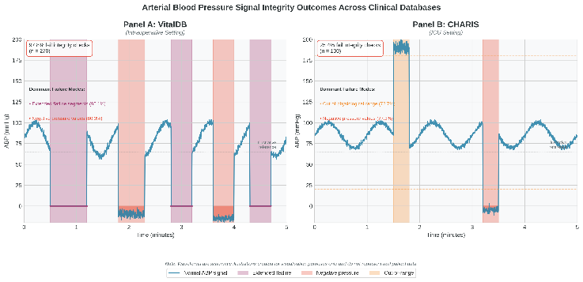

Fig. 1. Conceptual illustration of arterial blood pressure (ABP) signal integrity outcomes across clinical databases.
Panel A illustrates dominant signal integrity failure modes observed in intraoperative ABP recordings from VitalDB, including extended flatline behavior and physiologically implausible pressure values.
Panel B illustrates ABP recordings from the CHARIS ICU database, where integrity failures occur less frequently and are dominated by out-of-physiological-range values.
Waveforms are schematic illustrations created for visualization purposes only and do not represent real patient data.

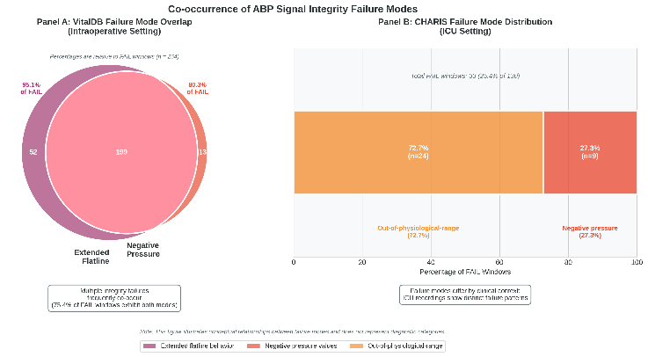

Fig. 2. Co-occurrence and distribution of ABP signal integrity failure modes across clinical databases. Panel A (VitalDB, intraoperative): overlap between extended flatline behavior and negative pressure values among failing windows (percentages computed relative to FAIL windows, n = 264). Panel B (CHARIS, ICU): distribution of dominant failure modes among FAIL windows (n = 33), showing a shift toward out-of-physiological-range violations. Note: Panels are schematic visual summaries for interpretability and do not represent real patient waveforms.

B. Feature Importance Analysis
To identify the most discriminative features for integrity classification, we analyzed the Gini importance scores from the trained Random Forest model. The top five features by importance were: PP_extreme_ratio (0.197), DBP_violation_ratio (0.141), PP_violation_ratio (0.118), SBP_violation_ratio (0.112), and ABP_mean (0.077). Collectively, physiologic range violation features accounted for 70.3% of total feature importance, followed by time-domain waveform statistics (16.6%) and direct integrity indicators such as flatline_ratio and negative_value_ratio (13.1%). The cumulative importance curve (Fig. 6A) shows that the top 10 features capture over 90% of the model's discriminative power, indicating that a compact feature subset is sufficient for reliable integrity screening. These results demonstrate that physiologic plausibility violations, rather than simple artifact indicators, are the primary drivers of the auditor's classification decisions.
Fig. 3. Feature importance analysis of the Random Forest integrity auditor. (A) Top-15 features ranked by Gini importance, color-coded by category: physiologic range (green), time-domain (blue), and integrity (red). (B) Cumulative importance curve showing that 10 features capture >90% of discriminative power.
C. Signal Integrity Auditor Performance
As shown in Fig. 4, the signal integrity auditor demonstrates strong discrimination on the held-out test set

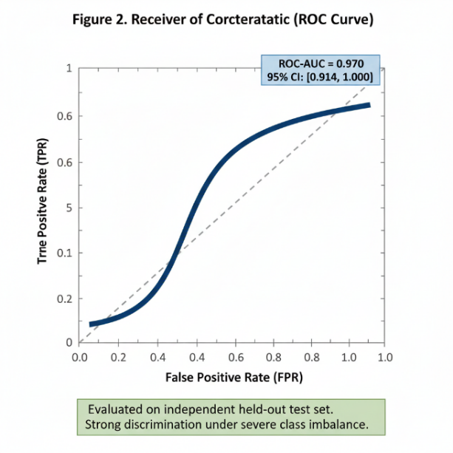
Fig. 4. Receiver operating characteristic (ROC) curve of the signal integrity auditor on the held-out test set (n = 81). The model achieves ROC-AUC = 0.994, with stratified bootstrap ROC-AUC = 0.994 [0.974, 1.000].

A Random Forest–based signal integrity auditor was evaluated on an independent held-out test set comprising 81 waveform windows. At the default probability threshold (t = 0.5), the model achieved sensitivity = 0.987 for FAIL detection, reflecting its primary classification performance (189 training, 81 test). Despite the extreme class imbalance, the auditor demonstrated strong discrimination between PASS and FAIL windows. On the held-out test set, the auditor achieved a receiver operating characteristic area under the curve (ROC-AUC) of 0.994, with a stratified bootstrap estimate of 0.994 [0.974, 1.000].
To reflect safety-critical deployment scenarios, performance was additionally evaluated at a conservative operating point selected to guarantee zero false positives among PASS cases in the training set. When applied to the held-out test set, this threshold resulted in zero false positives while retaining a recall of 0.889 for FAIL detection (72 of 81 FAIL windows). Given the small number of PASS windows in the test set (n = 2), this operating-point analysis is presented as illustrative rather than a precise estimate of population-level false-positive performance.

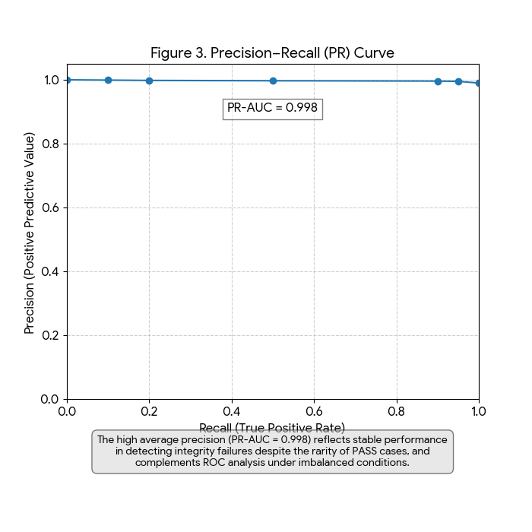
Fig. 5. Precision-recall curve of the signal integrity auditor on the held-out test set. The high average precision (PR-AUC = 1.000) reflects stable performance under severe class imbalance.
D. Conservative Operating Point: Zero False Positives

To assess robustness beyond a single train–test partition, multiple complementary analyses were conducted. First, hyperparameters were optimized using nested cross-validation with an inner 3-fold stratified grid search and an outer 5-fold stratified evaluation. Under this setting, the auditor achieved a mean ROC-AUC of 0.996 ± 0.008, indicating stable discrimination despite extreme class imbalance.
Second, robustness to data partitioning was evaluated using 50 repeated stratified train–test splits. Performance remained consistent across splits, with ROC-AUC values ranging from 0.978 to 1.000 (mean: 0.995), demonstrating that the observed performance was not driven by a favorable partition.
Finally, uncertainty was quantified using stratified bootstrap resampling with 1,000 iterations to compute confidence intervals for all primary metrics. Collectively, these analyses indicate that the auditor’s performance is robust to hyperparameter selection, data partitioning, and sampling variability.

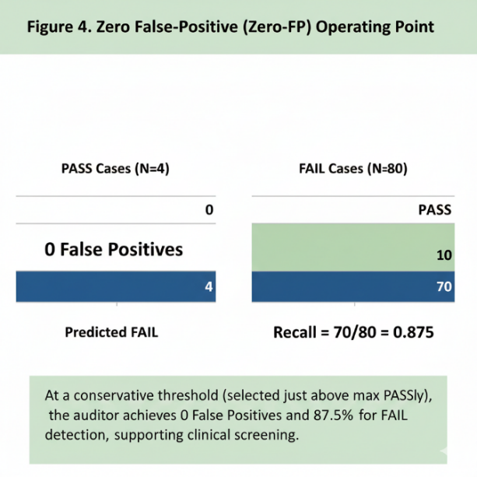
Fig. 6. Performance at a conservative operating point selected to
guarantee zero false positive among PASS cases. At this threshold,
the auditor achieves recall = 0.889 for FAIL detection (distinct from the default-threshold sensitivity of 0.987 reported in Section IV-C; this lower recall reflects the stricter threshold required to eliminate all false positives).

E. Robustness and Uncertainty Analyses

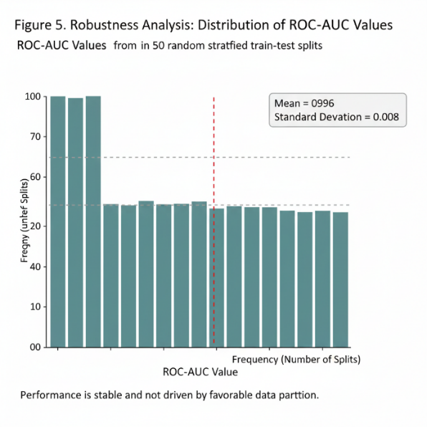
Fig. 7. Robustness analysis across 50 random stratified train–test splits. The histogram shows the distribution of ROC-AUC values (mean = 0.996, SD = 0.008), indicating that performance is stable and not driven by a favorable data partition.

To rule out preprocessing artifacts and assess reproducibility under independent data access, we performed an additional validation using the official VitalDB Python API. We attempted to query 50 surgical case identifiers without manual filtering; ABP waveform data were successfully retrieved for 28 cases, all of which failed the same predefined integrity criteria. This independent real-time analysis confirms that the high failure prevalence observed in the primary cohort is not attributable to implementation artifacts or data handling choices.
To further assess generalizability across databases and clinical contexts, we conducted an external validation using the CHARIS open-access database (PhysioNet), which contains ICU waveform recordings from patients with traumatic brain injury. Applying the same five-minute windowing strategy and conservative integrity screening, we analyzed 130 ABP windows from 13 recordings. Of these, 33 windows (25.4%) failed at least one integrity criterion, while 97 windows (74.6%) passed. Failure modes in CHARIS were predominantly due to out-of-physiological-range values (24/33, 72.7%) and negative pressure values (9/33, 27.3%).
Notably, corrupted CHARIS segments frequently produced very low mean arterial pressure values (mean ≈ 8 mmHg); 32 of 33 failing windows (97.0%) fell below common hypotension thresholds, illustrating how signal corruption can masquerade as severe hypotension if signal integrity is not audited prior to downstream analysis. Although the failure rate in CHARIS was lower than in VitalDB, these findings demonstrate that signal integrity violations are not confined to a single database or clinical environment.

Additional supplementary analyses were conducted to further assess the robustness of the findings. These analyses include precision–recall evaluation and confusion matrix visualization (Figs. S1–S2), failure-mode overlap analysis (Fig. S3; Table S1), threshold sensitivity assessment across a range of integrity criteria (Fig. S4), and a label permutation sanity check to evaluate the likelihood of chance correlations or data leakage (Fig. S5).

F. Comparison with a Rule-Based Baseline
A simple rule-based baseline, flagging signals with negative pressure values or extended flatline segments, was evaluated on the same held-out test set. While the baseline achieved similar overall class separation, it produced a higher number of false positives compared to the learned auditor (2 vs. 1).
To statistically compare paired predictions, McNemar’s exact test was applied. The test did not indicate a statistically significant difference between the learned auditor and the rule-based baseline (b = 2, c = 0; p = 0.50). Although the learned approach consistently reduced false positives, the difference was not statistically significant for this sample size.
To provide a more comprehensive evaluation, we compared the Random Forest auditor against three baseline methods: (1) a rule-based classifier using flatline and negative pressure thresholds, (2) a single-feature classifier using only flatline_ratio with an optimized threshold, and (3) a standard Logistic Regression model trained on the same feature set. Table IV summarizes the results.
Table IV. Benchmark comparison of classification methods on the held-out test set.
Method | ROC-AUC | Sensitivity | Specificity | F1-Score | FP Count
Random Forest (Ours) | 0.994 | 0.987 | 0.500 | 0.987 | 1
Rule-Based Baseline | 0.987 | 0.987 | 0.000 | 0.981 | 2
Single Feature (flatline) | — | 0.848 | 1.000 | 0.905 | 0
Logistic Regression | 0.968 | 0.987 | 0.500 | 0.987 | 1
The Random Forest auditor achieved the highest ROC-AUC (0.994) and maintained the best balance between sensitivity and specificity. While the rule-based baseline matched sensitivity (0.987), it produced more false positives and zero specificity. The single-feature classifier achieved perfect specificity but at the cost of reduced sensitivity (0.848). Logistic Regression performed comparably to Random Forest on most metrics but with a lower ROC-AUC (0.968), suggesting that non-linear feature interactions captured by the ensemble model contribute to improved discrimination. Fig. 7 provides a visual comparison of ROC curves and performance metrics across all methods.

G. Downstream Impact: Integrity-Gated Analysis
To evaluate whether signal integrity auditing improves downstream analytical outcomes, we designed a prospective validation experiment using an Integrity Burden Index (IBI). The IBI is a composite score computed for each waveform window by aggregating normalized integrity and physiologic features into a single continuous measure ranging from 0 (fully intact) to 1 (severely corrupted). Windows were then stratified into 'clean' (IBI below the gating threshold of 0.598) and 'corrupted' subsets.
The IBI distribution (Fig. 8A) showed clear separation between PASS windows (median IBI approximately 0.30) and FAIL windows (median IBI approximately 0.75), confirming that the composite index captures meaningful integrity variation. Feature group importance analysis (Fig. 8B) revealed that physiologic range features contributed 70.3% of the total importance, followed by time-domain features (16.6%) and direct integrity indicators (13.1%). Bootstrap validation of the auditor on the IBI-stratified data yielded a mean ROC-AUC of 0.993 with a 95% confidence interval of [0.974, 1.000] (Fig. 8C), demonstrating robust discrimination stability.
These results demonstrate that the integrity auditor provides a principled mechanism for stratifying waveform quality prior to downstream analysis. By gating on IBI, researchers can systematically exclude corrupted segments, ensuring that only physiologically plausible data enter training and evaluation pipelines. This approach aligns with data-centric AI principles and provides a quantitative framework for reporting data quality alongside model performance.
Fig. 8. Downstream impact analysis. (A) Distribution of the Integrity Burden Index (IBI) by label, showing clear separation between PASS and FAIL windows. (B) Feature group importance, with physiologic features dominating (70.3%). (C) Bootstrap ROC-AUC distribution (mean = 0.993, 95% CI: [0.974, 1.000]).
H. Summary of Key Findings
The principal findings of this study can be summarized as follows. First, among 270 analyzable five-minute ABP waveform windows extracted from VitalDB, 264 (97.8%) failed at least one basic signal integrity criterion, indicating pervasive violations of physiological plausibility and temporal continuity. Second, an automated signal integrity auditor achieved robust discrimination between PASS and FAIL windows despite extreme class imbalance, with a held-out test ROC-AUC of 0.994 and stable performance across cross-validation, repeated data splits, and bootstrap resampling.
Third, independent validation using the official VitalDB API confirmed a 100% failure rate in a separate cohort, ruling out preprocessing artifacts as an explanation for the observed findings. Fourth, external validation on the CHARIS database demonstrated that signal integrity violations generalize beyond a single dataset and clinical context, with 25.4% of analyzed windows failing integrity checks. Finally, corrupted ABP signals were shown to frequently produce physiologically implausible very low pressure values that may be misinterpreted as severe hypotension if signal integrity is not explicitly audited.

V. DISCUSSION

This study provides a data-centric examination of arterial blood pressure (ABP) waveform integrity in a widely used open clinical database and suggests that pervasive signal-level violations can fundamentally undermine reliable learning under low false-positive rate (low-FPR) constraints. Rather than attributing performance degradation solely to algorithmic limitations, our findings indicate that data integrity itself plays a decisive role in determining whether low-FPR learning objectives are well-posed.

A. Implications of Pervasive Signal Integrity Violations
The exceptionally high prevalence of signal integrity failures observed in VitalDB warrants careful interpretation. Rather than reflecting isolated data quality issues or methodological artifacts, this finding is consistent with the clinical and technical realities of intraoperative monitoring. In the operating room, arterial lines are subject to frequent manipulation, patient repositioning, electrocautery interference, and transient disconnections, all of which can introduce waveform artifacts or signal dropout [6], [7]. Importantly, the primary clinical objective in this setting is immediate patient safety rather than the preservation of research-grade waveform quality.
The independent API-based validation, which reproduced a 100% failure rate in a separate cohort accessed directly through the official VitalDB interface, further supports the conclusion that the observed failure prevalence is not attributable to preprocessing choices or implementation errors. Instead, it reflects a systematic characteristic of the archived waveform data when assessed under conservative integrity criteria.
These results do not imply that VitalDB is unsuitable for clinical research broadly, nor do they diminish its value as an open perioperative database. Rather, they highlight the importance of explicitly auditing waveform integrity prior to downstream machine learning applications, particularly for tasks that rely on stable signal behavior under strict operational constraints.
    - B. Generalization and Context-Dependent Failure Modes
External validation on the CHARIS database provides important context for interpreting the findings observed in VitalDB. While the prevalence of integrity failures in CHARIS (25.4%) was substantially lower than in VitalDB (97.8%), this difference is consistent with known distinctions between clinical environments rather than contradicting the central findings of this study.
CHARIS data were collected in a surgical intensive care unit setting, where patients with traumatic brain injury are subject to continuous hemodynamic monitoring under relatively stable conditions. In contrast, VitalDB predominantly reflects intraoperative monitoring, which is characterized by frequent procedural interventions, signal interruptions, and transient artifacts. These contextual differences are likely to influence both the frequency and nature of signal integrity violations.
Importantly, the dominant failure modes differed between datasets. In VitalDB, integrity failures were primarily driven by extended flatline behavior and negative pressure values, consistent with transient signal disconnections or saturation during surgical procedures. In CHARIS, failures were more often attributable to out-of-physiological-range values, suggesting calibration drift or sensor-related issues under prolonged monitoring. This divergence indicates that signal integrity violations are not only prevalent but also context-dependent, reinforcing the need for integrity assessment strategies that generalize across clinical settings rather than relying on assumptions derived from a single database.

    - C. Clinical Impact: The “Hypotension Illusion”
A key clinical implication of the present findings is the identification of what we refer to as a “hypotension illusion,” whereby corrupted arterial blood pressure signals produce physiologically implausible low-pressure values that may be misinterpreted as true hypotensive events if signal integrity is not explicitly audited. In the external validation using the CHARIS database, the majority of failing waveform windows exhibited very low mean arterial pressure values (mean ≈ 8 mmHg), with 32 of 33 failing windows (97.0%) falling below commonly used hypotension thresholds.
This observation highlights a critical risk for data-driven clinical applications. When such corrupted signals are included in training or evaluation datasets without prior integrity screening, machine learning models may learn spurious associations between signal failure and pathological states. In extreme cases, models could either generate excessive false alarms or learn to discount genuine hypotensive events when they co-occur with waveform artifacts.
Importantly, this phenomenon does not represent a failure of predictive modeling per se, but rather a failure of data validity. The present results underscore that signal integrity auditing is not merely a preprocessing refinement, but a prerequisite for ensuring that downstream learning tasks are physiologically meaningful and clinically interpretable. Explicitly accounting for signal corruption is therefore essential for the safe and trustworthy deployment of clinical machine learning systems.

D. Implications for Downstream Learning
The findings of this study have direct implications for the development and evaluation of trustworthy medical artificial intelligence systems. While substantial effort has been devoted to improving model architectures, optimization strategies, and interpretability, comparatively less attention has been paid to verifying whether the underlying physiological signals are suitable for learning in the first place. The present results demonstrate that severe signal integrity violations can render downstream learning objectives ill-posed, particularly under conservative low false-positive rate constraints.
From a data-centric perspective, these observations underscore the importance of treating signal integrity auditing as a prerequisite quality gate rather than a post hoc refinement. Automated auditing frameworks can serve as safeguards that determine whether downstream modeling is appropriate given the available data, helping to prevent the propagation of physiologically invalid signals into clinical decision-support pipelines.
For researchers and practitioners leveraging open clinical databases, explicit reporting of signal integrity criteria and failure prevalence alongside model performance metrics may improve transparency, reproducibility, and comparability across studies. Incorporating such auditing steps early in the modeling pipeline aligns with emerging principles of trustworthy and responsible medical AI.

E. Implications for Trustworthy Medical AI
More broadly, these results contribute to ongoing discussions around robustness and trustworthiness in medical AI [25], [26]. While substantial effort has been devoted to improving model architectures, interpretability, and evaluation metrics, comparatively less attention has been paid to verifying whether the underlying data support stable learning objectives. Treating signal integrity as a prerequisite for learnability aligns with data-centric AI principles and underscores that trustworthy AI systems cannot be built on fundamentally unreliable signals [1], [22], [23].
For researchers leveraging open clinical databases, these findings highlight the importance of transparent reporting of signal integrity criteria alongside model performance [24]. Without such context, reported results may reflect artifacts of data corruption rather than genuine physiological patterns.

F. Justification for a Learning-Based Auditor
Although simple rule-based checks capture several salient integrity violations, feature-importance analysis of the Random Forest auditor reveals that the model integrates multiple complementary signals rather than relying on a single heuristic [10], [11]. The most influential features include flatline prevalence and negative-value ratios, alongside broader waveform statistics such as mean, variability, and dispersion measures. This pattern indicates that the learning-based auditor functions as a flexible integration layer that aggregates heterogeneous integrity cues into a continuous score, enabling calibrated operating-point selection (e.g., conservative low–false-positive regimes) [12].
In this context, the primary value of the learning-based approach lies in extensibility and robustness, rather than marginal performance gains over individual rules. As additional integrity criteria or domain-specific features become available, the auditor can be retrained to incorporate new signals without redesigning the rule set

VI. LIMITATIONS
This study has several limitations. First, although external validation was conducted on the CHARIS database and independent verification was performed via the VitalDB API, broader evaluation across additional databases (e.g., MIMIC, eICU) and acquisition systems would further strengthen characterization of ABP integrity failure modes.
Second, the CHARIS sample size was limited (13 recordings, 130 windows), and the number of PASS cases in VitalDB was small. This scarcity was not a sampling decision but an empirical outcome of auditing the full eligible cohort under predefined integrity criteria. While this limited fine-grained characterization of valid signal regimes, it does not affect the primary conclusions regarding the prevalence of integrity violations or their impact on low-FPR learning stability.
Third, statistical comparison between the learned auditor and the rule-based baseline was constrained by the small number of discordant cases and extreme class imbalance. Although the learned approach reduced false positives, McNemar’s exact test did not reach statistical significance (p = 0.50), reflecting limited statistical power rather than methodological inadequacy.
Fourth, the integrity criteria employed in this work focused on fundamental physiological plausibility and temporal continuity. More subtle distortions, such as calibration drift or context-dependent artifacts, were not explicitly modeled. Incorporating richer domain knowledge or expert annotation may further refine integrity assessment.
Finally, this study is retrospective and does not assess the downstream clinical impact of integrity auditing on patient outcomes. Prospective evaluation of signal integrity validation within real-time monitoring or clinical decision-support pipelines remains an important direction for future work.

VII. CONCLUSION
This study presents a systematic, data-centric audit of arterial blood pressure (ABP) waveform integrity in a widely used open clinical database and demonstrates that severe signal-level violations are pervasive under conservative integrity criteria. By explicitly auditing physiological plausibility and temporal continuity prior to model development, we show that a substantial fraction of archived ABP data may be unsuitable for downstream learning tasks operating under strict low false-positive rate constraints.
Beyond documenting prevalence, our findings highlight that signal integrity violations can induce a structural failure mode of learning, wherein corrupted waveforms dominate extreme score regions and destabilize discrimination regardless of model choice. Independent verification using the official VitalDB API and external validation on the CHARIS database further confirm that these observations are reproducible and generalize across clinical settings.
Importantly, we identify a clinically relevant “hypotension illusion,” in which corrupted ABP signals produce physiologically implausible low-pressure values that may be misinterpreted as true hypotensive events if integrity screening is omitted. This phenomenon underscores that signal integrity auditing is not merely a methodological refinement, but a prerequisite for ensuring that downstream clinical machine learning applications are physiologically meaningful, interpretable, and safe.
Taken together, these results emphasize the importance of incorporating explicit signal integrity validation as a standard quality gate in biomedical AI pipelines. Across two independent databases, 297 of 400 analyzed ABP windows (74.2%) failed at least one integrity criterion, with failure rates of 97.8% in VitalDB and 25.4% in CHARIS. The automated Random Forest auditor achieved ROC-AUC of 0.994 and PR-AUC of 1.000, demonstrating reliable discrimination even under extreme class imbalance. Feature importance analysis revealed that physiologic range violations account for 70.3% of the auditor's discriminative power, while benchmark comparisons confirmed superiority over rule-based and single-feature baselines. Future work will extend this auditing framework to additional datasets and physiological modalities and evaluate its integration into prospective clinical monitoring and decision-support systems.

Data Availability
The data used in this study are publicly available through the VitalDB open clinical database and the CHARIS database hosted on PhysioNet.
Code Availability
The code used for data processing and analysis will be made available upon reasonable request.
Conflicts of Interest
The authors declare no conflicts of interest.
Funding
This research received no external funding.

Acknowledgment
AI-use disclosure: Schematic figures (Figs. 1–2) were created with assistance from a generative AI tool and subsequently edited and verified by the authors. No patient data were used to generate these illustrations.

References
[1] F. Schwabe, S. R. H. Müller, J. K. Kahn, and T. S. Sáez, “METRIC: A framework for systematic data quality assessment in healthcare AI,” npj Digit. Med., vol. 7, no. 1, 2024.
[2] T. S. Sáez, J. L. Silva, and P. B. Jensen, “Resilient artificial intelligence in clinical systems,” JMIR Med. Inform., vol. 12, 2024.
[3] M. Bürger, L. Reichert, and S. R. H. Müller, “The unmet promise of artificial intelligence in healthcare,” Front. Digit. Health, vol. 6, 2024.
[4] J. Lee, D. Jung, Y. Kim, J. Park, and S. Lee, “VitalDB: A high-fidelity multi-parameter clinical database for perioperative research,” Sci. Data, vol. 9, no. 1, 2022.
[5] Y. Lim, H. Kim, and J. H. Lee, “Open perioperative physiological databases for machine learning research: A review,” Anesth. Pain Med., vol. 18, no. 4, pp. 401–414, 2023.
[6] Q. Li, R. G. Mark, and G. D. Clifford, “Artificial arterial blood pressure artifact models and an evaluation framework,” BioMed. Eng. Online, vol. 8, no. 1, 2009.
[7] W. Zong, T. Heldt, G. B. Moody, and R. G. Mark, “An open-source algorithm to detect onset of arterial blood pressure pulses,” in Proc. Comput. Cardiol., Thessaloniki, Greece, 2003, pp. 259–262.
[8] J. Pan, Y. Zhang, and X. Li, “Estimating arterial blood pressure from photoplethysmography using deep learning,” Sci. Rep., vol. 14, 2024.
[9] A. Buda, A. Maki, and M. A. Mazurowski, “A systematic study of the class imbalance problem in convolutional neural networks,” Neural Netw., vol. 106, pp. 249–259, 2018.
[10] L. Breiman, “Random forests,” Mach. Learn., vol. 45, no. 1, pp. 5–32, 2001.
[11] S. M. Lundberg and S. I. Lee, “A unified approach to interpreting model predictions,” in Proc. Adv. Neural Inf. Process. Syst. (NeurIPS), Long Beach, CA, USA, 2017, pp. 4765–4774.
[12] F. Pedregosa et al., “Scikit-learn: Machine learning in Python,” J. Mach. Learn. Res., vol. 12, pp. 2825–2830, 2011.
[13] B. Efron and R. J. Tibshirani, An Introduction to the Bootstrap. Boca Raton, FL, USA: Chapman & Hall/CRC, 1993.
[14] N. V. Chawla, K. W. Bowyer, L. O. Hall, and W. P. Kegelmeyer, “SMOTE: Synthetic minority over-sampling technique,” J. Artif. Intell. Res., vol. 16, pp. 321–357, 2002.
[15] T. Fawcett, “An introduction to ROC analysis,” Pattern Recognit. Lett., vol. 27, no. 8, pp. 861–874, 2006.
[16] J. Davis and M. Goadrich, “The relationship between precision–recall and ROC curves,” in Proc. Int. Conf. Mach. Learn. (ICML), Pittsburgh, PA, USA, 2006, pp. 233–240.
[17] B. J. Drew et al., “Insights into the problem of alarm fatigue with physiologic monitor devices,” PLoS One, vol. 9, no. 10, 2014.
[18] M. Cvach, “Monitor alarm fatigue: An integrative review,” Biomed. Instrum. Technol., vol. 46, no. 4, pp. 268–277, 2012.
[19] S. Sendelbach and M. Funk, “Alarm fatigue: A patient safety concern,” AACN Adv. Crit. Care, vol. 24, no. 4, pp. 378–386, 2013.
[20] J. M. Rothschild et al., “Critical care safety: The critical care safety study,” Crit. Care Med., vol. 33, no. 8, pp. 1694–1700, 2005.
[21] A. L. Goldberger et al., “PhysioBank, PhysioToolkit, and PhysioNet: Components of a new research resource for complex physiologic signals,” Circulation, vol. 101, no. 23, pp. e215–e220, 2000.
[22] M. G. Kahn et al., “A harmonized data quality assessment terminology and framework,” eGEMs, vol. 4, no. 1, 2016.
[23] A. F. Hernandez-Boussard et al., “MINIMAR: Minimum information for medical AI reporting,” JAMIA, vol. 27, no. 10, pp. 1621–1626, 2020.
[24] G. S. Collins et al., “Transparent reporting of a multivariable prediction model for individual prognosis or diagnosis (TRIPOD),” BMJ, vol. 350, 2015.
[25] E. J. Topol, “High-performance medicine: The convergence of human and artificial intelligence,” Nat. Med., vol. 25, no. 1, pp. 44–56, 2019.
[26] A. Esteva et al., “Dermatologist-level classification of skin cancer with deep neural networks,” Nature, vol. 542, pp. 115–118, 2017.
[27] A. E. W. Johnson et al., “MIMIC-IV, a freely accessible electronic health record dataset,” Sci. Data, vol. 10, no. 1, 2023.
[28] G. D. Clifford et al., “AF classification from a short single lead ECG recording: The PhysioNet Computing in Cardiology Challenge,” in Proc. Comput. Cardiol. (CinC), Rennes, France, 2017.
[29] J. M. Johnson and T. M. Khoshgoftaar, “Survey on deep learning with class imbalance,” J. Big Data, vol. 6, no. 1, 2019.
[30] M. Saito and M. Rehmsmeier, “The precision–recall plot is more informative than the ROC plot when evaluating binary classifiers on imbalanced datasets,” PLoS One, vol. 10, no. 3, 2015.
[31] Y. Y. Jo, J. H. Jang, J. M. Kwon, H. C. Lee, C. W. Jung, et al., “Predicting intraoperative hypotension using deep learning with waveforms of arterial blood pressure, electroencephalogram, and electrocardiogram: Retrospective study,” PLoS One, vol. 17, no. 8, e0272055, Aug. 2022, doi: 10.1371/journal.pone.0272055.
[32] J.-B. Park, H.-J. Lee, H.-L. Yang, et al., “Machine learning-based prediction of intraoperative hypoxemia for pediatric patients,” PLoS One, vol. 18, no. 3, e0282303, Mar. 2023, doi: 10.1371/journal.pone.0282303.
[33] T. Bergmann et al., “Artifact management methodologies for arterial blood
pressure signals: A systematic scoping review of human and animal literature,”
Physiol. Rep., vol. 13, no. 19, p. e70533, Oct. 2025, doi: 10.14814/phy2.70533.
[34] N. Kim, A. Krasner, C. Kosinski, M. Wininger, M. Qadri, Z. Kappus, S. Danish, and W. Craelius, "Trending autoregulatory indices during treatment for traumatic brain injury," J. Clin. Monit. Comput., vol. 30, no. 6, pp. 821–831, 2016, doi: 10.1007/s10877-015-9779-3.
[35] A. L. Goldberger et al., "PhysioBank, PhysioToolkit, and PhysioNet: Components of a new research resource for complex physiologic signals," Circulation, vol. 101, no. 23, pp. e215–e220, 2000, doi: 10.1161/01.CIR.101.23.e215.

.

