|  |
| --- |
| Full Grid Test Configuration |
| Version 1.0.0 |
| CGMES 2.4.15 |
| 29 September 2017 |

Contents

Contents 2

1. Introduction 3

2. Usage and content of the test configuration 3

3. CIMdesk validation 22

4. Single line diagram 25

1. Introduction

This document is providing an overview of the Full Grid Test Configuration applicable for the ENTSO-E Common Grid Model Exchange Specification (CGMES) Conformity Assessment Framework 2.0, hereafter referred as “the Framework”.

Versioning of the document is following the rules specified in the Chapter 6.1 of IEC 61970-600-1, 1st Edition.

**Disclaimer**

The Test Configurations (test models) are owned by ENTSO-E and are provided by ENTSO-E “as it is”. To the fullest extent permitted by law, ENTSO-E shall not be liable for any damages of any kind arising out of the use of the models (including any of their subsequent modifications). ENTSO-E neither warrants, nor represents that the use of the models will not infringe the rights of third parties. Any use of the models shall include a reference to ENTSO-E. ENTSO-E web site is the only official source of information related to these models.

1. Usage and content of the test configuration

This test configuration, containing the all of the classes/properties defined in all of the CGMES profiles, is developed to test the full import/export capabilities of the tools. It is NOT intended for testing any analytical functionality of the tools.

The test configuration is based on the Micro Grid Test Configuration – Type T3 node/breaker model (with short circuit support). All of the missing classes/properties (i.e. those declared in the CGMES profiles, but not found in Micro Grid Test Configuration – Type T3) are added in a proper way to make the test configuration complete and valid. The goal is to ensure that the tools tested are capable of handling the full CGMES profiles.

The test configuration contains four sets of TSO test models, each containing an EQ, an SSH, a TP, and an SV model file:

* CGMES_v2.4.15_FullGridTestConfiguration_BB_BE_v1.zip – A bus/branch test (none-Operation) model without Short Circuit support
* CGMES_v2.4.15_FullGridTestConfiguration_BB_BE_v2.zip – A bus/branch test (none-Operation) model with Short Circuit support
* CGMES_v2.4.15_FullGridTestConfiguration_NB_BE_v3.zip – A node/breaker (Operation) test model without Short Circuit support
* CGMES_v2.4.15_FullGridTestConfiguration_NB_BE_v4.zip – A node/breaker (Operation) test model with Short Circuit support

Additionally, a boundary set test model is included in the package. Its file name is “CGMES_v2.4.15_FullGridTestConfiguration_BD_v1.zip”.

The four sets of test models are auto-generated from an assembled base test model using the filtering/partition functions of CIMdesk. Table 1 - 4 summarize the contents at class level in the base test configuration. If a class is marked as ‘Operation Only’ in the Comment column, the corresponding objects will be filtered out, thus not included in the bus/branch models. If a class is marked as ‘Short Circuit Only’ in the Comment column, the corresponding objects will be filtered out, thus not included in the test models without Short Circuit support.

**Table 1: Summary of Classes in EQ Test Model**

| **Class** | **Number of Objects** | **Description** | **Comment** |
| --- | --- | --- | --- |
| ACDCConverterDCTerminal | 8 | A DC electrical connection point at the AC/DC converter. The AC/DC converter is electrically connected also to the AC side. The AC connection is inherited from the AC conducting equipment in the same way as any other AC equipment. The AC/DC converter DC terminal is separate from generic DC terminal to restrict the connection with the AC side to AC/DC converter and so that no other DC conducting equipment can be connected to the AC side. |  |
| ACLineSegment | 11 | A wire or combination of wires, with consistent electrical characteristics, building a single electrical system, used to carry alternating current between points in the power system.For symmetrical, transposed 3ph lines, it is sufficient to use attributes of the line segment, which describe impedances and admittances for the entire length of the segment. Additionally impedances can be computed by using length and associated per length impedances.The BaseVoltage at the two ends of ACLineSegments in a Line shall have the same BaseVoltage.nominalVoltage. However, boundary lines may have slightly different BaseVoltage.nominalVoltages and variation is allowed. Larger voltage difference in general requires use of an equivalent branch. |  |
| Accumulator | 1 | Accumulator represents an accumulated (counted) Measurement, e.g. an energy value. | Operation Only |
| AccumulatorLimit | 1 | Limit values for Accumulator measurements. | Operation Only |
| AccumulatorLimitSet | 1 | An AccumulatorLimitSet specifies a set of Limits that are associated with an Accumulator measurement. | Operation Only |
| AccumulatorReset | 1 | This command reset the counter value to zero. | Operation Only |
| AccumulatorValue | 1 | AccumulatorValue represents an accumulated (counted) MeasurementValue. | Operation Only |
| ActivePowerLimit | 1 | Limit on active power flow. | Operation Only |
| Analog | 1 | Analog represents an analog Measurement. | Operation Only |
| AnalogLimit | 1 | Limit values for Analog measurements. | Operation Only |
| AnalogLimitSet | 1 | An AnalogLimitSet specifies a set of Limits that are associated with an Analog measurement. | Operation Only |
| AnalogValue | 1 | AnalogValue represents an analog MeasurementValue. | Operation Only |
| ApparentPowerLimit | 1 | Apparent power limit. | Operation Only |
| AsynchronousMachine | 1 | A rotating machine whose shaft rotates asynchronously with the electrical field. Also known as an induction machine with no external connection to the rotor windings, e.g squirrel-cage induction machine. |  |
| BaseVoltage | 9 | Defines a system base voltage which is referenced. |  |
| Bay | 1 | A collection of power system resources (within a given substation) including conducting equipment, protection relays, measurements, and telemetry. A bay typically represents a physical grouping related to modularization of equipment. | Operation Only |
| Breaker | 21 | A mechanical switching device capable of making, carrying, and breaking currents under normal circuit conditions and also making, carrying for a specified time, and breaking currents under specified abnormal circuit conditions e.g. those of short circuit. |  |
| BusNameMarker | 1 | Used to apply user standard names to topology buses. Typically used for "bus/branch" case generation. Associated with one or more terminals that are normally connected with the bus name. The associated terminals are normally connected by non-retained switches. For a ring bus station configuration, all busbar terminals in the ring are typically associated. For a breaker and a half scheme, both busbars would normally be associated. For a ring bus, all busbars would normally be associated. For a "straight" busbar configuration, normally only the main terminal at the busbar would be associated. |  |
| BusbarSection | 9 | A conductor, or group of conductors, with negligible impedance, that serve to connect other conducting equipment within a single substation. Voltage measurements are typically obtained from VoltageTransformers that are connected to busbar sections. A bus bar section may have many physical terminals but for analysis is modelled with exactly one logical terminal. |  |
| Command | 1 | A Command is a discrete control used for supervisory control. | Operation Only |
| ConformLoad | 1 | ConformLoad represent loads that follow a daily load change pattern where the pattern can be used to scale the load with a system load. |  |
| ConformLoadGroup | 1 | A group of loads conforming to an allocation pattern. |  |
| ConformLoadSchedule | 1 | A curve of load versus time (X-axis) showing the active power values (Y1-axis) and reactive power (Y2-axis) for each unit of the period covered. This curve represents a typical pattern of load over the time period for a given day type and season. |  |
| ConnectivityNode | 40 | Connectivity nodes are points where terminals of AC conducting equipment are connected together with zero impedance. | Operation Only |
| ControlArea | 1 | A control area is a grouping of generating units and/or loads and a cutset of tie lines (as terminals) which may be used for a variety of purposes including automatic generation control, powerflow solution area interchange control specification, and input to load forecasting. Note that any number of overlapping control area specifications can be superimposed on the physical model. |  |
| ControlAreaGeneratingUnit | 1 | A control area generating unit. This class is needed so that alternate control area definitions may include the same generating unit. Note only one instance within a control area should reference a specific generating unit. |  |
| CsConverter | 2 | DC side of the current source converter (CSC). |  |
| CurrentLimit | 148 | Operational limit on current. |  |
| CurveData | 5 | Multi-purpose data points for defining a curve. The use of this generic class is discouraged if a more specific class can be used to specify the x and y axis values along with their specific data types. |  |
| DCBreaker | 1 | A breaker within a DC system. |  |
| DCBusbar | 1 | A busbar within a DC system. |  |
| DCChopper | 1 | Low resistance equipment used in the internal DC circuit to balance voltages. It has typically positive and negative pole terminals and a ground. |  |
| DCConverterUnit | 4 | Indivisible operative unit comprising all equipment between the point of common coupling on the AC side and the point of common coupling â€“ DC side, essentially one or more converters, together with one or more converter transformers, converter control equipment, essential protective and switching devices and auxiliaries, if any, used for conversion. |  |
| DCDisconnector | 1 | A disconnector within a DC system. |  |
| DCGround | 4 | A ground within a DC system. |  |
| DCLine | 2 | Overhead lines and/or cables connecting two or more HVDC substations. |  |
| DCLineSegment | 2 | A wire or combination of wires not insulated from one another, with consistent electrical characteristics, used to carry direct current between points in the DC region of the power system. |  |
| DCNode | 13 | DC nodes are points where terminals of DC conducting equipment are connected together with zero impedance. |  |
| DCSeriesDevice | 1 | A series device within the DC system, typically a reactor used for filtering or smoothing. Needed for transient and short circuit studies. |  |
| DCShunt | 1 | A shunt device within the DC system, typically used for filtering. Needed for transient and short circuit studies. |  |
| DCSwitch | 1 | A switch within the DC system. |  |
| DCTerminal | 20 | An electrical connection point to generic DC conducting equipment. |  |
| DayType | 1 | Group of similar days. For example it could be used to represent weekdays, weekend, or holidays. | Operation Only |
| Disconnector | 1 | A manually operated or motor operated mechanical switching device used for changing the connections in a circuit, or for isolating a circuit or equipment from a source of power. It is required to open or close circuits when negligible current is broken or made. |  |
| Discrete | 1 | Discrete represents a discrete Measurement, i.e. a Measurement representing discrete values, e.g. a Breaker position. | Operation Only |
| DiscreteValue | 1 | DiscreteValue represents a discrete MeasurementValue. | Operation Only |
| EnergyConsumer | 3 | Generic user of energy - a point of consumption on the power system model. |  |
| EnergySource | 1 | A generic equivalent for an energy supplier on a transmission or distribution voltage level. |  |
| EquivalentBranch | 1 | The class represents equivalent branches. |  |
| EquivalentInjection | 5 | This class represents equivalent injections (generation or load). Voltage regulation is allowed only at the point of connection. |  |
| EquivalentNetwork | 2 | A class that represents an external meshed network that has been reduced to an electrically equivalent model. The ConnectivityNodes contained in the equivalent are intended to reflect internal nodes of the equivalent. The boundary Connectivity nodes where the equivalent connects outside itself are NOT contained by the equivalent. |  |
| EquivalentShunt | 1 | The class represents equivalent shunts. |  |
| ExternalNetworkInjection | 1 | This class represents external network and it is used for IEC 60909 calculations. |  |
| FossilFuel | 1 | The fossil fuel consumed by the non-nuclear thermal generating unit. For example, coal, oil, gas, etc. This a the specific fuels that the generating unit can consume. |  |
| GeneratingUnit | 3 | A single or set of synchronous machines for converting mechanical power into alternating-current power. For example, individual machines within a set may be defined for scheduling purposes while a single control signal is derived for the set. In this case there would be a GeneratingUnit for each member of the set and an additional GeneratingUnit corresponding to the set. |  |
| GeographicalRegion | 1 | A geographical region of a power system network model. |  |
| GrossToNetActivePowerCurve | 1 | Relationship between the generating unit's gross active power output on the X-axis (measured at the terminals of the machine(s)) and the generating unit's net active power output on the Y-axis (based on utility-defined measurements at the power station). Station service loads, when modeled, should be treated as non-conforming bus loads. There may be more than one curve, depending on the auxiliary equipment that is in service. | Operation Only |
| Ground | 1 | A point where the system is grounded used for connecting conducting equipment to ground. The power system model can have any number of grounds. | Short Circuit Only |
| GroundDisconnector | 1 | A manually operated or motor operated mechanical switching device used for isolating a circuit or equipment from ground. | Short Circuit Only |
| GroundingImpedance | 1 | A fixed impedance device used for grounding. | Short Circuit Only |
| HydroGeneratingUnit | 1 | A generating unit whose prime mover is a hydraulic turbine (e.g., Francis, Pelton, Kaplan). |  |
| HydroPowerPlant | 1 | A hydro power station which can generate or pump. When generating, the generator turbines receive water from an upper reservoir. When pumping, the pumps receive their water from a lower reservoir. |  |
| HydroPump | 1 | A synchronous motor-driven pump, typically associated with a pumped storage plant. |  |
| Junction | 1 | A point where one or more conducting equipments are connected with zero resistance. |  |
| Line | 12 | Contains equipment beyond a substation belonging to a power transmission line. |  |
| LinearShuntCompensator | 4 | A linear shunt compensator has banks or sections with equal admittance values. |  |
| LoadArea | 1 | The class is the root or first level in a hierarchical structure for grouping of loads for the purpose of load flow load scaling. | Operation Only |
| LoadBreakSwitch | 1 | A mechanical switching device capable of making, carrying, and breaking currents under normal operating conditions. |  |
| LoadResponseCharacteristic | 1 | Models the characteristic response of the load demand due to changes in system conditions such as voltage and frequency. This is not related to demand response. If LoadResponseCharacteristic.exponentModel is True, the voltage exponents are specified and used as to calculate: Active power component = Pnominal * (Voltage/cim:BaseVoltage.nominalVoltage) ** cim:LoadResponseCharacteristic.pVoltageExponent Reactive power component = Qnominal * (Voltage/cim:BaseVoltage.nominalVoltage)** cim:LoadResponseCharacteristic.qVoltageExponent Where * means multiply" and ** is "raised to power of"." |  |
| MeasurementValueQuality | 1 | Measurement quality flags. Bits 0-10 are defined for substation automation in draft IEC 61850 part 7-3. Bits 11-15 are reserved for future expansion by that document. Bits 16-31 are reserved for EMS applications. | Operation Only |
| MeasurementValueSource | 1 | MeasurementValueSource describes the alternative sources updating a MeasurementValue. User conventions for how to use the MeasurementValueSource attributes are described in the introduction to IEC 61970-301. | Operation Only |
| MutualCoupling | 1 | This class represents the zero sequence line mutual coupling. | Short Circuit Only |
| NonConformLoad | 1 | NonConformLoad represent loads that do not follow a daily load change pattern and changes are not correlated with the daily load change pattern. |  |
| NonConformLoadGroup | 1 | Loads that do not follow a daily and seasonal load variation pattern. |  |
| NonConformLoadSchedule | 1 | An active power (Y1-axis) and reactive power (Y2-axis) schedule (curves) versus time (X-axis) for non-conforming loads, e.g., large industrial load or power station service (where modeled). |  |
| NonlinearShuntCompensator | 1 | A non linear shunt compensator has bank or section admittance values that differs. |  |
| NonlinearShuntCompensatorPoint | 1 | A non linear shunt compensator bank or section admittance value. |  |
| NuclearGeneratingUnit | 1 | A nuclear generating unit. |  |
| OperationalLimitSet | 45 | A set of limits associated with equipment. Sets of limits might apply to a specific temperature, or season for example. A set of limits may contain different severities of limit levels that would apply to the same equipment. The set may contain limits of different types such as apparent power and current limits or high and low voltage limits that are logically applied together as a set. |  |
| OperationalLimitType | 9 | The operational meaning of a category of limits. |  |
| PerLengthDCLineParameter | 1 |  |  |
| PetersenCoil | 1 | A tunable impedance device normally used to offset line charging during single line faults in an ungrounded section of network. | Short Circuit Only |
| PhaseTapChangerAsymmetrical | 1 | Describes the tap model for an asymmetrical phase shifting transformer in which the difference voltage vector adds to the primary side voltage. The angle between the primary side voltage and the difference voltage is named the winding connection angle. The phase shift depends on both the difference voltage magnitude and the winding connection angle. |  |
| PhaseTapChangerLinear | 1 | Describes a tap changer with a linear relation between the tap step and the phase angle difference across the transformer. This is a mathematical model that is an approximation of a real phase tap changer.The phase angle is computed as stepPhaseShitfIncrement times the tap position. The secondary side voltage magnitude is the same as at the primary side. |  |
| PhaseTapChangerSymmetrical | 1 | Describes a symmetrical phase shifting transformer tap model in which the secondary side voltage magnitude is the same as at the primary side. The difference voltage magnitude is the base in an equal-sided triangle where the sides corresponds to the primary and secondary voltages. The phase angle difference corresponds to the top angle and can be expressed as twice the arctangent of half the total difference voltage. |  |
| PhaseTapChangerTable | 1 | Describes a tabular curve for how the phase angle difference and impedance varies with the tap step. |  |
| PhaseTapChangerTablePoint | 1 | Describes each tap step in the phase tap changer tabular curve. |  |
| PhaseTapChangerTabular | 1 |  |  |
| PowerTransformer | 11 | An electrical device consisting of two or more coupled windings, with or without a magnetic core, for introducing mutual coupling between electric circuits. Transformers can be used to control voltage and phase shift (active power flow). A power transformer may be composed of separate transformer tanks that need not be identical. A power transformer can be modeled with or without tanks and is intended for use in both balanced and unbalanced representations. A power transformer typically has two terminals, but may have one (grounding), three or more terminals. The inherited association ConductingEquipment.BaseVoltage should not be used. The association from TransformerEnd to BaseVoltage should be used instead. |  |
| PowerTransformerEnd | 23 | A PowerTransformerEnd is associated with each Terminal of a PowerTransformer. The impedance values r, r0, x, and x0 of a PowerTransformerEnd represents a star equivalent as follows 1) for a two Terminal PowerTransformer the high voltage PowerTransformerEnd has non zero values on r, r0, x, and x0 while the low voltage PowerTransformerEnd has zero values for r, r0, x, and x0. 2) for a three Terminal PowerTransformer the three PowerTransformerEnds represents a star equivalent with each leg in the star represented by r, r0, x, and x0 values. 3) for a PowerTransformer with more than three Terminals the PowerTransformerEnd impedance values cannot be used. Instead use the TransformerMeshImpedance or split the transformer into multiple PowerTransformers. |  |
| RaiseLowerCommand | 1 | An analog control that increase or decrease a set point value with pulses. | Operation Only |
| RatioTapChanger | 7 | A tap changer that changes the voltage ratio impacting the voltage magnitude but not the phase angle across the transformer. |  |
| RatioTapChangerTable | 1 | Describes a curve for how the voltage magnitude and impedance varies with the tap step. |  |
| RatioTapChangerTablePoint | 1 | Describes each tap step in the ratio tap changer tabular curve. |  |
| ReactiveCapabilityCurve | 1 | Reactive power rating envelope versus the synchronous machine's active power, in both the generating and motoring modes. For each active power value there is a corresponding high and low reactive power limit value. Typically there will be a separate curve for each coolant condition, such as hydrogen pressure. The Y1 axis values represent reactive minimum and the Y2 axis values represent reactive maximum. |  |
| RegularTimePoint | 5 | Time point for a schedule where the time between the consecutive points is constant. | See Notes Below |
| RegulatingControl | 7 | Specifies a set of equipment that works together to control a power system quantity such as voltage or flow. Remote bus voltage control is possible by specifying the controlled terminal located at some place remote from the controlling equipment. In case multiple equipment, possibly of different types, control same terminal there must be only one RegulatingControl at that terminal. The most specific subtype of RegulatingControl shall be used in case such equipment participate in the control, e.g. TapChangerControl for tap changers. For flow control load sign convention is used, i.e. positive sign means flow out from a TopologicalNode (bus) into the conducting equipment. |  |
| RegulationSchedule | 1 | A pre-established pattern over time for a controlled variable, e.g., busbar voltage. | Operation Only |
| ReportingGroup | 1 | A reporting group is used for various ad-hoc groupings used for reporting. |  |
| Season | 1 | A specified time period of the year. | Operation Only |
| SeriesCompensator | 1 | A Series Compensator is a series capacitor or reactor or an AC transmission line without charging susceptance. It is a two terminal device. |  |
| SetPoint | 1 | An analog control that issue a set point value. | Operation Only |
| SolarGeneratingUnit | 1 | A solar thermal generating unit. |  |
| StaticVarCompensator | 1 | A facility for providing variable and controllable shunt reactive power. The SVC typically consists of a stepdown transformer, filter, thyristor-controlled reactor, and thyristor-switched capacitor arms. The SVC may operate in fixed MVar output mode or in voltage control mode. When in voltage control mode, the output of the SVC will be proportional to the deviation of voltage at the controlled bus from the voltage setpoint. The SVC characteristic slope defines the proportion. If the voltage at the controlled bus is equal to the voltage setpoint, the SVC MVar output is zero. |  |
| StationSupply | 1 | Station supply with load derived from the station output. | Operation Only |
| StringMeasurement | 1 | StringMeasurement represents a measurement with values of type string. | Operation Only |
| StringMeasurementValue | 1 | StringMeasurementValue represents a measurement value of type string. | Operation Only |
| SubGeographicalRegion | 3 | A subset of a geographical region of a power system network model. |  |
| SubLoadArea | 1 | The class is the second level in a hierarchical structure for grouping of loads for the purpose of load flow load scaling. | Operation Only |
| Substation | 6 | A collection of equipment for purposes other than generation or utilization, through which electric energy in bulk is passed for the purposes of switching or modifying its characteristics. |  |
| Switch | 1 | A generic device designed to close, or open, or both, one or more electric circuits. All switches are two terminal devices including grounding switches. |  |
| SwitchSchedule | 1 | A schedule of switch positions. If RegularTimePoint.value1 is 0, the switch is open. If 1, the switch is closed. | Operation Only |
| SynchronousMachine | 7 | An electromechanical device that operates with shaft rotating synchronously with the network. It is a single machine operating either as a generator or synchronous condenser or pump. |  |
| TapChangerControl | 11 | Describes behavior specific to tap changers, e.g. how the voltage at the end of a line varies with the load level and compensation of the voltage drop by tap adjustment. |  |
| TapSchedule | 1 | A pre-established pattern over time for a tap step. | Operation Only |
| Terminal | 144 | An AC electrical connection point to a piece of conducting equipment. Terminals are connected at physical connection points called connectivity nodes. |  |
| ThermalGeneratingUnit | 1 | A generating unit whose prime mover could be a steam turbine, combustion turbine, or diesel engine. |  |
| TieFlow | 1 | A flow specification in terms of location and direction for a control area. |  |
| ValueAliasSet | 1 | Describes the translation of a set of values into a name and is intended to facilitate custom translations. Each ValueAliasSet has a name, description etc. A specific Measurement may represent a discrete state like Open, Closed, Intermediate etc. This requires a translation from the MeasurementValue.value number to a string, e.g. 0-"Invalid", 1-"Open", 2-"Closed", 3-;"Intermediate". Each ValueToAlias member in ValueAliasSet.Value describe a mapping for one particular value to a name. | Operation Only |
| ValueToAlias | 1 | Describes the translation of one particular value into a name, e.g. 1 as Open. | Operation Only |
| VoltageLevel | 14 | A collection of equipment at one common system voltage forming a switchgear. The equipment typically consist of breakers, busbars, instrumentation, control, regulation and protection devices as well as assemblies of all these. |  |
| VoltageLimit | 1 | Operational limit applied to voltage. |  |
| VsCapabilityCurve | 1 | The P-Q capability curve for a voltage source converter, with P on x-axis and Qmin and Qmax on y1-axis and y2-axis. |  |
| VsConverter | 2 | DC side of the voltage source converter (VSC). |  |
| WindGeneratingUnit | 1 | A wind driven generating unit. May be used to represent a single turbine or an aggregation. |  |
| EnergySchedulingType | 1 | Used to define the type of generation for scheduling purposes. |  |
| FullModel | 1 | Header describing the full model and its contents. |  |

Note:

* The object count in Table 1 is based on the Node/Breaker model with Short Circuit support. The object count could be a little different for other test sets. For example, the number of Terminals could be fewer for the bus/branch test sets due to reduction of none-retained switching devices.
* Class RegularTimePoint is marked as “Operation” in the CGMES EQ profile. But it should be applicable to the base profile to support ConformLoadSchedule and NonConformLoadSchedule which are NOT marked as “Operation”. Therefore, class RegularTimePoint is also included in the Bus/Branch test set.

**Table 2: Summary of Classes in SSH Test Model**

| **Class** | **Number of Objects** | **Description** | **Comment** |
| --- | --- | --- | --- |
| ACDCConverterDCTerminal | 8 | A DC electrical connection point at the AC/DC converter. The AC/DC converter is electrically connected also to the AC side. The AC connection is inherited from the AC conducting equipment in the same way as any other AC equipment. The AC/DC converter DC terminal is separate from generic DC terminal to restrict the connection with the AC side to AC/DC converter and so that no other DC conducting equipment can be connected to the AC side. |  |
| AsynchronousMachine | 1 | A rotating machine whose shaft rotates asynchronously with the electrical field. Also known as an induction machine with no external connection to the rotor windings, e.g squirrel-cage induction machine. |  |
| Breaker | 21 | A mechanical switching device capable of making, carrying, and breaking currents under normal circuit conditions and also making, carrying for a specified time, and breaking currents under specified abnormal circuit conditions e.g. those of short circuit. |  |
| ConformLoad | 1 | ConformLoad represent loads that follow a daily load change pattern where the pattern can be used to scale the load with a system load. |  |
| ControlArea | 1 | A control area is a grouping of generating units and/or loads and a cutset of tie lines (as terminals) which may be used for a variety of purposes including automatic generation control, powerflow solution area interchange control specification, and input to load forecasting. Note that any number of overlapping control area specifications can be superimposed on the physical model. |  |
| CsConverter | 2 | DC side of the current source converter (CSC). |  |
| DCTerminal | 20 | An electrical connection point to generic DC conducting equipment. |  |
| Disconnector | 1 | A manually operated or motor operated mechanical switching device used for changing the connections in a circuit, or for isolating a circuit or equipment from a source of power. It is required to open or close circuits when negligible current is broken or made. |  |
| EnergyConsumer | 3 | Generic user of energy - a point of consumption on the power system model. |  |
| EnergySource | 1 | A generic equivalent for an energy supplier on a transmission or distribution voltage level. |  |
| EquivalentInjection | 5 | This class represents equivalent injections (generation or load). Voltage regulation is allowed only at the point of connection. |  |
| ExternalNetworkInjection | 1 | This class represents external network and it is used for IEC 60909 calculations. |  |
| GeneratingUnit | 3 | A single or set of synchronous machines for converting mechanical power into alternating-current power. For example, individual machines within a set may be defined for scheduling purposes while a single control signal is derived for the set. In this case there would be a GeneratingUnit for each member of the set and an additional GeneratingUnit corresponding to the set. |  |
| GroundDisconnector | 1 | A manually operated or motor operated mechanical switching device used for isolating a circuit or equipment from ground. | Short Circuit Only |
| HydroGeneratingUnit | 1 | A generating unit whose prime mover is a hydraulic turbine (e.g., Francis, Pelton, Kaplan). |  |
| LinearShuntCompensator | 4 | A linear shunt compensator has banks or sections with equal admittance values. |  |
| LoadBreakSwitch | 1 | A mechanical switching device capable of making, carrying, and breaking currents under normal operating conditions. |  |
| NonConformLoad | 1 | NonConformLoad represent loads that do not follow a daily load change pattern and changes are not correlated with the daily load change pattern. |  |
| NonlinearShuntCompensator | 1 | A non linear shunt compensator has bank or section admittance values that differs. |  |
| NuclearGeneratingUnit | 1 | A nuclear generating unit. |  |
| PhaseTapChangerAsymmetrical | 1 | Describes the tap model for an asymmetrical phase shifting transformer in which the difference voltage vector adds to the primary side voltage. The angle between the primary side voltage and the difference voltage is named the winding connection angle. The phase shift depends on both the difference voltage magnitude and the winding connection angle. |  |
| PhaseTapChangerLinear | 1 | Describes a tap changer with a linear relation between the tap step and the phase angle difference across the transformer. This is a mathematical model that is an approximation of a real phase tap changer. The phase angle is computed as stepPhaseShitfIncrement times the tap position. The secondary side voltage magnitude is the same as at the primary side. |  |
| PhaseTapChangerSymmetrical | 1 | Describes a symmetrical phase shifting transformer tap model in which the secondary side voltage magnitude is the same as at the primary side. The difference voltage magnitude is the base in an equal-sided triangle where the sides corresponds to the primary and secondary voltages. The phase angle difference corresponds to the top angle and can be expressed as twice the arctangent of half the total difference voltage. |  |
| PhaseTapChangerTabular | 1 |  |  |
| RatioTapChanger | 7 | A tap changer that changes the voltage ratio impacting the voltage magnitude but not the phase angle across the transformer. |  |
| RegulatingControl | 7 | Specifies a set of equipment that works together to control a power system quantity such as voltage or flow. Remote bus voltage control is possible by specifying the controlled terminal located at some place remote from the controlling equipment. In case multiple equipment, possibly of different types, control same terminal there must be only one RegulatingControl at that terminal. The most specific subtype of RegulatingControl shall be used in case such equipment participate in the control, e.g. TapChangerControl for tap changers. For flow control load sign convention is used, i.e. positive sign means flow out from a TopologicalNode (bus) into the conducting equipment. |  |
| SolarGeneratingUnit | 1 | A solar thermal generating unit. |  |
| StaticVarCompensator | 1 | A facility for providing variable and controllable shunt reactive power. The SVC typically consists of a stepdown transformer, filter, thyristor-controlled reactor, and thyristor-switched capacitor arms. The SVC may operate in fixed MVar output mode or in voltage control mode. When in voltage control mode, the output of the SVC will be proportional to the deviation of voltage at the controlled bus from the voltage setpoint. The SVC characteristic slope defines the proportion. If the voltage at the controlled bus is equal to the voltage setpoint, the SVC MVar output is zero. |  |
| StationSupply | 1 | Station supply with load derived from the station output. | Operation Only |
| Switch | 1 | A generic device designed to close, or open, or both, one or more electric circuits. All switches are two terminal devices including grounding switches. |  |
| SynchronousMachine | 7 | An electromechanical device that operates with shaft rotating synchronously with the network. It is a single machine operating either as a generator or synchronous condenser or pump. |  |
| TapChangerControl | 11 | Describes behavior specific to tap changers, e.g. how the voltage at the end of a line varies with the load level and compensation of the voltage drop by tap adjustment. |  |
| Terminal | 144 | An AC electrical connection point to a piece of conducting equipment. Terminals are connected at physical connection points called connectivity nodes. |  |
| ThermalGeneratingUnit | 1 | A generating unit whose prime mover could be a steam turbine, combustion turbine, or diesel engine. |  |
| VsConverter | 2 | DC side of the voltage source converter (VSC). |  |
| WindGeneratingUnit | 1 | A wind driven generating unit. May be used to represent a single turbine or an aggregation. |  |
| FullModel | 1 | Header describing the full model and its contents. |  |

**Table 3: Summary of Classes in TP Test Model**

| **Class** | **Number of Objects** | **Description** | **Comment** |
| --- | --- | --- | --- |
| ACDCConverterDCTerminal | 8 | A DC electrical connection point at the AC/DC converter. The AC/DC converter is electrically connected also to the AC side. The AC connection is inherited from the AC conducting equipment in the same way as any other AC equipment. The AC/DC converter DC terminal is separate from generic DC terminal to restrict the connection with the AC side to AC/DC converter and so that no other DC conducting equipment can be connected to the AC side. |  |
| ConnectivityNode | 40 | Connectivity nodes are points where terminals of AC conducting equipment are connected together with zero impedance. |  |
| DCNode | 13 | DC nodes are points where terminals of DC conducting equipment are connected together with zero impedance. |  |
| DCTerminal | 20 | An electrical connection point to generic DC conducting equipment. |  |
| DCTopologicalNode | 13 | DC bus. |  |
| Terminal | 104 | An AC electrical connection point to a piece of conducting equipment. Terminals are connected at physical connection points called connectivity nodes. |  |
| TopologicalNode | 20 | For a detailed substation model a topological node is a set of connectivity nodes that, in the current network state, are connected together through any type of closed switches, including jumpers. Topological nodes change as the current network state changes (i.e., switches, breakers, etc. change state). For a planning model, switch statuses are not used to form topological nodes. Instead they are manually created or deleted in a model builder tool. Topological nodes maintained this way are also called busses"." |  |
| FullModel | 1 | Header describing the full model and its contents. |  |

**Table 4: Summary of Classes in SV Test Model**

| **Class** | **Number of Objects** | **Description** | **Comment** |
| --- | --- | --- | --- |
| CsConverter | 2 | DC side of the current source converter (CSC). |  |
| DCTopologicalIsland | 1 | An electrically connected subset of the network. DC topological islands can change as the current network state changes: e.g. due to disconnect switches or breakers change state in a SCADA/EMS manual creation, change or deletion of topological nodes in a planning tool. |  |
| SvInjection | 1 | The SvInjection is reporting the calculated bus injection minus the sum of the terminal flows. The terminal flow is positive out from the bus (load sign convention) and bus injection has positive flow into the bus. SvInjection may have the remainder after state estimation or slack after power flow calculation. |  |
| SvPowerFlow | 26 | State variable for power flow. Load convention is used for flow direction. This means flow out from the TopologicalNode into the equipment is positive. |  |
| SvShuntCompensatorSections | 5 | State variable for the number of sections in service for a shunt compensator. |  |
| SvStatus | 1 | State variable for status. | Operation Only |
| SvTapStep | 11 | State variable for transformer tap step. This class is to be used for taps of LTC (load tap changing) transformers, not fixed tap transformers. |  |
| SvVoltage | 25 | State variable for voltage. |  |
| TopologicalIsland | 1 | An electrically connected subset of the network. Topological islands can change as the current network state changes: e.g. due to - disconnect switches or breakers change state in a SCADA/EMS- manual creation, change or deletion of topological nodes in a planning tool. |  |
| VsConverter | 2 | DC side of the voltage source converter (VSC). |  |
| FullModel | 1 | Header describing the full model and its contents. |  |

1. CIMdesk validation

All of the test models in the test configuration successfully pass the CIMdesk validation. Table 5 – 8 summarize the validation results produced by CIMdesk. It has been confirmed that all of the reported errors are due to network cut at the boundary set. Network cut points, unfortunately, are not distinguishable. The warning messages in Table 8 are introduced by the boundary set. All of the error/warning messages have been evaluated and confirmed to be acceptable.

**Table 5: CIMdesk Validation Results for Model CGMES_v2.4.15_FullGridTestConfiguration_NB_SC_BE_EQ_v1.xml**

|  |  |  |  |  |
| --- | --- | --- | --- | --- |
| **Type** | **Class** | **Reported Objects** | **Total Objects** | **Description** |
| Error | cim:Terminal | 10 | 144 | The Terminal contains an invalid value for Association Terminal.ConnectivityNode. The referenced object doesn't exist. |
| Error | cim:Terminal | 10 | 144 | Missing Association cim:Terminal.ConnectivityNode. |

**Table 6: CIMdesk Validation Results for Model CGMES_v2.4.15_FullGridTestConfiguration_NB_SC_BE_TP_v1.xml**

|  |  |  |  |  |
| --- | --- | --- | --- | --- |
| **Type** | **Class** | **Reported Objects** | **Total Objects** | **Description** |
| Error | cim:Terminal | 10 | 104 | The Terminal contains an invalid value for Association Terminal.TopologicalNode. The referenced object doesn't exist. |

**Table 7: CIMdesk Validation Results for Model**

**Assembled from CGMES_v2.4.15_FullGridTestConfiguration_NB_SC_BE.zip**

|  |  |  |  |  |
| --- | --- | --- | --- | --- |
| **Type** | **Class** | **Reported Objects** | **Total Objects** | **Description** |
| Error | cim:SvVoltage | 5 | 25 | The SvVoltage contains an invalid value for Association SvVoltage.TopologicalNode. The referenced object doesn't exist. |
| Error | cim:Terminal | 10 | 144 | The Terminal contains an invalid value for Association Terminal.ConnectivityNode. The referenced object doesn't exist. |
| Error | cim:Terminal | 10 | 144 | The Terminal contains an invalid value for Association Terminal.TopologicalNode. The referenced object doesn't exist. |
| Error | cim:Terminal | 10 | 144 | Missing associated TopologicalNode, required for Terminal of the ConductingEquipment used for power flow study. |
| Error | cim:Terminal | 10 | 144 | Missing Association cim:Terminal.ConnectivityNode. |

**Table 8: CIMdesk Validation Results for Model**

**Assembled from CGMES_v2.4.15_FullGridTestConfiguration_NB_SC_BE.zip &**

**Boundary Set CGMES_v2.4.15_FullGridTestConfiguration_BD_v1.zip**

| **Type** | **Class** | **Reported Objects** | **Total Objects** | **Description** |
| --- | --- | --- | --- | --- |
| Warning | cim:ConnectivityNode | 1 | 46 | No Terminals are associated with ConnectivityNode via Association Terminal.ConnectivityNode, expecting at least 2. |
| Warning | cim:SubGeographicalRegion | 1 | 4 | No Substations are associated with SubGeographicalRegion via Association Substation.Region, expecting at least 1. |
| Warning | cim:TopologicalNode | 1 | 26 | No Terminals are associated with TopologicalNode via Association Terminal.TopologicalNode, expecting at least 2. |
| Warning | cim:ACLineSegment | 5 | 11 | The BaseVoltages of the two connected TopologicalNodes are not the same. |
| Warning | cim:TopologicalNode | 1 | 26 | The TopologicalNode is an island without Terminals connected or with all of the associated Terminals disconnected. |

Note the validation results in Table 5-8 are based on model set CGMES_v2.4.15_FullGridTestConfiguration_NB_SC_v1.zip. The validation is also performed for other test sets. No additional warnings/errors are generated.

1. Single line diagram

Figure 1 – 9 show the related diagrams auto-generated by CIMdesk.

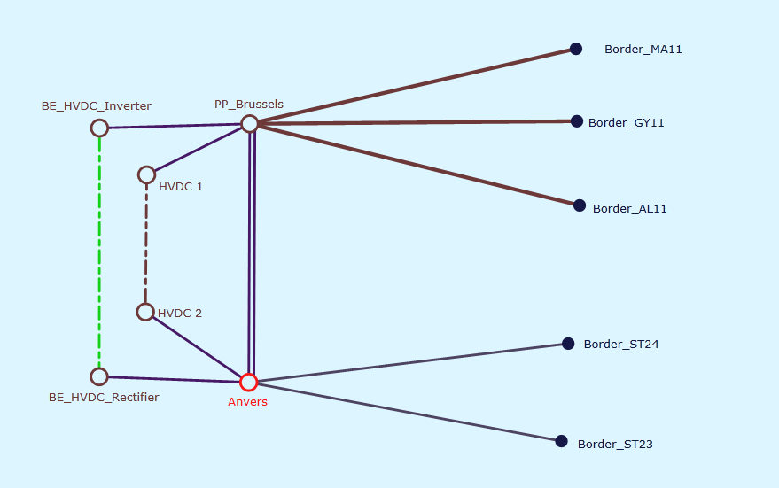

Figure 1: Line-Substation Diagram

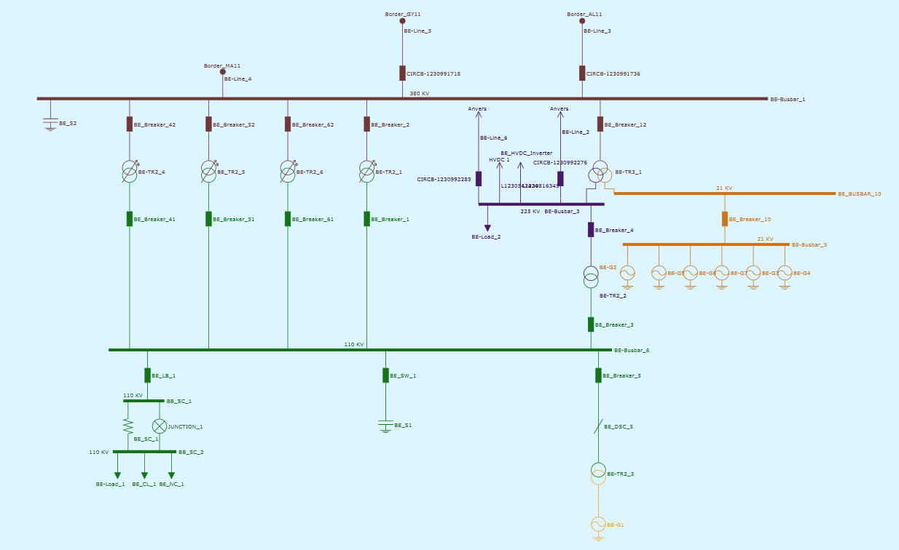

Figure 2: Node/Breaker Diagram for Substation PP_Brussels

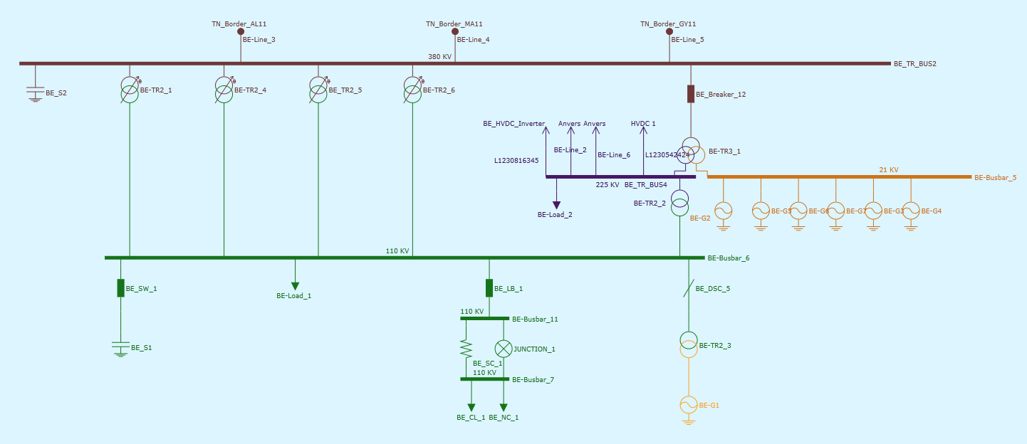

Figure 3: Bus/Branch Diagram for Substation PP_Brussels

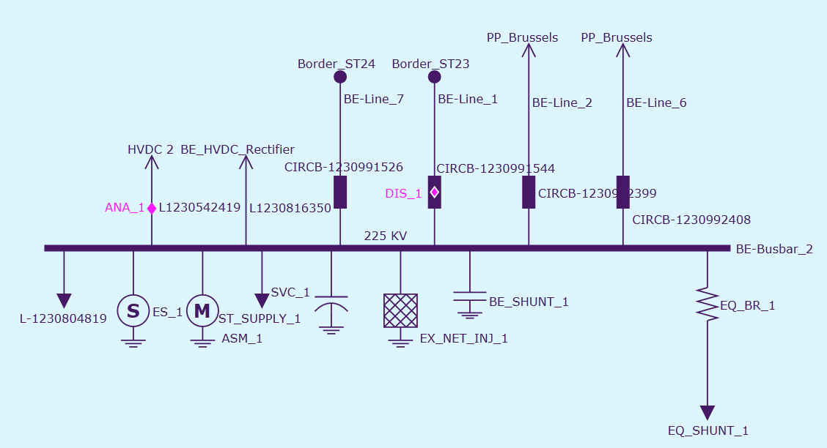

Figure 4: Node/Breaker Diagram for Substation Anvers

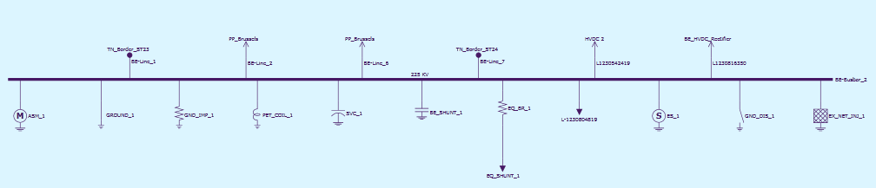

Figure 5: Bus/Branch Diagram for Substation Anvers

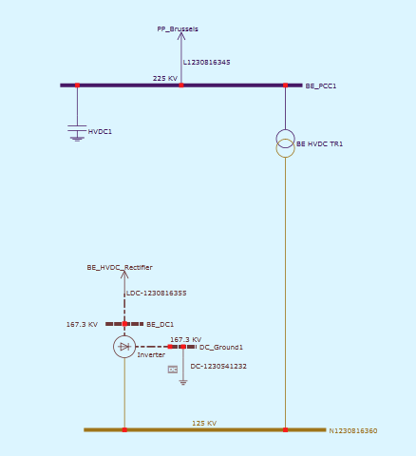

Figure 6: Node/Breaker Diagram for Substation BE_HVDC_Inverter

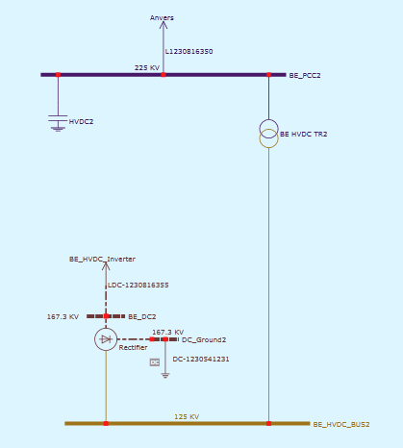

Figure 7: Node/Breaker Diagram for Substation BE_HVDC_Rectifier

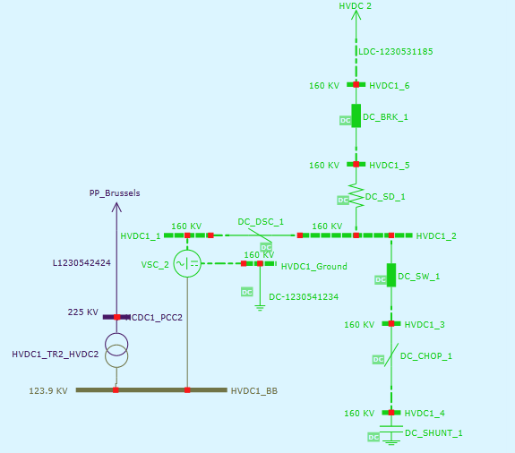

Figure 8: Node/Breaker Diagram for Substation HVDC1

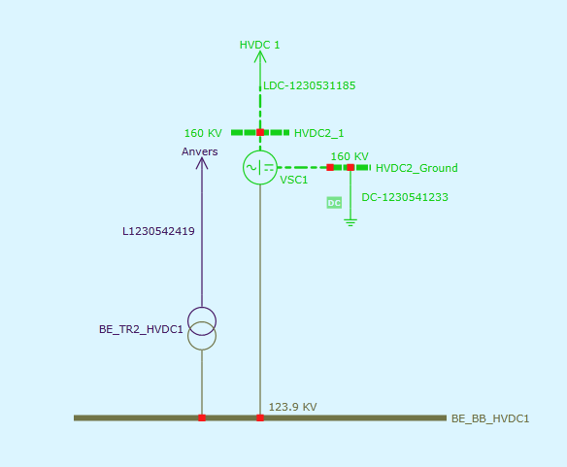

Figure 9: Node/Breaker Diagram for Substation H