|  |
| --- |
| Real Grid Test Configuration |
| Version 2 |
| CGMES 2.4.15 |
| 1 June 2015 |

Contents

Contents 2

1. Introduction 3

2. Usage and content of the test configuration 3

3. CIMdesk validation report 3

4. Number and types of elements in the model 5

5. Example of a 380 kV substation (substation 2117506) 6

6. Example of a 225 kV substation (substation 7858252) 7

7. Load flow calculation information 8

1. Introduction

The document is providing an overview of the Real Grid Test Configuration applicable for the ENTSO-E Common Grid Model Exchange Standard (CGMES) Conformity Assessment Framework hereafter referred as “the Framework”.

Versioning of the document is following the rules specified in the Chapter 5.1 of the CGMES.

**Disclaimer**

The Test Configurations (test models) are owned by ENTSO-E and are provided by ENTSO-E “as it is”. To the fullest extent permitted by law, ENTSO-E shall not be liable for any damages of any kind arising out of the use of the models (including any of their subsequent modifications). ENTSO-E neither warrants, nor represents that the use of the models will not infringe the rights of third parties. Any use of the models shall include a reference to ENTSO-E. ENTSO-E web site is the only official source of information related to these models.

1. Usage and content of the test configuration

The Real Grid (RG) test configuration is available as a zip package which contains instance data for the following CGMES profiles:

* Equipment;
* Topology;
* Steady State Hypothesis;
* State Variables.

The RG test configuration represents a bus-branch model of a real power system. The test configuration does not include boundary set as the model has no dangling references to external power systems or boundaries.

It includes only useful switches, so the topology can be considered as semi-detailed topology.

rdf:ID is expressed as a string (see R.4.1.2.4).

1. CIMdesk validation report
   1. Validation report on the EQ instance file

| **Type** | **Class** | **Recurrence** | **Description** |
| --- | --- | --- | --- |
| Warning | VoltageLevel | [1166/5577](http://localhost:8080/CIMSpy/contents/javascript) | The VoltageLevel doesn't contain any child instances (or is not referenced by other instances). |
| Warning | ACLineSegment | [53/7561](http://localhost:8080/CIMSpy/contents/javascript) | ACLineSegment.x/ACLineSegment.r ratio is too large. |

The warning on VoltageLevel appears because TP file is not merged into EQ file.

The warning on ACLineSegment is a real data issue (and not a format issue).

* 1. Validation report on the TP instance file

| **Type** | **Class** | **Recurrence** | **Description** |
| --- | --- | --- | --- |
| Warning | TopologicalNode | [42/7359](http://localhost:8080/CIMSpy/contents/javascript) | Fewer than 2 Terminals are associated with TopologicalNode via Association Terminal.TopologicalNode, expecting at least 2. |

The warning on TopologicalNode is due to semi detailed topology.

* 1. Validation report on the SSH instance file

There are no errors and warning reported by CIMDesk.

* 1. Validation report on the SV instance file

There are no errors and warning reported by CIMDesk.

* 1. Validation report on the complete model

| **Type** | **Class** | **Recurrence** | **Description** |
| --- | --- | --- | --- |
| Warning | TopologicalNode | [42/7359](http://localhost:8080/CIMSpy/contents/javascript) | Fewer than 2 Terminals are associated with TopologicalNode via Association Terminal.TopologicalNode, expecting at least 2. |
| Warning | SvVoltage | [240/7359](http://localhost:8080/CIMSpy/contents/javascript) | The voltage value of the SvVoltage is 10% greater or less than the nominal voltage. |
| Warning | TopologicalNode | [204/7359](http://localhost:8080/CIMSpy/contents/javascript) | The TopologicalNode is an island without Terminals connected or with all of the associated Terminals disconnected. |
| Warning | SvPowerFlow | [4/8348](http://localhost:8080/CIMSpy/contents/javascript) | The positive active power is injected into a SynchronousMachine. |
| Warning | SvPowerFlow | [253/8348](http://localhost:8080/CIMSpy/contents/javascript) | The negative active power is consumed by a EnergyConsumer. |
| Warning | PowerTransformerEnd | [18/3018](http://localhost:8080/CIMSpy/contents/javascript) | The rated voltage doesn't match the nominal voltage of the connected node. |
| Warning | RegulatingControl | [10/1350](http://localhost:8080/CIMSpy/contents/javascript) | The target voltage specified in the RegulatingControl doesn't match the nominal voltage of the regulated node. |
| Warning | TapChangerControl | [9/1194](http://localhost:8080/CIMSpy/contents/javascript) | The target voltage specified in the RegulatingControl doesn't match the nominal voltage of the regulated node. |
| Warning | ACLineSegment | [53/7561](http://localhost:8080/CIMSpy/contents/javascript) | ACLineSegment.x/ACLineSegment.r ratio is too large. |

All these warning are acceptable for this model. They are read data issues. For instance:

* The first warning on TopologicalNode is already commented above.
* The second warning on TopologicalNode is due to semi detailed topology.
* The three warnings on SvVoltage and SvPowerFlow are real data issues (and not a format issue).
* The warning on PowerTransformerEnd is a real data issue (and not a format issue).
* The warning on RegulatingControl is a real data issue (and not a format issue).
* The warning on TapChangerControl is a real data issue (and not a format issue).
* The warning on ACLineSegment is a real data issue (and not a format issue).

| **Type** | **Class** | **Recurrence** | **Description** |
| --- | --- | --- | --- |
| Alert | PowerTransformer | [191/1509](http://localhost/CIMSpy/contents/javascript) | The PowerTransformer connects two different Substations. |

The alert on PowerTransformer is a real data issue (and not a format issue).

1. Number and types of elements in the model

| **Class** | **# of Objects** |
| --- | --- |
| ACLineSegment | [7561](http://localhost:8080/CIMSpy/contents/javascript) |
| BaseVoltage | [8](http://localhost:8080/CIMSpy/contents/javascript) |
| ControlArea | [1](http://localhost:8080/CIMSpy/contents/javascript) |
| ControlAreaGeneratingUnit | [1](http://localhost:8080/CIMSpy/contents/javascript) |
| CurrentLimit | [32182](http://localhost:8080/CIMSpy/contents/javascript) |
| CurveData | [2720](http://localhost:8080/CIMSpy/contents/javascript) |
| EnergyConsumer | [6687](http://localhost:8080/CIMSpy/contents/javascript) |
| FossilFuel | [138](http://localhost:8080/CIMSpy/contents/javascript) |
| GeneratingUnit | [25](http://localhost:8080/CIMSpy/contents/javascript) |
| GeographicalRegion | [1](http://localhost:8080/CIMSpy/contents/javascript) |
| HydroGeneratingUnit | [727](http://localhost:8080/CIMSpy/contents/javascript) |
| HydroPump | [2](http://localhost:8080/CIMSpy/contents/javascript) |
| LinearShuntCompensator | [311](http://localhost:8080/CIMSpy/contents/javascript) |
| LoadResponseCharacteristic | [6687](http://localhost:8080/CIMSpy/contents/javascript) |
| NuclearGeneratingUnit | [59](http://localhost:8080/CIMSpy/contents/javascript) |
| OperationalLimitSet | [17960](http://localhost:8080/CIMSpy/contents/javascript) |
| OperationalLimitType | [6](http://localhost:8080/CIMSpy/contents/javascript) |
| PhaseTapChangerTable | [9](http://localhost:8080/CIMSpy/contents/javascript) |
| PhaseTapChangerTablePoint | [280](http://localhost:8080/CIMSpy/contents/javascript) |
| PhaseTapChangerTabular | [9](http://localhost:8080/CIMSpy/contents/javascript) |
| PowerTransformer | [1509](http://localhost:8080/CIMSpy/contents/javascript) |
| PowerTransformerEnd | [3018](http://localhost:8080/CIMSpy/contents/javascript) |
| RatioTapChanger | [1185](http://localhost:8080/CIMSpy/contents/javascript) |
| ReactiveCapabilityCurve | [1347](http://localhost:8080/CIMSpy/contents/javascript) |
| RegulatingControl | [1350](http://localhost:8080/CIMSpy/contents/javascript) |
| StaticVarCompensator | [3](http://localhost:8080/CIMSpy/contents/javascript) |
| SubGeographicalRegion | [7](http://localhost:8080/CIMSpy/contents/javascript) |
| Substation | [4875](http://localhost:8080/CIMSpy/contents/javascript) |
| SvPowerFlow | [8348](http://localhost:8080/CIMSpy/contents/javascript) |
| SvShuntCompensatorSections | [311](http://localhost:8080/CIMSpy/contents/javascript) |
| SvTapStep | [1194](http://localhost:8080/CIMSpy/contents/javascript) |
| SvVoltage | [7359](http://localhost:8080/CIMSpy/contents/javascript) |
| Switch | [1292](http://localhost:8080/CIMSpy/contents/javascript) |
| SynchronousMachine | [1347](http://localhost:8080/CIMSpy/contents/javascript) |
| TapChangerControl | [1194](http://localhost:8080/CIMSpy/contents/javascript) |
| Terminal | [29072](http://localhost:8080/CIMSpy/contents/javascript) |
| ThermalGeneratingUnit | [138](http://localhost:8080/CIMSpy/contents/javascript) |
| TopologicalIsland | [131](http://localhost:8080/CIMSpy/contents/javascript) |
| TopologicalNode | [7359](http://localhost:8080/CIMSpy/contents/javascript) |
| VoltageLevel | [5577](http://localhost:8080/CIMSpy/contents/javascript) |
| WindGeneratingUnit | [398](http://localhost:8080/CIMSpy/contents/javascript) |

1. Example of a 380 kV substation (substation 2117506)

In the following diagrams:

* black arrows represent active injection (P)
* blue arrows represent reactive injection (Q)

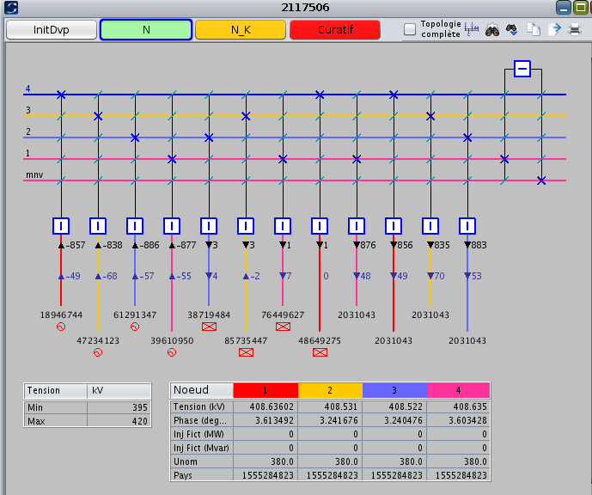

1. Example of a 225 kV substation (substation 7858252)

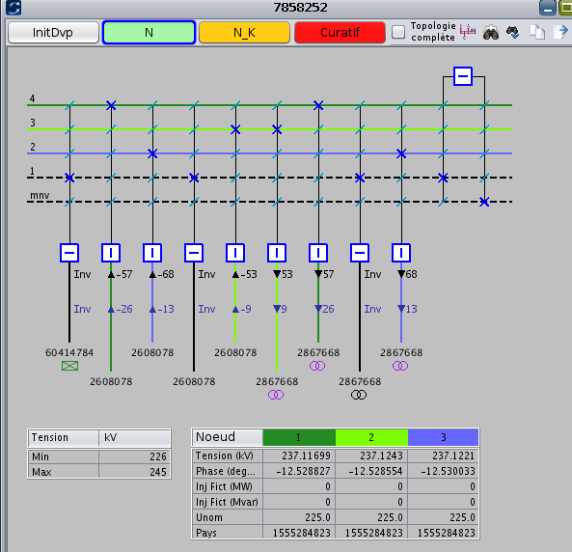

1. Load flow calculation information

We have used the Newton-Raphson load flow with reactive limits and with fixed tap changers.

Number of iteration: 9.

Intermediary slack bus: 25940661, followed by slack distribution over all buses.

Total losses: 974 MW

Total generation: 51 699 MW

Total load: 50 725 MW

Load flow results are given in a separated spreadsheet.