|  |
| --- |
| Small Grid Test Configuration |
| Version: 3.0.0 |
| CGMES v2.4.15 |
| 31 May 2015 |

Contents

[1. Introduction 3](#_Toc420827951)

[2. Usage and content of the test configuration 3](#_Toc420827952)

[3. Small Grid Base Case 5](#_Toc420827953)

[3.1. General information 5](#_Toc420827954)

[3.2. Network topology and data 5](#_Toc420827955)

[3.3. Load flow calculation information 6](#_Toc420827956)

[3.4. CIMdesk validation report for bus-branch version 6](#_Toc420827957)

[3.5. CIMdesk validation report for node-breaker version 6](#_Toc420827958)

[4. Small Grid HVDC 6](#_Toc420827959)

[4.1. General information 6](#_Toc420827960)

[4.2. Network topology and data 7](#_Toc420827961)

[4.3. Load flow calculation information 8](#_Toc420827962)

[4.4. CIMdesk validation report for bus-branch version 9](#_Toc420827963)

[4.5. CIMdesk validation report for node-breaker version 9](#_Toc420827964)

[5. Small Grid Reduced Network 10](#_Toc420827965)

[5.1. General information 10](#_Toc420827966)

[5.2. Network topology and data 12](#_Toc420827967)

[5.3. Load flow calculation information 12](#_Toc420827968)

[5.4. CIMdesk validation report for bus-branch version 13](#_Toc420827969)

[5.5. CIMdesk validation report for node-breaker version 13](#_Toc420827970)

[6. Geographic information Small Grid 14](#_Toc420827971)

[7. Single line diagrams 16](#_Toc420827972)

[8. References 25](#_Toc420827973)

1. Introduction

The document is providing an overview of the Small Grid Test Configuration applicable for the ENTSO-E Common Grid Model Exchange Standard (CGMES) Conformity Assessment Framework hereafter referred as “the Framework”.

Versioning of the document is following the rules specified in the Chapter 5.1 of the CGMES.

**Disclaimer**

The Test Configurations (test models) are owned by ENTSO-E and are provided by ENTSO-E “as it is”. To the fullest extent permitted by law, ENTSO-E shall not be liable for any damages of any kind arising out of the use of the models (including any of their subsequent modifications). ENTSO-E neither warrants, nor represents that the use of the models will not infringe the rights of third parties. Any use of the models shall include a reference to ENTSO-E. ENTSO-E web site is the only official source of information related to these models.

1. Usage and content of the test configuration

The Small Grid test configuration is packaged in the following structure:

* Documentation which contains configuration descriptions and results
  + CGMES\_v2.4.15\_SmallGridTestConfiguration\_v3.0.0.docx - file explaining Small Grid test configurations (Base Case, HVDC and Reduced Network)
  + <CGMES_v2.4.15_SmallGridTestConfiguration_v3.0.0.xls> - Small Grid test configurations (Base Case, HVDC and Reduced Network), file containing in different sheets model descriptions and load flow results
* BusBranch which contains the data for the bus-branch configuration
  + CGMES\_v2.4.15\_SmallGridTestConfiguration\_BaseCase\_Complete\_v3.0.0.zip
  + CGMES\_v2.4.15\_SmallGridTestConfiguration\_HVDC\_Complete\_v3.0.0.zip
  + CGMES\_v2.4.15\_SmallGridTestConfiguration\_ReducedNetwork\_Complete\_v3.0.0.zip
  + CGMES\_v2.4.15\_SmallGridTestConfiguration\_Boundary\_v3.0.0.zip
  + HVDC\_Difference which contains
    - SmallGridTestConfiguration\_HVDC\_TP\_diff\_v3.0.0.xml
    - SmallGridTestConfiguration\_HVDC\_EQ\_diff\_v3.0.0.xml
    - SmallGridTestConfiguration\_HVDC\_GL\_diff\_v3.0.0.xml
  + ReducedNetwork\_Difference which contains
    - SmallGridTestConfiguration\_RN\_TP\_diff\_v3.0.0.xml
    - SmallGridTestConfiguration\_RN\_EQ\_diff\_v3.0.0.xml
    - SmallGridTestConfiguration\_RN\_GL\_diff\_v3.0.0.xml
* NodeBreaker which contains the data for the node-breaker configuration
  + CGMES\_v2.4.15\_SmallGridTestConfiguration\_BaseCase\_Complete\_v3.0.0.zip
  + CGMES\_v2.4.15\_SmallGridTestConfiguration\_HVDC\_Complete\_v3.0.0.zip
  + CGMES\_v2.4.15\_SmallGridTestConfiguration\_ReducedNetwork\_Complete\_v3.0.0.zip
  + CGMES\_v2.4.15\_SmallGridTestConfiguration\_Boundary\_v3.0.0.zip
  + BaseCase\_Difference which contains
    - SmallGridTestConfiguration\_BC\_EQ\_diff\_v3.0.0.xml
    - SmallGridTestConfiguration\_BC\_TP\_diff\_v3.0.0.xml
  + HVDC\_Difference which contains
    - SmallGridTestConfiguration\_HVDC\_EQ\_diff\_v3.0.0.xml
    - SmallGridTestConfiguration\_HVDC\_TP\_diff\_v3.0.0.xml
  + ReducedNetwork\_Difference which contains
    - SmallGridTestConfiguration\_RN\_EQ\_diff\_v3.0.0.xml
    - SmallGridTestConfiguration\_RN\_TP\_diff\_v3.0.0.xml

Small Grid test configurations models are planned to be used for testing of both interoperability of HVDC and interoperability of equivalent elements. Also they are used to test the support to a load flow analyses. Short-circuit calculations and dynamics simulations cannot be performed using this test configuration.

For both variants (node-breaker and bus-branch) available for this test configuration there are Base Case, HVDC and Reduced Network model versions. All the models are created from the Small Grid Base Case (bus-branch) applying the appropriate difference files like on the Figure 1. The complete HVDC and Reduced Network models are also given in the zip package.

For the bus-branch configuration EQ, TP and SSH can be used without SV file, the same results are achieved like with the SV file, while for the node-breaker only EQ and SSH are enough for the load flow calculations.

All test models created from the Small Grid Base Case are shown in the following chart.



Figure 1 – Dependencies between Small Grid Base Case and HVDC and Reduced Network for bus-branch and node-breaker configurations

1. Small Grid Base Case
   1. General information

The Small Grid Base Case (SGBC) model is based on the IEEE 118 nodes (Figure 10). Originally the IEEE 118 Bus Test Case represents a portion of the American Electric Power System (in the Midwestern US) as of December, 1962.

This model is used to test interoperability of substation diagrams and wide area diagrams in addition to geographical representation and also as a support for the load flow analyses. The SGBC includes geographical location and wide area diagram instance files.

Boundary instance files are the same for the Base Case, HVDC and Reduced Network. They are located in the zip file “CGMES\_v2.4.15\_SmallGridTestConfiguration\_Boundary\_v3.0.0”.

Difference files are used for creating HVDC and reduced network from the base case and for creating node-breaker from bus-branch configurations, like it is shown before on the Figure 1. Beside the difference files, there are also complete HVDC and Reduced Network models.

Difference files for geographical location are also shown on the Figure 1.

* 1. Network topology and data

The summary of the Small Grid Base Case model is shown in the figure below.

**Type Of Element**

**No.**

**Nodes**

**118**

**Lines**

**176**

**Transformers (ratio tap changer)**

**10**

**Generators**

**19**

**Synchronous Compensators**

**14**

**Loads**

**106**

Figure 2 – Small Grid Base Case Model Summary

Detail information about the each grid element is given in the external excel document <CGMES_v2.4.15_SmallGridTestConfiguration_v3.0.0.xls> in different sheets (md\_Nodes, md\_Lines, md\_Transformers, md\_CSConverter…).

There are two different configuration of the Small Grid Base Case model:

1. Bus-Branch Configuration
2. Node-Breaker Configuration

Node-breaker configuration is created by applying difference files (SmallGridTestConfiguration\_BC\_EQ\_diff\_v3.0.0.xml,SmallGridTestConfiguration\_BC\_TP\_diff\_v3.0.0.xml) on the standard SGBC bus-branch related model.

* 1. Load flow calculation information

Load flow system summary, where results were obtained by setting all voltage angles to zero and all voltage magnitudes to 1.0 p.u (“flat” start):

**AC Load Flow Type**

**Full Newton-Raphson**

**Reactive limits**

**Off**

**Relative Error Tolerance**

**P=0.002 Q=0.005**

**Number of Iterations**

**3**

**P = 515.1 MW**

**Q = -62.3 MVAr**

**V = 136.6 kV**

**angle = 0**

**Slack Bus "Sporn1"**

The load flow results are the same for the both SGBC configurations and they are available in the excel document <CGMES_v2.4.15_SmallGridTestConfiguration_v3.0.0.xls>, in the sheet “SGBC\_AC\_Results”.

* 1. CIMdesk validation report for bus-branch version

CIMdesk validation report (validation against Base profiles) on the assembled model which includes boundary and the base case bus-branch version is the following:

| **Type** | **Class** | **Recurrence** | **Description** |
| --- | --- | --- | --- |
| Warning | SubGeographicalRegion | [1/2](http://localhost:8080/CIMSpy/contents/javascript) | No Substations are associated with SubGeographicalRegion via Association Substation.Region, expecting at least 1. |
| Warning | Location | [3/284](http://localhost:8080/CIMSpy/contents/javascript) | Fewer than 2 PositionPoints are associated with Location of the Junction that span two Substations. |
| Warning | ACLineSegment | [1/176](http://localhost:8080/CIMSpy/contents/javascript) | ACLineSegment.x/ACLineSegment.r ratio is too large. |

The above warnings should be ignored as:

* SubGeographicalRegion in the boundary can not contain any Substations, but they are referenced from Line containers in boundary.
* The rest are considered data issues.
  1. CIMdesk validation report for node-breaker version

CIMdesk validation report (validation against Operation) on the assembled model which includes boundary and the base case node-breaker version is the following:

| **Type** | **Class** | **Recurrence** | **Description** |
| --- | --- | --- | --- |
| Warning | SubGeographicalRegion | [1/2](http://localhost:8080/CIMSpy/contents/javascript) | No Substations are associated with SubGeographicalRegion via Association Substation.Region, expecting at least 1. |
| Warning | ACLineSegment | [1/176](http://localhost:8080/CIMSpy/contents/javascript) | ACLineSegment.x/ACLineSegment.r ratio is too large. |

The above warnings should be ignored as:

* SubGeographicalRegion in the boundary can not contain any Substations, but they are referenced from Line containers in boundary.
* Data issue which is considered normal for the provided model.

1. Small Grid HVDC
   1. General information

The Small Grid HVDC model is based on the Small Grid Base Case model (Figure 16). This model is used to test interoperability of HVDC and also as a support for load flow analyses.

The bus-branch Small Grid HVDC model is created by upgrading the standard SGBC model by applying three difference files:

* SmallGridTestConfiguration\_HVDC\_TP\_diff\_v3.0.0.xml
* SmallGridTestConfiguration\_HVDC\_EQ\_diff\_v3.0.0.xml
* SmallGridTestConfiguration\_HVDC\_GL\_diff\_v3.0.0.xml

The node-breaker Small Grid HVDC model is created by upgrading the Small Grid HVDC bus-branch related model, applying two difference files:

* SmallGridTestConfiguration\_HVDC\_EQ\_diff\_v3.0.0.xml
* SmallGridTestConfiguration\_HVDC\_TP\_diff\_v3.0.0.xml

The following modifications were made (Figure 4):

1. internal AC line with the ID “\_0473e004-c766-11e1-8775-005056c00008” (name “30-38”) was replaced with the HVDC line (CSC) consisting of the following elements:

|  |  |  |
| --- | --- | --- |
| TYPE | CIM ID | NAME |
| RatioTapChanger | \_5dbb1c11\_5e13\_4629\_88a2\_a4b4bd9e8022 | rtc1 |
| CsConverter | \_5ede3438\_e591\_4816\_bbc4\_6e97c5e18ecb | Conv1 |
| DCGround | \_197ecdfb\_1c8f\_4a1f\_bfd1\_9a3725621adb | DCGnd1 |
| DCLineSegment | \_80b1e96c\_befd\_41d7\_8b3e\_4039f66aa74f | dcLine |
| DCGround | \_0da46fb4\_7c06\_4923\_9324\_d4550e6c8e62 | DCGnd2 |
| CsConverter | \_0df30da2\_66ad\_44d9\_ba01\_5c121c0a6ab7 | Conv2 |
| RatioTapChanger | \_5dbb1c11\_5e13\_4629\_88a2\_a4b4bd9e802w | rtc2 |

1. replacing the tie-line with the HVDC line (VSC) wasn’t possible because there were no two MAS, and due to internal AC line with the ID “\_0475dbd8-c766-11e1-8775-005056c00008” (name “63-64”) was replaced with the HVDC line (VSC) consisting of the following elements:

|  |  |  |
| --- | --- | --- |
| TYPE | CIM ID | NAME |
| VsConverter | \_d22aec18\_082e\_41a8\_ae50\_35ed0c886d8e | VSC1 |
| DCGround | \_4b0e1c8b\_b8d9\_46e0\_9531\_d1a31bdaa64d | DCGnd3 |
| DCLineSegment | \_354bf631\_051f\_41b4\_bde7\_ed399ffb696d | dcLine2 |
| DCGround | \_6786173f\_0a9c\_46e7\_8245\_96204f73d844 | DCGnd4 |
| VsConverter | \_8375e53f\_9c4b\_41b9\_99fb\_330ea4a6f2fc | VSC2 |
| SeriesCompensator | \_951a1096\_7388\_4ef3\_b309\_94b8479f8abb | reactor1 |
| SeriesCompensator | \_5cd34b0f\_ee15\_4b71\_b69e\_8f8eb72253c1 | reactor2 |

* 1. Network topology and data

The summary of the Small Grid HVDC model is shown in the figure below.

**Type Of Element**

**No.**

**Nodes(including 8 DC nodes)**

**122**

**Lines**

**174**

**Transformers (ratio tap changer)**

**11**

**Generators**

**19**

**Synchronous Compensators**

**14**

**Loads**

**106**

**DC Line**

**2**

**VS Converter**

**2**

**CS Converter**

**2**

Figure 3 – Small Grid HVDC Model Summary



Figure 4 – HVDC (CSC) and HVDC (VSC)

There are two different configuration of the Small Grid HVDC (SG\_HVDC) model:

1. Bus-Branch Configuration
2. Node-Breaker Configuration

Node-breaker configuration is created by applying the difference files (SmallGridTestConfiguration\_BC\_EQ\_diff\_v3.0.0.xml,SmallGridTestConfiguration\_BC\_TP\_diff\_v3.0.0.xml) on the SGBC node-breaker related model.

* 1. Load flow calculation information

Load flow calculation is based on sequential method for AC-DC networks [1, 2, 3, 4]. The sequential method solves AC and DC systems separately. Converters are treated as loads or power sources on an AC system and iterations between AC and DC power flow algorithms are made to match boundary conditions between AC and DC systems.

Load flow system summary, with calculation achieved from flat start

**AC Load Flow Type**

**Full Newton-Raphson**

**Reactive limits**

**Off**

**Relative Error Tolerance**

**P=0.002 Q=0.005**

**Number of Iterations**

**5**

**P = 519.2 MW**

**Q = -62.1 MVAr**

**V = 136.6 kV**

**angle = 0**

**Slack Bus "Sporn1"**

The load flow results are the same for the both Small Grid HVDC configurations and they are available in the excel document <CGMES_v2.4.15_SmallGridTestConfiguration_v3.0.0.xls>, for the AC load flow in sheet “SG\_HVDC\_AC\_Results” and for DC load flow in sheet “SG\_HVDC\_DC\_Results”.

* 1. CIMdesk validation report for bus-branch version

CIMdesk validation report (validation against Base profiles) on the assembled model which includes boundary and the HVDC bus-branch version is the following:

| **Type** | **Class** | **Recurrence** | **Description** |
| --- | --- | --- | --- |
| Error | CsConverter | [1/2](http://localhost:8080/CIMSpy/contents/javascript) | Target DC voltage is less than minimum DC voltage. |
| Error | VsConverter | [1/2](http://localhost:8080/CIMSpy/contents/javascript) | Target DC voltage is less than minimum DC voltage. |
| Warning | SubGeographicalRegion | [1/2](http://localhost:8080/CIMSpy/contents/javascript) | No Substations are associated with SubGeographicalRegion via Association Substation.Region, expecting at least 1. |
| Warning | Location | [3/284](http://localhost:8080/CIMSpy/contents/javascript) | Fewer than 2 PositionPoints are associated with Location of the Junction that span two Substations. |
| Warning | ACLineSegment | [1/174](http://localhost:8080/CIMSpy/contents/javascript) | ACLineSegment.x/ACLineSegment.r ratio is too large. |

The above warnings should be ignored as:

* The 2 errors should be investigated and potentially ignored or fixed in the next version of the test configuration.
* SubGeographicalRegion in the boundary can not contain any Substations, but they are referenced from Line containers in boundary.
* The other 2 warnings are considered data issues.
  1. CIMdesk validation report for node-breaker version

CIMdesk validation report (validation against Operation) on the assembled model which includes boundary and the HVDC node-breaker version is the following:

| **Type** | **Class** | **Recurrence** | **Description** |
| --- | --- | --- | --- |
| Error | CsConverter | [1/2](http://localhost:8080/CIMSpy/contents/javascript) | Target DC voltage is less than minimum DC voltage. |
| Error | VsConverter | [1/2](http://localhost:8080/CIMSpy/contents/javascript) | Target DC voltage is less than minimum DC voltage. |
| Warning | SubGeographicalRegion | [1/2](http://localhost:8080/CIMSpy/contents/javascript) | No Substations are associated with SubGeographicalRegion via Association Substation.Region, expecting at least 1. |
| Warning | ACLineSegment | [1/174](http://localhost:8080/CIMSpy/contents/javascript) | ACLineSegment.x/ACLineSegment.r ratio is too large. |

The above warnings should be ignored as:

* The 2 errors should be investigated and potentially ignored or fixed in the next version of the test configuration.
* SubGeographicalRegion in the boundary can not contain any Substations, but they are referenced from Line containers in boundary.
* ACLineSegment warning is a data issue which is considered normal for the provided model.

1. Small Grid Reduced Network
   1. General information

The Small Grid Reduced Network (SGRN) model is based on the SGBC model (Figure 17). This model is used to test interoperability of equivalent elements and also as a support for load flow analyses on a reduced network.

The bus-branch SGRN model is created by performing the following modifications on the standard Small Grid Base Case (SGBC) model by applying three difference files:

* SmallGridTestConfiguration\_RN\_TP\_diff\_v3.0.0.xml
* SmallGridTestConfiguration\_RN\_EQ\_diff\_v3.0.0.xml
* SmallGridTestConfiguration\_RN\_GL\_diff\_v3.0.0.xml

The node-breaker SGRN model is created by performing the same modifications but on the node-breaker Small Grid Base Case (SGBC) model, by applying the two difference files:

* SmallGridTestConfiguration\_RN\_EQ\_diff\_v3.0.0.xml
* SmallGridTestConfiguration\_RN\_TP\_diff\_v3.0.0.xml

Reverse Differences

Difference files replaces elements from the model with equivalent elements, which are represented by the following classes defined in the CGMES. The following elements were removed from the model.

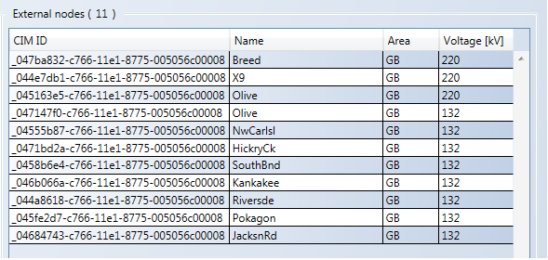

Figure 5 – Reduced Nodes

List of the removed terminals is located in the “SmallGridTestConfiguration\_RN\_EQ\_diff\_v3.0.0.xml” file.

* ACLineSegment:
  + \_045a3d89-c766-11e1-8775-005056c00008
  + \_04535fb7-c766-11e1-8775-005056c00008
  + \_045c8776-c766-11e1-8775-005056c00008
  + \_047f78c2-c766-11e1-8775-005056c00008
  + \_0483be84-c766-11e1-8775-005056c00008
  + \_044b9789-c766-11e1-8775-005056c00008
  + \_048963d9-c766-11e1-8775-005056c00008
  + \_0484f709-c766-11e1-8775-005056c00008
  + \_044bbe91-c766-11e1-8775-005056c00008
  + \_044a5f09-c766-11e1-8775-005056c00008
  + \_04553477-c766-11e1-8775-005056c00008
  + \_0474a358-c766-11e1-8775-005056c00008
  + \_0468e382-c766-11e1-8775-005056c00008
  + \_045ed162-c766-11e1-8775-005056c00008
  + \_04614263-c766-11e1-8775-005056c00008
  + \_04642896-c766-11e1-8775-005056c00008
* EnergyConsumer:
  + \_044a5f08-c766-11e1-8775-005056c00008
  + \_0447ee05-c766-11e1-8775-005056c00008
  + \_044ea4c0-c766-11e1-8775-005056c00008
  + \_048b5fa5-c766-11e1-8775-005056c00008
  + \_04867dab-c766-11e1-8775-005056c00008
  + \_0485e168-c766-11e1-8775-005056c00008
  + \_045645e2-c766-11e1-8775-005056c00008
  + \_046a4319-c766-11e1-8775-005056c00008
  + \_047a48a8-c766-11e1-8775-005056c00008
* ThermalGeneratingUnit
  + \_045868c0-c766-11e1-8775-005056c00008:
* PowerTransformer:
  + \_04575750-c766-11e1-8775-005056c00008
* LinearShuntCompensator:
  + \_0447c6f6-c766-11e1-8775-005056c00008

Forward Differences

Difference file introduces new elements to the model: EquivalentBranch, EquivalentInjection and EquivalentShunt. The following elements were changed:

* node “Concord“ with the ID “\_045b4ef9-c766-11e1-8775-005056c00008” had obtained the following:

1. new EquivalentBranch i.e. AC line segment towards the node “TwinBrch” with the ID “\_047566a8-c766-11e1-8775-005056c00008”
2. new EquivalentBranch i.e. transformer towards the node “Sorenson2” with the ID “\_046c3ee8-c766-11e1-8775-005056c00008“
3. new EquivalentShunt
4. new EquivalentInjection

* node “TwinBrch“ with the ID “\_047566a8-c766-11e1-8775-005056c00008” had obtained the following:

1. new EquivalentBranch i.e. AC line segment towards the node “Concord” with the ID “\_045b4ef9-c766-11e1-8775-005056c00008”
2. new EquivalentBranch i.e. transformer towards the node “Sorenson2” with the ID “\_046c3ee8-c766-11e1-8775-005056c00008“
3. new EquivalentShunt
4. new EquivalentInjection

* node “Sorenson2“ with the ID “\_046c3ee8-c766-11e1-8775-005056c00008“ had obtained the following:

1. new EquivalentBranch i.e. transformer towards the node “Concord” with the ID “\_045b4ef9-c766-11e1-8775-005056c00008”
2. new EquivalentBranch i.e. i.e. transformer towards the node “TwinBrch” with the ID “\_047566a8-c766-11e1-8775-005056c00008”
3. new EquivalentShunt
4. new EquivalentInjection
   1. Network topology and data

The summary of the Small Grid Reduced Network model is shown in the figure below.

**Type Of Element**

**No.**

**Nodes**

**107**

**Lines**

**161**

**Transformers (ratio tap changer)**

**9**

**Generators**

**18**

**Synchronous Compensators**

**16**

**Loads**

**Transformers (non-regulated) 2**

**100**

Figure 6 – Small Grid Reduced Network Model Summary

There are two different configuration of the Small Grid Reduced Network (SGRN) model:

1. Bus-Branch Configuration
2. Node-Breaker Configuration

Node-breaker configuration is created by applying the difference files (SmallGridTestConfiguration\_BC\_EQ\_diff\_v3.0.0.xml, SmallGridTestConfiguration\_BC\_TP\_diff\_v3.0.0.) on the SGBC node-breaker related model.

* 1. Load flow calculation information

Load flow system summary, where results were obtained by setting all voltage angles to zero and all voltage magnitudes to 1.0 p.u (“flat” start):

**AC Load Flow Type**

**Full Newton-Raphson**

**Reactive limits**

**Off**

**Relative Error Tolerance**

**P=0.002 Q=0.005**

**Number of Iterations**

**3**

**P = 515.2 MW**

**Q = -62.3 MVAr**

**V = 136.6 kV**

**angle = 0**

**Slack Bus "Sporn1"**

The load flow results are the same for the both Small Grid Reduced Network configurations and they are available in the excel document <CGMES_v2.4.15_SmallGridTestConfiguration_v3.0.0.xls>, in the sheet “SGRN\_AC\_Results”.

* 1. CIMdesk validation report for bus-branch version

CIMdesk validation report (validation against Base profiles) on the assembled model which includes boundary and the Reduced network bus-branch version is the following:

| **Type** | **Class** | **Recurrence** | **Description** |
| --- | --- | --- | --- |
| Warning | SubGeographicalRegion | [1/2](http://localhost:8080/CIMSpy/contents/javascript) | No Substations are associated with SubGeographicalRegion via Association Substation.Region, expecting at least 1. |
| Warning | EquivalentShunt | [2/3](http://localhost:8080/CIMSpy/contents/javascript) | The value of Attribute EquivalentShunt.g is less than lower limit: 0. |
| Warning | Location | [3/258](http://localhost:8080/CIMSpy/contents/javascript) | Fewer than 2 PositionPoints are associated with Location of the Junction that span two Substations. |
| Warning | ACLineSegment | [1/160](http://localhost:8080/CIMSpy/contents/javascript) | ACLineSegment.x/ACLineSegment.r ratio is too large. |

The above warnings should be ignored as:

* SubGeographicalRegion in the boundary can not contain any Substations, but they are referenced from Line containers in boundary.
* The model is result from a network reduction function and the EquivalentShunt.g can have negative value.
* The other 2 warnings are considered data issues.
  1. CIMdesk validation report for node-breaker version

CIMdesk validation report (validation against Operation) on the assembled model which includes boundary and the Reduced node-breaker version is the following:

| **Type** | **Class** | **Recurrence** | **Description** |
| --- | --- | --- | --- |
| Warning | SubGeographicalRegion | [1/2](http://localhost:8080/CIMSpy/contents/javascript) | No Substations are associated with SubGeographicalRegion via Association Substation.Region, expecting at least 1. |
| Warning | EquivalentShunt | [2/3](http://localhost:8080/CIMSpy/contents/javascript) | The value of Attribute EquivalentShunt.g is less than lower limit: 0. |
| Warning | ACLineSegment | [1/160](http://localhost:8080/CIMSpy/contents/javascript) | ACLineSegment.x/ACLineSegment.r ratio is too large. |

The above warnings should be ignored as:

* SubGeographicalRegion in the boundary can not contain any Substations, but they are referenced from Line containers in boundary.
* The model is result from a network reduction function and the EquivalentShunt.g can have negative value.
* Data issue which is considered normal for the provided model.

1. Geographic information Small Grid

The geographic view of the Small Grid Base Case network is illustrated in the Figure 7.

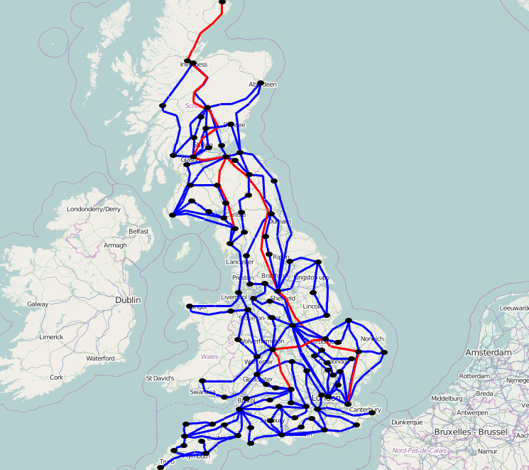

Figure 7 – Small Grid Base Case geographic view

The geographic view of the Small Grid HVDC network is illustrated in the Figure 8.

DC lines are shown in green colour.

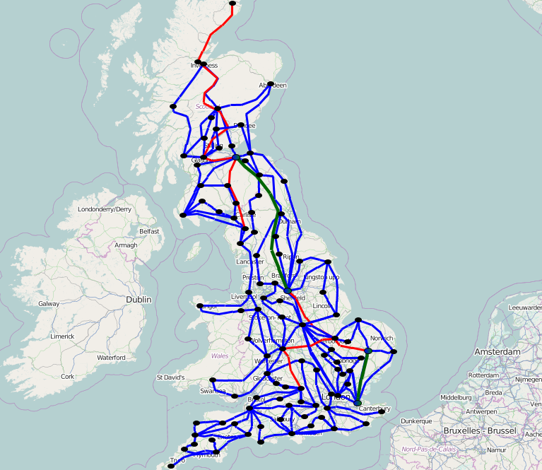

Figure 8 - Small Grid HVDC geographic view

The geographic view of the Small Grid Reduced Network is illustrated in the Figure 9.

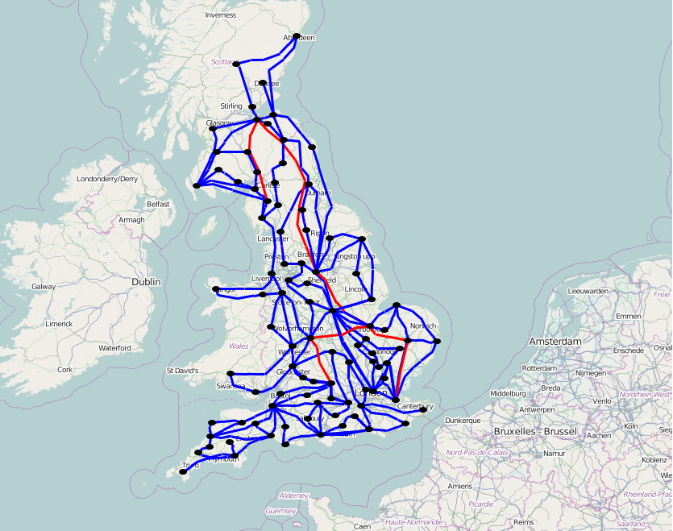

Figure 9 - Small Grid Reduced Network geographic view

1. Single line diagrams

The single line diagram of the Small Grid Base Case network is illustrated in the Figure 10, while in the Figure 15 is shown Small Grid Reduced Network. On the diagrams blue colour represents 220 kV voltage level while the red represents 133 kV.

Substation diagrams for bus-branch and node breaker configurations of SGBC model are shown in the figures between Figure 11and Figure 14.

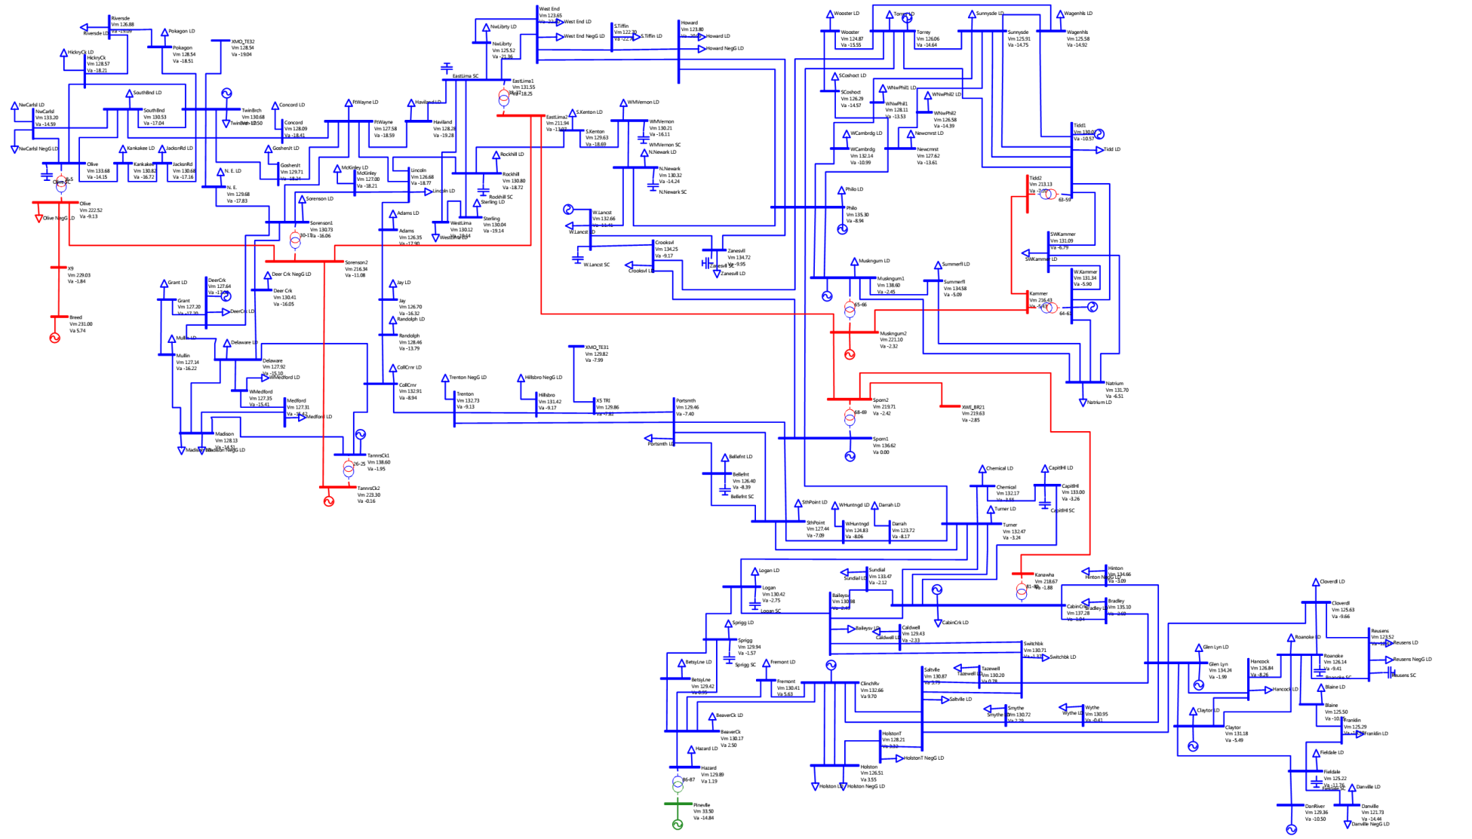

Figure 10 - SGBC single line diagram

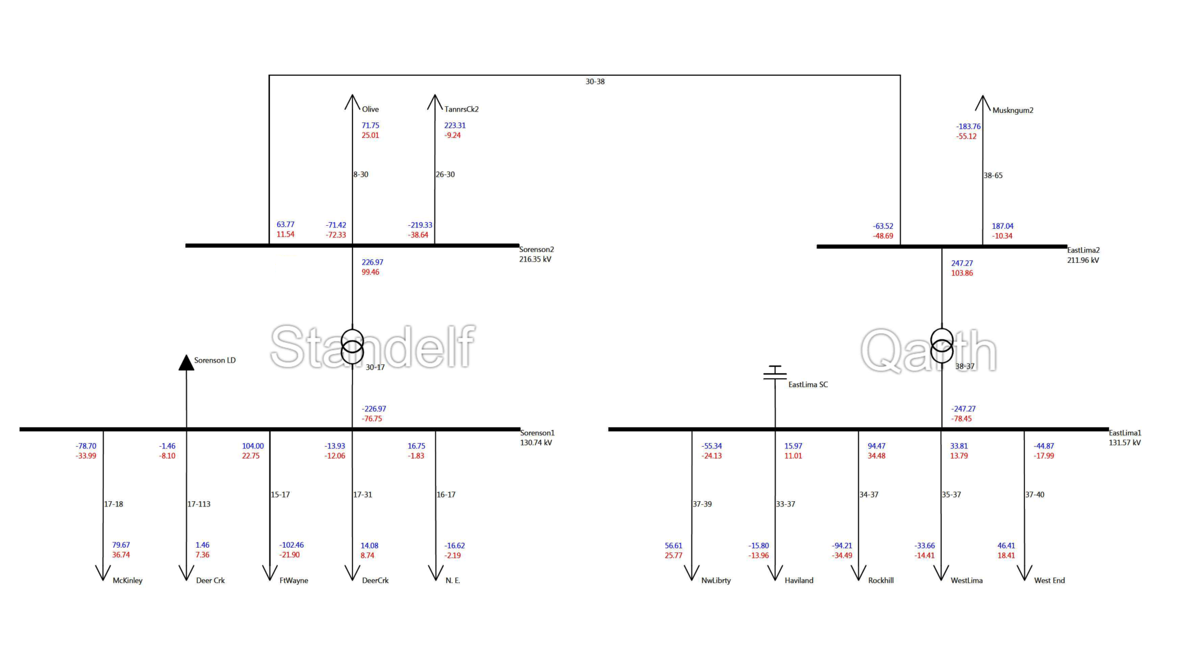

Figure 11- SGBC bus-branch, diagram for substations Standelf-Qarth

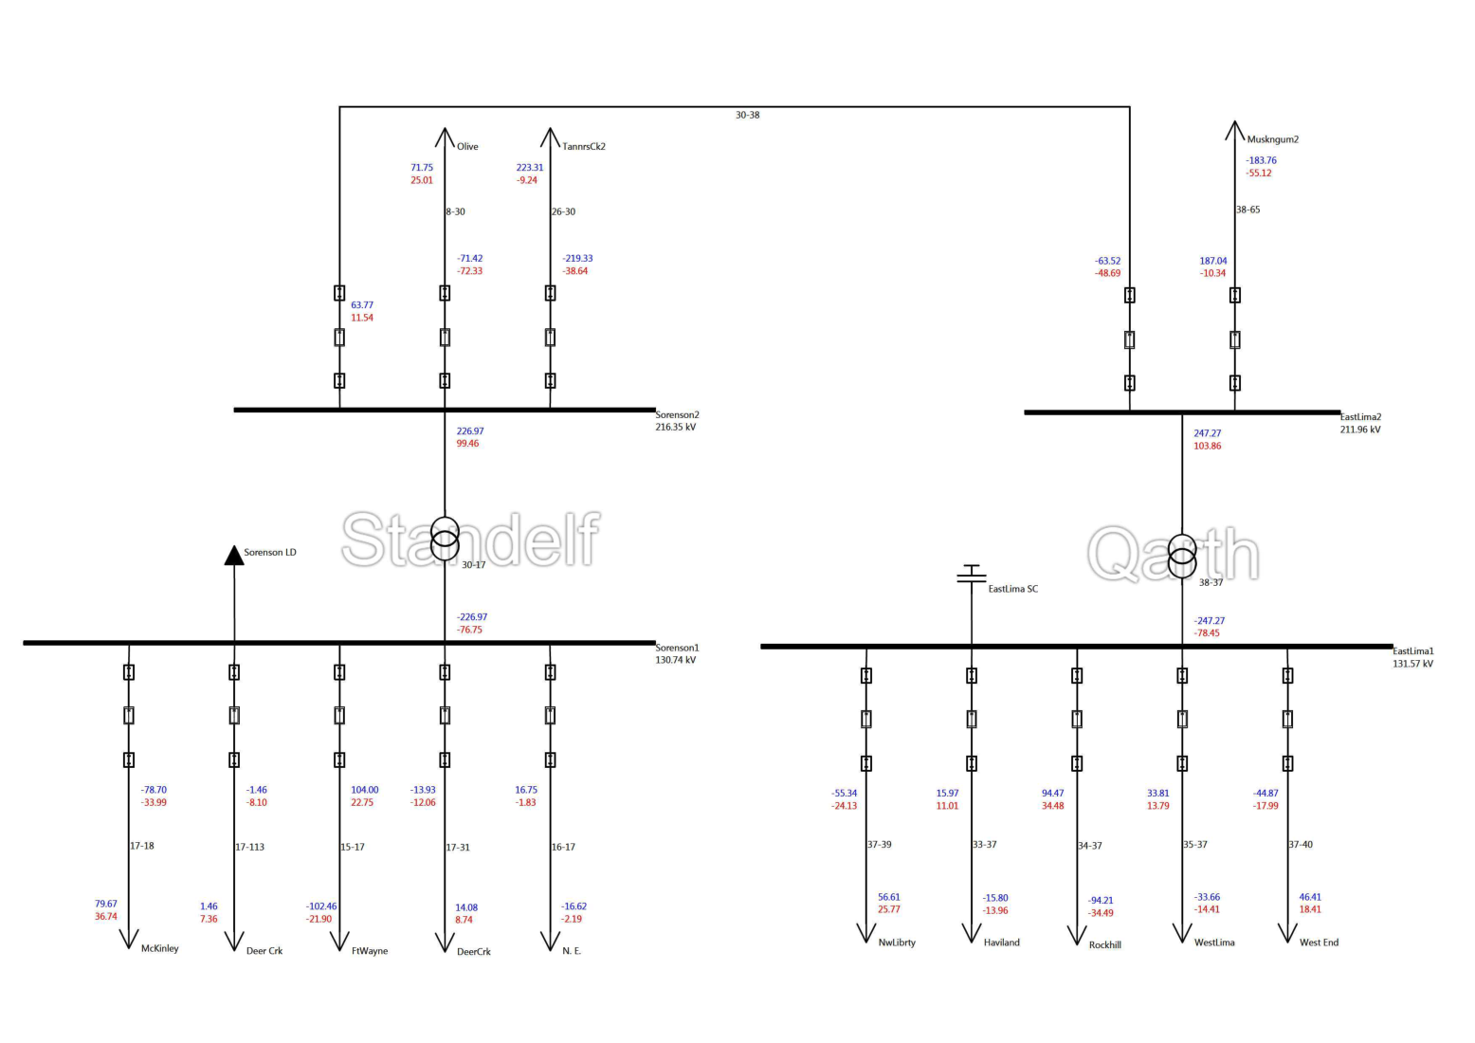

Figure 12 - SGBC node-breaker, diagram for substations Standelf-Qarth

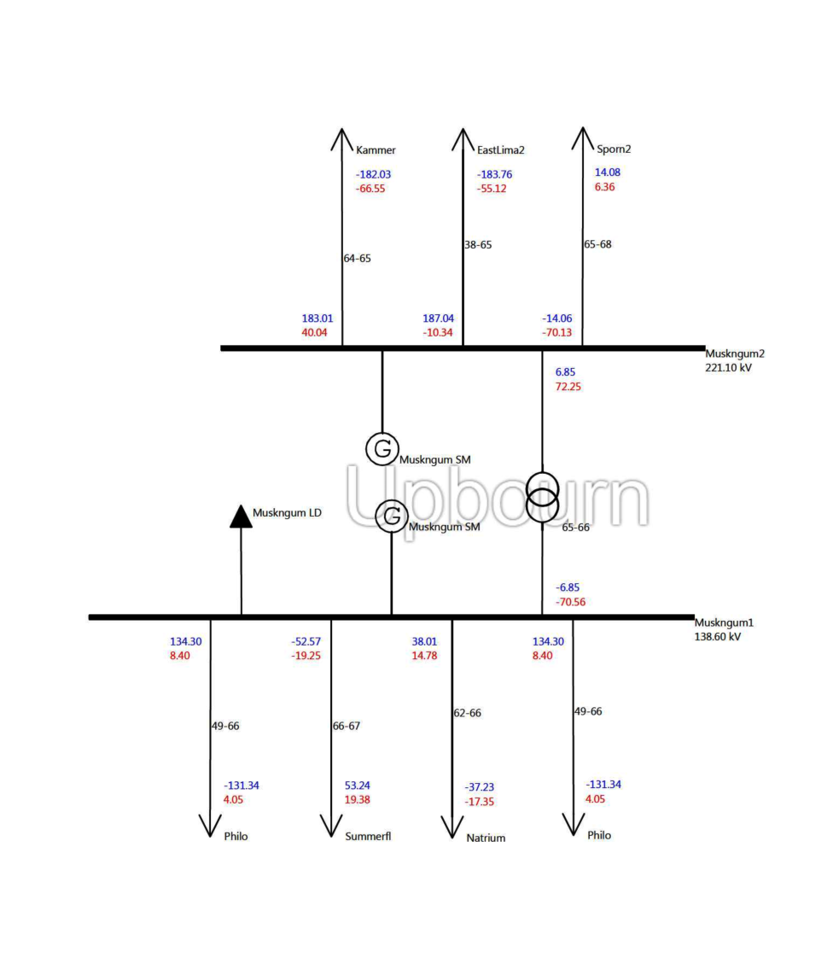

Figure 13 - SGBC bus-branch, diagram for substation Upbourn

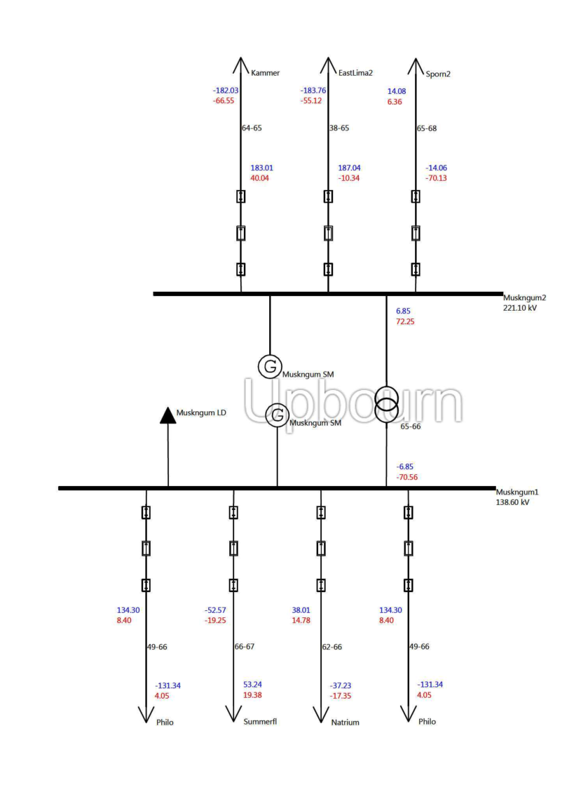

Figure 14 - SGBC node-breaker, diagram for substation Upbourn

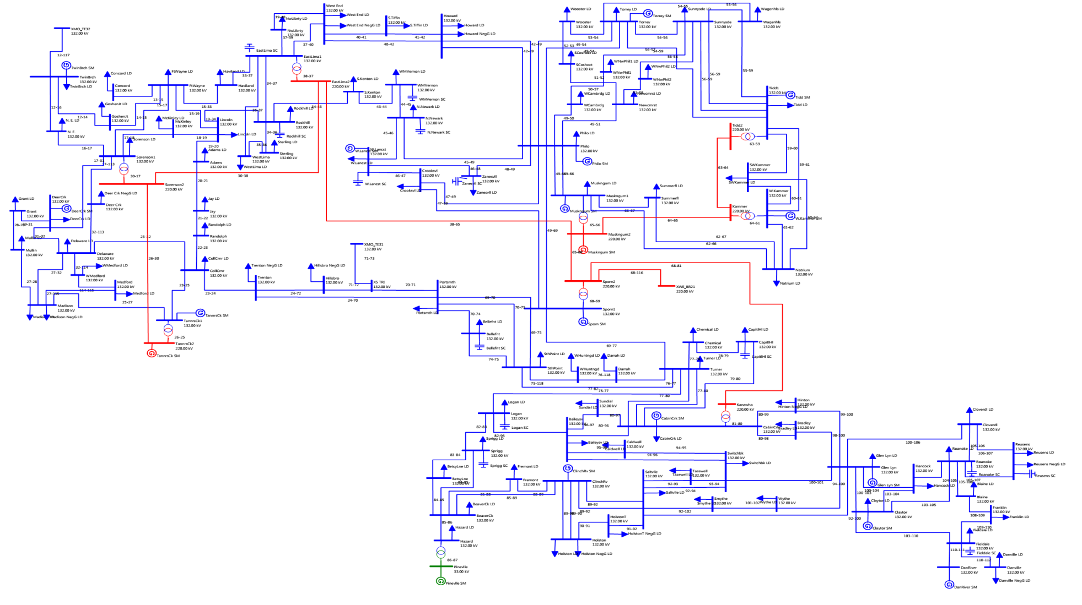

Figure 15- Small Grid Reduced Network(SGRN) single line diagram

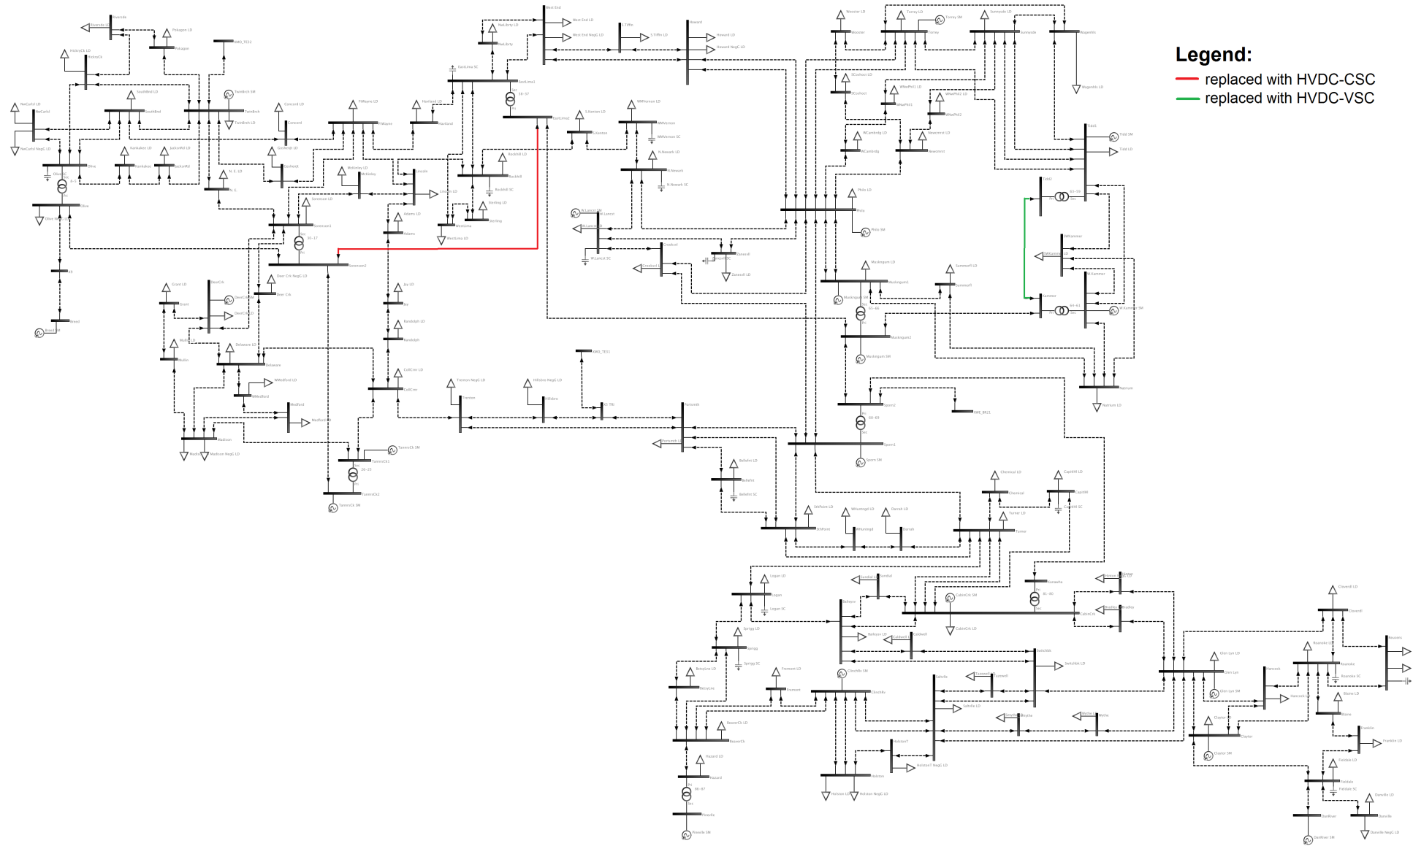

Figure 16 - SGBC network with the marked(red colour) replacements for HVDC configuration

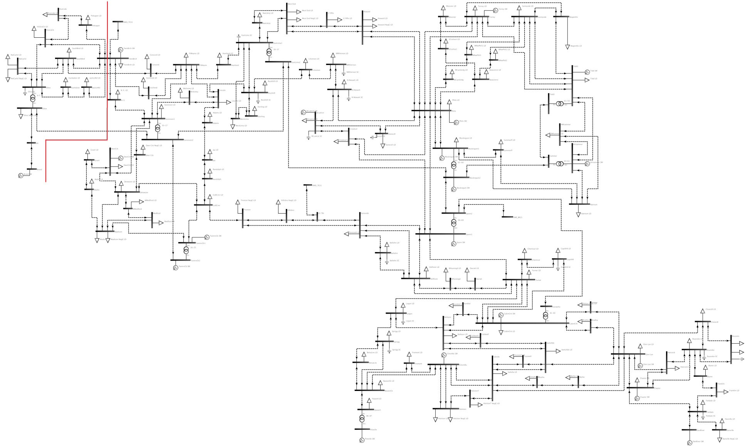

Figure 17 - SGBC network with the marked replacements for Reduced Network

1. References
2. Ugur Arifoglu: *The power flow algorithm for balanced and unbalanced bipolar multiterminal ac-dc systems*, Electric Power Systems Research 64, 2003.
3. Vijay K. Sood: *HVDC and FACTS Controllers, Applications of Static Converters in Power Systems*, Kluwer Academic Publishers, 2004.
4. C. Liu, B. Zhang, Y. Hou, F.F. Wu: *An Improved Approach for AC-DC Power Flow calculation with multi-infeed DC systems*, IEEE Transactions on Power Systems, 2011.
5. F. Gonzalez-Longatt, J. Roldan and C. A. Charalambous: *Power Flow Solution on Multt-Terminal HVDC Systems: Supergrid Case*, International Conference on Renawable Energies and Power Quality (ICREPQ 2012), Spain, 2012.