|  |
| --- |
| Mini Grid Test Configuration |
| Version 3.0.0 |
| CGMES 2.4.15 |
| 31 May 2015 |

Contents

[Contents 2](#_Toc420821012)

[1. Introduction 3](#_Toc420821013)

[2. Usage and content of the test configuration 3](#_Toc420821014)

[3. Mini Grid Base Case 5](#_Toc420821015)

[3.1. General information 5](#_Toc420821016)

[3.2. Network topology and data 5](#_Toc420821017)

[3.3. Load flow and short-circuit calculation information 8](#_Toc420821018)

[Three-phase short-circuit currents 8](#_Toc420821019)

[Line-to-earth short-circuit currents 8](#_Toc420821020)

[3.4. CIMdesk validation report for bus-branch version 12](#_Toc420821021)

[3.5. CIMdesk validation report for node-breaker version 12](#_Toc420821022)

[4. Mini Grid Type 1 12](#_Toc420821023)

[4.1. Load flow and short-circuit calculation information 14](#_Toc420821024)

[Three-phase short-circuit currents 14](#_Toc420821025)

[Line-to-earth short-circuit currents 14](#_Toc420821026)

[4.2. CIMdesk validation report for bus-branch version 18](#_Toc420821027)

[4.3. CIMdesk validation report for node-breaker version 18](#_Toc420821028)

[5. Mini Gird Type 2 18](#_Toc420821029)

[5.1. Load flow and short-circuit calculation information 20](#_Toc420821030)

[Three-phase short-circuit currents 20](#_Toc420821031)

[Line-to-earth short-circuit currents 20](#_Toc420821032)

[5.2. CIMdesk validation report for bus-branch version 24](#_Toc420821033)

[5.3. CIMdesk validation report for node-breaker version 24](#_Toc420821034)

[6. References 24](#_Toc420821035)

1. Introduction

The document is providing an overview of the Mini Grid Test Configuration applicable for the ENTSO-E Common Grid Model Exchange Standard (CGMES) Conformity Assessment Framework hereafter referred as “the Framework”.

Versioning of the document is following the rules specified in the Chapter 5.1 of the CGMES.

**Disclaimer**

The Test Configurations (test models) are owned by ENTSO-E and are provided by ENTSO-E “as it is”. To the fullest extent permitted by law, ENTSO-E shall not be liable for any damages of any kind arising out of the use of the models (including any of their subsequent modifications). ENTSO-E neither warrants, nor represents that the use of the models will not infringe the rights of third parties. Any use of the models shall include a reference to ENTSO-E. ENTSO-E web site is the only official source of information related to these models.

1. Usage and content of the test configuration

The Mini Grid test configuration is packaged in the following structure:

* Documentation which contains configuration descriptions and results
  + CGMES\_v2.4.15\_MiniGridTestConfiguration\_v3.0.0.doc - file explaining MiniGrid test configurations (Base Case, Type 1 and Type 2)
  + <CGMES_v2.4.15_MiniGridTestConfiguration_BC_v3.0.0.xls> - Mini Grid Base Case configuration, file containing in different sheets model description, load flow and short-circuit results
  + <CGMES_v2.4.15_MiniGridTestConfiguration_T1_v3.0.0.xls> - Mini Grid Type 1 configuration, file containing in different sheets model description and short-circuit results
  + <CGMES_v2.4.15_MiniGridTestConfiguration_T2_v3.0.0.xls> - Mini Grid Type 2 configuration, file containing in different sheets model description and short-circuit results
* NodeBreaker which contains data for the node-breaker configuration
  + CGMES\_v2.4.15\_MiniGridTestConfiguration\_BaseCase\_Complete\_v3.zip
  + CGMES\_v2.4.15\_MiniGridTestConfiguration\_Boundary\_v3.zip
  + CGMES\_v2.4.15\_MiniGridTestConfiguration\_T1\_Complete\_v3.zip
  + CGMES\_v2.4.15\_MiniGridTestConfiguration\_T2\_Complete\_v3.zip
  + BaseCase\_Difference
    - MiniGridTestConfiguration\_BC\_EQ\_diff\_v3.0.0.xml
    - MiniGridTestConfiguration\_BC\_TP\_diff\_v3.0.0.xml
  + T1\_Difference
    - MiniGridTestConfiguration\_T1\_EQ\_diff\_v3.0.0.xml
  + T2\_Difference
    - MiniGridTestConfiguration\_T2\_EQ\_diff\_v3.0.0.xml
* BusBranch which contains data for the bus-branch configuration
  + CGMES\_v2.4.15\_MiniGridTestConfiguration\_BaseCase\_v3.zip
  + CGMES\_v2.4.15\_MiniGridTestConfiguration\_Boundary\_v3.zip
  + CGMES\_v2.4.15\_MiniGridTestConfiguration\_T1\_Complete\_v3.zip
  + CGMES\_v2.4.15\_MiniGridTestConfiguration\_T2\_Complete\_v3.zip
  + Type1\_Difference
    - MiniGridTestConfiguration\_T1\_EQ\_diff\_v3.0.0.xml
  + Type2\_Difference
    - MiniGridTestConfiguration\_T2\_EQ\_diff\_v3.0.0.xml

Mini Grid test configurations models are planned to be used only for short-circuit calculations (according to the IEC 60909-4 standard), but not for load flow and dynamic calculations.

For the both configurations (node-breaker and bus-branch) there are base case, type 1 and type 2 model versions. All the models are created from the Mini Grid Base Case applying the appropriate difference file like on the Figure 1. The complete type 1 and type 2 models are also given in the zip package.

Differences between Base Case and configurations:

* Type 1 - power line L3\_a is disabled
* Type 2 - ground connection of T4 transformer is disconnected

Mini Grid Type 1 model is intended to validate that values of short circuit current is changed upon changing network topology (disconnecting power line L3\_a).

Mini Grid Type 2 model is intended to validate that values of line to earth short circuit current is changed upon changing power transformer grounding (ground of second winding of transformer T4 is disconnected).

For the bus-branch configuration EQ, TP and SSH can be used without SV file, the same results are achieved like with the SV file, while for the node-breaker only EQ and SSH are enough for the short-circuit calculations.

All test models created from the Mini Grid Base Case are shown in the following chart.



Figure 1 – Dependencies between Mini Grid Base Case and Mini Grid Type 1 and Mini Grid Type 2 for the bus-branch and node-breaker configurations

1. Mini Grid Base Case
   1. General information

The following test network with data of electrical equipment and results for the short-circuit currents in accordance with IEC 60909-0 shall offer the possibility to the designers and users of digital programs to check the results found with their program in comparison to the results given.

Maximum three-phase short-circuit currents shall be calculated at the busbars 1 to 8 with c = cmax = 1,1 in accordance with table 1 of IEC 60909-0 and, in addition, maximum line-to-earth short-circuit currents at the busbars 2 to 5 only. In any case, the short-circuit impedance is to be related to the voltage level where the short-circuit location is situated.

The complex impedance of network feeders at the connection point shall be calculated with  
 , if the ratio RQ/XQ is given (see equation (5) of IEC 60909-0) because the approximation XQ » 0,995 ZQ is offered only for the special case RQ/XQ = 0,1 (3.2 of IEC 60909-0). A similar procedure should be chosen for asynchronous motors if the ratio RM/XM is given (3.8.1 of IEC 60909-0).

Line capacitances are not taken into account because the earth fault factor is smaller than 1,4 (2.3.2 of IEC 60909-0).

KT is calculated with equation (12a) of IEC 60909-0 because load flow conditions are not known for the test network.

It is anticipated for the calculation of the impedance correction factor KS1 for the power station unit S1 that the generator is operated only in the overexcited region (figure 7 of IEC 60909-1).

In the case of negative values for the reactances of three-winding transformers in the positive-sequence or the negative-sequence system, these should not be interpreted as capacitances, especially in the case of the calculation with the equivalent frequency method (4.3.1.2c) of IEC 60909-0). The negative sign may occur for the equivalent reactance (see figure 7b of IEC 60909-01) of the winding which is situated in between the other two windings in the case of a three-winding transformer (see table 3B of IEC 60909-2, for instance No. 6).

When using the 20 Hz or the 24 Hz method respectively to find the factor k in meshed networks, the impedance correction factors KG, KS and KT shall be used in the form given (IEC 60909-0).

There are two different configuration of the Mini Grid Base Case model:

1. Bus-Branch Configuration
2. Node-Breaker Configuration

Node-breaker configuration is created by applying difference files (MiniGridTestConfiguration\_BC\_EQ\_diff\_v3.0.0 and MiniGridTestConfiguration\_BC\_TP\_diff\_v3.0.0) on the standard Mini Grid Base Case bus-branch related model.

* 1. Network topology and data

Figure 2 gives the topology of the three-phase a.c. test network, 50 Hz, with the busbars **1** to **8** and the electrical equipment. The busbars **1** to **8** shall be the short-circuit locations in the case of three-phase short circuits and the busbars **2** to **5** in the case of line-to-earth short circuits.

There are three earthing points in the 110 kV part of the network: transformer T4, power-station unit S1(G1 + T1) and feeder Q2 (IEC 60909-4).



Figure 2 - High-voltage a.c. test network 380 kV/110 kV/30 kV/10 kV (IEC 60909-4) with added three phase short circuit results

G1 + T1 = S1: Power-station unit with on-load tap-changer

G2 + T2 = S2: Power-station unit without on-load tap-changer

10 kV network with resonance earthing, R6: Arc-suppression coil

1...8 busbars and short-circuit locations

Three phase short circuit results, listed in IEC-60909-4, are added to Figure 2. One phase short circuit results are added to Figure 3. IEC-60909-4 results are also given in the xls document <CGMES_v2.4.15_MiniGridTestConfiguration_BC_v3.0.0.xls> in sheets “Three phase - IEC 60909-4” and “Phase to ground - IEC 60909-4”.



*Figure 3 - High-voltage a.c. test network 380 kV/110 kV/30 kV/10 kV (IEC 60909-4) with added one phase short circuit results*

The summary of the Mini Grid Base Case model is shown in the table below.



Detail information about the each grid element is given in the xls document <CGMES_v2.4.15_MiniGridTestConfiguration_BC_v3.0.0.xls> in the sheet “Model Description”.

* 1. Load flow and short-circuit calculation information

Results for load flow calculation are given in Figure 4.

Load flow system summary

**AC Load Flow Type**

**Full Newten-Rapson**

**Reactive limits**

**Off**

**Relative Error Tolerance**

**P=0.002 Q=0.005**

**Number of Iterations**

**11**

**P = 0.1 MW**

**Q = 0.2 MVAr**

**V = 10.0 kV**

**angle = 0**

**Slack Bus “HG2”**

Three-phase short-circuit currents

The results of the three-phase short circuits at the busbars 1 to 8 are given in the xls document <CGMES_v2.4.15_MiniGridTestConfiguration_BC_v3.0.0.xls> in the sheet “Three phase”, while in the sheet “Three phase - IEC 60909-4” are actual results from the IEC 60909-4 standard for comparison. Values of the short-circuit currents Ik” , Ip, Ib and Sk” are given for the each case. Results for three-phase short circuit are given in Figure 5.

Line-to-earth short-circuit currents

The results of the line-to-earth short circuits at the busbars 2 to 5 are given in the xls document <CGMES_v2.4.15_MiniGridTestConfiguration_BC_v3.0.0.xls> in the sheet “Phase to Ground”, while in the sheet “Phase to ground - IEC 60909-4” are actual results from IEC 60909-4 standard for comparison. Values of the short-circuit currents Ik1” and Ip1 are given for the each case. Results for three-phase short circuit are given in Figure 6.

The peak short-circuit current ip with k(1) is calculated with k(1) found from the positive-sequence impedances at the short-circuit locations F using the 20 Hz method. The peak short-circuit current ip with k(012) is found with k(012) = (R(0) + R(1) + R(2))/(X(0) + X(1) + X(2)) at the short-circuit locations using the 20 Hz method.

Note: results from the IEC 60909-4 standards are only for comparison with the Base Case not with the Type 1 and Type 2 models.

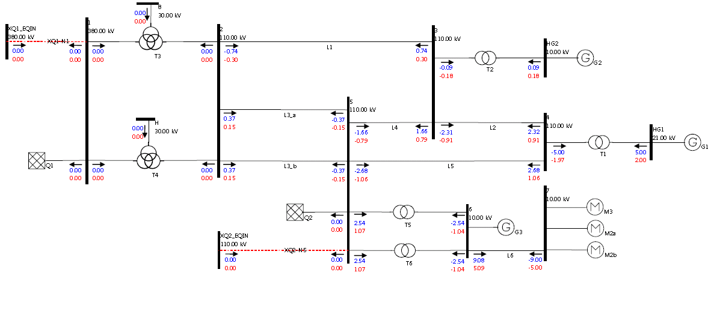

Figure 4 – Mini Grid Base Case Load Flow Results

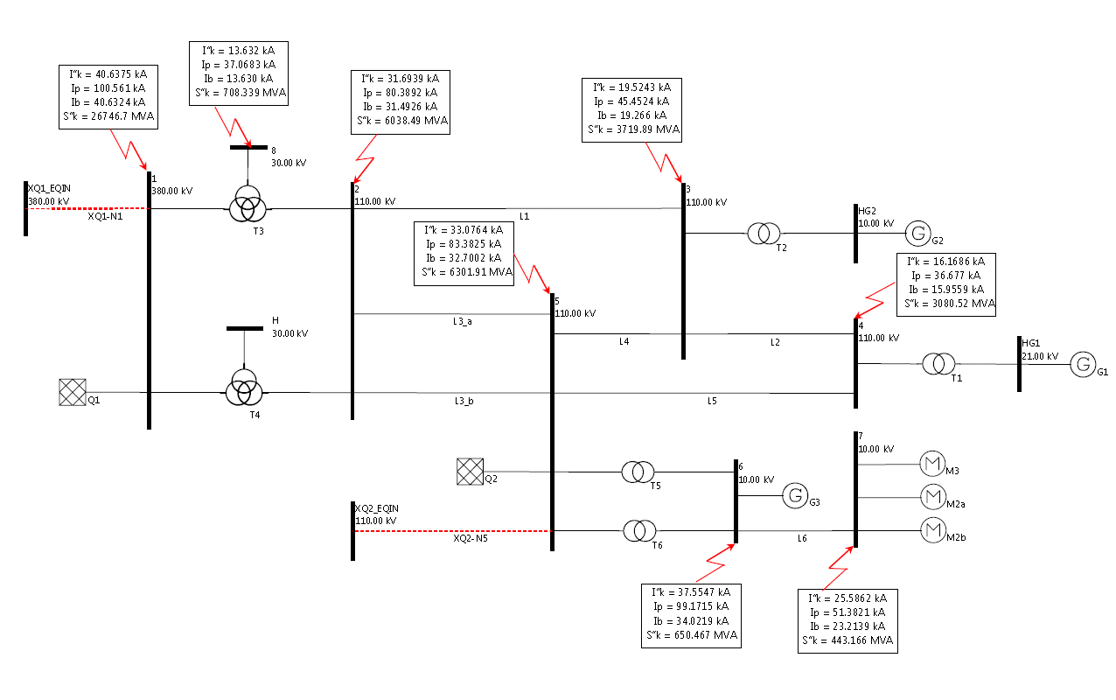

Figure 5 – Mini Grid Base Case Three Phase Short Circuit

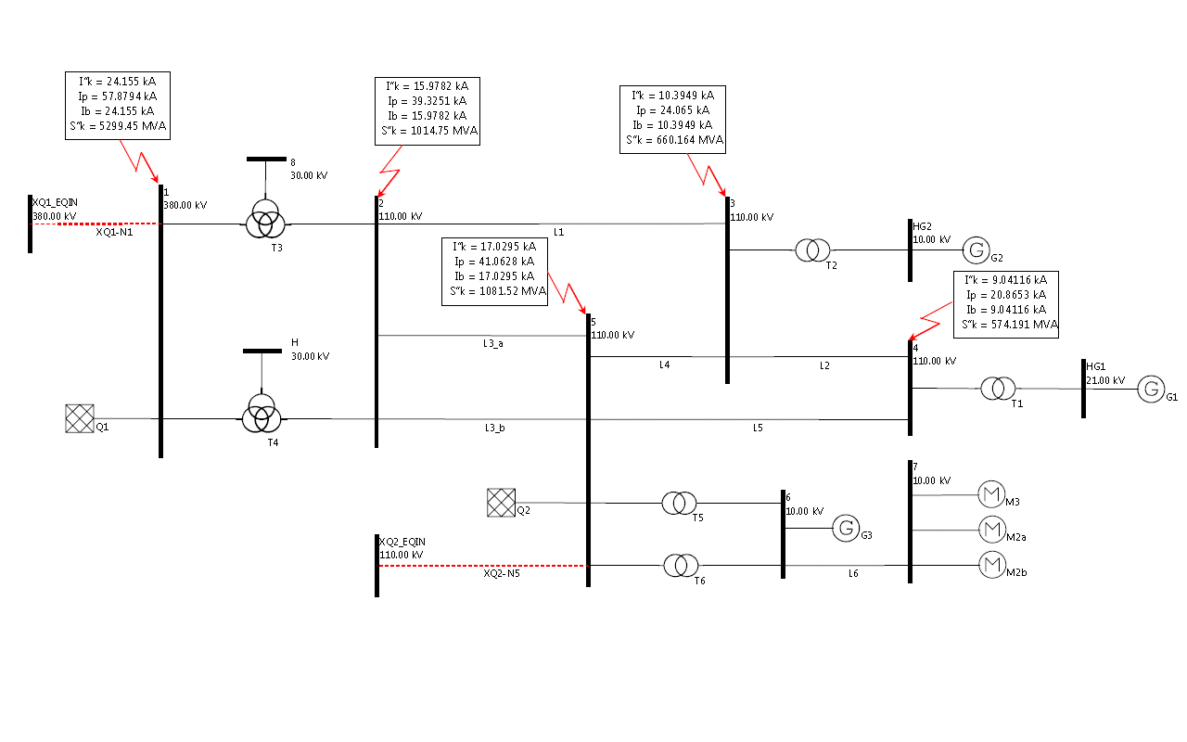

Figure 6 – Mini Grid Base Case Phase to Ground Short Circuit

* 1. CIMdesk validation report for bus-branch version

CIMdesk validation report (validation against Base profiles) on the assembled model which includes boundary and the base case bus-branch version is the following:

| **Type** | **Class** | **Recurrence** | **Description** |
| --- | --- | --- | --- |
| Warning | SubGeographicalRegion | [1/2](http://localhost:8080/CIMSpy/contents/javascript) | No Substations are associated with SubGeographicalRegion via Association Substation.Region, expecting at least 1. |
| Warning | TopologicalNode | [2/13](http://localhost:8080/CIMSpy/contents/javascript) | Fewer than 2 Terminals are associated with TopologicalNode via Association Terminal.TopologicalNode, expecting at least 2. |
| Warning | PowerTransformerEnd | [5/14](http://localhost:8080/CIMSpy/contents/javascript) | The rated voltage doesn't match the nominal voltage of the connected node. |

The above warnings should be ignored as:

* SubGeographicalRegion in the boundary can not contain any Substations, but they are referenced from Line containers in boundary.
* The reason is that the 3rd windings of transformers T3 and T4 are not connected.
* Data issue which is considered normal for the provided model.
  1. CIMdesk validation report for node-breaker version

CIMdesk validation report (validation against Operation) on the assembled model which includes boundary and the base case node-breaker version is the following:

| **Type** | **Class** | **Recurrence** | **Description** |
| --- | --- | --- | --- |
| Warning | SubGeographicalRegion | [1/2](http://localhost:8080/CIMSpy/contents/javascript) | No Substations are associated with SubGeographicalRegion via Association Substation.Region, expecting at least 1. |
| Warning | PowerTransformerEnd | [5/14](http://localhost:8080/CIMSpy/contents/javascript) | The rated voltage doesn't match the nominal voltage of the connected node. |

The above warnings should be ignored as:

* SubGeographicalRegion in the boundary cannot contain any Substations, but they are referenced from Line containers in boundary.
* Data issue which is considered normal for the provided model.

1. Mini Grid Type 1

The Mini Grid Type 1 model is based on the Mini Grid Base Case network model.

The Mini Grid Type 1 model is created by upgrading the standard Mini Grid Base Case model with the following modifications:

* Power line L3\_a is disabled (Figure 7).

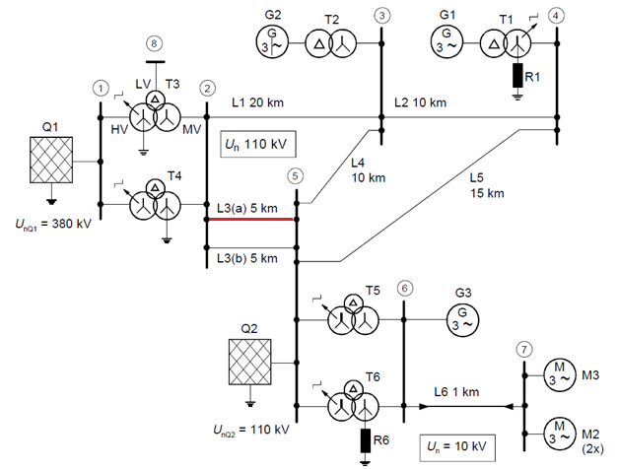

Figure 7 – Mini Grid Base Case network model changes for Type 1 (picture from IEC 60909-4)

There are two different configuration of the Mini Grid Type 1 model:

1. Bus-Branch Configuration
2. Node-Breaker Configuration

Bus-branch configuration Mini Grid Type 1 is created by applying the difference file (MiniGridTestConfiguration\_T1\_EQ\_diff\_v3.0.0.xml) on the Mini Grid Base Case bus-branch related model (Figure 8).

Node-breaker configuration Mini Grid Type 1 is created by applying the difference files (MiniGridTestConfiguration\_T1\_EQ\_diff\_v3.0.0.xml) on the Mini Grid Base Case node-breaker related model (Figure 8).



Figure 8 – Creation of the bus-branch and node-breaker Mini Grid Type 1 models from related Mini Grid Base Case models

Detail information about the each grid element is given in the xls document <CGMES_v2.4.15_MiniGridTestConfiguration_T1_v3.0.0.xls>

* 1. Load flow and short-circuit calculation information

Results for load flow calculation are given in Figure 9.

Load flow system summary

**AC Load Flow Type**

**Full Newton-Raphson**

**Reactive limits**

**Off**

**Relative Error Tolerance**

**P=0.002 Q=0.005**

**Number of Iterations**

**12**

**P = 0.1 MW**

**Q = 0.2 MVAr**

**V = 10.0 kV**

**angle = 0**

**Slack Bus "HG2"**

Three-phase short-circuit currents

The results of the three-phase short circuits at the busbars 1 to 8 are given in the xls document <CGMES_v2.4.15_MiniGridTestConfiguration_T1_v3.0.0.xls> in the sheet “Three phase”. Graphical results are presented in Figure 10.

Line-to-earth short-circuit currents

The results of the line-to-earth short circuits at the busbars 2 to 5 are given in the xls document <CGMES_v2.4.15_MiniGridTestConfiguration_T1_v3.0.0.xls> in the sheet “Phase to Ground”. Graphical results are presented in Figure 11.

Note: results from the IEC 60909-4 standards are only for comparison with the Base Case not with the Type 1 and Type 2 models.

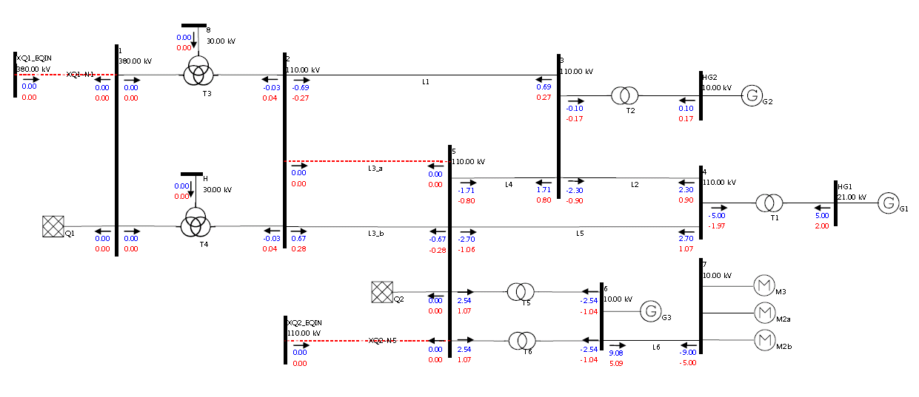

Figure 9 – Mini Grid Type 1 Load Flow Results

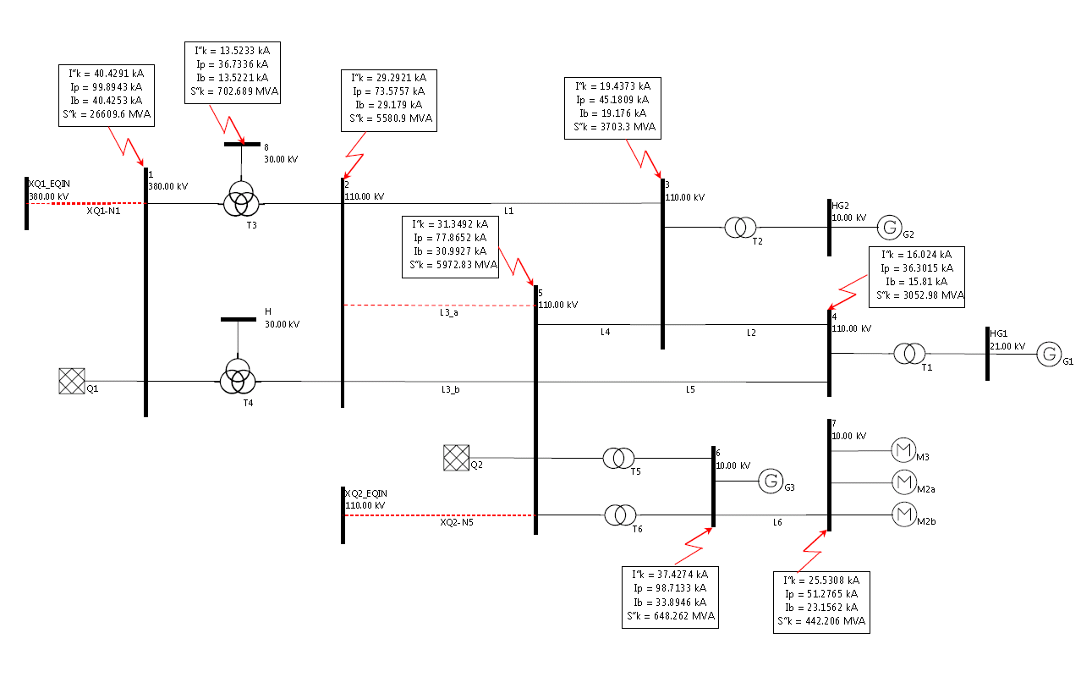

Figure 10 – Mini Grid Type 1 Three Phase Short Circuit

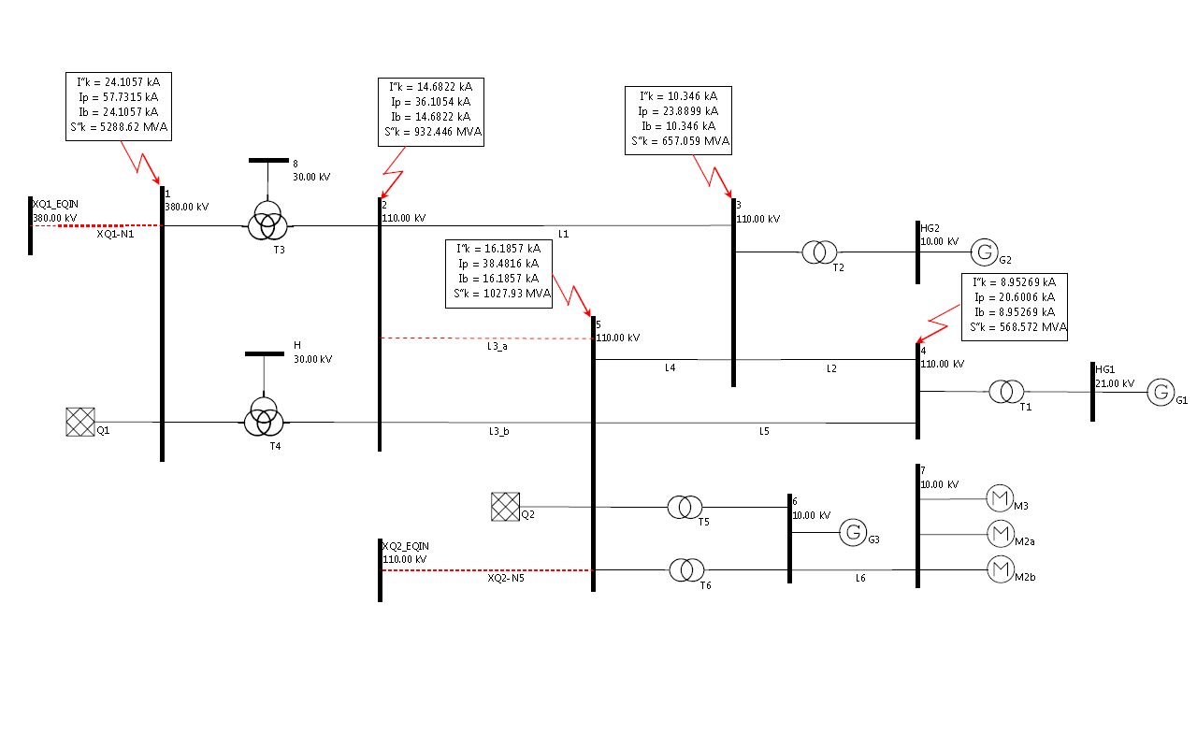

Figure 11 – Mini Grid Type 1 Phase to Ground Short Circuit

* 1. CIMdesk validation report for bus-branch version

CIMdesk validation report (validation against Base profiles) on the assembled model which includes boundary and the base case bus-branch version is the following:

| **Type** | **Class** | **Recurrence** | **Description** |
| --- | --- | --- | --- |
| Warning | SubGeographicalRegion | [1/2](http://localhost:8080/CIMSpy/contents/javascript) | No Substations are associated with SubGeographicalRegion via Association Substation.Region, expecting at least 1. |
| Warning | TopologicalNode | [2/13](http://localhost:8080/CIMSpy/contents/javascript) | Fewer than 2 Terminals are associated with TopologicalNode via Association Terminal.TopologicalNode, expecting at least 2. |
| Warning | PowerTransformerEnd | [5/14](http://localhost:8080/CIMSpy/contents/javascript) | The rated voltage doesn't match the nominal voltage of the connected node. |

The above warnings should be ignored as:

* SubGeographicalRegion in the boundary can not contain any Substations, but they are referenced from Line containers in boundary.
* The reason is that the 3rd windings of transformers T3 and T4 are not connected.
* Data issue which is considered normal for the provided model.
  1. CIMdesk validation report for node-breaker version

CIMdesk validation report (validation against Operation) on the assembled model which includes boundary and the base case node-breaker version is the following:

| **Type** | **Class** | **Recurrence** | **Description** |
| --- | --- | --- | --- |
| Warning | SubGeographicalRegion | [1/2](http://localhost:8080/CIMSpy/contents/javascript) | No Substations are associated with SubGeographicalRegion via Association Substation.Region, expecting at least 1. |
| Warning | PowerTransformerEnd | [5/14](http://localhost:8080/CIMSpy/contents/javascript) | The rated voltage doesn't match the nominal voltage of the connected node. |

The above warnings should be ignored as:

* SubGeographicalRegion in the boundary can not contain any Substations, but they are referenced from Line containers in boundary.
* Data issue which is considered normal for the provided model.

1. Mini Gird Type 2

The Mini Grid Test Case 2 model is based on the Mini Grid Base Case network model.

The Mini Grid Test Case 2 model is created by upgrading the standard Mini Grid Base Case model with the following modifications:

* Ground connection of T4 transformer is disconnected (Figure 12).

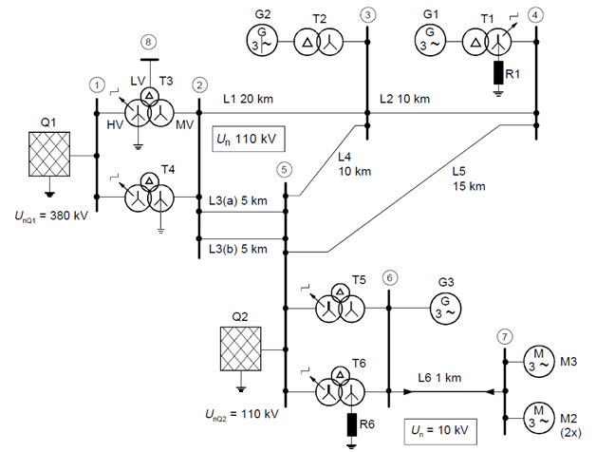

Figure 12 – Mini Grid Base Case network model changes for Type 2 (picture from IEC 60909-4)

There are two different configuration of the Mini Grid Type 2 model:

1. Bus-Branch Configuration
2. Node-Breaker Configuration

Bus-branch Type 2 configuration is created by applying the difference file (MiniGridTestConfiguration\_T2\_EQ\_diff\_v3.0.0.xml) on the Mini Grid Base Case bus-branch related model (Figure 13).

Node-breaker configuration is created by applying the difference files (MiniGridTestConfiguration\_T2\_EQ\_diff\_v3.0.0.xml) on the Mini Grid Base Case node-breaker related model (Figure 13).



Figure 13 - Creation of the bus-branch and node-breaker Mini Grid Type 2 models from related Mini Grid Base Case models

Detail information about the each grid element is given in the xls document <CGMES_v2.4.15_MiniGridTestConfiguration_T2_v3.0.0.xls>.

* 1. Load flow and short-circuit calculation information

Results for load flow calculation are given in Figure 14.

Load flow system summary

**AC Load Flow Type**

**Full Newton-Raphson**

**Reactive limits**

**On**

**Relative Error Tolerance**

**P=0.002 Q=0.005**

**Number of Iterations**

**11**

**P = 0.1 MW**

**Q = 0.2 MVAr**

**V = 10.0 kV**

**angle = 0**

**Slack Bus "HG2"**

Three-phase short-circuit currents

The results of the three-phase short circuits at the busbars 1 to 8 are given in the xls document [<CGMES_v2.4.15_MiniGridTestConfiguration_T2_v3.0.0.xls> in the sheet “Three phase”.](file:///E:\Podaci\CIM\DMS%20modeli%20(IOP%202014)\Final\Models%20Documentation_2.6.2014\Mini%20Grid\MinGC2%20-%20Three%20phase%20SC.xls) Graphical results are presented in Figure 15.

Line-to-earth short-circuit currents

The results of the line-to-earth short circuits at the busbars 2 to 5 are given in the xls document <CGMES_v2.4.15_MiniGridTestConfiguration_T2_v3.0.0.xls> in the sheet “Phase to Ground”. Graphical results are presented in Figure 16.

Note: results from the IEC 60909-4 standards are only for comparison with the Base Case not with the Type 1 and Type 2 models.



Figure 14 – Mini Grid Type 2 Load Flow Results



Figure 15 – Mini Grid Type 2 Three Phase Short Circuit

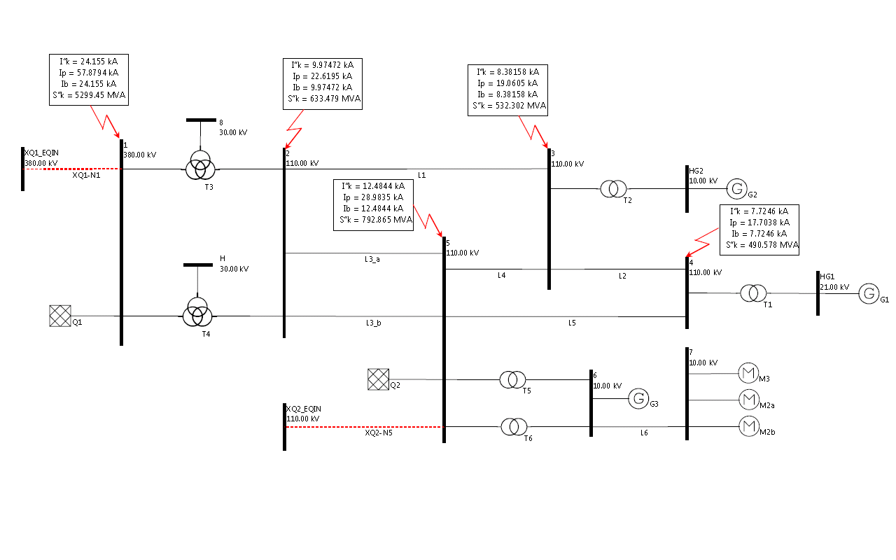

Figure 16 – Mini Grid Type 2 Phase to Ground Short Circuit

* 1. CIMdesk validation report for bus-branch version

CIMdesk validation report (validation against Base profiles) on the assembled model which includes boundary and the base case bus-branch version is the following:

| **Type** | **Class** | **Recurrence** | **Description** |
| --- | --- | --- | --- |
| Warning | SubGeographicalRegion | [1/2](http://localhost:8080/CIMSpy/contents/javascript) | No Substations are associated with SubGeographicalRegion via Association Substation.Region, expecting at least 1. |
| Warning | TopologicalNode | [2/13](http://localhost:8080/CIMSpy/contents/javascript) | Fewer than 2 Terminals are associated with TopologicalNode via Association Terminal.TopologicalNode, expecting at least 2. |
| Warning | PowerTransformerEnd | [5/14](http://localhost:8080/CIMSpy/contents/javascript) | The rated voltage doesn't match the nominal voltage of the connected node. |

The above warnings should be ignored as:

* SubGeographicalRegion in the boundary can not contain any Substations, but they are referenced from Line containers in boundary.
* The reason is that the 3rd windings of transformers T3 and T4 are not connected.
* Data issue which is considered normal for the provided model.
  1. CIMdesk validation report for node-breaker version

CIMdesk validation report (validation against Operation) on the assembled model which includes boundary and the base case node-breaker version is the following:

| **Type** | **Class** | **Recurrence** | **Description** |
| --- | --- | --- | --- |
| Warning | SubGeographicalRegion | [1/2](http://localhost:8080/CIMSpy/contents/javascript) | No Substations are associated with SubGeographicalRegion via Association Substation.Region, expecting at least 1. |
| Warning | PowerTransformerEnd | [5/14](http://localhost:8080/CIMSpy/contents/javascript) | The rated voltage doesn't match the nominal voltage of the connected node. |

The above warnings should be ignored as:

* SubGeographicalRegion in the boundary can not contain any Substations, but they are referenced from Line containers in boundary.
* Data issue which is considered normal for the provided model.

1. References

IEC 60909-0:2000, *Short-circuit currents in three-phase a.c. systems*

IEC 60909-1:1991, *Short-circuit current calculation in three-phase a.c. systems*

IEC 60909-2:1992, *Electrical equipment – Data for short-circuit current calculations in accordance with IEC 60909*

IEC 60909-3:1995, *Short-circuit currents in three-phase a.c. systems*

IEC 60909-4:2000*, Examples for the calculation of short-circuit currents*