**Rate Constant Study of CVBR**

In this experiment, a 0.665 L constant volume batch reactor (CVBR) was first filled with sodium hydroxide solution and heated to reaction temperatures between 21°C and 38.5°C. The process was operated under isothermal condition and assumed to be well mixed. Ethyl acetate solution was then injected into the reactor to initiate the reaction. Conductivity of the solution was measured as a function of time during the experiment under different reaction temperatures.

The objectives of this experiment were to determine the rate constants using integration and differential methods and activation energy for the reaction between sodium hydroxide and ethyl acetate, and to determine the concentration of ethyl acetate at which the reaction starts to deviate from second order behaviour.

All of the data importing/exporting, cleaning, calculations, statistical analysis and modeling as well as model evaluations were automated via the creation of the **Matlab code**. All of the input data files can be analyzed and the resulting figures (see below) can be generated simply by running the program.

The following figures are some featured results for demonstration purpose:

*1. Integration method modeling*

*2. Differential method modeling*

Raw Data from experiment:

<https://docs.google.com/spreadsheets/d/1ZFvqKQYzamdzsqCNKwkONhdC-TRZnsREnoOWltkoUjE/edit#gid=1645308463>

Code (Matlab) for Demo:

<https://drive.google.com/file/d/1k8NAUwXnD0cXuHEm6pJ7B1sgXGhUESRq/view?usp=sharing>

1. Integration method modeling:

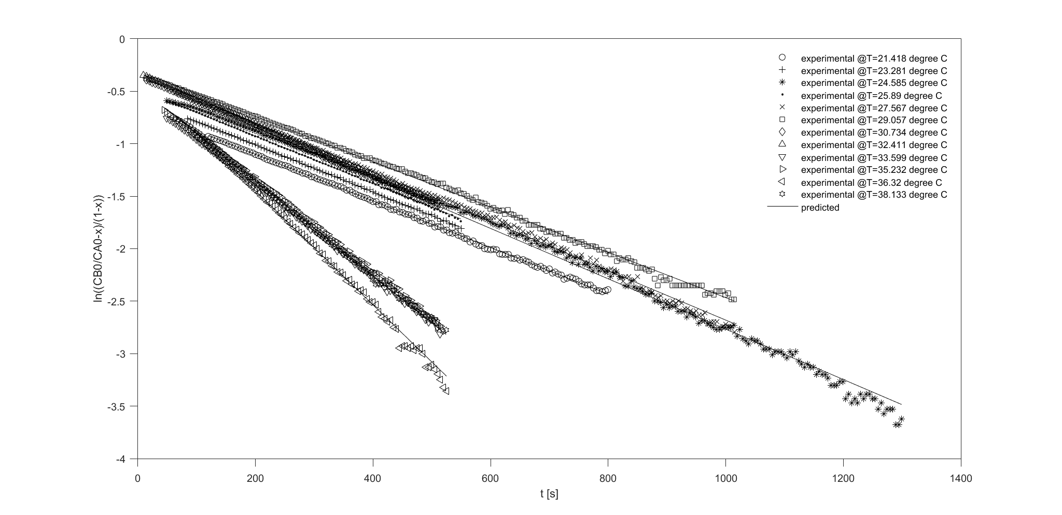

Figure 1. ln((CB0/CA0-x)/(1-x)) vs. t at 12 different T with predicted regression line after data truncation.

2. Differential method modeling:

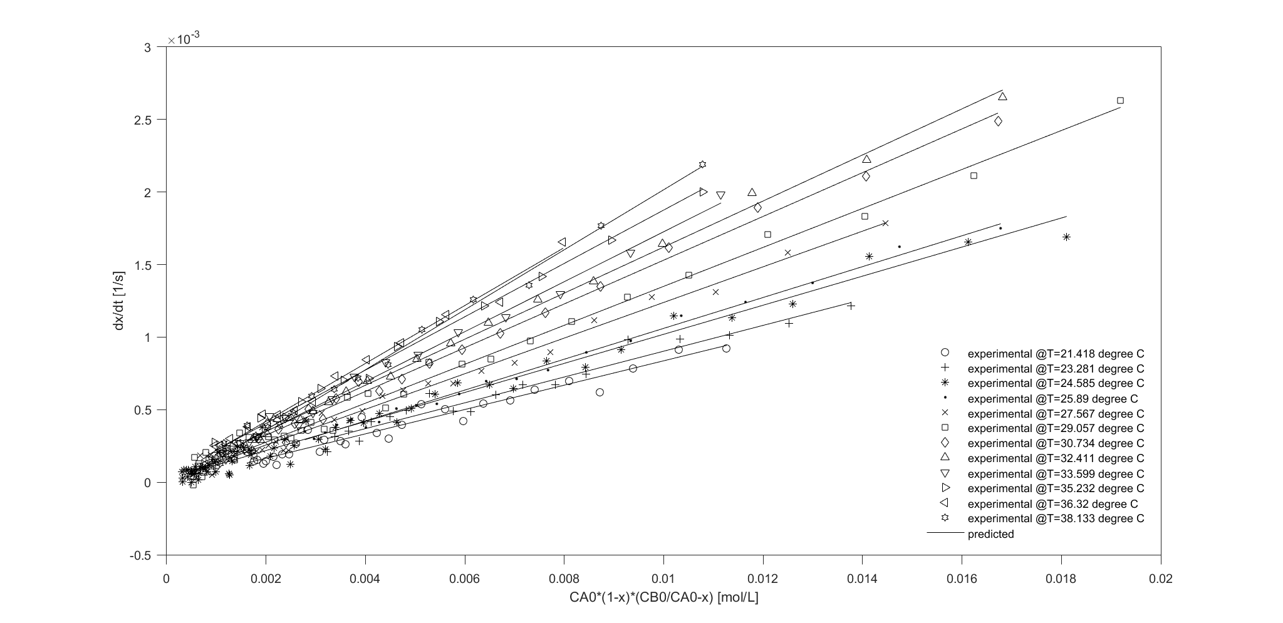

Figure 2. dx/dt vs. CA0*(1-x)*(CB0/CA0-x) at 12 different T with predicted regression line after data truncation.