This project used Matlab Code to analyze the data using Raw Data Source which was stored in Excel format.

Includes:

1. Data Import & Extraction, Truncation and Preprocessing.

2. Data (statistical) analysis with: User-defined functions for calculation purpose, Array/table for storing variables/data.

3. Plotting in required format.

4. Results/Data Export to external sources (e.g. Excel).

The following graphs are for demonstration purpose:

* Original Data

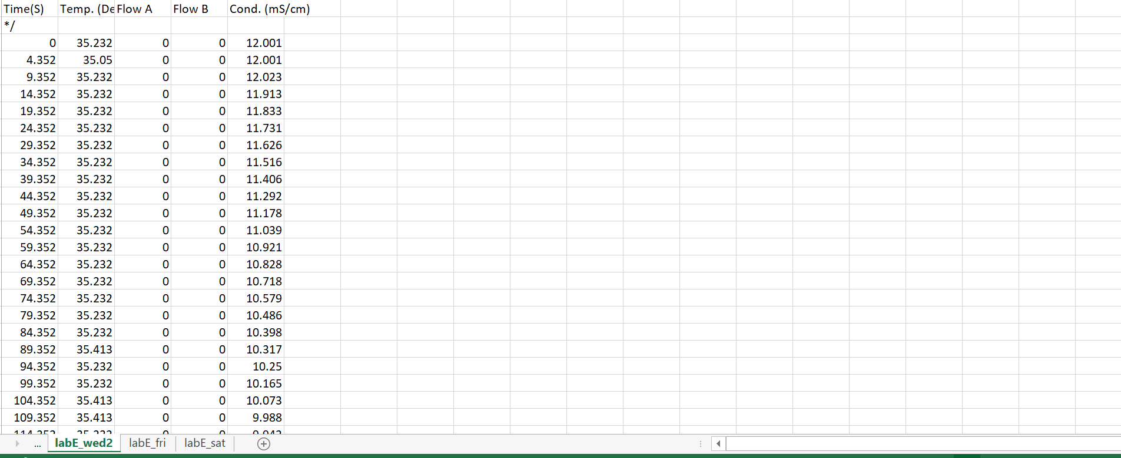

* Data Extraction (from raw data source) and Truncation (cleaning)

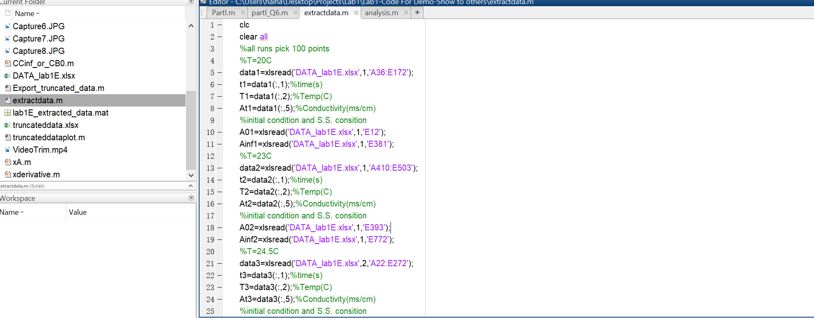

* Data (Statistics) Analysis with clear explanation (documentation and comments)

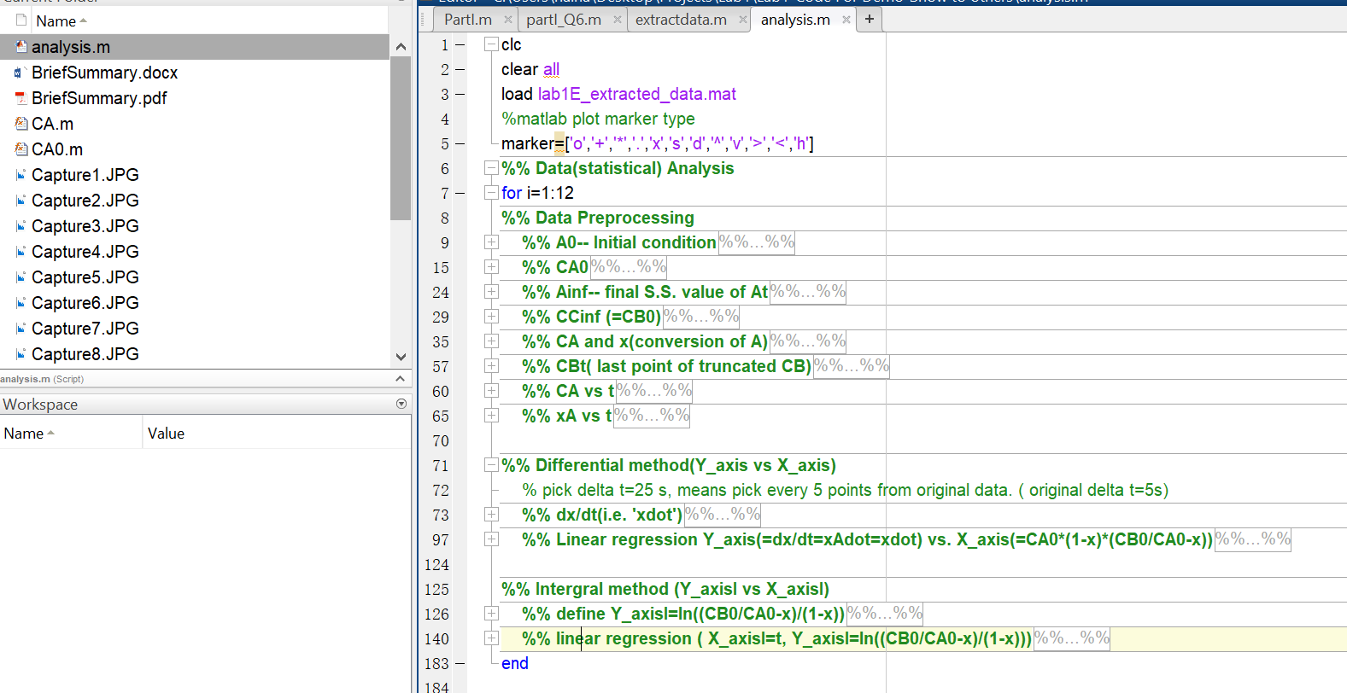

* Plotting with required format:

