The goal of this experiment was to study the characteristics of a packed bed distillation

column under normal operation. Water - methanol mixture was fed to a distillation column of

0.10 diameter and 1.35 m height, and containing random Pall Ring packing. Vapor mass flow

rate and reflux ratio were manipulated individually with vapor mass flow rates varied between 13.6 to 25.5 kg/h and reflux ratio varied between 0.85 to 2.5. The objectives of this experiment were to determine the pressure drop and experimental height equivalent to a theoretical plate (HETP) of the column as a function of the vapour rate and reflux ratio under normal operation. The results were compared with predicted values and trends.

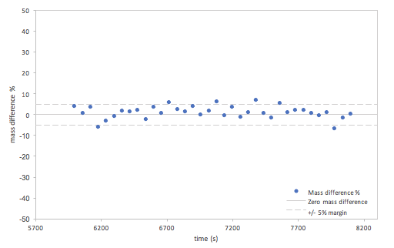

Figure 1. Total Mass Difference vs. time for Run 5

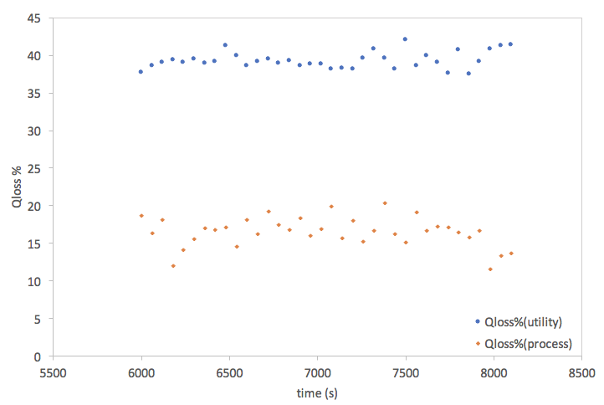

Figure 2. Energy loss vs. time for utility and process side in Run 5

Table 1. Energy difference between utility and process side for varying vapour rate

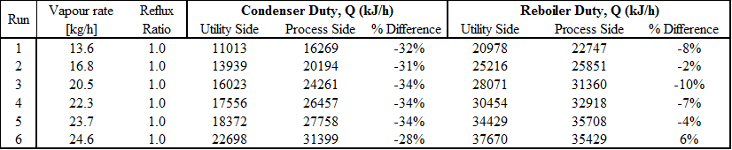

Table 2. Energy difference between utility and process side for varying reflux ratio

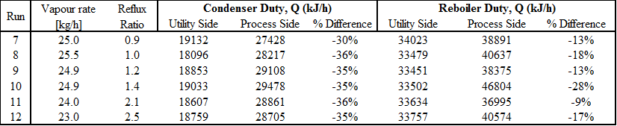

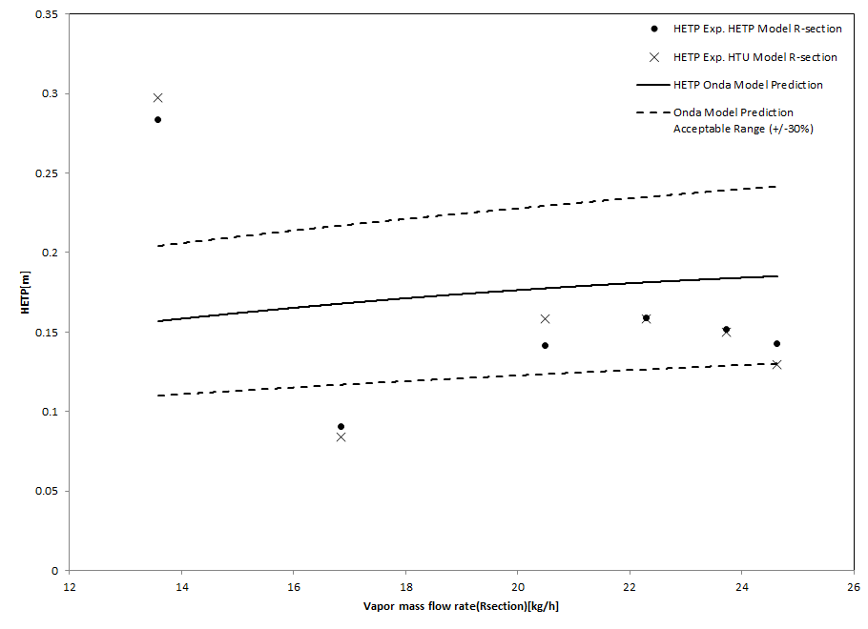

Figure 3. HETP with varying vapour mass flow rate

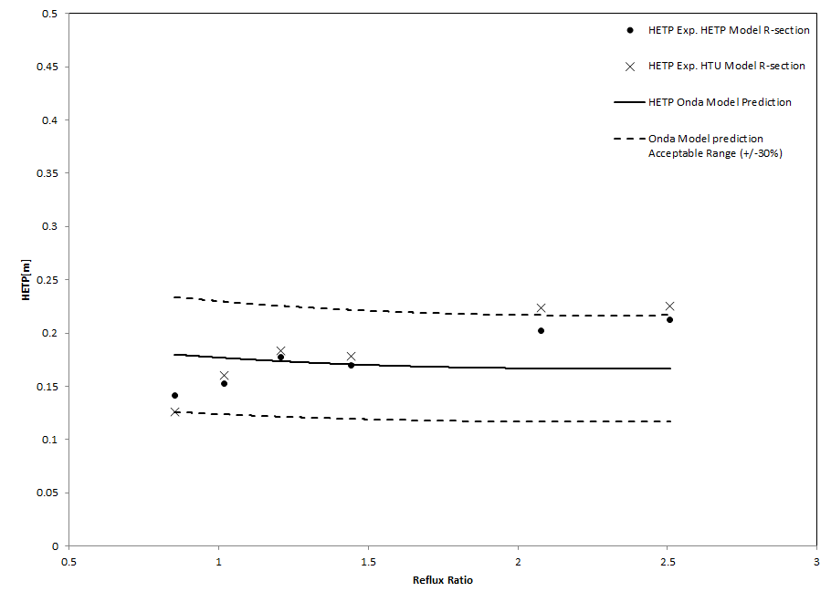

Figure 4. HETP with varying reflux ratio

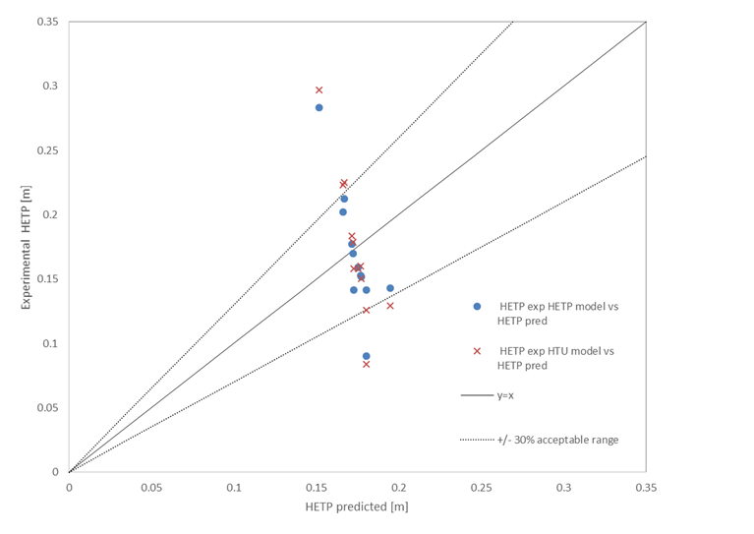

Figure 5. HETP parity plot

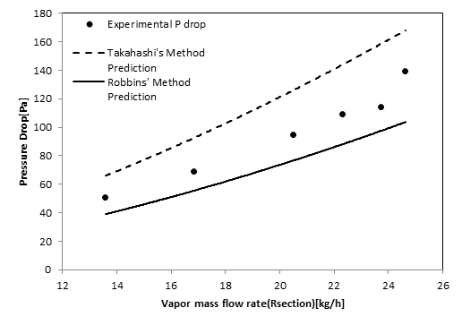

Figure 6. Pressure drop with varying vapour mass flow rate

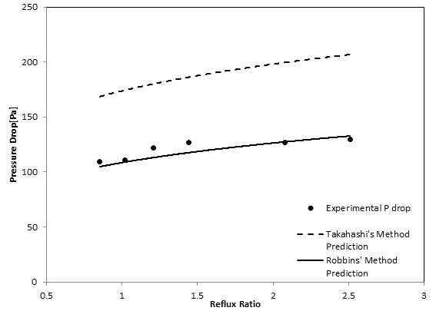

Figure 7. Pressure drop with varying reflux ratio

Original data (One part of data):

<https://docs.google.com/spreadsheets/d/1BXnj6JIG0Fg-S4qg8IGJadkRW6ozpZZHqdiKoiDR5pE/edit#gid=973042511>

Code (Excel VBA) for Demo:

<https://drive.google.com/drive/folders/1NUPo3KXETfQpC0PI8-5zN1lCGYt7EC-l>