**ASSIGNMENT 2 FRONT SHEET**

|  |  |  |  |
| --- | --- | --- | --- |
| **Qualification** | **BTEC Level 5 HND Diploma in Computing** | | |
| **Unit number and title** | Unit 13:Computing Research Project | | |
| **Submission date** |  | **Date Received 1st submission** |  |
| **Re-submission Date** |  | **Date Received 2nd submission** |  |
| **Student Name** | Nguyen Ngoc Son | **Student ID** |  |
| **Class** | IT0501 | **Assessor name** |  |
| **Student declaration**  I certify that the assignment submission is entirely my own work and I fully understand the consequences of plagiarism. I understand that making a false declaration is a form of malpractice. | | | |
|  |  | **Student’s signature** |  |

**Grading grid**

|  |  |  |  |
| --- | --- | --- | --- |
| P6 | P7 | M4 | D3 |
|  |  |  |  |

|  |  |  |
| --- | --- | --- |
| **❒ Summative Feedback: ❒ Resubmission Feedback:** | | |
| **Grade:** | **Assessor Signature:** | **Date:** |
| **Internal Verifier’s Comments:** | | |
| **Signature & Date:** | | |

Table of Contents

**I.** **INTRODUCTION** 5

**II.** **CONTENTS** 5

**P6 Reflect on the effectiveness of research methods applied for meeting objectives of the computing research project** 5

**1.** **Impact of research proposal** 5

**2.** **Impact of Sequential Research Process** 5

**3.** **Research methods used** 5

**3.1.** **Secondary research** 5

**3.1.1.** **I have learned several things from the Secondary Research** 5

**3.1.2.** **Advantages and Disadvantages of Secondary Research** 5

**3.1.3.** **Merits** 5

**3.1.4.** **Limitations** 5

**3.2.** **Quantitative Research** 5

**3.2.1.** **I have learned several things from the Quantitative Research** 5

**3.2.2.** **Advantages and Disadvantages of Quantitative Research** 5

**3.2.3.** **Merits** 5

**3.2.4.** **Limitations** 5

**3.3.** **Qualitative Research** 6

**3.3.1.** **I have learned several things from the Qualitative Research** 6

**3.3.2.** **Advantages and Disadvantages of Qualitative Research** 6

**3.3.3.** **Merits** 6

**3.3.4.** **Limitations** 6

**3.4.** **The relationship between Primary and Secondary Research** 6

**4.** **Project plan** 6

**5.** **Literature review** 6

**P7 Consider alternative research methodologies and lessons learnt in view of the outcomes** 6

**1.** **Mistakes during your research process** 6

**2.** **Reflection on the result of the research** 6

**3.** **Alternative research methodologies and improvement in future research** 6

**3.1.** **Experimental Research in Environmental Sustainability** 6

**3.2.** **Future Research Improvements** 6

**3.3.** **Case studies** 7

**3.3.1.** **Improvement in Future case studies** 7

**4.** **Lessons learned in view of the outcomes** 7

**4.1.** **Achieved result** 7

**4.2.** **Lessons learned from the outcomes** 7

**4.3.** **Evalution of the results** 7

**4.4.** **Key takeaways** 7

**5.** **Conclusion** 7

**5.1.** **Limitations and Recommendations for Future work** 7

**5.2.** **Reflection** 7

**III.** **CONCLUSION** 7

**IV.** **REFERENCES** 7

1. **INTRODUCTION**
2. **CONTENTS**

## **P6 Reflect on the effectiveness of research methods applied for meeting objectives of the computing research project**

1. **Impact of research proposal**

* The impact of a research proposal in the field of exploring alternative materials for big data storage models can be significant and far-reaching across various dimensions:

Environmental Impact: One of the primary impacts of such research would be the potential reduction of environmental harm caused by conventional data storage methods. By developing and implementing alternative materials and technologies that are more energy-efficient and less resource-intensive, the carbon footprint and environmental degradation associated with data storage could be minimized.

Technological Advancement: Research in this area has the potential to drive technological innovation. Discovering new materials and methods for data storage could lead to breakthroughs in efficiency, capacity, and reliability, which would benefit not only the environment but also the performance and capabilities of data storage systems.

Economic Implications: The adoption of sustainable practices and technologies in the data storage industry could have significant economic implications. Companies that are able to develop and implement environmentally friendly solutions may gain a competitive edge in the market, attract environmentally conscious consumers, and potentially reduce operational costs associated with energy consumption and waste management.

Policy and Regulation: Research findings and proposals in this area could also influence policy-making and regulation related to data storage and environmental protection. Governments and regulatory bodies may be more inclined to support and enforce policies that encourage the adoption of sustainable practices in the technology sector based on scientific research and evidence.

Global Awareness and Collaboration: By highlighting the environmental impact of data storage and proposing sustainable alternatives, research in this area can raise awareness about the intersection of technology and environmental sustainability. It can also foster collaboration among researchers, industry stakeholders, policymakers, and environmental advocates to address shared challenges and work towards common goals.

Long-Term Sustainability: Ultimately, the impact of research proposals in this field could contribute to the long-term sustainability of digital infrastructure and the planet as a whole. By mitigating the environmental impact of data storage, we can help ensure that future generations have access to the resources they need to thrive in a rapidly evolving digital world.

* In summary, research proposals focused on exploring alternative materials for big data storage models have the potential to drive positive change across environmental, technological, economic, and societal dimensions, ultimately contributing to a more sustainable future.

1. **Impact of Sequential Research Process**

* The impact of a sequential research process in exploring alternative materials for big data storage models can be significant and multifaceted:

Systematic Progression: A sequential research process allows for a systematic and structured approach to exploring different materials and technologies. This ensures that researchers can build upon previous findings, gradually refining their understanding and identifying the most promising alternatives.

Efficient Resource Utilization: By following a sequential research process, resources such as time, funding, and manpower can be utilized more efficiently. Researchers can prioritize the most promising avenues of investigation, reducing the risk of investing resources into less viable options.

Accelerated Innovation: A sequential research process can facilitate the rapid advancement of knowledge and technology in the field of big data storage. By systematically testing and refining different materials and technologies, researchers can accelerate the pace of innovation and bring new solutions to market more quickly.

Identification of Optimal Solutions: Through a sequential research process, researchers can identify the most optimal solutions for big data storage in terms of performance, cost-effectiveness, and environmental impact. By systematically comparing and evaluating different options, researchers can make informed decisions about which materials and technologies are best suited to meet the needs of users and industry stakeholders.

Collaborative Opportunities: Sequential research processes often involve collaboration between researchers, industry partners, and other stakeholders. By working together, different groups can leverage their expertise and resources to accelerate progress and address complex challenges more effectively.

Evidence-Based Decision Making: A sequential research process generates a wealth of data and evidence that can inform decision-making at various levels, from individual research projects to industry-wide initiatives. By basing decisions on empirical evidence rather than conjecture or intuition, stakeholders can have greater confidence in the effectiveness and reliability of proposed solutions.

Long-Term Impact: The impact of a sequential research process extends beyond individual projects or initiatives. By building a solid foundation of knowledge and understanding, researchers can lay the groundwork for continued innovation and progress in the field of big data storage, ensuring a lasting impact on the industry and society as a whole.

1. **Research methods used**
2. **Secondary research**

Secondary research is a research method that uses data that was collected by someone else. In other words, whenever you conduct research using data that already exists, you are conducting secondary research. On the other hand, any type of research that you undertake yourself is called primary research.

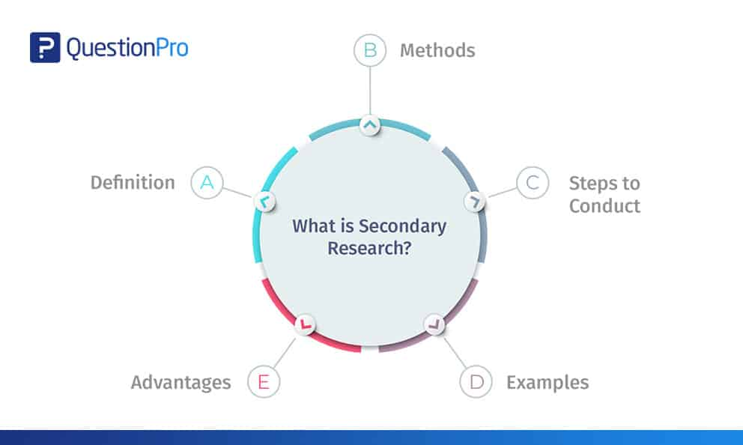

1. **I have learned several things from the Secondary Research**

Through secondary research, I have gained valuable insights into alternative materials for big data storage models. Firstly, I have developed a comprehensive understanding of the current landscape of big data storage technologies and materials, including their strengths, limitations, and emerging trends. Additionally, I have learned about the significant environmental impacts associated with conventional data storage methods, such as energy consumption and electronic waste generation. This knowledge has highlighted the urgent need for more sustainable alternatives.

Moreover, my secondary research has exposed me to innovative technologies and materials being explored as alternatives for big data storage. These include advancements in solid-state drives, optical storage, and novel materials with reduced environmental footprints. Furthermore, I have gained insights into industry trends, market dynamics, and regulatory considerations relevant to sustainable data storage solutions.

By studying best practices and case studies from organizations successfully implementing sustainable data storage solutions, I have identified valuable strategies and approaches for future research and implementation efforts. Overall, the knowledge gained from my secondary research has provided a solid foundation for informed decision-making, guiding further exploration, and driving positive change in the field of big data storage.

1. **Advantages and Disadvantages of Secondary Research**

**Advantages of Secondary research:**

- Secondary data is very easy to source and readily available.

- It is also often free or accessible through your educational institution’s library or network, making it much cheaper to conduct than primary research.

- As you are relying on research that already exists, conducting secondary research is much less time consuming than primary research. Since your timeline is so much shorter, your research can be ready to publish sooner.

- Using data from others allows you to show reproducibility and replicability, bolstering prior research and situating your own work within your field.

**Disadvantages of Secondary research:**

- Ease of access does not signify credibility. It’s important to be aware that secondary research is not always reliable, and can often be out of date. It’s critical to analyze any data you’re thinking of using prior to getting started, using a method like the CRAAP test.

- Secondary research often relies on primary research already conducted. If this original research is biased in any way, those research biases could creep into the secondary results.

1. **Merits**

Secondary research offers several advantages that make it a valuable approach in the research process. Firstly, it is cost-effective since researchers utilize existing data and information, eliminating the need for costly data collection procedures. This aspect is particularly advantageous for researchers with limited budgets. Secondly, secondary research is time-efficient as it allows access to a vast amount of existing data relatively quickly. Researchers can analyze trends and patterns across diverse datasets without the time-consuming process of data collection. Additionally, secondary research provides access to large sample sizes, enhancing the statistical power and generalizability of research findings. Moreover, the validation and corroboration of findings are facilitated through secondary research by comparing them with existing research and data, thereby enhancing the reliability and credibility of results. The broad scope of coverage in secondary research enables researchers to access diverse perspectives and insights from various sources, enriching their understanding of complex issues. Ethical concerns related to participant confidentiality and privacy are minimized in secondary research as researchers often analyze anonymized or aggregated data. Finally, secondary research allows for longitudinal analysis by accessing historical data, enabling researchers to examine trends and changes over time. In conclusion, the advantages of secondary research, including cost-effectiveness, time efficiency, access to existing data, large sample sizes, validation of findings, broad scope of coverage, consideration of ethical concerns, and opportunities for longitudinal analysis, make it an invaluable tool in the research process.

1. **Limitations**

Secondary research, while offering numerous advantages, also presents several limitations that researchers must consider. Firstly, the quality and reliability of secondary data can vary widely depending on the sources and methods used for data collection. This necessitates careful evaluation to ensure the accuracy and validity of findings. Secondly, researchers have limited control over the data collection process in secondary research, potentially leading to biases or limitations in the data, especially if the original data collection methods were not rigorous. Additionally, secondary data may be incomplete or outdated, which can hinder its relevance to research objectives. Furthermore, the lack of contextual information in secondary data may limit researchers' ability to interpret findings accurately. Moreover, researchers must be cautious of bias, as selective data sources or interpretations can skew results. Accessing certain datasets may also be challenging due to restrictions imposed by copyright laws or proprietary concerns. Generalizability concerns may arise due to sample selection bias or differences in data collection methods across studies. Finally, researchers must avoid plagiarism by properly citing and referencing original sources. In conclusion, while secondary research offers valuable insights, researchers must navigate these limitations to ensure the integrity and validity of their findings.

1. **Quantitative Research**

Quantitative research is the process of collecting and analyzing numerical data. It can be used to find patterns and averages, make predictions, test causal relationships, and generalize results to wider populations.

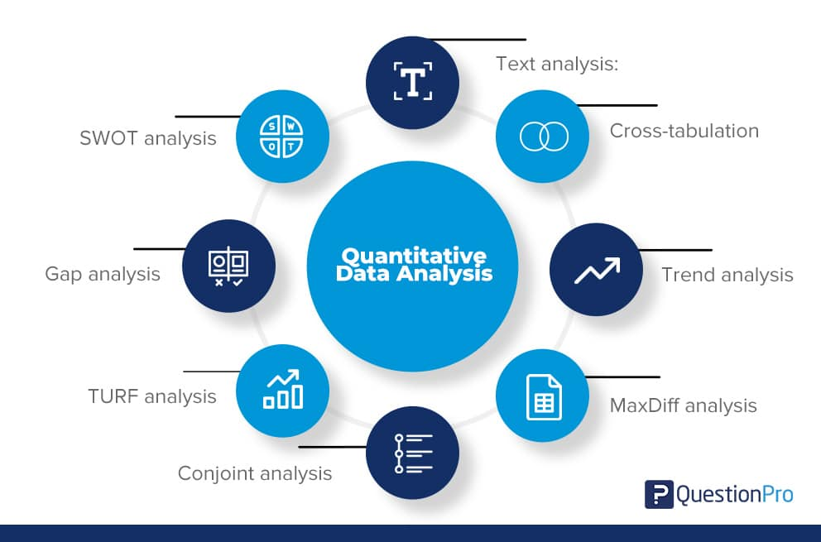

1. **I have learned several things from the Quantitative Research**

Learning about quantitative research has provided me with valuable insights into its structured approach to data collection and analysis. I've come to understand that quantitative research involves formulating clear research questions or hypotheses and using standardized instruments to collect numerical data. This data is then analyzed using statistical techniques to uncover patterns, relationships, and associations between variables. Additionally, I've learned about the importance of large sample sizes to ensure the validity and generalizability of findings, as well as the objective and replicable nature of quantitative research. Understanding common methods such as surveys, experiments, and observational studies, as well as the distinction between cross-sectional and longitudinal designs, has expanded my knowledge of how quantitative research is conducted. Moreover, I've realized the wide-ranging applications of quantitative research across various disciplines, including social sciences, psychology, education, business, and public health. Overall, learning about quantitative research has equipped me with valuable skills for analyzing data, conducting research studies, and making evidence-based decisions in my field of interest.

1. **Advantages and Disadvantages of Quantitative Research**

**Advantages of Quantitative research:**

- Replication:Repeating the study is possible because of standardized data collection protocols and tangible definitions of abstract concepts.

- Direct comparisons of results:The study can be reproduced in other cultural settings, times or with different groups of participants. Results can be compared statistically.

- Large samples:Data from large samples can be processed and analyzed using reliable and consistent procedures through quantitative data analysis.

- Hypothesis testing:Using formalized and established hypothesis testing procedures means that you have to carefully consider and report your research variables, predictions, data collection and testing methods before coming to a conclusion.

**Disadvantages of Quantitative research:**

- Superficiality:Using precise and restrictive operational definitions may inadequately represent complex concepts. For example, the concept of mood may be represented with just a number in quantitative research, but explained with elaboration in qualitative research.

- Narrow focus:Predetermined variables and measurement procedures can mean that you ignore other relevant observations.

- Structural bias:Despite standardized procedures, structural biases can still affect quantitative research. Missing data, imprecise measurements or inappropriate sampling methods are biases that can lead to the wrong conclusions.

- Lack of context:Quantitative research often uses unnatural settings like laboratories or fails to consider historical and cultural contexts that may affect data collection and results.

1. **Merits**

Quantitative research offers numerous merits that render it invaluable in the research process. Its structured approach and reliance on standardized methods promote objectivity and reliability in data collection and interpretation, enhancing the credibility of research findings. Moreover, the ability to collect data from large sample sizes allows for the generalization of findings to broader populations, increasing the external validity of the research. Quantitative research's utilization of statistical techniques enables researchers to identify patterns, trends, and relationships between variables with precision, facilitating evidence-based decision-making. Additionally, its replicability ensures the robustness of findings, as other researchers can verify results using the same procedures and data. Furthermore, quantitative research's quantification of relationships provides precise estimates of effect sizes and probabilities, supporting quantitative predictions and meaningful conclusions. Its efficiency, ease of data analysis, and ability to provide decision-making support across various fields further underscore its significance in generating knowledge and insights. In summary, the merits of quantitative research make it an indispensable tool for researchers seeking to understand complex phenomena and inform evidence-based practices and policies.

1. **Limitations**

Quantitative research, despite its strengths, is not without limitations, which researchers should acknowledge and address. One notable limitation is its tendency to prioritize breadth over depth, potentially resulting in a superficial understanding of complex phenomena. This is compounded by the restrictiveness of standardized instruments, which may not capture the full spectrum of human experiences or behaviors, limiting the data collected. Moreover, quantitative methods struggle to explore intricate constructs such as attitudes or emotions comprehensively, often requiring supplementary qualitative approaches. Additionally, there's a risk of oversimplification, as quantitative research reduces phenomena to numerical data and statistical analyses, potentially neglecting important contextual factors. Unanticipated findings may also be overlooked due to the hypothesis-driven nature of quantitative research. Ethical considerations, such as participant privacy and consent, must be carefully managed, especially in sensitive research areas. Furthermore, sampling limitations and measurement errors can affect the generalizability and validity of findings. In summary, while quantitative research offers valuable insights, researchers must navigate these limitations judiciously to ensure the robustness and applicability of their findings.

1. **Qualitative Research**

Qualitative research involves collecting and analyzing non-numerical data (e.g., text, video, or audio) to understand concepts, opinions, or experiences. It can be used to gather in-depth insights into a problem or generate new ideas for research.

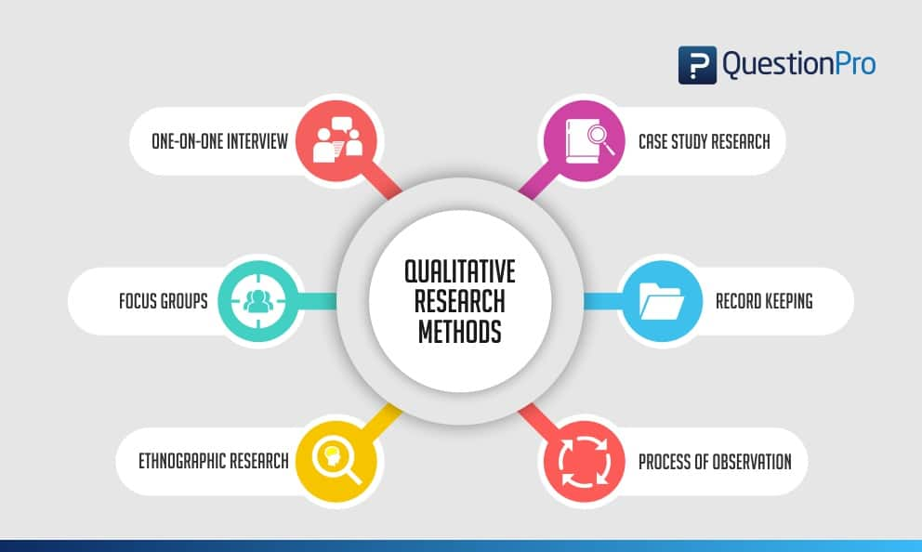

1. **I have learned several things from the Qualitative Research**

It's great to hear that you've gained valuable insights from learning about qualitative research. Here are some key takeaways you may have learned:

Exploratory Nature: Qualitative research emphasizes exploration and understanding of complex phenomena, focusing on in-depth examination rather than statistical analysis.

Data Collection Methods: You may have learned about various data collection methods used in qualitative research, such as interviews, focus groups, participant observation, and document analysis, each offering unique insights into participants' experiences and perspectives.

Non-Numerical Data Analysis: Qualitative research involves the systematic analysis of non-numerical data, such as text, audio recordings, or visual images, using techniques like thematic analysis, content analysis, and narrative analysis.

Contextual Understanding: Qualitative research values understanding phenomena within their natural context, considering social, cultural, and historical factors that shape participants' experiences and perspectives.

Participant Perspectives: Qualitative research prioritizes the perspectives and voices of participants, allowing them to share their lived experiences and insights in their own words, which can lead to a deeper understanding of the phenomenon under study.

Inductive Approach: You may have learned about the inductive approach used in qualitative research, where themes and patterns emerge from the data rather than being imposed by preconceived hypotheses, allowing for flexibility and openness to new insights.

Rich Descriptions: Qualitative research produces rich, detailed descriptions of phenomena, providing contextually rich accounts that capture the depth and complexity of human experiences.

Triangulation and Reflexivity: You may have learned about techniques like triangulation and reflexivity, which enhance the validity and reliability of qualitative research by validating findings through multiple data sources and methods, and by reflecting on researchers' biases and assumptions throughout the research process.

Overall, qualitative research offers a holistic and nuanced understanding of human behavior, experiences, and phenomena, making it a valuable approach for exploring complex social, cultural, and psychological phenomena across various disciplines.

1. **Advantages and Disadvantages of Qualitative Research**

**Advantages of Qualitative research:**

- Flexibility:The data collection and analysis process can be adapted as new ideas or patterns emerge. They are not rigidly decided beforehand.

- Natural settings:Data collection occurs in real-world contexts or in naturalistic ways.

- Meaningful insights:Detailed descriptions of people’s experiences, feelings and perceptions can be used in designing, testing or improving systems or products.

- Generation of new ideas:Open-ended responses mean that researchers can uncover novel problems or opportunities that they wouldn’t have thought of otherwise.

**Disadvantages of Qualitative research:**

- Unreliability:The real-world setting often makes qualitative research unreliable because of uncontrolled factors that affect the data.

- Subjectivity:Due to the researcher’s primary role in analyzing and interpreting data, qualitative research cannot be replicated. The researcher decides what is important and what is irrelevant in data analysis, so interpretations of the same data can vary greatly.

- Limited generalizability:Small samples are often used to gather detailed data about specific contexts. Despite rigorous analysis procedures, it is difficult to draw generalizable conclusions because the data may be biased and unrepresentative of the wider population.

- Labor-intensive:Although software can be used to manage and record large amounts of text, data analysis often has to be checked or performed manually.

1. **Merits**

Certainly, here are the merits or advantages of qualitative research:

In-depth Understanding: Qualitative research allows for a deep understanding of complex phenomena by exploring participants' perspectives, experiences, and behaviors within their natural context. This depth of insight can uncover rich, nuanced meanings and patterns.

Flexibility: Qualitative research methods are flexible and adaptable, enabling researchers to modify their approach based on emerging insights and new developments. This flexibility allows for the exploration of unexpected findings and the adjustment of methods accordingly.

Participant Perspectives: Qualitative research prioritizes the voices and perspectives of participants, enabling them to share their lived experiences and insights in their own words. This participant-centered approach fosters empathy, trust, and rapport between researchers and participants.

Exploratory Nature: Qualitative research is exploratory in nature, allowing researchers to explore new topics, generate hypotheses, and identify novel insights without preconceived notions or rigid frameworks. This exploratory approach can lead to the discovery of new theories or perspectives.

Contextual Understanding: Qualitative research emphasizes understanding phenomena within their natural context, considering social, cultural, and historical factors that shape participants' experiences and perspectives. This contextual understanding provides deeper insights into the complexity of human behavior and social processes.

Rich Data: Qualitative research generates rich, detailed data that capture the complexity and depth of human experiences. Data sources such as interviews, observations, and documents provide a wealth of information that can be analyzed to uncover meaningful insights.

Holistic Approach: Qualitative research takes a holistic approach to studying phenomena, considering multiple perspectives and dimensions. This holistic perspective allows researchers to explore the interconnectedness of factors and understand the complexity of social, cultural, and psychological phenomena.

Validity and Transferability: Qualitative research focuses on ensuring the validity and transferability of findings through rigorous methodological practices such as triangulation, member checking, and thick description. These practices enhance the trustworthiness and applicability of research findings.

Overall, the merits of qualitative research, including its in-depth understanding, flexibility, participant perspectives, exploratory nature, contextual understanding, rich data, holistic approach, and focus on validity and transferability, make it a valuable tool for exploring complex phenomena and generating meaningful insights in various disciplines.

1. **Limitations**

Qualitative research, while valuable, is not without limitations that researchers should consider. One significant limitation is its susceptibility to researcher subjectivity and bias, potentially impacting the reliability and validity of findings. Additionally, qualitative methods can be time-consuming and resource-intensive, requiring substantial investment in data collection and analysis. The small, non-representative samples used in qualitative research may limit the generalizability of findings to broader populations. Interpreting subjective, nuanced data can also be challenging and may lead to multiple interpretations. Ethical considerations, such as participant privacy and informed consent, must be carefully managed, especially when studying sensitive topics. Furthermore, qualitative research may lack replicability due to its focus on unique contexts and perspectives. Overinterpretation of findings and the resource-intensive nature of qualitative research further underscore its limitations. In summary, while qualitative research offers valuable insights, researchers must be aware of its limitations and employ rigorous methodological practices to ensure the validity and reliability of findings.

1. **The relationship between Primary and Secondary Research**

The relationship between primary and secondary research is complementary, as they serve distinct yet interconnected roles in the research process.

Primary Research: This involves collecting original data directly from sources through methods such as surveys, experiments, interviews, or observations. Primary research is conducted to address specific research questions or objectives and generates firsthand data tailored to the researcher's needs. It allows researchers to gather data that is relevant, timely, and specific to their research context. Primary research often serves as the foundation for generating new knowledge, testing hypotheses, or validating existing theories.

Secondary Research: This involves the analysis and interpretation of existing data and information collected by others. Secondary research sources include academic journals, books, government reports, market studies, and databases. Researchers use secondary research to review and synthesize existing literature, gain background knowledge on a topic, identify gaps in the literature, and contextualize their findings within the broader body of research. Secondary research provides valuable insights, context, and support for primary research endeavors.

The relationship between primary and secondary research can be conceptualized as follows:

Informing Primary Research: Secondary research often precedes primary research by providing background information and context for the study. Researchers conduct a thorough review of existing literature to identify gaps, formulate research questions, and design appropriate methodologies for primary data collection.

Supporting Primary Research: Secondary research provides supporting evidence and theoretical frameworks that guide the design, analysis, and interpretation of primary research findings. Researchers draw upon existing literature to contextualize their findings, validate their hypotheses, and compare their results with previous studies.

Supplementing Primary Research: Secondary research supplements primary research by providing additional data and perspectives that enhance the depth and breadth of the study. Researchers may incorporate secondary data sources into their analyses to enrich their findings or triangulate their results with multiple sources of evidence.

Validating Primary Research: Secondary research can serve as a benchmark for evaluating the validity and reliability of primary research findings. Researchers compare their results with existing literature to assess consistency, identify discrepancies, and validate their interpretations.

Overall, primary and secondary research are interconnected components of the research process, with each playing a complementary role in generating knowledge, informing research design, supporting findings, and advancing understanding within a particular field of study. Integrating both primary and secondary research enables researchers to conduct rigorous, comprehensive investigations that contribute to the advancement of knowledge and scholarship.

1. **Project plan**

**Work breakdown:**

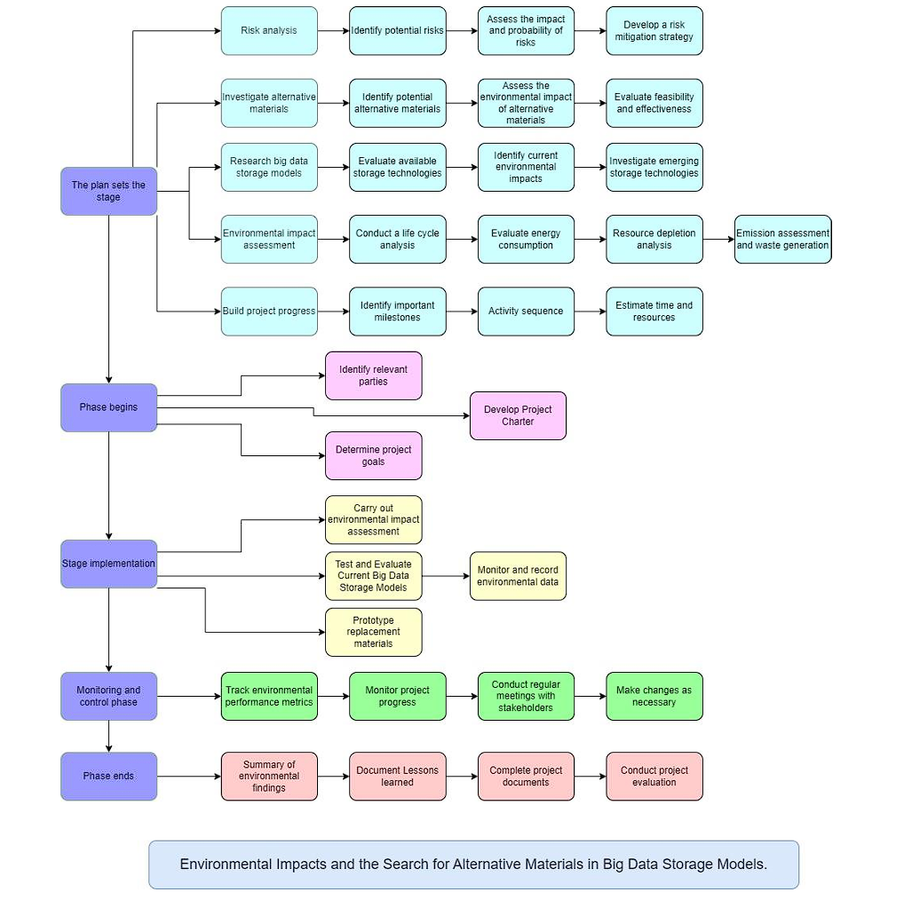

**Time estimates:**

* Planning Phase( 2 Month)

+ Risks Analysis (1 Week)

+ Investigate alternative materials (2 Week)

+ Research big data storage models (2 Week)

+ Environmental impact assessment (2 Week)

+ Build project progress (1 Week)

* Phase begins ( 1 Week )
* Stage implementation ( 1 Week )
* Monitoring and control phase ( 3 Week)
* Phase ends (1 Week)
* Completion report (2 Week)

**Milestone identification:**

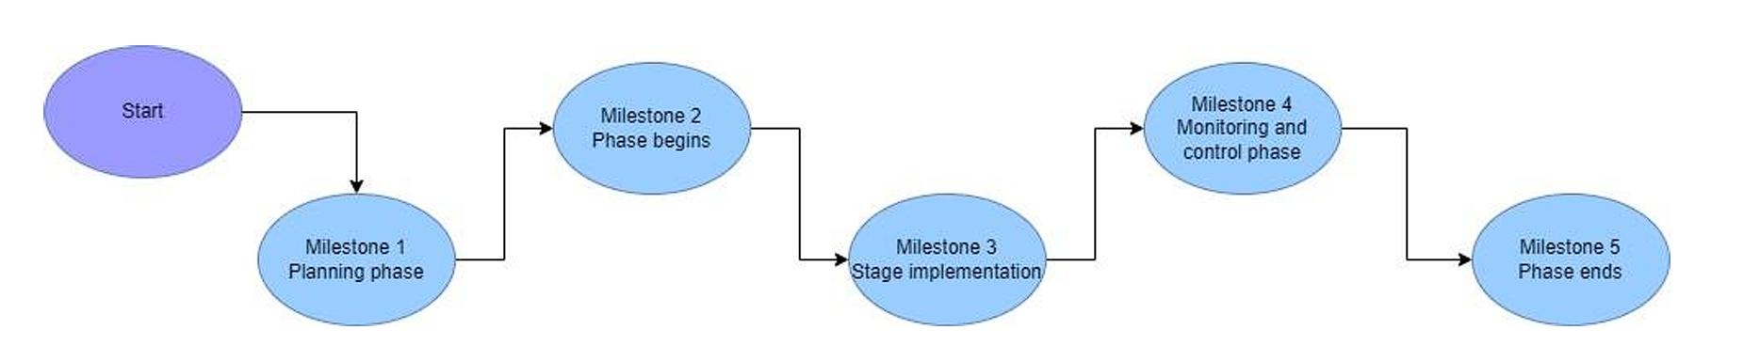

**Scheduling:**

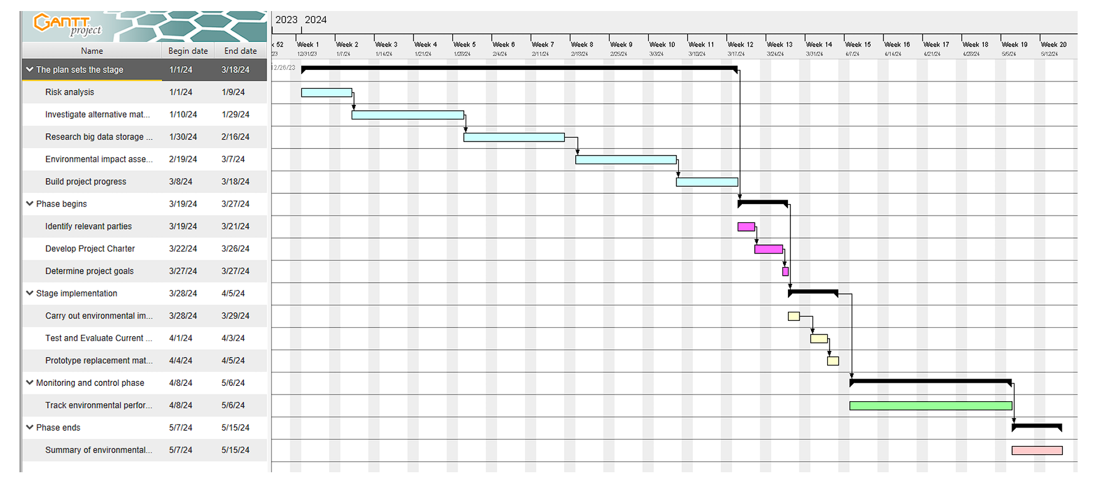

1. **Literature review**

## **P7 Consider alternative research methodologies and lessons learnt in view of the outcomes**

1. **Mistakes during your research process**

During the research process, several common mistakes can occur, hindering the quality and validity of the findings. Here are some mistakes researchers may encounter:

* Poorly Defined Research Objectives: Failing to clearly define research objectives can lead to ambiguity and confusion throughout the research process. Researchers should establish specific, measurable, achievable, relevant, and time-bound (SMART) objectives to guide their study effectively.
* Inadequate Literature Review: Conducting a superficial or incomplete literature review can result in overlooking relevant prior research, leading to gaps in understanding or duplication of efforts. Researchers should conduct a thorough review of existing literature to build on previous work and inform their research design effectively.
* Biased Sampling: Selecting a biased sample can skew research findings and limit their generalizability. Researchers should use random or stratified sampling techniques to ensure that the sample is representative of the population of interest and minimizes bias.
* Data Collection Errors: Errors during data collection, such as poorly designed surveys or inconsistent data recording, can compromise the integrity of the data. Researchers should carefully plan and pilot-test data collection instruments to minimize errors and ensure data quality.
* Confirmation Bias: Confirmation bias occurs when researchers selectively seek or interpret evidence that confirms their preconceived beliefs or hypotheses, leading to distorted conclusions. Researchers should remain open-minded and actively seek to challenge their assumptions throughout the research process.
* Misinterpretation of Data: Misinterpreting data or drawing unwarranted conclusions can result from insufficient data analysis or overreliance on statistical significance. Researchers should use appropriate analytical techniques and critically evaluate their findings to ensure accurate interpretation.
* Ethical Violations: Failing to adhere to ethical principles, such as obtaining informed consent from participants or maintaining confidentiality, can compromise the integrity of the research and harm participants. Researchers should prioritize ethical considerations and follow ethical guidelines throughout the research process.
* Ignoring Negative Results: Ignoring or downplaying negative results can lead to publication bias and misrepresentation of findings. Researchers should acknowledge and transparently report all results, including those that do not support their hypotheses or expectations.
* Overlooking Methodological Limitations: Failing to acknowledge or address methodological limitations can weaken the validity and reliability of the research findings. Researchers should transparently discuss the limitations of their study and consider alternative explanations for their results.
* Lack of Reproducibility: Conducting research that is not reproducible or replicable can undermine the credibility of the findings. Researchers should provide detailed documentation of their methods and make their data and analysis code available to enable others to reproduce their results.

By being aware of these common mistakes and taking proactive steps to address them, researchers can enhance the quality, rigor, and credibility of their research findings.

1. **Reflection on the result of the research**

Reflecting on the results of a research study is a crucial step in the research process, as it allows researchers to critically evaluate their findings, draw meaningful conclusions, and consider implications for future research or practical applications. Here are some key aspects to consider when reflecting on research results:

* Validity and Reliability: Assess the validity and reliability of the research findings by considering the robustness of the research design, data collection methods, and analysis techniques. Reflect on any potential sources of bias or limitations that may have influenced the results.
* Consistency with Hypotheses or Research Questions: Evaluate whether the results align with the research hypotheses or questions posed at the outset of the study. Consider whether the findings support, refute, or modify existing theories or knowledge in the field.
* Interpretation of Patterns and Trends: Reflect on the patterns, trends, or themes identified in the data analysis. Consider the significance of these findings in relation to the research objectives and their implications for theory, practice, or policy.
* Alternative Explanations and Limitations: Consider alternative explanations for the results and reflect on any methodological limitations that may have influenced the findings. Acknowledge and transparently discuss any limitations or constraints of the study that may affect the interpretation of the results.
* Unexpected Findings: Reflect on any unexpected or counterintuitive findings that emerged during the research process. Consider possible explanations for these findings and their implications for future research or theoretical frameworks.
* Contributions to Knowledge: Evaluate the contributions of the research findings to the existing body of knowledge in the field. Reflect on how the results advance understanding, fill gaps in the literature, or offer new insights that may inform future research directions.
* Practical Implications: Consider the practical implications of the research findings for real-world applications, interventions, or policy decisions. Reflect on how the results may be translated into actionable recommendations or strategies to address practical challenges or issues.
* Future Research Directions: Reflect on potential avenues for future research suggested by the findings. Consider unanswered questions, unresolved issues, or areas for further exploration that emerged during the study.
* Ethical Considerations: Reflect on any ethical considerations raised by the research findings, particularly regarding participant confidentiality, privacy, and well-being. Consider whether the research results have any ethical implications that need to be addressed.
* Personal Growth and Learning: Reflect on your own growth and learning throughout the research process. Consider the strengths and weaknesses of your research approach, as well as lessons learned that may inform future research endeavors.

Overall, reflecting on the results of a research study involves critically evaluating the validity, significance, and implications of the findings, as well as considering opportunities for future research and personal growth. This reflective process enhances the rigor and credibility of the research and contributes to the advancement of knowledge in the field.

1. **Alternative research methodologies and improvement in future research**

In enhancing the rigor and effectiveness of research endeavors, considering alternative research methodologies and improvements for future research is paramount. One alternative approach is mixed-methods research, which integrates both quantitative and qualitative methodologies to offer a comprehensive understanding of the research topic. This approach allows researchers to triangulate findings, validate results, and explore complex phenomena from multiple perspectives. Longitudinal studies, tracking changes in variables over time, offer another alternative, providing insights into trends, patterns, and causal relationships. Experimental designs, such as randomized controlled trials (RCTs), establish causal relationships and test the effectiveness of interventions or treatments, thereby enhancing internal validity.

Additionally, action research involves collaborating with stakeholders to address real-world problems or implement interventions, emphasizing active participation, reflection, and iterative cycles of planning, action, observation, and reflection. Case studies offer an in-depth exploration of specific instances or phenomena within their natural context, providing rich, contextualized insights. Network analysis methodologies enable the study of relationships, interactions, and structures within complex systems or networks, offering insights into the dynamics of social, organizational, or technological networks. Qualitative comparative analysis (QCA) combines qualitative and quantitative techniques to analyze complex causal configurations, identifying necessary and sufficient conditions for outcomes of interest.

Improvements for future research include strengthening methodological rigor by addressing potential sources of bias, increasing sample sizes, improving measurement validity and reliability, and employing appropriate statistical techniques. Enhancing transparency and reproducibility involves fully documenting research methods, materials, and procedures, and making data, analysis code, and research protocols openly accessible. Foster collaboration and engagement with diverse stakeholders to ensure research questions, methods, and findings are relevant, meaningful, and impactful. Prioritize ethical considerations throughout the research process, including obtaining informed consent, protecting participant confidentiality, and addressing potential risks or harms. Effectively communicate research findings to diverse audiences and translate them into actionable recommendations or interventions that address real-world challenges. By embracing these alternative methodologies and opportunities for improvement, researchers can advance the quality, relevance, and impact of their research endeavors, contributing to the betterment of society.

* 1. **Experimental Research in Environmental Sustainability**

Experimental research in environmental sustainability involves conducting controlled experiments to investigate various factors affecting environmental systems, resource management, conservation efforts, and sustainable development initiatives. This type of research aims to understand the impacts of human activities on the environment, evaluate the effectiveness of interventions, and develop strategies for mitigating environmental degradation and promoting sustainable practices. Here are key components and examples of experimental research in environmental sustainability:

Research Objectives: Experimental research in environmental sustainability typically aims to address specific research questions or hypotheses related to environmental issues, such as the effects of pollution on ecosystems, the efficiency of renewable energy technologies, or the efficacy of conservation measures.

Experimental Design: Researchers design controlled experiments to manipulate independent variables (e.g., pollutant levels, land use practices, energy sources) and measure their effects on dependent variables (e.g., biodiversity, air or water quality, energy efficiency). Experimental designs may include randomized controlled trials, field experiments, laboratory experiments, or simulation models.

Data Collection and Analysis: Experimental research involves collecting quantitative or qualitative data to assess the outcomes of interventions or treatments. Data collection methods may include field measurements, laboratory analyses, surveys, interviews, or observations. Researchers use statistical analysis techniques to analyze data, identify patterns or trends, and determine the significance of results.

Examples of Experimental Research:

Evaluating the effectiveness of wastewater treatment technologies in removing pollutants and improving water quality.

Assessing the impact of deforestation on soil erosion rates and biodiversity in experimental plots.

Investigating the effects of climate change on plant growth and ecosystem dynamics using controlled greenhouse experiments.

Testing the efficiency of renewable energy systems, such as solar panels or wind turbines, in generating electricity under different environmental conditions.

Experimenting with alternative agricultural practices, such as organic farming or agroforestry, to promote soil health, biodiversity, and carbon sequestration.

Ethical Considerations: Researchers conducting experimental research in environmental sustainability must adhere to ethical guidelines to ensure the well-being of human participants, minimize harm to ecosystems, and respect the rights of indigenous communities or stakeholders affected by the research. Ethical considerations may include obtaining informed consent, protecting biodiversity and natural resources, and promoting environmental justice.

Application and Policy Implications: Findings from experimental research in environmental sustainability contribute to evidence-based decision-making, policy development, and environmental management practices. Research outcomes may inform the design of conservation programs, land use policies, renewable energy strategies, pollution control measures, and sustainable development initiatives.

Overall, experimental research plays a crucial role in advancing knowledge, informing interventions, and promoting environmental sustainability by providing empirical evidence of the effectiveness of various approaches and technologies in addressing environmental challenges.

* 1. **Future Research Improvements**

In order to advance environmental sustainability research, several key improvements can be made in future research endeavors. Firstly, fostering interdisciplinary collaboration among researchers from diverse fields such as environmental science, economics, social sciences, and engineering is crucial. This collaboration can provide holistic insights into complex environmental issues and promote innovative solutions. Additionally, implementing long-term monitoring and assessment programs will help track environmental changes over time and evaluate the effectiveness of conservation efforts.

Furthermore, community engagement and participatory research approaches should be emphasized to involve local communities and stakeholders in research processes, ensuring the relevance and sustainability of research outcomes. Embracing technological innovations and methodological advancements, such as remote sensing and modeling approaches, can enhance the efficiency and accuracy of environmental research.

Integrating traditional ecological knowledge (TEK) and indigenous knowledge systems into research practices is essential for promoting cultural diversity, resilience, and sustainability. Moreover, conducting policy-relevant research and translating findings into actionable recommendations can inform evidence-based policymaking and governance mechanisms.

Investing in capacity building and education initiatives to train the next generation of environmental researchers and practitioners is vital. These efforts should also prioritize ethical considerations, social justice, and equity to ensure that research respects the rights and values of all stakeholders and addresses environmental injustices. Overall, by embracing these future research improvements, the environmental research community can contribute significantly to advancing knowledge and fostering sustainability in a rapidly changing world.

* 1. **Case studies**
     1. **Improvement in Future case studies**

1. **Lessons learned in view of the outcomes**
2. **Achieved result**
3. **Lessons learned from the outcomes**
4. **Evalution of the results**
5. **Key takeaways**
6. **Conclusion**
7. **Limitations and Recommendations for Future work**
8. **Reflection**

1. **CONCLUSION**
2. **REFERENCES**