**ASSIGNMENT 1 FRONT SHEET**

|  |  |  |  |
| --- | --- | --- | --- |
| **Qualification** | **BTEC Level 5 HND Diploma in Computing** | | |
| **Unit number and title** | Unit 13:Computing Research Project | | |
| **Submission date** |  | **Date Received 1st submission** |  |
| **Re-submission Date** |  | **Date Received 2nd submission** |  |
| **Student Name** | Pham Xuan Hai | **Student ID** | BH00132 |
| **Class** | IT0503 | **Assessor name** | Nguyen Thanh Trieu |
| **Student declaration**  I certify that the assignment submission is entirely my own work and I fully understand the consequences of plagiarism. I understand that making a false declaration is a form of malpractice. | | | |
|  |  | **Student’s signature** | Hai |

**Grading grid**

|  |  |  |  |  |  |  |  |  |  |
| --- | --- | --- | --- | --- | --- | --- | --- | --- | --- |
| P1 | P2 | P3 | P4 | P5 | M1 | M2 | M3 | D1 | D2 |
|  |  |  |  |  |  |  |  |  |  |

|  |  |  |
| --- | --- | --- |
| **❒ Summative Feedback: ❒ Resubmission Feedback:** | | |
| **Grade:** | **Assessor Signature:** | **Date:** |
| **Internal Verifier’s Comments:** | | |
| **Signature & Date:** | | |

Table of Contents

I. INTRODUCTION 5

II. CONTENTS 5

P1 Produce a research proposal that clearly defines a research question or hypothesis supported by a literature review 5

1. Research topic 5

2. Project type 5

3. Abstracts 6

4. Situation 7

5. Project plan 9

P2 Examine appropriate research methods and approaches to primary and secondary research 11

1. Research Methods 11

2. Primary research 12

3. Secondary research 16

4. Compare Primary research with Secondary research 18

5. Qualitative research 20

6. Quantitative research 21

7. Compare Qualitative research with Quantitative research 23

8. Scientific method 23

9. Research process 26

10. Population in research 26

P3 Conduct primary and secondary research using appropriate methods for a computing research project that consider costs, access and ethical issues 27

1. Secondary research 27

2. Primary research 28

P4 Apply appropriate analytical tools, analyse research findings and data 29

1. Interview 30

2. Interview summary 34

3. Survey 34

4. Survey summary 37

5. Analyze the results of the Primary research 41

P5 Communicate research outcomes in an appropriate manner for the intended audience 42

1. Conclution 42

2. Recommendation 43

III. CONCLUSION 44

IV. REFERENCES 44

# INTRODUCTION

In the digital age, big data stands as a beacon of progress, offering transformative potential across

various sectors. However, this rapid expansion of data collection, processing, and storage brings to light

significant environmental concerns. The burgeoning energy demands of data centers, escalating

greenhouse gas emissions, and the proliferation of electronic waste pose serious challenges to

sustainable development. This report delves into the intricate relationship between big data and

environmental sustainability, exploring the adverse impacts and advocating for innovative solutions.

Through a meticulous examination of current practices and future possibilities, it aims to chart a course

towards a more sustainable and responsible digital future.

# CONTENTS

## P1 Produce a research proposal that clearly defines a research question or hypothesis supported by a literature review

### Research topic

Environmental Impacts and the Search for Alternative Materials in Big Data Storage Models

### Project type

The project type for this endeavor is a comprehensive environmental impact assessment and mitigation project. This involves conducting thorough research, data analysis, and stakeholder engagement to assess the current state of the environment and identify key challenges. The project will encompass various aspects, including climate change, pollution, biodiversity loss, habitat degradation, and resource management.

Furthermore, the project will involve evaluating existing mitigation strategies and policies aimed at addressing environmental challenges, as well as identifying opportunities for improvement and innovation. It will also explore sustainable practices, conservation efforts, and climate adaptation strategies to promote environmental resilience.

Stakeholder engagement will be a crucial component of the project, involving collaboration with government agencies, non-governmental organizations, academia, industry partners, and the public. This collaboration will facilitate knowledge sharing, gather diverse perspectives, and garner support for effective solutions.

Overall, the project aims to generate insights, inform decision-making, and catalyze action towards building a more sustainable and resilient future for both current and future generations.

### Abstracts

The definition of big data is data that contains greater variety, arriving in increasing volumes and with more velocity. This is also known as the three Vs.

Put simply, big data is larger, more complex data sets, especially from new data sources. These data sets are so voluminous that traditional data processing software just can’t manage them. But these massive volumes of data can be used to address business problems you wouldn’t have been able to tackle before.

- **How does it affect the environment?**

The impact of big data on the environment is multifaceted, including both positive and negative aspects.

**Negative side:**

High Energy Consumption: Large data storage and processing requires a large number of data centers, which consume a significant amount of electricity. This leads to increased carbon emissions and negatively affects the environment.

Impact on Resources: Producing and maintaining the hardware needed for data centers (such as servers and storage systems) also impacts the environment through the use of raw materials, water and energy.

E-Waste Generation: Finally, when hardware is no longer in use, it becomes e-waste, which is difficult to recycle and can contain toxic substances that affect the environment and human health. .

**Upsides**

However, big data also brings benefits to the environment through enhancing the ability to monitor and manage environmental resources more effectively:

Resource Management and Environmental Protection: Big data allows monitoring, analyzing and predicting environmental trends, thereby helping organizations and governments make better decisions in protecting the environment and protecting the environment. natural resource management.

Optimize Energy Consumption: Smart systems using big data can help optimize energy use in operations, construction and even in households, reducing waste of energy.

Clean Energy Development: Big data also supports the development and growth of renewable energy sources such as wind and solar, informing weather pattern predictions and output optimization products.

To minimize the negative impact and enhance the extreme benefits of big data on the environment, organizations and individuals need to take solid measures and improve the quantitative efficiency of data centers, history of using renewable energy, recycling electronic waste and applying green technology solutions.

### Situation

The study of environmental influences is a vast field, encompassing many different cases and texts. Some typical examples include the impact of climate change on ecology and human life, air pollution and health impacts, as well as deforestation and biodiversity loss. This research is also focused on enhancing environmental protection and sustainable development, as well as cooperating with environmental pollution to reproduce and develop species. Not only that, but there are also studies on the impact of landscape change on mood and mental health, as well as the impact of land change and human dislocation on natural ecosystems. course . All of these studies play an important role in better understanding the impact of the environment and how we can respond to the formal environments we face.

Define the main aims and objectives of the report

The main aims and objectives of this report revolve around comprehensively assessing the current environmental landscape and its ramifications. It seeks to delve into various facets of environmental impact, including climate change, pollution, biodiversity loss, and habitat degradation. By scrutinizing the underlying causes of environmental degradation, such as industrialization, deforestation, and urban expansion, the report aims to elucidate the drivers behind these trends.

Furthermore, it endeavors to elucidate the potential repercussions of environmental deterioration on ecosystems, wildlife, human health, and socio-economic development. Through meticulous analysis, it aims to pinpoint critical areas requiring intervention and propose viable strategies for mitigating environmental challenges effectively.

Ultimately, the report aims to advocate for sustainable practices, conservation efforts, and policy reforms to foster environmental resilience. By disseminating scientific findings and fostering dialogue among stakeholders, policymakers, and the public, it seeks to galvanize collective action towards safeguarding the planet and fostering a sustainable future for generations to come.

#### Aims

The aim of this report is to conduct a thorough examination of the current environmental landscape, with a specific focus on understanding key challenges and their impacts. Through this analysis, we intend to shed light on critical issues such as climate change, pollution, biodiversity loss, and habitat degradation. By delving into the root causes and drivers behind these challenges, including human activities and natural phenomena, we aim to provide insights into their complexities.

Furthermore, this report seeks to assess the potential consequences of environmental degradation on various aspects of life, including ecosystems, wildlife, natural resources, and human well-being. By elucidating these impacts, we aim to underscore the urgency of addressing environmental concerns and the need for concerted action.

In addition, we aim to emphasize the importance of adopting sustainable practices, conservation efforts, and policy reforms to mitigate environmental impact and promote long-term sustainability. Through the provision of recommendations and strategies, we aspire to empower stakeholders, policymakers, businesses, and individuals to contribute effectively to environmental protection and climate resilience.

Ultimately, the overarching aim of this report is to raise awareness, stimulate dialogue, and catalyze collective action towards building a more sustainable and resilient future for current and future generations.

#### Objectives

The objectives of this report are multifaceted. Firstly, we aim to conduct a thorough review of existing literature and data on environmental challenges to establish a comprehensive understanding of the current landscape. This involves analyzing various sources, including scientific studies and expert opinions, to identify trends, patterns, and emerging issues.

Secondly, we seek to evaluate the efficacy of current mitigation strategies and policy measures designed to address environmental challenges. By assessing their strengths, weaknesses, and areas for improvement, we aim to provide insights into how these efforts can be enhanced.

Furthermore, we endeavor to explore innovative approaches and best practices in sustainable resource management, conservation, and climate adaptation. This involves examining successful initiatives and their potential applicability in different contexts.

Engagement with stakeholders from diverse sectors is also a key objective. By soliciting insights and recommendations from government agencies, NGOs, academia, and the private sector, we aim to enrich our understanding and foster collaboration.

Communication of findings is paramount. We aim to present our insights and recommendations clearly and accessibly to a broad audience, including policymakers, practitioners, researchers, educators, and the general public.

Ultimately, our overarching objective is to catalyze dialogue, collaboration, and collective action. By fostering a shared understanding of environmental challenges and opportunities, we hope to mobilize support for effective solutions and interventions, contributing to a more sustainable and resilient future for all.

### Project plan

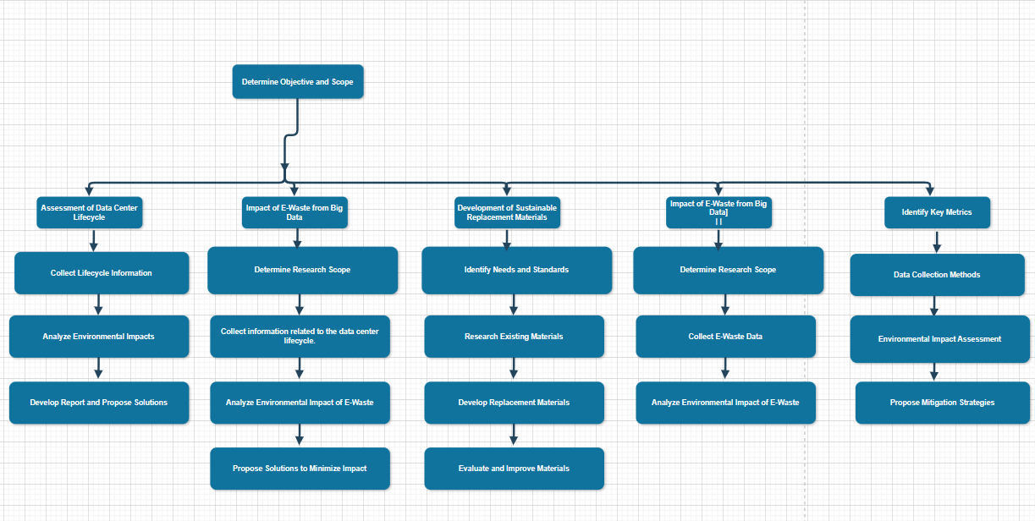

**Task:**

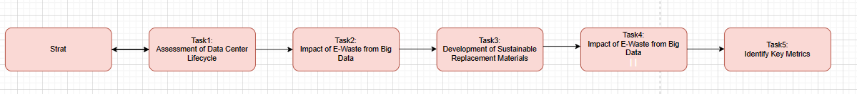

**Milestone:**

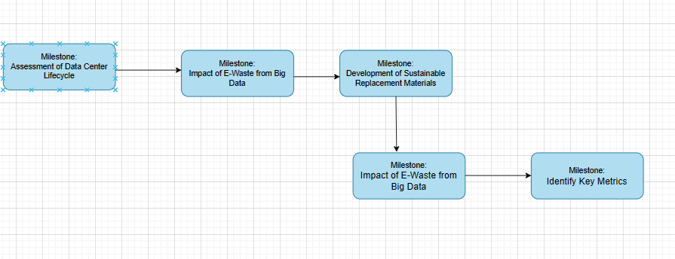

**gantt chart:**

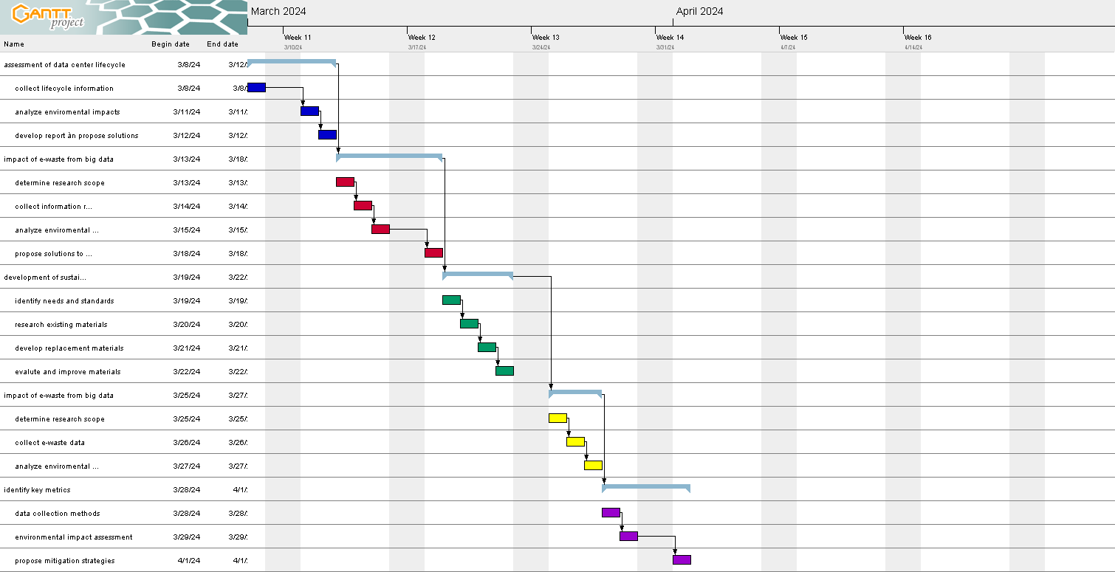

## P2 Examine appropriate research methods and approaches to primary and secondary research

### Research Methods

Research methods refer to the techniques, processes, and procedures used by researchers to collect, analyze, and interpret data to answer research questions or test hypotheses. These methods vary depending on the nature of the research, the discipline, and the objectives of the research. Some popular research methods include:

Quantitative research methods: These methods involve collecting and analyzing numerical data to quantify phenomena and test hypotheses. Examples include surveys, experiments, and statistical analysis.

Qualitative research methods: Qualitative methods focus on understanding complex social phenomena by exploring human experiences, perceptions, and behaviors through non-numerical data. Techniques such as interviews, focus groups and observations are often used.

Mixed methods research: Mixed methods research combines elements of both quantitative and qualitative methods to provide a comprehensive understanding of the research problem. Researchers use this method to organize data, validate findings, or explore different aspects of a phenomenon.

Experimental Research: Experimental research involves manipulating variables to establish cause and effect relationships. This method typically involves controlled experiments in which researchers manipulate one or more variables and observe the effects on other variables.

Observational Research: Observational research involves systematically observing and recording behaviors or phenomena without intervening or manipulating them. This method is often used in natural environments to study social interactions, behaviors or processes.

Survey research: Surveys are used to collect data from a sample of individuals using standard questionnaires or interviews. Surveys can provide insight into the attitudes, opinions, behaviors and demographic characteristics of a population.

Case Study: A case study involves an in-depth examination of a specific individual, group, organization or phenomenon in its real-life context. Researchers use multiple data sources such as interviews, documents, and observations to understand the complexity of the case.

Action Research: Action research is a participatory approach in which researchers work closely with stakeholders to identify and solve real-world problems or challenges in the environment. real school. This method emphasizes collaboration, reflection, and iterative problem solving.

Ethnographic Research: Ethnography involves long-term, in-depth fieldwork in a specific cultural or social setting to understand the culture, behavior, and social interactions of the participants. Researchers often participate in the activities of the group they are studying to better understand their perspectives and practices.

Content Analysis: Content analysis involves the systematic analysis of textual, visual, or audiovisual data to identify patterns, themes, or trends. Researchers use this method to study media content, documents, social media posts, or other forms of communication.

Researchers choose appropriate methods based on the research question, theoretical framework, available resources, and ethical considerations. They can also combine multiple methods to organize findings and enhance the validity and reliability of their research.

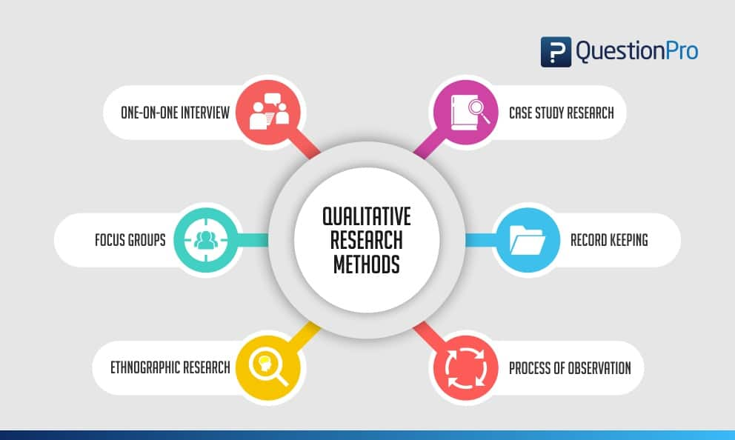

### Primary research

Primary research is a research method that relies on direct data collection, rather than relying on data that’s already been collected by someone else. In other words, primary research is any type of research that you undertake yourself, firsthand, while using data that has already been collected is called secondary research.

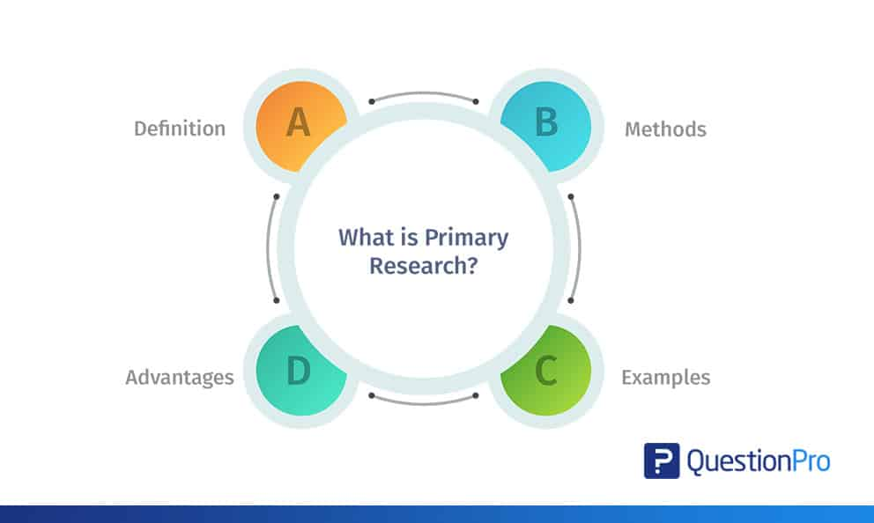

#### Types of Primary research

Surveys and questionnaires

Surveys and questionnaires collect information about a group of people by asking them questions and analyzing the results. They are a solid choice if your research topic seeks to investigate something about the characteristics, preferences, opinions, or beliefs of a group of people.

Surveys and questionnaires can take place online, in person, or through the mail. It is best to have a combination of open-ended and closed-ended questions, and how the questions are phrased matters. Be sure to avoid leading questions, and ask any related questions in groups, starting with the most basic ones first.

Observational studies

Observational studies are an easy and popular way to answer a research question based purely on what you, the researcher, observes. If there are practical or ethical concerns that prevent you from conducting a traditional experiment, observational studies are often a good stopgap.

There are three types of observational studies: cross-sectional studies, cohort studies, and case-control studies. If you decide to conduct observational research, you can choose the one that’s best for you. All three are quite straightforward and easy to design—just beware of confounding variables and observer bias creeping into your analysis.

Interviews and focus groups

Similarly to surveys and questionnaires, interviews and focus groups also rely on asking questions to collect information about a group of people. However, how this is done is slightly different. Instead of sending your questions out into the world, interviews and focus groups involve two or more people—one of whom is you, the interviewer, who asks the questions.

There are 3 main types of interviews:

Structured interviews ask predetermined questions in a predetermined order.

Unstructured interviews are more flexible and free-flowing, proceeding based on the interviewee’s previous answers.

Semi-structured interviews fall in between, asking a mix of predetermined questions and off-the-cuff questions.

While interviews are a rich source of information, they can also be deceptively challenging to do well. Be careful of interviewer bias creeping into your process. This is best mitigated by avoiding double-barreled questions and paying close attention to your tone and delivery while asking questions.

Alternatively, a focus group is a group interview, led by a moderator. Focus groups can provide more nuanced interactions than individual interviews, but their small sample size means that external validity is low.

#### Advantages of Primary research

Advantages include:

The ability to conduct really tailored, thorough research, down to the “nitty-gritty” of your topic. You decide what you want to study or observe and how to go about doing that.

You maintain control over the quality of the data collected, and can ensure firsthand that it is objective, reliable, and valid.

The ensuing results are yours, for you to disseminate as you see fit. You maintain proprietary control over what you find out, allowing you to share your findings with like-minded individuals or those conducting related research that interests you for replication or discussion purposes.

#### Disadvantages of Primary research

Disadvantages include:

In order to be done well, primary research can be very expensive and time consuming. If you are constrained in terms of time or funding, it can be very difficult to conduct your own high-quality primary research.

Primary research is often insufficient as a standalone research method, requiring secondary research to bolster it.

Primary research can be prone to various types of research bias. Bias can manifest on the part of the researcher as observer bias, Pygmalion effect, or demand characteristics. It can occur on the part of participants as a Hawthorne effect or social desirability bias.

### Secondary research

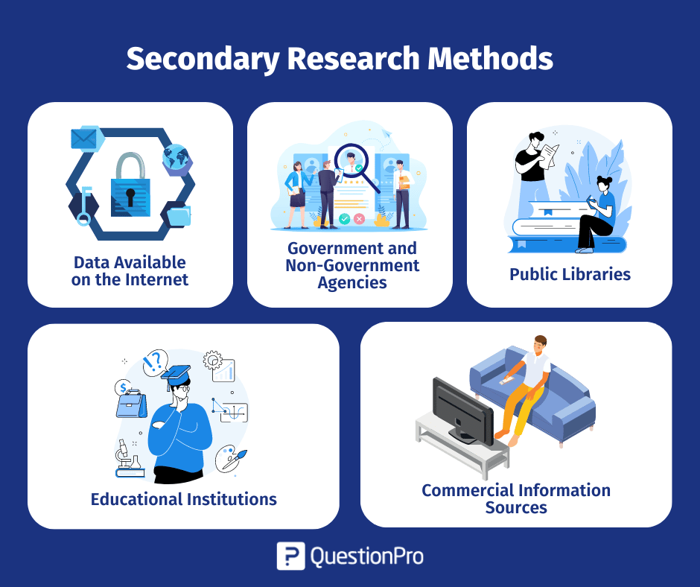

Secondary research, also known as desk research, is a research method that involves compiling existing data sourced from a variety of channels. This includes internal sources (e.g.in-house research) or, more commonly, external sources (such as government statistics, organisational bodies, and the internet).

Secondary research comes in several formats, such as published datasets, reports, and survey responses, and can also be sourced from websites, libraries, and museums.

The information is usually free — or available at a limited access cost — and gathered using surveys, telephone interviews, observation, face-to-face interviews, and more.

When using secondary research, researchers collect, verify, analyse and incorporate it to help them confirm research goals for the research period.

As well as the above, it can be used to review previous research into an area of interest. Researchers can look for patterns across data spanning several years and identify trends — or use it to verify early hypothesis statements and establish whether it’s worth continuing research into a prospective area.

#### Types of Secondary research

Types of secondary research, also known as supporting research, are often studies that do not directly continue to collect new data but rely on previously created sources of information. Here are some common types of secondary research:

Information Synthesis (Literature Review): Synthesize information from previous research to understand and synthesize available knowledge on a specific topic. This type of research helps determine the direction of new research and identify architectural gaps that need to be filled.

Secondary Analysis: Analyzing data that has been collected from previous studies to reach new conclusions or test different hypotheses. This work may include reusing data from previous studies or combining data from various sources.

Infrastructure Database Analysis (Secondary Data Analysis): Uses available data from sources such as database databases, international databases, or non-profit organizations to perform Now analyze and create new Formula architecture.

Content Analysis: Analyzing the content of a pre-existing document or data text, such as an article, political statement, or television news report, to gain a deeper understanding of a specific topic. the.

Data Synthesis (Data Synthesis): Synthesize and combine data from many different sources to create a more comprehensive and complex view of a problem or field of research.

Systematic Review (Systematic Review): Synthesis and synthesis of results of published studies on a specific topic, with the goal of assessing the quality of the studies and providing conclusions overall.

#### Advantages of Secondary research

There are several benefits of using secondary research, which we’ve outlined below:

* **Easily and readily available data** – There is an abundance of readily accessible data sources that have been pre-collected for use, in person at local libraries and online using the internet. This data is usually sorted by filters or can be exported into spreadsheet format, meaning that little technical expertise is needed to access and use the data.
* **Faster research speeds** – Since the data is already published and in the public arena, you don’t need to collect this information through primary research. This can make the research easier to do and faster, as you can get started with the data quickly.
* **Low financial and time costs** – Most secondary data sources can be accessed for free or at a small cost to the researcher, so the overall research costs are kept low. In addition, by saving on preliminary research, the time costs for the researcher are kept down as well.
* **Secondary data can drive additional research actions**– The insights gained can support future research activities (like conducting a follow-up survey or specifying future detailed research topics) or help add value to these activities.
* **Secondary data can be useful pre-research insights**– Secondary source data can provide [pre-research insights](https://www.qualtrics.com/au/core-xm/research-insights-software-old/) and information on effects that can help resolve whether research should be conducted. It can also help highlight knowledge gaps, so subsequent research can consider this.
* **Ability to scale up results**– Secondary sources can include large datasets (like Census data results across several states) so research results can be scaled up quickly using large secondary data sources.

#### Disadvantages of Secondary research

The disadvantages of secondary research are worth considering in advance of [conducting research](https://www.qualtrics.com/experience-management/research/market-research-guide/):

* **Secondary research data can be out of date**– Secondary sources can be updated regularly, but if you’re exploring the data between two updates, the data can be out of date. Researchers will need to consider whether the data available provides the right research coverage dates, so that insights are accurate and timely, or if the data needs to be updated. Also, fast-moving markets may find secondary data expires very quickly.
* **Secondary research needs to be verified and interpreted**– Where there’s a lot of data from one source, a researcher needs to review and analyse it. The data may need to be verified against other data sets or your hypotheses for accuracy and to ensure you’re using the right data for your research.
* **The researcher has had no control over the secondary research**– As the researcher has not been involved in the secondary research, invalid data can affect the results. It’s therefore vital that the methodology and controls are closely reviewed so that the data is collected in a systematic and error-free way.
* **Secondary research data is not exclusive**– As data sets are commonly available, there is no exclusivity and many researchers can use the same data. This can be problematic where researchers want to have exclusive rights over the research results and risk duplication of research in the future.

### Compare Primary research with Secondary research

|  |  |  |
| --- | --- | --- |
|  | Primary research | Secondary research |
| Original data | Collected by you | Collected by someone else |
| Research type | Qualitative or quantitative | Qualitative or quantitative |
| Methods | * Surveys * Focus groups * Interviews * Observations * Experiments | Any type of research previously collected by someone else |
| Key advantages | * You decide what you want to study or observe and how * You maintain control over the data. You ensure that it is objective, reliable, and valid * The ensuing results are yours to manage as you wish | * Information you need is readily available * Research is quick and efficient * Secondary data can give you great ideas for primary research |
| Key disadvantages | * Expensive and time-consuming * Often insufficient as a standalone research method * Prone to bias | * Data can be outdated, corrupted, biased, or unethical * Quality is not known * Public availability can lead to duplicate findings and research aims |

### Qualitative research



Qualitative research involves collecting and analyzing non-numerical data (e.g., text, video, or audio) to understand concepts, opinions, or experiences. It can be used to gather in-depth insights into a problem or generate new ideas for research.

#### Qualitative research methods

Each of the research approaches involve using one or more data collection methods. These are some of the most common qualitative methods:

* Observations: recording what you have seen, heard, or encountered in detailed field notes.
* Interviews: personally asking people questions in one-on-one conversations.
* Focus groups: asking questions and generating discussion among a group of people.
* Surveys: distributing questionnaires with open-ended questions.
* Secondary research: collecting existing data in the form of texts, images, audio or video recordings, etc.

#### Qualitative data analysis

Qualitative data can take the form of texts, photos, videos and audio. For example, you might be working with interview transcripts, survey responses, fieldnotes, or recordings from natural settings.Most types of qualitative data analysis share the same five steps:

* Prepare and organize your data. This may mean transcribing interviews or typing up fieldnotes.
* Review and explore your data. Examine the data for patterns or repeated ideas that emerge.
* Develop a data coding system. Based on your initial ideas, establish a set of codes that you can apply to categorize your data.
* Assign codes to the data. For example, in qualitative survey analysis, this may mean going through each participant’s responses and tagging them with codes in a spreadsheet. As you go through your data, you can create new codes to add to your system if necessary.
* Identify recurring themes. Link codes together into cohesive, overarching themes.

#### Advantages of Qualitative research

* Flexibility:The data collection and analysis process can be adapted as new ideas or patterns emerge. They are not rigidly decided beforehand.
* Natural settings:Data collection occurs in real-world contexts or in naturalistic ways.
* Meaningful insights:Detailed descriptions of people’s experiences, feelings and perceptions can be used in designing, testing or improving systems or products.
* Generation of new ideas:Open-ended responses mean that researchers can uncover novel problems or opportunities that they wouldn’t have thought of otherwise.

#### Disadvantages of Qualitative research

* Unreliability:The real-world setting often makes qualitative research unreliable because of uncontrolled factors that affect the data.
* Subjectivity:Due to the researcher’s primary role in analyzing and interpreting data, qualitative research cannot be replicated. The researcher decides what is important and what is irrelevant in data analysis, so interpretations of the same data can vary greatly.
* Limited generalizability:Small samples are often used to gather detailed data about specific contexts. Despite rigorous analysis procedures, it is difficult to draw generalizable conclusions because the data may be biased and unrepresentative of the wider population.
* Labor-intensive:Although software can be used to manage and record large amounts of text, data analysis often has to be checked or performed manually.

### Quantitative research

Quantitative research is the process of collecting and analyzing numerical data. It can be used to find patterns and averages, make predictions, test causal relationships, and generalize results to wider populations.

#### Quantitative research methods

You can use quantitative research methods for descriptive, correlational or experimental research.

* In descriptive research, you simply seek an overall summary of your study variables.
* In correlational research, you investigate relationships between your study variables.
* In experimental research, you systematically examine whether there is a cause-and-effect relationship between variables.

Correlational and experimental research can both be used to formally test hypotheses, or predictions, using statistics. The results may be generalized to broader populations based on the sampling method used.

To collect quantitative data, you will often need to use operational definitions that translate abstract concepts (e.g., mood) into observable and quantifiable measures (e.g., self-ratings of feelings and energy levels).

#### Quantitative data analysis

Once data is collected, you may need to process it before it can be analyzed.

Descriptive statistics will give you a summary of your data and include measures of averages and variability. You can also use graphs, scatter plots and frequency tables to visualize your data and check for any trends or outliers.

Using inferential statistics, you can make predictions or generalizations based on your data. You can test your hypothesis or use your sample data to estimate the population parameter.

Next, you perform inferential statistics to test your hypothesis. Using a t-test to compare the mean ratings of the two groups, you find a significant difference and support for your hypothesis.

You can also assess the reliability and validity of your data collection methods to indicate how consistently and accurately your methods actually measured what you wanted them to.

#### Advantages of Quantitative research

* Replication:Repeating the study is possible because of standardized data collection protocols and tangible definitions of abstract concepts.
* Direct comparisons of results:The study can be reproduced in other cultural settings, times or with different groups of participants. Results can be compared statistically.
* Large samples:Data from large samples can be processed and analyzed using reliable and consistent procedures through quantitative data analysis.
* Hypothesis testing:Using formalized and established hypothesis testing procedures means that you have to carefully consider and report your research variables, predictions, data collection and testing methods before coming to a conclusion.

#### Disadvantages of Quantitative research

* Superficiality:Using precise and restrictive operational definitions may inadequately represent complex concepts. For example, the concept of mood may be represented with just a number in quantitative research, but explained with elaboration in qualitative research.
* Narrow focus:Predetermined variables and measurement procedures can mean that you ignore other relevant observations.
* Structural bias:Despite standardized procedures, structural biases can still affect quantitative research. Missing data, imprecise measurements or inappropriate sampling methods are biases that can lead to the wrong conclusions.
* Lack of context:Quantitative research often uses unnatural settings like laboratories or fails to consider historical and cultural contexts that may affect data collection and results.

### Compare Qualitative research with Quantitative research

|  |  |  |
| --- | --- | --- |
|  | Qualitative research | Quantitative research |
| Focus | Exploring ideas or formulating hypotheses/theories | Testing hypotheses or theories |
| Analysis | Summarizing, categorizing, interpreting | Math and statistical analysis |
| Expressed in | Words | Numbers, graphs, tables, fewer words |
| Sample | Few respondents | Many respondents |
| Questions | Open-ended | Close-ended or multiple choice |
| Charaterized by | Understanding, context, complexity, subjectivity | Testing, measurement, objectivity, replicability |

### Scientific method

The scientific method is a process for experimentation that is used to explore observations and answer questions.

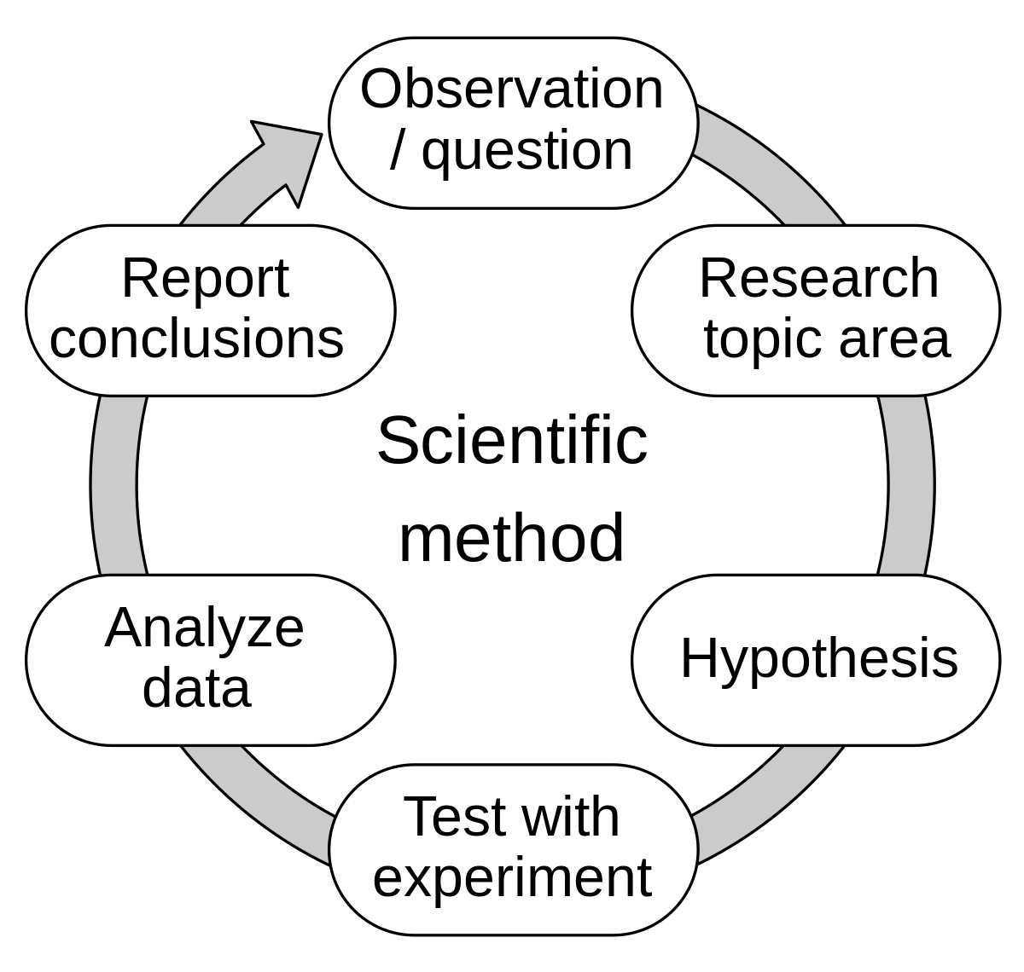

#### The scientific method in technology and computers

The scientific method is a systematic approach used by scientists and researchers to investigate natural phenomena, acquire new knowledge, and refine existing understanding. Although traditionally associated with the natural sciences such as biology, physics, and chemistry, the scientific method is also applied in the fields of technology and computing. Here's how to apply the scientific method to technology and computers:

Observation: The scientific method begins with observation. In technology and computing, observations can include identifying trends, patterns, or problems in existing systems or processes. For example, noticing slow computer performance or identifying security vulnerabilities in software.

Questions: Based on observations, researchers form questions or hypotheses to explore further. These questions may focus on understanding the causes of observed phenomena or improving existing technology. For example: "What factors contribute to reduced performance of computer systems?"

Hypothesis: Researchers propose hypotheses, which are tentative explanations for observed phenomena or answers to posed questions. Technological and computational hypotheses may involve proposing solutions to identified problems or predicting the outcomes of certain interventions. For example: "Increasing the amount of RAM in a computer system will improve its performance."

Prediction: After hypotheses are formed, researchers make predictions about what results they expect to observe if the hypothesis is correct. Technology and computing predictions may involve anticipated changes in system behavior or performance metrics. For example, it is predicted that more RAM will result in faster processing speeds.

Experiment: Researchers design and conduct experiments to test their hypotheses. In technology and computing, tests may involve making changes to hardware or software configurations, collecting data about system performance, and analyzing the results. For example, conduct a benchmark test to compare the performance of a computer system before and after increasing RAM.

Analysis: Researchers analyze data collected from experiments to evaluate whether the results support or refute their hypotheses. In technology and computing, data analysis may involve statistical techniques, performance metrics, or qualitative assessments. For example, compare processing speed and system responsiveness between different configurations.

Conclusion: Based on the analysis of experimental results, the researchers draw conclusions about the correctness of their hypotheses. Conclusions about technology and computing can lead to insights into system operations, suggestions for improvements, or the development of new technologies. For example, it is concluded that increasing RAM will significantly improve the performance of certain computational tasks.

Iteration and refinement: The scientific method is iterative, meaning it often involves repeating steps, refining hypotheses, and conducting further experiments to build on previous findings there. In technology and computing, this iterative process drives continuous improvement, innovation, and progress.

In summary, the scientific method plays an important role in technology and computing by providing a systematic framework for inquiry, experimentation, and problem solving. It enables researchers to understand complex systems, identify opportunities for improvement, and drive innovation in the field.

#### Step of the Scientific method

* Ask a Question
* Do Background Research
* Construct a Hypothesis
* Test Your Hypothesis by Doing an Experiment
* Analyze Your Data and Draw a Conclusion
* Communicate Your Results

### Research process

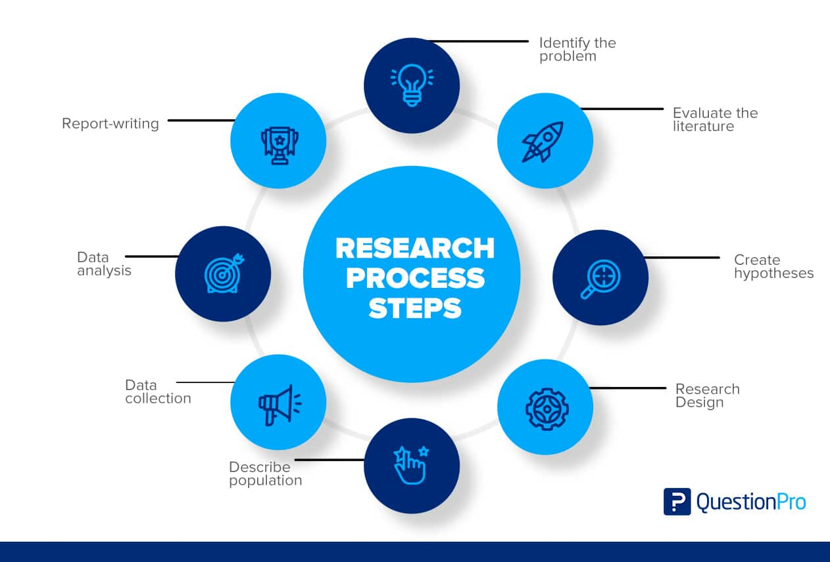

The research process is a set of ordered steps a researcher takes to ensure that all parts of an investigation are completed to a high standard. Following the research process allows the researcher to cover all angles and ensure that the information they gather is reliable and effectively presented.

#### Step of the Research process

* Identify the purpose or research question
* Design a research plan
* Collect the required data
* Interpret the collected data
* Present the research findings

### Population in research

In research, a population doesn’t always refer to people. It can mean a group containing elements of anything you want to study, such as objects, events, organizations, countries, species, organisms, etc.

#### Collecting data from a population

Populations are used when your research question requires, or when you have access to, data from every member of the population.

Usually, it is only straightforward to collect data from a whole population when it is small, accessible and cooperative.

However, historically, marginalized and low-income groups have been difficult to contact, locate and encourage participation from. Because of non-responses, the population count is incomplete and biased towards some groups, which results in disproportionate funding across the country.

In cases like this, sampling can be used to make more precise inferences about the population.

## P3 Conduct primary and secondary research using appropriate methods for a computing research project that consider costs, access and ethical issues

### Secondary research

#### Source

Below are some sources of scientific articles that may be useful for the research topic "Environmental impact and search for alternative materials in large data storage models":

"Environmental Implications of Big Data: How Should We Address Them?" by Raluca Ada Popa and David Mazières. This article focuses on the environmental issues of big data and offers solutions to minimize the impact.

- "Sustainability in Big Data Storage: A Survey" by Diogo F. C. Patrão and co-authors. This paper evaluates new methods and technologies to improve the sustainability of data repositories.

- "Green big data: Greenwashing or a step towards sustainability?" by Fernando Romero and authors. This article analyzes the pros and cons of data storage technologies from angular environments.

- "Sustainable Big Data: Challenges and Opportunities" by R. Ranjan and colleagues. This article delves into the complete formulations and foundations related to sustainability in big data in the field.

- "Environmental Impact of Data Centers: A Review" by Rashedur M. Rahman and co-authors. This article focuses on issues related to the impact of data centers on the environment and proposes mitigation solutions.

- "Towards sustainable big data management in cloud computing" by Hong-Linh Truong and colleagues. This article investigates strategies and technologies to optimize data management in cloud environments with the goal of sustainability.

You can find these through academic databases such as Google Scholar, IEEE Xplore or ACM Digital Library. Be sure to double-check informational links such as publication date and institution to ensure the accuracy of the reference.

#### Interpretation and implications of the findings

The approaching scientific article "Environmental impact and search for alternative materials in big data storage models" provides an important knowledge base for this research topic. Below is the meaning of each article regarding the topic:

*"Environmental implications of big data: How should we address them?"*: This article provides an overview of environmental issues related to big data and the propose tool solutions that can reduce the impact to a minimum. This can provide essential tips for developing sustainable data repositories.

*"Sustainability in Big Data Storage: A Survey"*: This article provides a survey of new methods and technologies in the field of sustainable big data storage. These discovered messages can assist in the selection of appropriate materials and technologies to reduce environmental impact.

*"Green Big Data: Greenwashing or a Step to Sustainability?"*: This article takes a deeper look at the extent to which big data storage technologies and strategies actually aim for sustainability solid. This can help to better define concepts and models that can be applied in research.

*"Sustainable Big Data: Challenges and Opportunities"*: This article focuses on identifying formulas and opportunities in developing sustainable big data storage solutions . These aspects can help clarify limitations and possibilities in research.

*"Environmental Impact of Data Centers: A Review"*: This article focuses on the impacts of data centers on the environment. A better understanding of these issues can help shape specific solutions for optimizing archival storage data.

*"Towards sustainable big data management in cloud computing"*: This article addresses the management of big data in cloud environments with the goal of sustainability. The strategies and technologies proposed in the article can provide guiding tools to help develop a sustainable data storage model.

In summary, this article provides important information and useful tools for research on the environmental impact of big data storage models and the search for alternative materials.

### Primary research

I will use two research methods: interviews and surveys. Detailed content updates are in p4

#### Interview

The interview will include questions:

"Can you describe the best uses of big data to evaluate prices and manage user impacts on the environment?"

"Are there any concrete examples of using big data to monitor and measure potential environmental pollution?"

"How to ensure data is used properly and reliably in a price-influenced environment?"

"Do you think data can help predict and prevent environmental problems such as climate change and biodiversity loss?"

“What challenges are there in using big data in regulatory settings that you think need to be considered and addressed?”

#### Survey

The Survey will include questions:

"Can you describe the best uses of big data to evaluate prices and manage user impacts on the environment?"

"Are there any concrete examples of using big data to monitor and measure potential environmental pollution?"

"How to ensure data is used properly and reliably in a price-influenced environment?"

"Do you think data can help predict and prevent environmental problems such as climate change and biodiversity loss?"

“What challenges are there in using big data in regulatory settings that you think need to be considered and addressed?”

## P4 Apply appropriate analytical tools, analyse research findings and data

### Interview

Professor: Dinh Tien Dung was born October 5, 1981 in Nam Dinh. During his student days, he studied and graduated from Course 44 in Crops major at Hanoi University of Agriculture, where he held positions such as President of the Student Association of the Faculty of Agronomy, President of the Student Association. Hanoi University of Agriculture.

#### Interview 1

Hai: "Hello, thank you for the question. Big data really plays a very important role in assessing and managing human impact on the environment. First, we collect data from many various sources such as sensors, monitoring systems, reports from the community and geo-data. Then, through analysis and processing of this data, we can evaluate environmental issues such as air pollution, climate change, deforestation and biodiversity loss."

Interviewer: "So can you provide a concrete example of how big data can be used to evaluate users' impact on the environment?"

Hai: "Certainly, a very positive example is the use of data from spatial monitoring systems and sensors to measure air pollution rates in urban areas. Through the work of collecting Data data on pollutants such as car exhaust and factory fumes, we can identify localities with poor air quality and suggest measures to improve them such as reducing vehicle emissions. convenient information."

Questioner: "Very interesting. How to ensure the correctness and reliability of big data used in the assessment photo environment?"

Hai: "Yes, this is an important part. To ensure the correctness and reliability of big data, we need to check and evaluate the reliability of the data source, making sure they are will meet data quality standards and regulations. Additionally, security solutions are required to ensure that information does not take up space or be misused."

Interviewer: "Thank you for sharing the information, Hai. It's very interesting to understand how big data can be applied in a field environment."

Hai: "It's a pleasure to share this information with you. Thank you for this opportunity."

#### Interview 2

Interviewer: "Hello, Hai. I'd like to ask you about concrete examples of using big data to monitor and measure environmental pollution. Can you describe how this is done?"

Hai: "Hello, thank you for the question. Yes, there are several concrete examples of using big data to monitor and measure environmental pollution. One example is the use of satellite imagery and sensor data to track air quality in urban areas. By analyzing data on pollutants such as vehicle emissions and industrial smoke, we can identify regions with poor air quality and implement measures to improve it, such as reducing emissions from vehicles."

Interviewer: "That's fascinating. Could you provide another example of how big data is used to monitor environmental pollution?"

Hai: "Certainly. Another example is the use of water quality sensors in rivers and lakes to monitor pollution levels. These sensors continuously collect data on parameters such as pH, dissolved oxygen, and nutrient levels. By analyzing this data in real-time, we can detect pollution events such as chemical spills or excessive nutrient runoff from agriculture, allowing for prompt response and mitigation efforts."

Interviewer: "That sounds like a valuable application of big data. How about the use of big data in monitoring pollution from industrial sources?"

Hai: "Yes, big data is also used to monitor pollution from industrial sources. For example, factories and industrial facilities often have sensors installed to monitor emissions of pollutants such as sulfur dioxide and nitrogen oxides. By collecting and analyzing this data, environmental agencies can ensure that these facilities comply with regulations and take action against violations."

Interviewer: "Thank you for sharing those examples, Hai. It's clear that big data plays a crucial role in monitoring environmental pollution."

Hai: "You're welcome. I'm glad to provide insights into how big data contributes to environmental monitoring."

#### Interview 3

Interviewer: "Hello, thank you for joining us today. I'd like to discuss how we ensure data is used properly and reliably in environments that impact assessment work. Can you provide some insights on this?"

Hai: "Of course, thank you for having me. Ensuring the proper and reliable use of data in impact assessment work is paramount to the success and accuracy of our assessments. One key aspect is data quality control. This involves establishing rigorous protocols for data collection, ensuring that data is accurate, consistent, and up-to-date."

Interviewer: "That makes sense. Can you elaborate on how you ensure data accuracy and reliability?"

Hai: "Certainly. We employ various measures to ensure data accuracy and reliability. This includes implementing quality assurance procedures, such as regular calibration and maintenance of monitoring equipment. We also conduct validation checks and data verification to confirm the integrity of the data collected."

Interviewer: "And how do you address concerns about data integrity and security?"

Hai: "Data integrity and security are top priorities for us. We utilize secure data storage and transmission protocols to protect sensitive information. Additionally, access to data is strictly controlled, with permissions granted only to authorized personnel. Regular audits and security assessments are conducted to identify and mitigate potential vulnerabilities."

Interviewer: "That's reassuring to hear. How do you ensure that data is used appropriately in impact assessment work?"

hai: "We have clear guidelines and procedures in place for the use of data in impact assessment work. This includes ensuring that data is used in accordance with relevant regulations and standards. Additionally, we provide training and ongoing support to personnel involved in data analysis and interpretation to ensure that data is used appropriately and effectively."

Interviewer: "Thank you for providing those insights, Navy. It's clear that ensuring data integrity and reliability is crucial in impact assessment work."

Hai: "Absolutely. It's essential for accurate decision-making and effective environmental management."

#### Interview 4

Interviewer: "Hello, thank you for coming to this interview. I would like to discuss with you the ability of big data to predict and prevent environmental problems such as climate change and biodiversity loss. Do you think big data can help in this?"

Hai : "Hello, thank you for asking this question. I believe that big data can play an important role in predicting and preventing important environmental problems such as climate change and depression." reducing biodiversity. By using predictive models and data analytics, we can identify climate change trends and predict their impact on the environment."

Interviewer: "Yes, but do we have enough data to be able to predict major changes like climate change?"

Hai: "Yes, this is a challenge. However, with the development of technology and new data collection methods, we are getting a large amount of data from different sources such as sensors variables, monitoring systems, and social networks. By combining and analyzing this data, we can get an overview and predict climate change trends."

Interviewer: "So, how can we use big data to prevent environmental problems like biodiversity loss?"

Hai: "One way is to use data to locate and protect important areas for the environment and biodiversity. We can use data on observations from satellites, sensors and other Scientific research to identify areas at risk of biodiversity loss and implement protection measures."

Interviewer: "Thank you for sharing these perspectives, Navy. It's very interesting to hear about how big data can be applied in environmental protection."

Hai: "It's a pleasure to share with you. Thank you for this opportunity."

### Interview summary

During the interview, the interviewer asked Hai about the potential of big data in predicting and preventing environmental problems such as climate change and biodiversity loss. The Hai expressed confidence in the role of big data in addressing these challenges. They emphasized that with the development of new technologies and data collection methods, there will be a significant amount of data available from various sources such as sensors, monitoring systems and social networks. This data, when combined and analyzed, can provide insight into climate change trends and potential impacts on the environment.

As for predicting major changes like climate change, the hai admits it poses a challenge. However, they emphasize the importance of using available data to gain a comprehensive understanding and forecast of climate change trends.

When discussing preventing environmental problems such as biodiversity loss, the hai recommends using data to identify and protect important environmental and biodiversity areas. They refer to the use of satellite observations, sensors and scientific research to identify areas at risk and implement protective measures.

Overall, the Hai expressed optimism about the potential of big data in environmental protection and emphasized the importance of leveraging data to address pressing environmental challenges.

### Survey

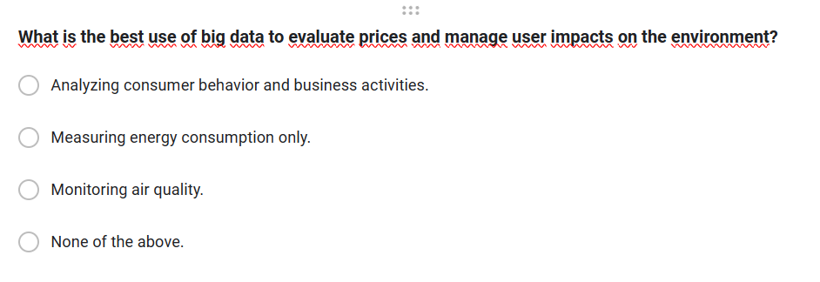

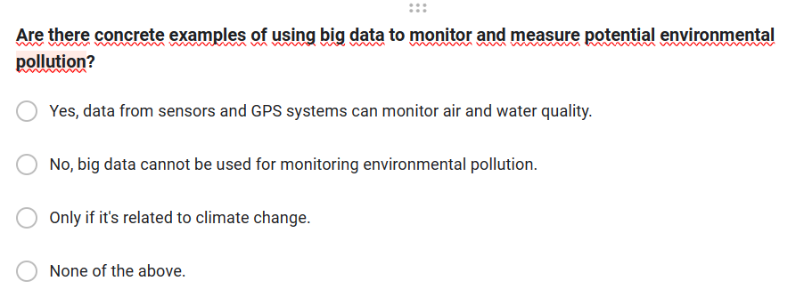

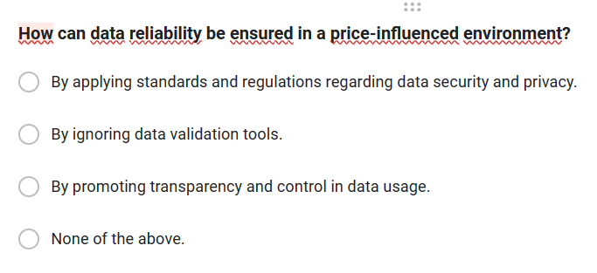

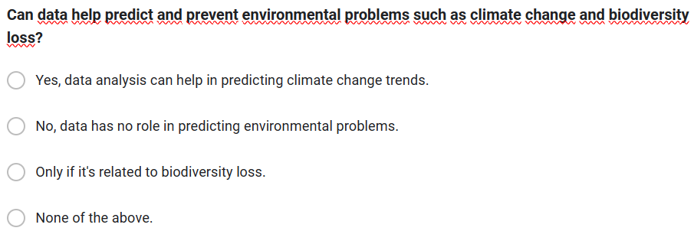

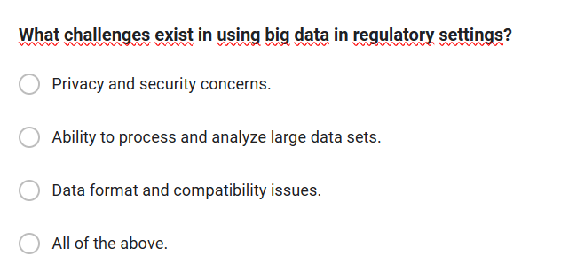



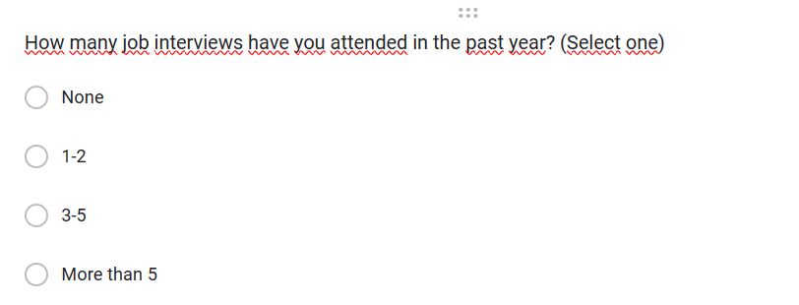

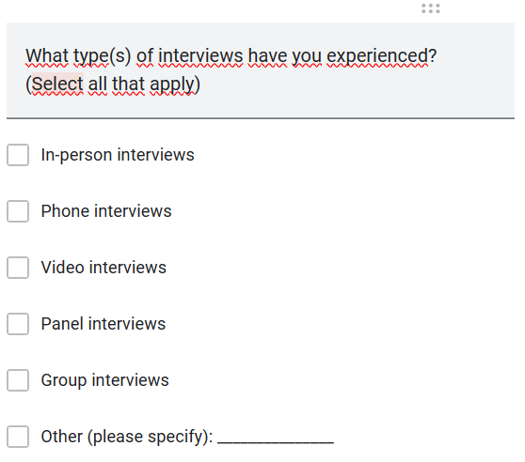

### Survey summary

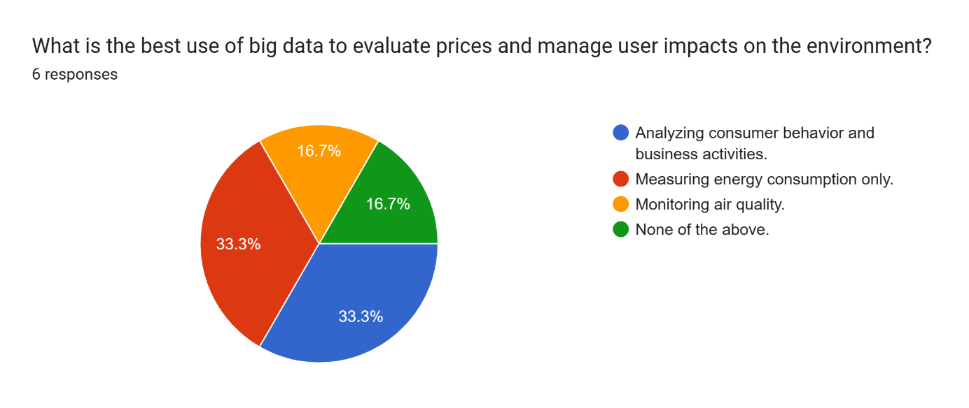

What is the best use of big data to evaluate prices and manage user impacts on the environment?Analyzingconsumer behavior andbusiness activities.33% ;

Measuring energy consumption only.33%

Monitoring air quality.16,7%

None of the above.16,7%

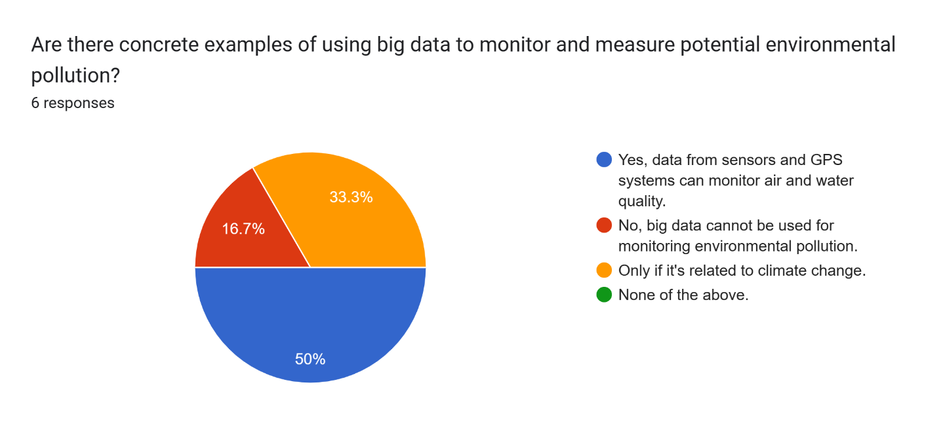

Are there concrete examples of using big data to monitor and measure potential environmental pollution?

Yes, data from sensors and GPS systems can monitor air and water quality. No, big data cannot be used for. 50%

monitoring environmental pollution.16,7%

Only if it's related to climate change.33%

None of the above.0%

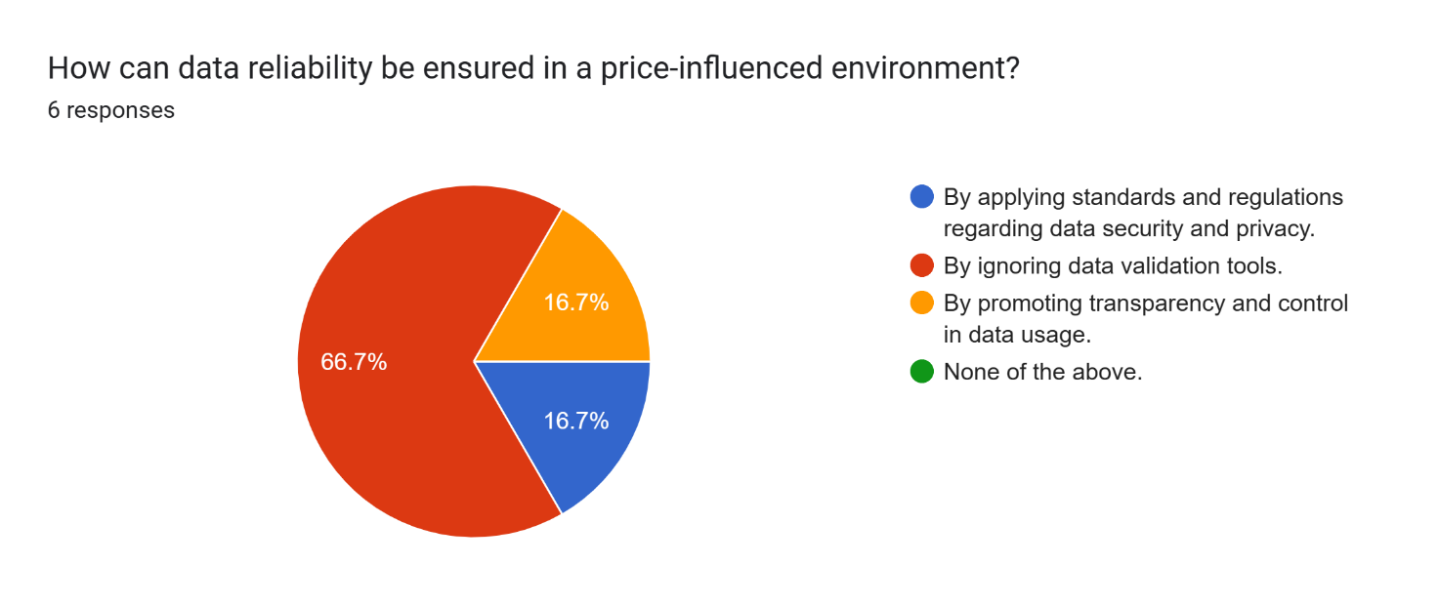

How can data reliability be ensured in a price-influenced environment?

By applying standards and regulations regarding data security and privacy. 16,7%

By ignoring data validation tools.66.7%

By promoting transparency and control in data usage.16,7%

None of the above.0%

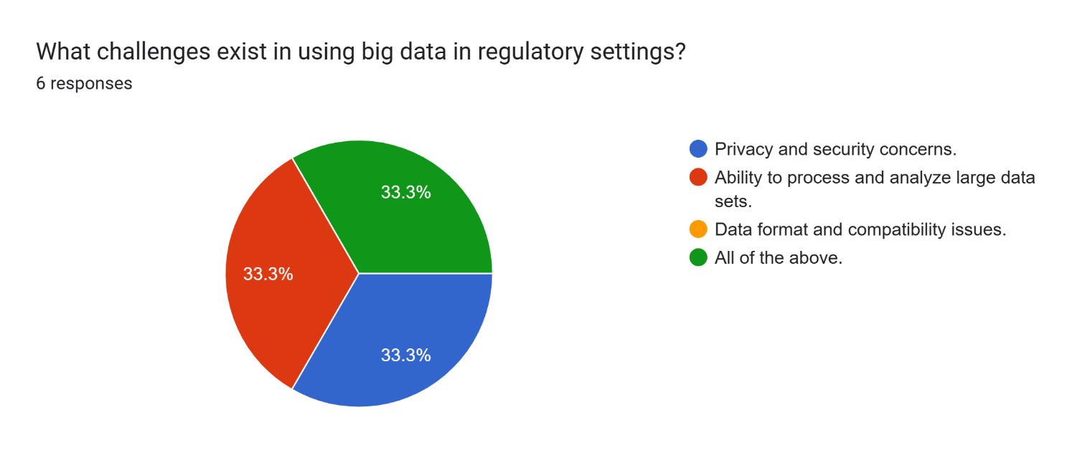

What challenges exist in using big data in regulatory settings?

Privacy and security concerns.33%

Ability to process and analyze large data sets.33%

Data format and compatibility issues.0%

All of the above.33%

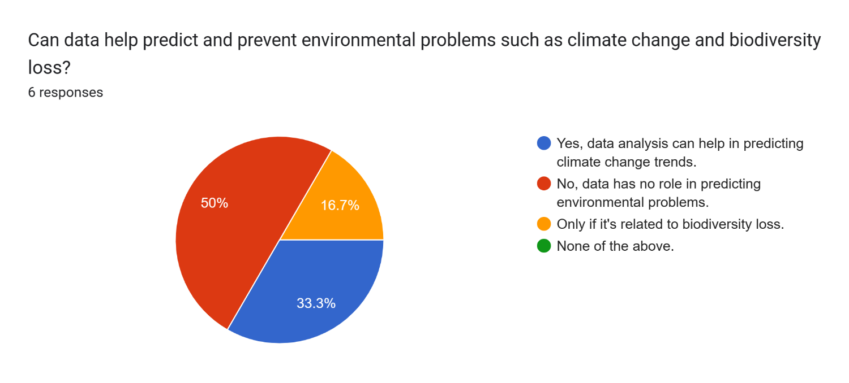

Can data help predict and prevent environmental problems such as climate change and biodiversity loss?

Yes, data analysis can help in predicting climate change trends.33%

No, data has no role in predicting environmental problems.50%

Only if it's related to biodiversity loss.16,7%

None of the above.0%

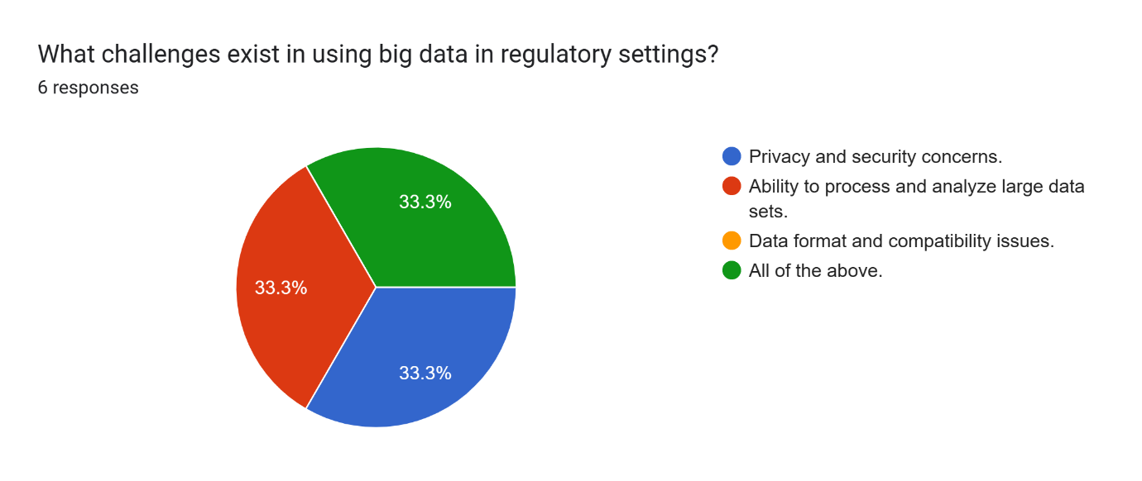

What challenges exist in using big data in regulatory settings?

Privacy and security concerns.33%

Ability to process and analyze large data sets.33%

Data format and compatibility issues.0%

All of the above.33%

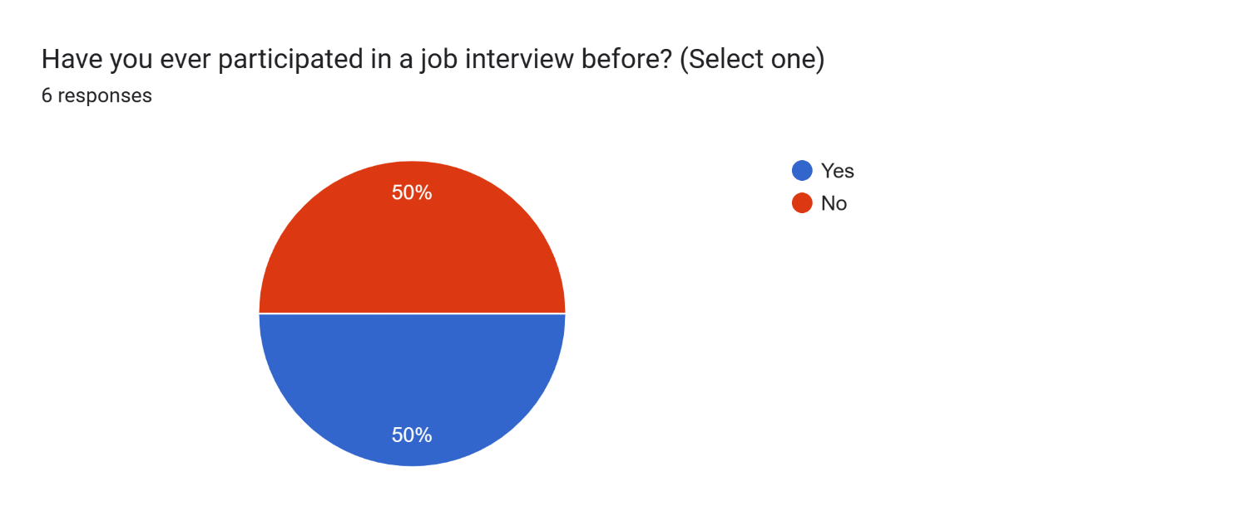

Have you ever participated in a job interview before? (Select one)

Yes:50%

No:50%

### Analyze the results of the Primary research

To analyze the results of primary research, you typically follow a structured approach, which involves several key steps:

Data Collection Methods: Understand the methods used to collect the data. Was it through surveys, interviews, experiments, observations, or a combination of these methods? Each method has its strengths and weaknesses that can affect the interpretation of results.

Data Analysis Techniques: Identify the techniques used to analyze the data. This could include qualitative analysis (coding, thematic analysis) or quantitative analysis (statistical tests, regression analysis).

Data Presentation: Examine how the data are presented. Are there tables, charts, or graphs? Consider whether the presentation effectively communicates the findings to the audience.

Key Findings: Identify the main findings of the research. What are the most significant insights or trends discovered through the research process?

Interpretation: Interpret the findings in the context of the research objectives. What do the results mean in relation to the research questions or hypotheses?

Implications: Discuss the implications of the findings. How do the results contribute to existing knowledge in the field? What are the practical implications for stakeholders or decision-makers?

Limitations: Recognize the limitations of the research. What are the potential biases, constraints, or uncertainties associated with the data collection and analysis process?

Future Research Directions: Suggest potential areas for future research. Are there any unanswered questions or areas that warrant further investigation based on the findings of the study?

Conclusion: Summarize the main points of the analysis and draw overall conclusions. Reflect on the significance of the research and its contribution to the broader academic or practical context.

By following these steps, you can conduct a thorough analysis of the results of primary research and draw meaningful conclusions that advance understanding in the relevant field.

## P5 Communicate research outcomes in an appropriate manner for the intended audience

### Conclution

Environmental impact and the search for alternative materials in large data storage models is an important topic in today's era, when the information technology industry is growing rapidly and consuming large amounts of data. large data is increasing. Below are the basic knowledge and conclusions that can be drawn from this topic:

Environmental impact of big data storage models:

Energy consumption: Large data storage systems often consume large amounts of energy, especially data centers and cloud computing systems. This energy consumption contributes to carbon emissions and increased global temperatures.

Use of natural resources: The production and transportation of data storage devices, as well as the cooling and air conditioning of data centers, all impact the environment, using many materials. and natural resources.

Search for alternative materials and optimize:

Searching for environmentally friendly materials: Researchers and businesses are looking for new materials that can replace traditional materials in the production of data storage devices, in order to minimize the impact on consumption. extremely harmful to the environment.

Optimize energy efficiency: Improvements in data storage technology to minimize energy consumption are a top priority. This includes developing more efficient data storage technologies and designing more efficient cooling systems for data centers.

Policy and regulation: Governments and international organizations are increasingly focusing on managing and minimizing the impact of the information technology industry on the environment. The adoption of environmental regulations and standards can impact how businesses select materials and manage their data storage systems.

Innovations in Data Storage: The quest for more sustainable data storage solutions has led to innovations such as:

Solid-state drives (SSDs): These drives are more energy-efficient and faster than traditional hard disk drives (HDDs).

Optical storage: Research into using light-based storage systems, like holographic data storage, which can potentially offer higher storage densities and lower energy consumption compared to conventional methods.

Efficient data compression algorithms: By improving data compression techniques, less physical storage space is required, leading to reduced energy consumption and environmental impact.

Collaboration and Education: Addressing the environmental impact of large-scale data storage requires collaboration among stakeholders, including government agencies, technology companies, researchers, and consumers. Additionally, educate users and industry professionals about the importance of sustainable data storage practices can foster greater awareness and drive positive change.

In conclusion, finding alternative materials and optimization in big data storage models is extremely important to minimize the environmental impact of the IT industry and ensure sustainable use. resource use.

### Recommendation

* Đề xuất cải tiến/thông điệp

Publishing is improved and messages can be displayed as follows:

Improve:

Research and development of environmentally friendly materials: Consulting on research and development of new and advanced materials that can replace traditional materials in the production of data storage devices. This includes using recycled materials, naturally degradable materials or energy-efficient materials during production and use.

Optimizing Energy Storage Technology: Continued research and development of new data storage technologies to increase performance and minimize energy consumption. This may include developing more efficient compression methods, using energy-efficient storage technologies such as SSDs, and designing smart cooling and power management systems.

Message:

Committed to Environmental Protection: We are committed to working to protect the environment and reduce the IT industry's impact on the planet. By focusing on work using environmentally friendly materials and optimal technology, we are able to build a solid system that is compatible.

Necessity of Collaboration: To achieve our goals, rationality between stakeholders is necessary. We need to work together - from government to business and the scientific community - to create innovative solutions and deliver positive change.

Creating Social and Business Value: Investing in environmentally friendly data storage solutions not only benefits the environment but can also create business and social value. Customers increasingly appreciate businesses with a strong commitment to protecting the environment and are willing to support products and services that have a positive impact.

# CONCLUSION

The exploration of big data's environmental impact reveals a complex panorama of challenges and opportunities. It's evident that while big data drives technological and economic growth, it also necessitates a critical reassessment of its environmental footprint. The findings underscore the urgent need for integrated solutions—ranging from energy-efficient data management to the adoption of renewable resources and innovative materials. Moving forward, a concerted effort from all stakeholders, including policymakers, industry leaders, and the academic community, is crucial in harnessing the potential of big

data while ensuring the preservation of our planet. Embracing sustainability as a core principle of digital advancement is not only a moral imperative but a strategic necessity for the continued flourishing of our global society.

# REFERENCES

George, T. (2023). *Primary Research | Definition, Types, & Examples*. [online] Scribbr. Available at: [https://www.scribbr.com/methodology/primary-research/](https://www.scribbr.com/methodology/primary-research/%20) [Accessed 15 Jan. 2024].

Walker, J. (2021). *Advantages of Primary Research*. [online] ResearchProspect. Available at: [https://www.researchprospect.com/advantages-of-primary-research/](https://www.researchprospect.com/advantages-of-primary-research/%20) [Accessed 15 Jan. 2024].

Niosi, A. and Summer (2020). *Types of Secondary Research Data*. [online] Pressbooks.pub. Available at: [https://kpu.pressbooks.pub/openimc/chapter/primary-data-v-s-secondary-data/](https://kpu.pressbooks.pub/openimc/chapter/primary-data-v-s-secondary-data/%20) [Accessed 15 Jan. 2024].

Bhat, A. (2018). *Secondary Research: Definition, Methods & Examples*. [online] QuestionPro. Available at: <https://www.questionpro.com/blog/secondary-research/> [Accessed 15 Jan. 2024].

MCG Management Consulting. (2021). *Nghiên cứu định tính và nghiên cứu định lượng trong nghiên cứu và khảo sát điều tra - Định nghĩa và các công cụ phổ biến - MCG Management Consulting*. [online] Available at: [https://mcg.com.vn/nghien-cuu-dinh-tinh-va-nghien-cuu-dinh-luong-trong-nghien-cuu-va-khao-sat-dieu-tra-ky-1-dinh-nghia-va-cac-cong-cu-pho-bien/](%20https:/mcg.com.vn/nghien-cuu-dinh-tinh-va-nghien-cuu-dinh-luong-trong-nghien-cuu-va-khao-sat-dieu-tra-ky-1-dinh-nghia-va-cac-cong-cu-pho-bien/%20) [Accessed 15 Jan. 2024].

Bhat, A. (2018). *Qualitative Research: Definition, Types, Methods and Examples*. [online] QuestionPro. Available at: [https://www.questionpro.com/blog/qualitative-research-methods/#Types_of_qualitative_research_methods_with_examples](https://www.questionpro.com/blog/qualitative-research-methods/%23Types_of_qualitative_research_methods_with_examples%20) [Accessed 26 Jan. 2024].

Anup Surendran (2018). *Qualitative Data: Definition, Types, Analysis and Examples*. [online] QuestionPro. Available at: [https://www.questionpro.com/blog/qualitative-data/#Qualitative_data_analysis_methods](https://www.questionpro.com/blog/qualitative-data/%23Qualitative_data_analysis_methods%20) [Accessed 26 Jan. 2024].

Indeed.com. (2022). *What Is Quantitative Research? (With Advantages and Disadvantages) | Indeed.com*. [online] Available at: [https://www.indeed.com/career-advice/career-development/what-is-quantitative-research#:~:text=Advantages%20of%20quantitative%20research&text=Researchers%20who%20collect%20accurate%20data,aligns%20with%20a%20preconceived%20theory.](https://www.indeed.com/career-advice/career-development/what-is-quantitative-research%23:~:text=Advantages%20of%20quantitative%20research&text=Researchers%20who%20collect%20accurate%20data,aligns%20with%20a%20preconceived%20theory.%20) [Accessed 26 Jan. 2024].

Team, S. (2023). *The Disadvantages Of Qualitative Study - Speak Ai*. [online] Speak Ai. Available at: [https://speakai.co/the-disadvantages-of-qualitative-study/](https://speakai.co/the-disadvantages-of-qualitative-study/%20) [Accessed 26 Jan. 2024].

Divya Sreekumar (2023). *What is Quantitative Research? Definition, Methods, Types, and Examples | Researcher.Life*. [online] Researcher.life. Available at: [https://researcher.life/blog/article/what-is-quantitative-research-types-and-examples/#What_is_quantitative_research12](https://researcher.life/blog/article/what-is-quantitative-research-types-and-examples/%23What_is_quantitative_research12) [Accessed 26 Jan. 2024].

Ofem Eteng (2022). *Quantitative Data Analysis: A Comprehensive Guide*. [online] Learn | Hevo. Available at: [https://hevodata.com/learn/quantitative-data-analysis/](https://hevodata.com/learn/quantitative-data-analysis/%20) [Accessed 28 Jan. 2024].

gemma.dolby@crunchdigitalmedia.com (2022). *Quantitative Research Advantages – Spark Market Research*. [online] Spark Market Research. Available at: <https://www.sparkmr.com/quantitative-market-research-advantages/> [Accessed 28 Jan. 2024].

Indeed.com. (2022). *What Is Quantitative Research? (With Advantages and Disadvantages) | Indeed.com*. [online] Available at: <https://www.indeed.com/career-advice/career-development/what-is-quantitative-research> [Accessed 28 Jan. 2024].

StudySmarter UK. (2019). *Research Process: Definition & Steps | StudySmarter*. [online] Available at: [https://www.studysmarter.co.uk/explanations/english/research-and-composition/research-process/#:~:text=The%20research%20process%20is%20a%20set%20of%20ordered%20steps%20that,data%2C%20and%20reporting%20the%20findings.](https://www.studysmarter.co.uk/explanations/english/research-and-composition/research-process/%23:~:text=The%20research%20process%20is%20a%20set%20of%20ordered%20steps%20that,data%2C%20and%20reporting%20the%20findings.%20) [Accessed 7 Mar. 2024].