**ASSIGNMENT 2 FRONT SHEET**

|  |  |  |  |
| --- | --- | --- | --- |
| **Qualification** | **TEC Level 5 HND Diploma in Computing** | | |
| **Unit number and title** | **Unit 2: Networking** | | |
| **Submission date** |  | **Date Received 1st submission** |  |
| **Re-submission Date** |  | **Date Received 2nd submission** |  |
| **Student Name** |  | **Student ID** |  |
| **Class** |  | **Assessor name** |  |
| **Student declaration**  I certify that the assignment submission is entirely my own work and I fully understand the consequences of plagiarism. I understand that making a false declaration is a form of malpractice. | | | |
|  |  | **Student’s signature** |  |

**Grading grid**

|  |  |  |  |  |  |  |
| --- | --- | --- | --- | --- | --- | --- |
| P5 | P6 | P7 | P8 | M3 | M4 | D2 |
|  |  |  |  |  |  |  |

# **Introduction**

Nguyen Networking Limited is embarking on a pivotal networking endeavor tailored for a local educational institution. This institution boasts a dynamic community, comprising 200 students, 15 teachers, and 12 staff members, all housed within a multi-floor facility. In addition to its human resources, the institution features specialized assets such as student lab computers and printers, strategically positioned throughout the premises.

The overarching goal of this project is to optimize connectivity and collaboration within the institution, with a keen focus on three key objectives: ensuring seamless connectivity, implementing robust security measures, and facilitating streamlined access to resources across all levels of the organization. Nguyen Networking Limited is committed to leveraging its expertise and state-of-the-art solutions to construct a network infrastructure that not only meets but exceeds these objectives.

Through a combination of meticulous planning, efficient deployment strategies, and unwavering ongoing support, we are poised to revolutionize the institution's technological landscape. Our aim is to create an environment that fosters innovation, facilitates seamless collaboration, and empowers educational excellence. With Nguyen Networking Limited at the helm, the institution's stakeholders will be equipped to navigate and thrive in today's rapidly evolving digital landscape.

# **Content**

## **P5. Design a networked system to meet a given specification.**

### **The difference between logical and physical design**

|  |  |
| --- | --- |
| Physical Design | Logical Design |
| The physical design is highly detailed. | Logical design is a high-level design and doesn’t provide any detail. |
| Physical design is more graphical than textual; however, it can comprise both. | Logical design can be textual, graphic, or both. |
| A physical design focuses on specific solutions explaining how they are assembled or configured | A logical design focuses on satisfying the design factors, including risks, requirements, constraints, and assumptions. |

### **The USER Requirement for the design**

User requirements for the design:

* Building: 3 floors, all computers and printers are on the ground floor apart from the IT labs – one lab located on the first floor and another located on the second floor.
* People: 200 students, 15 teachers, 12 marketing and administration staff, 5 higher managers including the head of academics and the program manager, and 3 computer network administrators.
* Resources: 50 student lab computers, 35 staff computers, 3 printers.
* When implementing, ensure stability, clear hierarchy, simplicity, and affordability.

### **Logical design of the network based on user requirement**

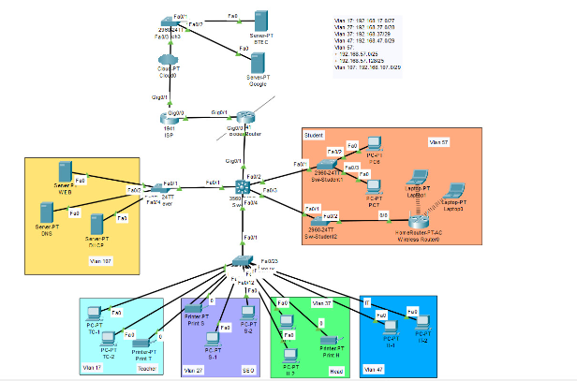

### **Physical design of the network based on user requirement**

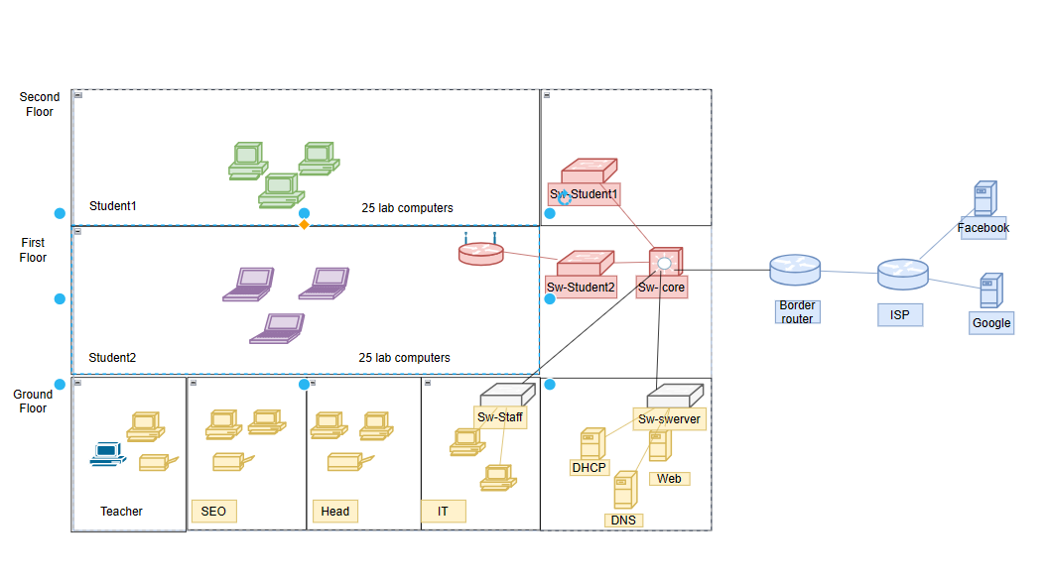

### **Addressing table for the network you design**

|  |  |  |  |  |  |  |
| --- | --- | --- | --- | --- | --- | --- |
| Type of user | Vlan | Network Address | Subnets Mask | Default Gateway | DHCP | DNS |
| Teacher | 17 | 192.168.17.0 | 255.255.255.224 | 192.168.17.1 | 192.168.107.2 | 192.168.107.3 |
| SEO | 27 | 192.168.27.0 | 255.255.255.240 | 192.168.27.1 | 192.168.107.2 | 192.168.107.3 |
| Head | 37 | 192.168.37.0 | 255.255.255.248 | 192.168.37.1 | 192.168.107.2 | 192.168.107.3 |
| IT | 47 | 192.168.47.0 | 255.255.255.248 | 192.168.47.1 | 192.168.107.2 | 192.168.107.3 |
| Student | 57 | 192.168.57.0 | 255.255.255.0 | 192.168.57.1 | 192.168.107.2 | 192.168.107.3 |
| server | 107 | 192.168.107.0 | 255.255.255.248 | 192.168.107.1 | 192.168.107.2 | 192.168.107.3 |

**Explain the subnetmask division:**

Split Subnet Mask brings some benefits as follows:

Easier network management: Dividing the network into smaller subnets makes it easier to manage devices on the network.

Enhance network security: Split subnet mask helps isolate subnets from each other, helping to increase network security.

Optimal performance network: Split network mask helps minimize minimum broadcast, helping to optimize network performance.

## **P6. Design a maintenance schedule to support the networked system.**

### **Network maintenance definition.**

[Network maintenance](https://mglobalservices.com/third-party-maintenance/network-maintenance/) is essentially what you need to do to keep your network up and running smoothly. This definition encompasses some duties such as installing and configuring hardware and software, troubleshooting network problems, monitoring and improving network performance and planning for network growth.

### **Task for the maintenance plan.**

* **Troubleshooting Problems**: Proactively identify and resolve network issues, distinguishing between internal and external causes. Utilize network monitoring tools for early detection.
* **Performing Data and Configuration Backups**: Regularly back up critical data and network configurations, ensuring backups are accessible, verified, and up to date.
* **Device Inventory Management**: Maintain an accurate inventory of all network devices, tracking their status, updates, and lifecycle for efficient maintenance and replacement.
* **Malware/Ransomware Protection**: Implement robust security measures to protect against evolving threats, including regular updates, scans, and configuration adjustments.
* **Power Checks**: Test and maintain UPS systems to ensure uninterrupted power supply, scaling capacity with network growth.
* **Network Documentation**: Document all network components, maintenance activities, and relevant details to facilitate troubleshooting and knowledge transfer.
* **Hardware Checks**: Regularly inspect and maintain network hardware for damage, dust, and connectivity issues to prevent failures.
* **Compliance Checks**: Ensure network operations comply with legal and industry regulations, implementing necessary policies and security standards.
* **Preemptive Repairs**: Conduct scheduled maintenance to address potential issues before they disrupt network operations.
* **Configurations and Upgrades**: Regularly update software and devices to address security vulnerabilities and accommodate organizational changes.
* **Future Network Growth Planning**: Plan for network scalability and expansion based on past performance, recurring issues, and anticipated needs.

### **Maintenance schedule**

|  |  |  |  |  |
| --- | --- | --- | --- | --- |
|  | **Daily** | **Weekly** | **Monthly** | **Yearly** |
| **System Checks: Check for any physical damage or signs of wear on networking equipment.** | **x** |  |  |  |
| **Software Updates** |  | **x** |  |  |
| **Cable and Physical Infrastructure Inspection** |  |  | **x** |  |
| **Data Backup** | **x** |  |  |  |
| **User Account Management.** |  | **x** |  |  |
| **Monitoring Network Performance:** |  |  | **x** |  |
| **Server access reviewed** |  | **x** |  |  |
| **Firewall Rules reviewed** |  | **x** |  |  |
| **Hardware physically cleaned and errors checked** |  |  | **x** |  |
| **System Performance Optimization** |  |  | **x** |  |
| **Security Checks** |  | **x** |  |  |
| **System Error Checking and Handling** |  |  | **x** |  |
| **Security Audits** |  |  |  | **x** |
| **Check and Replace Old Hardware** |  |  |  | **x** |
| **Scaling and Future Planning** |  |  |  | **x** |

## **P7. Implement a networked system based on a prepared design.**



**Here are the specific steps to configure each part of the network:**

* **Sw Core:**
* **Security Configuration:**
* **Set passwords for console and enable mode.**

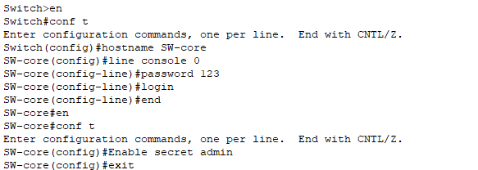

* **VTP Configuration:**
* **Set the domain, mode, and VTP password.**

* **Name the Vlans:**

* **Trunking Configuration:**
* **Configure trunk ports on interfaces f0/1-4.**

* **Sw Server**

* **Sw-Staff:**

* **Sw-Student:**

* **IP address for each VLAN**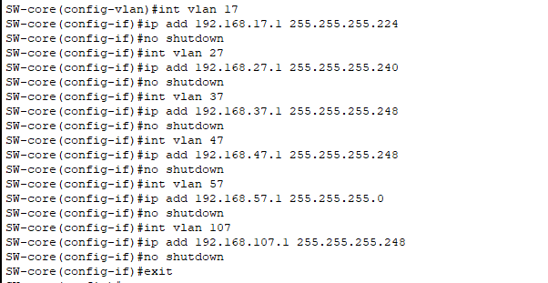
* **relay Configuration:**

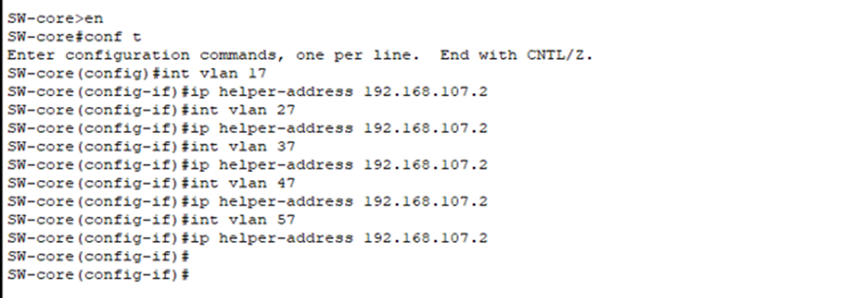

* **Assign VLANs to ports**

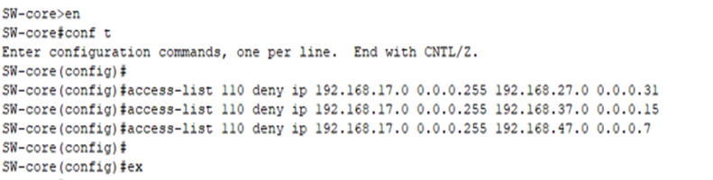

* **Routing Configuration**

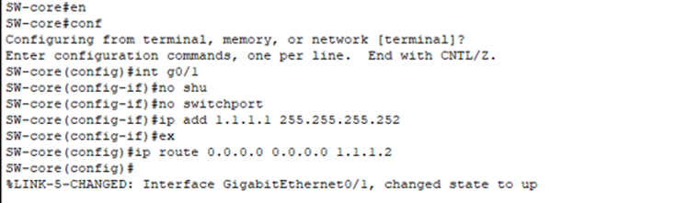

* **Border Router Configuration**

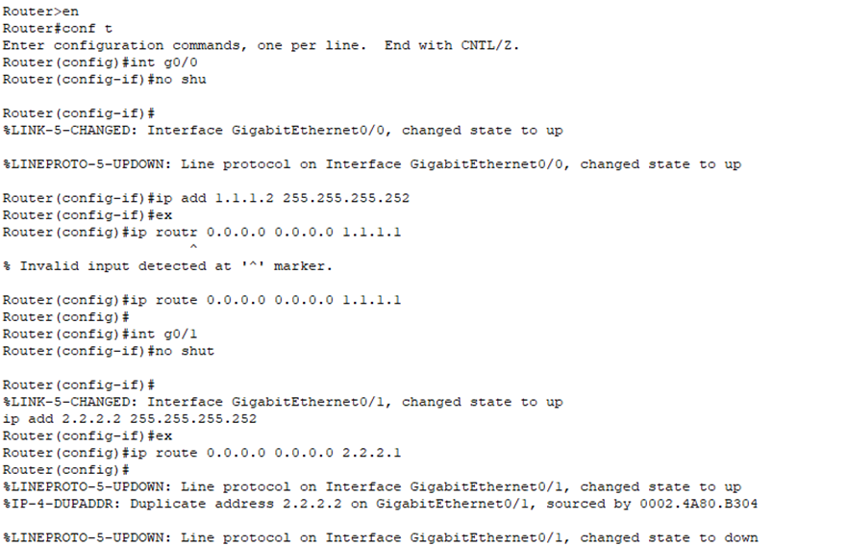

* **ISP Router Configuration:**



* **Internet Router Configuration**

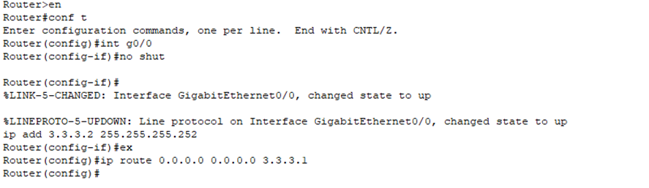

* **Servers DHCP configuration**

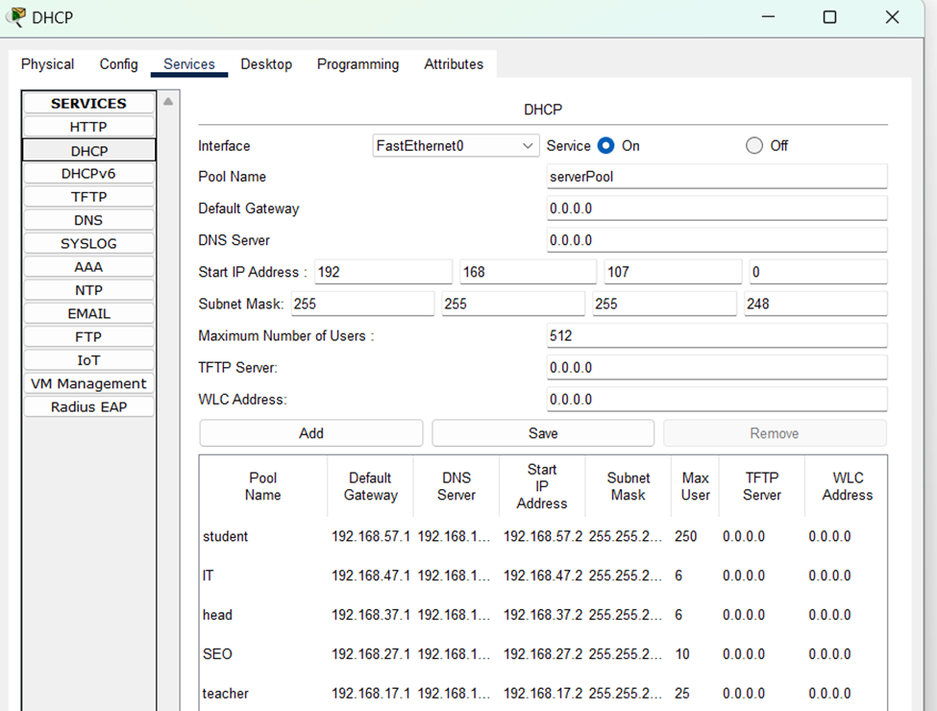

* **Boder router configuration:**

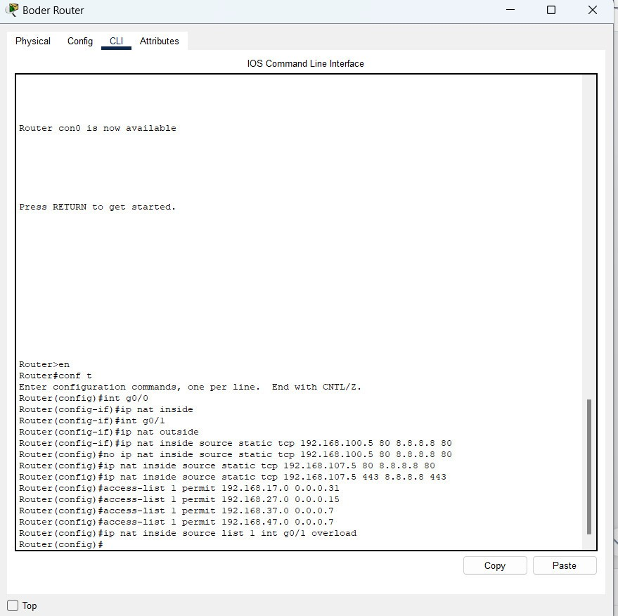

### **P8. Document and analyze test results against expected results**

* **Set passwords for console and enable mode**

**Switch>en**

**Switch#conf t**

**Enter configuration commands, one per line. End with CNTL/Z.**

**Switch(config)#hostname SW-core**

**SW-core(config)#line console 0**

**SW-core(config-line)#password 123**

**SW-core(config-line)#login**

**SW-core(config-line)#ex**

**% Ambiguous command: "ex"**

**SW-core(config-line)#exit**

* **Set the domain, mode, and VTP password.**

**conf t**

**Enter configuration commands, one per line. End with CNTL/Z.**

**SW-core(config)#line vty 0 4**

**SW-core(config-line)#password cissco123**

**SW-core(config-line)#login**

**SW-core(config-line)#^Z**

**SW-core#**

**%SYS-5-CONFIG_I: Configured from console by console**

**conf t**

**Enter configuration commands, one per line. End with CNTL/Z.**

**SW-core(config)#vtp domain btec.vn**

**Changing VTP domain name from NULL to btec.vn**

**SW-core(config)#vtp mode server**

**Device mode already VTP SERVER.**

**SW-core(config)#vtp password btec123**

* **Configure trunk ports on interfaces f0/1-4.**

**Setting device VLAN database password to btec123**

**SW-core(config)#int range f0/1-4**

**SW-core(config-if-range)#sw trunk enc dot1Q**

**SW-core(config-if-range)#sw mode trunk**

**SW-core(config-if-range)#end**

* **Name the Vlans**

**SW-core#en**

**SW-core#conf t**

**Enter configuration commands, one per line. End with CNTL/Z.**

**SW-core(config)#ip routing**

**SW-core(config)#vlan 17**

**SW-core(config-vlan)#name teacher**

**SW-core(config-vlan)#vlan 27**

**SW-core(config-vlan)#name SEO**

**SW-core(config-vlan)#vlan 37**

**SW-core(config-vlan)#name Head**

**SW-core(config-vlan)#vlan 47**

**SW-core(config-vlan)#name IT**

**SW-core(config-vlan)#vlan 57**

**SW-core(config-vlan)#name student**

**SW-core(config-vlan)#vlan 107**

**SW-core(config-vlan)#name server**

**SW-core(config-vlan)#int vlan 17**

* **IP address for each vlan**

SW-core(config-vlan)#int vlan 17

SW-core(config-if)#ip add 192.168.17.1 255.255.255.224

SW-core(config-if)#no shutdown

SW-core(config-if)#int vlan 27

SW-core(config-if)#ip add 192.168.27.1 255.255.255.240

SW-core(config-if)#no shutdown

SW-core(config-if)#int vlan 37

SW-core(config-if)#ip add 192.168.37.1 255.255.255.248

SW-core(config-if)#no shutdown

SW-core(config-if)#int vlan 47

SW-core(config-if)#ip add 192.168.47.1 255.255.255.248

SW-core(config-if)#no shutdown

SW-core(config-if)#int vlan 57

SW-core(config-if)#ip add 192.168.57.1 255.255.255.0

SW-core(config-if)#no shutdown

SW-core(config-if)#int vlan 107

SW-core(config-if)#ip add 192.168.107.1 255.255.255.248

SW-core(config-if)#no shutdown

SW-core(config-if)#exit

* **relay Configuration:**

**SW-core(config)#int vlan 17**

**SW-core(config-if)#ip helper-address 192.168.107.2**

**SW-core(config-if)#int vlan 27**

**SW-core(config-if)#ip helper-address 192.168.107.2**

**SW-core(config-if)#int vlan 37**

**SW-core(config-if)#ip helper-address 192.168.107.2**

**SW-core(config-if)#int vlan 47**

**SW-core(config-if)#ip helper-address 192.168.107.2**

**SW-core(config-if)#int vlan 57**

**SW-core(config-if)#ip helper-address 192.168.107.2**

* **Assign VLANs to ports**

**SW-core(config)#access-list 110 deny ip 192.168.17.0.0.0.0.255 192.168.27.0.0.0.0.31**

**SW-core(config)#access-list 110 deny ip 192.168.17.0.0.0.0.255 192.168.37.0.0.0.0.15**

**SW-core(config)#access-list 110 deny ip 192.168.17.0.0.0.0.255 192.168.47.0.0.0.0.7**

* **Routing Configuration**

**SW-core(config-if)#**int g0/1

**SW-core(config-if)#**ip address 1.1.1.1 255.255.255.252

**SW-core(config-if)#**no shutdown

* **Configuration on Sw-staff**

Switch(config)#hostname SW-Staff

SW-Staff(config)#vtp domain btec.vn

Changing VTP domain name from NULL to btec.vn

SW-Staff(config)#vtp mode client

Setting device to VTP CLIENT mode.

SW-Staff(config)#vtp pass btec123

Setting device VLAN database password to btec123

SW-Staff(config)#int f0/1

SW-Staff(config-if)#sw mode trunk

SW-Staff(config-if)#int range f0/2-10

SW-Staff(config-if-range)#sw mode acc

SW-Staff(config-if-range)#sw acc vlan 17

SW-Staff(config-if-range)#int range f0/11-15

SW-Staff(config-if-range)#sw mode acc

SW-Staff(config-if-range)#sw acc vlan 27

SW-Staff(config-if-range)#int range f0/16-21

SW-Staff(config-if-range)#sw mode acc

SW-Staff(config-if-range)#sw acc vlan 37

SW-Staff(config-if-range)#int range f0/22-24

SW-Staff(config-if-range)#sw mode acc

SW-Staff(config-if-range)#sw acc vlan 47

* **Configuration above Sw-server**

Sw- student 1

Switch>en

Switch#conf t

Enter configuration commands, one per line. End with CNTL/Z.

Switch(config)#hostname SW-student1

SW-student1(config)#vtp domain btec.vn

Domain name already set to btec.vn.

SW-student1(config)#vtp mode client

Setting device to VTP CLIENT mode.

SW-student1(config)#vtp pass btec123

Setting device VLAN database password to btec123

SW-student1(config)#int f0/1

SW-student1(config-if)#sw mode trunk

SW-student1(config-if)#int range f0/2-4

SW-student1(config-if-range)#sw mode acc

SW-student1(config-if-range)#sw acc vlan 107

* ‌ **Configuration on Sw-student**

**Sw- student 1**

**Switch>en**

**Switch#conf t**

**Enter configuration commands, one per line. End with CNTL/Z.**

**Switch(config)#hostname SW-student1**

**SW-student1(config)#vtp domain btec.vn**

**Domain name already set to btec.vn.**

**SW-student1(config)#vtp mode client**

**Setting device to VTP CLIENT mode.**

**SW-student1(config)#vtp pass btec123**

**Setting device VLAN database password to btec123**

**SW-student1(config)#int f0/1**

**SW-student1(config-if)#sw mode trunk**

**SW-student1(config-if)#int range f0/2-10**

**SW-student1(config-if-range)#sw mode acc**

**SW-student1(config-if-range)#sw acc vlan 57**

* **Border Router Configuration:**

**Router(config)#ip route 192.168.0.0 255.255.0.0 10.10.12.1**

**Router(config)#ip route 0.0.0.0 0.0.0.0 1.1.1.2**

**Router(config)#int g0/0**

**Router(config)#ip add 1.1.1.2 255.255.255.252**

**Router(config)#no sht**

* **ISP Router Configuration:**

**Router(config)#int g0/0**

**Router(config-if)#no shut**

**Router(config-if)#ip add 2.2.2.1 255.255.255.252**

**Router(config-if)#ex**

**Router(config)# ip route 0.0.0.0 0.0.0.0 2.2.2.2**

**Router(config)#int g0/1**

**Router(config-if)#no shut**

**Router(config-if)#ex**

**Router(config)# ip route 0.0.0.0 0.0.0.0 3.3.3.2**

* **Internet Router Configuration**

Router(config)#int g0/0

Router(config-if)#no shut

Router(config-if)#ex

Router(config)# ip route 0.0.0.0 0.0.0.0 3.3.3.1

### **‌2. Testting.**

* **Check password**
* 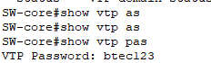

**Check configure VTP**

**-check status**

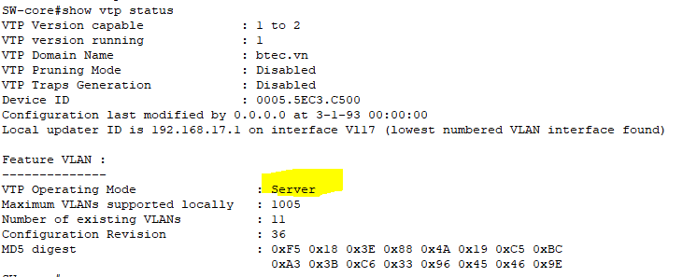

Ping Realtime:

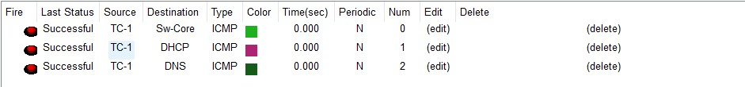

TC-1 computer is dynamically assigned IP by DHCP:

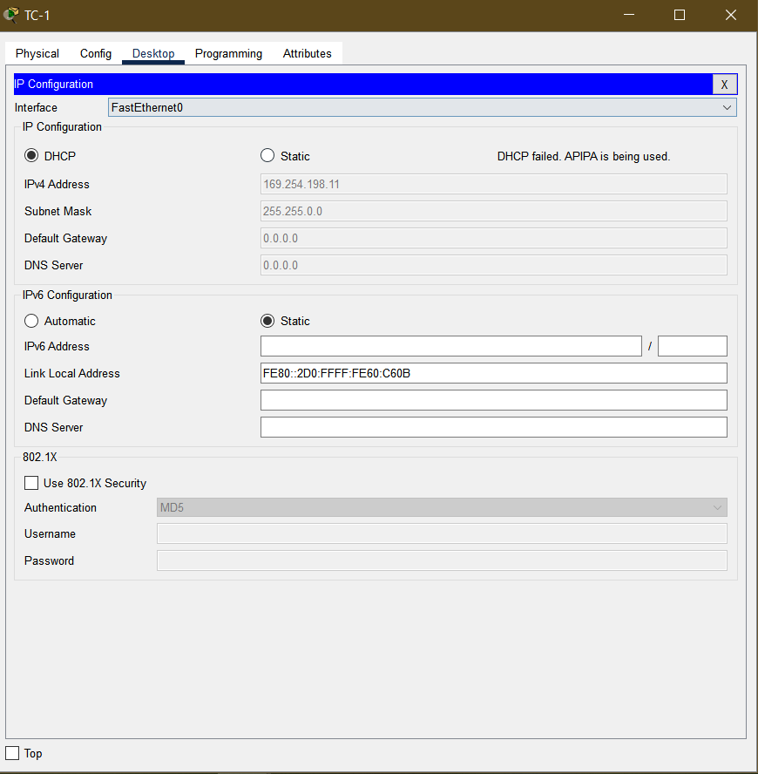

* The network system is managed following by each VLAN, each department uses a separate IP range

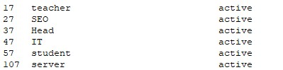

* Computers with different VLANs can ping each other

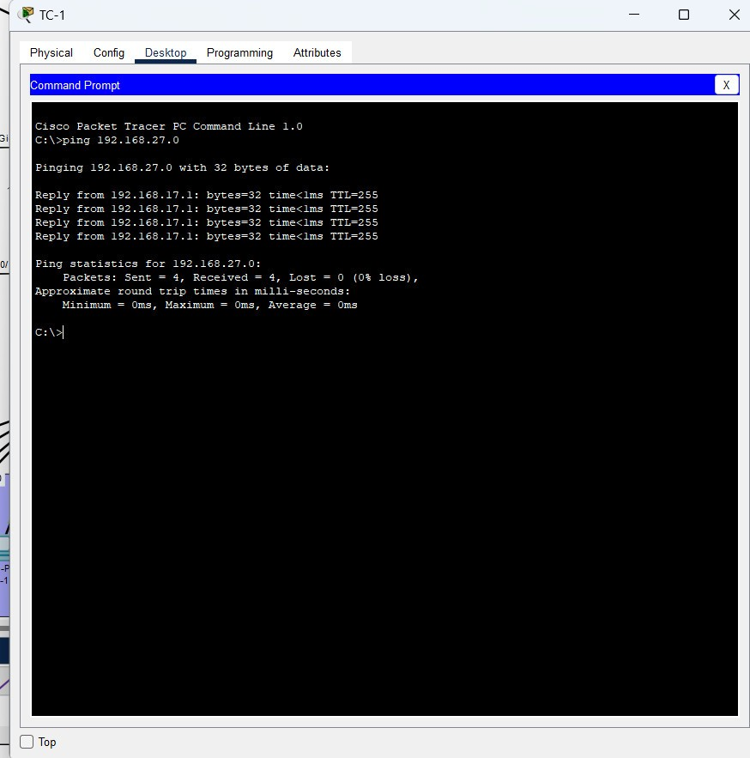

- Computers with different VLANs can ping each other

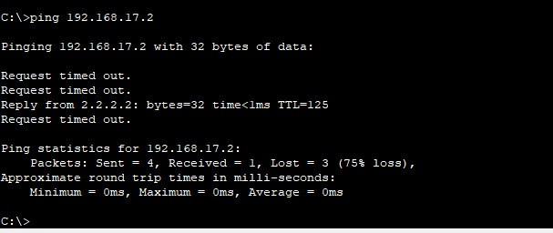

# Reference

Business, A. (2022). *Understanding the Logical and Physical Design of IoT*. [online] Airtel B2B Blog. Available at: <https://www.airtel.in/blog/business/physical-and-logical-design-of-iot/#:~:text=Logical%20design%20is%20a%20high>.

M Global Services. (n.d.). *What is Network Maintenance?* [online] Available at: <https://mglobalservices.com/knowledge-center/blog/what-is-network-maintenance/>.

Velayudhan, D. (2023). *11 Critical Tasks in a Network Maintenance Checklist | ConnectWise*. [online] www.connectwise.com. Available at: <https://www.connectwise.com/blog/rmm/network-maintenance-checklist-tasks>.