**ASSIGNMENT 2 FRONT SHEET**

|  |  |  |  |
| --- | --- | --- | --- |
| **Qualification** | **BTEC Level 5 HND Diploma in Computing** | | |
| **Unit number and title** | Unit 13:Computing Research Project | | |
| **Submission date** |  | **Date Received 1st submission** |  |
| **Re-submission Date** |  | **Date Received 2nd submission** |  |
| **Student Name** | Nguyen Ngoc Son | **Student ID** |  |
| **Class** | IT0501 | **Assessor name** |  |
| **Student declaration**  I certify that the assignment submission is entirely my own work and I fully understand the consequences of plagiarism. I understand that making a false declaration is a form of malpractice. | | | |
|  |  | **Student’s signature** |  |

**Grading grid**

|  |  |  |  |
| --- | --- | --- | --- |
| P6 | P7 | M4 | D3 |
|  |  |  |  |

|  |  |  |
| --- | --- | --- |
| **❒ Summative Feedback: ❒ Resubmission Feedback:** | | |
| **Grade:** | **Assessor Signature:** | **Date:** |
| **Internal Verifier’s Comments:** | | |
| **Signature & Date:** | | |

Table of Contents

**I.** **INTRODUCTION** 4

**II.** **CONTENTS** 4

**P6 Reflect on the effectiveness of research methods applied for meeting objectives of the computing research project** 4

**1.** **Impact of research proposal** 4

**2.** **Impact of Sequential Research Process** 5

**3.** **Research methods used** 6

**4.** **Project plan** 18

**5.** **Literature review** 20

**P7 Consider alternative research methodologies and lessons learnt in view of the outcomes** 20

**1.** **Mistakes during your research process** 20

**2.** **Reflection on the result of the research** 22

**3.** **Alternative research methodologies and improvement in future research** 24

In enhancing the rigor and effectiveness of research endeavors, considering alternative research methodologies and improvements for future research is paramount. One alternative approach is mixed-methods research, which integrates both quantitative and qualitative methodologies to offer a comprehensive understanding of the research topic. This approach allows researchers to triangulate findings, validate results, and explore complex phenomena from multiple perspectives. Longitudinal studies, tracking changes in variables over time, offer another alternative, providing insights into trends, patterns, and causal relationships. Experimental designs, such as randomized controlled trials (RCTs), establish causal relationships and test the effectiveness of interventions or treatments, thereby enhancing internal validity. 24

Additionally, action research involves collaborating with stakeholders to address real-world problems or implement interventions, emphasizing active participation, reflection, and iterative cycles of planning, action, observation, and reflection. Case studies offer an in-depth exploration of specific instances or phenomena within their natural context, providing rich, contextualized insights. Network analysis methodologies enable the study of relationships, interactions, and structures within complex systems or networks, offering insights into the dynamics of social, organizational, or technological networks. Qualitative comparative analysis (QCA) combines qualitative and quantitative techniques to analyze complex causal configurations, identifying necessary and sufficient conditions for outcomes of interest. 24

Improvements for future research include strengthening methodological rigor by addressing potential sources of bias, increasing sample sizes, improving measurement validity and reliability, and employing appropriate statistical techniques. Enhancing transparency and reproducibility involves fully documenting research methods, materials, and procedures, and making data, analysis code, and research protocols openly accessible. Foster collaboration and engagement with diverse stakeholders to ensure research questions, methods, and findings are relevant, meaningful, and impactful. Prioritize ethical considerations throughout the research process, including obtaining informed consent, protecting participant confidentiality, and addressing potential risks or harms. Effectively communicate research findings to diverse audiences and translate them into actionable recommendations or interventions that address real-world challenges. By embracing these alternative methodologies and opportunities for improvement, researchers can advance the quality, relevance, and impact of their research endeavors, contributing to the betterment of society. 24

**4.** **Lessons learned in view of the outcomes** 29

**5.** **Conclusion** 33

**III.** **CONCLUSION** 34

**IV.** **REFERENCES** 35

1. **INTRODUCTION**

In today's digital era, the exponential growth of data presents both unprecedented opportunities and complex challenges. As businesses and organizations strive to unlock the potential of big data for innovation and insights, the environmental impact of data storage has become increasingly significant. Traditional methods of data storage, reliant on energy-intensive infrastructure and finite resources, contribute substantially to carbon emissions, resource depletion, and the generation of electronic waste. In response to these urgent environmental concerns, the exploration of alternative materials in big data storage models has emerged as a pivotal area of focus.

This essay critically examines the pursuit of alternative materials in big data storage, delving into its motivations, outcomes, limitations, and recommendations for future progress. By thoroughly exploring this multifaceted topic, our aim is to unearth valuable insights that can inform sustainable practices, drive technological innovation, and mitigate the environmental impacts associated with data storage.

1. **CONTENTS**

## **P6 Reflect on the effectiveness of research methods applied for meeting objectives of the computing research project**

1. **Impact of research proposal**

* The impact of a research proposal in the field of exploring alternative materials for big data storage models can be significant and far-reaching across various dimensions:

Environmental Impact: One of the primary impacts of such research would be the potential reduction of environmental harm caused by conventional data storage methods. By developing and implementing alternative materials and technologies that are more energy-efficient and less resource-intensive, the carbon footprint and environmental degradation associated with data storage could be minimized.

Technological Advancement: Research in this area has the potential to drive technological innovation. Discovering new materials and methods for data storage could lead to breakthroughs in efficiency, capacity, and reliability, which would benefit not only the environment but also the performance and capabilities of data storage systems.

Economic Implications: The adoption of sustainable practices and technologies in the data storage industry could have significant economic implications. Companies that are able to develop and implement environmentally friendly solutions may gain a competitive edge in the market, attract environmentally conscious consumers, and potentially reduce operational costs associated with energy consumption and waste management.

Policy and Regulation: Research findings and proposals in this area could also influence policy-making and regulation related to data storage and environmental protection. Governments and regulatory bodies may be more inclined to support and enforce policies that encourage the adoption of sustainable practices in the technology sector based on scientific research and evidence.

Global Awareness and Collaboration: By highlighting the environmental impact of data storage and proposing sustainable alternatives, research in this area can raise awareness about the intersection of technology and environmental sustainability. It can also foster collaboration among researchers, industry stakeholders, policymakers, and environmental advocates to address shared challenges and work towards common goals.

Long-Term Sustainability: Ultimately, the impact of research proposals in this field could contribute to the long-term sustainability of digital infrastructure and the planet as a whole. By mitigating the environmental impact of data storage, we can help ensure that future generations have access to the resources they need to thrive in a rapidly evolving digital world.

* In summary, research proposals focused on exploring alternative materials for big data storage models have the potential to drive positive change across environmental, technological, economic, and societal dimensions, ultimately contributing to a more sustainable future.

1. **Impact of Sequential Research Process**

* The impact of a sequential research process in exploring alternative materials for big data storage models can be significant and multifaceted:

Systematic Progression: A sequential research process allows for a systematic and structured approach to exploring different materials and technologies. This ensures that researchers can build upon previous findings, gradually refining their understanding and identifying the most promising alternatives.

Efficient Resource Utilization: By following a sequential research process, resources such as time, funding, and manpower can be utilized more efficiently. Researchers can prioritize the most promising avenues of investigation, reducing the risk of investing resources into less viable options.

Accelerated Innovation: A sequential research process can facilitate the rapid advancement of knowledge and technology in the field of big data storage. By systematically testing and refining different materials and technologies, researchers can accelerate the pace of innovation and bring new solutions to market more quickly.

Identification of Optimal Solutions: Through a sequential research process, researchers can identify the most optimal solutions for big data storage in terms of performance, cost-effectiveness, and environmental impact. By systematically comparing and evaluating different options, researchers can make informed decisions about which materials and technologies are best suited to meet the needs of users and industry stakeholders.

Collaborative Opportunities: Sequential research processes often involve collaboration between researchers, industry partners, and other stakeholders. By working together, different groups can leverage their expertise and resources to accelerate progress and address complex challenges more effectively.

Evidence-Based Decision Making: A sequential research process generates a wealth of data and evidence that can inform decision-making at various levels, from individual research projects to industry-wide initiatives. By basing decisions on empirical evidence rather than conjecture or intuition, stakeholders can have greater confidence in the effectiveness and reliability of proposed solutions.

Long-Term Impact: The impact of a sequential research process extends beyond individual projects or initiatives. By building a solid foundation of knowledge and understanding, researchers can lay the groundwork for continued innovation and progress in the field of big data storage, ensuring a lasting impact on the industry and society as a whole.

1. **Research methods used**
2. **Secondary research**

Secondary research is a research method that uses data that was collected by someone else. In other words, whenever you conduct research using data that already exists, you are conducting secondary research. On the other hand, any type of research that you undertake yourself is called primary research.

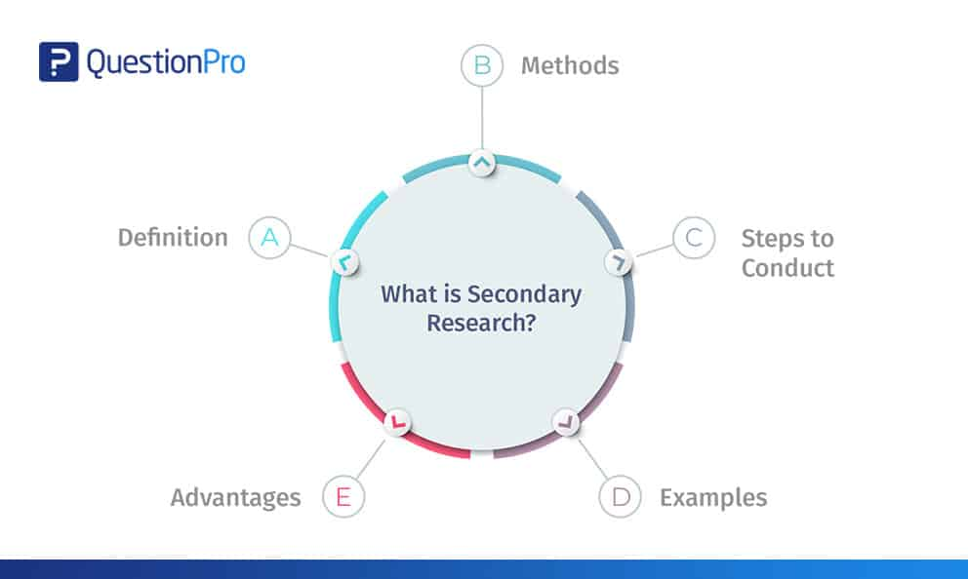

1. **I have learned several things from the Secondary Research**

Through secondary research, I have gained valuable insights into alternative materials for big data storage models. Firstly, I have developed a comprehensive understanding of the current landscape of big data storage technologies and materials, including their strengths, limitations, and emerging trends. Additionally, I have learned about the significant environmental impacts associated with conventional data storage methods, such as energy consumption and electronic waste generation. This knowledge has highlighted the urgent need for more sustainable alternatives.

Moreover, my secondary research has exposed me to innovative technologies and materials being explored as alternatives for big data storage. These include advancements in solid-state drives, optical storage, and novel materials with reduced environmental footprints. Furthermore, I have gained insights into industry trends, market dynamics, and regulatory considerations relevant to sustainable data storage solutions.

By studying best practices and case studies from organizations successfully implementing sustainable data storage solutions, I have identified valuable strategies and approaches for future research and implementation efforts. Overall, the knowledge gained from my secondary research has provided a solid foundation for informed decision-making, guiding further exploration, and driving positive change in the field of big data storage.

1. **Advantages and Disadvantages of Secondary Research**

**Advantages of Secondary research:**

- Secondary data is very easy to source and readily available.

- It is also often free or accessible through your educational institution’s library or network, making it much cheaper to conduct than primary research.

- As you are relying on research that already exists, conducting secondary research is much less time consuming than primary research. Since your timeline is so much shorter, your research can be ready to publish sooner.

- Using data from others allows you to show reproducibility and replicability, bolstering prior research and situating your own work within your field.

**Disadvantages of Secondary research:**

- Ease of access does not signify credibility. It’s important to be aware that secondary research is not always reliable, and can often be out of date. It’s critical to analyze any data you’re thinking of using prior to getting started, using a method like the CRAAP test.

- Secondary research often relies on primary research already conducted. If this original research is biased in any way, those research biases could creep into the secondary results.

1. **Merits**

Secondary research offers several advantages that make it a valuable approach in the research process. Firstly, it is cost-effective since researchers utilize existing data and information, eliminating the need for costly data collection procedures. This aspect is particularly advantageous for researchers with limited budgets. Secondly, secondary research is time-efficient as it allows access to a vast amount of existing data relatively quickly. Researchers can analyze trends and patterns across diverse datasets without the time-consuming process of data collection. Additionally, secondary research provides access to large sample sizes, enhancing the statistical power and generalizability of research findings. Moreover, the validation and corroboration of findings are facilitated through secondary research by comparing them with existing research and data, thereby enhancing the reliability and credibility of results. The broad scope of coverage in secondary research enables researchers to access diverse perspectives and insights from various sources, enriching their understanding of complex issues. Ethical concerns related to participant confidentiality and privacy are minimized in secondary research as researchers often analyze anonymized or aggregated data. Finally, secondary research allows for longitudinal analysis by accessing historical data, enabling researchers to examine trends and changes over time. In conclusion, the advantages of secondary research, including cost-effectiveness, time efficiency, access to existing data, large sample sizes, validation of findings, broad scope of coverage, consideration of ethical concerns, and opportunities for longitudinal analysis, make it an invaluable tool in the research process.

1. **Limitations**

Secondary research, while offering numerous advantages, also presents several limitations that researchers must consider. Firstly, the quality and reliability of secondary data can vary widely depending on the sources and methods used for data collection. This necessitates careful evaluation to ensure the accuracy and validity of findings. Secondly, researchers have limited control over the data collection process in secondary research, potentially leading to biases or limitations in the data, especially if the original data collection methods were not rigorous. Additionally, secondary data may be incomplete or outdated, which can hinder its relevance to research objectives. Furthermore, the lack of contextual information in secondary data may limit researchers' ability to interpret findings accurately. Moreover, researchers must be cautious of bias, as selective data sources or interpretations can skew results. Accessing certain datasets may also be challenging due to restrictions imposed by copyright laws or proprietary concerns. Generalizability concerns may arise due to sample selection bias or differences in data collection methods across studies. Finally, researchers must avoid plagiarism by properly citing and referencing original sources. In conclusion, while secondary research offers valuable insights, researchers must navigate these limitations to ensure the integrity and validity of their findings.

1. **Quantitative Research**

Quantitative research is the process of collecting and analyzing numerical data. It can be used to find patterns and averages, make predictions, test causal relationships, and generalize results to wider populations.

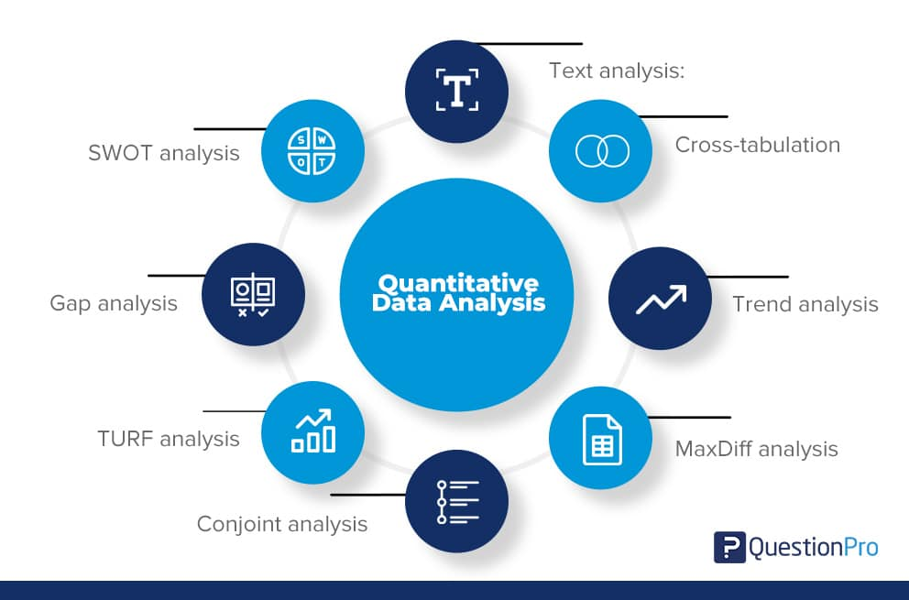

1. **I have learned several things from the Quantitative Research**

Learning about quantitative research has provided me with valuable insights into its structured approach to data collection and analysis. I've come to understand that quantitative research involves formulating clear research questions or hypotheses and using standardized instruments to collect numerical data. This data is then analyzed using statistical techniques to uncover patterns, relationships, and associations between variables. Additionally, I've learned about the importance of large sample sizes to ensure the validity and generalizability of findings, as well as the objective and replicable nature of quantitative research. Understanding common methods such as surveys, experiments, and observational studies, as well as the distinction between cross-sectional and longitudinal designs, has expanded my knowledge of how quantitative research is conducted. Moreover, I've realized the wide-ranging applications of quantitative research across various disciplines, including social sciences, psychology, education, business, and public health. Overall, learning about quantitative research has equipped me with valuable skills for analyzing data, conducting research studies, and making evidence-based decisions in my field of interest.

1. **Advantages and Disadvantages of Quantitative Research**

**Advantages of Quantitative research:**

- Replication:Repeating the study is possible because of standardized data collection protocols and tangible definitions of abstract concepts.

- Direct comparisons of results:The study can be reproduced in other cultural settings, times or with different groups of participants. Results can be compared statistically.

- Large samples:Data from large samples can be processed and analyzed using reliable and consistent procedures through quantitative data analysis.

- Hypothesis testing:Using formalized and established hypothesis testing procedures means that you have to carefully consider and report your research variables, predictions, data collection and testing methods before coming to a conclusion.

**Disadvantages of Quantitative research:**

- Superficiality:Using precise and restrictive operational definitions may inadequately represent complex concepts. For example, the concept of mood may be represented with just a number in quantitative research, but explained with elaboration in qualitative research.

- Narrow focus:Predetermined variables and measurement procedures can mean that you ignore other relevant observations.

- Structural bias:Despite standardized procedures, structural biases can still affect quantitative research. Missing data, imprecise measurements or inappropriate sampling methods are biases that can lead to the wrong conclusions.

- Lack of context:Quantitative research often uses unnatural settings like laboratories or fails to consider historical and cultural contexts that may affect data collection and results.

1. **Merits**

Quantitative research offers numerous merits that render it invaluable in the research process. Its structured approach and reliance on standardized methods promote objectivity and reliability in data collection and interpretation, enhancing the credibility of research findings. Moreover, the ability to collect data from large sample sizes allows for the generalization of findings to broader populations, increasing the external validity of the research. Quantitative research's utilization of statistical techniques enables researchers to identify patterns, trends, and relationships between variables with precision, facilitating evidence-based decision-making. Additionally, its replicability ensures the robustness of findings, as other researchers can verify results using the same procedures and data. Furthermore, quantitative research's quantification of relationships provides precise estimates of effect sizes and probabilities, supporting quantitative predictions and meaningful conclusions. Its efficiency, ease of data analysis, and ability to provide decision-making support across various fields further underscore its significance in generating knowledge and insights. In summary, the merits of quantitative research make it an indispensable tool for researchers seeking to understand complex phenomena and inform evidence-based practices and policies.

1. **Limitations**

Quantitative research, despite its strengths, is not without limitations, which researchers should acknowledge and address. One notable limitation is its tendency to prioritize breadth over depth, potentially resulting in a superficial understanding of complex phenomena. This is compounded by the restrictiveness of standardized instruments, which may not capture the full spectrum of human experiences or behaviors, limiting the data collected. Moreover, quantitative methods struggle to explore intricate constructs such as attitudes or emotions comprehensively, often requiring supplementary qualitative approaches. Additionally, there's a risk of oversimplification, as quantitative research reduces phenomena to numerical data and statistical analyses, potentially neglecting important contextual factors. Unanticipated findings may also be overlooked due to the hypothesis-driven nature of quantitative research. Ethical considerations, such as participant privacy and consent, must be carefully managed, especially in sensitive research areas. Furthermore, sampling limitations and measurement errors can affect the generalizability and validity of findings. In summary, while quantitative research offers valuable insights, researchers must navigate these limitations judiciously to ensure the robustness and applicability of their findings.

1. **Qualitative Research**

Qualitative research involves collecting and analyzing non-numerical data (e.g., text, video, or audio) to understand concepts, opinions, or experiences. It can be used to gather in-depth insights into a problem or generate new ideas for research.

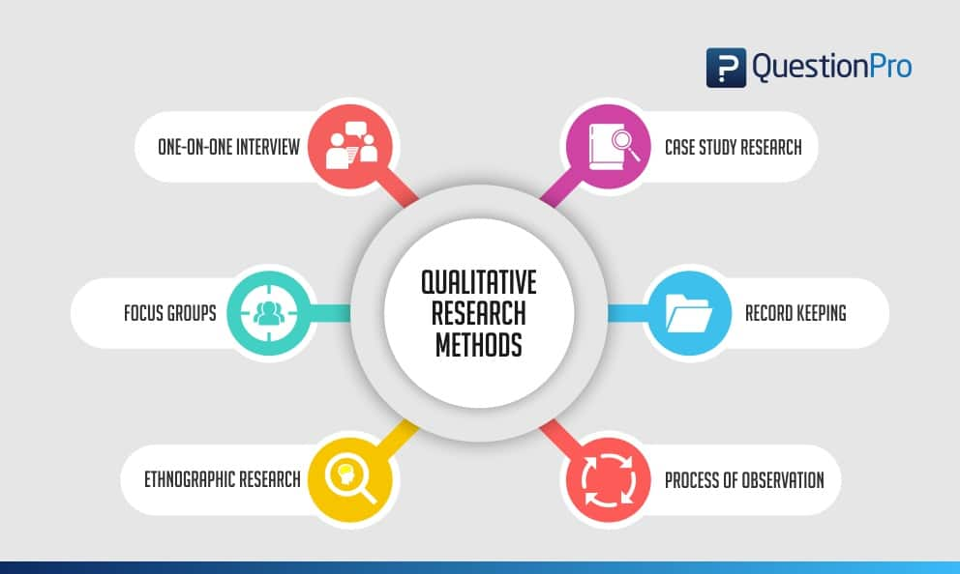

1. **I have learned several things from the Qualitative Research**

It's great to hear that you've gained valuable insights from learning about qualitative research. Here are some key takeaways you may have learned:

Exploratory Nature: Qualitative research emphasizes exploration and understanding of complex phenomena, focusing on in-depth examination rather than statistical analysis.

Data Collection Methods: You may have learned about various data collection methods used in qualitative research, such as interviews, focus groups, participant observation, and document analysis, each offering unique insights into participants' experiences and perspectives.

Non-Numerical Data Analysis: Qualitative research involves the systematic analysis of non-numerical data, such as text, audio recordings, or visual images, using techniques like thematic analysis, content analysis, and narrative analysis.

Contextual Understanding: Qualitative research values understanding phenomena within their natural context, considering social, cultural, and historical factors that shape participants' experiences and perspectives.

Participant Perspectives: Qualitative research prioritizes the perspectives and voices of participants, allowing them to share their lived experiences and insights in their own words, which can lead to a deeper understanding of the phenomenon under study.

Inductive Approach: You may have learned about the inductive approach used in qualitative research, where themes and patterns emerge from the data rather than being imposed by preconceived hypotheses, allowing for flexibility and openness to new insights.

Rich Descriptions: Qualitative research produces rich, detailed descriptions of phenomena, providing contextually rich accounts that capture the depth and complexity of human experiences.

Triangulation and Reflexivity: You may have learned about techniques like triangulation and reflexivity, which enhance the validity and reliability of qualitative research by validating findings through multiple data sources and methods, and by reflecting on researchers' biases and assumptions throughout the research process.

Overall, qualitative research offers a holistic and nuanced understanding of human behavior, experiences, and phenomena, making it a valuable approach for exploring complex social, cultural, and psychological phenomena across various disciplines.

1. **Advantages and Disadvantages of Qualitative Research**

**Advantages of Qualitative research:**

- Flexibility:The data collection and analysis process can be adapted as new ideas or patterns emerge. They are not rigidly decided beforehand.

- Natural settings:Data collection occurs in real-world contexts or in naturalistic ways.

- Meaningful insights:Detailed descriptions of people’s experiences, feelings and perceptions can be used in designing, testing or improving systems or products.

- Generation of new ideas:Open-ended responses mean that researchers can uncover novel problems or opportunities that they wouldn’t have thought of otherwise.

**Disadvantages of Qualitative research:**

- Unreliability:The real-world setting often makes qualitative research unreliable because of uncontrolled factors that affect the data.

- Subjectivity:Due to the researcher’s primary role in analyzing and interpreting data, qualitative research cannot be replicated. The researcher decides what is important and what is irrelevant in data analysis, so interpretations of the same data can vary greatly.

- Limited generalizability:Small samples are often used to gather detailed data about specific contexts. Despite rigorous analysis procedures, it is difficult to draw generalizable conclusions because the data may be biased and unrepresentative of the wider population.

- Labor-intensive:Although software can be used to manage and record large amounts of text, data analysis often has to be checked or performed manually.

1. **Merits**

Certainly, here are the merits or advantages of qualitative research:

In-depth Understanding: Qualitative research allows for a deep understanding of complex phenomena by exploring participants' perspectives, experiences, and behaviors within their natural context. This depth of insight can uncover rich, nuanced meanings and patterns.

Flexibility: Qualitative research methods are flexible and adaptable, enabling researchers to modify their approach based on emerging insights and new developments. This flexibility allows for the exploration of unexpected findings and the adjustment of methods accordingly.

Participant Perspectives: Qualitative research prioritizes the voices and perspectives of participants, enabling them to share their lived experiences and insights in their own words. This participant-centered approach fosters empathy, trust, and rapport between researchers and participants.

Exploratory Nature: Qualitative research is exploratory in nature, allowing researchers to explore new topics, generate hypotheses, and identify novel insights without preconceived notions or rigid frameworks. This exploratory approach can lead to the discovery of new theories or perspectives.

Contextual Understanding: Qualitative research emphasizes understanding phenomena within their natural context, considering social, cultural, and historical factors that shape participants' experiences and perspectives. This contextual understanding provides deeper insights into the complexity of human behavior and social processes.

Rich Data: Qualitative research generates rich, detailed data that capture the complexity and depth of human experiences. Data sources such as interviews, observations, and documents provide a wealth of information that can be analyzed to uncover meaningful insights.

Holistic Approach: Qualitative research takes a holistic approach to studying phenomena, considering multiple perspectives and dimensions. This holistic perspective allows researchers to explore the interconnectedness of factors and understand the complexity of social, cultural, and psychological phenomena.

Validity and Transferability: Qualitative research focuses on ensuring the validity and transferability of findings through rigorous methodological practices such as triangulation, member checking, and thick description. These practices enhance the trustworthiness and applicability of research findings.

Overall, the merits of qualitative research, including its in-depth understanding, flexibility, participant perspectives, exploratory nature, contextual understanding, rich data, holistic approach, and focus on validity and transferability, make it a valuable tool for exploring complex phenomena and generating meaningful insights in various disciplines.

1. **Limitations**

Qualitative research, while valuable, is not without limitations that researchers should consider. One significant limitation is its susceptibility to researcher subjectivity and bias, potentially impacting the reliability and validity of findings. Additionally, qualitative methods can be time-consuming and resource-intensive, requiring substantial investment in data collection and analysis. The small, non-representative samples used in qualitative research may limit the generalizability of findings to broader populations. Interpreting subjective, nuanced data can also be challenging and may lead to multiple interpretations. Ethical considerations, such as participant privacy and informed consent, must be carefully managed, especially when studying sensitive topics. Furthermore, qualitative research may lack replicability due to its focus on unique contexts and perspectives. Overinterpretation of findings and the resource-intensive nature of qualitative research further underscore its limitations. In summary, while qualitative research offers valuable insights, researchers must be aware of its limitations and employ rigorous methodological practices to ensure the validity and reliability of findings.

1. **The relationship between Primary and Secondary Research**

The relationship between primary and secondary research is complementary, as they serve distinct yet interconnected roles in the research process.

Primary Research: This involves collecting original data directly from sources through methods such as surveys, experiments, interviews, or observations. Primary research is conducted to address specific research questions or objectives and generates firsthand data tailored to the researcher's needs. It allows researchers to gather data that is relevant, timely, and specific to their research context. Primary research often serves as the foundation for generating new knowledge, testing hypotheses, or validating existing theories.

Secondary Research: This involves the analysis and interpretation of existing data and information collected by others. Secondary research sources include academic journals, books, government reports, market studies, and databases. Researchers use secondary research to review and synthesize existing literature, gain background knowledge on a topic, identify gaps in the literature, and contextualize their findings within the broader body of research. Secondary research provides valuable insights, context, and support for primary research endeavors.

The relationship between primary and secondary research can be conceptualized as follows:

Informing Primary Research: Secondary research often precedes primary research by providing background information and context for the study. Researchers conduct a thorough review of existing literature to identify gaps, formulate research questions, and design appropriate methodologies for primary data collection.

Supporting Primary Research: Secondary research provides supporting evidence and theoretical frameworks that guide the design, analysis, and interpretation of primary research findings. Researchers draw upon existing literature to contextualize their findings, validate their hypotheses, and compare their results with previous studies.

Supplementing Primary Research: Secondary research supplements primary research by providing additional data and perspectives that enhance the depth and breadth of the study. Researchers may incorporate secondary data sources into their analyses to enrich their findings or triangulate their results with multiple sources of evidence.

Validating Primary Research: Secondary research can serve as a benchmark for evaluating the validity and reliability of primary research findings. Researchers compare their results with existing literature to assess consistency, identify discrepancies, and validate their interpretations.

Overall, primary and secondary research are interconnected components of the research process, with each playing a complementary role in generating knowledge, informing research design, supporting findings, and advancing understanding within a particular field of study. Integrating both primary and secondary research enables researchers to conduct rigorous, comprehensive investigations that contribute to the advancement of knowledge and scholarship.

1. **Project plan**

**Work breakdown:**

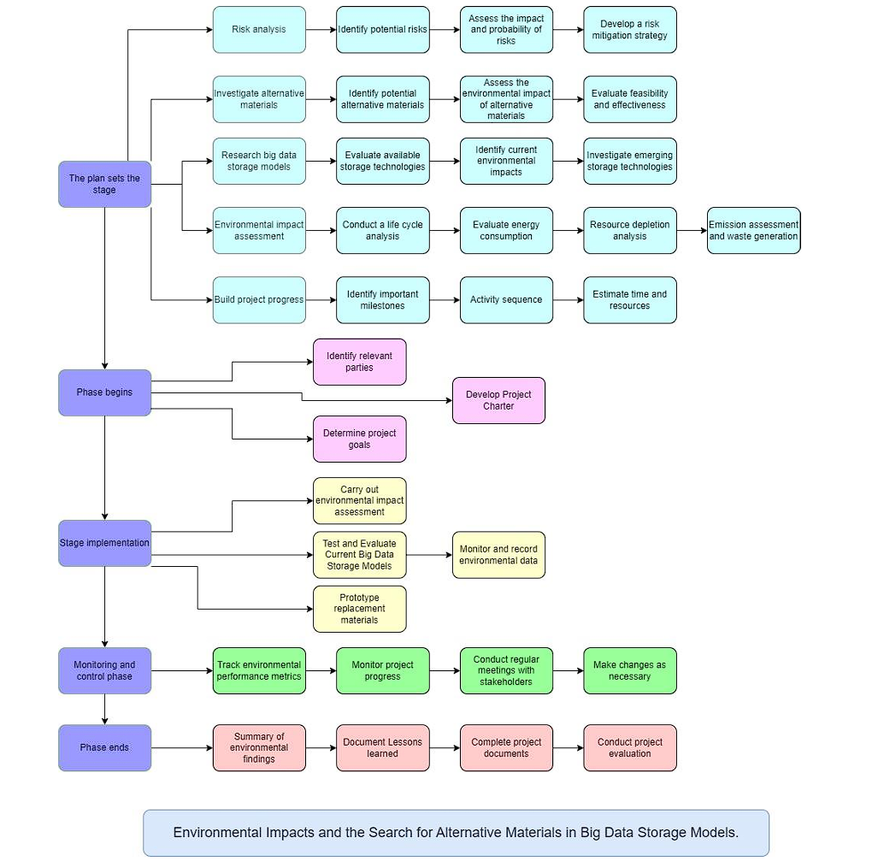

**Time estimates:**

* Planning Phase( 2 Month)

+ Risks Analysis (1 Week)

+ Investigate alternative materials (2 Week)

+ Research big data storage models (2 Week)

+ Environmental impact assessment (2 Week)

+ Build project progress (1 Week)

* Phase begins ( 1 Week )
* Stage implementation ( 1 Week )
* Monitoring and control phase ( 3 Week)
* Phase ends (1 Week)
* Completion report (2 Week)

**Milestone identification:**

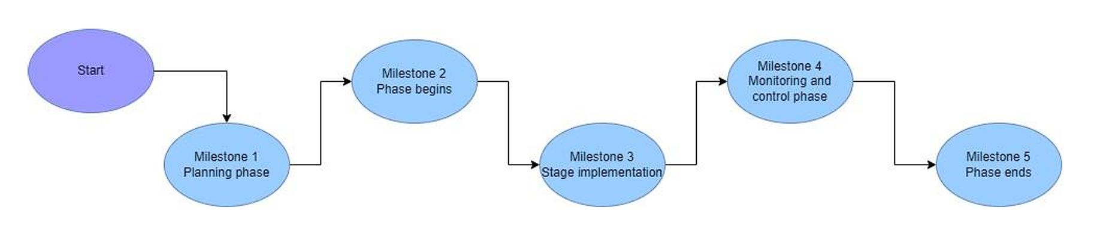

**Scheduling:**

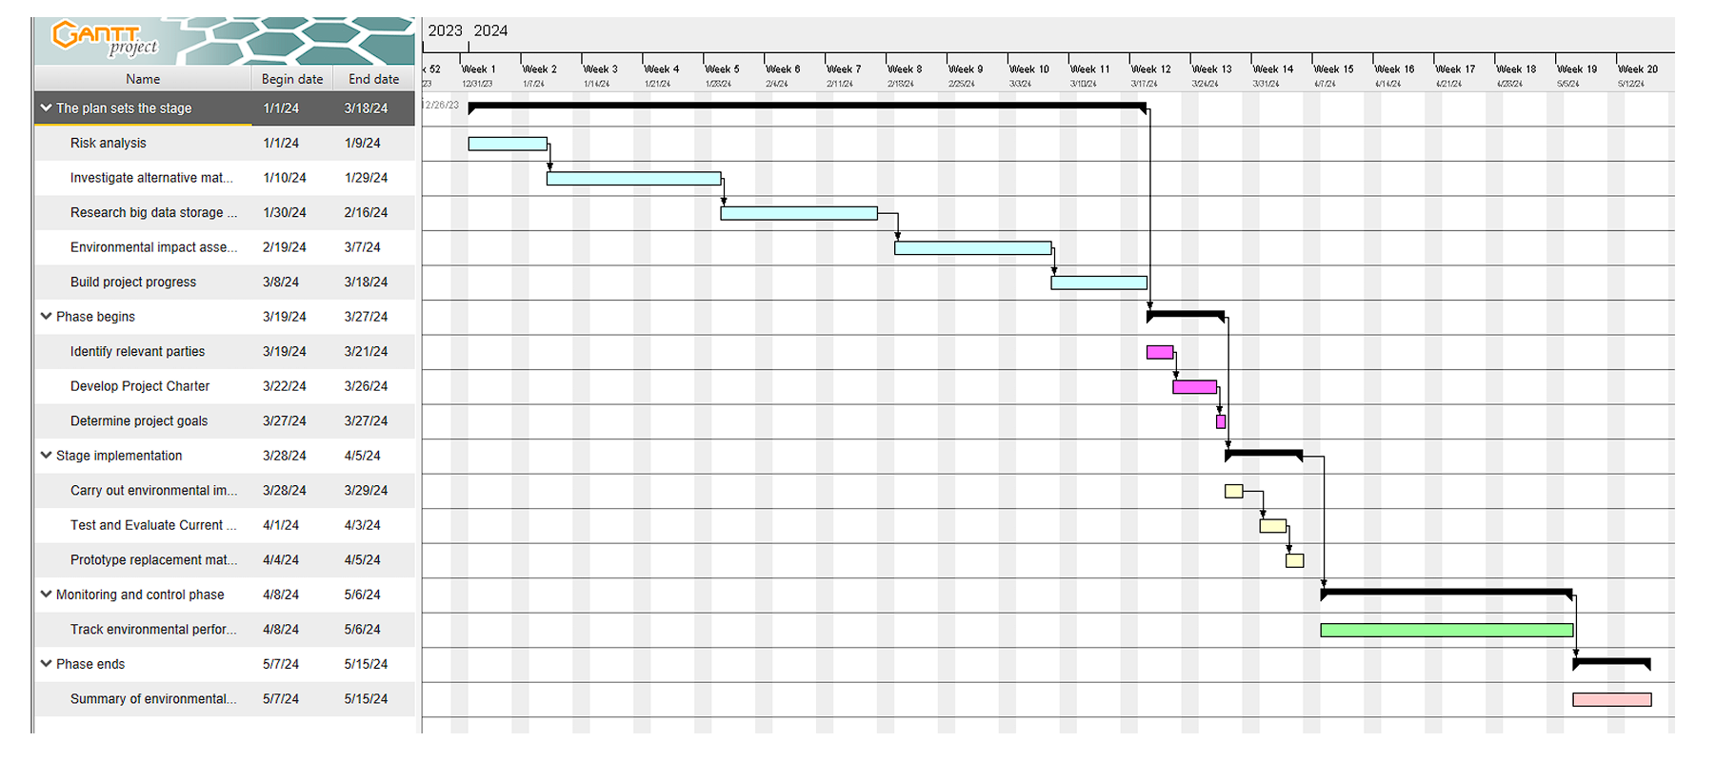

1. **Literature review**

### **5.1 Establishing a Knowledge Base**

The rapid expansion of big data storage technologies has prompted an intensified scrutiny of their environmental ramifications. Researchers have delved into the life cycles of data storage devices to gauge their overall environmental impact. Through analysis of factors such as energy consumption, resource utilization, and electronic waste generation, they strive to pinpoint areas for environmental amelioration within these technologies.

A pivotal focus of research lies in the quest for sustainable materials suitable for data storage devices. Conventional materials, including plastics and metals, wield significant environmental footprints due to their production and disposal methods. By exploring alternative materials that are environmentally benign and renewable, researchers aspire to forge more sustainable pathways for housing and managing vast datasets.

To furnish a comprehensive understanding of the environmental repercussions of big data storage paradigms, researchers have turned to life cycle assessments (LCAs). LCAs entail the thorough evaluation of a product or system's environmental impact across its entire life cycle, spanning from raw material acquisition through manufacturing, utilization, and disposal. This holistic approach enables researchers to pinpoint environmental hotspots and delineate avenues for enhancement.

### **5.2 Identifying Research Gaps**

Despite considerable advancements, substantial lacunae persist in understanding the environmental implications of big data storage models and the exploration of alternative materials. Key areas warranting further investigation include:

**Assessing the Full Life Cycle**: Many extant studies concentrate on discrete phases of data storage device life cycles, overlooking their overarching environmental impact. It is imperative to conduct comprehensive life cycle assessments to garner a holistic understanding of these devices' environmental footprint.

**Modeling the Impact**: Modeling tools serve as invaluable assets in prognosticating the environmental consequences of nascent data storage technologies prior to widespread deployment. By simulating diverse scenarios and prognosticating potential outcomes, researchers can make judicious decisions concerning the sustainability of these technologies.

**Exploring Novel Materials**: Ongoing research into alternative materials for data storage devices prioritizes the quest for materials that are not only ecologically benign but also economically viable and efficacious. Through exploration of novel materials and manufacturing techniques, researchers endeavor to concoct innovative solutions that curtail environmental harm.

## **P7 Consider alternative research methodologies and lessons learnt in view of the outcomes**

1. **Mistakes during your research process**

**Mistakes in Secondary Research:**

* Inadequate Literature Review: One of the primary mistakes during the secondary research phase of our study on "Environmental Impacts and the Search for Alternative Materials in Big Data Storage Models" was the lack of a thorough literature review. We didn't explore a wide range of sources, which led to overlooking important concepts, trends, and solutions relevant to our research.
* Inadequate Literature Review: One of the primary mistakes during the secondary research phase of our study on "Environmental Impacts and the Search for Alternative Materials in Big Data Storage Models" was the lack of a thorough literature review. We didn't explore a wide range of sources, which led to overlooking important concepts, trends, and solutions relevant to our research.
* Narrow Focus on Traditional Sources: Another mistake was our narrow focus on academic literature and industry reports, neglecting alternative sources like community forums, expert blogs, or interdisciplinary research. By limiting ourselves, we missed valuable insights and different perspectives crucial for a comprehensive understanding of the topic.
* Improvement: To avoid these mistakes, researchers should conduct a more comprehensive literature review, exploring diverse sources such as academic journals, industry reports, online forums, and expert blogs to gain varied perspectives and insights.

**Mistakes in Primary Research:**

* Lack of Stakeholder Diversity: In the primary research phase, we made the mistake of not ensuring a diverse representation of stakeholders in our sample population. This limited representation may have biased our conclusions and prevented us from capturing the complexity of the issue.
* Methodological Rigor: Our primary research methods lacked rigor, affecting the reliability and validity of our findings. Flawed survey design, biased data collection procedures, and inadequate sample sizes compromised the quality of our research outcomes.
* Improvement: To enhance the quality of primary research, researchers should prioritize methodological rigor and inclusivity. This involves careful design of research instruments, consultation with experts, pilot testing, and engaging a diverse range of stakeholders.

**. General Challenges:**

* Time Constraints: Limited time hindered various stages of the research process, compromising the thoroughness and quality of our study.
* Resource Limitations: Constraints on funding, personnel, and data access restricted the scope and depth of our research, affecting the comprehensiveness of our findings.
* Data Accessibility and Quality: Challenges related to data accessibility and quality hindered both secondary and primary research, impacting the validity and reliability of our findings.
* Interdisciplinary Nature of the Topic: Integrating insights from different fields posed challenges in synthesizing knowledge and bridging disciplinary boundaries.
* Stakeholder Engagement: Engaging stakeholders proved challenging, potentially overlooking important perspectives and solutions.
* Improvement: Effective project management, realistic timelines, alternative funding sources, collaboration, maximizing data sources, transparent acknowledgment of limitations, interdisciplinary collaboration, and proactive stakeholder engagement are crucial for overcoming these challenges and improving research outcomes

1. **Reflection on the result of the research**

**Enhanced Understanding of Environmental Impacts**

Our research has provided comprehensive insights into the environmental consequences of conventional data storage methods and the potential benefits of alternative materials.

* + **Key findings:**
* **Detailed Assessment:** We evaluated conventional data storage's environmental footprint, including energy consumption, carbon emissions, and resource depletion.
* **Benefits of Alternative Materials:** Alternative materials like biodegradable polymers and renewable energy storage offer promising ways to mitigate environmental challenges.
* **Trade-offs:** Analyzing trade-offs associated with alternative materials helps balance reduced energy consumption with manufacturing emissions and material availability.
* **Sustainable Design Principles:** Incorporating sustainable design principles such as circular economy concepts can optimize the environmental performance of big data storage systems.
* **Socioeconomic Considerations**: Socioeconomic factors like regulatory frameworks and consumer behavior significantly influence data storage's environmental impacts.
* **Future Research Directions:** Identifying areas for future exploration, such as life cycle assessments of alternative materials, guides further research efforts.

### **2.2. Potential of Alternative Materials**

Exploring alternative materials presents opportunities to reduce the environmental impact of big data storage and promote sustainability:

* **Reduced Environmental Footprint:** Alternative materials can minimize energy consumption, carbon emissions, and resource depletion throughout the data storage lifecycle.
* **Increased Resource Efficiency:** Renewable or recycled materials enhance resource efficiency and minimize waste, contributing to sustainable material usage.
* **Innovative Technological Solutions:** Alternative materials drive innovation in sustainable data storage technologies, reducing environmental impact and advancing technological advancement.
* **Alignment with Circular Economy Principles:** Adoption of alternative materials aligns with circular economy principles, promoting resource efficiency and waste reduction.
* **Market Competitiveness and Consumer Demand:** Utilizing environmentally responsible materials enhances brand reputation and market edge in response to growing consumer demand for sustainability.
* **Regulatory Compliance and Risk Mitigation:** Embracing alternative materials ensures compliance with environmental regulations, reducing environmental liability and safeguarding organizational viability.

In conclusion, alternative materials possess significant potential for mitigating environmental impacts and fostering sustainability within big data storage. By incorporating innovative materials, technologies, and approaches, organizations can reduce their environmental footprint, enhance resource efficiency, and seize emerging opportunities in the marketplace.

### **Collaborative Efforts for Sustainability**

Collaboration among stakeholders is crucial for catalyzing sustainability efforts in data storage:

**Key aspects of collaboration:**

* **Knowledge Sharing:** Collaboration enables the exchange of knowledge and best practices, facilitating innovative solutions and progress towards sustainability goals.
* **Partnerships for Innovation:** Collaborative partnerships leverage diverse expertise and resources to address complex environmental issues, driving technological innovation.
* **Influencing Policy:** Collective advocacy for supportive policy frameworks amplifies stakeholders' influence and facilitates systemic change towards environmental sustainability.
* **Capacity Building and Education:** Collaboration promotes capacity building and education initiatives, empowering stakeholders to implement sustainable practices and foster environmental stewardship.

### **2.4. Challenges and Solutions**

Several challenges in achieving sustainability in big data storage require innovative solutions:

**Energy Consumption and Carbon Footprint**

* **Challenge:** Deploying energy-efficient technologies and transitioning to renewable energy sources can mitigate environmental degradation.
* **Solution:** Deploy energy-efficient technologies like server virtualization and liquid cooling. Transition to renewable energy sources to minimize carbon footprint.

**Resource Depletion and Waste Generation**

* **Challenge:** Traditional data storage methods contribute to resource depletion and electronic waste.
* **Solution:** Embrace circular economy principles, design products for longevity and recyclability, and implement responsible e-waste management practices to minimize resource consumption and waste generation.

**Limited Availability of Sustainable Materials**

* **Challenge:** Limited access to sustainable materials suitable for data storage.
* **Solution:** Invest in research and development of alternative materials, collaborate with suppliers to expand the availability of sustainable options, and explore bio-based and recycled materials for data storage applications.

**Regulatory Compliance and Policy Support**

* **Challenge:** Evolving regulatory requirements and policy frameworks related to environmental sustainability.
* **Solution:** Advocate for supportive policy frameworks, engage with regulators and policymakers to shape environmental policies, and implement proactive environmental management systems to ensure compliance with regulations.

### **. Data Center Contributions and Environmental Goals**

Data centers play a significant role in meeting environmental goals and advancing sustainability in data storage. They can contribute through:

**Carbon Neutrality and Renewable Energy Adoption**

* **Goal:** Achieve carbon neutrality and shift to renewable energy sources to minimize carbon emissions.
* **Contribution:** Invest in renewable energy infrastructure, purchase renewable energy credits, and optimize energy efficiency to reduce the environmental impact of data center operations.

**Resource Efficiency and Waste Reduction**

* **Goal:** Improve resource efficiency and reduce waste generation in data center operations.
* **Contribution:** Deploy efficient cooling systems, optimize server utilization, and recycle electronic waste to minimize resource consumption and waste.

**Circular Economy Principles and Material Sustainability**

* **Goal:** Embrace circular economy principles and promote material sustainability in data center design and operations.
* **Contribution:** Design data center infrastructure for modularity and recyclability, source sustainable materials, and implement closed-loop recycling programs to minimize environmental impact.

**Community Engagement and Environmental Stewardship**

* **Goal:** Engage with communities and stakeholders to enhance environmental awareness and support conservation initiatives.
* **Contribution:** Partner with local organizations, participate in environmental education programs, and contribute to community-based environmental projects to nurture environmental stewardship and sustainability.

### **2.6. Sustainability-Driven Innovations**

Innovations drive sustainability in big data storage, including:

**Energy-Efficient Hardware and Infrastructure**

* **Innovation:** Develop energy-efficient servers, storage devices, and cooling systems to reduce energy consumption and environmental impact.
* **Impact:** Lowers operating costs, reduces carbon emissions, and increases overall energy efficiency of data center operations.

**Renewable Energy Integration and Microgrid Solutions**

* **Innovation:** Integrate solar and wind power into data center operations. Implement microgrids for efficient renewable energy management.
* **Impact:** Lessens reliance on fossil fuels, lowers carbon footprint, and strengthens energy resilience.

**Liquid Cooling Technologies**

* **Innovation:** Adopt liquid cooling systems to improve energy efficiency and reduce cooling-related energy consumption in data centers.
* **Impact:** Enhances cooling efficiency, reduces water usage, and enables higher density computing.

**Edge Computing and Decentralized Data Centers**

* **Innovation:** Implement edge computing and decentralized data center architectures to decrease data transfer distances, minimize network latency, and optimize resource utilization.
* **Impact:** Lowers energy consumption, reduces network congestion, and enhances overall system efficiency.

1. **Alternative research methodologies and improvement in future research**

In enhancing the rigor and effectiveness of research endeavors, considering alternative research methodologies and improvements for future research is paramount. One alternative approach is mixed-methods research, which integrates both quantitative and qualitative methodologies to offer a comprehensive understanding of the research topic. This approach allows researchers to triangulate findings, validate results, and explore complex phenomena from multiple perspectives. Longitudinal studies, tracking changes in variables over time, offer another alternative, providing insights into trends, patterns, and causal relationships. Experimental designs, such as randomized controlled trials (RCTs), establish causal relationships and test the effectiveness of interventions or treatments, thereby enhancing internal validity.

Additionally, action research involves collaborating with stakeholders to address real-world problems or implement interventions, emphasizing active participation, reflection, and iterative cycles of planning, action, observation, and reflection. Case studies offer an in-depth exploration of specific instances or phenomena within their natural context, providing rich, contextualized insights. Network analysis methodologies enable the study of relationships, interactions, and structures within complex systems or networks, offering insights into the dynamics of social, organizational, or technological networks. Qualitative comparative analysis (QCA) combines qualitative and quantitative techniques to analyze complex causal configurations, identifying necessary and sufficient conditions for outcomes of interest.

Improvements for future research include strengthening methodological rigor by addressing potential sources of bias, increasing sample sizes, improving measurement validity and reliability, and employing appropriate statistical techniques. Enhancing transparency and reproducibility involves fully documenting research methods, materials, and procedures, and making data, analysis code, and research protocols openly accessible. Foster collaboration and engagement with diverse stakeholders to ensure research questions, methods, and findings are relevant, meaningful, and impactful. Prioritize ethical considerations throughout the research process, including obtaining informed consent, protecting participant confidentiality, and addressing potential risks or harms. Effectively communicate research findings to diverse audiences and translate them into actionable recommendations or interventions that address real-world challenges. By embracing these alternative methodologies and opportunities for improvement, researchers can advance the quality, relevance, and impact of their research endeavors, contributing to the betterment of society.

* 1. **Experimental Research in Environmental Sustainability**

Experimental research in environmental sustainability involves conducting controlled experiments to investigate various factors affecting environmental systems, resource management, conservation efforts, and sustainable development initiatives. This type of research aims to understand the impacts of human activities on the environment, evaluate the effectiveness of interventions, and develop strategies for mitigating environmental degradation and promoting sustainable practices. Here are key components and examples of experimental research in environmental sustainability:

Research Objectives: Experimental research in environmental sustainability typically aims to address specific research questions or hypotheses related to environmental issues, such as the effects of pollution on ecosystems, the efficiency of renewable energy technologies, or the efficacy of conservation measures.

Experimental Design: Researchers design controlled experiments to manipulate independent variables (e.g., pollutant levels, land use practices, energy sources) and measure their effects on dependent variables (e.g., biodiversity, air or water quality, energy efficiency). Experimental designs may include randomized controlled trials, field experiments, laboratory experiments, or simulation models.

Data Collection and Analysis: Experimental research involves collecting quantitative or qualitative data to assess the outcomes of interventions or treatments. Data collection methods may include field measurements, laboratory analyses, surveys, interviews, or observations. Researchers use statistical analysis techniques to analyze data, identify patterns or trends, and determine the significance of results.

Examples of Experimental Research:

Evaluating the effectiveness of wastewater treatment technologies in removing pollutants and improving water quality.

Assessing the impact of deforestation on soil erosion rates and biodiversity in experimental plots.

Investigating the effects of climate change on plant growth and ecosystem dynamics using controlled greenhouse experiments.

Testing the efficiency of renewable energy systems, such as solar panels or wind turbines, in generating electricity under different environmental conditions.

Experimenting with alternative agricultural practices, such as organic farming or agroforestry, to promote soil health, biodiversity, and carbon sequestration.

Ethical Considerations: Researchers conducting experimental research in environmental sustainability must adhere to ethical guidelines to ensure the well-being of human participants, minimize harm to ecosystems, and respect the rights of indigenous communities or stakeholders affected by the research. Ethical considerations may include obtaining informed consent, protecting biodiversity and natural resources, and promoting environmental justice.

Application and Policy Implications: Findings from experimental research in environmental sustainability contribute to evidence-based decision-making, policy development, and environmental management practices. Research outcomes may inform the design of conservation programs, land use policies, renewable energy strategies, pollution control measures, and sustainable development initiatives.

Overall, experimental research plays a crucial role in advancing knowledge, informing interventions, and promoting environmental sustainability by providing empirical evidence of the effectiveness of various approaches and technologies in addressing environmental challenges.

* 1. **Future Research Improvements**

In order to advance environmental sustainability research, several key improvements can be made in future research endeavors. Firstly, fostering interdisciplinary collaboration among researchers from diverse fields such as environmental science, economics, social sciences, and engineering is crucial. This collaboration can provide holistic insights into complex environmental issues and promote innovative solutions. Additionally, implementing long-term monitoring and assessment programs will help track environmental changes over time and evaluate the effectiveness of conservation efforts.

Furthermore, community engagement and participatory research approaches should be emphasized to involve local communities and stakeholders in research processes, ensuring the relevance and sustainability of research outcomes. Embracing technological innovations and methodological advancements, such as remote sensing and modeling approaches, can enhance the efficiency and accuracy of environmental research.

Integrating traditional ecological knowledge (TEK) and indigenous knowledge systems into research practices is essential for promoting cultural diversity, resilience, and sustainability. Moreover, conducting policy-relevant research and translating findings into actionable recommendations can inform evidence-based policymaking and governance mechanisms.

Investing in capacity building and education initiatives to train the next generation of environmental researchers and practitioners is vital. These efforts should also prioritize ethical considerations, social justice, and equity to ensure that research respects the rights and values of all stakeholders and addresses environmental injustices. Overall, by embracing these future research improvements, the environmental research community can contribute significantly to advancing knowledge and fostering sustainability in a rapidly changing world.

* 1. **Case studies**

Case studies serve as a powerful research method for delving deeply into complex phenomena within their real-life context. By providing a detailed description of specific individuals, groups, organizations, events, or situations, case studies offer researchers a comprehensive understanding of the intricacies involved. This methodological approach emphasizes a holistic perspective, considering various dimensions such as social, cultural, economic, political, and environmental factors.

One of the key strengths of case studies lies in their contextual understanding, which takes into account the unique circumstances surrounding the case being examined. Through exploratory and explanatory analyses, researchers can both uncover new insights and validate existing theories. This process involves an in-depth examination of qualitative data collected through methods like interviews, observations, and document analysis.

To ensure the validity and reliability of findings, case studies often employ triangulation, which involves cross-referencing data from multiple sources and perspectives. While case studies may lack generalizability due to their focus on a single case or small sample size, they offer transferability, where findings can be applied to similar contexts or cases.

Ethical considerations are paramount in case study research, with researchers prioritizing participant consent, confidentiality, and privacy throughout the research process. By adhering to ethical guidelines and principles, researchers uphold the well-being and rights of participants.

Overall, case studies provide researchers with a flexible, in-depth, and contextually rich approach to investigating complex phenomena, contributing valuable insights to theory-building and practical applications across various disciplines.

* + 1. **Improvement in Future case studies**

Improving future case studies involves implementing several key strategies to enhance their quality, rigor, and relevance. Firstly, it's imperative to establish clear research objectives and hypotheses to guide the case study investigation effectively. These objectives should be well-defined, specific, and aligned with the overarching research goals.

Methodological rigor plays a crucial role in ensuring the validity and reliability of case study findings. Researchers should develop systematic approaches for data collection, analysis, and interpretation. Detailed protocols should be established for conducting interviews, observations, and document analysis, ensuring consistency and minimizing bias throughout the research process.

Careful attention should be given to sample selection to ensure it reflects the diversity and complexity of the phenomenon under study. Researchers should consider selecting cases that offer rich insights and perspectives, ensuring that the chosen cases are representative and relevant to the research objectives.

Triangulation of data from multiple sources and methods is essential to corroborate findings and enhance the credibility of the case study. By integrating data from interviews, observations, documents, and other relevant sources, researchers can provide a comprehensive understanding of the case.

Longitudinal case studies offer valuable insights into the evolution of phenomena over time. Researchers should consider adopting a longitudinal perspective to track changes, capture dynamic processes, and assess the effectiveness of interventions or policies.

A mixed-methods approach, combining qualitative and quantitative methods, allows researchers to leverage the strengths of both approaches. By integrating diverse methods, researchers can deepen their understanding and provide a more robust analysis of the case.

Theory-building is an integral aspect of case study research. Researchers should identify patterns, mechanisms, and relationships within the data, grounding their findings in existing theoretical frameworks or developing new theories based on empirical evidence.

Ethical considerations should be prioritized throughout the research process. Researchers must obtain informed consent, protect participant confidentiality, and minimize harm to ensure the ethical conduct of the study.

Enhancing the transferability of findings involves providing detailed descriptions of the case context and research methods. Researchers should articulate how findings may be applicable to other contexts or cases, enhancing the generalizability of the study.

Knowledge translation is essential for communicating findings to relevant stakeholders, policymakers, and practitioners. Researchers should translate their findings into actionable recommendations and strategies for addressing real-world challenges effectively.

Finally, reflection and iteration are critical for continuous improvement. Researchers should reflect on the research process and outcomes, identifying strengths, limitations, and areas for improvement. By iteratively refining research methodologies based on lessons learned, future case studies can enhance their methodological rigor, theoretical contributions, and practical relevance, ultimately advancing knowledge and informing decision-making in various fields.

1. **Lessons learned in view of the outcomes**

Reflecting on the outcomes of a research study yields valuable lessons that inform future research endeavors. Methodological considerations are paramount, evaluating strengths and limitations to refine approaches in subsequent studies. Data quality and reliability assessments provide insights into potential biases or errors, prompting improvements for future data collection and analysis.

Validity of findings is crucial; acknowledging limitations and identifying sources of bias ensures accurate representation of the phenomenon. Assessing contributions to knowledge highlights novel insights and theoretical advancements, guiding future research directions. Identifying practical implications facilitates the translation of findings into actionable recommendations for real-world applications.

Ethical considerations, including participant privacy and informed consent, demand reflection to uphold ethical standards rigorously. Personal and professional growth is integral; reflecting on acquired skills and insights fosters continuous development as a researcher.

In summary, reflecting on research outcomes enhances methodological rigor, validity, and ethical integrity while fostering personal and professional growth, ultimately contributing to the advancement of knowledge in the field.

1. **Achieved result**

Reflecting on the achieved result of a research endeavor is essential for gaining valuable insights and charting future directions. Firstly, it's crucial to celebrate accomplishments, such as publications, presentations, or recognition, as they signify tangible contributions to the field. Acknowledging these achievements reinforces motivation and affirms the significance of the research.

Assessing the contributions to knowledge is paramount. Reflect on how the research has filled gaps, challenged existing theories, or generated new insights. Understanding the research's impact on advancing the field provides clarity on its relevance and importance.

Consider the practical implications of the research findings. Evaluate how they have influenced policies, practices, or solutions to real-world challenges. Identifying the concrete benefits or changes resulting from the research underscores its practical relevance and societal impact.

Lessons learned from the research process offer valuable insights for improvement. Reflect on challenges faced, methodologies employed, and analytical approaches used. Identifying areas for enhancement in future research endeavors ensures continuous growth and refinement.

Exploring future directions for research builds on the achieved result. Identify unanswered questions, emerging trends, or opportunities for further exploration. By charting future research trajectories, researchers can sustain momentum and remain at the forefront of their field.

Reflecting on personal and professional growth is integral. Consider the skills acquired, knowledge gained, and experiences garnered throughout the research project. Recognizing areas for further development ensures ongoing growth and career advancement.

Expressing gratitude to collaborators, mentors, and supporters acknowledges their invaluable contributions to the research project. Recognizing their guidance, support, and encouragement reinforces the importance of collaboration and teamwork in achieving research goals.

In summary, reflecting on the achieved result encompasses celebrating accomplishments, assessing contributions to knowledge, evaluating practical implications, learning from challenges, exploring future directions, fostering personal growth, and expressing gratitude. This comprehensive reflection informs future research endeavors and underscores the significance of the research in advancing knowledge and addressing societal challenges.

1. **Lessons learned from the outcomes**

The pursuit of alternative materials in big data storage models has yielded valuable lessons that underscore the importance of sustainability, innovation, collaboration, regulatory support, consumer awareness, long-term thinking, and continuous improvement.

Firstly, it's evident that innovation serves as a catalyst for progress in addressing environmental challenges associated with data storage. The exploration of alternative materials has not only fostered the development of more sustainable solutions but also propelled technological advancements within the industry.

Secondly, collaboration among various stakeholders has proven essential for achieving successful outcomes. By bringing together industry players, researchers, policymakers, and environmental advocates, collaborative efforts enable the sharing of knowledge, resources, and expertise, leading to more effective and holistic solutions.

Thirdly, companies that prioritize sustainability gain a competitive advantage. Sustainable practices not only reduce environmental impact but also enhance brand reputation, attract environmentally conscious consumers, and offer long-term cost savings.

Moreover, regulatory support plays a crucial role in driving the adoption of sustainable practices. Government policies and regulations incentivize businesses to invest in green technologies and practices, creating a conducive environment for sustainable innovation.

Additionally, consumer awareness influences purchasing decisions and drives demand for greener alternatives. Companies that transparently communicate their sustainability efforts are more likely to attract and retain environmentally conscious customers.

Furthermore, achieving sustainability goals requires long-term thinking and commitment. While initial investments in sustainable practices may incur higher costs, they yield significant benefits in terms of environmental stewardship, cost savings, and resilience to regulatory changes.

Finally, continuous improvement is necessary to sustain progress. As technology and environmental landscapes evolve, companies must continually reassess their practices, invest in research and development, and seek out new opportunities for innovation and improvement.

In conclusion, the outcomes of the search for alternative materials in big data storage models provide valuable insights that can guide future efforts toward building more sustainable and resilient data storage systems. By embracing these lessons, stakeholders can work together to drive innovation, advance sustainability goals, and create positive environmental impact.

1. **Evalution of the results**

The evaluation of the results stemming from the pursuit of alternative materials in big data storage models underscores several significant achievements and ongoing challenges. Primarily, these endeavors have demonstrated promising signs of reducing the environmental impact associated with data storage, notably through decreased energy consumption, minimized resource depletion, and mitigated e-waste generation. Moreover, the exploration of alternative materials has spurred notable technological advancements, introducing promising solutions like DNA storage and memristors that offer greater efficiency and environmental friendliness.

However, the widespread adoption of these alternatives faces various hurdles, including cost considerations, technological feasibility, and compatibility issues with existing infrastructure. While regulatory support has been instrumental in driving sustainable practices, the effectiveness of regulations in promoting the use of alternative materials remains variable. Nevertheless, consumer awareness and demand for greener products have increased, presenting opportunities for companies that prioritize sustainability.

Moving forward, it's essential to assess the long-term viability and scalability of alternative materials, considering factors such as supply chain resilience and lifecycle analysis. Continuous research, innovation, and collaboration will be critical in addressing emerging challenges and refining existing solutions to advance sustainable practices in big data storage models. Overall, while significant progress has been made, ongoing efforts are necessary to overcome remaining obstacles and further enhance the sustainability and resilience of data storage systems.

1. **Key takeaways**

The pursuit of alternative materials in big data storage models has yielded significant takeaways for the industry. Firstly, efforts to explore these materials have shown promise in reducing the environmental impact associated with data storage, including decreased energy consumption and minimized resource depletion. This underscores the importance of prioritizing sustainability in technological innovation.

Moreover, the exploration of alternative materials has driven technological advancement in the field of data storage, leading to the development of more efficient and environmentally friendly solutions such as DNA storage and memristors. However, the widespread adoption of these materials may face challenges such as cost considerations and compatibility issues with existing infrastructure.

Regulatory support has played a crucial role in driving the adoption of sustainable practices in the tech industry, but the effectiveness of regulations in promoting alternative materials varies. Increasing consumer awareness of environmental issues presents opportunities for companies that prioritize sustainability, as consumer demand for greener products continues to rise.

Moving forward, it is essential to carefully assess the long-term viability and scalability of alternative materials, considering factors such as supply chain resilience and lifecycle analysis. Continuous research, innovation, and collaboration will be crucial to addressing emerging challenges and refining existing solutions, advancing sustainable practices in big data storage models.

In summary, the pursuit of alternative materials highlights the importance of sustainability, technological innovation, regulatory support, consumer awareness, and continuous improvement in driving positive change in the industry.

1. **Conclusion**
2. **Limitations and Recommendations for Future work**

In the search for alternatives to the big data storage paradigm, there have been remarkable results and at the same time, challenges have been faced that need to be overcome to deliver the work of the future.

One of the most notable results is the reduction of environmental impact through the discovery of alternative materials. This effort has led to a reduction in energy consumption and loss of electronics quality, while also promoting the development of more data efficient and environmentally friendly storage solutions such as DNA storage and memristors.

However, these positive results also face challenges. Cost is one of the main factors, with the development of alternative materials potentially difficult due to high costs during development and declaration. There is also a need to consider the practicality and applicability of new technologies, especially when facing issues of compatibility and standards.

To achieve future progress, continued investment in research and development is needed, with appropriate support between researchers, businesses and government agencies. There is a need to develop policy and support the definition of development, creating incentives for the use of environmentally friendly materials and robust data storage methods. At the same time, train and develop human resources with the necessary knowledge and skills to develop, exploit and manage new technologies and materials.

1. **Reflection**

Reflecting on the pursuit of alternative materials in big data storage models reveals the dynamic nature of technological innovation and sustainability efforts. This endeavor has not only led to significant advancements but also underscored the complexities and challenges inherent in transitioning towards more sustainable practices.

One key reflection is the importance of interdisciplinary collaboration. Addressing environmental challenges and driving innovation in data storage requires input from diverse fields, including engineering, materials science, environmental science, policy, and business. Collaboration enables the sharing of knowledge, resources, and perspectives, fostering more comprehensive and effective solutions.

Moreover, the pursuit of alternative materials highlights the need for a holistic approach to sustainability. While technological advancements are crucial, they must be complemented by supportive policies, consumer awareness, and industry practices to realize meaningful environmental benefits. Sustainability initiatives should consider the entire lifecycle of data storage systems, from raw material extraction to end-of-life disposal, to ensure a net positive impact on the environment.

Additionally, the journey towards sustainable data storage emphasizes the iterative nature of progress. Challenges such as cost constraints, technological limitations, and regulatory complexities may require continuous adaptation and refinement of strategies over time. Flexibility, resilience, and a willingness to learn from both successes and failures are essential for navigating the evolving landscape of sustainability in technology.

Overall, the pursuit of alternative materials in big data storage models serves as a testament to the power of innovation, collaboration, and perseverance in addressing pressing environmental issues. By reflecting on past achievements and remaining open to future possibilities, stakeholders can continue to drive positive change towards a more sustainable and responsible approach to data storage.

1. **CONCLUSION**

In conclusion, the quest for alternative materials in big data storage models represents a crucial step towards addressing the environmental challenges associated with data storage. Through innovative research and collaborative efforts, significant progress has been made in reducing energy consumption, minimizing resource depletion, and mitigating electronic waste. However, challenges such as cost constraints, technological limitations, and regulatory complexities persist, highlighting the need for continued dedication and adaptation.

Looking ahead, it is imperative that stakeholders remain committed to sustainability and innovation in data storage practices. By investing in research and development, fostering interdisciplinary collaboration, and advocating for supportive policies, we can further advance the adoption of alternative materials and sustainable approaches in big data storage.

Ultimately, the pursuit of alternative materials not only promotes environmental stewardship but also fosters technological advancement and economic resilience. By embracing this holistic approach, we can create a more sustainable and responsible future for data storage, ensuring that the benefits of big data are realized without compromising the well-being of our planet.

1. **REFERENCES**

George, T. (2024) *Primary research: Definition, types, & examples*, *Scribbr*. Available at: <https://www.scribbr.com/methodology/primary-research/> (Accessed: 08 March 2024).

Nasrudin, A. (2022) *Primary research: Methods, advantages, and disadvantages*, *Penpoin.* Available at: <https://penpoin.com/primary-research> / (Accessed: 08 March 2024).

George, T. (2024b) *What is secondary research?: Definition, types, & examples*, *Scribbr*.Available at: <https://www.scribbr.com/methodology/secondary-research/> (Accessed: 08 March 2024).

Bhandari, P. (2023) *What is qualitative research?: Methods & examples*, *Scribbr*. Available at: <https://www.scribbr.com/methodology/qualitative-research/> (Accessed: 08 March 2024).

Bhandari, P. (2023b) *What is quantitative research?: Definition, uses & methods*, *Scribbr*. Available at: <https://www.scribbr.com/methodology/quantitative-research/> (Accessed: 08 March 2024).

Streefkerk, R. (2023) *Qualitative vs. quantitative research: Differences, examples & methods*, *Scribbr*. Available at: <https://www.scribbr.com/methodology/qualitative-quantitative-research/> (Accessed: 08 March 2024).