 

ASSIGNMENT 2 FRONT SHEET

|  |  |  |  |
| --- | --- | --- | --- |
| **Qualification** | **TEC Level 5 HND Diploma in Computing** | | |
| **Unit number and title** | **Unit 2: Networking** | | |
| **Submission date** |  | **Date Received 1st submission** |  |
| **Re-submission Date** |  | **Date Received 2nd submission** |  |
| **Student Name** | Pham Xuan Hai | **Student ID** | BH00132 |
| **Class** | SE07101 | **Assessor name** | Nguyen Hong Hanh |
| **Student declaration**  I certify that the assignment submission is entirely my own work and I fully understand the consequences of plagiarism. I understand that making a false declaration is a form of malpractice. | | | |
|  | | **Student’s signature** | hai |

# Grading grid

|  |  |  |  |  |  |  |
| --- | --- | --- | --- | --- | --- | --- |
| P5 | P6 | P7 | P8 | M3 | M4 | D2 |
|  |  |  |  |  |  |  |

Page | 1

|  |  |  |
| --- | --- | --- |
| * **Summative Feedback:**  **Resubmission Feedback:** | | |
| **Grade:** | **Assessor Signature:** | **Date:** |
| **Internal Verifier’s Comments:** | | |
| **Signature & Date:** | | |

# Table of Contents

1. Introduction 5
2. Content 5

P5. Design a networked system to meet a given specification 5

* 1. The difference between logical and physical design 5
  2. The USER Requirement for the design 5
  3. Logical design of the network based on user requirement 6
  4. Physical design of the network based on user requirement 6
  5. Explain the subnetmask division 7

P6. Design a maintenance schedule to support the networked system. 7

1. Network maintenance definition 7
2. Task for the maintenance plan 8
3. Maintenance schedule 8

P7. Implement a networked system based on a prepared design 10

1. Sw Core 10
2. Sw-Server 11
3. Sw-Staff 12
4. Sw-Student: 12
5. Border Router Configuration 15
6. ISP Router Configuration 16
7. Internet Router Configuration 16
8. Servers DHCP configuration 17
9. NAT and PAT image on Router Border 18
10. Wireless Router Configuration 19

P8. Document and analyze test results against expected results 20

1. Documentation 20
2. Testing 22
3. Conclusion 29
4. Reference 29
5. . Links Drive……………………………………………………………………………………………………………………………………………….29

**Table of figure**

Figure 1:Logical design 6

Figure 2:Physical design 6

Figure 3:Logical design 10

Figure 4:Set passwords for console and enable mode 10

Figure 5:Set the domain, mode, and VTP password 11

Figure 6:Name the Vlans 11

Figure 7:Configure trunk ports on interfaces f0/1-4 11

Figure 8:Sw-Server 12

Figure 9: Sw-Staff 12

Figure 10: Sw-Student 13

Figure 11:IP address for each VLAN 13

Figure 12:Configuring IP helper addresses on VLAN 14

Figure 13:Configuring an access control list 14

Figure 14:Configure routing on sw-core 14

Figure 15:Border Router Configuration 15

Figure 16:ISP Router Configuration 16

Figure 17:Internet Router Configuration 16

Figure 18:Servers DHCP configuration 17

Figure 19:NAT and PAT image on Router Border 18

Figure 20:Setup Wireless Router 19

Figure 21:Check password 22

Figure 22:Check configure VTP and check status 22

Figure 23:Check Vlan 22

Figure 24:Check Trunking 23

Figure 25:Check configure VTP and check status of Sw- server 23

Figure 26:Check configure VTP and check status of Sw- staff 24

Figure 27:Check configure VTP and check status of Sw- student 24

Figure 28:Check services DHCP 25

Figure 29:TC-1 computer is dynamically assigned IP by DHCP 26

Figure 30:Ping Realtime 26

Figure 31:Check ping after configuring an access control list 27

Figure 32:Check ping from outside to inside after configuring NAT 27

# Introduction

Nguyen Networking Limited is embarking on a pivotal networking endeavor tailored for a local educational institution. This institution boasts a dynamic community, comprising 200 students, 15 teachers, and 12 staff members, all housed within a multi-floor facility. In addition to its human resources, the institution features specialized assets such as student lab computers and printers, strategically positioned throughout the premises.

The overarching goal of this project is to optimize connectivity and collaboration within the institution, with a keen focus on three key objectives: ensuring seamless connectivity, implementing robust security measures, and facilitating streamlined access to resources across all levels of the organization. Nguyen Networking Limited is committed to leveraging its expertise and state-of-the-art solutions to construct a network infrastructure that not only meets but exceeds these objectives.

Through a combination of meticulous planning, efficient deployment strategies, and unwavering ongoing support, we are poised to revolutionize the institution's technological landscape. Our aim is to create an environment that fosters innovation, facilitates seamless collaboration, and empowers educational excellence. With Nguyen Networking Limited at the helm, the institution's stakeholders will be equipped to navigate and thrive in today's rapidly evolving digital landscape.

# Content

# P5. Design a networked system to meet a given specification.

# The difference between logical and physical design:

|  |  |
| --- | --- |
| **Physical Design** | **Logical Design** |
| The physical design is highly detailed. | Logical design is a high-level design  and doesn’t provide any detail. |
| Physical design is more graphical than textual; however, it can comprise  both. | Logical design can be textual, graphic, or both. |
| A physical design focuses on specific solutions explaining how they are assembled or configured | A logical design focuses on satisfying the design factors, including risks, requirements, constraints, and assumptions. |

# The USER Requirement for the design

User requirements for the design:

* Building: 3 floors, all computers and printers are on the ground floor apart from the IT labs – one lab located on the first floor and another located on the second floor.
* People: 200 students, 15 teachers, 12 marketing and administration staff, 5 higher managers including the head of academics and the program manager, and 3 computer network administrators.
* Resources: 50 student lab computers, 35 staff computers, 3 printers.
* When implementing, ensure stability, clear hierarchy, simplicity, and affordability.

# Logical design of the network based on user requirement

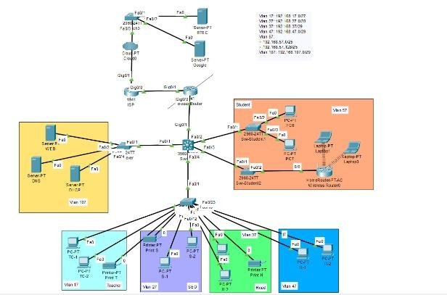

*Figure 1:Logical design*

# Ảnh có chứa ảnh chụp màn hình, biểu đồ Mô tả được tạo tự độngPhysical design of the network based on user requirement

Page | 6

*Figure 2:Physical design*

|  |  |  |  |  |  |  |
| --- | --- | --- | --- | --- | --- | --- |
| Type of user | Vlan | Network Address | Subnets Mask | Default Gateway | DHCP | DNS |
| Teacher | 17 | 192.168.17.0 | 255.255.255.224 | 192.168.17.1 | 192.168.107.2 | 192.168.107.3 |
| SEO | 27 | 192.168.27.0 | 255.255.255.240 | 192.168.27.1 | 192.168.107.2 | 192.168.107.3 |
| Head | 37 | 192.168.37.0 | 255.255.255.248 | 192.168.37.1 | 192.168.107.2 | 192.168.107.3 |
| IT | 47 | 192.168.47.0 | 255.255.255.248 | 192.168.47.1 | 192.168.107.2 | 192.168.107.3 |
| Student | 57 | 192.168.57.0 | 255.255.255.0 | 192.168.57.1 | 192.168.107.2 | 192.168.107.3 |
| server | 107 | 192.168.107.0 | 255.255.255.248 | 192.168.107.1 | 192.168.107.2 | 192.168.107.3 |

# Explain the subnetmask division:

* Simplified network management: Breaking down the network into smaller subnets simplifies the task of managing devices within the network.
* Improved network security: Splitting the subnet mask aids in segregating subnets, thereby bolstering network security.
* Enhanced network performance: Utilizing a split network mask reduces unnecessary broadcast traffic, thereby optimizing network performance.
* Split subinterface saves IPV4

# P6. Design a maintenance schedule to support the networked system.

# Network maintenance definition.

[Network maintenance](https://mglobalservices.com/third-party-maintenance/network-maintenance/) is essentially what you need to do to keep your network up and running smoothly. This definition encompasses some duties such as installing and configuring hardware and software, troubleshooting network problems, monitoring and improving network performance and planning for network growth.

# Task for the maintenance plan.

* **Troubleshooting Problems:** Proactively identify and resolve network issues, distinguishing between internal and external causes. Utilize network monitoring tools for early detection.
* **Performing Data and Configuration Backups**: Regularly back up critical data and network configurations, ensuring backups are accessible, verified, and up to date.
* **Device Inventory Management:** Maintain an accurate inventory of all network devices, tracking their status, updates, and lifecycle for efficient maintenance and replacement.
* **Malware/Ransomware Protection:** Implement robust security measures to protect against evolving threats, including regular updates, scans, and configuration adjustments.
* **Power Checks:** Test and maintain UPS systems to ensure uninterrupted power supply, scaling capacity with network growth.
* **Network Documentation:** Document all network components, maintenance activities, and relevant details to facilitate troubleshooting and knowledge transfer.
* **Hardware Checks:** Regularly inspect and maintain network hardware for damage, dust, and connectivity issues to prevent failures.
* **Compliance Checks:** Ensure network operations comply with legal and industry regulations, implementing necessary policies and security standards.
* **Preemptive Repairs:** Conduct scheduled maintenance to address potential issues before they disrupt network operations.
* **Configurations and Upgrades:** Regularly update software and devices to address security vulnerabilities and accommodate organizational changes.
* **Future Network Growth Planning**: Plan for network scalability and expansion based on past performance, recurring issues, and anticipated needs.

•

# Maintenance schedule

|  |  |  |  |  |
| --- | --- | --- | --- | --- |
|  | Daily | Weekly | Monthly | Yearly |
| **System Checks: Check for any physical damage or signs of wear on networking**  **equipment.** | x |  |  |  |
| **Software Updates** |  | x |  |  |
| **Cable and Physical Infrastructure Inspection** |  |  | x |  |
| **Data Backup** | x |  |  |  |
| **User Account** |  | x |  |  |

|  |  |  |  |  |
| --- | --- | --- | --- | --- |
| **Management.** |  |  |  |  |
| **Monitoring Network**  **Performance:** |  |  | x |  |
| **Server access**  **reviewed** |  | x |  |  |
| **Firewall Rules**  **reviewed** |  | x |  |  |
| **Hardware physically cleaned**  **and errors checked** |  |  | x |  |
| **System Performance Optimization** |  |  | x |  |
| **Security Checks** |  | x |  |  |
| **System Error Checking and**  **Handling** |  |  | x |  |
| **Security Audits** |  |  |  | x |
| **Check and Replace**  **Old Hardware** |  |  |  | x |
| **Scaling and Future**  **Planning** |  |  |  | x |

# P7. Implement a networked system based on a prepared design.



*Figure 3:Logical design*

# Here are the specific steps to configure each part of the network:

# Sw Core:

* Security Configuration:
  + Set passwords for console and enable mode.

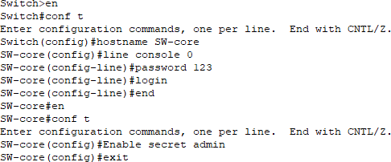

*Figure 4:Set passwords for console and enable mode*

-

* VTP Configuration:
* 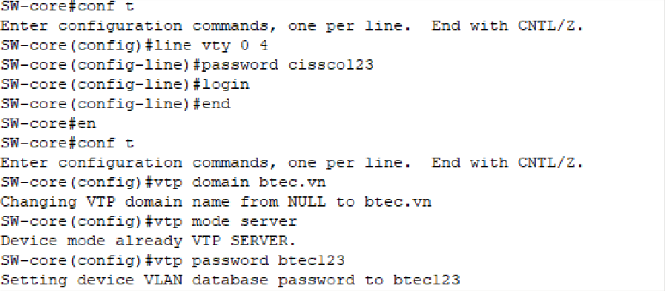Set the domain, mode, and VTP password.
* Name the Vlans:

*Figure 5:Set the domain, mode, and VTP password*

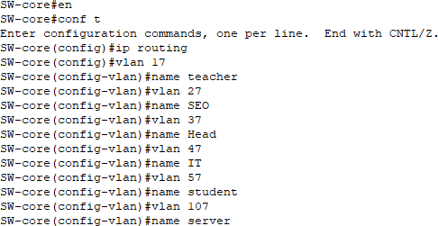

*Figure 6:Name the Vlans*

* Trunking Configuration:
  + Configure trunk ports on interfaces f0/1-4

*Figure 7:Configure trunk ports on interfaces f0/1-4*

# Sw-Server:

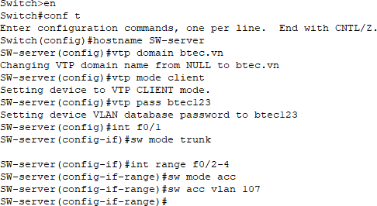

*Figure 8:Sw-Server*

# Sw-Staff:

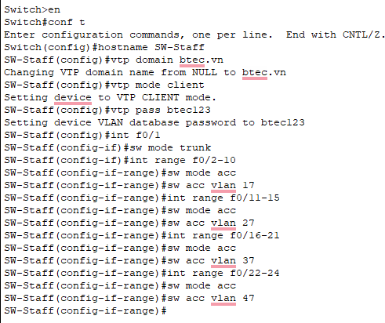

*Figure 9: Sw-Staff*

# Sw-Student:

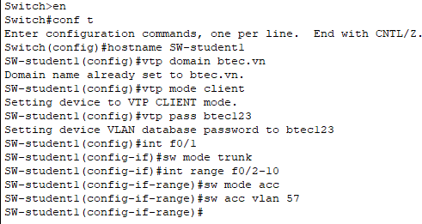

* + IP address for each VLAN:

*Figure 10: Sw-Student*

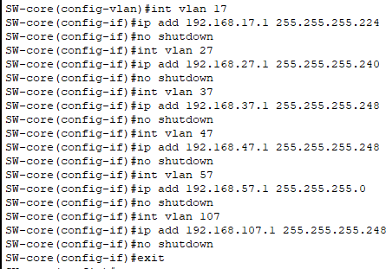

*Figure 11:IP address for each VLAN*

* + Configuring IP helper addresses on VLAN:

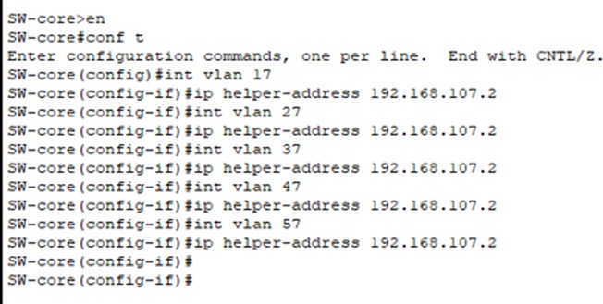

*Figure 12:Configuring IP helper addresses on VLAN*

* + Configuring an access control list:

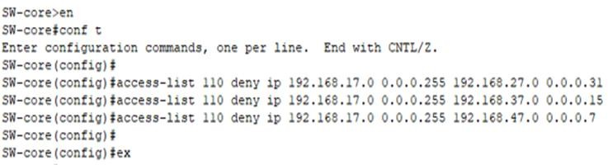

*Figure 13:Configuring an access control list*

* + Configure routing on sw-core:

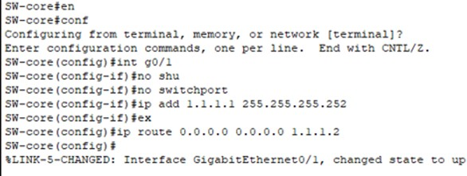

*Figure 14:Configure routing on sw-core*

# Border Router Configuration:

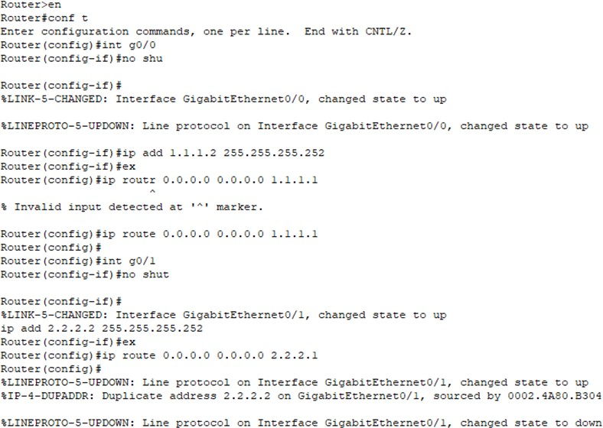

*Figure 15:Border Router Configuration*

# ISP Router Configuration:



*Figure 16:ISP Router Configuration*

# Internet Router Configuration:

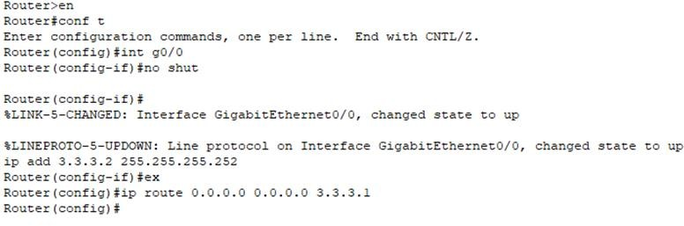

*Figure 17:Internet Router Configuration*

# Servers DHCP configuration:

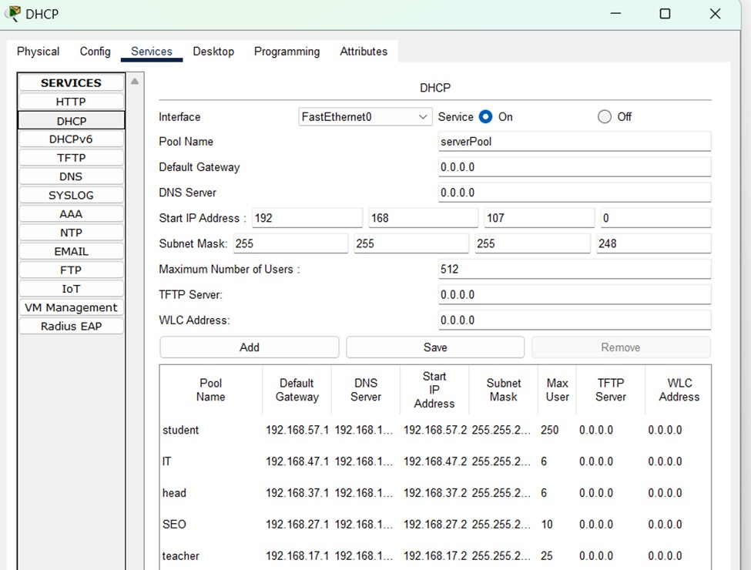

*Figure 18:Servers DHCP configuration*

# NAT and PAT image on Router Border:

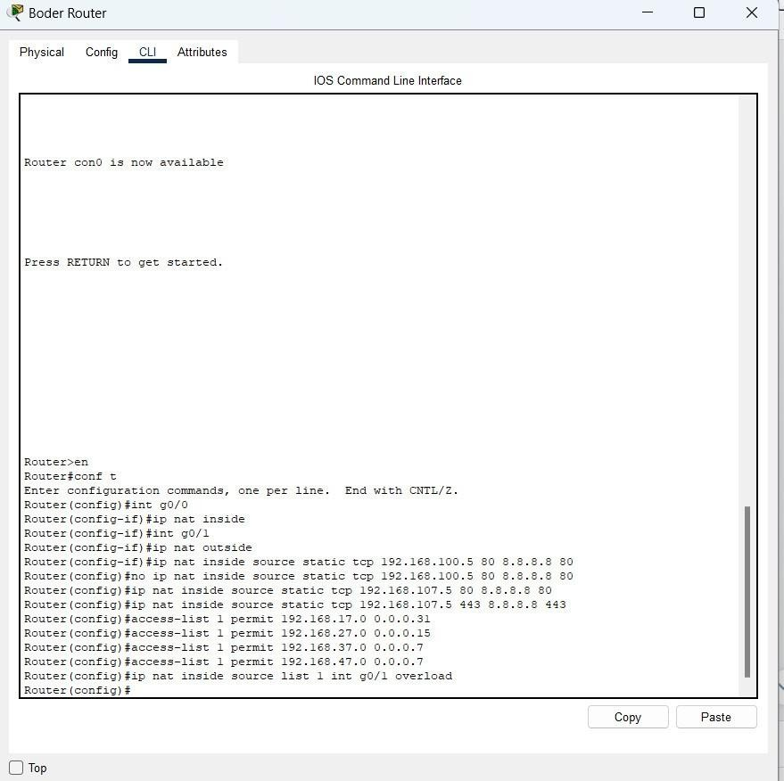

*Figure 19:NAT and PAT image on Router Border*

1. ***Wireless Router Configuration***

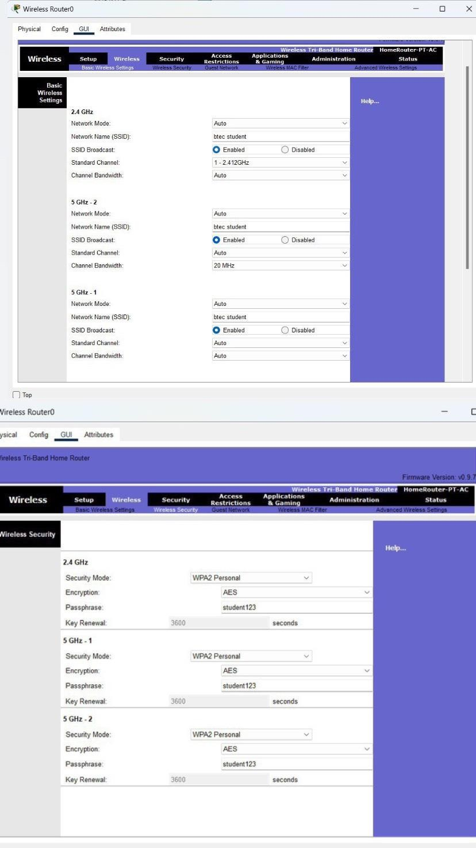

*Figure 20:Setup Wireless Router*

# P8. Document and analyze test results against expected results

# Documentation

**Configuration on Sw-core**

|  |  |
| --- | --- |
| Set passwords for console and enable mode | hostname SW-core line console 0  password 123 login  en conf t  Enable secret admin  exit |
| Set the domain, mode, and VTP password. | line vty 0 4 password cissco123 login  end en conf t  vtp domain btec.vn vtp mode server  vtp password btec123 |
| Configure trunk ports on interfaces f0/1-4. | int range f0/1-4  sw trunk enc dot1Q  sw mode trunk |
| Name the Vlans | ip routing Vlan 17  Name teacher |
| IP address for each vlan | Int vlan17  ip add 192.168.17.1 255.255.255.224  no shutdown |
| Configuring IP helper addresses on VLAN | int vlan 17  ip helper-address 192.168.107.2 |
| Configuring an access control list | Access-list 110 deny ip 192.168.17.0 0.0.0.255  192.168.27.0 0.0.0.31  Access-list 110 deny ip 192.168.17.0 0.0.0.255  192.168.37.0 0.0.0.15 |
| Configure routing on sw-core | Int g0/0 No shut  No switchport  Ip add 1.1.1.1 255.255.255.252  Ex  Ip route 0.0.0.0 0.0.0.0 1.1.1.2 |

* **Configuration on Sw-staff, Sw-server, Sw-Student1**

|  |  |
| --- | --- |
| Set name, and the VTP mode to client and passwords | hostname SW-Staff vtp domain btec.vn vtp mode client vtp pass btec123 |
| Configures the interface as a trunk port, allowing it to carry traffic for multiple VLANs. | int f0/1  sw mode trunk int range f0/2-10 sw mode acc |

**Border Router Configuration:**

|  |  |
| --- | --- |
| Configure routing on Border router | ip route 192.168.0.0 255.255.0.0 10.10.12.1  ip route 0.0.0.0 0.0.0.0 1.1.1.2  int g0/0  ip add 1.1.1.2 255.255.255.252  no shut |
| NAT image on Router Border | int g0/0  ip nat inside int g0/1  ip nat outside  ip nat inside source static tcp 192.168.107.5 80 8.8.8.8 80  ip nat inside source static tcp 192.168.107.5  443 8.8.8.8 443 |
| Pat image on Router Border | ccess-list 1 permit 192.168.10.0 0.0.0.31  access-list 1 permit 192.168.20.0 0.0.0.15  access-list 1 permit 192.168.30.0 0.0.0.7  ip nat inside source list 1 int g0/1 overload |

* **ISP Router Configuration:**

|  |  |
| --- | --- |
| Configure routing on ISP router | int g0/0 no shut  ip add 2.2.2.1 255.255.255.252  ex  ip route 0.0.0.0 0.0.0.0 2.2.2.2 |

# Testing.

* **Check password**

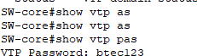

*Figure 21:Check password*

**Check configure VTP and check status.**

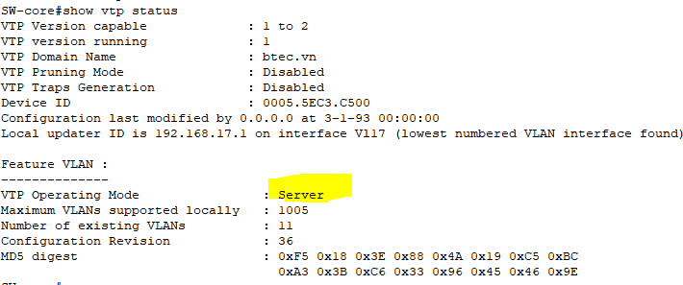

*Figure 22:Check configure VTP and check status*

**Check Vlan:**

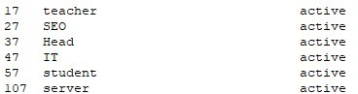

*Figure 23:Check Vlan*

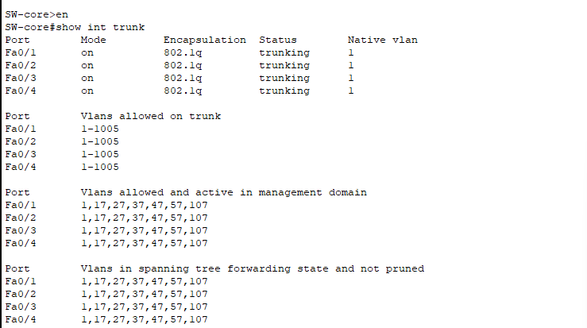**Check Trunking**

*Figure 24:Check Trunking*

**Check configure VTP and check status of Sw- server:**

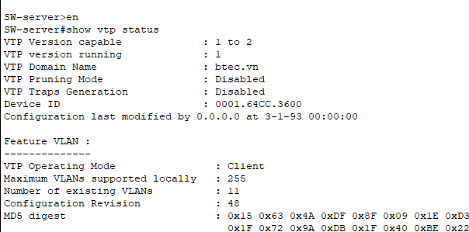

*Figure 25:Check configure VTP and check status of Sw- server*

**Check configure VTP and check status of Sw- staff:**

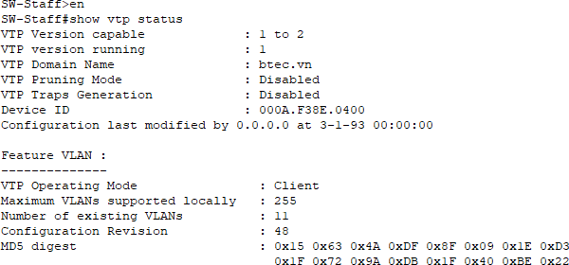

*Figure 26:Check configure VTP and check status of Sw- staff*

**Check configure VTP and check status of Sw- student:**

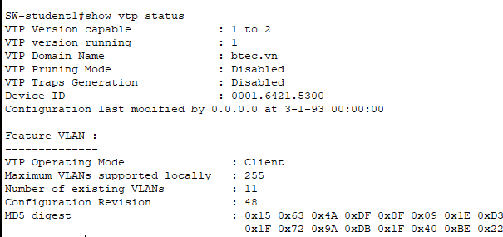

*Figure 27:Check configure VTP and check status of Sw- student*

**Check services DHCP:**

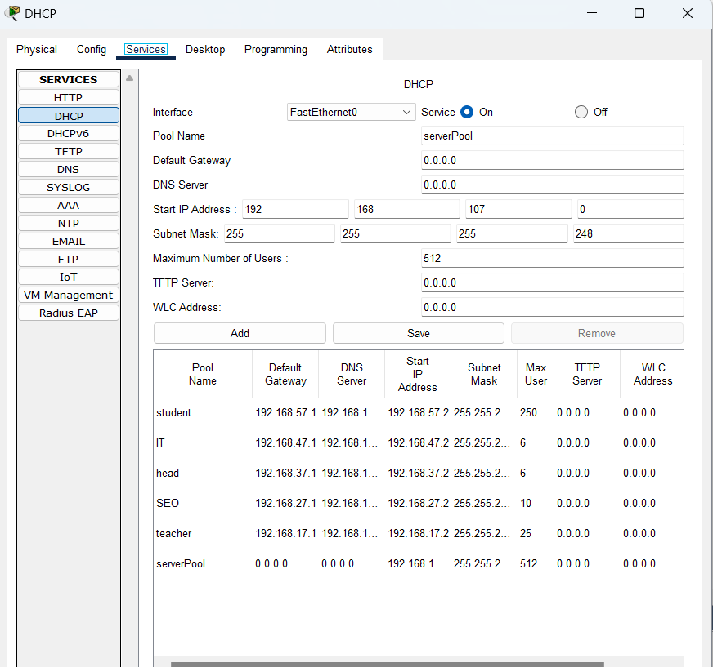

*Figure 28:Check services DHCP*

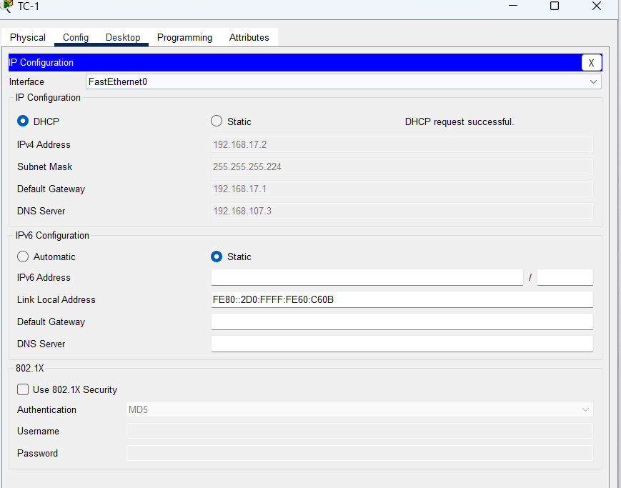**TC-1 computer is dynamically assigned IP by DHCP:**

*Figure 29:TC-1 computer is dynamically assigned IP by DHCP*

**Ping Realtime:**

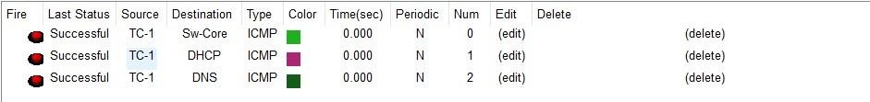

- *Figure 30:Ping Realtime*

**Check ping after configuring an access control list:**

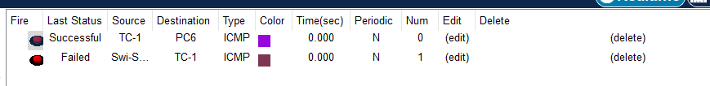

*Figure 31:Check ping after configuring an access control list*

**Check cmputers with different VLANs can ping each other:**

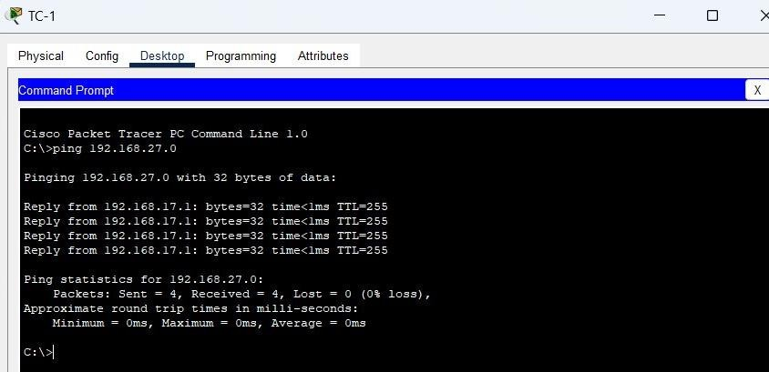

*Figure 31:Check computers with different VLANs can ping each other*

**Check ping from outside to inside after configuring NAT:**

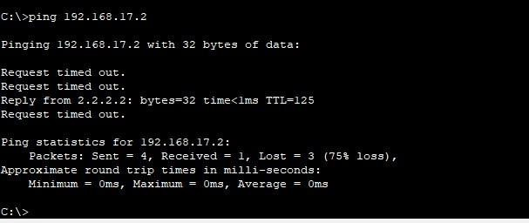

*Figure 32:Check ping from outside to inside after configuring NAT*

**Check DNS web serve:**

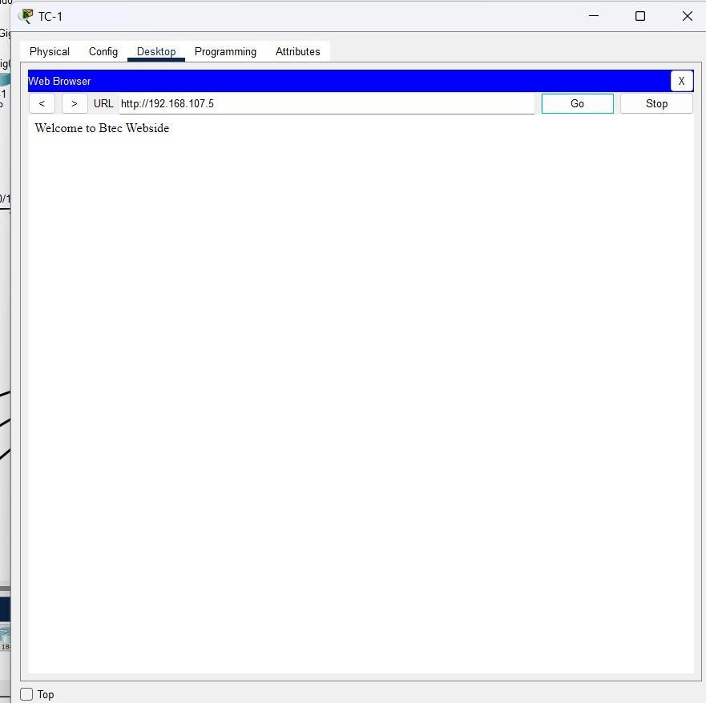

*Figure 33: Check DNS*

# Conclusion

In conclusion, I have presented the required contents of the task are: Provide a logical and physical design of the networked system with clear explanation and addressing table; Evaluate the design to meet the requirements; Implement a networked system based on a prepared design; Document and analyze test results against expected results in this report.

# Reference

Business, A. (2022). *Understanding the Logical and Physical Design of IoT*. [online] Airtel B2B Blog. Available at: [https://www.airtel.in/blog/business/physical-and-logical-design-of-](https://www.airtel.in/blog/business/physical-and-logical-design-of-iot/#%3A~%3Atext%3DLogical%20design%20is%20a%20high) [iot/#:~:text=Logical%20design%20is%20a%20high](https://www.airtel.in/blog/business/physical-and-logical-design-of-iot/#%3A~%3Atext%3DLogical%20design%20is%20a%20high).

M Global Services. (n.d.). *What is Network Maintenance?* [online] Available at: <https://mglobalservices.com/knowledge-center/blog/what-is-network-maintenance/>.

Velayudhan, D. (2023). *11 Critical Tasks in a Network Maintenance Checklist | ConnectWise*. [online] [www.connectwise.com.](http://www.connectwise.com/) Available at: [https://www.connectwise.com/blog/rmm/network-maintenance-](https://www.connectwise.com/blog/rmm/network-maintenance-checklist-tasks) [checklist-tasks](https://www.connectwise.com/blog/rmm/network-maintenance-checklist-tasks).

# Links Drive

<https://drive.google.com/file/d/1GLxhFcNa7WMOuSjsz2m_V-vcog5AziW5/view?usp=sharing>