Top 10 pixels for Class 4 attribute selection:

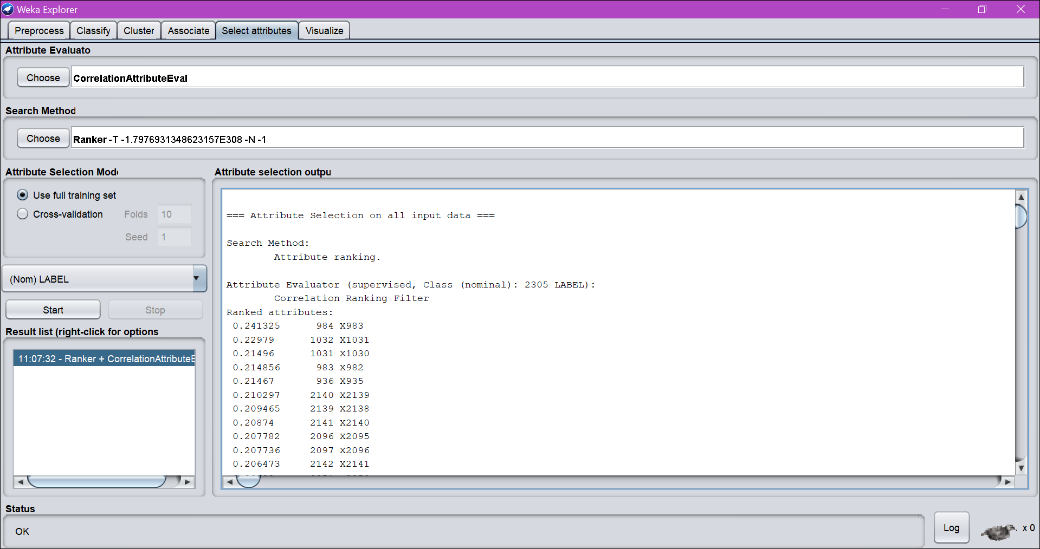

Top 10 pixels for Class 5 attribute selection:

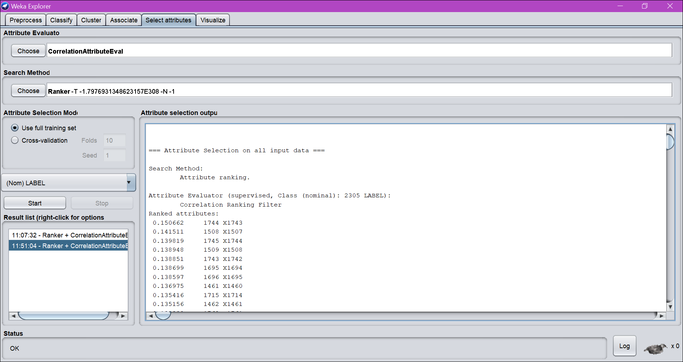

Top 10 pixels for Class 6 attribute selection:

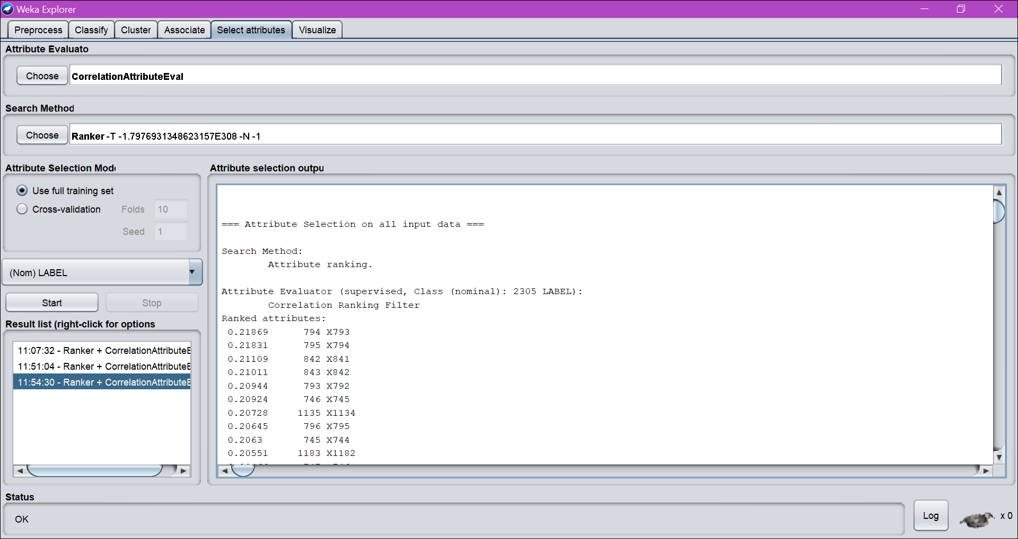

Selecting 10 pixels for class 6

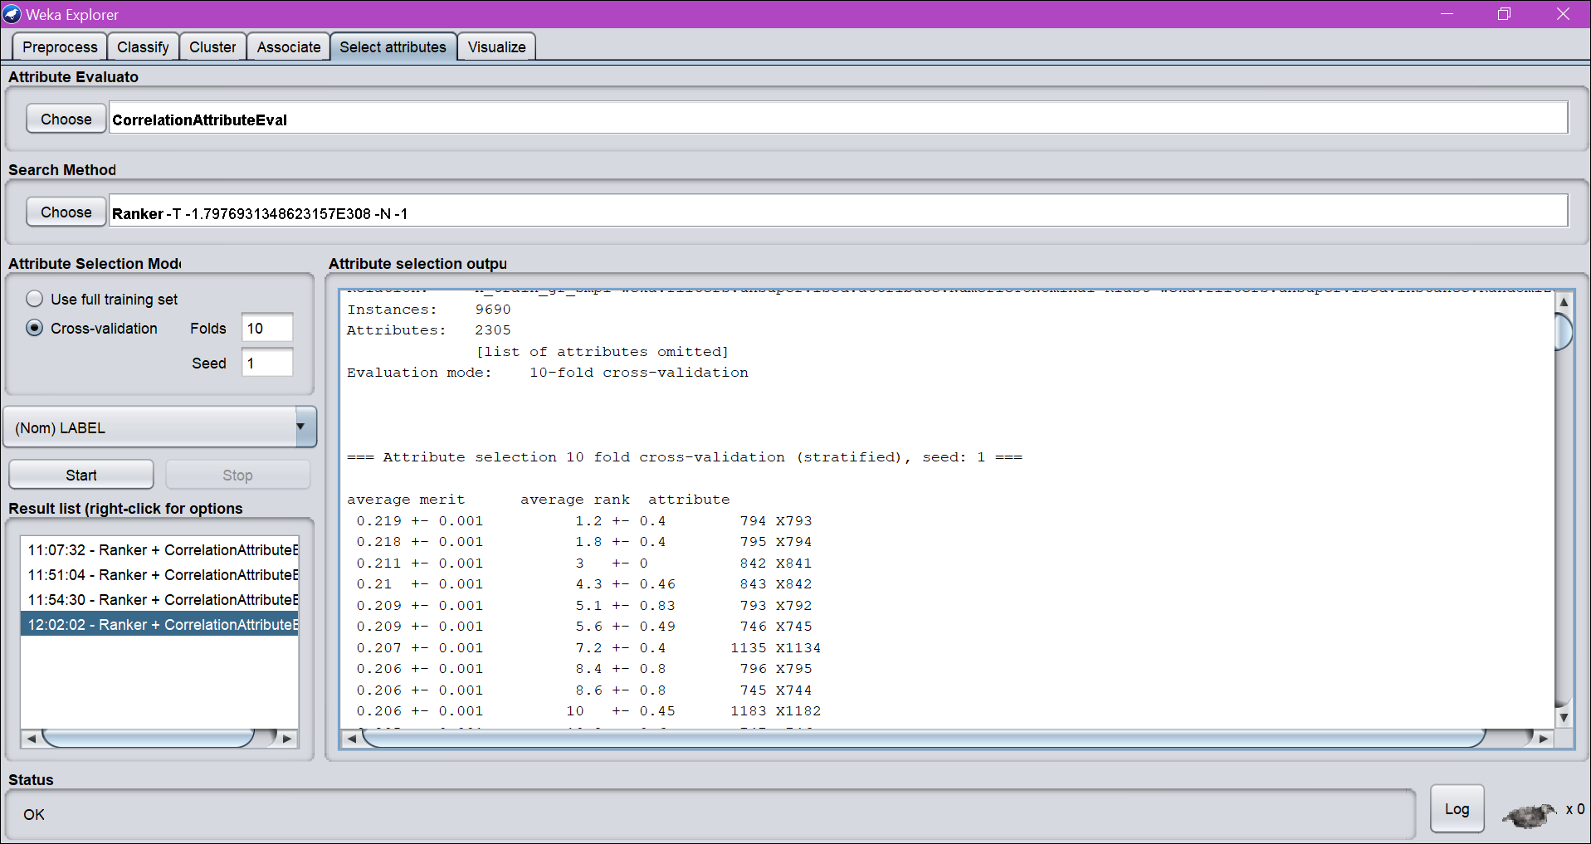

Selecting 10 pixels for Class 5

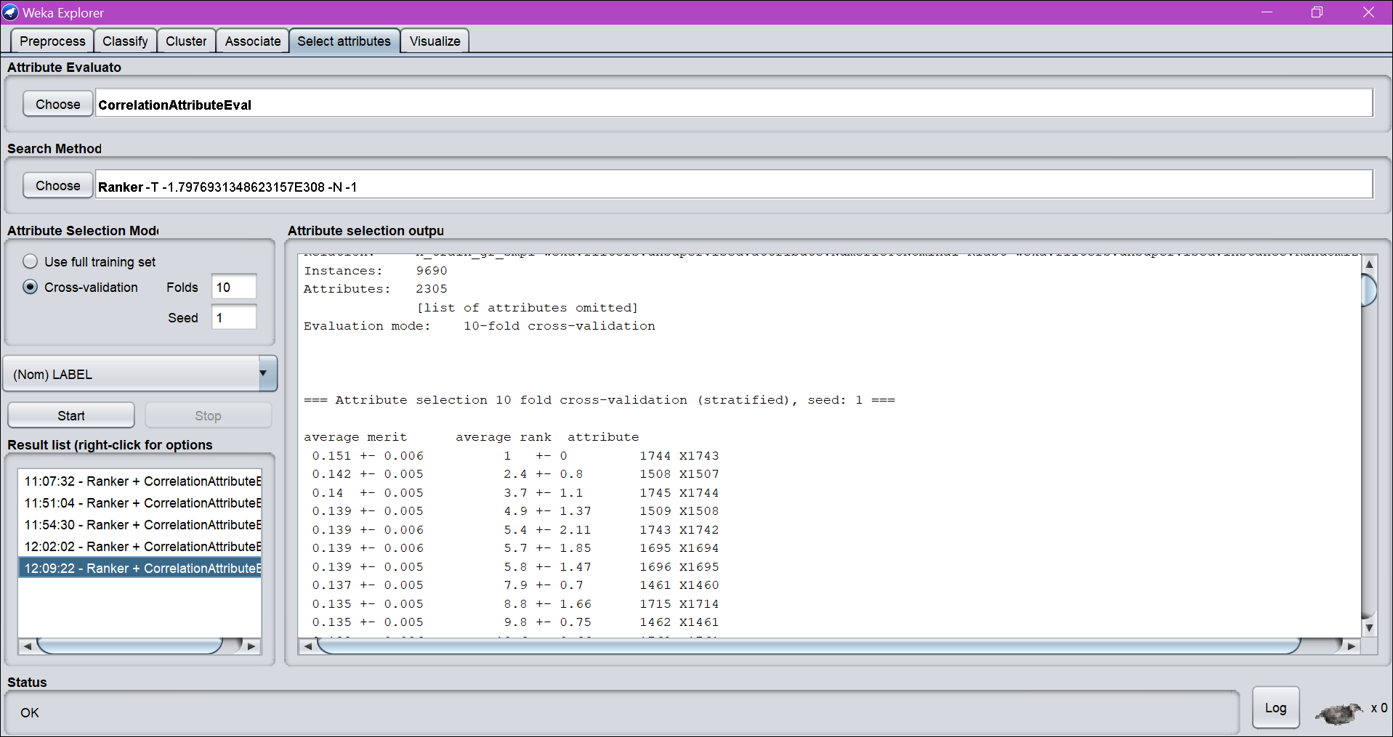

Selecting 10 pixels for Class 4

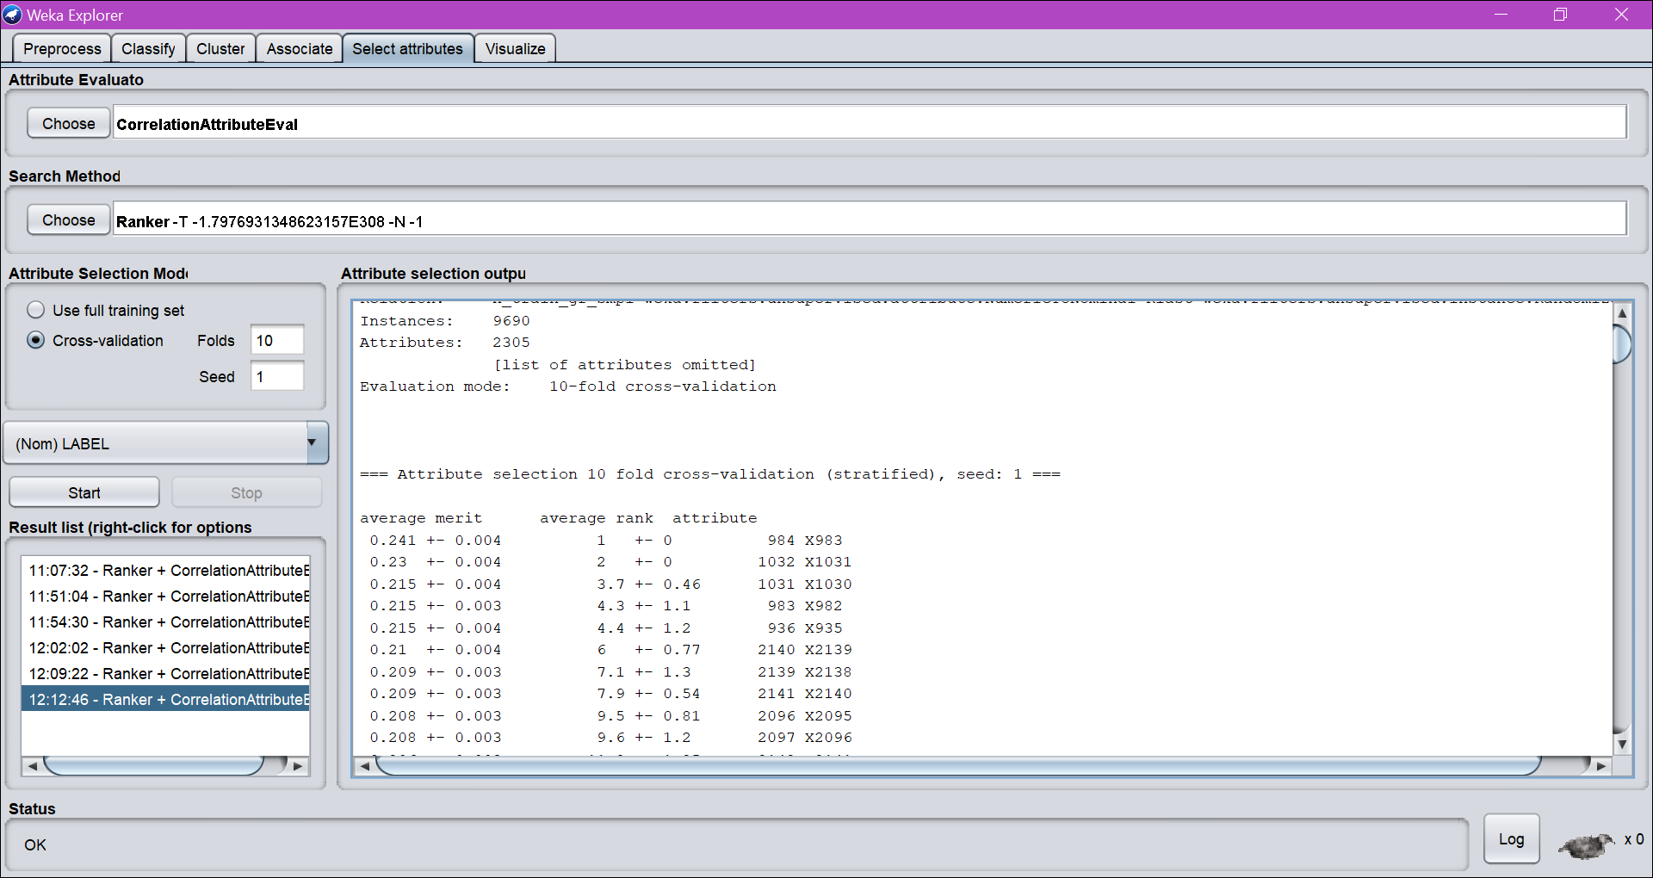

Class 3 Selecting 10 pixels:

