EM – Algorithm – NO of Clusters = 5

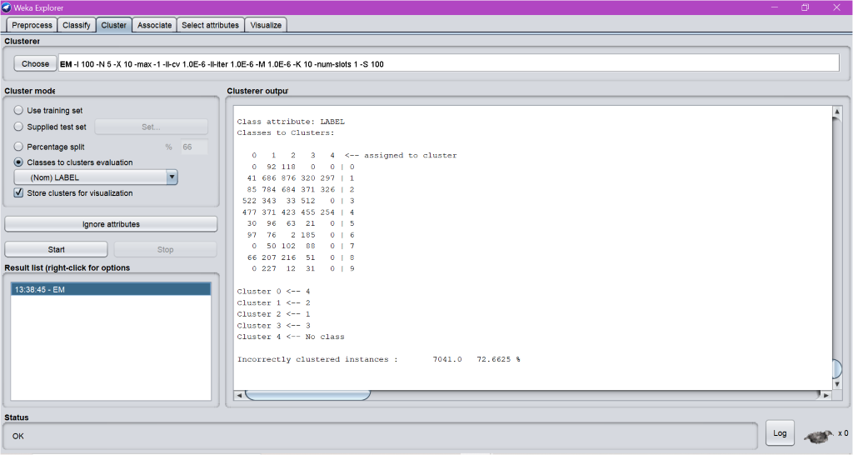

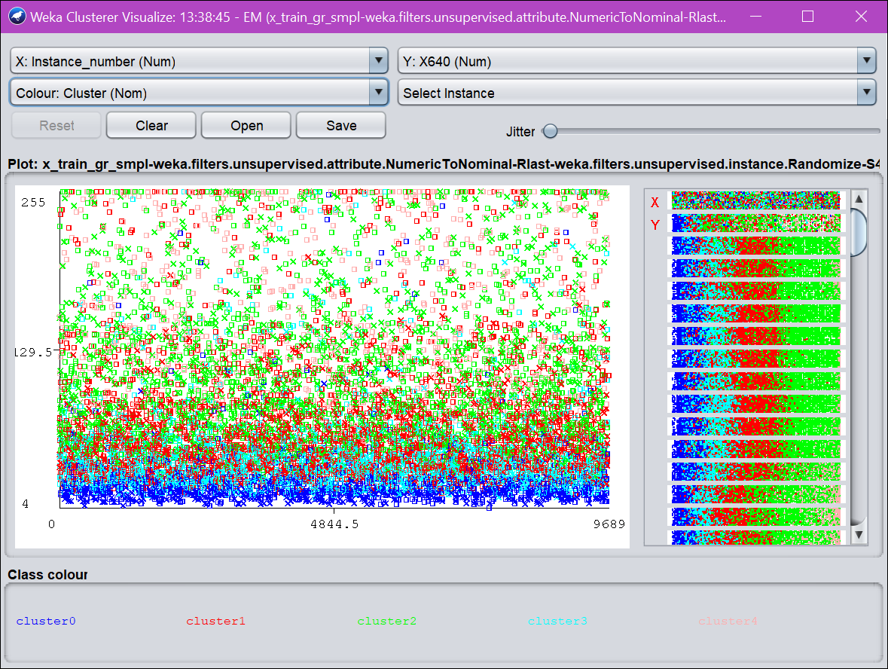

EM – Algorithm – No of Clusters = 8

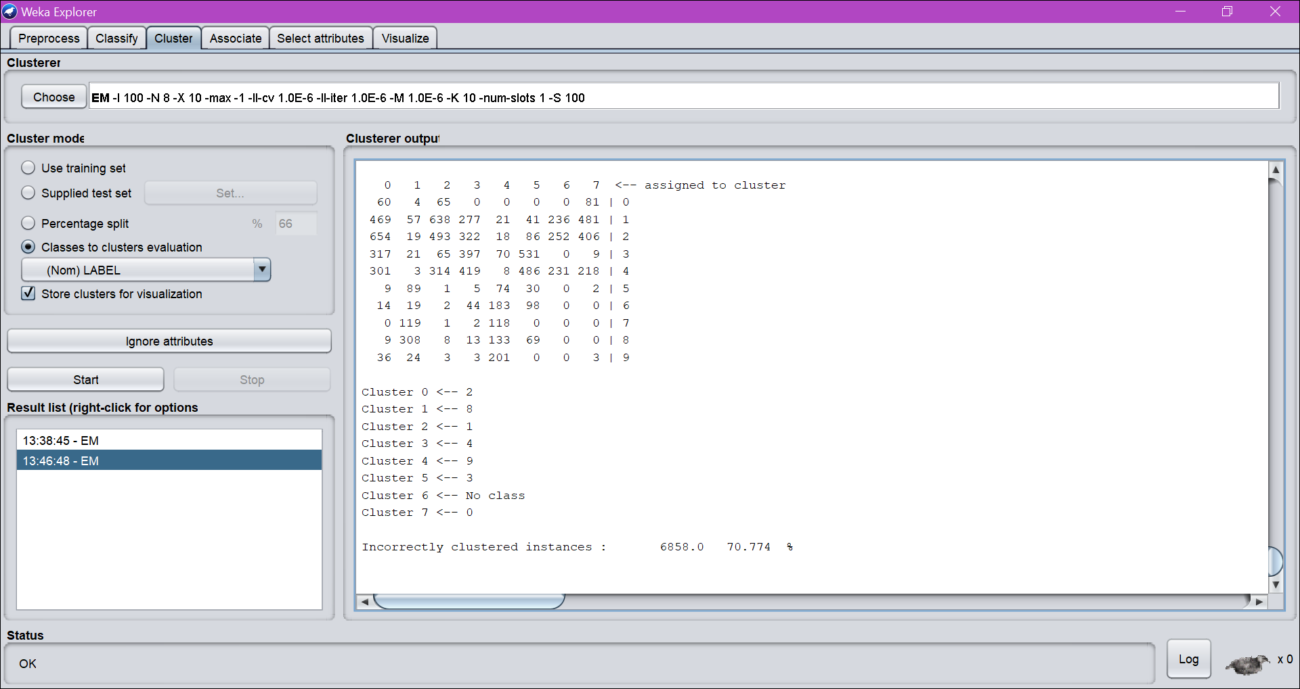

Visualize:

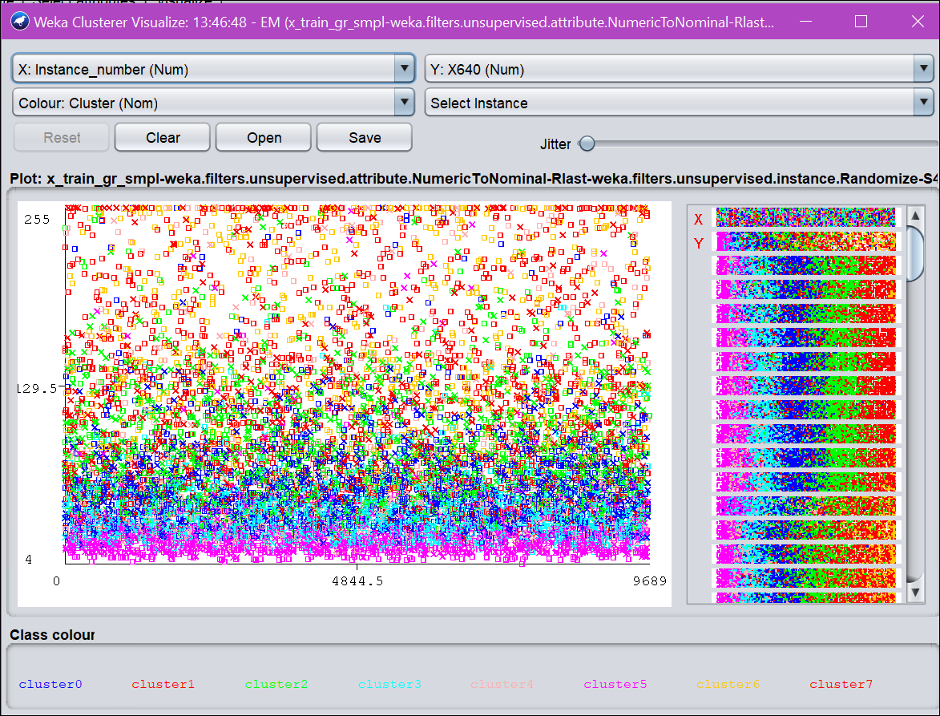

Increasing the number of clusters decreases the performance of the algorithm as well as the accuracy.

EM – Algorithm – No of Clusters = 10

Results for Cluster = 12

