IoT-Enabled MikroTik Parental Control System

MUHAMMAD SAFFUAN ATIF BIN MASRI
52223122625

MALAYSIAN INSTITUTE OF INFORMATION
TECHNOLOGY UNIVERSITI KUALA LUMPUR

MARCH 2025

IoT-Enabled MikroTik Parental Control System

MUHAMMAD SAFFUAN ATIF BIN MASRI
52223122625

Report Submitted to Fulfill the Partial Requirements
For the Bachelor of Computer Engineering Technology
(Networking Systems) with Honours Malaysian Institute of Information Technology,
Universiti Kuala Lumpur

MARCH 2025

APPROVAL PAGE

We have Supervised and examined this report and verify that its meets the programmes and University’s requirements for Bachelor of Computer Engineering Technology (Networking Systems) with Honours

Date: --/--/---- Signature: ……………………………………......
Supervisor: Sir Muhammd Ezra Bin Muhammad Ismail
Official Stamp:

Date: --/--/---- Signature: …………………………………......
Co Supervisor: Sir Syafiq Fikri Nordin
Official Stamp:

TABLE OF CONTENT
APPROVAL PAGE........................................................................................................i
TABLE OF CONTENT..................................................................................................ii
LIST OF FIGURES.......................................................................................................v
LIST OF TABLES.........................................................................................................x
LIST OF ABBREVIATIONS.........................................................................................xi
ABSTRAK (Malay)......................................................................................................xii
ABSTRACT (English)................................................................................................xiii
CHAPTER 1: INTRODUCTION……………………………………………………………1
1.1 Introduction……………...............................................................................1
1.2 Problem Statement.....................................................................................2
1.3 Project Objectives.......................................................................................3
1.4 Project Scope..............................................................................................4
1.5 Expected Outcome.....................................................................................4
1.6 Limitation of Project....................................................................................4
CHAPTER 2: LITERATURE REVIEW…………………………………………………….6
2.1 Introduction.................................................................................................6
2.2 Concept (Overview of Parental Control Systems) .....................................7
2.2.1 Parental Control System Overview...............................................7
2.3 Related Concept.........................................................................................8
2.3.1 Parental Control Systems...........................................................8
2.3.2 Internet Content Filtering.............................................................8
2.3.3 Time-Based Access Control………………………………….........8
2.3.4 MikroTik RouterOS…………………………………………………..9
2.3.5 Internet of Things (IoT) in Home Network Control……………….9
2.3.6 User Interface (UI) Design for Non-Technical Users…………….9
2.3.7 Cybersecurity and Safe Browsing for Children…………………..9
2.3.8 Access Control Mechanisms……………………………………...10
2.4 Research Study…………………………………………………………….10
2.4.1 Tsai & Estell (2024) – Network Activity for Parental
Monitoring…………………………………………………………..10
2.4.2 Dath et al. (2024) – Granular Network Traffic Classification
for Parental Control………………………………………………..11
2.4.3 Stewart, Brodowsky, & Sciglimpaglia (2021) – Adoption of ddddd Parental Control Software…………………………………………12
2.4.4 Ali et al. (2020) – Security and Privacy Risks in Parental
Control Solutions…………………………………………………...12
2.4.5 Altarturi et al. (2020) – Cyber Parental Control:
A Bibliometric Study………………………………………………..13
2.5 Critical Analysis…………………………………………………………….14
2.5.1 Literature Review Attribute………………………………………..14
2.5.2 Literature Review Matrix…………………………………………..16
2.6 Proposed Project…………………………………………………………..17
CHAPTER 3: RESEARCH METHODOLOGY…………………………………………..21
3.1 Introduction...............................................................................................21
3.1.1 Research Methodology Structure................................................22
3.1.2 Phase……………………………………………………………...….23
3.1.2.1 Planning Phase.............................................................23
3.1.2.2 Design Phase................................................................23
3.2.2.3 Development Phase......................................................24
3.2.2.4 Testing Phase................................................................24
3.2.2.5 Deployment Phase........................................................25
3.2.2.6 Review Phase...............................................................25
3.1.3 Resources.................................................................................26
3.1.3.1 MikroTik Router Os………………………………………..26
3.1.3.2 Phyton...........................................................................26
3.1.3.3 MQTT.............................................................................27
3.1.3.4 HTML.............................................................................28
3.1.3.5 CSS...............................................................................28
3.1.3.6 JavaScript......................................................................29
3.1.3.7 MikroTik Router……………………………………………30
3.1.3.8 ESP32………………………………………………….......30
3.1.3.9 Performance Laptop………………………………………31
3.1.3.10 SimCard Modem…………………………………………32
3.1.3.11 Winbox………………………………………….………...32
3.1.3.12 Ethernet Cables………………………………………….33
3.1.4 Budget and Costing………………………………………….........34
3.1.5 Flow Chart…………………………………………………………..35
3.1.6 Work Breakdown Structure………………………………………..35
3.1.7 Gantt Chart………………………………………………………….35
3.2 Prototype Development……………………………………………………36
3.2.1 Introduction…………………………………………………………38
3.2.2 Hardware Setup, Software Installation & Configuration……….39
3.2.2.1 Setup MikroTik Router……………………………..39
CHAPTER 4: RESULT AND DISSCUSION……………………………………………..44
CHAPTER 5: CONCLUSION……………………………………………………………..45
APPENDICES.……………………………………………………………………………..48
APPENDIX A – Flow Chart………………………………………………………..48
APPENDIX B - Work Breakdown Structure (WBS)…………………………….49
APPENDIX C – Gantt Chart………………………………………………………49

LIST OF FIGURES
Figure 2.1 System Flow Explanation for IoT-Enabled MikroTik
Parental Control System…………………………………………………..18
Figure 3.1 Agile Methodology Phase…………………………………………………22
Figure 3.2 MikroTik RouterOS…………………………………………………………26
Figure 3.3 Python……………………………………………………………………….26
Figure 3.4 MQTT ……………………………………………………………………….27
Figure 3.5 HTML………………………………………………………………………..28
Figure 3.6 CSS………………………………………………………………………….28
Figure 3.7 JavaScript…………………………………………………………………..29
Figure 3.8 MikroTik Router…………………………………………………………….30
Figure 3.9 ESP32……………………………………………………………………….30
Figure 3.10 Performance Laptop……………………………………………………….31
Figure 3.11 Simcard Modem……………………………………………………………32
Figure 3.12 Winbox………………………………………………………………………32
Figure 3.13 Ethernet Cables…………………………………………………………….33

LIST OF ABBREVIATIONS

IoT | (Internet of Things)
OS | (Operating System)
GUI | (Graphical User Interface)
API | (Application Programming Interface)
DNS | (Domain Name System)
HTML | (HyperText Markup Language)
CSS | (Cascading Style Sheets)
MQTT | (Message Queuing Telemetry Transport)
UI | (User Interface)
TBAC | (Time-Based Access Control)
VPN | (Virtual Private Network)
ESP8266 | (Wi-Fi-enabled Microcontroller used in IoT applications)
RPi / Pi | (Raspberry Pi)

ABSTRACT
The vast use of the internet by children has brought about concerns regarding exposure to inappropriate content, cyber-attacks, and unhealthy screen time. Existing parental control tools are not user-friendly, customizable, or seamlessly integrated within networking hardware such as MikroTik routers. The work proposes the creation of an IoT-Enabled MikroTik Parental Control System designed to provide parents simple access to controlling the availability of the internet. With the IoT technology and Mikrotik RouterOS features, the system supports the monitoring of the device in real time, management of content access in real time, and auto-scheduling of the connectivity of the device. An individualized management console will provide parents the ability to monitor settings remotely without the necessity of intricate settings and promote healthier and safer use of the internet by children within the house. The solution addresses the limitations of existing tools by providing a cost-effective, responsive, and scalable parental control solution ideal for both homes and schools. The work explores the potential of marketing the solution as a cost- and feature-efficient option for small office/home office (SOHO) consumers and educational institutions.

CHAPTER 1: INTRODUCTION

  - Introduction

As children's exposure continues to increase for entertainment as well as educational purposes on the internet, parents increasingly search for means of monitoring or censoring offensive content. Traditional parental software for access restriction may be effective but needs to be installed on each device as a stand-alone application and may be costly, while free versions do not generally offer the network-based administrative tools that function unseen
(R. Tsai & L. Estell, 2024).

This project suggests creating an IoT-Enabled MikroTik Parental Control System to address these issues by controlling internet usage at the router level. The system enables parents to more effectively manage their complete home network by utilizing the robust features of MikroTik RouterOS and incorporating an Internet of Things control device. This involves blocking out objectionable or inappropriate websites, scheduling broadband to limit internet access during particular hours, and continuously monitoring all network-connected devices.

By classifying and regulating network activity at the router level, this project suggests a novel parental control system that controls and limits internet access. The system may classify internet activity into social media, gaming, entertainment, and educational categories by combining intelligent control mechanisms with MikroTik RouterOS. Parents can assist ensure a safer and healthier digital environment for their children by blocking or restricting access to particular categories of information using this classification. Parents may better control internet usage within the home network and shield their kids from inappropriate or dangerous online content by implementing this centralized approach (D. J. P G. A. Dath, M. K. Chinta and A. Karki, 2024).

Compared with traditional methods that necessitate manual configuration on each device, this system provides a centralized, cost-effective, and user-friendly alternative. Without requiring complicated setups or software installations on every device, parents can guarantee a safer, more regulated internet environment at home by moving control to the network layer. Additionally, the suggested system may be scalable for small offices and educational settings where centralized internet administration is essential.

  - Problem Statement

Now, with the continually expanding virtual world, parents are increasingly struggling to monitor and manage their children's online activity. Overuse of screens, exposure to indecent or harmful content, and cyber attacks have become issues as children are using the internet more and more for education and recreation. Although there are some parental control solutions, there is a critical lack of products that offer real-time monitoring of network activity and centralized management. This deficiency is highlighted by Tsai and Estell (2024), quoting the absence of real-world and intuitive solutions that support live monitoring on a network level. Similarly, Dath et al. (2024) indicate the limitation of current traffic classification methods, which typically do not offer the level of control necessary to enable optimal parental management. These limitations point to the growing need for strong and open parental controls that can better secure family online spaces.

Despite the existence of many parental control solutions, they are either too technical or lack user-friendly automation features that render them easy to implement. Ali et al. (2020) discuss how usability and security problems plague most of these tools, discouraging non-technical users—especially parents—from adopting them. Moreover, Altarturi et al. (2020) point out the fragmented nature of the current landscape, calling for more integrated and accessible solutions. In order to address the aforementioned gaps, the project proposes developing a streamlined, IoT-based system for parental control. The system will provide parents with an easy-to-use platform that enables them to schedule access, block objectionable content, and monitor network usage easily, making their children's digital life safer and easier. seeks to make sure that kids' online experiences are safer and easier to handle at home.

  - Project Objectives

- The primary objective of the project is to design and develop a parental control system based on Internet of Things (IoT) that is completely compatible with MikroTik RouterOS. The system would provide a centralized, effective method for parents to monitor and manage children's internet activities at the network level instead of using traditional device-based applications that need to be installed on every device. By leveraging the power of MikroTik routers and including an IoT controller such as a ESP32 , the system will allow parents to trigger main actions such as setting internet usage, blocking sites, and monitoring real-time network usage. One of the primary areas of emphasis for this objective is also ensuring that the platform is accessible through a welcoming website, whereby even non-technical users are able to utilize the system comfortably and with confidence.

- The second objective of this project is to contrast the functionality and effectiveness of the principal features incorporated within the system, with special emphasis on the ability to schedule internet use, block off undesirable content, and monitor network use simply. The contrast will examine how well these features perform under real use, quantify their responsiveness, and determine how simple and effective they are for a parent to utilize. This will make sure that the system accomplishes the task of providing a stable and available parental control solution.
  - Project Scope

A highly specialized and proficient parental control system that is completely compatible with MikroTik routers will also be integrated into the project, allowing for smooth integration and real-time internet access management. In order to ensure a safe and controlled online environment at all times, this system will provide a variety of features, such as secure user authentication to ensure only authorized access, flexible and customizable scheduling options to allow parents to set specific time limits for internet usage, comprehensive content filtering to block harmful or inappropriate websites, and remote access capabilities that will allow parents to monitor and manage their children's online activities from virtually anywhere.

  - Expected Outcome

The final outcome of this project is an IoT-based end device that completely assists parents in managing and regulating their kids' use of the internet at the network level. The system will be technically optimized for ensuring reliability and usability so that users without technical know-how can easily operate it with minimum effort. Key features such as scheduling access to the internet, filtering content, active monitoring, and user management using a web or mobile interface will be integrated to address some of the most prevalent parental issues regarding online safety and screen time. The solution must operate efficiently in an actual home network environment, using a Raspberry Pi as the controller and a MikroTik router for policy enforcement. Once the project is completed, the system would be a simple, effective, and helpful parental control system that promotes appropriate use of the internet and protects children from harmful online activities, user-friendliness and efficient internet management will be the end result.

  - Limitation of Project
Considering the project's goal of offering an effective and straightforward parental management system, a few limitations must be taken into consideration as well. The system's limited compatibility with MikroTik routers may hinder its wider acceptance, as it cannot be installed on routers from other brands. The device also needs a steady internet connection to work properly, which could be problematic in places with erratic connections. Even while the system will provide real-time control and monitoring, it might not completely take into consideration all potential online threats, particularly those that come from unidentified or highly skilled sources. Another restriction is that if the system's remote access feature is not set up correctly, it could be vulnerable to security flaws. Finally, the project might not offer the wide range of customization possibilities that more technical users might want because it is intended to be user-friendly. Despite these drawbacks, the project will nevertheless offer parents a useful way to efficiently control their kids' internet usage.

CHAPTER 2: LITERATURE REVIEW
2.1 Introduction
Parental control systems are essential for promoting appropriate and secure online behavior, especially in considering the increase in children's internet usage in today's technologically advanced culture. As digital technologies develop, parents' challenges in keeping an eye on and restricting access to hazardous or unsuitable content have become increasingly complex. This chapter provides a comprehensive analysis of the most recent studies and technological advancements in the field of parental control systems, emphasizing solutions that integrate seamlessly with home networking hardware such as MikroTik routers.
The review explores basic topics such as detailed traffic classification, network-level activity monitoring, and the behavioral and social impacts of children's exposure to digital environments. For instance, presented fine-grained traffic classification techniques for mobile applications to increase the accuracy of parental control features (Dath et al., 2024). In addition, emphasized the value of network activity monitoring at the router level as a practical and successful approach to parental supervision (Tsai and Estell, 2024). Furthermore, user trust and ease of use are critical for successful implementation in family contexts, examination of parental control tool adoption variables (Stewart et al.'s, 2022).
By integrating the insights from these recent studies, this chapter establishes the foundation for developing a strong, user-friendly parental control system. The goal is to address the needs of families in the modern period by providing a tool that not only enhances children's online safety but also satisfies the technical requirements and usability standards of modern home networks.

2.2 Concept (Overview of Parental Control Systems)
Application packages known as parental control tools allow parents the ability to keep an eye on, supervise, and regulate their children's online activity. The younger generation is increasingly using the internet for enjoyment, learning, and social networking purposes, raising severe concerns about their online safety. A variety of technologies are used by parental control programs to protect young users from inappropriate content, inappropriate viewing times, and online dangers.

2.2.1 Types of Parental Control System
Parental control solutions can be broadly categorized based on their implementation levels:
- Device-Level Control: These are the ones that are directly downloaded to individual devices such as smartphones or computers. They have the ability to restrict usage, censure content, and monitor activities on that specific device. (Stewart et al., 2022) argue that their usage relies on considerations that also include perceived usefulness as well as personal innovativeness.

- Network-Level Control: These controls reside in the router or network location to regulate the internet use for all the devices within a home network. Parents also have the ability to configure settings on routers to implement a content filter, schedule the use of the internet and monitor the traffic on multiple devices. (Ali et al., 2020) note that although efficient, these tools also pose security and privacy risks when not managed.

- Hybrid Solution: Some solutions provide a more comprehensive approach to internet safety by combining controls at the network and device levels. Parents can monitor and control their children's online behavior across several platforms and devices with the help of these solutions' centralized dashboards. In their discussion of the definition of cyber parental control tools, (Altarturi et al., 2020) stress the importance of whole tactics that cover a range of control levels.

2.3 Related Concept
2.3.1 Parental Control Systems
Parental control systems give parents the ability to keep an eye on, regulate, and limit their kids' internet use. Children are protected by these systems from harmful content, excessive screen time, and online dangers. Both device-level and network-level implementations are possible; network-based solutions provide centralized control over all linked devices (Ali, S., Elgharabawy, M., Duchaussoy, Q., Mannan, M., & Youssef, A., 2020).

2.3.2 Internet Content Filtering
Blocking or permitting access to online content according to categories, domains, or certain policies is known as internet content filtering. When implemented at the network level, it guarantees that all network-connected devices follow the same content access guidelines, irrespective of the browser or application being used (Ojo, F. F. , 2024).

2.3.3 Time-Based Access Control
A security paradigm called Time-Based Access Control (TBAC) applies limitations and permissions according to predetermined time limits. TBAC dynamically permits or denies access to resources according to the time and duration stated in the access policies, in contrast to conventional static access control techniques (Wang, B., Li, W., & Xiong, N. N., 2019b).

2.3.4 MikroTik RouterOS
MikroTik RouterOS is the operating system of MikroTik's RouterBOARD hardware. Routing, firewalling, bandwidth management, wireless access points, VPN servers, and more are all part of its extensive feature set. It may be used to develop bespoke network solutions because of its scripting capabilities and flexibility (Riga, Latvia & Santa Clara, 2024)

2.3.5 Internet of Things (IoT) in Home Network Control
The Internet of Things (IoT) refers to the network of interconnected devices that collect and exchange data. IoT gadgets like the Raspberry Pi and ESP32 can be used to automate and manage network settings in homes, giving parents the ability to keep an eye on and regulate their kids' internet usage (Al-Mutawa, R. F., & Eassa, F. A. , 2020).

2.3.6 User Interface (UI) Design for Non-Technical Users
The goal of user interface (UI) design is to make interfaces that are simple and straightforward, particularly for non-technical people. A well-designed user interface (UI) in parental control systems guarantees that parents can easily access and modify settings without needing to grasp complex technical details (Wang, G., Zhao, J., Van Kleek, M., & Shadbolt, N., 2021).

2.3.7 Cybersecurity and Safe Browsing for Children
Children's cybersecurity includes tactics and resources to shield young users from internet dangers such exposure to offensive material, cyberbullying, and privacy violations. A key element of digital parenting is teaching kids safe browsing practices and putting safety precautions in place (Wang, G., Zhao, J., Van Kleek, M., & Shadbolt, N., 2021).
2.3.8 Access Control Mechanisms
In a computing context, access control techniques govern who or what is allowed to view or utilize resources. They are essential to security because they reduce the possibility of unwanted access by guaranteeing that only authorized users can access particular data or systems (Mohamed et al., 2022b).

2.4 Research Study
2.4.1 Tsai & Estell (2024) – Network Activity for Parental Monitoring
Tsai and Estell, in their 2024 paper, explored the work on creating and applying a system based on network activity monitoring in order to assist parental control features. The work wanted an approach that was lightweight in the sense that it monitored and analyzed data packets in the local home network with the goal of learning about activities the children engaged in online. Their system revolved around non-intrusive monitoring—that is, not having to install anything in all the children's computers, following the new trend in centralized parental control via network gateways and routers.
The work offered a dashboard for the parents to monitor histories of activities as well as categorizing the websites accessed on each device. It aggregated all the information, and the system created each child's usage profile, allowing the parents to learn patterns and make informed decisions. The method allowed real-time and historical views, and it showed the value of passive monitoring in comparison to device-centric methods. Tsai and Estell prioritized privacy-respecting designs above all things by avoiding the use of deep packet inspection, thereby upholding ethical data-gathering practices.

I find the paper interesting in that it too is tackling the problem of centralized monitoring and control at the network level. Similar to them, in my project, I am proposing the use of router-based configurations—a MikroTik router in my project—to gain visibility and control without having the application installed in every machine. Their paper validates the notion that parental control would be stronger if implemented at the network layer.

2.4.2 Dath et al. (2024) – Granular Network Traffic Classification for Parental Control
Research into fine-grained traffic classification for the purposes of improving parental control systems was carried out by Dath, Chinta, and Karki (2024). It made use of machine learning algorithms in the detection as well as the differentiation between the types of traffic—e.g., gaming, video streaming, social networking, and education. According to the network-level behavior of the apps, the system was able to determine the type of use and execute predetermined actions such as logging, monitoring, or blocking.

The paper by the authors propounded an architecture that would be deployable at the network edge–e.g., in the routers, or in IoT-specific devices–to capture encrypted and plaintext traffic patterns. It identified the problem of app traffic classification in the presence of encryption and presented flow-level metadata-based alternatives for the sake of content inspection. Their paper shows that traffic classification can power contextual awareness for parental control in cases where the conventional approach using URL filtering would not work in the presence of obfuscation or encrypted domains.

The project falls in nicely with my project objective of creating an at-router parental control system. As my existing scope entails DNS filtering and scheduling through the features offered by MikroTik, their approach suggests an extension—adding application-level traffic classification. It would allow for greater granularity and smart control of internet usage according to the kind of usage rather than specific domain names.

2.4.3 Stewart, Brodowsky, & Sciglimpaglia (2021) – Adoption of Parental Control Software
What Stewart et al. (2021) did was an examination into the psychological and behavioral determinants for the adoption of parental control technology. It identified the extent that parents' trust in technology, attitudes towards online child safety requirements, and privacy impact its uptake in utilizing the tools. What emerged from their analysis was that the majority of parents, as much as they were aware, avoided utilizing parental control software owing to its complexity or the likelihood that it would invade the privacy of children or damage the parent-child relationship.

The authors emphasized the need for simplicity, usability, and clarity in design for software. Parents sought software that was easy to use, well-structured in its interface, and not requiring high-tech knowledge. It suggests an overall problem in which implemented solutions either require high technical ability or fail to include intuitive elements, leading to the underutilization or abandonment of parental control software.

This supports the idea for my project, which is the development of an IoT-based parental control system that works but is still intuitive enough for non-technical parents. The intuitive interface I would design—web-based, for instance, or mobile—directly addresses the issues revealed in this research. Reducing technical complexity, I seek to increase usage among those parents who would be deterred from conventional software-based alternatives.

2.4.4 Ali et al. (2020) – Security and Privacy Risks in Parental Control Solutions
Ali, Elgharabawy, Duchaussoy, Mannan, and Youssef (2020) performed an in-depth security review of some commercially available parental control products. The study discovered that a number of the products, in their quest to safeguard children, had introduced critical security and privacy weaknesses in home networks. Insecure data storage problems, lack of or weak encryption, and weak authentication protocols were discovered. In some cases, parental control software was even found to be collecting sensitive user data in the absence of clear user consent, which is morally dubious.

The research highlighted that, although parents use these systems for peace of mind, they could be leaving their home networks and children's information open to exploitation by third parties. The authors called for a more privacy-conscious design for parental control systems, where processing is done locally and only minimal external communication is necessary. Their paper proposes that data minimization should be a priority for any new system under development and that a security-by-design mindset should be followed from the start.

This aligns with the objectives of my own project. Because my system is centered on a MikroTik router and an IoT interface, I'm trying to get rid of cloud-based storage or third-party processing of data altogether. Filtering, monitoring, and scheduling are all going to be done locally on the network. This blocks the type of vulnerabilities Ali et al. discovered, and keeps user data secure and private in the home network.

2.4.5 Altarturi et al. (2020) – Cyber Parental Control: A Bibliometric Study
Altarturi, Saadoon, and Anuar (2020) carried out an extensive bibliometric review of the research literature on cyber parental control systems. Their study identified growing interest in this area over the last ten years, especially with internet access for children increasingly on the rise. The study categorized current research into a number of areas, which included technical solutions (such as filtering and scheduling), social issues (such as ethical monitoring), and system design methods. One of their main findings was the absence of integration between parental control systems based on routers and IoT technologies in existing academic research.

They indicated that although most of the parental control products are installed software on the device, with increasing demand, there is a shift towards network-based solutions that centrally manage all devices without invasive installations. They also indicated that their research called for more user-centered design that addresses both technical and non-technical parents' needs. This would include creating easy-to-use interfaces and making common tasks such as device grouping or filtering rule maintenance automatic.

This bibliometric study also confirms the trajectory of my project. My proposed IoT-based parental control system completes the research gap of their study by pairing MikroTik router management with an intuitive control interface. It also contributes to the literature by outlining an operable, router-based control strategy that is both less intrusive and easier to manage than device-specific software. The system I'm creating specifically solves the design, usability, and implementation problems pointed out by Altarturi et al.

2.5 Critical Analysis
2.5.1 Literature Review Attribute
No | Article | Description | Method | Conclusion
1 |  | Explores real-time network activity monitoring for parental control purposes. | Creates a monitoring system to view children's browsing habits by employing traffic analysis techniques. | Supports the router-based methodology of this project by highlighting the benefits of centralized network observation for parental usage and recommending router-level visibility.
  Network Activity for Parental Monitoring
  (Tsai & Estell, 2024)
2 |  | Proposes a fine-grained traffic classifier for identifying app-specific usage patterns on mobile networks.. | Classifies network traffic into app-specific classifications using supervised learning. | Supports real-time filtering and access limitation by achieving high classification accuracy for a variety of mobile services. This encourages the suggested system to use exact filtering.
  Granular Network Traffic Classification on Mobile Application Service for Better Parental Control
  (Dath et al., 2024)
3 |  | Analyzes adoption factors of parental control software and effectiveness in practice. | Surveys and behavioral data that look at why parents utilize monitoring systems and what obstacles they face. | Discovers that system transparency and convenience of use are crucial for adoption, highlighting the necessity of user-friendly control systems, which is the project's main goal.
  Parental Supervision and Control of Adolescents’ Problematic Internet Use
  (Stewart et al., 2021)
4 |  | Investigates security flaws and privacy concerns in existing parental control tools. | Evaluates vulnerabilities and reverse engineers commercial software. | Highlights the need for a safe, local (MikroTik-based) solution by identifying significant hazards from third-party control apps.
  Betrayed by The Guardian: Security and Privacy Risks of Parental Control Solutions
  (Ali et al., 2020)
5 |  | Reviews global trends, technologies, and gaps in parental control research. | Performs bibliometric study on academic databases pertaining to online parenting resources. | Discovers a growing interest in automation and network-level solutions, confirming the applicability and timeliness of this project's IoT-enhanced architecture.
  Cyber Parental Control: A Bibliometric Study
  (Altarturi et al., 2020)
Table 2.1 : Literature Review Attribute
2.5.2 Literature Review Matrix
Article | Puropse | Key Findings | Methods | Strenghts | Limitations
Network Activity for Parental Monitoring  (Tsai & Estell, 2024) | To provide parents with network activity insights for monitoring children’s internet use. | Centralized monitoring helps detect inappropriate use and ensures safety via network-level observation. | Implements traffic analysis to visualize browsing behavior in real-time. | Easy integration with existing home networks; gives parents comprehensive device-level insights. | Requires technical setup; limited to traffic-level analysis without device-based restrictions.
Granular Network Traffic Classification on Mobile Application Service for Better Parental Control  (Dath et al., 2024) | To classify mobile application traffic for improved filtering in parental control systems. | Achieved high accuracy in app identification, supporting targeted access blocking. |  | Real-time and accurate classification improves filtering precision. | Needs model updates with new apps and encrypted traffic challenges.
  Supervised learning on app-specific traffic patterns.
Parental Supervision and Control of Adolescents’ Problematic Internet Use  (Stewart et al., 2021) | To explore factors influencing parental adoption of internet control tools. | User-friendliness and transparency are crucial for software adoption among parents. |  | Provides behavioral insights for designing intuitive interfaces. | Findings may not reflect all cultures or technology adoption levels.
  Survey-based analysis of user behavior and tool acceptance.
Betrayed by The Guardian: Security and Privacy Risks of Parental Control Solutions  (Ali et al., 2020) |  | Identified vulnerabilities in various tools that could compromise family privacy. |  | Raises awareness on the need for secure parental control development. | Commercial tools often rely on cloud access, increasing risks.
  To analyze security and privacy issues in commercial parental control software.
  Reverse engineering and vulnerability testing of software.
Cyber Parental Control: A Bibliometric Study  (Altarturi et al., 2020) | To analyze research trends and gaps in cyber parental control. | Emphasized the growing focus on centralized and automated network-level controls. |  | Confirms research gap and supports router-based control approach. | Does not provide implementation specifics; more theoretical in nature.
  Bibliometric review across multiple databases.
Table 2.2 : Literature Review Matrix

2.6 Proposed Project
Project Diagram
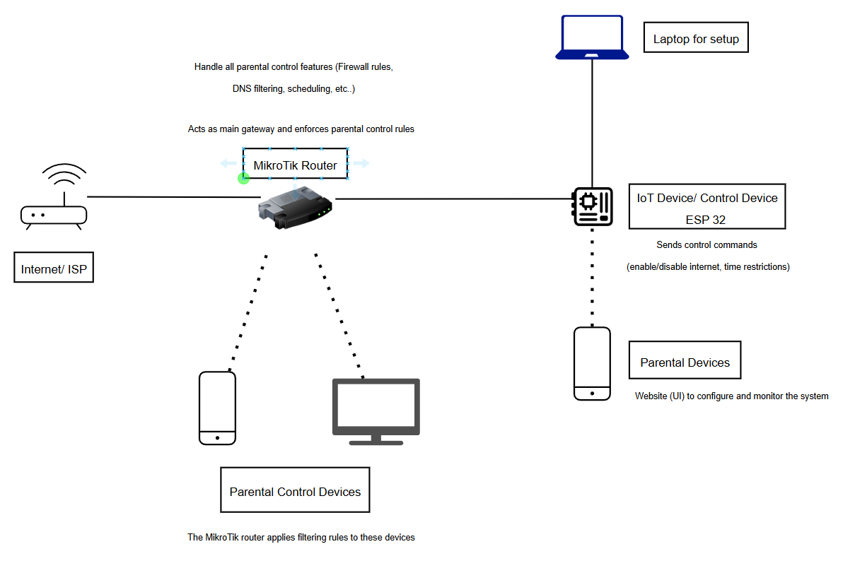
Figure 2.1

System Flow Explanation for IoT-Enabled MikroTik Parental Control System

Step 1: Setting up internet connection through MikroTik router
- The connection of the internet from the Internet Service Provider (ISP) to the MikroTik router
- The main gateway providing Wi-Fi to all the devices on the network is the MikroTik router.
- It has the responsibility for applying parental controls such as firewall blocking and DNS filtering and scheduling access.
Step 2: Parental controls devices are interfaced to the internet
- Devices of children (computers, smartphones, or tablets) connect to MikroTik's Wi-Fi network.
- Upon plugging and association, the router detects these devices and applies the pre-defined filtering on MAC/IP or schedule rules set beforehand.
- They are "Parental Control Devices" as they are the objects of controlling policies themselves.

Step 3: IoT control device sends message to the router
- The controlling layer function is performed by a networked IoT controller device (ESP32).
- The utility instructs the MikroTik router what action to take, like enabling or disabling access to the internet, modifying time limits, or modifying access parameters.

Step 4: Parental device speaks to the control system
- The parents set up and monitor the system through a web or smartphone application interface on their cell phone.
- It's plugged into the IoT controller device and not the router directly.
Using this application, parents can:
  - Block or allow specific websites
  - Implement daily or weekly timetables of internet usage
  - Analyze device and usage history

Step 5: Instructions are actioned and implemented in real time
- The command from the parent is then received by the IoT device and passed on to the MikroTik router.
- The router then implements the newly established rules immediately and applies them on the devices in question.
- This centralized enforcement provides oversight across the network without software installation on any child’s machine.

CHAPTER 3: RESEARCH METHODLOGY
3.1 Introduction
This chapter discusses the research methodology used in the Agile development process for the IoT-Enabled MikroTik Parental Control System. Because it allows for dynamic system change design, functionality, and development based on real input and test results, Agile's adaptability proves crucial in this project. Agile's continuous lifecycle ensures ongoing development, testing, feedback, and refinement because parental control systems need to be flexible enough to adapt to changing user needs and technical problems.

The use of the Agile methodology enables the progressive development of each system component, including the construction of the parental control interface, the integration of IoT device (ESP32), and router configuration on the MikroTik router. In every phase, the system is analyzed, enhanced, and expanded to meet essential needs including user friendliness, real-time functioning, secure access, and filterable network stability. The method enables cross-functional development, in which hardware control, network rule implementation, and web/app interface construction all take place concurrently but theoretically together.

On this front, the Agile development is suited for the IoT-based parental control system and how it enables for continuous development of real-time internet access management and scheduling is shown. Requirement collection, phase planning, designing, developing, testing, releasing and feedback cycles compose the sets of activities which are iterated for system performance and usability enhancement. Additionally, the Agile methodology helps in adapting to new data and unforeseen technological difficulties, ensuring that the final product is a reliable and user-friendly parental control system based on MikroTik and the Internet of Things.

3.1.1 Research Methodology Structure
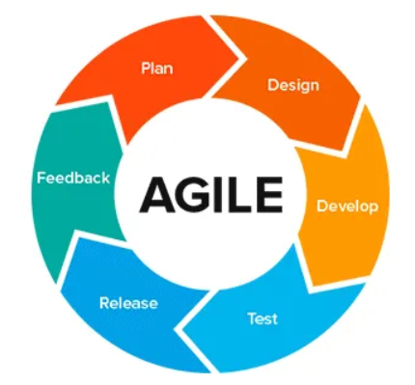
Figure 3.1 : Agile Methodology Phase

In this chapter, the methodology followed in developing the IoT-Enabled MikroTik Parental Control System is explained. The process used to create the MikroTik Parental Control System with Internet of Things capabilities is described in this chapter. Because of its adaptable and continuous nature, which enables ongoing development and improvement throughout the project cycle, the Agile methodology was selected. Agile, in contrast to more conventional models like the Waterfall technique, allows for gradual modifications, which is crucial when creating a system that combines MikroTik router configuration, user interfaces, and IoT control devices.
The system may be tested, examined and enhanced at every level of development thanks to agile's ability to encourage continuous feedback loops. The parental control system closely complies with user expectations and functional needs thanks to this continuous procedure. Additionally, Agile makes it easier to integrate different project components, like web/mobile-based parental interfaces, MikroTik firewall and DNS rule enforcement, and real-time command transfer via ESP32.
The project's objective of modifying the system in response to real-world facts, like network activity and parental usage patterns, is further supported by Agile's flexibility. A more reliable and user-friendly parental control system is the outcome of this dynamic method, which can be adjusted while it is being developed to achieve maximal performance and dependability.

3.1.2 Phase
3.1.2.1 Planning phase
The planning phase is the initial stage of the Agile methodology applied in this project. The Agile technique used in this project starts with the planning phase. The primary goal of this phase is quite clear: to create an Internet of Things-based parental control system that is connected to MikroTik routers. The goal of this system is to give linked devices in a home or small network setting real-time internet control, scheduling, and filtering.
During this stage, important stakeholders are identified, including the developer, end users (parents), and network testers. To track the development and integration of system components including the control interface, IoT device connectivity, and MikroTik rule configurations, particular objectives have been specified. A web-based or mobile-based parental interface, ESP32 as the IoT control device, and MikroTik routers are only a few examples of the hardware and software requirements that are established.

To ensure that all activities and components stay in line with the project's goals and user needs, a project roadmap is established to direct each iterative development cycle.

3.1.2.2 Design Phase
Following the planning stage is the design phase, where the overall system architecture for the IoT-enabled parental control solution is outlined. Through scheduling, page blocking, and device monitoring, the MikroTik router can successfully regulate internet access because to the design's focus on ensuring that the IoT control device—such as the ESP32 communicates with it.
The control logic is set up to allow for the execution of commands in real time, such as turning on or off internet access for particular users. Additionally planned is a straightforward and user-friendly web or mobile interface that will allow parents to manage network restrictions without the need for technical know-how. The RouterOS on the MikroTik router is set up to permit dynamic upgrades via firewall filters or scripts that are initiated by the IoT controller.
Furthermore, a framework for data monitoring is created to keep eyes on user behavior and network activities, allowing the system to report and give feedback to the parental interface. This aids in evaluating how the system affects internet usage and guarantees that the objectives of responsible, controlled online behavior are successfully achieved.

3.1.2.3 Development Phase
The deployment phase focuses on the implementation of the developed IoT-based parental control system into a real-world or test environment. At this point, the MikroTik router may enforce internet usage rules like scheduling access times, restricting particular websites, and keeping an eye on device activity because the IoT control device (ESP32) is completely set to connect with it.
RouterOS is used to upload custom security settings and scripts to the MikroTik router, allowing for automatic control via commands issued from the IoT controller. The system is linked to a web or mobile interface, providing parents with a centralized dashboard that is easy to use to manage their home network.
To assess the system's performance and functionality, a full prototype is set up and tested in a controlled setting. To make sure the system functions well under various usage scenarios, metrics like rule execution time, device response, and system stability are tracked. This stage confirms that the parental control system is workable and feasible in a normal family environment.

3.1.2.4 Testing Phase
The system goes through a comprehensive evaluation during the testing phase once initial development is finished to make sure it satisfies the desired functional and performance requirements. To ensure that important features like device blocking, scheduling, and website filtering work properly through the connection of the IoT controller and MikroTik router, the parental control system is tested in a real-time-settings.
Specific tests are carried out to evaluate the system's capacity to consistently operate connected devices, the responsiveness of commands given from the online or mobile interface, and the dependability of internet access rules. While stress testing simulate heavy traffic or numerous connected devices to confirm system stability, functional tests make sure that planned restrictions activate as intended.
Finding any operational problems or performance gaps is made easier by the results of this phase. The control logic and user interface are improved based on testing feedback, guaranteeing that the finished product is reliable and easy for parents to use when monitoring their kids' internet activity.

3.1.2.5 Release/Deploy Phase
After testing successfully, the system advances to the last stage of deployment, when it is put into use in an actual home network setting. To guarantee optimum performance, the IoT controller and MikroTik router configurations are modified as needed in response to test input. The solution seamlessly integrates with the current network configuration, preventing interruptions to regular internet usage. To find areas for additional development and make sure the parental controls are operating efficiently in real-time, ongoing monitoring is done.

3.1.2.6 Feedback/Review Phase
The final phase is the review and continuous improvement stage, where feedback is gathered from system performance data and users (such as parents or testers). Review and continuous improvement is the last step. This is where comments from users (like parents or testers) and system performance data is gathered. This stage determines where parental control tools, including scheduling, blocking, or monitoring, might be improved for better effectiveness and usability. Any problems or recommendations are fixed in the following development cycles by utilizing Agile's continuous methodology. Each phase yields new insights that help the system be gradually improved so that it continues to be dependable, easy to use, and flexible enough to meet the needs of evolving users.

3.1.3 Resources
3.1.3.1 MIKROTIK ROUTER OS

Figure 3.2 : MikroTik RouterOS
The Linux network operating system from MikroTik is called MikroTik RouterOS. With its advanced routing, firewall, bandwidth control, hotspot, VPN, and wireless access point features, it is MikroTik router software. RouterOS gives users the most flexibility in configuring and processing network traffic using its command line, API, and graphical user interfaces (WebFig, Winbox). RouterOS's performance, scalability, and flexibility make it a popular choice for enterprise and ISP deployments.

3.1.3.2 PHYTON

Figure 3.3 : Python
Python is a user-friendly, multi-purpose program language, which will take the key role in the project by acting as the interface to enable communication amongst the MikroTik Parental Control System, which is IoT-capable, and the MikroTik router through its API. Python will take charge of the backend operations, implementing the parental control rules such as scheduling internet access, content filtering, and device management. Python will enable the implementation of a web interface, which will allow the parents to monitor and manage children's internet access through simple, easy-to-use interfaces. Python, due to ease of development, extensive libraries, and the support for the Raspberry Pi, is the perfect candidate to implement the back-end of the system and integrate it into network hardware.

3.1.3.3 MQTT

Figure 3.4 : MQTT
MQTT is an efficient, lightweight protocol for messaging, which is suitable to implement in IoT environments. MQTT in the current project will provide communication among the MikroTik router, Raspberry Pi, and other devices like smartphones. With the help of the publish/subscribe model, the messages will be published by the Raspberry Pi to the central broker in the case of any change in the settings made by the parent, and the broker will publish the updates to the subscribed devices. It is apt for the current project because MQTT will provide efficient communication with low bandwidth, which will fit the constraints of the IoT applications.
3.1.3.4 HTML

Figure 3.5 : HTML
HTML is the standard language used to structure web pages. The design and content of the web interface for the Internet of Things-enabled MikroTik Parental Control System will be specified by HTML in my project. It will generate the page's basic elements, including buttons, input fields, forms, and sections where parents can conveniently control parameters like content filtering rules and internet access schedules. The web interface's functionality and organization are guaranteed by HTML.

3.1.3.5 CSS

Figure 3.6 : CSS
CSS is responsible for styling and designing the visual appearance of web pages. The web interface in my project will be improved by using CSS to make it more aesthetically pleasing, intuitive, and easy to use. By managing the layout, colors, fonts, and spacing, it makes sure the user interface is clear and responsive across a range of devices, giving them a flawless experience.

`

Figure 3.7 Java Script
JavaScript is a programming language that gives websites dynamic behavior and interactivity. In my project, JavaScript will be used to manage tasks like displaying real-time status updates on the child's internet usage, updating the page in real-time without requiring a page reload, and submitting parental control settings. It makes it possible for the interface to be interactive, guaranteeing that parents can effortlessly manage and keep an eye on their children's internet usage with little effort.

3.1.3.7 MIKROTIK ROUTER
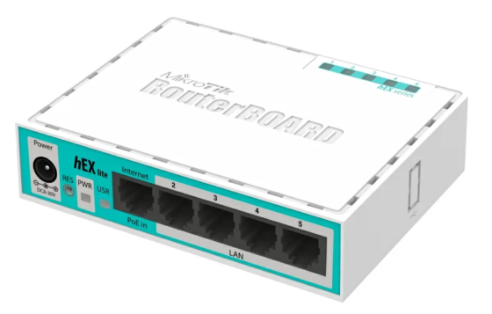
Figure 3.8 : MikroTik Router
The MikroTik Router is a powerful and customizable network device that uses RouterOS, an operating system specifically designed for managing network traffic. The MikroTik router is the primary device in my project that enforces the parental control rules, which include controlling connected devices, restricting internet access, and blocking websites. Advanced configurations such as traffic monitoring, user access control, and firewall filtering are possible. I can more effectively manage these controls by integrating external systems and custom scripts with RouterOS and its API.

3.1.3.8 ESP32
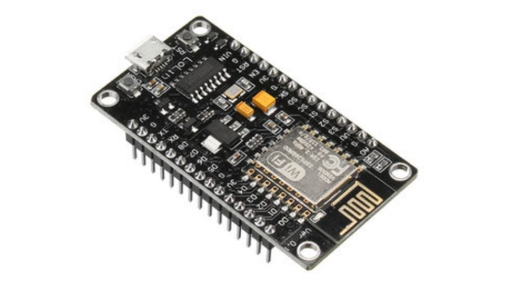
Figure 3.9 : ESP32
The ESP32 is a low-cost Wi-Fi microcontroller commonly used in IoT projects to connect sensors or devices to the internet. In my project, the ESP32 could be used for lightweight monitoring tasks, such as detecting device connections or sending alerts to the system. While it’s not as powerful as the Raspberry Pi, it can be used to extend the system’s capabilities, especially for simple automation tasks or status updates over Wi-Fi. It’s ideal for adding more IoT features without increasing cost or complexity.

3.1.3.9 PERFORMANCE LAPTOP

Figure 3.10 : Performance Laptop
Laptop (ASUS TUF Gaming A15 ,AMD Ryzen 7, RTX3050 Ti 16 GB RAM): In this project, the laptop is used as the main device for developing, configuring, and managing the IoT-enabled MikroTik Parental Control System. It serves as the platform for writing code, setting up the parental control interface, configuring the MikroTik router, and testing the system's functionality.

3.1.3.10 SIMCARD MODEM
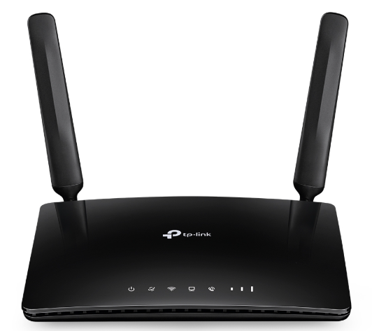
Figure 3.11 : Simcard Modem
The SIM card modem is used in this project to provide internet connectivity to the MikroTik router, especially in areas without wired internet. It enables the parental control system to function in real-time by allowing remote access, monitoring, and control through a mobile data network.

3.1.3.11 WINBOX

Figure 3.12 : Winbox

WinBox is a little application created by MikroTik that offers a graphical user interface (GUI) for MikroTik RouterOS device configuration. Through a Windows-based program, it enables administrators to view and control all of the router's configuration choices. Because of its drag-and-drop support, real-time monitoring features, and convenience of use in comparison to command-line setting, WinBox is particularly helpful-for-network-administrators.
Users can set up wireless connections, DHCP servers, firewall rules, NAT settings, bandwidth control, and many other advanced features with WinBox. It provides both local and distant access by connecting to the router via the device's MAC address or IP address.

3.1.3.12 ETHERNET CABLES
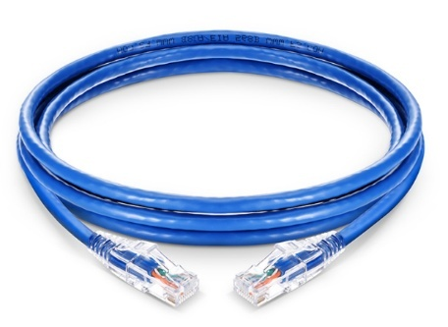
Figure 3.13 : Ethernet Cables

In a Local Area Network (LAN), Ethernet cables are physical networking cables that link devices including switches, routers, PCs, and Internet of Things controllers. In this project, Ethernet cables are the main means of creating a dependable, fast connection between the MikroTik router, the internet source, and the Internet of Things-based controller (such as the Raspberry-Pi-or-ESP8266).
Particularly crucial for network-level parental control, where packet inspection and filtering take place in real time, these cables guarantee steady data transfer, lower latency, and offer a secure communication channel. Cat5e and Cat6, which offer data transmission speeds up to 1 Gbps and 10 Gbps, respectively, over short distances, are common varieties used in home and office networks.
3.1.4 Budget and Costing
NO | DETAILS | QUANTITY | PRICE | REMARK
HARDWARE
1 | Mikrotik hEX refresh (E50UG) - 5x Gigabit Ethernet ports Dual Core router with 512MB RAM | 1 | RM 251.00 | -
2 | ESP8622(ESP32 WROOM Development Board WiFi+Bluetooth)/Raspberry Pi (Raspberry Pi 4 Model B (4GB)) | Either 1 | RM29.00/ RM359.00 | -
3 | Laptop (ASUS TUF Gaming A15 ,AMD Ryzen 7, RTX3050 Ti 16 GB RAM) | 1 | FREE | PERSONAL LAPTOP
4 | TP-Link UNLIMITED MR105 / MR100 4G LTE Router Sim Card Modem Wi-Fi Router-by pass hotspot share unlimited data | 1 | RM136.60 | -
5 | CAT 6 1000Mbps ETHERNET CABLE | 2 OR MORE | RM 1.06/meter | -
SOFTWARE
6 | MikroTik OS | - | - | OPEN SOURCE
7 | PYTHON | - | - | OPEN SOURCE
8 | MQTT | - | - | OPEN SOURCE
9 | HTML | - | - | OPEN SOURCE
10 | CSS | - | - | OPEN SOURCE
11 | JavaScript | - | - | OPEN SOURCE
12 | WINBOX | - | - | OPEN SOURCE
TOTAL |  |  | RM 418.12 (ESP32 & 2 METER CABLE) /  RM 748.12(RASPBERRY PI/2 METER CABLE)

3.1.5 Flow Chart
In the context of a process, a flow chart is a visual representation that displays the order of steps or decisions that are required to carry out a task or accomplish a result. The IoT-Enabled MikroTik Parental Control System's whole development process, from early planning to system implementation and release, is depicted in this project's flow chart.
The flow chart gives a clear picture of the connections between each task and aids in visualizing the project's logic and structure. By outlining the process step-by-step, it makes it easier to comprehend, communicate, and analyze. Throughout the project lifecycle, this facilitates the identification of dependencies, bottlenecks, or places for improvement (Refer Appendix A).

3.1.6 Work Breakdown Structure

A Work Breakdown Structure (WBS) is a way to break down a job into smaller, easier-to-handle tasks or parts. Better planning, assignment, tracking, and control of project activities are made possible by the division of the total scope-of-work-into-deliverable-and-sub-deliverables.
A higher degree of information is represented by each WBS level, which is usually organized in an outline or tree manner. This framework facilitates efficient resource allocation, scheduling, and progress tracking by giving project teams a clear understanding of what must be done, by whom, and in what order (Refer Appendix B).

3.1.7 Gantt Chart

A Gantt chart is a project management tool that uses horizontal bars to visually represent a project timetable. Every bar represents a distinct task, displaying the start and finish dates of that task on a timeline. This chart facilitates task organization, progress monitoring, and the identification of activity dependencies or overlaps. It is frequently used to efficiently plan and track project timelines (Refer Appendix C).

3.2 Prototype Development

3.2.1 Introduction

The objective of this project is to develop a prototype for the parental control system which incorporates the use of MikroTik routers, as well as IoT technology, to control and limit the use of the internet by the connected devices. The development does not require individual installations since it is designed to work at a router level.
This part addresses the initial setup configuration required for the implementation of the prototype, starting from the configuration of the ESP32, which will be utilized as the main IoT controller. The installation of the required firmware as well as the necessary libraries to be used in the ESP32 enables it to act as a mediator between the interface of the parental control system and the MikroTik router.
The current scope involves setting up the development environment on the ESP32, uploading the codes necessary for the project, as well as ensuring a networking communication functionality among the user's devices, the IoT Controller, as well as the MikroTik router. The main idea is to set up a system from scratch, as future versions would require a comprehensive system encompassing many features, as well as graphical user interface interaction.

3.2.2 Hardware Setrup ,Software Installation & Configuration
3.2.2.1 Set Up Mikrotik Router

Step 1: Plug Mikrotik into power
Step 2: Connect laptop to MikroTik (via Ethernet cable or WiFi default SSID)
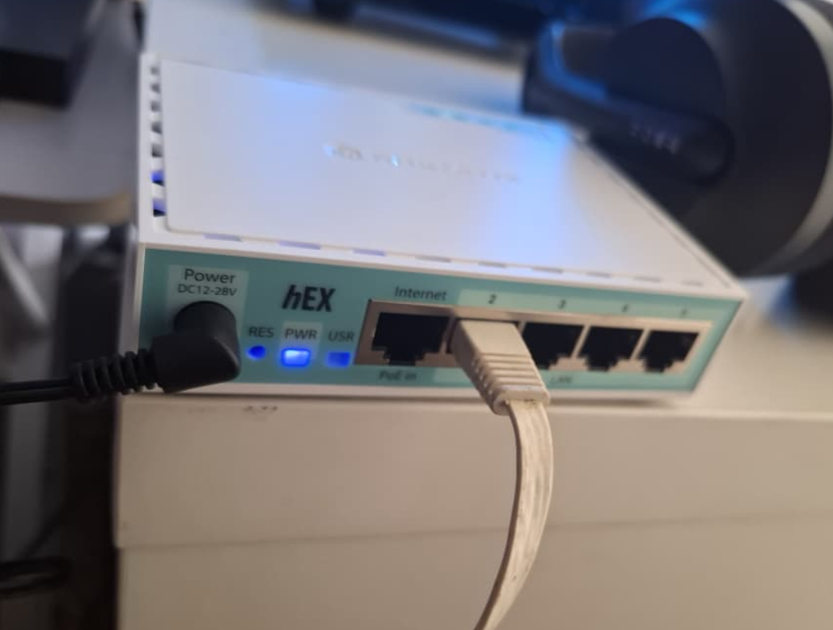
Figure 3.25: Connect MikroTik to laptop
Step 3: Install Winbox
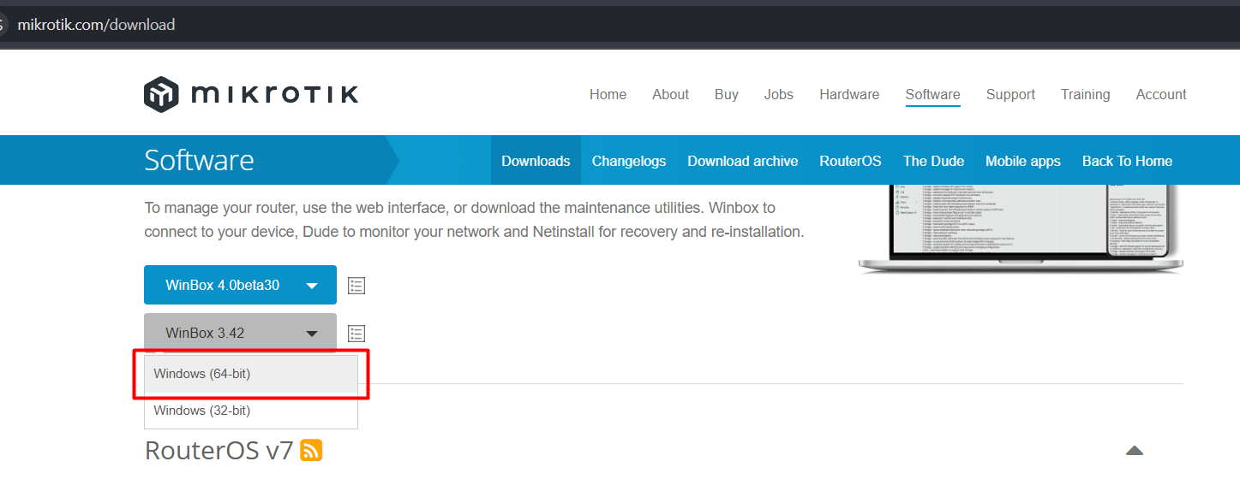
Figure: 3.26 : Install Winbox from MikroTik site

Step 4: Login to MikroTik , check RouterOS is working
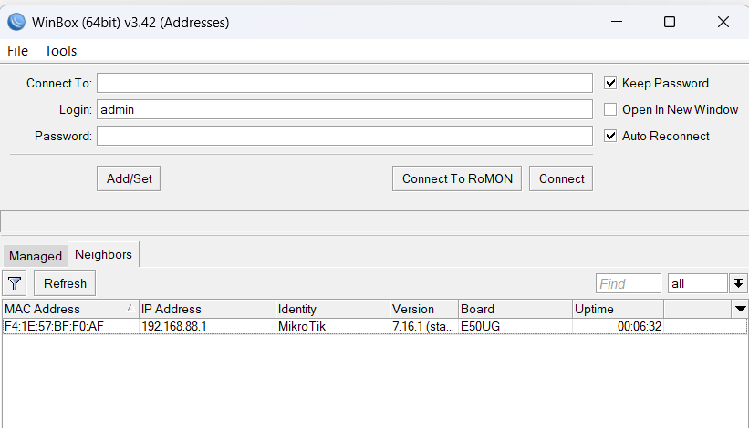
Figure 3.27: Checking RouterOS

3.2.2.2 Hardware (Mikrotik Router) IP & routes configuration setup
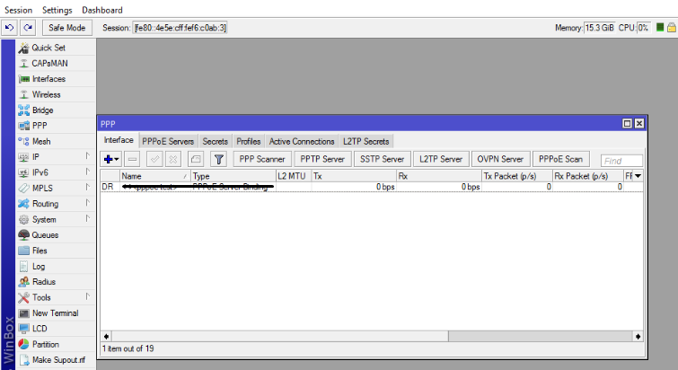
Figure 3.28: MikroTik Router Main Interface (Winbox)
- Assign IP Address to Internal Network Interface (ether2)

Once access to the MikroTik router has been achieved and it has been confirmed that RouterOS is functioning properly, the internal network interface is created. In this project, ether2 has been designated as the Local Area Network (LAN) interface that connects client machines like access points and downstream routers.
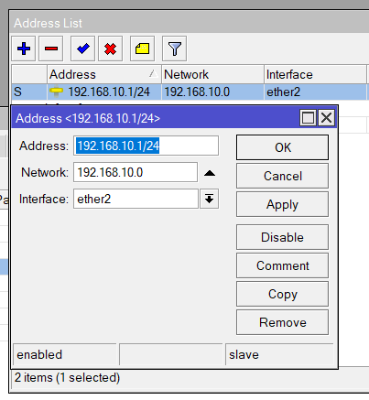
Figure 3.29: Assign IP Address to ether2

The IP address is manually configured on ether2 in order for it to act as the default gateway for devices in the LAN. The default gateway is vital for forwarding any internet traffic initiated from the devices to the router. In this case, it is what makes it possible for devices on the network to access the internet.

The assignment of an IP address to ether2 ensures that:

- The LAN network has a defined network segment
- Internal devices can communicate with the router
- Routing and firewall rules can be applied correctly
- DHCP services can later be bound to this interface
This step establishes the foundation for all further network-based parental control mechanisms implemented in the project.

- Configure Network for DHCP Service

Once completing the LAN interface configuration, the next step is to create network parameters that are associated with the DHCP server service. In this process, it defines how clients will view the network when connected to the router.
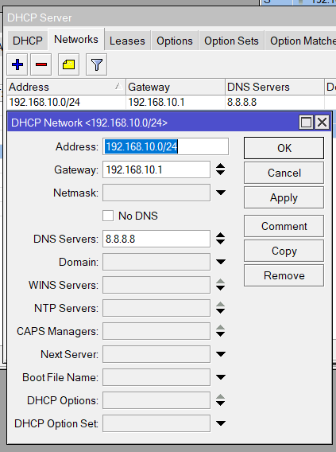
Figure 3.30: Network Configuration for DHCP

The network configuration includes the following components:

- Network address: Defines the LAN subnet
- Gateway address: Points client devices to the router’s LAN interface
- DNS server address: Enables domain name resolution
- Broadcast address: Facilitates device discovery in the local network

By configuring these parameters, the MikroTik router gains full control over how devices behave on the network. This step ensures consistency across all connected devices and eliminates the need for manual configuration on individual clients.
Network-level configuration is particularly important for this parental control system because restrictions and monitoring are applied centrally rather than on each device.

- Set Default Route (Gateway to ISP)

To enable internet access for the internal network, a default route is configured on the MikroTik router. The default route specifies where traffic should be forwarded when the destination is outside the local network.
In this project, all outbound traffic (0.0.0.0/0) is directed toward the ISP gateway through the WAN interface (ether1). This allows devices connected to the LAN interface to access the internet via the router.

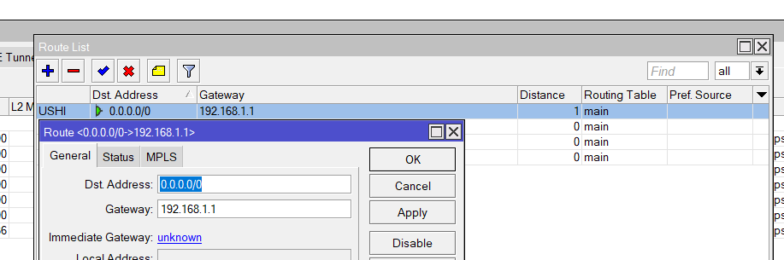
Figure 3.40: Default Route Configuration
The importance of this step lies in the following:

- Allows LAN devices to reach external networks
- Enables DNS resolution and web access
- Supports traffic filtering and monitoring at the router level
- Ensures parental control policies are enforced before traffic leaves the network
Without a correctly configured default route, internal devices may receive IP addresses but will be unable to access internet services, making further testing and enforcement impossible. In this case, I’ve setup the gateway same with my ISP network segment (192.167.1.0).

- Create IP Address Pool

To support multiple devices connecting to the network, an IP address pool is created. This pool defines a specific range of IP addresses that can be assigned dynamically to client devices by the DHCP server.

For the IP Pool name “fyp”, I’ve gave the range is 192.168.0.10-.125

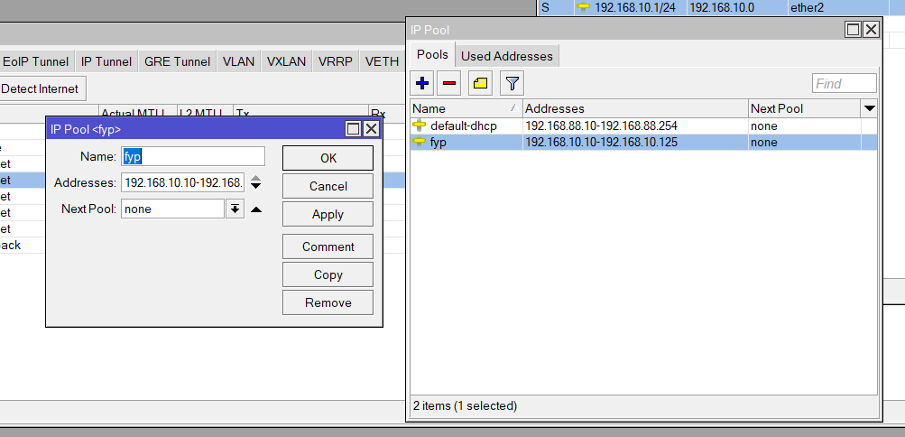
Figure 3.41: IP Pool Configuration

The IP pool is carefully designed to:

- Avoid conflict with static IP addresses
- Support multiple client connections
- Maintain consistent addressing for monitoring and control
- Facilitate device identification during rule enforcement

Key advantages of using an IP pool include:

- Automatic IP management
- Reduced configuration overhead
- Scalability for additional devices
- Compatibility with firewall and scheduling rules

The IP pool plays a vital role in ensuring that all client devices receive valid network configuration parameters and can be centrally controlled.

- Configure DHCP Server and Bind IP Pool

With the IP pool prepared, the DHCP server is configured and enabled on the MikroTik router. The DHCP server automates the process of assigning IP addresses and network information to client devices.

The DHCP server is linked to:

- The LAN interface (ether2)
- The predefined IP address pool
- The configured network parameters
- 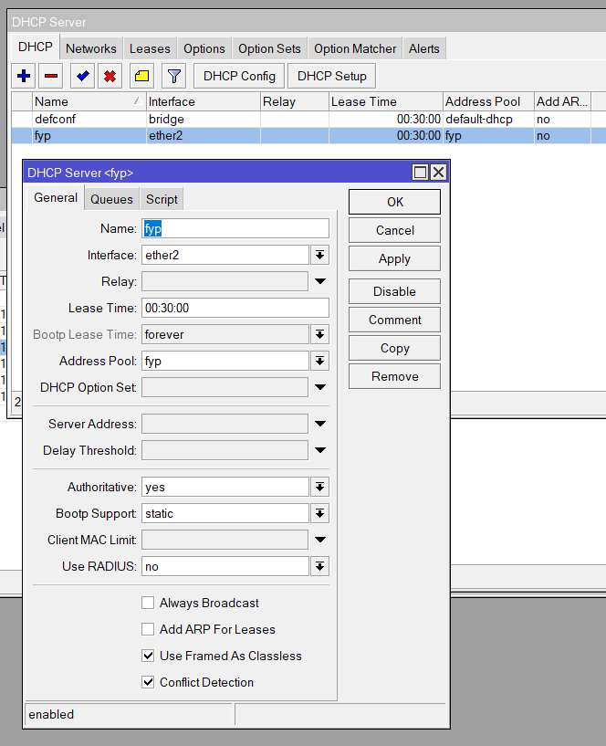
- Figure3.42: DHCP Server Setup

When a device connects to the network, it automatically receives:

- An IP address
- Gateway address
- DNS server
- Lease duration

This automation is essential for the usability of the parental control system, as it allows devices to connect seamlessly without technical intervention by users. It also ensures consistency across all devices, which is necessary for accurate monitoring and control.

- Create Firewall Layer 7 Protocol Rules

Once networking services are established, the system moves into application-level traffic control. Layer 7 (L7) protocol rules are created to detect specific online services based on domain patterns rather than IP addresses.

Layer 7 rules are used in this project to identify services such as:

- YouTube
- Facebook
- TikTok
- Other web-based platforms

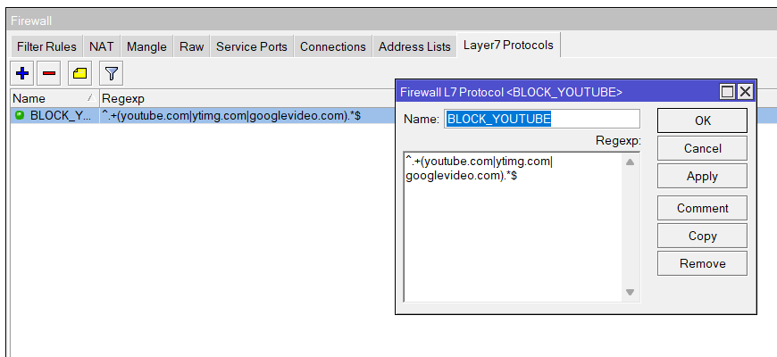
Figure 3.43: Layer 7 Protocol Creation

The figure above shows the configuration of a protocol used to block access to YouTube (Name: BLOCK_YOUTUBE). Layer 7 filtering is implemented by defining regular expression (RegExp) patterns that are capable of identifying specific web services based on their domain names. These protocols inspect traffic content to match predefined patterns, enabling the router to recognize specific applications even when they use dynamic IP addresses.

The use of Layer 7 filtering provides several advantages:

- Accurate detection of web services
- Centralized control regardless of device type
- Independence from browser or application
- Effective enforcement of parental restrictions

3.2.2.3 Hardware (OenWRT) configuration setup
At the early planning stage of this project, the OpenWRT router was initially intended to function solely as a wireless access point that would extend network connectivity to client devices. Its primary role was to provide wireless access while routing and core network operations were handled by the MikroTik router. However, during the development and implementation phase, it became evident that OpenWRT offers advanced flexibility and powerful networking features that are well suited for implementing network-level parental control mechanisms.
As the project progressed, the role of the OpenWRT router was expanded beyond basic wireless functionality. In addition to providing wireless connectivity, OpenWRT was configured to perform content filtering, website blocking, Safe Search enforcement, and device-based policy control. These configurations allow OpenWRT to act as the centralized policy enforcement point, while the MikroTik router continues to serve as the primary gateway to the Internet Service Provider (ISP).
By integrating both wireless access and parental control logic within OpenWRT, the system achieves a more modular and scalable design. This approach simplifies rule implementation, enhances control over client traffic, and enables more effective enforcement of parental control policies at the network level rather than on individual devices.

CHAPTER 4: RESULT AND DISCUSSION

CHAPTER 5: CONCLUSION

REFERENCES

- R. Tsai and L. Estell, "Network Activity for Parental Monitoring," 2024 IEEE MIT Undergraduate Research Technology Conference (URTC), Cambridge, MA, USA, 2024, pp. 1-4, doi: 10.1109/URTC65039.2024.10937630.
- D. J. P G. A. Dath, M. K. Chinta and A. Karki, "Granular Network Traffic Classification on Mobile Application Service for Better Parental Control", IEEE International Conference on Interdisciplinary Approaches in Technology and Management for Social Innovation, vol. 2, pp. 1-6, 2024.

- Stewart, K., Brodowsky, G., & Sciglimpaglia, D. (2021). Parental supervision and control of adolescents’ problematic internet use: understanding and predicting adoption of parental control software. Young Consumers Insight and Ideas for Responsible Marketers, 23(2), 213–232. https://doi.org/10.1108/yc-04-2021-1307

- Ali, S., Elgharabawy, M., Duchaussoy, Q., Mannan, M., & Youssef, A. (2020).
Betrayed by The Guardian: Security and privacy risks of parental control solutions. Annual Computer Security Applications Conference.
https://doi.org/10.1145/3427228.3427287

- Altarturi, H. H., Saadoon, M., & Anuar, N. B. (2020). Cyber parental control: A bibliometric study. Children and Youth Services Review, 116, 105134. https://doi.org/10.1016/j.childyouth.2020.105134

- Ali, S., Elgharabawy, M., Duchaussoy, Q., Mannan, M., & Youssef, A. (2020a). Betrayed by The Guardian: Security and privacy risks of parental control solutions. Annual Computer Security Applications Conference. https://doi.org/10.1145/3427228.3427287
- Ojo, F. F. (2024). An Overview of Web Content Filtering Techniques. ResearchGate. Retrieved from https://www.researchgate.net/publication/381306880_An_Overview_of_Web_Content_Filtering_Techniques

- Wang, B., Li, W., & Xiong, N. N. (2019b). Time-Based access control for multi-attribute data in internet of things. Mobile Networks and Applications, 26(2), 797–807. https://doi.org/10.1007/s11036-019-01327-2

- Riga, Latvia & Santa Clara, (2024). RouterOS - RouterOS - MikroTik Documentation. (n.d.). https://help.mikrotik.com/docs/display/ROS/RouterOS

- Al-Mutawa, R. F., & Eassa, F. A. (2020). A Smart Home System based on Internet of Things. arXiv preprint arXiv:2009.05328. Retrieved from https://arxiv.org/abs/2009.05328

- Wang, G., Zhao, J., Van Kleek, M., & Shadbolt, N. (2021). Protection or Punishment? Relating the Design Space of Parental Control Apps and Perceptions about Them to Support Parenting for Online Safety. Proceedings of the ACM on Human-Computer Interaction, 5(CSCW2), 1–26. https://doi.org/10.1145/3476084

- Mohamed, A. K. Y. S., Auer, D., Hofer, D., & Küng, J. (2022b). A systematic literature review for authorization and access control: definitions, strategies and models. International Journal of Web Information Systems, 18(2/3), 156–180. https://doi.org/10.1108/ijwis-04-2022-0077

APPENDICES
APPENDIX A – FLOW CHART
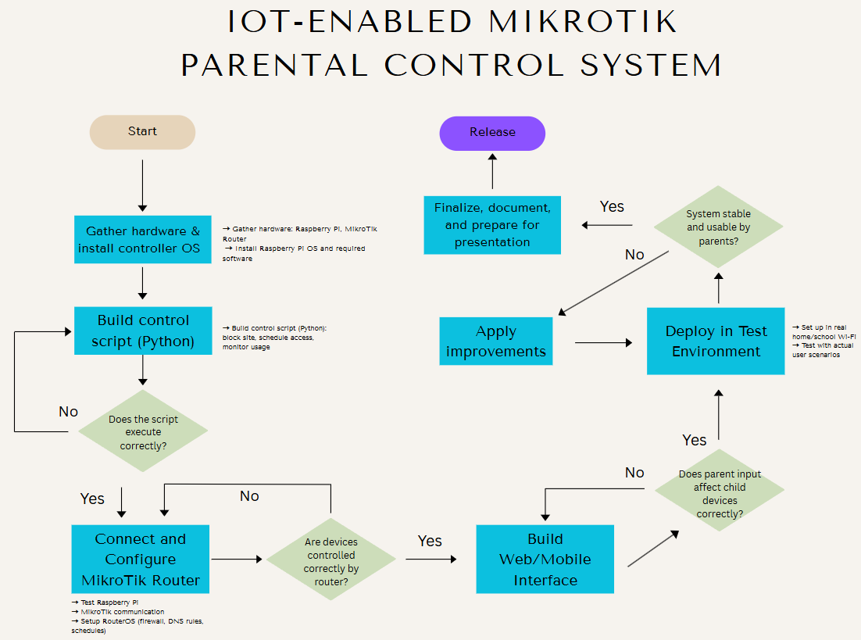

APPENDIX B – WBS (WORK BREAKDOWN STRUCTURE)
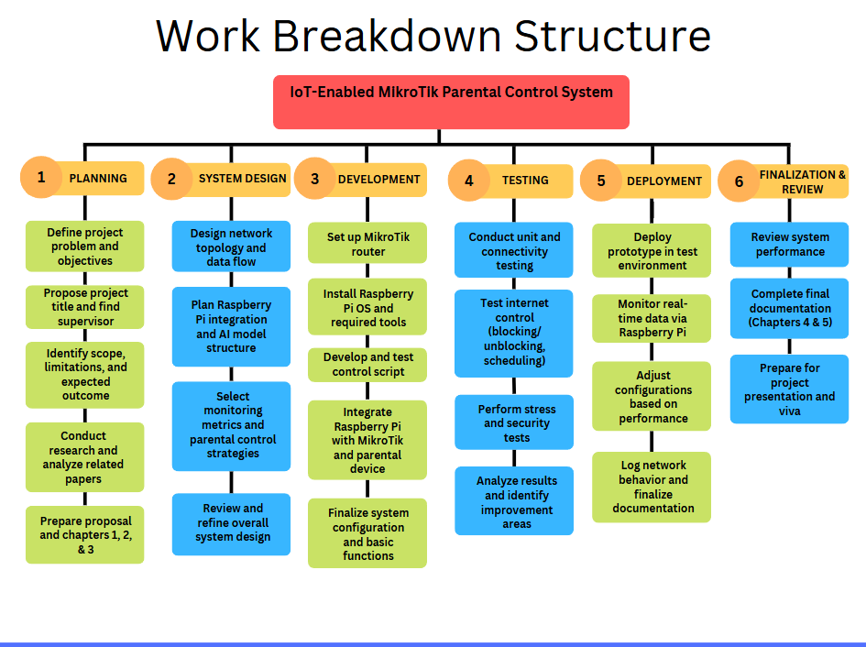

APPENDIX C – GANTT CHART
