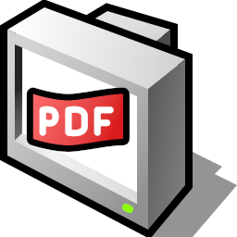
DocumentViewer

The MIT License (MIT)
Copyright (c) 2011 Haiku Inc.
Permission is hereby granted, free of charge, to any person obtaining a copy of this software and associated documentation files (the “Software”), to deal in the Software without restriction, including without limitation the rights to use, copy, modify, merge, publish, distribute, sublicense, and/or sell copies of the Software, and to permit persons to whom the Software is furnished to do so, subject to the following conditions:
The above copyright notice and this permission notice shall be included in all copies or substantial portions of the Software.
THE SOFTWARE IS PROVIDED “AS IS”, WITHOUT WARRANTY OF ANY KIND, EXPRESS OR IMPLIED, INCLUDING BUT NOT LIMITED TO THE WARRANTIES OF MERCHANTABILITY, FITNESS FOR A PARTICULAR PURPOSE AND NONINFRINGEMENT. IN NO EVENT SHALL THE AUTHORS OR COPYRIGHT HOLDERS BE LIABLE FOR ANY CLAIM, DAMAGES OR OTHER LIABILITY, WHETHER IN AN ACTION OF CONTRACT, TORT OR OTHERWISE, ARISING FROM, OUT OF OR IN CONNECTION WITH THE SOFTWARE OR THE USE OR OTHER DEALINGS IN THE SOFTWARE.

Author : Ciprian Nedisan (cipri)

ICONS :

 : Opens a friendly pop-up which helps to browse your file.

 : Show’s you the thumbnail images.

 : Search anything within the file using this tool.

 : Give’s you access to feature’s like changing page, printing, opening a new file and closing current one.

 : Give’s a print command .

 : Give’s you access to tools like Zoom In, Zoom Out, Fit to width, Fit to height, full screen window etc .

: Zoom Out

: Zoom In

 : Fit to width

: Fit to height

: Takes you to this guide in your browser.

: Takes you to the support page in your browser.

Rest of the application is self-explanatory in case of any help ping us @ irc.freenode.org Haiku .

